STEMotion – Report 3: Software Requirement Specification
Oct 29, 2026 · Nguyen Viet Hoang
Project: STEMotion - AI-Assisted STEM Video Production Platform Using Remotion (FA26SE054) · Supervisor: Lại Đức Hùng · Baseline: tag review-2 (BE 4156dff, FE 88570f2, RENDER 3344a29); the STEM requirements of section IV.3.12 are built on an isolated branch. This SRS specifies what the system must do; requirements marked Planned come from the mentor meeting of 26/10/2026 and are not yet built.

I. Record of Changes
Date | A/M/D | In charge | Change description
29/10/2026 | A | Nguyen Viet Hoang | First version of Report 3: overall description, actors and use cases, functional requirements per module, screen authorization, non-functional requirements, business rules and messages, aligned with Report 1 (FE-01 to FE-17) and the implemented system.
02/11/2026 | M | Nguyen Viet Hoang | Aligned with the team use case diagram (Figure 1) and the registration form of 17/08/2026: use case list mapped to the diagram; internal library publishing by Producer and Admin (UC-22, FR-39); YouTube publishing (FE-13, FR-40) stated as registered scope; added FR-48 to FR-55 and storage in FR-43 so every use case of Figure 1 maps to a requirement.
09/11/2026 | M | Nguyen Viet Hoang | Aligned with Review 2 (03/11/2026) and auth v2: use case diagram and list extended to the 61 use cases of Figure 1 (UC-43 to UC-67 added; combined rows split so that each diagram use case has one identifier); FR-01 to FR-05 rewritten for username login and the Google whitelist; added FR-56 to FR-61 (whitelist, profile, Google link, sessions, notifications) and section 3.12 with FR-62 to FR-73 and BR-ST01 to BR-ST15 for the STEM curriculum framework (BM03 change 1, in progress on an isolated branch); actors, screens, entities and messages updated; acceptance criteria for every FR (section IV.4) and pass thresholds for NFR-08, NFR-11 and NFR-12 (BM02 SR-06, SR-08).
A - Added, M - Modified, D - Deleted

II. Overall Description

1. Product Overview
STEMotion is a web platform that carries a short Vietnamese STEM explainer clip from script to published video inside one role-based workflow. A Writer drafts the script scene by scene, a Reviewer approves it with per-scene comments, a Producer tunes the auto-generated Remotion composition and renders it, and the Reviewer approves the clip before it is published to the internal library. AI assists at each step (drafting, segmentation, readability, terminology, narration, captions, quality checks), but every AI result is a suggestion a person accepts or ignores. Each script version carries a STEM brief for its education level (grade, subjects, curriculum outcomes, usage context and S-T-E-M evidence per scene), checked on submit and assessed by the Reviewer with a rubric.

2. System Context
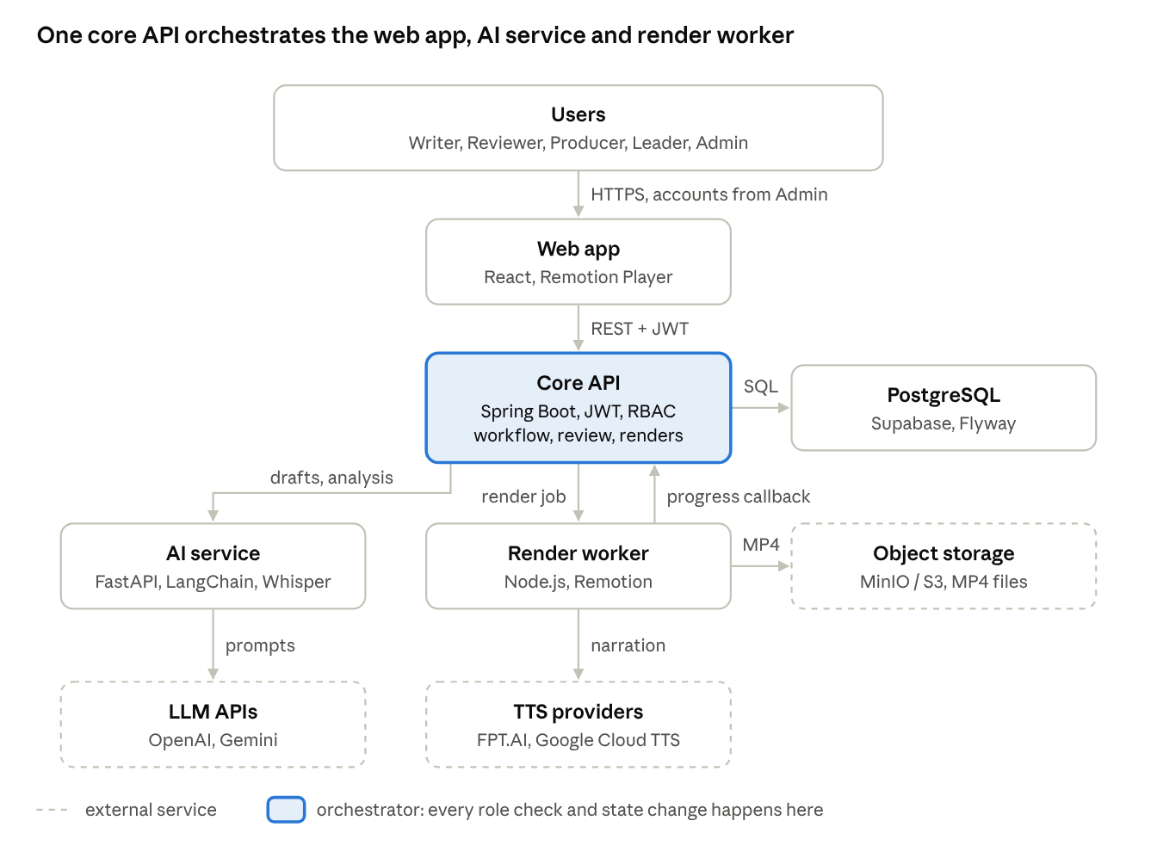
System context · 4 internal components, 3 external services
The web app talks only to the core API; the core API drives the AI service and the render worker, and the worker reports progress back by callback.
Component | Technology | Responsibility
Web application | React + Vite, Tailwind CSS, Remotion Player | Role-based studios (Writer, Reviewer, Producer), admin portal, in-browser preview
Core API | Spring Boot 3 (Java 17), Spring Security + JWT | Auth, RBAC, workspace and project lifecycle, review, composition, render orchestration, publishing
Rendering service | Node.js + Remotion, headless Chromium, job queue | Renders compositions to MP4, TTS narration, duration sync, reports progress by callback
AI microservice | Python FastAPI + LangChain; OpenAI / Gemini providers; Whisper | Script drafting and analysis with schema-validated output; word-level caption alignment
Database | PostgreSQL (Supabase), Flyway migrations | Users, workspaces, projects, script versions, compositions, render jobs, clips, publications, AI usage
Object storage | MinIO / S3-compatible | Rendered MP4 files and media assets
External services | FPT.AI / Google Cloud TTS, LLM APIs | Narration voices, language models

3. Scope
In scope are the 17 major features FE-01 to FE-17 of Report 1, extended by the mentor requirements of 26/10/2026 and by the STEM curriculum framework requested at Review 2 on 03/11/2026 (section IV.3.12, in progress) (workspace staffing, Leader permissions, project approval, edit locking, contribution). Limitations LI-01 to LI-10 of Report 1 still apply, with three changes:
- YouTube publishing (FE-13) is registered scope and committed for Defense 1.1; until the channel connection is built the API returns 503 PUBLISH_TARGET_UNAVAILABLE; publishing to the internal library and an LMS embed code works.
- LMS embed exists as a publish target (embed code only); LI-08 still excludes LMS integration beyond that code.
- Login (FE-01) uses Admin-provisioned accounts. Users sign in with a username and password, or with Google when the verified Gmail address is on the Admin's whitelist (auth v2); there is no self-registration and no request-access flow.

4. User Classes
User class | Description | Main goals
Guest | Not signed in | Sign in
Writer | Teacher or content author in a workspace | Draft and revise scripts, author the STEM brief, use AI assistance, answer feedback
Reviewer | Subject expert in a workspace | Approve or return scripts and clips with comments; assess STEM content with the rubric
Producer | Motion/video producer in a workspace | Build the composition, narration and timing; render; publish
Leader | A workspace member flagged as leader (additional responsibility, not a fourth production role) | Assign roles, approve project proposals and join requests, track progress
Admin | System administrator | Manage users and system roles, the Google whitelist, workspaces and templates; monitor render queue, storage and AI cost; manage STEM policies

5. Assumptions and Constraints
- C-01 Clips are 20 to 180 seconds long (QA bounds); the render-time target covers 60 to 90 seconds.
- C-02 Output is MP4 H.264 at 30 fps; 720p, 1080p and 1440p presets.
- C-03 Narration and captions are Vietnamese only.
- C-04 AI output is advisory; no AI result approves, passes QA or publishes on its own.
- C-05 Supported browsers: Chrome, Firefox, Edge 100+ and Safari 15+.
- A-01 Every user belongs to at least one workspace before working on projects; an Admin provisions accounts (no public self-registration).
- A-02 LLM, TTS and storage providers are reachable and within the configured monthly AI budget.

III. User Requirements

1. Actors
# | Actor | Description
1 | Guest | Anyone not signed in. Can only sign in.
2 | Authorized User | Any signed-in user. Writer, Reviewer, Producer and Admin inherit the shared actions: Logout, Change Password, View / Update Profile, Link Whitelisted Google Identity, View / Select Workspace, View Pipeline Board, View Clip Project, View Script, Browse & Search Media Library (filtered by level, grade, outcome and usage context) and Export Video / Get LMS Embed Code.
3 | Writer | Creates and edits clip projects; writes scripts scene by scene, views script history, requests AI assistance, accepts or ignores suggestions, submits scripts, reads and resolves feedback, and views review history. STEM (Planned): authors the STEM brief and learner context, selects grade, subjects and curriculum outcomes, links S-T-E-M evidence to scenes, requests grounded AI assistance and completes the STEM mapping of legacy projects.
4 | Reviewer | Views the review queue; reviews scripts with inline comments, approval or change requests; reviews video compositions or clips with timestamp annotations, approval or return to production; views automated pre-publish QA, compares versions and publishes clips to the internal library. STEM (Planned): reviews scripts against the STEM rubric and evidence and verifies clips against the learning objectives.
5 | Producer | Opens and edits draft compositions and scenes; selects or replaces media assets; generates or edits narration and captions; previews scenes and video; submits clips for review; renders, monitors and retries jobs; views render and review history, resolves feedback and publishes clips, including to YouTube (committed, in development). Rendering, submitting for video review and publishing include the semantic freshness check; publishing stores the STEM learning card snapshot (Planned).
6 | Leader | A workspace member with the leader flag. Assigns roles inside the workspace; approves project proposals and join requests (Planned). This additional workspace responsibility is not a separate actor in Figure 1.
7 | Admin | Manages users and system roles (ADMIN or USER), the Google whitelist and its email notifications, workspaces and members, and Remotion templates; monitors render queue, storage and AI cost; publishes approved clips to the library; configures AI/TTS budgets (Planned); manages STEM policy versions and assigns them to workspaces (Planned).
8 | Render Worker (system) | Renders MP4, synthesises narration, measures durations and reports progress back by callback. Internal system component; not a separate actor in Figure 1.
9 | AI Service (system) | Drafts and analyses scripts, aligns captions to narration. Internal system component; not a separate actor in Figure 1.

2. Use Case Diagram
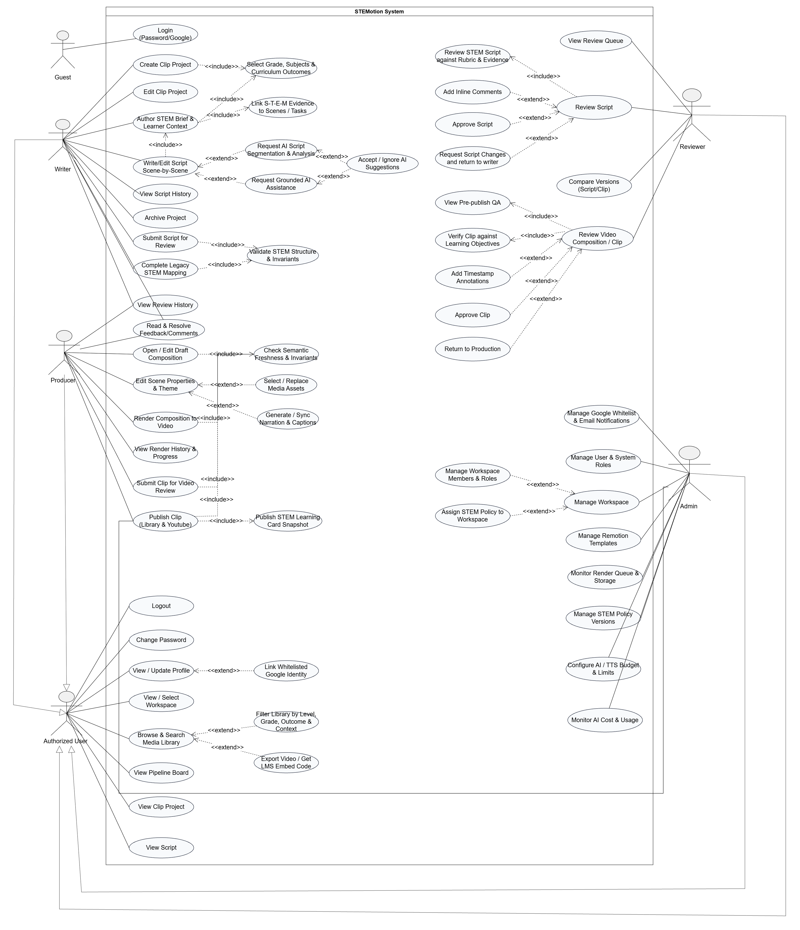
Figure 1. Updated STEMotion use case diagram (61 use cases, including the STEM brief, validation and review use cases): Guest, Authorized User, Writer, Reviewer, Producer and Admin. Actions use the labels and relationships shown in the diagram; YouTube publishing is registered scope, still in development. Shared actions require authentication and project access. Project-scoped actions require an open project and depend on the workspace role and project status; View Script also requires a selected script.

3. Use Case List
ID | Use case | Primary actor | Feature | Status
UC-01 | Login (Password / Google): username and password, or Google with a whitelisted Gmail; Admin-provisioned account | Guest | FE-01 | Implemented (auth v2)
UC-02 | Logout | Authorized User | FE-01 | Implemented
UC-03 | Change Password | Authorized User | FE-01 | Implemented
UC-04 | Create Clip Project; includes Select Grade, Subjects & Curriculum Outcomes (UC-46) | Writer | FE-02 | Implemented (UC-46 in progress)
UC-05 | Edit Clip Project | Writer | FE-02 | Implemented
UC-06 | Write / Edit Script Scene-by-Scene; includes Author STEM Brief & Learner Context (UC-43) | Writer | FE-03 | Implemented (UC-43 in progress)
UC-07 | View Script History | Writer | FE-03 | Implemented
UC-08 | Request AI Script Segmentation & Analysis (extends UC-06) | Writer | FE-04 | Implemented
UC-09 | Accept / Ignore AI Suggestions (extends UC-08 and UC-44) | Writer | FE-04 | Implemented
UC-10 | Submit Script for Review; includes Validate STEM Structure & Invariants (UC-48) | Writer | FE-05 | Implemented (UC-48 in progress)
UC-11 | View Pipeline Board | Authorized User | FE-05 | Implemented
UC-12 | Read & Resolve Feedback / Comments | Writer, Producer | FE-06 | Implemented
UC-13 | Review Script; includes UC-52; extended by Add Inline Comments (UC-53), Approve Script (UC-54) and Request Script Changes (UC-55) | Reviewer | FE-07 | Implemented
UC-14 | Open / Edit Draft Composition; includes Check Semantic Freshness & Invariants (UC-49) | Producer | FE-08 | Implemented (UC-49 in progress)
UC-15 | Edit Scene Properties & Theme; extended by Select / Replace Media Assets (UC-50) and Generate / Sync Narration & Captions (UC-16) | Producer | FE-09 | Implemented
UC-16 | Generate / Sync Narration & Captions (extends UC-15) | Producer | FE-09 | Implemented
UC-17 | Submit Clip for Video Review; includes UC-49 | Producer | FE-11 | Implemented (UC-49 in progress)
UC-18 | Review Video Composition / Clip; includes View Pre-publish QA (UC-19) and UC-56; extended by Add Timestamp Annotations (UC-57), Approve Clip (UC-58) and Return to Production (UC-59) | Reviewer | FE-11 | Implemented
UC-19 | View Pre-publish QA (included by UC-18) | Reviewer | FE-11 | Implemented
UC-20 | Render Composition to Video (monitor progress, retry a failed render); includes UC-49 | Producer | FE-10 | Implemented (UC-49 in progress)
UC-21 | Compare Versions (Script / Clip) | Reviewer | FE-12 | Implemented
UC-22 | Publish Clip (Library & YouTube); includes UC-49 and Publish STEM Learning Card Snapshot (UC-51) | Producer, Admin | FE-13 | Library implemented; YouTube in development (committed); UC-49, UC-51 in progress
UC-23 | Browse & Search Media Library; extended by UC-41 and UC-67 | Authorized User | FE-14 | Implemented
UC-24 | Manage Users & System Roles (local accounts; system role ADMIN or USER) | Admin | FE-15 | Implemented (auth v2)
UC-25 | Manage Workspace; extended by Manage Workspace Members & Roles (UC-61) and Assign STEM Policy to Workspace (UC-62) | Admin | FE-15 | Implemented
UC-26 | Manage Remotion Templates | Admin | FE-16 | Implemented
UC-27 | Monitor Render Queue & Storage | Admin | FE-17 | Implemented
UC-28 | Archive Project | Writer (owner), Leader, Admin | FE-02 | Implemented
UC-29 | Propose a project; approve or reject the proposal | Writer, Leader | M12 | Planned
UC-30 | Request to join a project; approve, reject or revoke | Workspace member, Leader | M12, M14 | Planned
UC-31 | Acquire, renew and release an edit lock | Writer, Producer, Leader | M17 | Planned
UC-32 | View project contributions | Authorized User | M13 | Planned
UC-33 | Leader dashboard: inbox and progress board | Leader | M16 | Planned
UC-34 | Configure AI / TTS Budget & Limits | Admin | M06 | Planned
UC-35 | View Clip Project | Authorized User | FE-02 | Implemented
UC-36 | View Script | Authorized User | FE-03 | Implemented
UC-37 | View / Select Workspace | Authorized User | FE-15 | Implemented
UC-38 | View Review History | Writer, Producer | FE-06 | Implemented
UC-39 | Preview Scene & Video (part of UC-15; outside Figure 1) | Producer | FE-09 | Implemented
UC-40 | View Render History & Progress | Producer | FE-10 | Implemented
UC-41 | Export Video / Get LMS Embed Code (extends UC-23) | Authorized User | FE-14 | Implemented
UC-42 | View Review Queue | Reviewer | FE-05 | Implemented
UC-43 | Author STEM Brief & Learner Context; includes UC-46 and UC-47 | Writer | STEM | In progress (isolated branch)
UC-44 | Request Grounded AI Assistance (extends UC-06) | Writer | STEM | In progress (isolated branch)
UC-45 | Complete Legacy STEM Mapping; includes UC-48 | Writer | STEM | In progress (isolated branch)
UC-46 | Select Grade, Subjects & Curriculum Outcomes (included by UC-04 and UC-43) | Writer | STEM | In progress (isolated branch)
UC-47 | Link S-T-E-M Evidence to Scenes / Tasks (included by UC-43) | Writer | STEM | In progress (isolated branch)
UC-48 | Validate STEM Structure & Invariants (included by UC-10 and UC-45) | Writer (server check) | STEM | In progress (isolated branch)
UC-49 | Check Semantic Freshness & Invariants (included by UC-14, UC-17, UC-20 and UC-22) | Producer (server check) | STEM | In progress (isolated branch)
UC-50 | Select / Replace Media Assets (extends UC-15) | Producer | FE-09 | Implemented
UC-51 | Publish STEM Learning Card Snapshot (included by UC-22) | Producer, Admin | STEM | In progress (isolated branch)
UC-52 | Review STEM Script against Rubric & Evidence (included by UC-13) | Reviewer | STEM | In progress (isolated branch)
UC-53 | Add Inline Comments (extends UC-13) | Reviewer | FE-07 | Implemented
UC-54 | Approve Script (extends UC-13) | Reviewer | FE-07 | Implemented
UC-55 | Request Script Changes and Return to Writer (extends UC-13) | Reviewer | FE-07 | Implemented
UC-56 | Verify Clip against Learning Objectives (included by UC-18) | Reviewer | STEM | In progress (isolated branch)
UC-57 | Add Timestamp Annotations (extends UC-18) | Reviewer | FE-11 | Implemented
UC-58 | Approve Clip (extends UC-18) | Reviewer | FE-11 | Implemented
UC-59 | Return to Production (extends UC-18) | Reviewer | FE-11 | Implemented
UC-60 | Manage Google Whitelist & Email Notifications | Admin | FE-01, FE-15 | Implemented (auth v2)
UC-61 | Manage Workspace Members & Roles (extends UC-25) | Admin, Leader | FE-15 | Implemented
UC-62 | Assign STEM Policy to Workspace (extends UC-25) | Admin | STEM | In progress (isolated branch)
UC-63 | Manage STEM Policy Versions | Admin | STEM | In progress (isolated branch)
UC-64 | Monitor AI Cost & Usage | Admin | FE-17 | Implemented
UC-65 | View / Update Profile | Authorized User | FE-01 | Implemented (auth v2)
UC-66 | Link Whitelisted Google Identity (extends UC-65) | Authorized User | FE-01 | Implemented (auth v2)
UC-67 | Filter Library by Level, Grade, Outcome & Context (extends UC-23) | Authorized User | STEM | In progress (isolated branch)
Figure 1 has 61 use cases: UC-01 to UC-28, UC-34 to UC-38, UC-40 to UC-42 and UC-43 to UC-67. Each diagram use case has one identifier, and its include or extend relationships are named in its row. UC-29 to UC-33 (mentor requirements, Planned) and UC-39 (preview, part of UC-15) are supplementary and outside the diagram. Feature STEM marks the curriculum framework requested at Review 2 (BM03 change 1, BM01 F-14); these use cases are built on an isolated branch (phases P3 to P6, not merged) and are released with the production STEM migration. Auth v2 use cases are implemented on main; the shared database is migrated at the release cutover. Detailed requirements are in section IV.3; Planned requirements depend on decisions D08 to D21 of the master update plan.

IV. Functional Requirements

1. System Functional Overview

1.1 Screen Flow
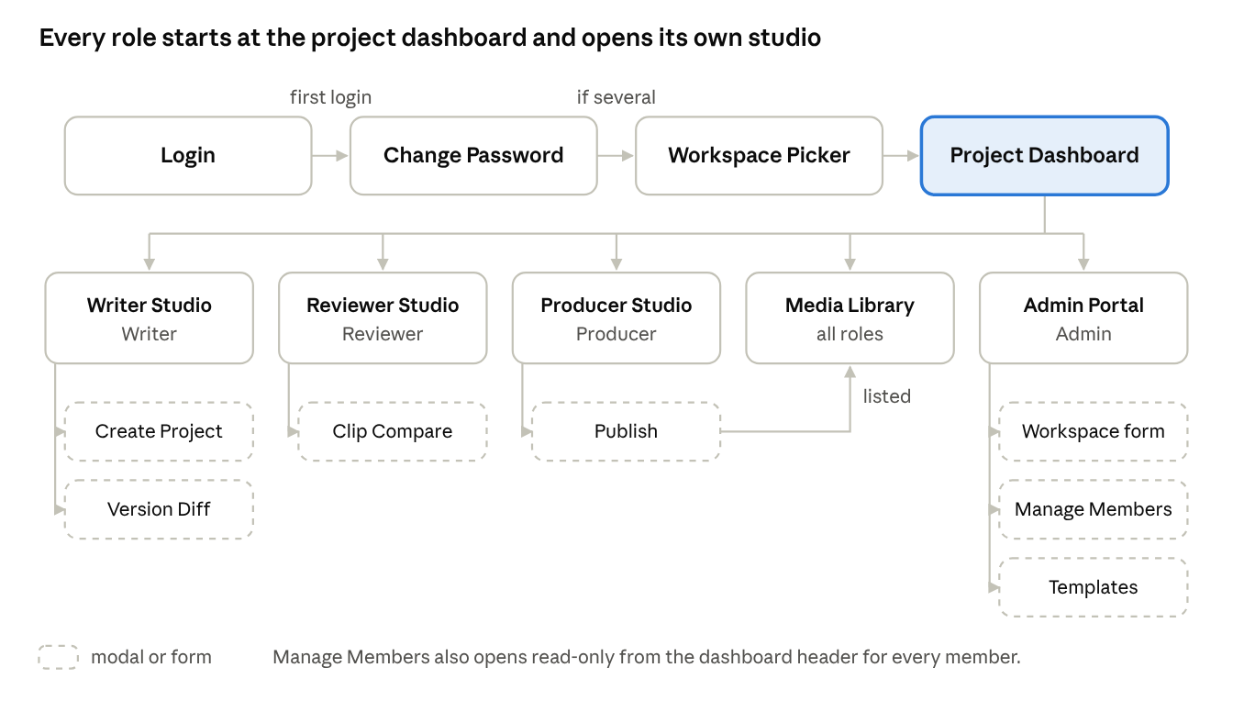
Screen flow · 4 entry steps, 5 main screens, 7 modals
Change Password and Workspace Picker appear only when needed; otherwise Login goes straight to the Project Dashboard.

1.2 Screen Descriptions
# | Screen | Description
1 | Login | Username + password sign-in, or Google sign-in for a whitelisted Gmail; accounts are created by an Admin; no registration link.
2 | Change Password (modal) | Forced after the first password sign-in of an Admin-provisioned account; not required in Google sessions.
3 | Workspace Picker (modal) | Choose the active workspace when the user belongs to several.
4 | Project Dashboard | Pipeline board of the workspace's projects with stage badges, filters and the user's next action.
5 | Create Project (modal) | Title, subject, grade; optional AI draft from a topic with three teaching approaches.
6 | Writer Studio | Scene list and scene editor, autosave, AI actions, TTS preview, duration sync, review notes and reject reason, submit for review.
7 | Version Diff (modal) | Side-by-side differences between two script versions.
8 | Reviewer Studio | Script review with per-scene notes; video review in the web player or MP4 with timestamped notes; QA report; approve, request changes, send back.
9 | Clip Compare (modal) | Two renders of the same project side by side.
10 | Producer Studio | Composition editor: scene properties, visual theme, blocks, timing, TTS preview, duration sync, render and progress, submit for video review.
11 | Publish (modal) | Choose targets (internal library, LMS embed, YouTube), title and description.
12 | Media Library | Published clips with subject and grade filters, playback and export links; level, outcome and usage-context filters and the STEM learning card (Planned).
13 | Admin Portal | Overview metrics, users and system roles, Google whitelist and email notifications, workspaces and members, templates, render queue, AI cost and usage; STEM policy versions (Planned).
14 | Create Workspace (form) | Name, department, leader and at least two more members covering the three roles.
15 | Manage Members (modal) | Member list; Admin adds, removes, activates and appoints leaders; Leader changes roles only.
16 | Template Catalog (modal) | Browse scene templates with recommended subjects and default theme.
17 | Profile & Settings | Own profile (full name only), password change and linking a whitelisted Google identity.

1.3 Screen Authorization
Screen | Writer | Reviewer | Producer | Leader | Admin
Project Dashboard | X | X | X | X | X
Create Project | X |  |  |  | X
Writer Studio (edit) | X |  |  |  | X
Writer Studio (read only) |  | X | X | X | X
Reviewer Studio (decide) |  | X |  |  | X
Producer Studio (edit) |  |  | X |  | X
Publish |  |  | X |  | X
Media Library | X | X | X | X | X
Manage Members: view | X | X | X | X | X
Manage Members: change role |  |  |  | X | X
Manage Members: add, remove, status, leader |  |  |  |  | X
Admin Portal, Create Workspace, Template admin |  |  |  |  | X
Roles are checked on the server for every request (BR-20); the screen matrix only decides what the user sees. Planned: the Admin column loses content decisions (approve, request changes, approve video) unless the Admin is also a project Reviewer.

1.4 Non-Screen Functions
# | Function | Description
1 | Scene autosave queue | Coalesces edits into one save after 600 ms of inactivity and runs saves of one script in order, sending the draft revision.
2 | Render orchestration | Freezes the approved composition revision, queues a render job, retries up to 3 times, records the resulting clip artifact.
3 | Render callback | Worker reports QUEUED, PROCESSING, COMPLETED or FAILED with progress and the video URL, authenticated by a shared service key.
4 | Pre-publish QA engine | Checks duration bounds, pacing, on-screen text, contrast, caption freshness and alignment on the composition as rendered.
5 | AI gateway and usage log | Sends AI requests to the AI service, validates structured output, records model, tokens, cost and the user's accept/ignore decision.
6 | Narration tools | TTS preview through the worker; duration sync with TTS + Whisper word timings.
7 | Request metrics | Logs method, path, status, duration and query count per request.

2. Entity Overview
Entity (table) | Purpose
User (users) | Account, system role, status, must-change-password flag
Workspace (workspaces) | Subject department (tổ bộ môn)
WorkspaceMember (workspace_members) | User in a workspace with one production role, leader flag, ACTIVE/INACTIVE
ClipProject (clip_projects) | Project with subject, grade, owner, script status, video status, archive flag
ScriptVersion (script_versions) | Immutable submitted version or the working draft, with draft revision
Scene (scenes) | Ordered scene of a script version: template type, narration, duration, props
Composition (compositions) | Producer's revisioned copy of the approved scenes plus visual theme
RenderJob (render_jobs) | Render of one composition revision: status, progress, attempts, resolution
Clip (clips) | Completed MP4 artifact of a render job
FeedbackComment (feedback_comments) | Inline (scene) or timestamped (clip) note, replies, resolved by/at
StatusHistory (status_histories) | Pipeline transitions and review decisions with actor and reason
AiRequest (ai_requests) | AI call, model, tokens, cost, outcome, user decision
RemotionTemplate (remotion_templates) | Template registry metadata, recommended subjects, default theme
Publication / PublishRecord (publications, publish_records) | Where a clip was published and the publish history
Planned (V23+): ProjectProposal, ProjectMember, ProjectJoinRequest, EditLease, ContributionEvent, LegacyMembershipFinding. Auth v2: GoogleWhitelist, GoogleIdentity and the notification outbox. STEM (isolated branch, not merged): StemCatalog (topics and topic versions, source editions, curriculum outcomes, level profiles, policies, rubrics), StemSettings per workspace, StemBrief, StemEvidence, StemValidationRun, StemAssessment, artifact snapshots, receipts and audit.

3. Functional Requirement Details
Each requirement is testable; Planned marks requirements from the mentor meeting not yet built.

3.1 Authentication and Accounts (UC-01 to UC-03, UC-24, UC-60, UC-65, UC-66)
- FR-01 The system shall authenticate a local account by its canonical username and password and issue a JWT; sign-in does not use the email address.
- FR-02 The system shall not offer public self-registration; every account is created by an Admin. Google sign-in shall require a verified Google ID token whose Gmail address is on the active whitelist; an unknown or revoked address is refused with ACCOUNT_NOT_IN_SYSTEM, and there is no request-access feature.
- FR-03 An Admin shall create a local account with full name, unique username, temporary password and system role (USER or ADMIN); workspace roles are assigned separately through membership (FR-06 to FR-09).
- FR-04 A temporary local password shall be changed before any other action in a password session; Google sessions do not require a local password change, and Google-only users have no local password.
- FR-05 An Admin shall change an account's system role and status with an explicit version; account status controls every sign-in method, whitelist revocation controls only Google sign-in, access changes revoke existing sessions, and at least one active Admin with a usable login always remains.
- FR-56 An Admin shall add a Gmail address to the Google whitelist, search and page the whitelist, and revoke or restore an entry (UC-60).
- FR-57 A user shall read their own profile and update only the full name; username, role and status cannot be changed there (UC-65).
- FR-58 A local user shall link an unowned whitelisted Google identity after re-entering the password; the user ID, ownership, workspaces and roles stay the same (UC-66).
- FR-59 A password change, an Admin reset or a Google link shall increase the credential version and invalidate older sessions.
- FR-60 Google sign-in and linking shall validate the Google token and use single-use challenges bound to purpose, user and version, with bounded throttling.
- FR-61 Adding or restoring a whitelist entry shall queue an email notification; a mail failure never removes login access, only an Admin resends (with a cooldown and a daily cap), and provider acceptance is recorded separately from inbox delivery (UC-60).

3.2 Workspaces and Members (UC-25, UC-61)
- FR-06 An Admin shall create a workspace with a leader and members totalling at least 3 different active users covering WRITER, REVIEWER and PRODUCER (BR-01); a refused request writes nothing.
- FR-07 Only an Admin shall add or remove members, change a member's status or appoint/revoke a leader (BR-02).
- FR-08 A Leader shall change members' roles inside their own workspace.
- FR-09 The system shall refuse any member change that leaves a covered production role without an active member, and the removal of the last active leader (BR-03).
- FR-10 Every member of a workspace shall see the member list read-only.
- FR-48 A user who belongs to several workspaces shall choose the active workspace; lists and actions are scoped to it.

3.3 Projects and Scripts (UC-04 to UC-07, UC-10, UC-28)
- FR-11 A Writer shall create a project with title, subject (Math, Physics, Chemistry, Biology, Computer Science) and grade.
- FR-12 A Writer shall add, edit, reorder and delete scenes of the working draft; each scene has a template type, title, narration, duration and template props validated per type.
- FR-13 The system shall autosave the draft and protect it with a draft revision: a save based on an older revision is refused with 409 STALE_REVISION and changes nothing (BR-10).
- FR-14 A Writer shall submit a draft with at least one scene; the version becomes immutable and the project moves to IN_REVIEW.
- FR-15 Users shall view every stored version and the differences between two versions.
- FR-16 The owner, a Leader or an Admin shall archive a project; archived projects disappear from lists but keep their clips.
- FR-17 Planned. A Writer shall propose a project; a Leader approves (exactly once) or rejects with a reason; a Writer who is a Leader approves their own proposal (BR-30).
- FR-49 Users shall view the pipeline board of their workspace's projects with stage, owner and next action, and open a project and its script read-only unless their role allows editing.

3.4 AI Assistance (UC-08, UC-09)
- FR-18 A Writer shall request a draft script from a topic, subject and grade, optionally following one of three AI-proposed teaching approaches.
- FR-19 A Writer shall run resegment, readability grade, concept extraction and terminology checks on a script.
- FR-20 The system shall reject topics that are not STEM-related with an explanatory message.
- FR-21 Every AI result shall be stored as a suggestion; the Writer accepts or ignores it, and nothing is saved into the script automatically (BR-12).
- FR-22 The system shall record model, tokens, cost and outcome of every AI request; malformed, refused or timed-out responses produce no result.

3.5 Script Review (UC-13, UC-53 to UC-55)
- FR-23 A Reviewer shall add comments pinned to a scene of the version in review.
- FR-24 A Reviewer shall approve the version or request changes with a mandatory reason; requesting changes opens a new draft version for the Writer.
- FR-25 Writers and Producers shall reply to notes and mark a root note resolved; the system records who resolved it and when.
- FR-50 A Reviewer shall see a queue of scripts and compositions waiting for review in their workspaces.
- FR-51 Writers and Producers shall see the review history of a project: script and video decisions with reviewer, reason and time.

3.6 Production (UC-14 to UC-17, UC-50)
- FR-26 Opening an approved script shall create revision 1 of its composition from the approved scenes.
- FR-27 A Producer shall edit scene properties, visual theme and composed blocks and preview them in the Remotion Player.
- FR-28 Every composition save shall name its base revision; a stale save is refused with 409 STALE_REVISION.
- FR-29 Writers (on drafts) and Producers (on compositions) shall preview TTS narration and sync scene durations to measured speech; a sync whose resource changed while measuring is refused and writes nothing (BR-11).
- FR-30 A Producer shall submit the composition for video review; the reviewed revision is frozen (IN_QA).
- FR-31 Planned. Only the holder of a valid edit lease shall write the script draft or composition; others see it read-only (BR-31).
- FR-52 A Producer shall select or replace the media assets of a scene (scene template from the catalog, STEM icons of illustrated scenes) without changing other scenes.
- FR-53 The system shall generate word-timed Vietnamese captions from the scene narration when rendering; editing the narration updates its captions on the next sync or render.

3.7 Rendering (UC-20)
- FR-32 A Producer shall start a render of the frozen or approved composition at 720p, 1080p or 1440p; only one render per project runs at a time.
- FR-33 The system shall show live status and progress and retry a failed job up to 3 times before marking it FAILED.
- FR-34 A Producer shall retry or cancel a job; a completed render is recorded as a clip of that composition revision.
- FR-54 A Producer shall see the render history of a project: every job with status, resolution, attempts, time and its clip.

3.8 Clip Review and QA (UC-18, UC-19, UC-21, UC-57 to UC-59)
- FR-35 A Reviewer shall review the submitted composition in the web player or its MP4 and add timestamped notes scoped to the clip under review.
- FR-36 A Reviewer shall approve the video only when no open notes block it; approving a composition without an MP4 starts its render (BR-13).
- FR-37 A Reviewer shall send the video back to production with a mandatory reason.
- FR-38 The system shall show automated QA findings as decision support; findings never approve or block on their own (BR-12).
- FR-55 A Reviewer shall compare two renders of the same project side by side.

3.9 Publishing and Library (UC-22, UC-23)
- FR-39 A Producer or an Admin shall publish an approved clip to the internal library and/or generate an LMS embed code; each target is published once.
- FR-40 Planned. Publishing to YouTube through the YouTube Data API; until configured the API answers 503 PUBLISH_TARGET_UNAVAILABLE.
- FR-41 Users shall browse published clips with subject and grade filters, play them and copy export links; lists support paging.

3.10 Administration (UC-26, UC-27, UC-34, UC-64)
- FR-42 An Admin shall create, edit and delete templates, including recommended subjects and default visual theme.
- FR-43 An Admin shall see render queue state, job success rate, recent jobs, storage used and AI cost and usage against the monthly budget.
- FR-44 Planned. An Admin shall configure allowed AI/TTS providers, models, voices and budgets; secrets are never returned by the API.

3.11 Collaboration and Tracking (UC-30, UC-32, UC-33) — Planned
- FR-45 Workspace members shall request to join a project with a role; a Leader approves, rejects or revokes; the approved role stays fixed for the project (BR-32).
- FR-46 The system shall record contribution events (script submission, composition revision, review decision, note resolution, publish) with the actor's role at the time.
- FR-47 A Leader shall see an inbox of proposals and join requests and a board of projects by stage, owner and blocker.

3.12 STEM Curriculum Framework (UC-43 to UC-49, UC-51, UC-52, UC-56, UC-62, UC-63, UC-67) — in progress on an isolated branch
- FR-62 The STEM catalogue shall hold versioned topics, source editions, curriculum outcomes, level profiles, policies and rubrics for the primary, lower-secondary and upper-secondary levels, each with its source; entries stay DRAFT/UNVERIFIED until verified and every member can read them. An Admin shall set the STEM settings of a workspace: mode (OFF, ADVISORY, or STRICT once released), allowed policies and a default policy; a stale settings revision is refused with 409 (UC-62, UC-63).
- FR-63 A Writer shall choose the policy, topic version, grade, subjects and curriculum outcomes of the brief from the catalogue; every outcome cites its source document, and the grade is never inferred from the project subject (UC-46).
- FR-64 A Writer shall author a STEM brief for each script version: usage context (pre-class, in-class screen, group practice, home self-study or department library) with its required details, a real-life problem, learning objectives, student tasks with their expected product, S-T-E-M contributions and safety notes (UC-43).
- FR-65 A Writer shall link each S, T, E and M component to the scenes or tasks that show it, with its contribution and pedagogical role; the first scene states the problem and the last returns to it (UC-47).
- FR-66 A Writer shall request AI suggestions grounded in the brief, the selected outcomes and the source documents; an accepted suggestion passes the same checks as manual input (UC-44, BR-ST11).
- FR-67 Validating a brief shall record append-only findings for the script or video phase (more than 10 requests a minute get 429); in ADVISORY mode the findings are shown and do not block; in STRICT mode (Planned) a failed check blocks the submit with 400 STEM_INVALID_FIELD and the script stays in draft (UC-48, BR-ST01 to BR-ST07, BR-ST09).
- FR-68 A Reviewer holding an active REVIEWER seat shall record a STEM assessment with the approval of the script or video: a judgment per rubric criterion (ADEQUATE, NEEDS_CHANGES, NOT_ASSESSED, or NOT_APPLICABLE with a rationale) with evidence pointing to scenes; the assessment is append-only and an Admin without the seat cannot record it (UC-52).
- FR-69 Opening, rendering, submitting for video review and publishing shall recompute the content fingerprint; a change to scientific content after approval requires a new STEM review, while presentation changes (timing, captions, theme) do not (UC-49, BR-ST12, BR-ST13).
- FR-70 A Reviewer shall verify the clip against the learning objectives of the approved brief before approving the video (UC-56).
- FR-71 Publishing shall store an immutable STEM learning card snapshot (grade, subjects, outcomes, sources, reviewer and date) with the publication; it requires media QA and a STEM decision for the same artifact (UC-51, BR-ST14).
- FR-72 Users shall filter the media library by level, grade, curriculum outcome and usage context (UC-67).
- FR-73 A Writer shall complete the STEM mapping of a legacy project before its next publication; the grade is never inferred from old data (UC-45, BR-ST15).

4. Acceptance Criteria
Each functional requirement has a given / when / then criterion that one or more test cases check (BM02 SR-06, BM04 RF-01). Planned requirements get their criterion when they are scheduled. Test case IDs per feature are in BM04 section 6.
FR | Acceptance criterion (given / when / then)
FR-01 | Given an ACTIVE local account, when it signs in with the right username and password, then 200 with a JWT; with a wrong password, 401 INVALID_CREDENTIALS and no token; the email address does not work as a username.
FR-02 | When anyone calls the registration endpoint, then 403. Given a Gmail on the active whitelist, Google sign-in returns a JWT; given an unknown or revoked Gmail, 403 ACCOUNT_NOT_IN_SYSTEM and no account is created.
FR-03 | Given an Admin, when it creates an account with a new username, then 201 without a token and the user must change the password; a duplicate username gives 409 USERNAME_TAKEN; a non-Admin gets 403.
FR-04 | Given a new local account, when it calls any API other than change password, then 403 PASSWORD_CHANGE_REQUIRED; after a successful change the call succeeds; a Google session is not asked to change a password.
FR-05 | Given an Admin, when it deactivates an account, then that user's existing tokens are rejected and every sign-in method fails; a stale account version gives 409; deactivating or demoting the last active Admin is refused.
FR-06 | Given at least 3 ACTIVE users covering WRITER, REVIEWER and PRODUCER and a leader, when an Admin creates the workspace, then 201 with every member ACTIVE; with fewer members or a missing role, 400 and no workspace or member row is written.
FR-07 | Given a Leader who is not an Admin, when it adds or removes a member, changes a status or appoints a leader, then 403 and nothing changes; an Admin making the same change succeeds.
FR-08 | Given a Leader of workspace A, when it changes a member role in A, then the role changes; the same call on workspace B gives 403.
FR-09 | Given the only active PRODUCER, when a change would leave that role or the workspace without an active member or leader, then 400 naming the role and nothing changes.
FR-10 | Given a member, when it opens the member list, then it sees every member; a write by a member who is neither Leader nor Admin gets 403.
FR-11 | Given a Writer, when it creates a project with a title, an allowed subject and a grade, then 201 in DRAFT; a missing title or an unknown subject gives 400; a non-Writer gets 403.
FR-12 | Given a DRAFT script, when the Writer adds, edits, reorders or deletes scenes, then the saved order and content match the request; invalid template props give 400 naming the field.
FR-13 | Given two editors on revision N, when both save, then the first succeeds (revision N+1) and the second gets 409 STALE_REVISION with nothing changed.
FR-14 | Given a draft with at least one scene, when the Writer submits, then the version is IN_REVIEW and later edits to it are refused; a draft with no scene gives 400 and stays DRAFT.
FR-15 | Given two submitted versions, when a user opens them, then both are readable and the diff shows exactly the changed scenes.
FR-16 | Given a project, when its owner, a Leader or an Admin archives it, then it disappears from lists and its clips stay readable; any other member gets 403.
FR-17 | Planned: the criterion is written when the requirement is scheduled (decisions D08 to D21).
FR-18 | Given a Writer, when it requests a draft for a STEM topic, then the returned scenes validate against the scene schema and are stored only as a suggestion.
FR-19 | Given a script, when the Writer runs resegment, readability, concept extraction or terminology, then each returns a result logged as an AI request and the script is unchanged.
FR-20 | When a Writer requests a draft for a non-STEM topic, then 400 with an explanatory message and nothing is added to the script.
FR-21 | Given an AI suggestion, when the Writer ignores it, then the script is unchanged; when the Writer accepts it, the content changes only through a normal draft save.
FR-22 | Given any AI call, then one AI request row stores model, tokens, cost and outcome; a malformed, refused or timed-out response stores no suggestion.
FR-23 | Given a version IN_REVIEW, when a Reviewer pins a comment to one of its scenes, then the comment is stored on that scene; a comment on a scene of another version is refused.
FR-24 | Given a version IN_REVIEW, when the Reviewer approves, then APPROVED with actor and time; requesting changes without a reason gives 400; with a reason, CHANGE_REQUESTED and a new draft version.
FR-25 | Given an open note, when a Writer or Producer resolves it, then it is RESOLVED with who and when; a reply cannot be resolved on its own.
FR-26 | Given an APPROVED script, when the Producer opens it, then composition revision 1 exists with one composition scene per approved scene.
FR-27 | Given a composition, when the Producer edits scene properties, theme or blocks, then the Player preview shows the change and the save stores it.
FR-28 | Given a composition at revision N, when a save names an older revision, then 409 STALE_REVISION and nothing changes.
FR-29 | Given a draft or composition, when duration sync runs, then each scene duration equals the measured speech; if the resource or script version changed while measuring, 409 and nothing is written.
FR-30 | Given a composition, when the Producer submits it for video review, then the video is IN_QA and the reviewed revision can no longer be edited.
FR-31 | Planned: the criterion is written when the requirement is scheduled (decisions D08 to D21).
FR-32 | Given an approved or frozen composition, when the Producer starts a render, then a job is QUEUED and the video is RENDERING; a second start while one runs gives 409.
FR-33 | Given a running job, then progress is reported until COMPLETED; a failing job is retried up to 3 attempts, then marked FAILED with the video back to NOT_RENDERED.
FR-34 | Given a failed or running job, when the Producer retries or cancels it, then a new attempt starts or the job stops; a COMPLETED job creates exactly one clip linked to its composition revision.
FR-35 | Given a clip IN_QA, when a Reviewer adds a note at a timestamp, then the note is stored for that clip and timestamp.
FR-36 | Given an open note on the current clip, when the Reviewer approves, then 400 "Resolve the N open review note(s)"; with no open note, APPROVED; approving a composition without an MP4 starts its render.
FR-37 | Given a clip IN_QA, when the Reviewer sends it back without a reason, then 400; with a reason, NOT_RENDERED and the reason is shown to the Producer.
FR-38 | Given QA findings on a clip, then the video status never changes because of them.
FR-39 | Given an APPROVED clip, when a Producer or Admin publishes to the library, then a library entry and an LMS embed code exist and the video is PUBLISHED; publishing the same target again gives 409; a clip that is not APPROVED is refused.
FR-40 | Given YouTube is not configured, when a Producer publishes to YOUTUBE, then 503 PUBLISH_TARGET_UNAVAILABLE and the library entry is kept.
FR-41 | Given published clips, when a user filters by subject and grade, then only matching published clips are listed, paged with X-Total-Count.
FR-42 | Given an Admin, when it creates, edits or deletes a template, then the catalog shows the change; a non-Admin gets 403.
FR-43 | Given render jobs and AI requests, when an Admin opens the portal, then queue counts, success rate, recent jobs, storage used and AI cost against the budget match the stored data.
FR-44 | Planned: the criterion is written when the requirement is scheduled (decisions D08 to D21).
FR-45 | Planned: the criterion is written when the requirement is scheduled (decisions D08 to D21).
FR-46 | Planned: the criterion is written when the requirement is scheduled (decisions D08 to D21).
FR-47 | Planned: the criterion is written when the requirement is scheduled (decisions D08 to D21).
FR-48 | Given a user in two workspaces, when it selects workspace A, then lists show only the projects of A and actions on projects of B are refused.
FR-49 | Given a member, when it opens the pipeline board, then every project of the active workspace is listed with stage, owner and next action, and no project of another workspace is listed.
FR-50 | Given scripts and compositions waiting for review, when a Reviewer opens the queue, then exactly the waiting items of its workspaces are listed.
FR-51 | Given past decisions, when a Writer or Producer opens the review history, then every script and video decision shows reviewer, reason and time.
FR-52 | Given a scene, when the Producer replaces its template or icon, then only that scene changes.
FR-53 | Given a rendered scene, then its captions follow its narration word by word in time order; after the narration is edited, the next sync or render updates them.
FR-54 | Given past renders, when the Producer opens the render history, then every job shows status, resolution, attempts, time and its clip.
FR-55 | Given two renders of a project, when the Reviewer opens Compare, then both play side by side.
FR-56 | Given an Admin, when it adds a Gmail, then the entry is ACTIVE and found by a paged search; revoking it blocks the next Google sign-in and restoring it allows sign-in again; a non-Admin gets 403.
FR-57 | Given a signed-in user, when it updates its profile, then only the full name changes; changing username, role or status there is refused and nothing changes.
FR-58 | Given a local user and an unowned whitelisted Google identity, when the user re-enters the password and links it, then later Google sign-ins open the same user ID with the same workspaces; a wrong password or an identity owned by another user is refused.
FR-59 | Given a valid session, when the password is changed, reset by an Admin or a Google identity is linked, then tokens issued before are rejected (401) and a new sign-in works.
FR-60 | When a Google token is invalid or a challenge is reused, expired or bound to another purpose or user, then the request is refused; attempts beyond the limit get 429.
FR-61 | Given an Admin adds or restores a whitelist entry, then one notification is queued; when the mail fails, the user can still sign in; a resend inside the cooldown or over the daily cap is refused, and a non-Admin cannot resend.
FR-62 | Given catalogue entries, when any member reads them, then each shows its source and DRAFT/UNVERIFIED status; an Admin saving workspace STEM settings with a stale revision gets 409, and a non-Admin change gets 403.
FR-63 | Given a brief, when the Writer selects topic version, grade, subjects and outcomes from the catalogue, then they are saved; an unknown catalogue reference gives 400 STEM_INVALID_FIELD.
FR-64 | Given a script version, when the Writer saves the brief, then the brief revision increases; a stale brief or script revision gives 409 STEM_STALE_TARGET; the brief of a submitted version is immutable (409).
FR-65 | Given S, T, E and M evidence, when it points to a scene of the same version, then it is saved; a scene of another version gives 400.
FR-66 | Given a brief, when the Writer requests a grounded suggestion, then the result is stored UNVERIFIED and the script changes only when the Writer edits and saves it.
FR-67 | Given a brief, when it is validated, then a new append-only run stores the findings; an eleventh request within a minute gets 429; in ADVISORY mode a submit with findings still succeeds.
FR-68 | Given a version in review, when a Reviewer with an active REVIEWER seat approves with a rubric assessment, then each criterion judgment is stored; NOT_APPLICABLE without a rationale gives 400; an Admin without the seat gets 403.
FR-69 | Given an approved STEM brief, when only timing, captions or theme change, then render and publish continue; when scientific content changes, they are refused until a new STEM review.
FR-70 | Given a clip IN_QA with an approved brief, when the Reviewer reviews it, then the learning objectives of the brief are shown next to the clip and the approval records the check.
FR-71 | Given a published clip, when its brief is edited later, then the stored learning card stays unchanged; publishing without a media QA result and a STEM decision for the same artifact is refused.
FR-72 | Given published clips with learning cards, when a user filters by level, grade, outcome or usage context, then only matching clips are returned with paging headers.
FR-73 | Given a legacy project without a STEM brief, when a new publication is attempted, then it is refused until the STEM mapping is completed; the grade is never filled from old data.

V. Non-Functional Requirements

1. External Interfaces
Interface | Requirement
User interface | Responsive web UI in Vietnamese; every action shows a pending state, blocks double submission and keeps unsaved input on error.
REST API | JSON over HTTPS under /api/v1, OpenAPI documented; one error envelope {status, code, message, timestamp, details?}; list endpoints accept optional page/size (default 20, max 100) and return X-Total-Count, X-Total-Pages, X-Page, X-Size.
Render worker | HTTP API secured by a shared service key; progress by callback to the core API.
AI service | HTTP API secured by a shared service key; structured JSON validated against schemas.
Third parties | LLM providers (OpenAI, Gemini), TTS (FPT.AI, Google Cloud), Google Identity Services (sign-in), S3-compatible storage; YouTube Data API Planned.

2. Quality Attributes
ID | Attribute | Requirement | Measure
NFR-01 | Performance | AI script analysis returns within 15 s. | p95 response time of AI endpoints
NFR-02 | Performance | A 60-90 s clip renders in under 5 minutes on the worker pool. | Render job duration
NFR-03 | Performance | Dashboards and lists load in under 3 s; reads use a constant number of queries regardless of row count (no N+1). | API latency log, query-count tests
NFR-04 | Scalability | Rendering scales horizontally by adding workers; target about 300 render jobs per day and 200 concurrent web users. | Load test
NFR-05 | Reliability | Failed render and AI jobs retry up to 3 times before alerting; render output is idempotent per composition revision. | Render retry tests
NFR-06 | Reliability | Concurrent edits never overwrite each other silently: draft and composition saves carry a revision and stale writes get 409; membership changes are serialised by a row lock. | Concurrency tests on PostgreSQL
NFR-07 | Reliability | Every write is atomic: a failed request leaves no partial data. | Transaction tests
NFR-08 | Security | Passwords hashed with BCrypt; sessions by JWT (24 h); Google sign-in only for Gmail addresses on the Admin's whitelist; no self-registration. | Code review and authentication tests. Pass: 0 plaintext passwords in the database or logs; a token older than 24 h is rejected; 100 % of sign-ins with an unknown or revoked Gmail are refused (403).
NFR-09 | Security | Role-based authorization on every endpoint, checked on the server; hidden buttons are never the only control. | Negative authorization tests per endpoint
NFR-10 | Security | Secrets (DB, JWT, AI, TTS, service keys) live in environment configuration, never in source, logs or API responses; leaked keys are rotated. | Secret scanning
NFR-11 | Security | CORS restricted to the configured front-end origins. | Configuration review and a cross-origin request test. Pass: 100 % of requests from an origin outside the configured list are refused; no wildcard (*) origin in the production configuration.
NFR-12 | Usability | A first-time Writer can create a project and submit a script without training; error messages say what to fix. | User test with 3 teachers. Pass: at least 2 of 3 create a project and submit a script within 15 minutes without help, and every error message they meet names what to fix.
NFR-13 | Compatibility | Chrome, Firefox, Edge 100+ and Safari 15+; output MP4 H.264, 30 fps, 720p/1080p/1440p. | Browser test matrix
NFR-14 | Maintainability | Schema changes only through versioned Flyway migrations with rollback scripts and migration tests; production schema is validated at start-up. | Migration test suite
NFR-15 | Testability | Automated tests run on every change: 360 back-end tests (5 on a real embedded PostgreSQL) and 188 front-end tests at the baseline. | CI results
NFR-16 | Cost control | AI usage is metered per request with model, tokens and cost and compared with a monthly budget. | Admin AI usage dashboard
NFR-01 to NFR-04 are targets from the registered proposal and have not yet been measured under load; NFR-06 and NFR-15 are verified at the baseline. Every measure names its pass threshold (BM02 SR-08).

VI. Requirement Appendix

1. Project Lifecycle
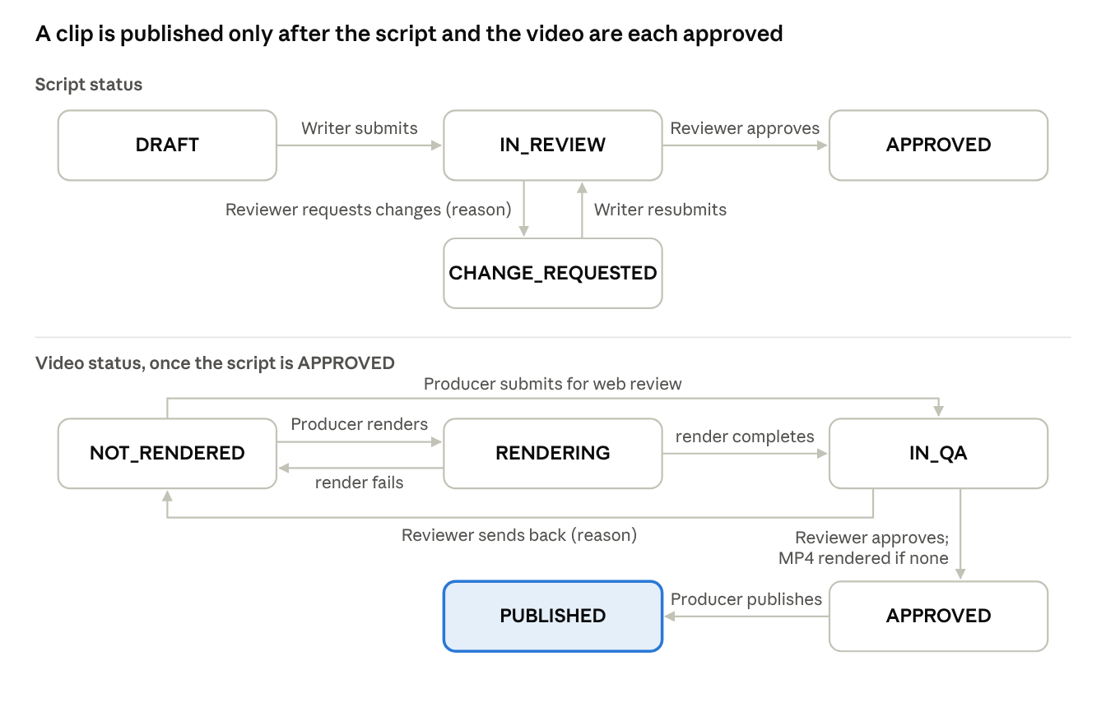
Project lifecycle · script status and video status
The script and the video each pass a Reviewer decision; a returned script or video always carries the reviewer's reason (BR-07). Archiving can happen at any state and hides the project without deleting its clips (BR-16).

2. Business Rules
ID | Rule
BR-01 | A workspace has at least 3 different active members covering WRITER, REVIEWER and PRODUCER; each member holds exactly one production role (never ADMIN) in that workspace; the leader flag is an extra responsibility.
BR-02 | Only an Admin adds or removes workspace members, changes a member's status or appoints a leader; a Leader only assigns roles in their own workspace.
BR-03 | No change may leave a production role that has an active member without one, or remove the last active leader. A workspace created before BR-01 may still be changed so that it can be completed.
BR-04 | A user belongs to a workspace at most once (unique user per workspace).
BR-05 | Only the Writer role creates projects and edits drafts; only DRAFT or CHANGE_REQUESTED drafts are editable.
BR-06 | A submitted script version is immutable; a change request creates a new draft version.
BR-07 | Returning a script or a video requires a written reason.
BR-08 | A script needs at least one scene before review; clips must be 20 to 180 seconds long to pass QA.
BR-09 | Only one render job per project runs at a time; a published clip is not re-rendered.
BR-10 | Draft and composition writes name the revision they were based on; a stale revision is refused (409 STALE_REVISION) and nothing is written.
BR-11 | Measured durations are applied only if the draft or composition is still at the revision that was measured.
BR-12 | AI suggestions and QA findings are advisory: they never change content, approve, pass or publish without a person.
BR-13 | A video is approved only when no open notes of the current clip (or unscoped notes) remain; the approved composition revision is the one rendered and published.
BR-14 | Each publish target is used once per project; YouTube publishing is unavailable until OAuth is configured.
BR-15 | Only the author of a note, or an Admin, deletes it; replies cannot be resolved separately from their root note.
BR-16 | Archiving keeps clips and publications; archived projects are read-only and hidden from lists.
BR-20 | Authorization is enforced on the server for every endpoint; the UI never decides permissions.
BR-30 | Planned. A project starts from an approved proposal; a Writer who is a Leader approves their own proposal; nobody approves their own content or video.
BR-31 | Planned. Writing a draft or composition requires a valid edit lease (TTL about 90 s, renewed while editing); comments do not.
BR-32 | Planned. A participant's project role is fixed when approved and does not follow later changes of the workspace role; revoked participants keep their history but cannot write.
BR-ST01 | Grade 1 to 12 matches its level and a policy allowed in the workspace. [Submit; server]
BR-ST02 | One main subject valid for the grade; coordinating subjects come from the catalog; the "at least two subjects" threshold is a team decision. [Submit; server and Reviewer]
BR-ST03 | At least one VERIFIED curriculum outcome of the right subject, grade and program version. [Submit; server and Reviewer]
BR-ST04 | Objectives are specific and linked objective, outcome, scene or task. [Submit; server and Reviewer]
BR-ST05 | A usage context with every field it requires and a real-life problem. [Submit; server and Reviewer]
BR-ST06 | An application activity and its expected product or criteria. [Submit; server and Reviewer]
BR-ST07 | S, T, E and M are declared with their contribution and where they appear. [Submit; server and rubric]
BR-ST08 | A risk assessment is present; NOT_APPLICABLE needs a reason. [Approve; Reviewer]
BR-ST09 | The first scene states the problem or objective; the last returns to the question, the conclusion and the next task. [Submit for roles, approve for content; server and Reviewer]
BR-ST10 | Figures and formulas have a source; illustrative numbers are marked as illustrative. [Approve; Reviewer]
BR-ST11 | AI only suggests; accepted output passes the same validation as manual input. [Every write; server]
BR-ST12 | A decision is valid only for the fingerprint it approved. [Render, review, publish; server]
BR-ST13 | Changing scientific content in the composition requires a new STEM review; presentation changes do not. [Video review; server and Reviewer]
BR-ST14 | Publishing needs media QA and a STEM decision for the same artifact; an Admin cannot bypass it. [Publish; server]
BR-ST15 | The grade of an old project is never inferred; a legacy project completes its STEM brief before a new publication. [Rollout; server]

3. Common Requirements
- CR-01 Dates and times are shown to users in Vietnam time (GMT+7).
- CR-02 Every list that can grow supports server-side paging and returns the paging headers.
- CR-03 Every state change records who did it and when (status history, resolved by, decided by).
- CR-04 UI text, narration and captions are Vietnamese; API error messages are in English or Vietnamese and shown to the user as returned.
- CR-05 A conflict (409) never triggers an automatic retry: the client keeps local edits and offers reload and compare.

4. Application Messages
# | Code | HTTP | Message | When
MSG01 | INVALID_CREDENTIALS | 401 | Tài khoản hoặc mật khẩu không đúng. | Password sign-in fails (FR-01)
MSG02 | PASSWORD_CHANGE_REQUIRED | 403 | Password change is required before accessing other resources | First login of a provisioned account
MSG03 | ACCESS_DENIED / FORBIDDEN | 403 | (role-specific message) | Action not allowed for the user's role
MSG04 | BAD_REQUEST | 400 | A workspace needs at least 3 different members (WRITER, REVIEWER and PRODUCER); got N | Workspace created with too few members
MSG05 | BAD_REQUEST | 400 | A workspace needs at least one WRITER, REVIEWER and PRODUCER; missing [ROLE] | Workspace created without a role
MSG06 | BAD_REQUEST | 400 | User NAME is not active and cannot join a workspace | Inactive user added
MSG07 | BAD_REQUEST | 400 | This change would leave the workspace without an active [ROLE]; give that role to another member first | BR-03 violated
MSG08 | FORBIDDEN | 403 | Only a system administrator can change a member's status or leader designation; a workspace leader assigns roles | Leader changes status or leader flag
MSG09 | BAD_REQUEST | 400 | Only a draft or returned script can be edited; submitted versions are immutable | Edit of a submitted version
MSG10 | BAD_REQUEST | 400 | A script needs at least one scene before it can be reviewed | Submit with no scenes
MSG11 | STALE_REVISION | 409 | The draft is now at revision N (your save started from M); reload it before trying again | BR-10, BR-11 (details gives resource and revisions)
MSG12 | REVIEW_REASON_REQUIRED | 400 | Cần ghi lý do khi trả về | Return without a reason (BR-07)
MSG13 | BAD_REQUEST | 400 | Resolve the N open review note(s) before approving the clip | BR-13
MSG14 | CONFLICT | 409 | A render is already running for this project | BR-09
MSG15 | PUBLISH_TARGET_UNAVAILABLE | 503 | YouTube OAuth publishing is not configured yet | YouTube target chosen
MSG16 | CONFLICT | 409 | A publication for this project and platform already exists | BR-14
MSG17 | FORBIDDEN | 403 | Public registration is disabled. Contact an administrator for an account | Self-registration attempted (FR-02)
MSG18 | USERNAME_TAKEN | 409 | Tài khoản đã tồn tại. | Admin creates an account with an existing username (FR-03)
MSG19 | ACCOUNT_NOT_IN_SYSTEM | 403 | Tài khoản không nằm trong hệ thống. | Google sign-in with a Gmail that is not on the active whitelist (FR-02)
MSG20 | ACCOUNT_DISABLED | 403 | Tài khoản đã bị khóa. | An inactive account signs in (FR-05)
MSG21 | STEM_INVALID_FIELD | 400 | details.field and details.findings name each problem | Invalid or unknown brief field, wrong scene version, or a failed STRICT check (FR-63 to FR-67)
MSG22 | STEM_STALE_TARGET | 409 | The brief, script or mode changed; reload before trying again | Stale revision on a STEM write, validation or assessment (FR-64 to FR-68)

5. Open Requirements (pending team decision)
Decision | Question | Affects
D03 | Strict black-and-white academic style, or neutral background with one meaningful accent colour? | Visual style of all templates
D08, D09 | Is the role fixed per workspace or per project; may a member take a different role in another project of the same workspace? | FR-45, BR-32
D12, D13, D14 | Self-approval and several Leaders; what non-participants may read; when a project must have a Reviewer and a Producer | FR-17, FR-45
D15 | Revoke, rejoin and Admin override | FR-45
D16, D17 | Edit lease scope, TTL, force release; comments while someone edits | FR-31, BR-31
D18 | Contribution for credit and traceability only, or also for evaluation? | FR-46
D04, D07 | AI/TTS providers, budget per clip, who configures them | FR-44, NFR-16
D20 | Final QC on the real MP4 before publishing | FR-36 to FR-39
D-PUB | Who publishes after approval (Producer, Leader) | FR-39
A-acct | Does a member whose account is locked still count toward role coverage? | BR-03
FE-13 | YouTube OAuth channel connection | FR-40

