

Capstone Project Report
Report 4 – Software Design Document

– Ho Chi Minh City, October 2026 –

Table of Contents
I. Record of Changes 3
II. Software Design Document 4
1. System Design 4
1.1 System Architecture 4
1.2 Package Diagram 4
2. Database Design 4
3. Detailed Design 5
3.1 <Feature/Function Name1> 5
3.2 <Feature/Function Name2> 6

I. Record of Changes
Date | A*  M, D | In charge | Change Description
31/10/2026 | A | Nguyễn Việt Hoàng | Create the first version of Report 4 - Software Design Document: system architecture, technology declaration, package diagrams, logical ERD, state machines, detailed design for seven features and activity diagrams of four main workflows; all diagrams kept as Mermaid sources.
02/11/2026 | M | Nguyễn Việt Hoàng | Aligned with the unchanged registration form of 17/08/2026: Google OAuth 2.0 sign-in for Admin-provisioned accounts declared (third-party services, package description, feature 3.1); YouTube publishing stated as committed scope.
09/11/2026 | M | Nguyen Viet Hoang | Auth v2 on main: username login, Google whitelist and identity linking, system roles ADMIN/USER, notification outbox (packages, third-party services, data, feature 3.1); schema status of auth v2 (V23/V24 at the release cutover) and of the STEM framework (isolated branch, from V25); workflow names follow verb + business object.
*A - Added M - Modified D - Deleted

II. Software Design Document
This document describes how STEMotion is built: the deployed sub-systems and how they communicate, the package structure of each sub-system, the database, and the detailed design of seven features. It refines Report 3 (SRS); requirement IDs such as FR-13 and BR-10 refer to that report. Baseline: core API commit 7f207bb, web application aa4d722, render worker 7e5aeea. Every diagram is kept as Mermaid source in the repository (STEMotion_BE/docs/diagrams/*.mmd) and the figures below are rendered from those files. Updated 09/11/2026 for tag review-2 (BE 4156dff, FE 88570f2, RENDER 3344a29): auth v2 is on main; the STEM framework of Report 3 section IV.3.12 is built on an isolated branch and is not yet part of this design baseline. Class and sequence figures of section 3.1 still show the email-based login and are redrawn with the next diagram update.

1. System Design

1.1 System Architecture
STEMotion is split into four deployable sub-systems. The web application talks only to the core API; the core API owns every permission check and state change and drives two worker services, one for rendering and narration and one for AI. Long-running work (rendering) is asynchronous: the core API queues a job and the render worker reports progress back by callback.
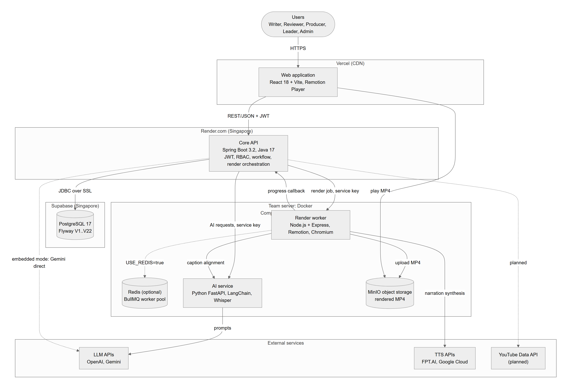
Figure 1. STEMotion deployment architecture
Component Descriptions
No | Component | Description
01 | Web application | React + Vite single-page application hosted on Vercel. Role-based studios (Writer, Reviewer, Producer), admin portal and media library. Previews scenes in the Remotion Player with the same composition code the worker renders. Holds no provider keys.
02 | Core API | Spring Boot 3 (Java 17) REST API on Render.com. Authentication (JWT, BCrypt, username login, Google whitelist), role-based authorization on every endpoint, workspace and project lifecycle, script versions, review decisions, composition revisions, render orchestration, publishing, AI gateway with usage and cost log.
03 | Database | PostgreSQL 17 on Supabase (Singapore). Schema managed by Flyway migrations V1 to V22; the auth v2 schema is prepared as V23/V24 for the release cutover and the STEM schema is planned from V25; production runs with schema validation and migrations are applied by operations before a release.
04 | Render worker | Node.js + Express service with Remotion and headless Chromium, run in Docker on the team server. Jobs run in an in-process queue, or a BullMQ queue on Redis when USE_REDIS=true. Bundles the web application's Remotion entry, synthesises narration through the configured TTS provider, measures durations, renders MP4 and uploads it. Secured by a shared service key.
05 | AI service | Python FastAPI service with LangChain providers (OpenAI, Gemini). Builds prompts, validates structured output against JSON schemas and aligns captions with Whisper. Called by the core API (remote mode, the deployed setting) and by the worker (alignment). Secured by a shared service key. In embedded mode (AI_SERVICE_MODE=embedded) the core API calls Gemini directly instead.
06 | Object storage | MinIO (S3 API) on the team server; stores rendered MP4 files that the web player streams.
07 | Tailscale Funnel | Publishes the render worker and AI service from the team server over HTTPS so the cloud-hosted core API can reach them.
08 | External services | LLM APIs (OpenAI, Gemini), TTS APIs (FPT.AI, Google Cloud). YouTube Data API publishing is planned and currently answers 503.

Key design decisions.
- Single orchestrator. Only the core API writes to the database; workers receive self-contained jobs and report results back, so permissions and audit stay in one place.
- Optimistic revisions plus short row locks. Draft and composition saves carry the revision they were based on; the server locks the row, compares and writes in one transaction, and answers 409 STALE_REVISION for stale writes (BR-10, BR-11).
- Asynchronous rendering. A render job is queued and tracked by status and progress; failures are retried up to three times (NFR-05).
- Advisory AI. AI output is stored as a suggestion with model, tokens and cost; nothing is applied to content without a person (BR-12).
- Configuration over code for providers. LLM, TTS and storage endpoints and keys are environment configuration of the process that calls them.

1.2 Package Diagram
Each sub-system is organised by feature. The core API follows a layered structure inside each domain package (controller, service, repository, entity, dto); cross-cutting code lives in core and calls to other services in integration.
1.2.1 Core API
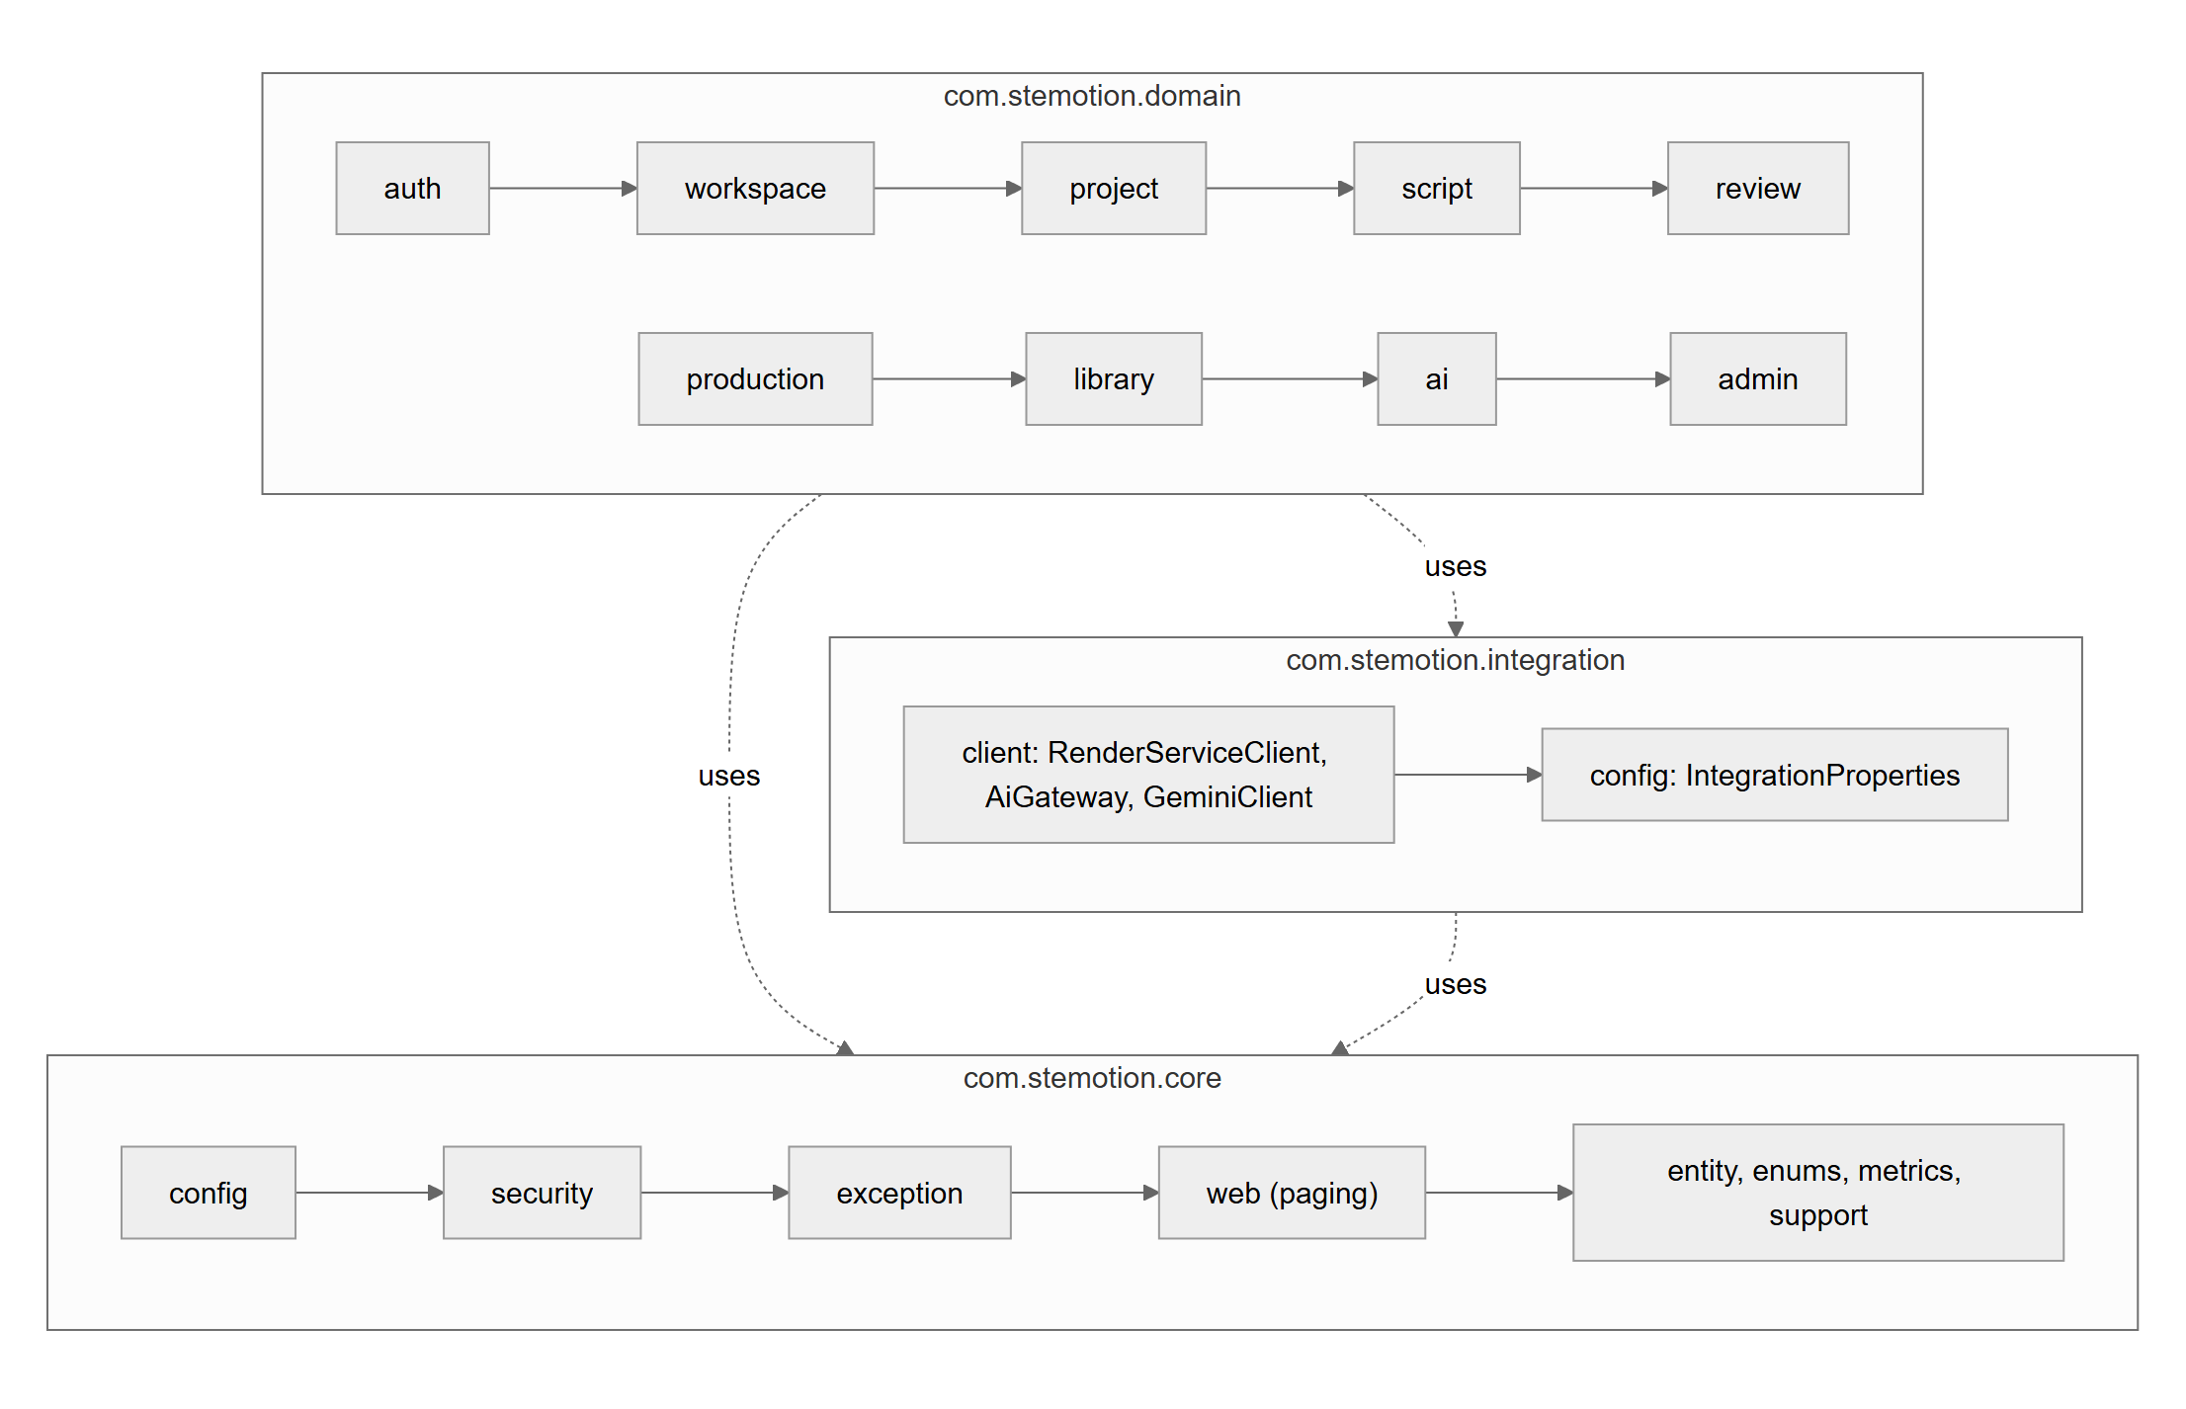
Figure 2. Core API package diagram
Package Descriptions
No | Package | Description
01 | core.config | Spring Security filter chain, CORS, password encoder, OpenAPI documentation.
02 | core.security | JwtAuthenticationFilter and JwtService (token issue and validation), CustomUserDetailsService, ResourceAccessInterceptor (scope checks per path, forced password change), WorkspaceAccess (membership and role checks, cached per request).
03 | core.exception | ApiException and GlobalExceptionHandler: one error envelope {status, code, message, timestamp, details}.
04 | core.web | PageParams and PagedResponse: optional page/size parameters and X-Total-Count headers.
05 | core.entity, enums, metrics, support | BaseEntity (UUID key, created/updated timestamps), shared enums (statuses, roles, scene types), request metrics with query counts, request-scoped cache.
06 | domain.auth | User entity, username login, password change, account provisioning by Admin (UserService); Google whitelist, identity linking and challenges (GoogleWhitelistService, GoogleAuthService); email notifications through an outbox (NotificationService).
07 | domain.workspace | Workspaces and members, team rules (three roles), leader permissions, role coverage.
08 | domain.project | ClipProject, status history of pipeline transitions and review decisions.
09 | domain.script | Script versions, scenes, scene props validation, draft revision, submit and review decisions.
10 | domain.review | Feedback notes and replies, video review (submit, approve, send back), pre-publish QA, review history.
11 | domain.production | Composition revisions, narration tools (TTS preview, duration sync), render jobs and clips, publishing, template registry.
12 | domain.library | Catalogue of published clips with subject and grade filters.
13 | domain.ai | AI actions (draft, approaches, resegment, grade, extract, terms), AI request log, cost calculation from AI_PRICING_JSON.
14 | domain.admin | Admin metrics: render queue, success rate, AI usage and budget.
15 | integration.client | RenderServiceClient (worker HTTP API), AiGateway (embedded Gemini or remote AI service), GeminiClient, GoogleTokenVerifier (Google sign-in for whitelisted Gmail addresses, on when GOOGLE_CLIENT_ID is set).
16 | integration.config | IntegrationProperties: URLs, keys, timeouts of external services.

1.2.2 Web application
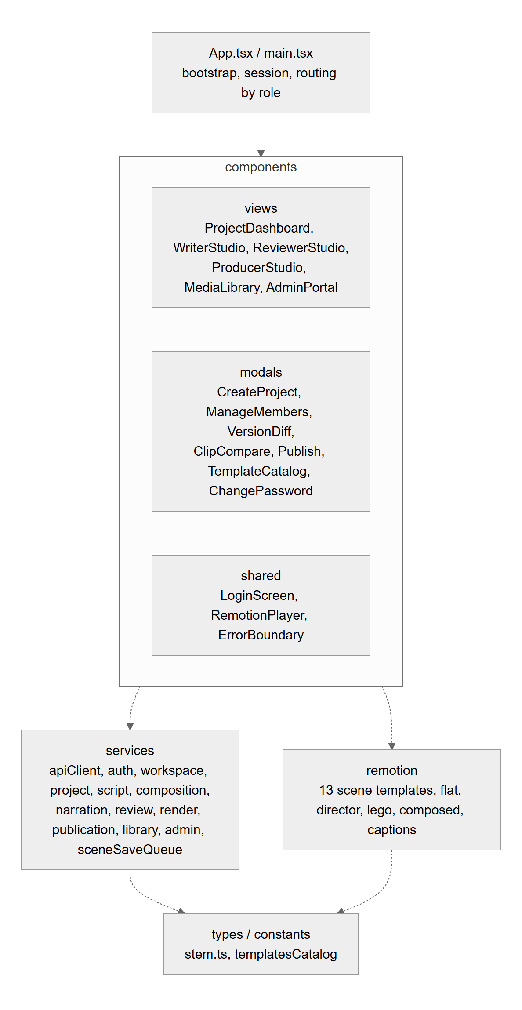
Figure 3. Web application package diagram
Package Descriptions
No | Package | Description
01 | App.tsx, main.tsx | Application bootstrap, session handling, active workspace and project, studio routing by role.
02 | components/views | The six main screens: ProjectDashboard, WriterStudio, ReviewerStudio, ProducerStudio, MediaLibrary, AdminPortal.
03 | components/modals | Dialogs: CreateProject, ManageMembers, VersionDiff, ClipCompare, Publish, TemplateCatalog, WorkspacePicker, ChangePassword.
04 | components (shared) | LoginScreen, RemotionPlayer wrapper, ErrorBoundary and reusable UI parts.
05 | services | apiClient (base URL, JWT header, error envelope with code and details) and one service per API area; sceneSaveQueue coalesces autosaves and carries the draft revision.
06 | remotion | Video compositions: 13 scene templates, flat and director styles, Lego and composed blocks, word-timed captions; Root.tsx is the entry the worker bundles.
07 | types, constants | Shared types (STEMScript, SceneData, statuses) and the template catalogue.

1.2.3 Render worker and AI service
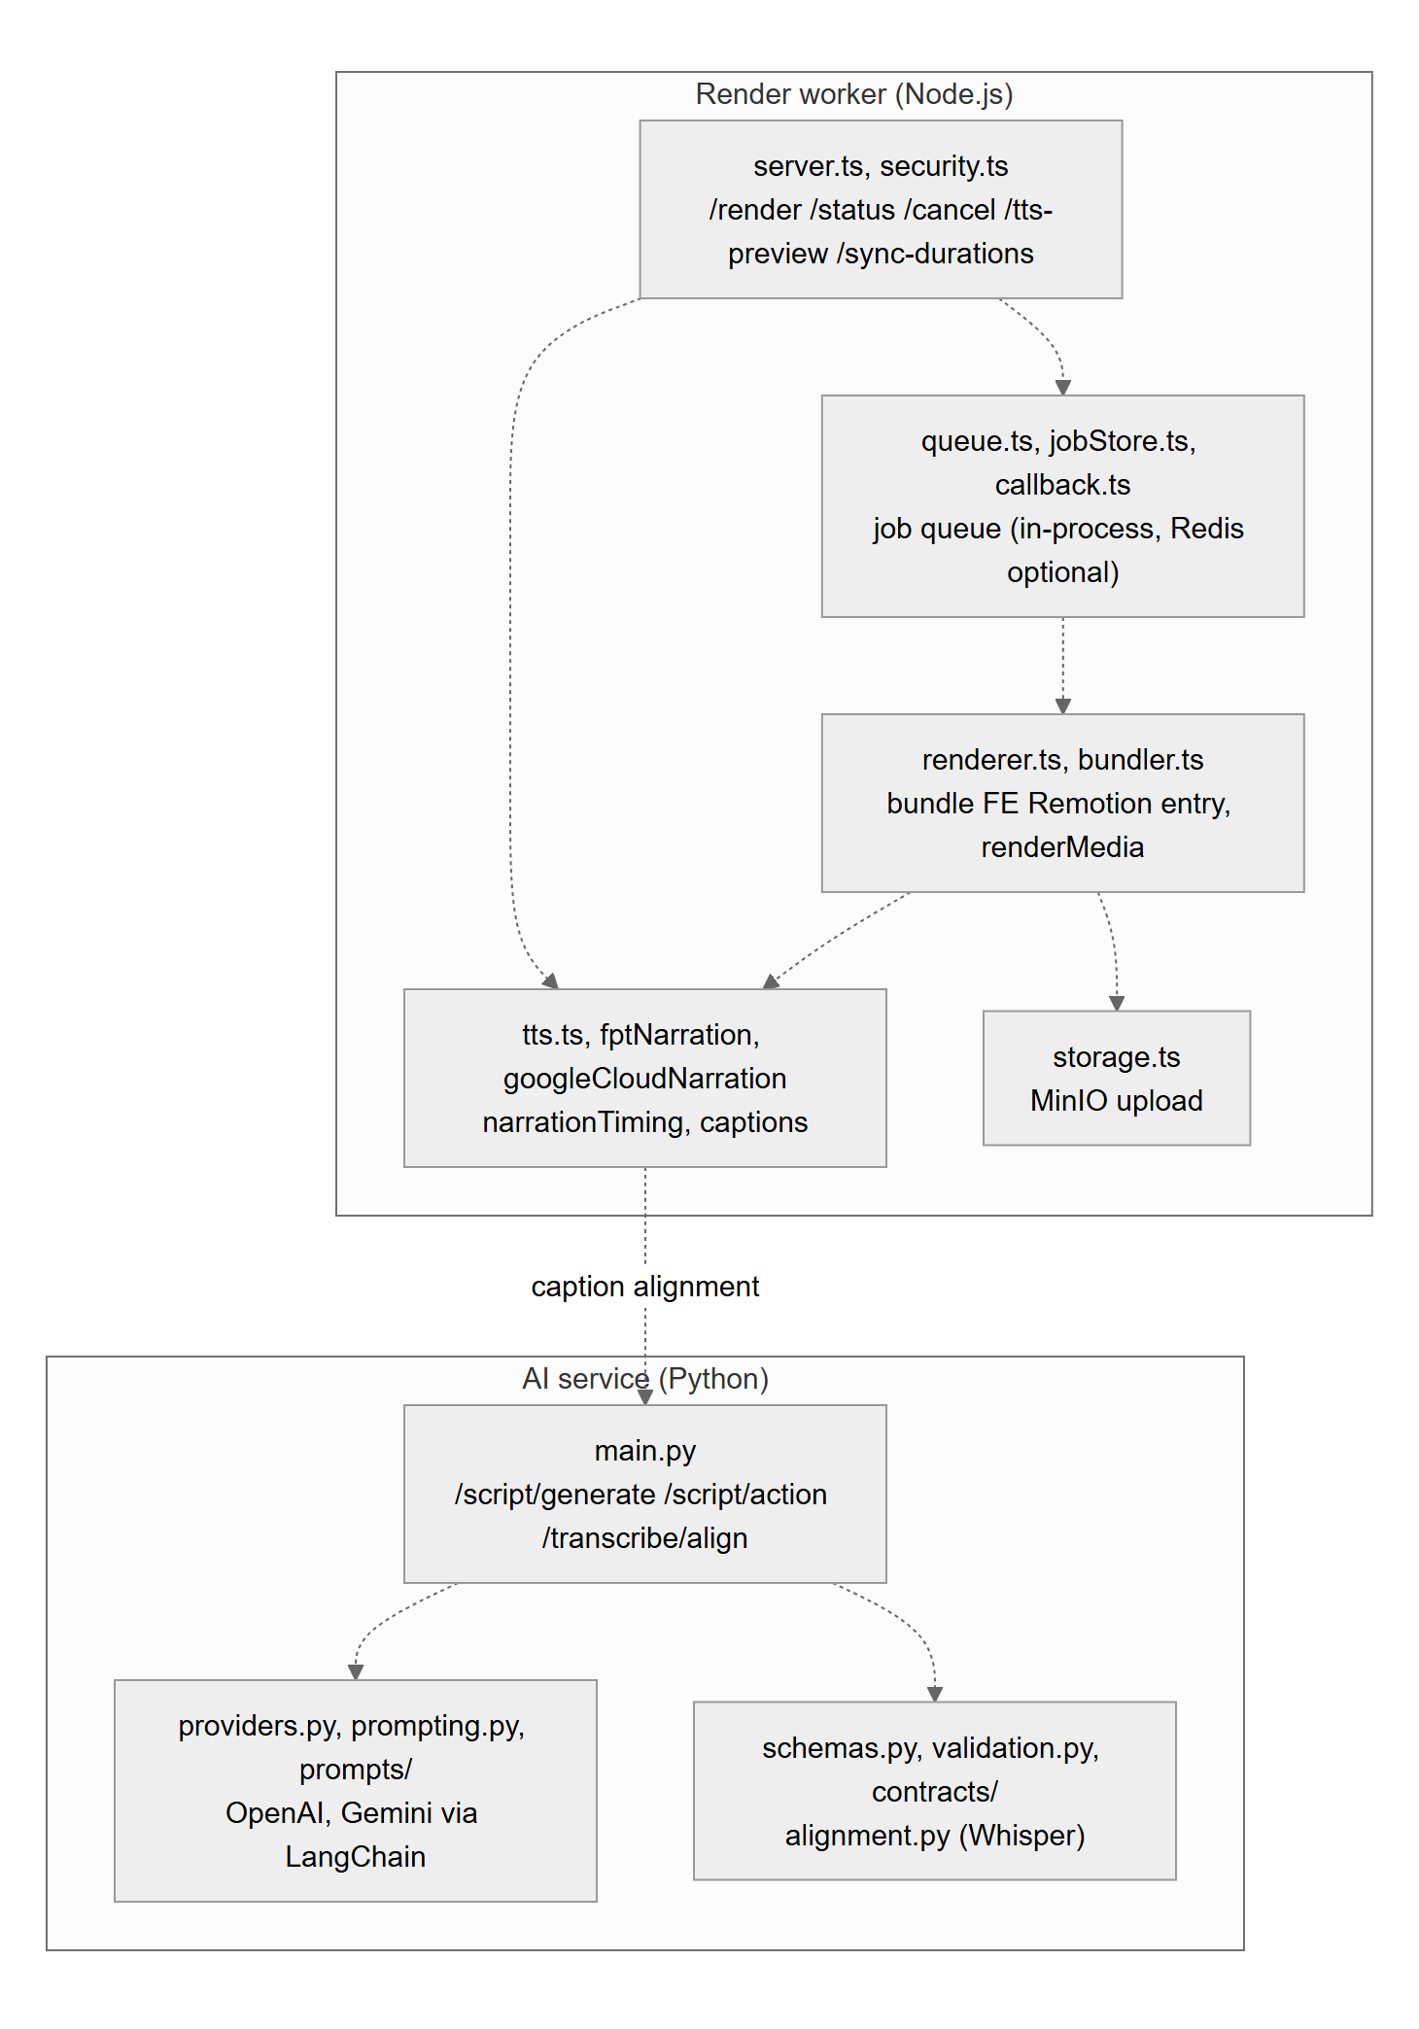
Figure 4. Render worker and AI service package diagrams
Package Descriptions
No | Package | Description
01 | worker: server.ts, security.ts | Express endpoints POST /render, GET /render-status/:jobId, DELETE /render/:jobId, GET /videos/:filename, GET /tts-preview, POST /sync-durations; service-key check.
02 | worker: queue.ts, jobStore.ts, callback.ts | Render job queue with de-duplication and the progress callback to the core API.
03 | worker: tts.ts and narration modules | TTS dispatcher for the configured provider (FPT.AI, Google Cloud), narration timing and caption building; provider errors never switch voices silently.
04 | worker: renderer.ts, bundler.ts | Bundles the web application's Remotion entry and renders MP4 with headless Chromium.
05 | worker: storage.ts | Uploads the MP4 to MinIO and returns its public URL.
06 | ai: main.py | FastAPI endpoints /script/generate, /script/action, /transcribe/align, health and readiness; service-key dependency.
07 | ai: providers.py, prompting.py, prompts/ | LangChain adapters (OpenAI, Gemini), prompt templates, deployment readiness checks.
08 | ai: schemas.py, validation.py, contracts/, alignment.py | JSON schemas of every AI response, output validation, Whisper word alignment.

1.3 Technology Declaration
Third-party Services
No | Service | Purpose and data sent
01 | Supabase (PostgreSQL) | Database hosting. All application data: accounts (BCrypt hashes, never plain passwords), workspaces, scripts, compositions, jobs, review notes, AI usage.
02 | Render.com | Hosting of the core API container. Receives all API traffic.
03 | Vercel | Static hosting of the web application. Serves the bundle only; no user data stored.
04 | OpenAI API, Google Gemini API | AI assistance. Sends the topic, subject, grade and script text of the project; no personal data of users.
05 | FPT.AI TTS, Google Cloud Text-to-Speech | Vietnamese narration. Sends the narration text of each scene.
06 | Tailscale Funnel | HTTPS exposure of the render worker and AI service on the team server. Carries render jobs, scene data and callbacks.
07 | MinIO (self-hosted) | Object storage of rendered MP4 files.
08 | YouTube Data API (committed, not yet built) | Publishing an approved clip to a connected channel: video file, title, description (registered scope, FR-40). Until built the API answers 503.
09 | Google Identity Services | Sign-in with Google (OAuth 2.0) for Gmail addresses on the Admin's whitelist: the web app sends the Google ID token, the core API verifies it and matches the verified Gmail against the active whitelist or a linked Google identity. No Google password or profile data is stored.

Development Technologies
No | Layer | Technology and version
01 | Front-end | React 18.3, TypeScript 5.6, Vite 8, Tailwind CSS 3.4, Remotion Player 4.0.526, Vitest 5
02 | Back-end | Java 17, Spring Boot 3.2.5 (Web, Security, Data JPA, Validation), Flyway, JJWT, Maven 3.9
03 | Render worker | Node.js 22 (Docker) / 20 (CI), Express 4.21, Remotion renderer and bundler 4.0.527, headless Chromium, BullMQ 5 + Redis (optional), MinIO client 8
04 | AI service | Python 3.12, FastAPI, Uvicorn, LangChain (langchain-openai 1.x, langchain-google-genai 4.x), faster-whisper 1.2.1
05 | Database | PostgreSQL 17 (Supabase); H2 and embedded PostgreSQL 16 for tests
06 | Mobile | Not applicable (web application only, LI-04)

Source Code and DevOps
Item | Declaration
Platform | GitHub organisation STEMotion-Capstone-FALL-2026: repositories STEMotion_BE (core API + AI service), STEMotion_FE, STEMotion_RENDER.
CI | GitHub Actions on every push and pull request to main: BE runs pytest (AI service) and mvn verify; FE runs tsc, Vitest and the production build; worker runs tsc, tests and a Chromium check.
CD | Vercel builds the web application from main; Render.com builds the core API Docker image from main; the team server runs worker, AI service and MinIO with Docker Compose.
Branch rules | main is the integration branch and must pass CI; work is done on short feature branches (feat/..., fix/..., docs/...) or small direct commits reviewed by the owner; release state is marked with tags (review-2).

Deployment Environments
Environment | Where and how | Rollback
Development | Each member's machine: Vite dev server, Spring Boot with the local profile, Docker Compose for worker, AI service and MinIO. | Not applicable
Staging (demo) | Hosted stack used for reviews and demos: Vercel (web), Render.com (core API), Supabase Singapore (database), team server via Tailscale Funnel (worker, AI, MinIO). Schema migrations are applied by operations before the API is deployed. | Redeploy the previous commit on Vercel / Render.com; Flyway rollback scripts in docs/rollback; previous Docker image on the team server.
Production | Currently the same hosted stack as staging; a separate production database and storage are planned (see Known Gaps). | As staging

AI Tools Used in Development
Tool and model | Stages
Claude Code (Anthropic, Claude Opus 5.5) | Specification and design drafting (SRS, SDD, diagrams), code and tests, code review, the BM02 self-review run. Every output is reviewed or tested by the owning member before merging.
Other assistants used by individual members | To be declared by each member (tool, model, stage).

2. Database Design

2.1 Logical ERD and Table Descriptions
The database has 15 application tables in PostgreSQL. Every table has a UUID primary key id and created_at / updated_at timestamps (BaseEntity). Schema changes are made only through versioned Flyway migrations, each with a rollback script and a migration test. Auth v2 adds google_login_whitelist, google_identities, google_auth_challenges, account_security_audit, notification_outbox and notification_audit and new user columns (username, system_role, auth_version, version) at the release cutover. The STEM tables (stem_catalog, stem_settings, stem_briefs, stem_evidence, stem_validation_runs, stem_assessments and the artifact snapshots) exist on the isolated STEM branch.
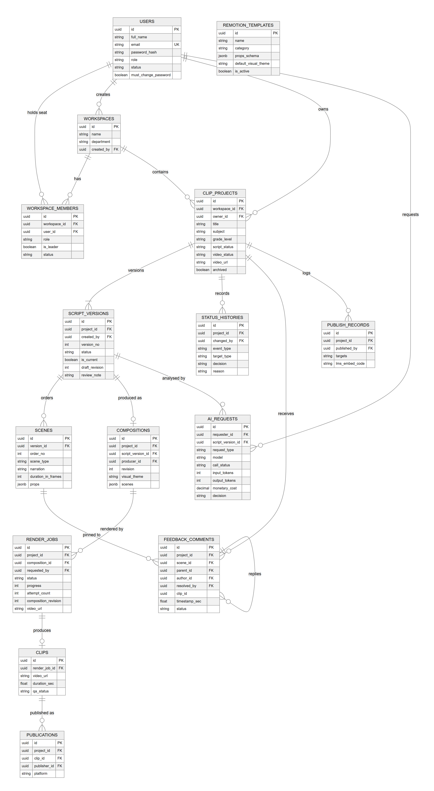
Figure 5. Logical entity relationship diagram
The database script is the ordered set of Flyway migrations V1 to V22 in STEMotion_BE/src/main/resources/db/migration; the JPA entities are validated against it at start-up.
Table Descriptions
No | Table | Description
01 | users | Accounts created by an Admin: full name, username (unique), email, BCrypt password hash, system role (ADMIN or USER), status, must_change_password, auth_version.  - Primary keys: id  - Foreign keys: none
02 | workspaces | Subject departments (tổ bộ môn).  - Primary keys: id  - Foreign keys: created_by -> users
03 | workspace_members | A user in a workspace with one production role (WRITER, REVIEWER, PRODUCER), leader flag and ACTIVE/INACTIVE status; unique (workspace_id, user_id).  - Primary keys: id  - Foreign keys: workspace_id -> workspaces, user_id -> users
04 | clip_projects | A clip project: title, subject, grade, fps, script_status, video_status, video_url, archived.  - Primary keys: id  - Foreign keys: workspace_id -> workspaces, owner_id -> users
05 | script_versions | Submitted versions and the working draft of a project; is_current marks the version in use, draft_revision (V22, CHECK >= 0) protects draft saves.  - Primary keys: id  - Foreign keys: project_id -> clip_projects, created_by -> users
06 | scenes | Ordered scenes of a script version: scene_type (template), title, narration, duration_in_frames, props (jsonb, validated per template).  - Primary keys: id  - Foreign keys: version_id -> script_versions
07 | status_histories | Pipeline transitions and review decisions with actor, target (SCRIPT, CLIP, COMPOSITION), decision and reason.  - Primary keys: id  - Foreign keys: project_id -> clip_projects, changed_by -> users
08 | compositions | The producer's revisioned copy of the approved scenes (scenes jsonb) and visual theme; revision increases on every save.  - Primary keys: id  - Foreign keys: project_id -> clip_projects, script_version_id -> script_versions, producer_id -> users
09 | render_jobs | Render of one composition revision: status, progress, stage, attempt_count, resolution, fps, voice, external job id, video URL, error.  - Primary keys: id  - Foreign keys: project_id -> clip_projects, version_id -> script_versions, composition_id -> compositions, requested_by -> users
10 | clips | Completed MP4 artifact of a render job with duration and QA result.  - Primary keys: id  - Foreign keys: render_job_id -> render_jobs
11 | feedback_comments | Review notes pinned to a scene or a clip timestamp, replies (parent_id), status and who resolved it when.  - Primary keys: id  - Foreign keys: project_id -> clip_projects, scene_id -> scenes, author_id -> users, parent_id -> feedback_comments, resolved_by -> users
12 | publications | Where an approved clip is published (platform), with metadata and time.  - Primary keys: id  - Foreign keys: project_id -> clip_projects, clip_id -> clips, publisher_id -> users
13 | publish_records | History of publish actions: targets, title, description, LMS embed code, YouTube URL (planned).  - Primary keys: id  - Foreign keys: project_id -> clip_projects, published_by -> users
14 | ai_requests | Every AI call: type, model, request/response, call status, tokens, latency, monetary cost with pricing provenance, user decision; at most one target.  - Primary keys: id  - Foreign keys: requester_id -> users, script_version_id -> script_versions, scene_id -> scenes, clip_id -> clips
15 | remotion_templates | Template registry: name, category, subject, props schema, slots, recommended subjects, default visual theme, active flag.  - Primary keys: id  - Foreign keys: none

2.2 Entity State Machines
Five entities have a lifecycle. Each transition names the functional requirement that triggers it; a transition not drawn is refused by the service with 400 or 409.
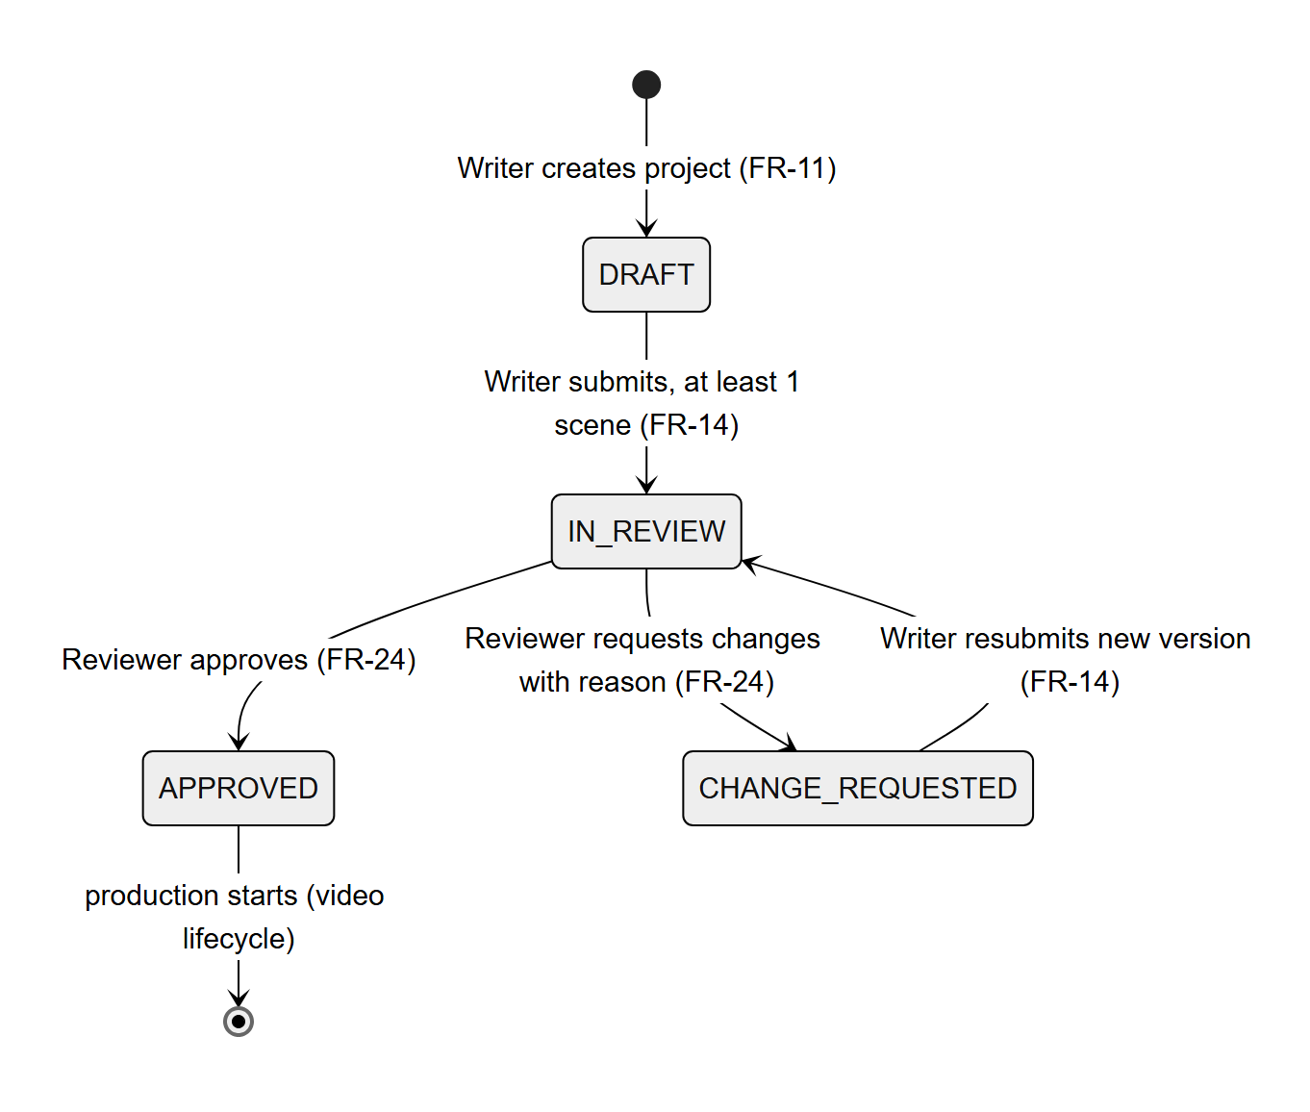
Figure 6. ClipProject script status
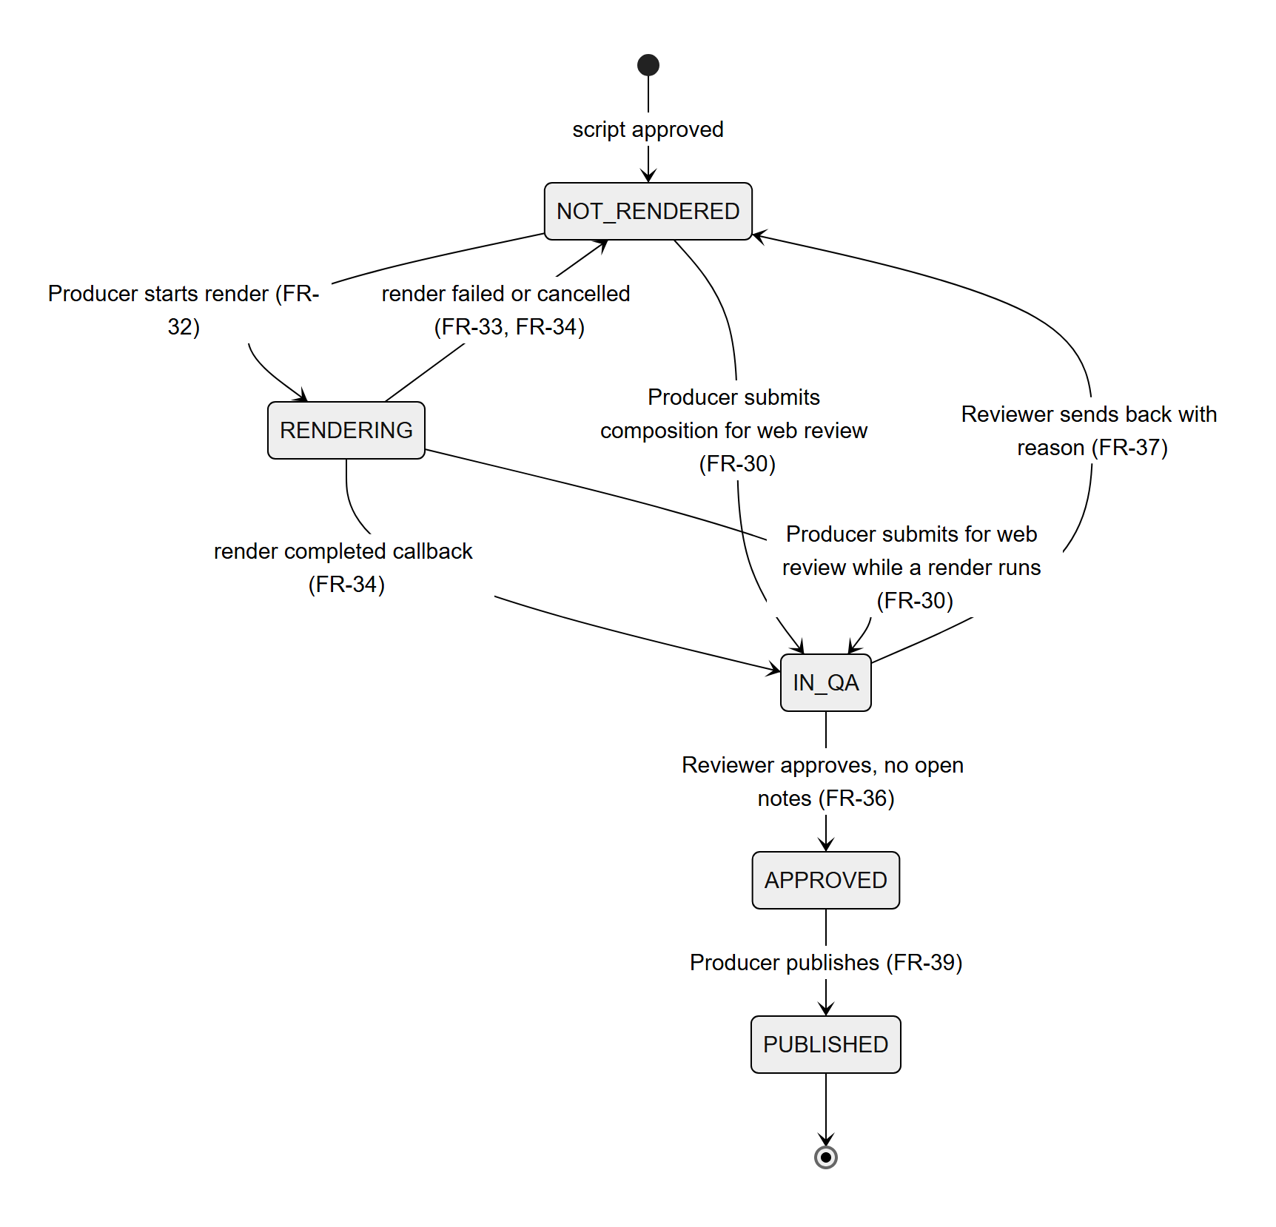
Figure 7. ClipProject video status
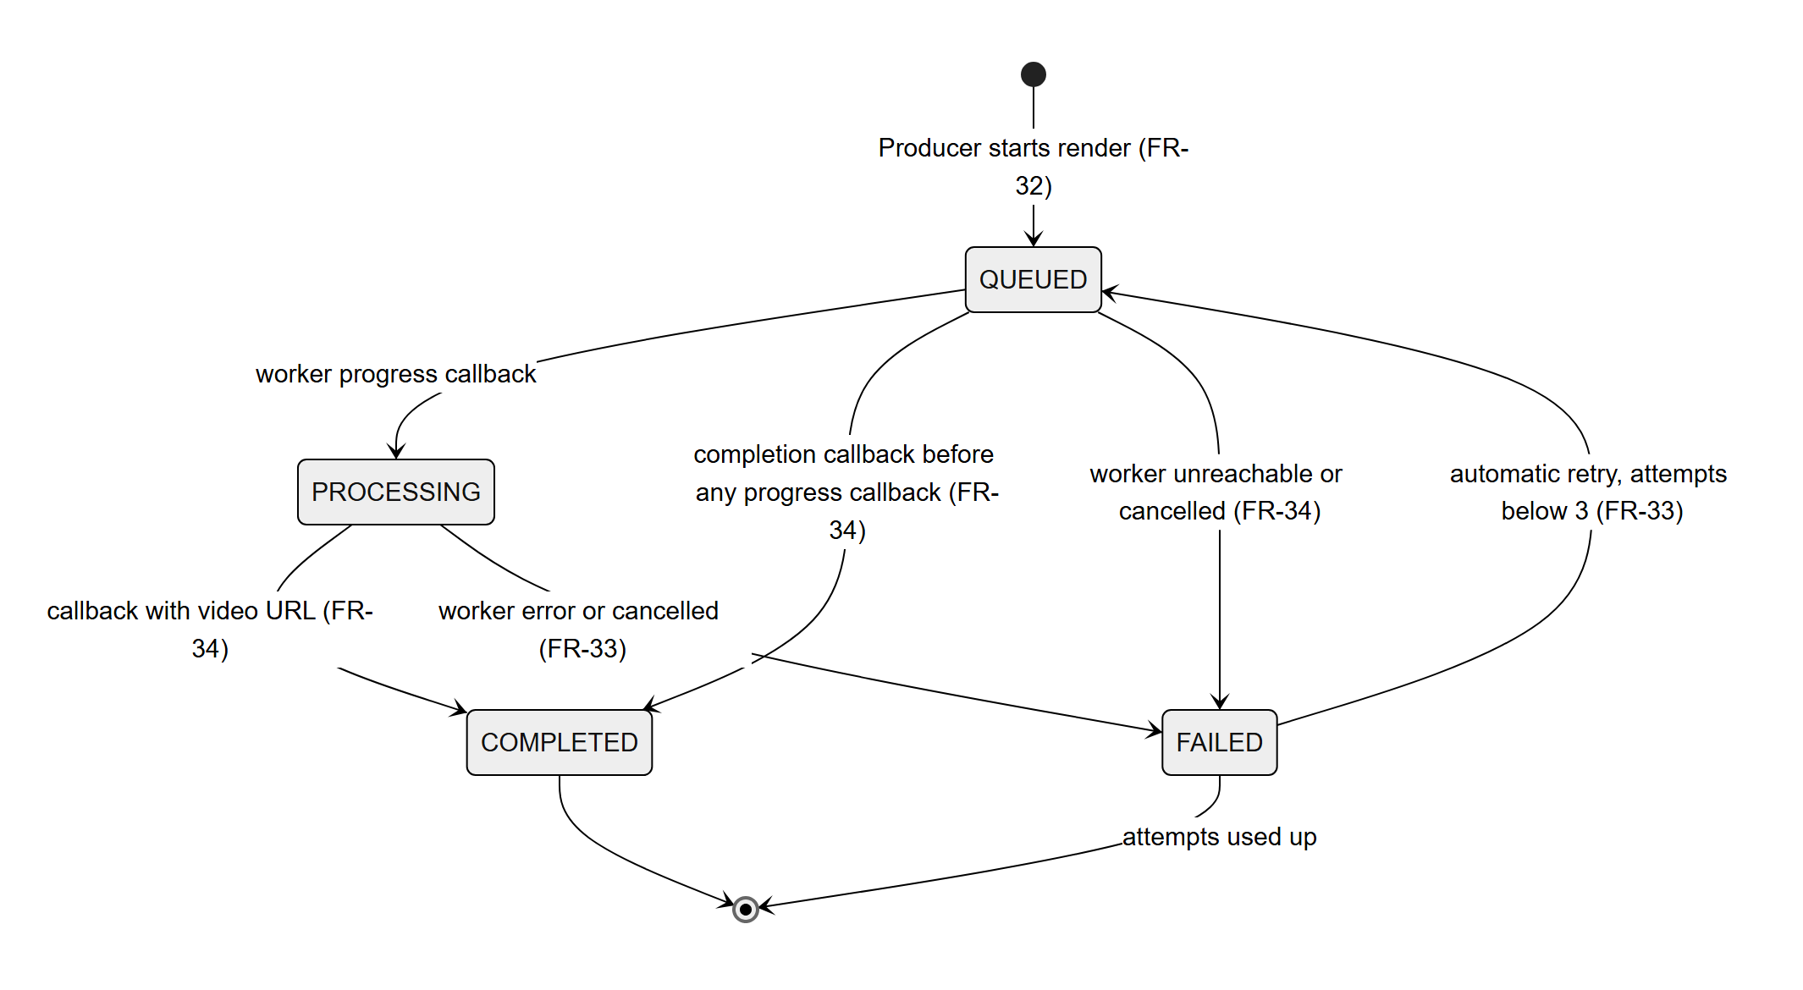
Figure 8. RenderJob status
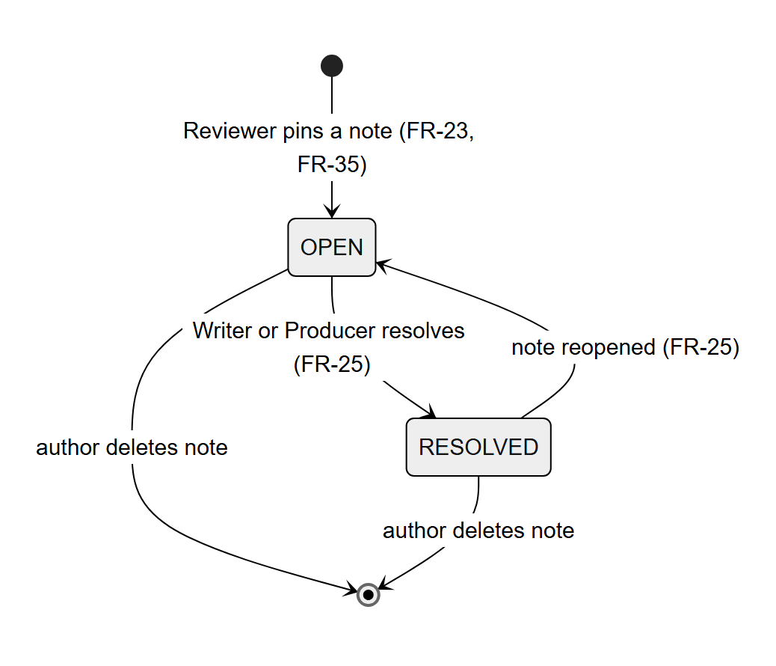
Figure 9. FeedbackComment status
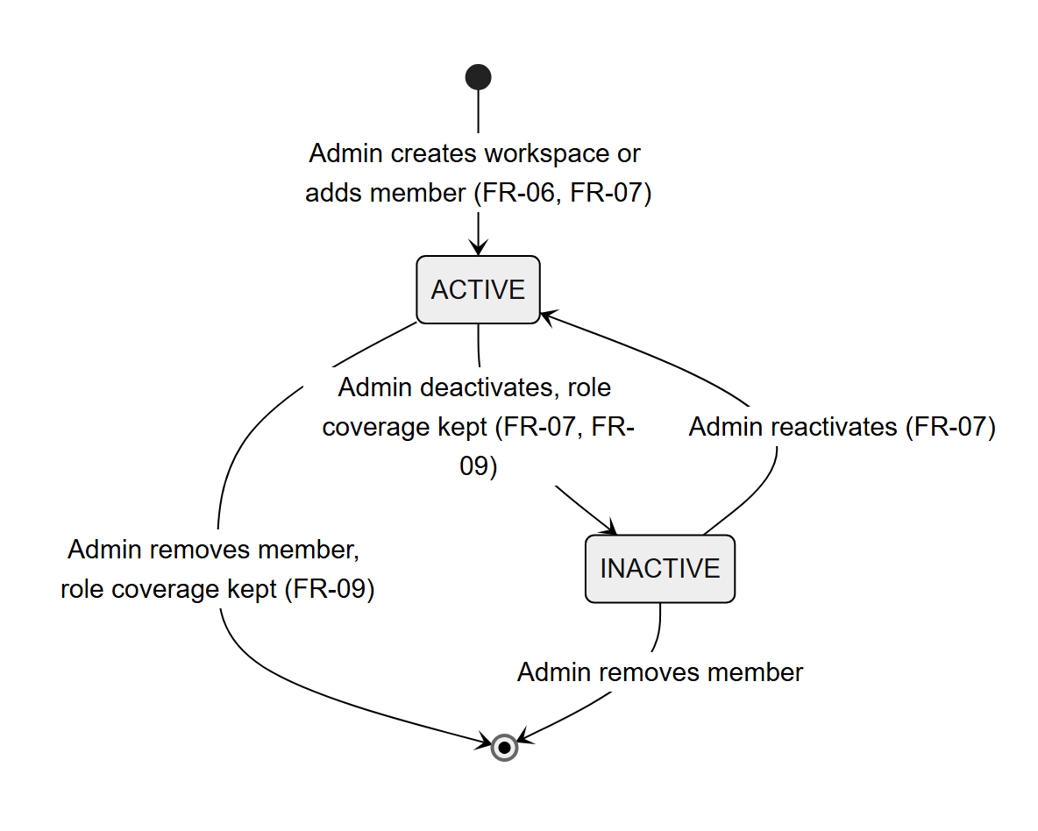
Figure 10. WorkspaceMember status

3. Detailed Design
Every feature uses the same layering: a controller validates the request and checks the role, a transactional service applies the business rules, repositories read and write the database, and integration clients call other services. Each section below gives the class diagram, the responsibilities of its classes and the sequence diagrams of its main flows.

3.1 Authentication and Account Provisioning
Accounts are created only by an Admin; there is no self-registration. Users sign in with a username and password, or with Google when the verified Gmail is on the active whitelist or linked to the account (FR-01 to FR-05, FR-56 to FR-61). A provisioned account must change its password at first login before it can use any other resource.

3.1.1 Class Diagram
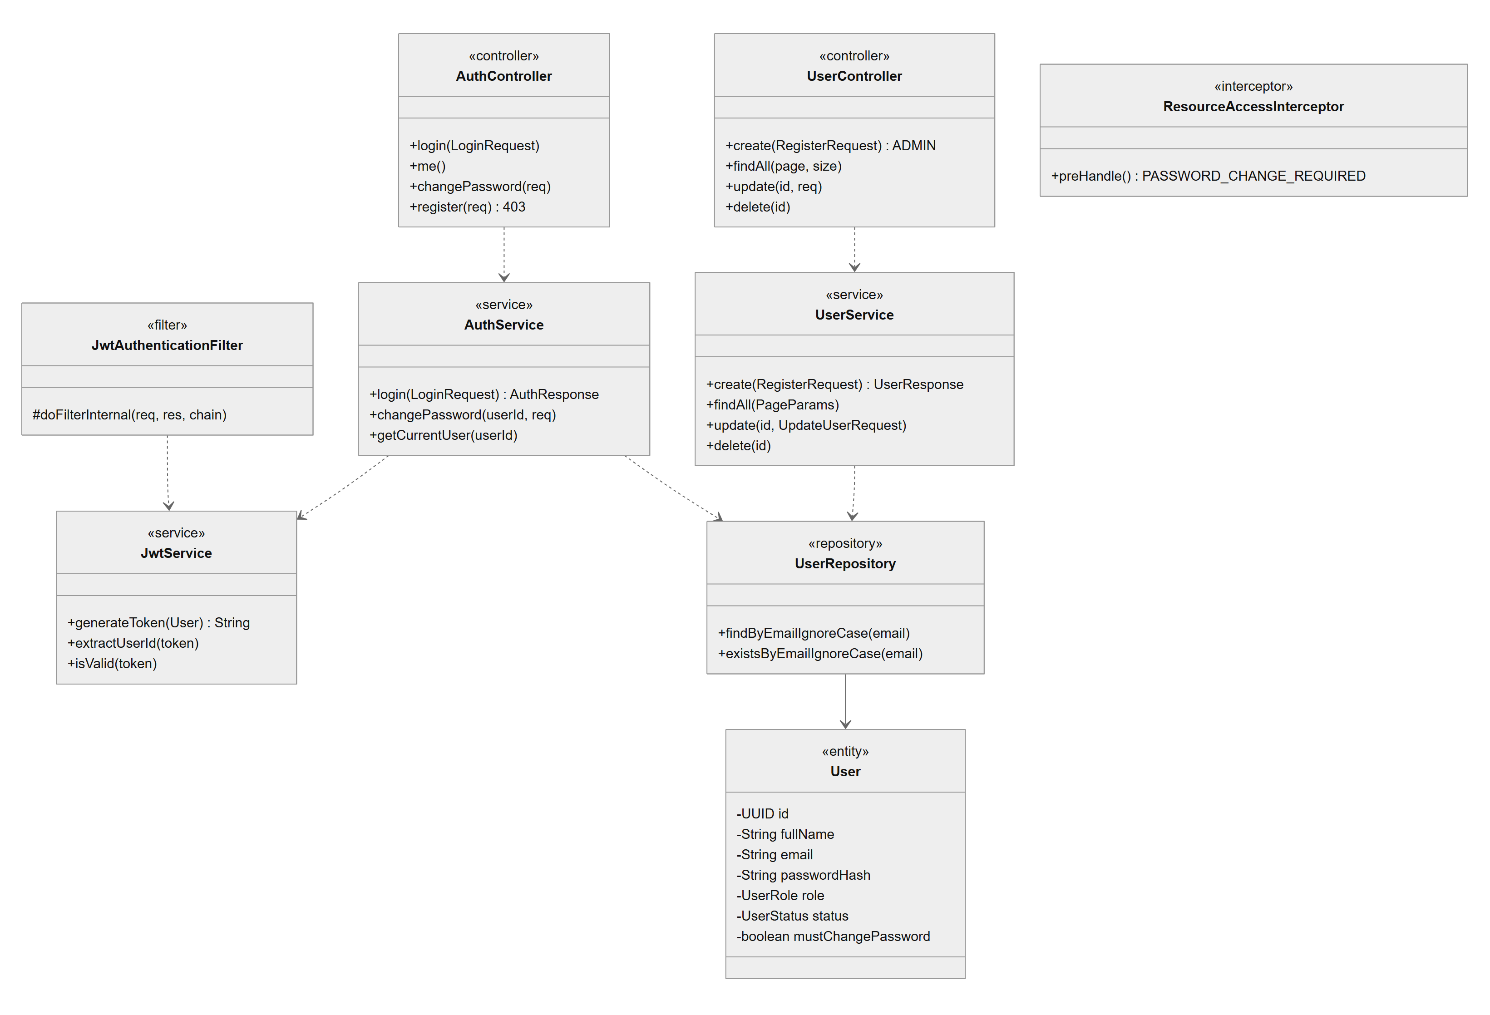
Figure 11. Authentication and Account Provisioning - class diagram
Class Specifications
Class | Responsibility
AuthController | Login, current user, password change; the registration endpoint always answers 403.
UserController / UserService | Admin-only account management: create (BCrypt hash, mustChangePassword = true, unique username), list with paging, update role and status, delete.
AuthService | Checks the username, ACTIVE status and password; issues the JWT; changes the password and clears the forced-change flag.
GoogleTokenVerifier | Verifies a Google ID token (audience GOOGLE_CLIENT_ID) for POST /auth/google; GoogleAuthService then requires an active whitelist entry or a linked identity for that Gmail (403 ACCOUNT_NOT_IN_SYSTEM otherwise).
JwtService / JwtAuthenticationFilter | Signs and validates 24-hour tokens and puts the user into the security context of each request.
ResourceAccessInterceptor | Blocks every other API call with 403 PASSWORD_CHANGE_REQUIRED until the password is changed.
User | Account entity: name, username, email, password hash, system role, status, must-change-password flag, auth version.

3.1.2 Provision an Account
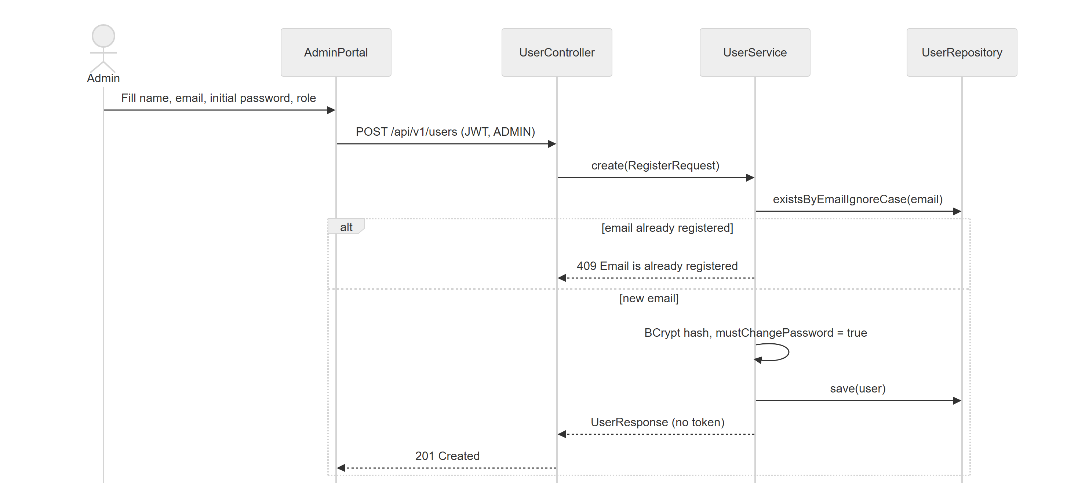
Figure 12. Provision an Account
The response carries the account only, never a token for the new user.

3.1.3 Login and Forced Password Change
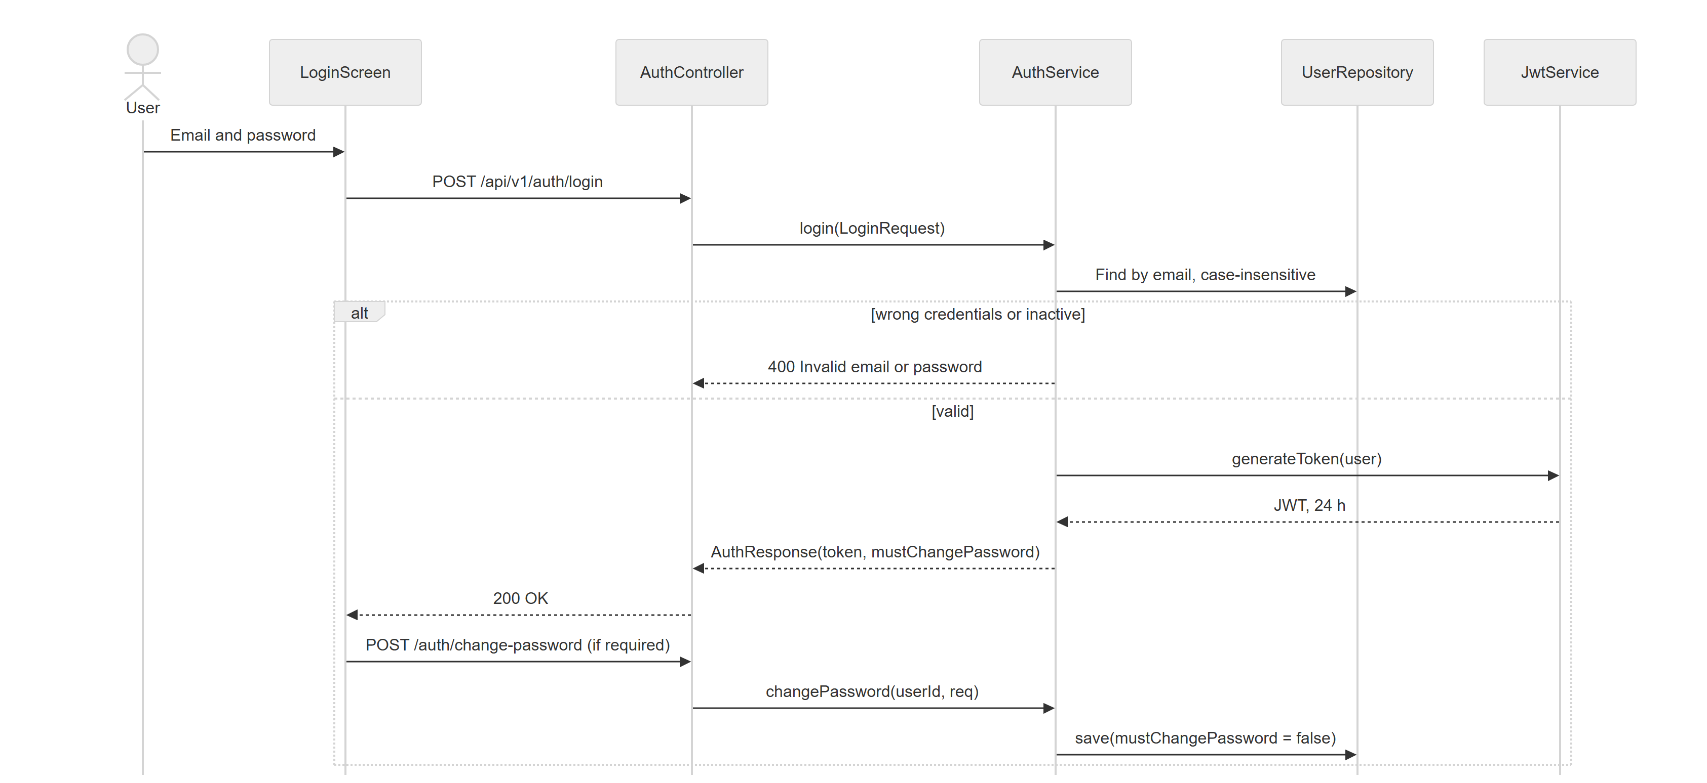
Figure 13. Login and Forced Password Change

3.2 Workspace and Member Management
An Admin creates a workspace with at least three different active users covering WRITER, REVIEWER and PRODUCER and is the only one who adds or removes members, changes their status or appoints leaders; a Leader changes roles inside the workspace (FR-06 to FR-10, BR-01 to BR-03). Every membership change locks the workspace row so concurrent changes cannot remove the last member of a role.

3.2.1 Class Diagram
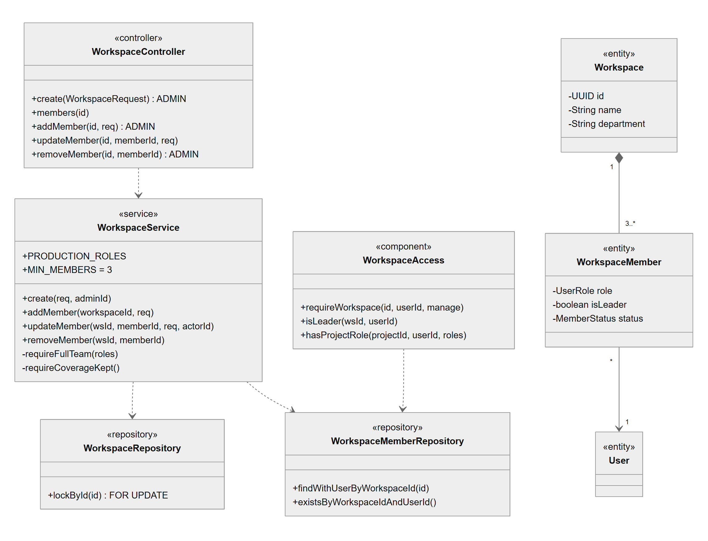
Figure 14. Workspace and Member Management - class diagram
Class Specifications
Class | Responsibility
WorkspaceController | Endpoints for workspaces and members; create, add, remove and candidates are Admin-only (@PreAuthorize).
WorkspaceService | Validates the team (distinct, active, production roles, three roles covered) before writing; checks role coverage on every change; rejects leader changes of status or leader flag.
WorkspaceAccess | Answers membership and role questions for the request (cached per request): leader, project role, workspace access.
ResourceAccessInterceptor | Applies the workspace scope check to every /workspaces/{id} path before the controller runs.
WorkspaceRepository | lockById issues SELECT ... FOR UPDATE to serialise membership changes of one workspace.
Workspace / WorkspaceMember | Department and the seat of a user in it: role, leader flag, status.

3.2.2 Create a Workspace with Its Team
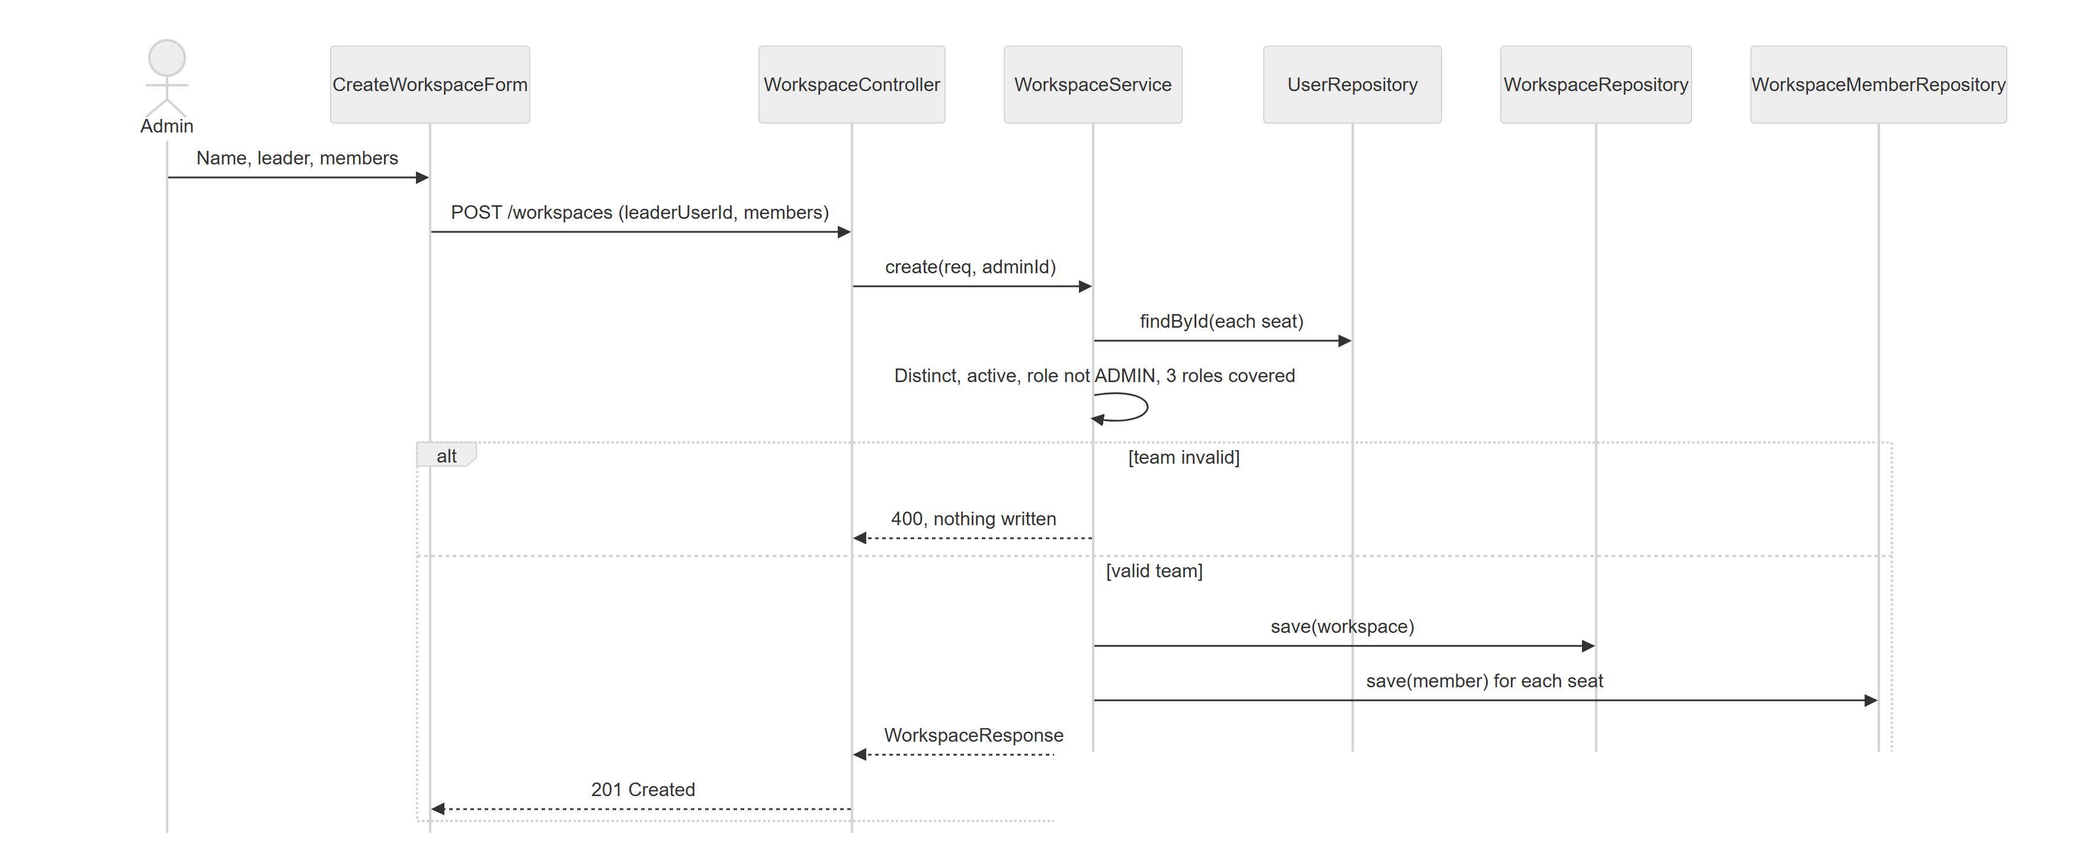
Figure 15. Create a Workspace with Its Team
All checks run before the workspace row is inserted, inside one transaction, so a refused team leaves nothing behind.

3.2.3 Leader Changes a Member Role
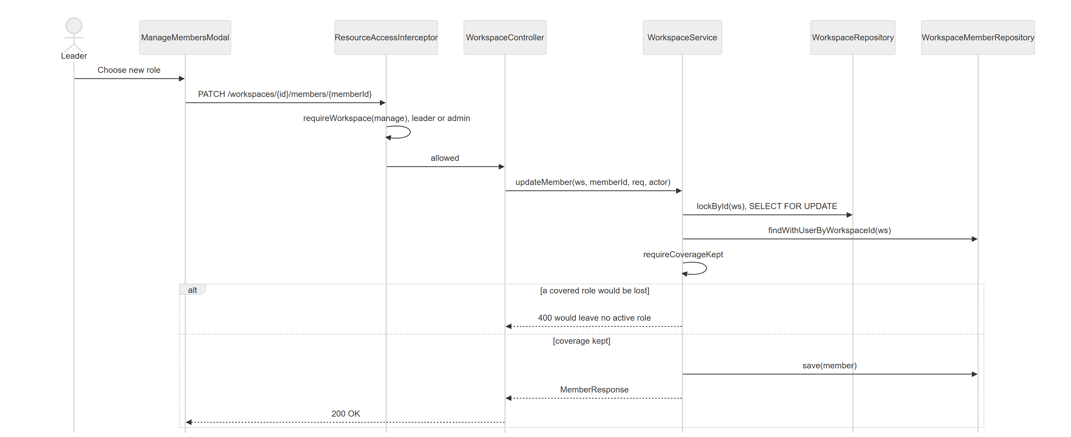
Figure 16. Leader Changes a Member Role

3.3 Script Authoring and Review
Writers edit the working draft scene by scene with autosave; the draft revision prevents silent overwrites between tabs or writers (FR-11 to FR-16, FR-23 to FR-25). Submitting freezes the version; the Reviewer approves it or requests changes with a reason, which opens a new draft version.

3.3.1 Class Diagram
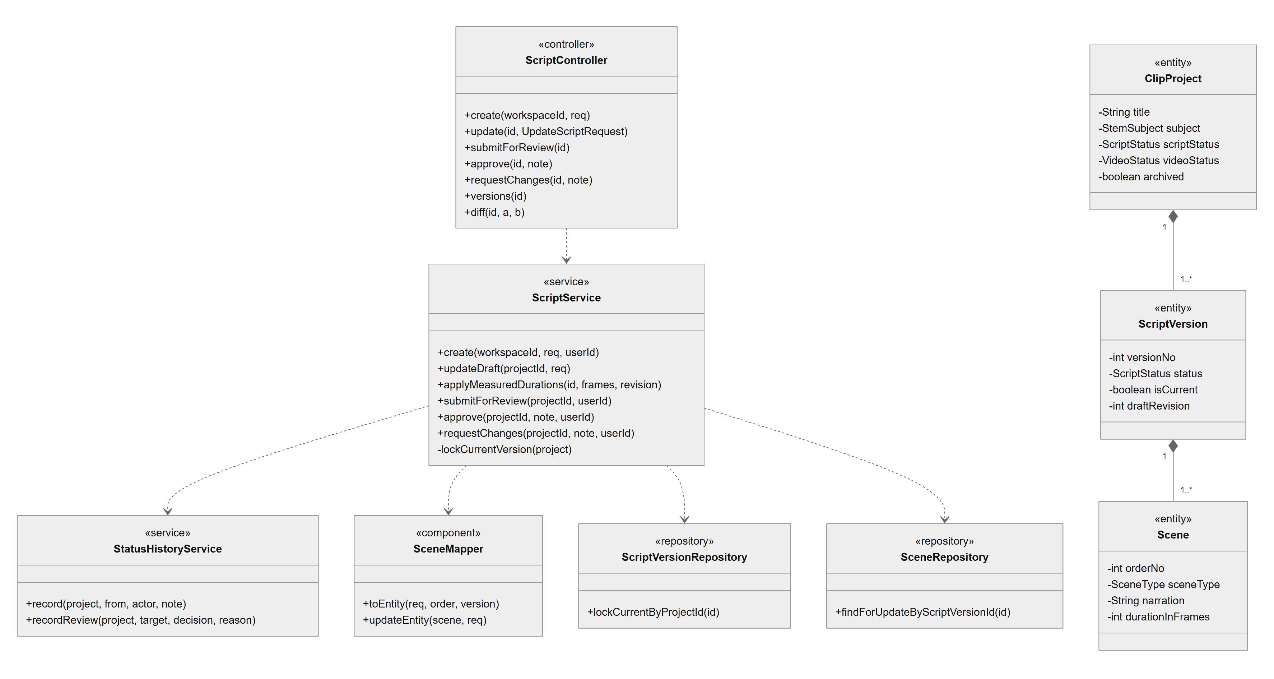
Figure 17. Script Authoring and Review - class diagram
Class Specifications
Class | Responsibility
ScriptController | Project creation, draft save, submit, approve, request changes, versions and diff; role checked with hasProjectRole.
ScriptService | Applies the lifecycle rules (DRAFT, IN_REVIEW, CHANGE_REQUESTED, APPROVED); locks the current version, compares baseRevision and bumps draftRevision; refuses stale sync results.
SceneMapper / ScenePropsValidator | Maps scene requests to entities and validates template props; keeps scene identity across reorders.
StatusHistoryService | Records pipeline transitions and review decisions with actor and reason.
ScriptVersionRepository | lockCurrentByProjectId locks the current version row for the revision check.
ClipProject / ScriptVersion / Scene | Project, its versions (draftRevision, isCurrent) and ordered scenes.

3.3.2 Autosave a Script Draft
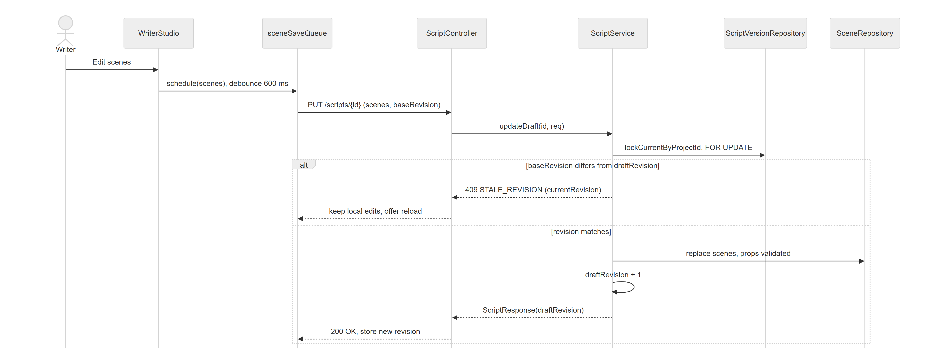
Figure 18. Autosave a Script Draft
The web client never retries a 409 automatically; it keeps the local edits and offers to reload.

3.3.3 Submit and Review a Script
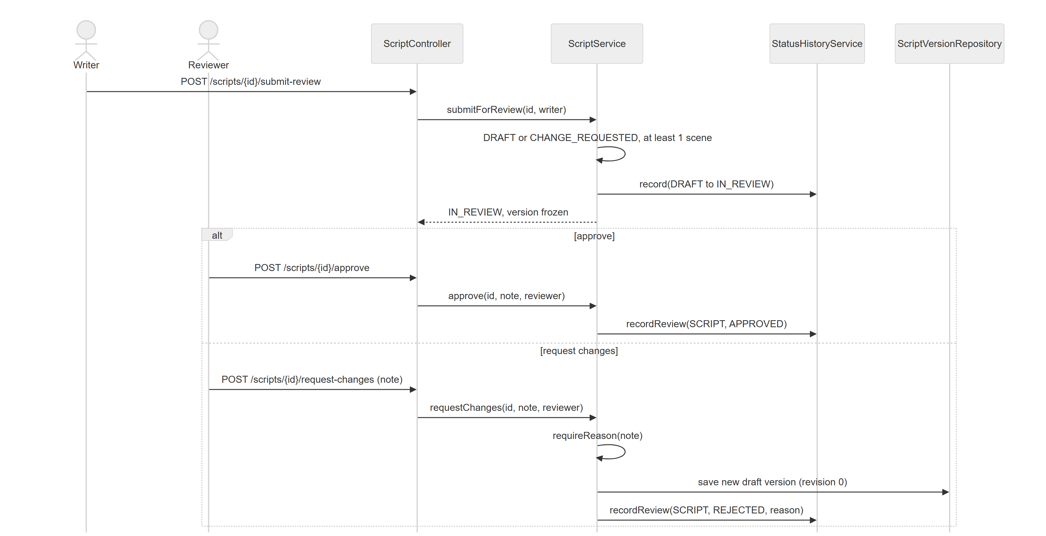
Figure 19. Submit and Review a Script

3.4 AI Assistance
Writers ask the AI for a draft script, teaching approaches or analyses (resegment, readability, concepts, terms). Results are suggestions: each call is logged with model, tokens and cost and the Writer accepts or ignores it (FR-18 to FR-22).

3.4.1 Class Diagram
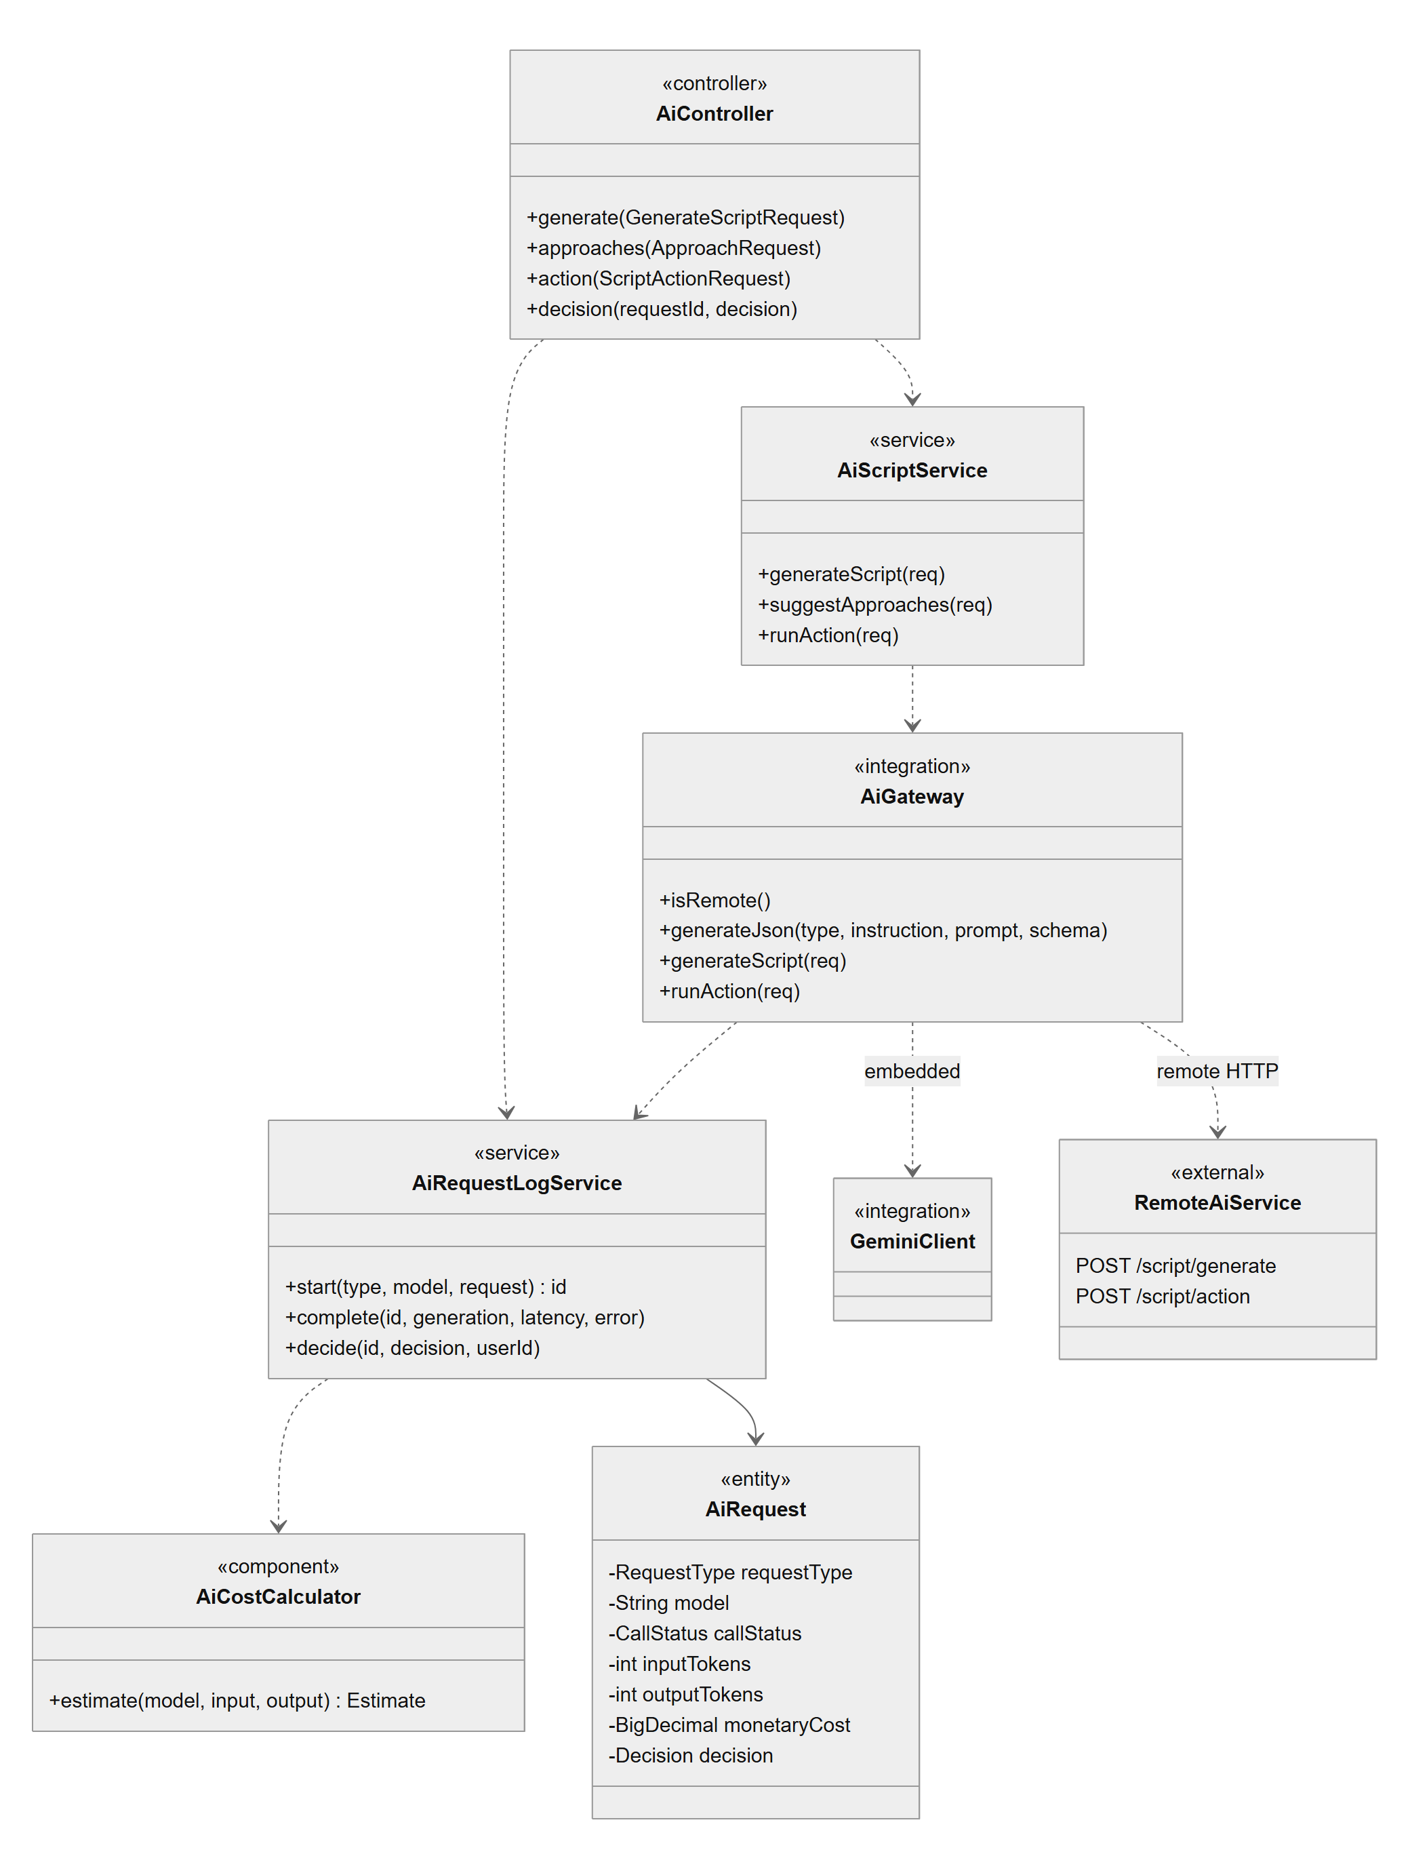
Figure 20. AI Assistance - class diagram
Class Specifications
Class | Responsibility
AiController | AI endpoints and the accept/ignore decision on a logged suggestion.
AiScriptService | Builds the prompt and schema for each action, rejects non-STEM topics, replaces unknown icon names.
AiGateway | Sends the request to the embedded Gemini client or to the remote AI service; logs start and completion of every call.
AiRequestLogService / AiCostCalculator | Persists AiRequest rows with tokens, latency and cost computed from AI_PRICING_JSON (unknown model: cost left empty).
ai-service (FastAPI) | Calls OpenAI or Gemini through LangChain and validates the JSON against the action's schema.
AiRequest | Log entity: type, model, status, tokens, cost, pricing provenance, decision.

3.4.2 Request AI Assistance
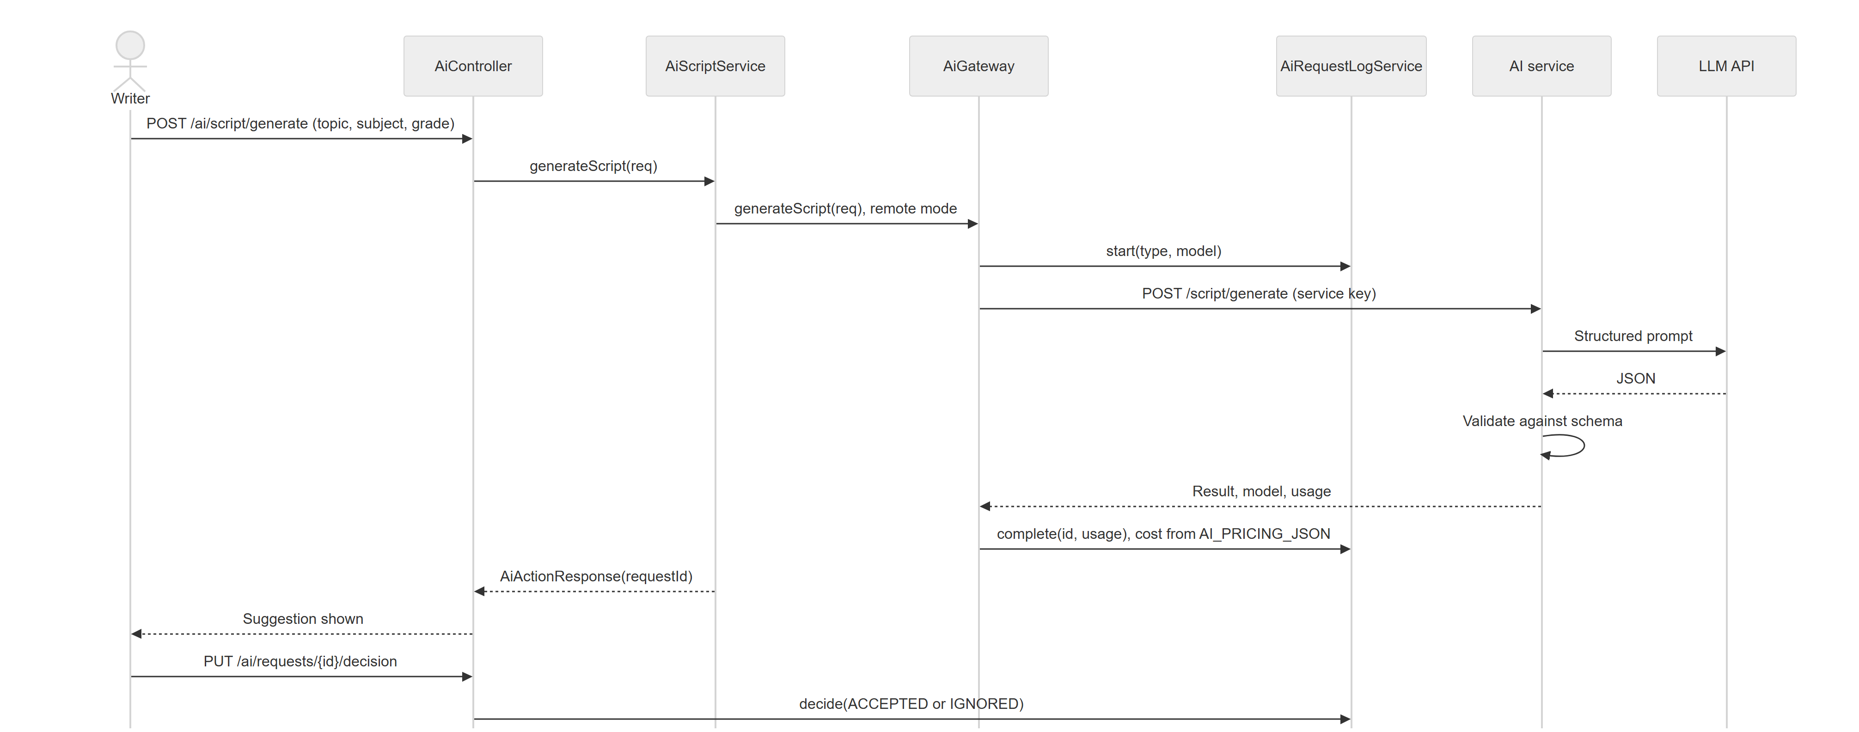
Figure 21. Request AI Assistance
Malformed, refused or timed-out responses are logged as FAILED and produce no suggestion.

3.5 Production: Composition and Narration
Opening an approved script creates revision 1 of its composition; the Producer edits scenes, theme and blocks, each save naming its base revision (FR-26 to FR-30). Narration tools preview TTS and sync scene durations to measured speech; a sync is applied only if the resource is still at the revision that was measured (BR-11).

3.5.1 Class Diagram
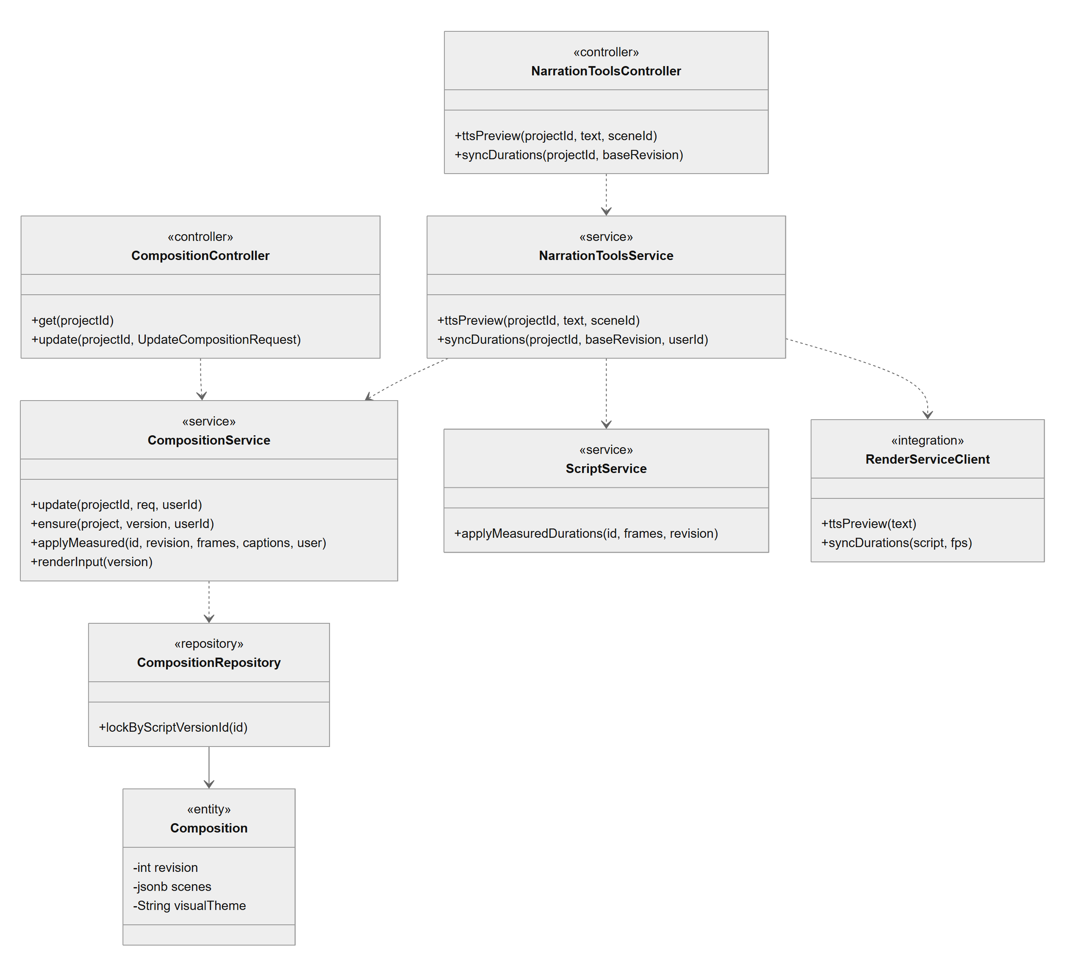
Figure 22. Production: Composition and Narration - class diagram
Class Specifications
Class | Responsibility
CompositionController / CompositionService | Reads and saves composition revisions under a row lock; ensure() freezes revision 1 for review; applyMeasured() writes measured durations and caption words.
NarrationToolsController / NarrationToolsService | TTS preview and duration sync; snapshots the measured revision before calling the worker and refuses a stale baseRevision before any TTS is spent.
ScriptService | Applies measured durations to a draft under the same revision rule.
RenderServiceClient | HTTP client of the render worker; compute calls time out after 180 seconds.
Composition | Revisioned scene list (jsonb), visual theme and producer.

3.5.2 Sync Scene Durations to Measured Narration
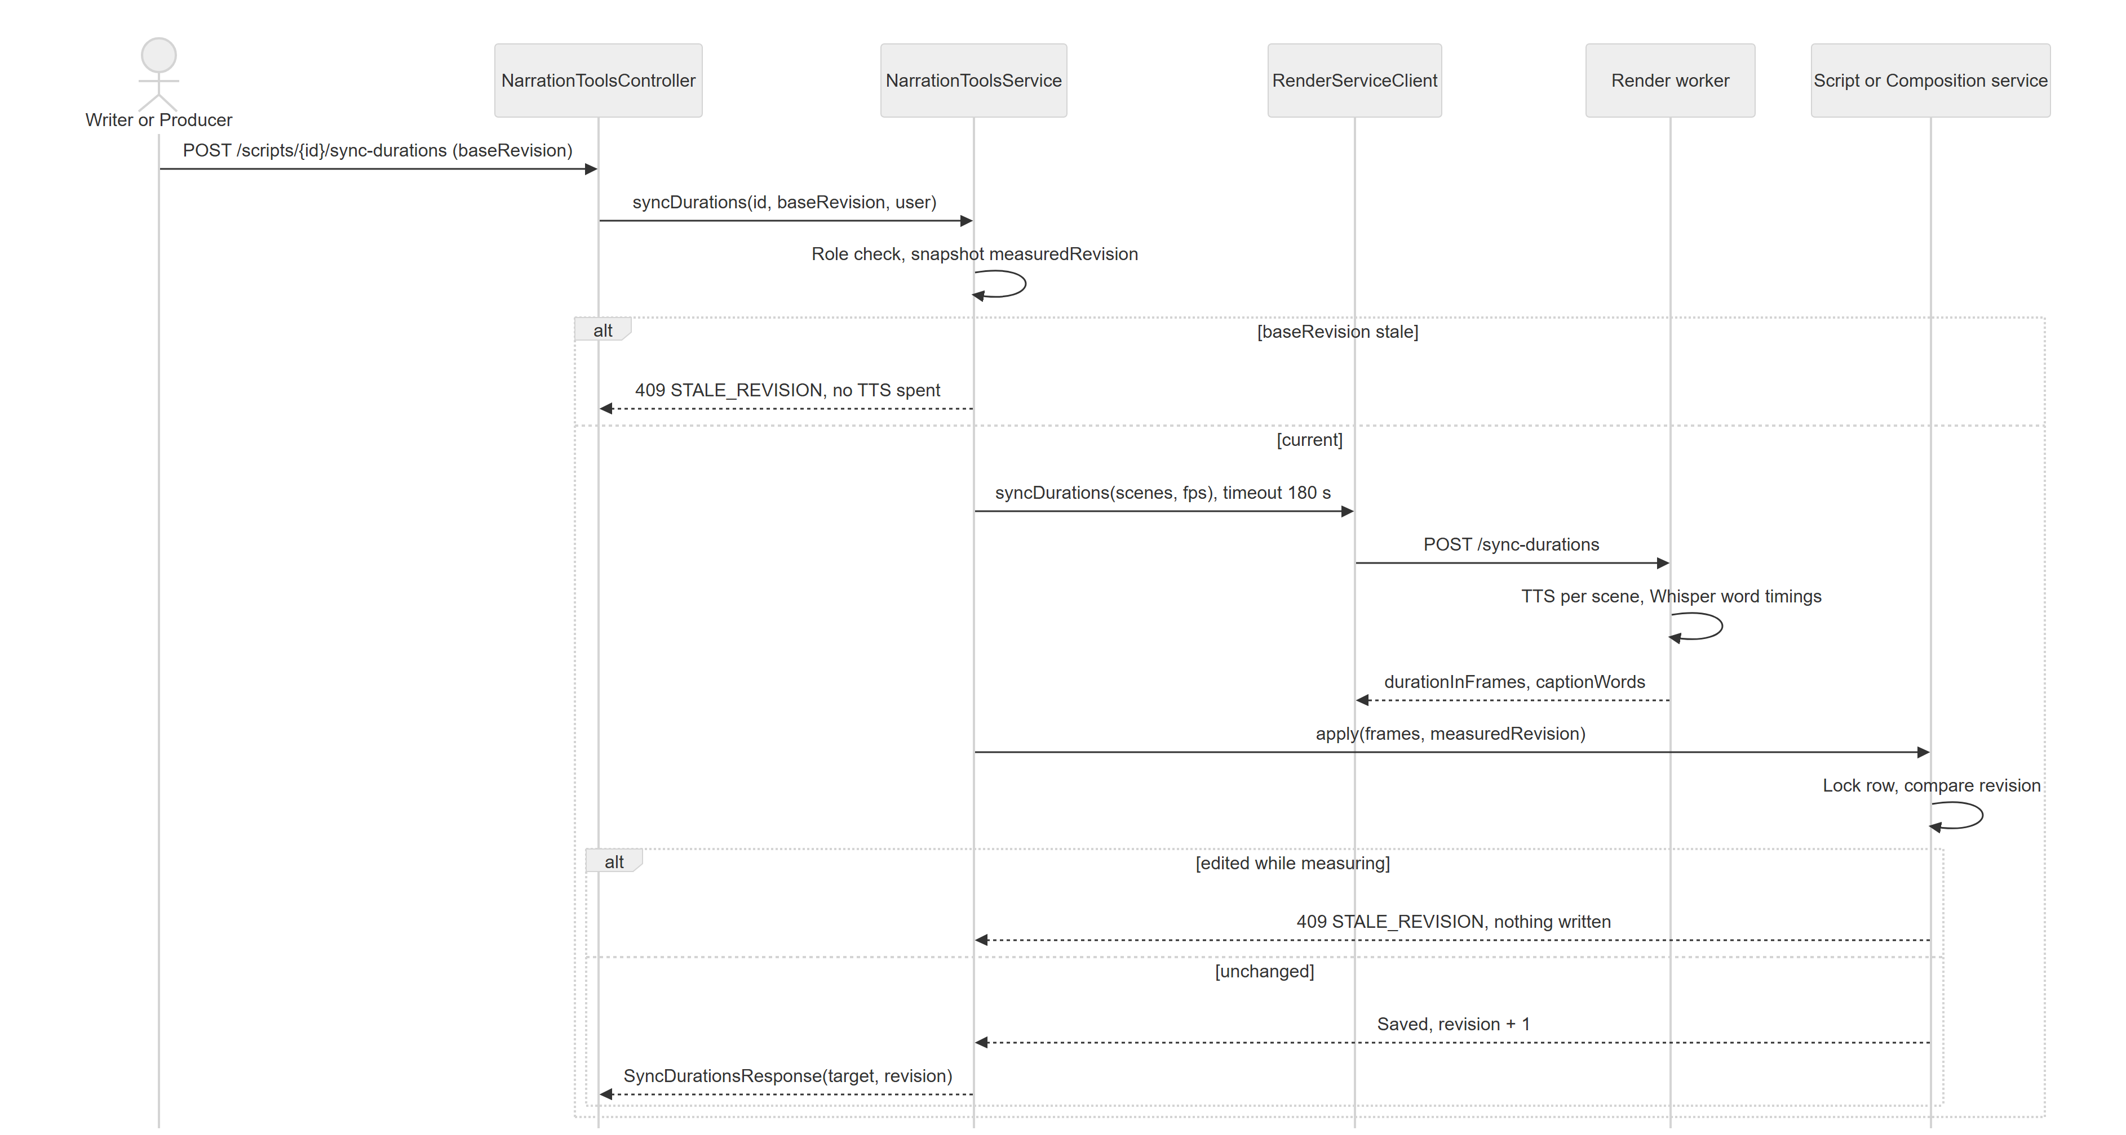
Figure 23. Sync Scene Durations to Measured Narration

3.6 Rendering
The Producer starts a render of the frozen composition at 720p, 1080p or 1440p. Only one render per project runs at a time; the worker reports progress by callback and failed jobs are retried up to three times (FR-32 to FR-34).

3.6.1 Class Diagram
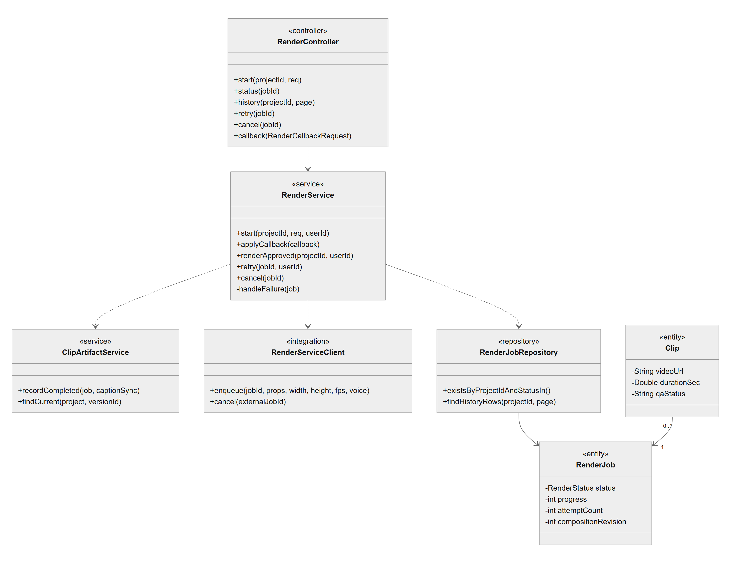
Figure 24. Rendering - class diagram
Class Specifications
Class | Responsibility
RenderController | Start, status, history, retry, cancel; the callback endpoint is authenticated by the worker service key.
RenderService | Checks preconditions, freezes the composition revision, creates the job, hands it to the worker, applies callbacks and moves the video status (NOT_RENDERED, RENDERING, IN_QA).
ClipArtifactService | Records the completed MP4 as a Clip of that composition revision and finds the current clip of a project.
RenderJobRepository / ClipRepository | Persistence of jobs (history paging, queue checks) and clips.
RenderJob / Clip | Job with status, progress, attempts and revision; resulting artifact with URL and QA result.

3.6.2 Render a Clip and Receive the Result
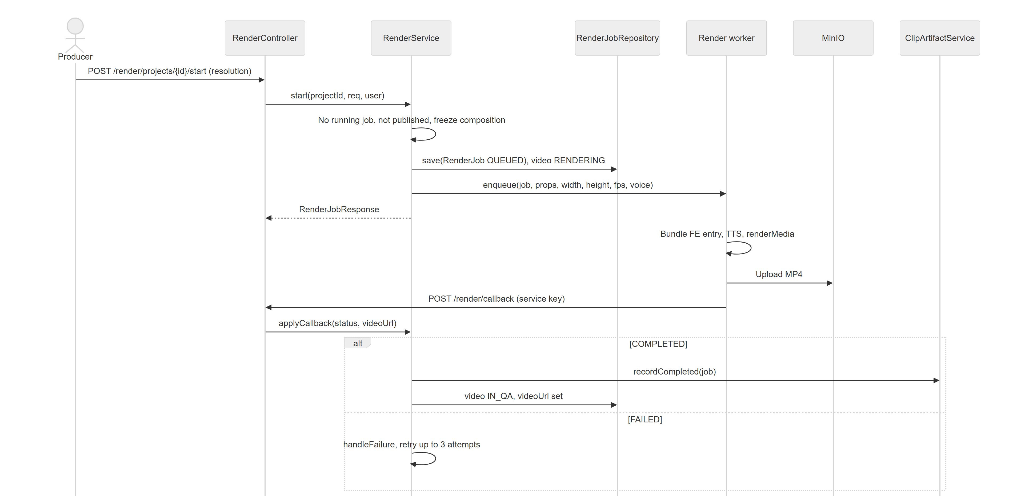
Figure 25. Render a Clip and Receive the Result

3.7 Video Review, QA and Publishing
The Producer submits the composition for video review; the Reviewer watches it in the web player or as MP4, pins timestamped notes and approves or sends it back with a reason. Approval is blocked while notes of the current clip are open; an approved clip is published to the internal library with an LMS embed code (FR-35 to FR-41).

3.7.1 Class Diagram
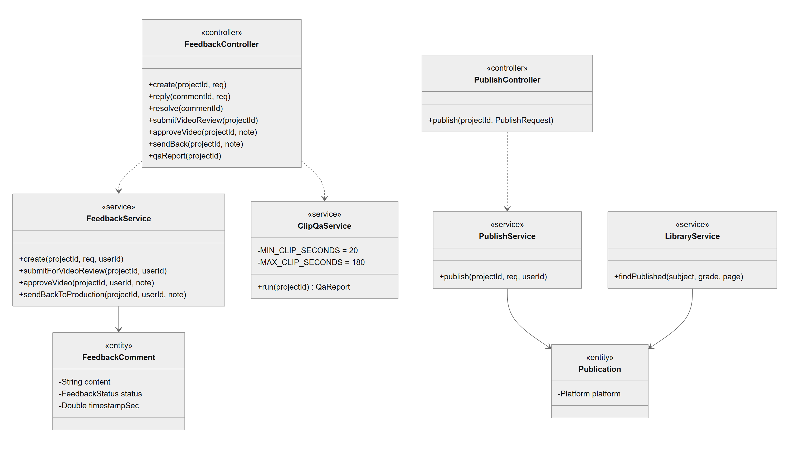
Figure 26. Video Review, QA and Publishing - class diagram
Class Specifications
Class | Responsibility
FeedbackController / FeedbackService | Notes, replies, resolve and reopen; submit for video review (freezes the revision, IN_QA); approve (open-notes gate, review record, render if no MP4); send back with reason.
ClipQaService | Pre-publish QA on the composition as rendered: duration 20 to 180 s, pacing, on-screen text, contrast, captions; advisory only.
PublishController / PublishService | Publishes an approved clip once per target; YouTube answers 503 until OAuth is configured.
LibraryController / LibraryService | Published clips with subject and grade filters, paged in SQL.
FeedbackComment / Publication / PublishRecord | Review notes with thread and resolution; publication per platform; publish history with embed code.

3.7.2 Approve the Video and Publish It
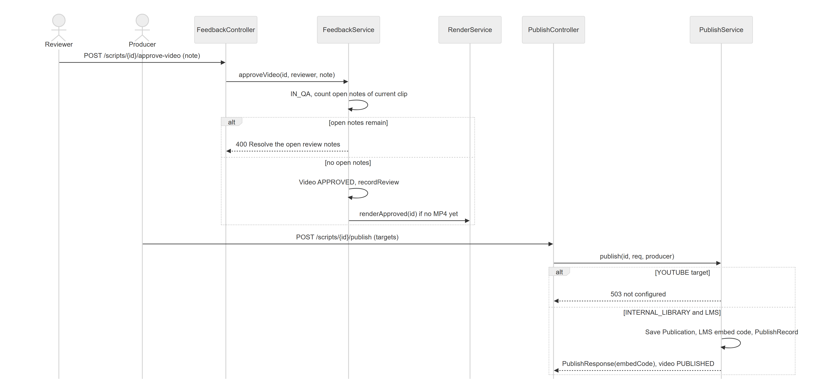
Figure 27. Approve the Video and Publish It

4. Main Business Workflows
The four main workflows below are the Defense 1.1 workflows of the Design Brief (Appendix A1). Each activity diagram shows the actors and the business steps, not the internal processing.

4.1 WF-01 Set Up a Workspace Team
Item | Description
Actors | Admin, new member, Leader
Trigger | Admin provisions accounts
Business outcome | A workspace with a valid team; every member has changed the initial password; roles assigned
Entity state path | WorkspaceMember: ACTIVE; User: mustChangePassword true -> false

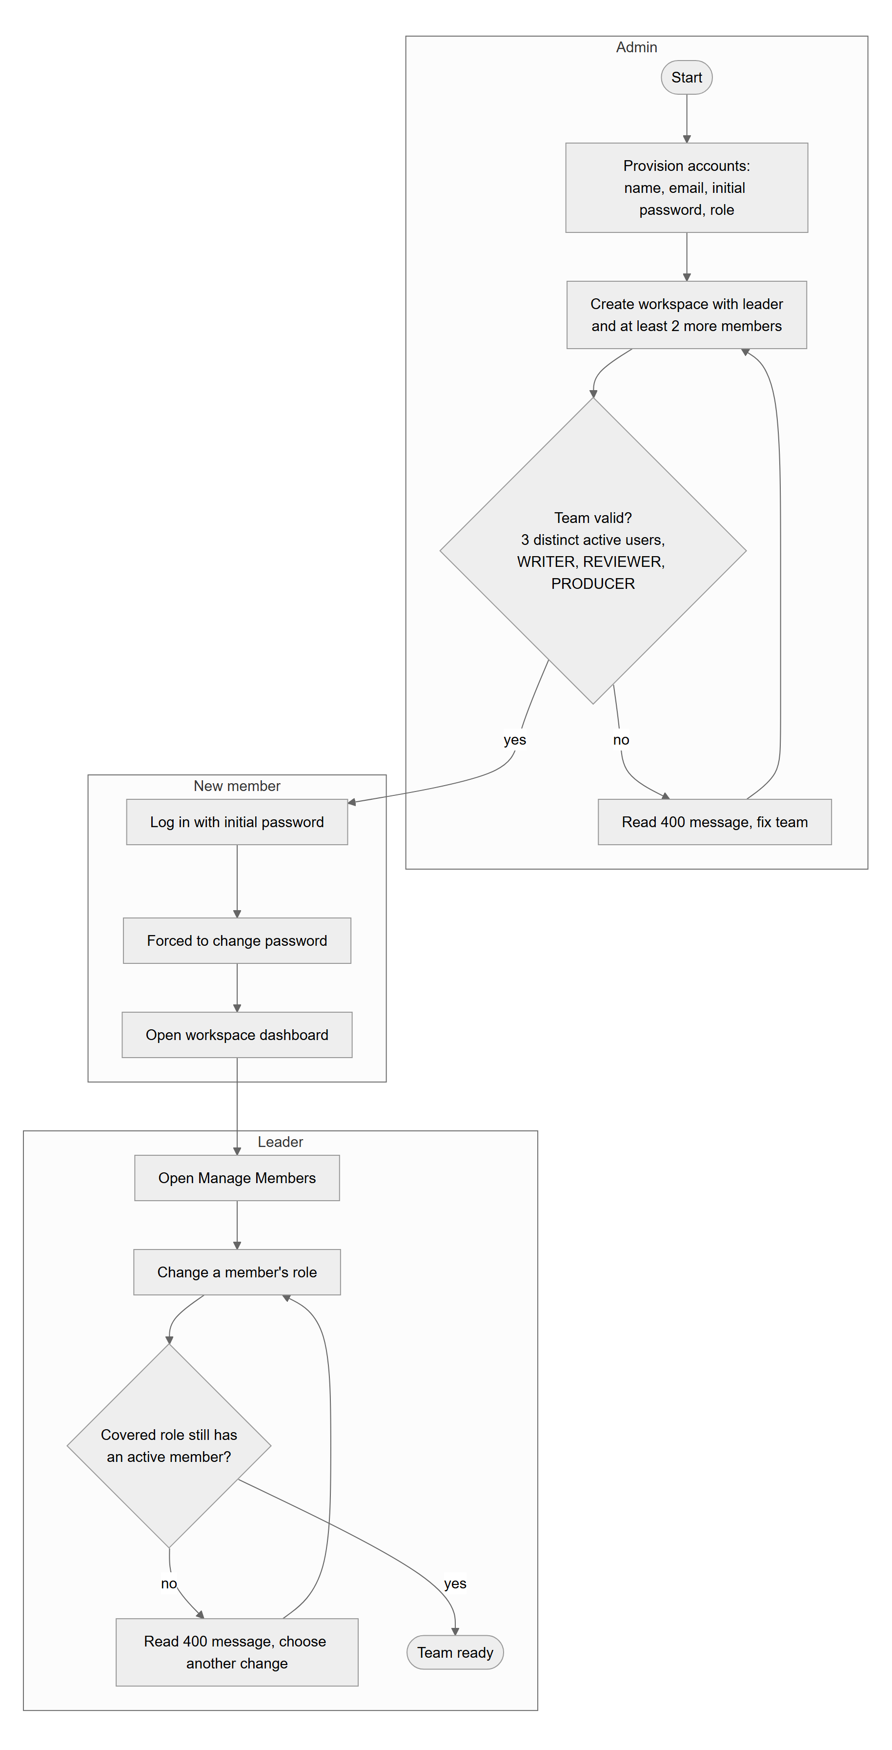
Figure 28. WF-01 Set Up a Workspace Team - activity diagram

4.2 WF-02 Write and Approve a STEM Script
Item | Description
Actors | Writer, Reviewer
Trigger | Writer creates a clip project
Business outcome | An approved script version ready for production
Entity state path | Script: DRAFT -> IN_REVIEW -> CHANGE_REQUESTED -> IN_REVIEW -> APPROVED

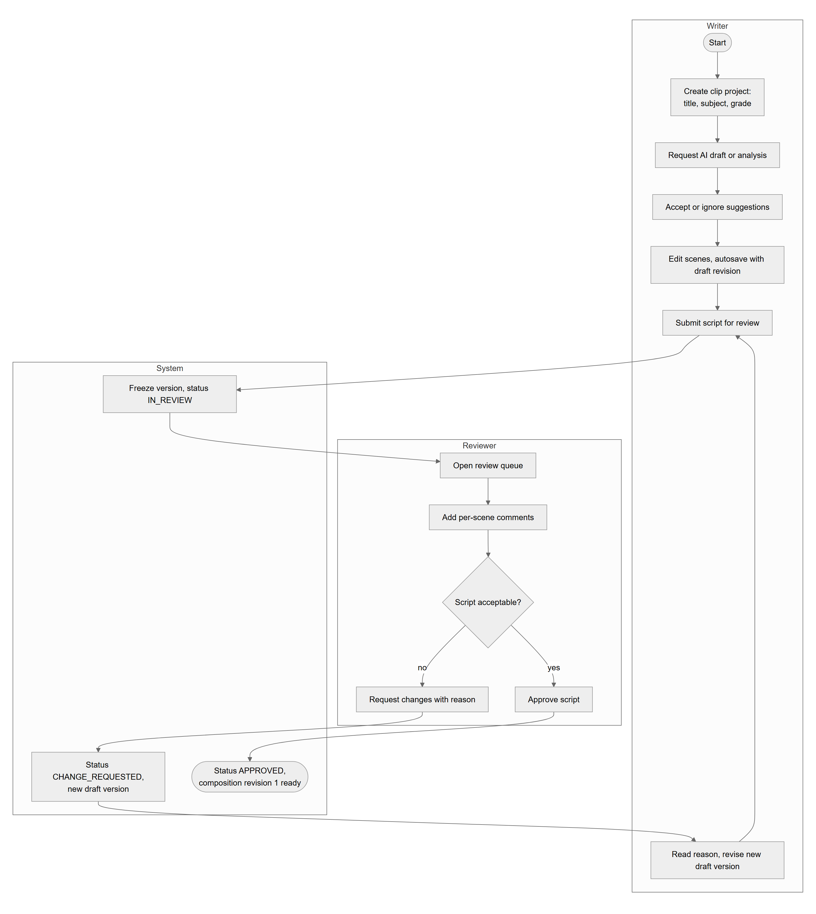
Figure 29. WF-02 Write and Approve a STEM Script - activity diagram

4.3 WF-03 Produce and Render a Clip
Item | Description
Actors | Producer, Render worker, Admin
Trigger | Producer opens an approved project
Business outcome | A rendered MP4 of the frozen composition revision waiting for review
Entity state path | Video: NOT_RENDERED -> RENDERING -> IN_QA; RenderJob: QUEUED -> PROCESSING -> COMPLETED

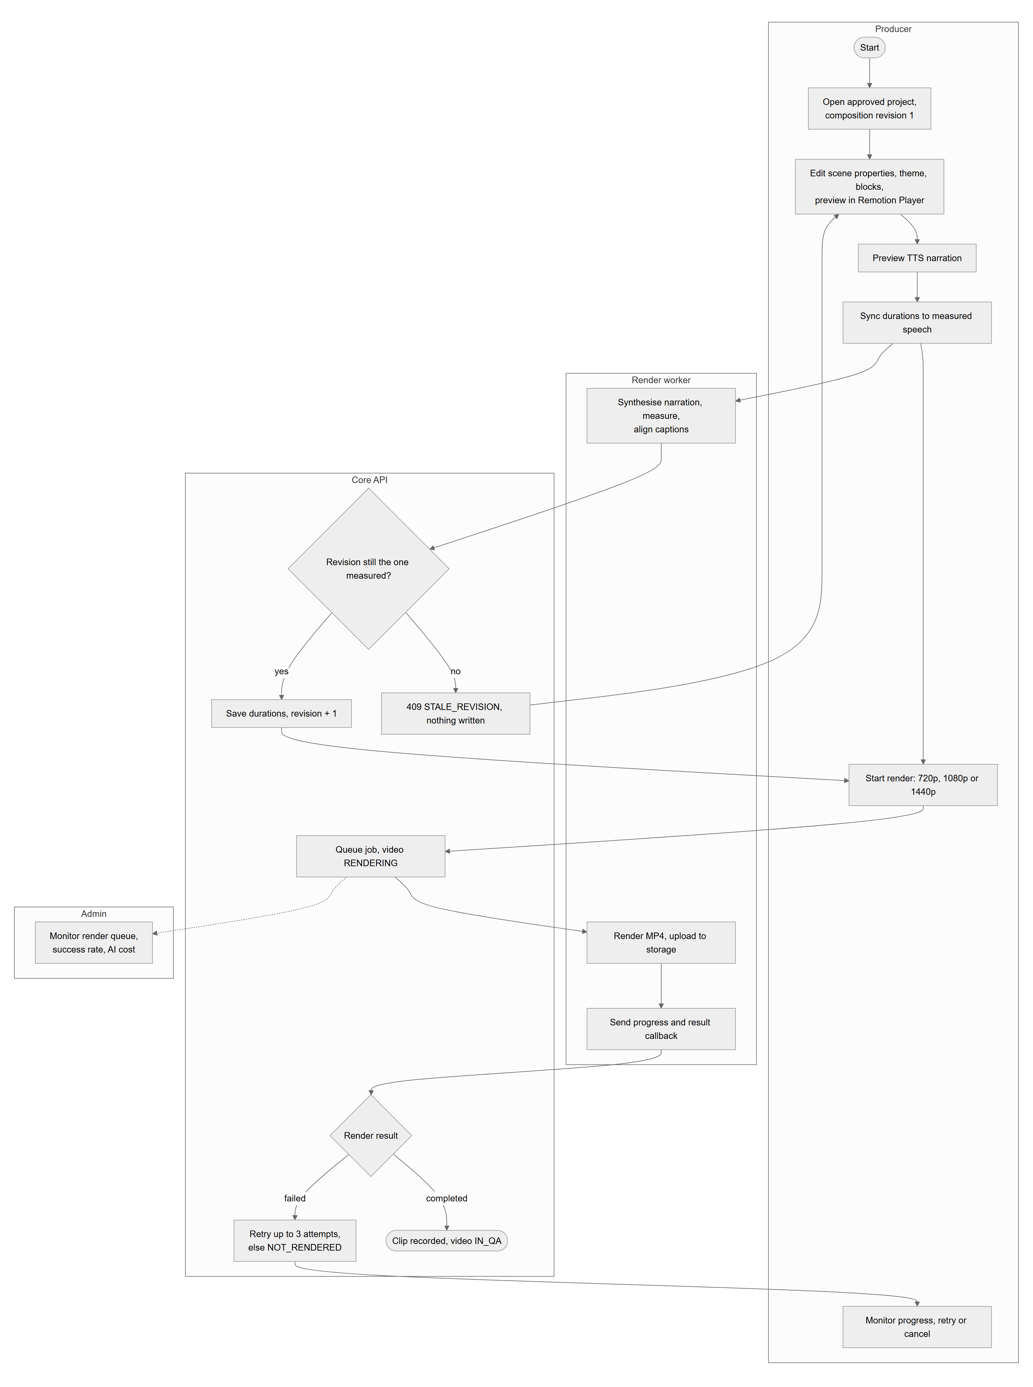
Figure 30. WF-03 Produce and Render a Clip - activity diagram

4.4 WF-04 Review and Publish a Clip
Item | Description
Actors | Producer, Reviewer, any member
Trigger | Producer submits the composition for video review
Business outcome | A published clip in the media library with an LMS embed code
Entity state path | Video: IN_QA -> NOT_RENDERED -> IN_QA -> APPROVED -> PUBLISHED

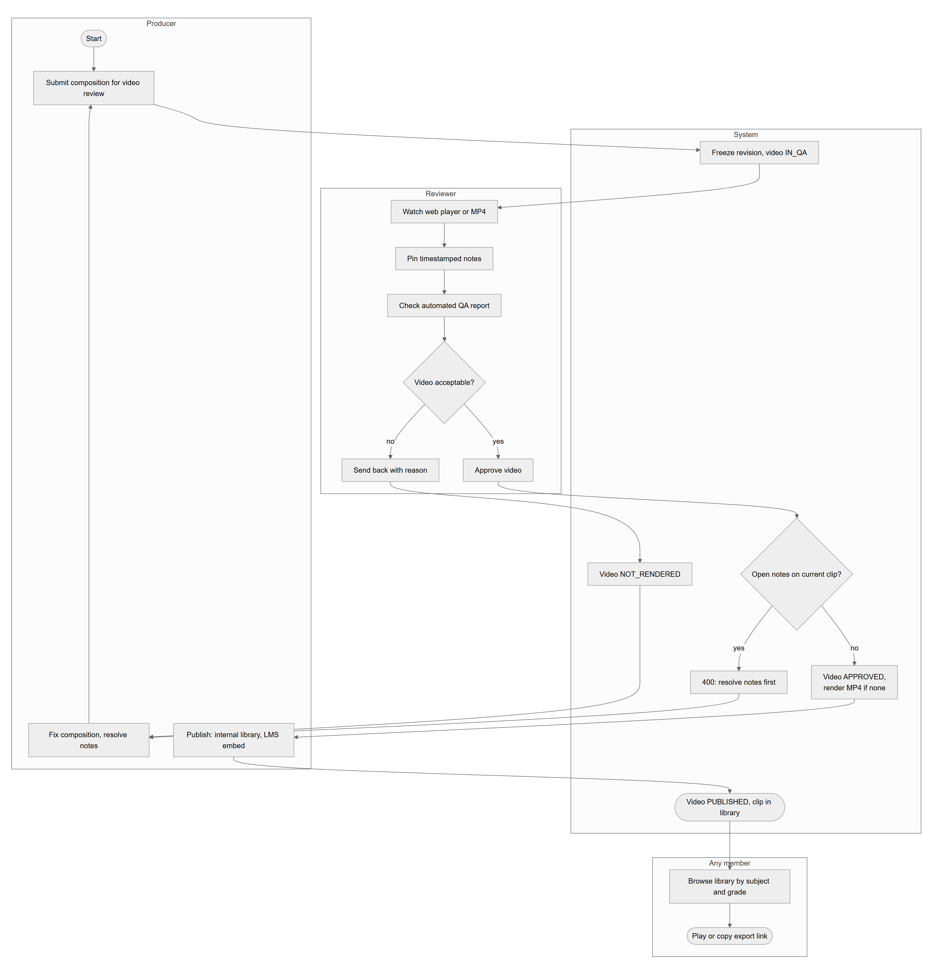
Figure 31. WF-04 Review and Publish a Clip - activity diagram

