

Capstone Project Report
Report 1 – Project Introduction

– Ho Chi Minh City, September 2026 –
Table of Contents

I. Record of Changes 3
II. Project Introduction 4
1. Overview 4
1.1 Project Information 4
1.2 Project Team 4
2. Product Background 5
3. Existing Systems 6
3.1 Synthesia 6
3.2 Lumen5 and Pictory 6
3.3 Frame.io 7
3.4 Remotion 7
3.5 Summary of the gap 8
4. Business Opportunity 8
5. Software Product Vision 9
6. Project Scope & Limitations 10
6.1 Major Features 10
6.2 Limitations & Exclusions 13

I. Record of Changes
Date | A*M, D | In charge | Change Description
25/09/2026 | A | Nguyễn Việt Hoàng | Create the first version of Report 1 - Project Introduction: overview, product background, existing systems, business opportunity, product vision, scope and limitations.
26/09/2026 | M | Nguyễn Việt Hoàng | Complete the project team information; align the major feature list with the Use Case Diagram and the Conceptual ERD; add Figure 1 and Figure 2.
02/11/2026 | M | Nguyễn Việt Hoàng | Aligned with the unchanged registration form of 17/08/2026: Google sign-in for Admin-provisioned accounts in FE-01; YouTube publishing in FE-13 as registered scope; internal library publishing by Producer and Admin, as in Figure 1.

*A - Added M - Modified D - Deleted

II. Project Introduction

1. Overview

1.1 Project Information
- Project name (English): STEMotion - AI-Assisted STEM Video Production Platform Using Remotion
- Project name (Vietnamese): STEMotion - Nền Tảng Sản Xuất Clip STEM Có Hỗ Trợ AI Trên Nền Remotion
- Project code: FA26SE054
- Group name: FA26SE054
- Software type: Web application (React + Vite front-end, Spring Boot REST API, Node.js / Remotion rendering service, Python FastAPI AI microservice)
- Duration: 09/2026 - 03/2027
- Profession / Specialty: Software Engineer / SE

1.2 Project Team
Full Name | Role | Email | Mobile
Lại Đức Hùng | Supervisor | hungld@fpt.edu.vn
Nguyễn Việt Hoàng | Leader | hoangnvse182984@fpt.edu.vn | 093182574
Trần Nguyễn Hoàng Lê | Member | letnhse181662@fpt.edu.vn | 0905053347
Phan Phước Long Trì | Member | tripplse184536@fpt.edu.vn | 0777655403
Phan Thế Trung | Member | trungptse184722@fpt.edu.vn | 0364342716

2. Product Background
STEM education is a national priority in Vietnam, and demand for short Vietnamese-language STEM explainer clips has grown quickly across schools, EdTech startups, and educational YouTube and TikTok channels. A clip that explains a single concept - a formula derivation, a labelled diagram, a data chart, or an algorithm walk-through - is now the format that teachers and content teams ask for most.
Producing such a clip today is slow and expensive. A traditional pipeline needs a scriptwriter, a motion or video editor working manually, a voice actor, and an editor. Review is done informally over chat and email, so there is no version control on scripts, no record of which comment belongs to which scene, and no standardized quality check before publishing. The practical result is that a small team can only ship a few clips per month, and the visual style drifts noticeably from one video to the next.
Remotion, a framework for producing videos programmatically with React, makes clips reusable, data-driven, and reproducible. That is a natural fit for STEM content, where the same visual pattern - a formula revealed step by step, a diagram with animated labels, a chart that grows, a quiz card - is reused across many topics. The same input data always renders the same output file, so a clip can be regenerated after a correction instead of being re-edited by hand.
Remotion on its own, however, is a developer framework. It does not manage the editorial workflow, it does not remove the repetitive manual steps, and it cannot be operated by a scriptwriter who does not write code. STEMotion wraps the full pipeline - script submission, review, assisted production, clip review, and publishing - into one web platform, and embeds lightweight, human-in-the-loop AI to cut the manual work, so that a small team can produce consistent STEM clips at scale.
The project idea was raised by the development team and is supervised by Mr. Lại Đức Hùng (FPT University) as capstone project FA26SE054, Fall 2026. The intended customers are Vietnamese STEM content teams: school media groups, EdTech companies, and independent educational channels.

3. Existing Systems
Four existing products cover parts of the problem that STEMotion addresses. Each was examined for the features it contributes and for the gap it leaves.

3.1 Synthesia
Link: https://www.synthesia.io
Description: a commercial AI video generator. The user pastes a script and the system renders a video in which an AI presenter speaks it, with templates, brand settings, and voiceover in many languages.
Actors: content creator, workspace administrator.
Features: script-to-video generation, AI voice synthesis, multilingual narration, slide-like templates, brand kit, shareable links.
Pros: very fast for talking-head explainers; no video-editing skill required; a large voice and language library.
Cons: the output is presenter-centric, so it is weak exactly where STEM content is strongest - animated formula derivations, labelled diagrams, growing data charts, and algorithm traces. There is no editorial workflow: no script version history, no per-scene review queue, no approval gate before publishing, and no automated quality check. Scene-level animation cannot be controlled programmatically, and Vietnamese STEM terminology is not tuned.

3.2 Lumen5 and Pictory
Link: https://lumen5.com and https://pictory.ai
Description: text-to-video tools that turn an article or a script into a short social clip by matching sentences to stock footage and adding captions.
Actors: marketer, content creator.
Features: automatic scene splitting from text, stock media search, automatic captions, brand templates, direct export to social platforms.
Pros: quick to produce a social-media clip; automatic captioning is reliable; low cost per video.
Cons: the visual layer is assembled from stock footage, so the tool cannot draw a formula, animate a labelled diagram, or plot a dataset - the core requirement of a STEM explainer. Output is not reproducible: re-running the same script does not give the same file. There is no role-based workflow, no reviewer annotations, and no quality gate before publishing.

3.3 Frame.io
Link: https://frame.io
Description: a video review and collaboration platform, now part of Adobe. Teams upload a cut and reviewers leave comments pinned to a timecode.
Actors: editor, reviewer, client.
Features: timestamped comments and drawing annotations, version stacking and side-by-side comparison, approval status per version, notifications, integration with editing software.
Pros: this is very close to the review model that STEMotion needs - timestamped annotations, explicit approval, and clear version history.
Cons: it reviews video but does not produce it. There is no scripting stage, no template system, no AI assistance, no narration or captioning, and no publishing step. A separate editing tool is still required upstream, so the script-to-clip gap that makes production slow remains unsolved.

3.4 Remotion
Link: https://www.remotion.dev
Description: an open-source framework for creating videos programmatically with React. Compositions are React components; the Remotion Player previews them in the browser and the renderer produces an MP4 with headless Chromium.
Actors: front-end developer.
Features: React-based compositions, in-browser Player, headless MP4 rendering, input props that drive a composition from data, and Remotion Lambda for distributed rendering.
Pros: reproducible and data-driven output, full control over every frame, and templates that can be reused across topics - the right engine for STEM visuals. STEMotion uses Remotion as its rendering core for exactly this reason.
Cons: it is a framework, not a product. Every clip requires a programmer; there is no interface for a writer or a reviewer, no workflow state machine, no AI assistance, no narration, and no publishing. Used alone, it would move the bottleneck from the video editor to the developer.

3.5 Summary of the gap
Synthesia and Lumen5 generate video but cannot render STEM visuals and offer no editorial control. Frame.io manages review but produces nothing. Remotion renders exactly the right visuals, but only in the hands of a developer. No existing product carries a Vietnamese STEM clip through the whole path - write, review, assisted production, clip review, quality check, publish - inside one role-based workflow. That is the gap STEMotion fills.

4. Business Opportunity
The market is Vietnamese STEM content production: school and university media teams, EdTech companies that ship lesson libraries, and independent educational YouTube and TikTok channels. All of them face the same constraint - the number of clips they can publish is limited by how many people they can put on a manual pipeline, not by how many topics they want to cover.
Without the product these problems cannot be solved. Scripts are reviewed over chat and email, so there is no reliable record of which version was approved or which comment was addressed. Each clip is animated by hand, so visual style drifts and nothing is reusable between videos. Narration requires booking a voice actor for every revision, which makes small corrections expensive enough that teams simply publish the flawed version. And nothing checks, before publishing, whether captions are in sync, whether on-screen text overflows, or whether the contrast is readable on a phone.
Existing products solve one slice each. AI generators such as Synthesia produce a finished file but cannot draw a derivation and give the team no editorial control. Stock-footage tools such as Lumen5 are fast but visually irrelevant for STEM. Frame.io manages review well but produces nothing. Remotion produces exactly the right output, but only through code. A team that wanted all four capabilities today would have to buy three subscriptions and hire a developer, and would still have no single place where the status of a clip is visible.
STEMotion is attractive because it combines the two halves that no competitor joins: a programmatic, reproducible rendering engine tuned for STEM visuals, and a role-based editorial workflow with human-in-the-loop AI. Because scenes are rendered from data rather than edited by hand, a correction becomes a re-render rather than a rework, and visual consistency is enforced by the template library instead of by discipline. The platform targets roughly 300 render jobs per day on a horizontally scalable worker pool, which takes a team from a few clips per month to a production line.
The direction also matches two clear trends: the national push for STEM education in Vietnam, and the shift of educational content to short-form video. A platform that lowers the marginal cost of a correct, consistent STEM clip fits both.

5. Software Product Vision
For Vietnamese STEM content teams - school media groups, EdTech companies, and educational channels - who need to publish short explainer clips faster than a manual pipeline allows, STEMotion is a web-based, AI-assisted video production platform built on Remotion. It carries a clip through one role-based lifecycle - Draft, Script Review, Approved, In Production, Clip Review, Published - so that a writer drafts scene by scene, a reviewer approves with per-scene comments, a producer tunes an auto-generated Remotion draft and renders it, and the finished MP4 is published to YouTube and filed in an internal library, all in one place.
Unlike AI avatar generators such as Synthesia or stock-footage tools such as Lumen5, which hand back a finished file with no editorial control and cannot render a formula or a diagram, and unlike review-only platforms such as Frame.io, which manage feedback but produce nothing, STEMotion keeps generation and governance together. Every scene is rendered programmatically from data, so clips are reproducible and visually consistent; and every AI result - segmentation, readability scoring, terminology flags, narration, captions, pre-publish quality checks - is a suggestion that a human accepts or ignores, never an automatic decision.
When the platform is in place, a STEM team stops being limited by how fast it can animate and starts being limited only by how fast it can decide what to teach. A correction that used to mean re-editing and re-recording becomes a re-render, nothing reaches an audience without a named reviewer approving it, and a small team publishes a consistent clip library instead of a handful of one-off videos.

6. Project Scope & Limitations

6.1 Major Features
The features below group the use cases in Figure 1 under FE-01 to FE-17. Writer, Reviewer and Producer inherit the shared actions of Authorized User. Shared actions require authentication and access to the target project; project-scoped actions require an open project and depend on the workspace role and current project status. View Script also requires a selected script.
FE-01: Login (Guest); Logout and Change Password (Authorized User). Users sign in to an Admin-provisioned account with email and password or with Google (OAuth 2.0), and authorization is enforced by role.
FE-02: Create Clip Project and Edit Clip Project (Writer): create and update a clip project with its subject and target grade. View Clip Project is available to an Authorized User with access to the target project.
FE-03: Write/Edit Script by Scene and View Script History (Writer). View Script is shared by Authorized Users when the target clip project is open and a script is selected.
FE-04: Request AI Assistance (Writer), which extends the scene editor, and Accept / Ignore AI Suggestions, which in turn extends the request. Both are optional: a writer can complete a script without ever invoking AI, and every returned suggestion is accepted or discarded individually.
FE-05: Submit Script (Writer) to move the project into Script Review; View Pipeline Board (Authorized User) to see the project lifecycle; View Review Queue (Reviewer) to find scripts and clips awaiting review.
FE-06: Read & Resolve Feedback and View Review History (Writer and Producer): inspect review decisions and comments on scripts or clips, and resolve the feedback.
FE-07: Review Script (Reviewer), extended by Add Inline Comments, Approve Script and Request Script Changes. The reviewer can annotate the script and either approve it or request revisions.
FE-08: Open / Edit Draft Composition (Producer): open and revise the composition derived from an approved script, using an ordered scene list and Remotion templates.
FE-09: Edit Scene (Producer), extended by Select / Replace Media Assets and Generate / Edit Narration & Captions. Preview Scene & Video is a separate Producer action for checking the composition before submission or rendering.
FE-10: Render Video, Monitor Render Progress, View Render History and Retry Failed Render (Producer): queue a render, follow its progress, inspect previous jobs and retry a failed job. The worker produces the clip as an MP4 video.
FE-11: Submit Clip for Review (Producer); Review Video Composition / Clip (Reviewer), extended by Add Timestamp Annotations, Approve Clip and Return to Production. View Automated Pre-publish QA is a separate Reviewer action providing decision support before approval.
FE-12: Compare Versions (Reviewer): place two ScriptVersion records, or two renders of the same clip, side by side across iterations.
FE-13: Publish Clip to Internal Library (Producer and Admin) and Publish Clip to YouTube (Producer): one-click publishing of an approved clip to a connected YouTube channel through the YouTube Data API with auto-filled metadata, as registered.
FE-14: Browse & Export from Media Library and Export Video / Get LMS Embed Code (Authorized User): browse finished clips, export video and obtain an LMS embed code.
FE-15: Manage Users & Roles, Manage Workspace and Manage Workspace Members (Admin). View / Select Workspace is shared by Authorized Users; workspace access and membership determine which projects they can open.
FE-16: Manage Templates (Admin): maintain the Remotion template library that every Scene is bound to.
FE-17: Monitor Render Queue & Storage and Monitor AI Cost & Usage (Admin): operational dashboards over the RenderJob queue, job success rate, storage consumption, and the cost and usage recorded on every AI_Request.

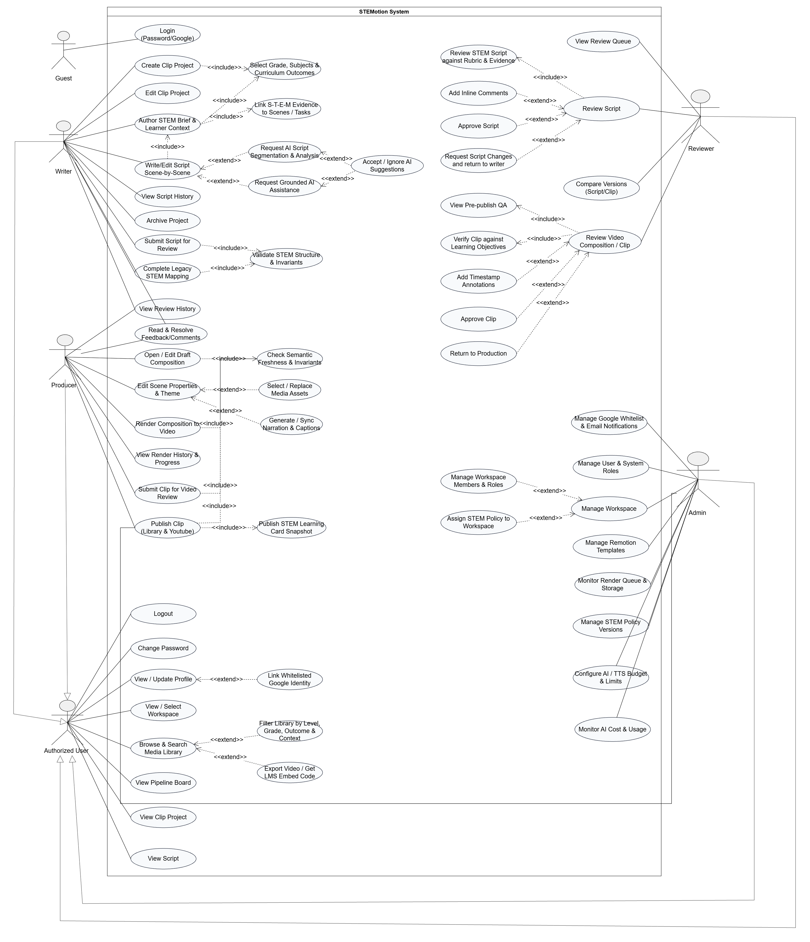Figure 1. STEMotion Use Case Diagram - six actors (Guest, Authorized User, Writer, Reviewer, Producer, Admin) and the 61 use cases the major features are derived from, including the STEM brief, validation and review use cases.
The conceptual data model behind these features is shown in Figure 2. Eleven entities carry the pipeline: a ClipProject owns one or more ScriptVersion records; a FeedbackComment targets either a ScriptVersion (inline) or a Clip (timestamped); an AI_Request records every analysis, narration or quality check the platform runs, together with its cost; an approved ScriptVersion is mapped to a Composition, which contains one or more Scene records, each using a Template and optionally an Asset_Media; a Composition triggers one or more RenderJob records, a RenderJob produces a Clip, and an approved Clip is released as a Publication. The four actors are modelled separately from the content entities so that responsibility for each step stays explicit.
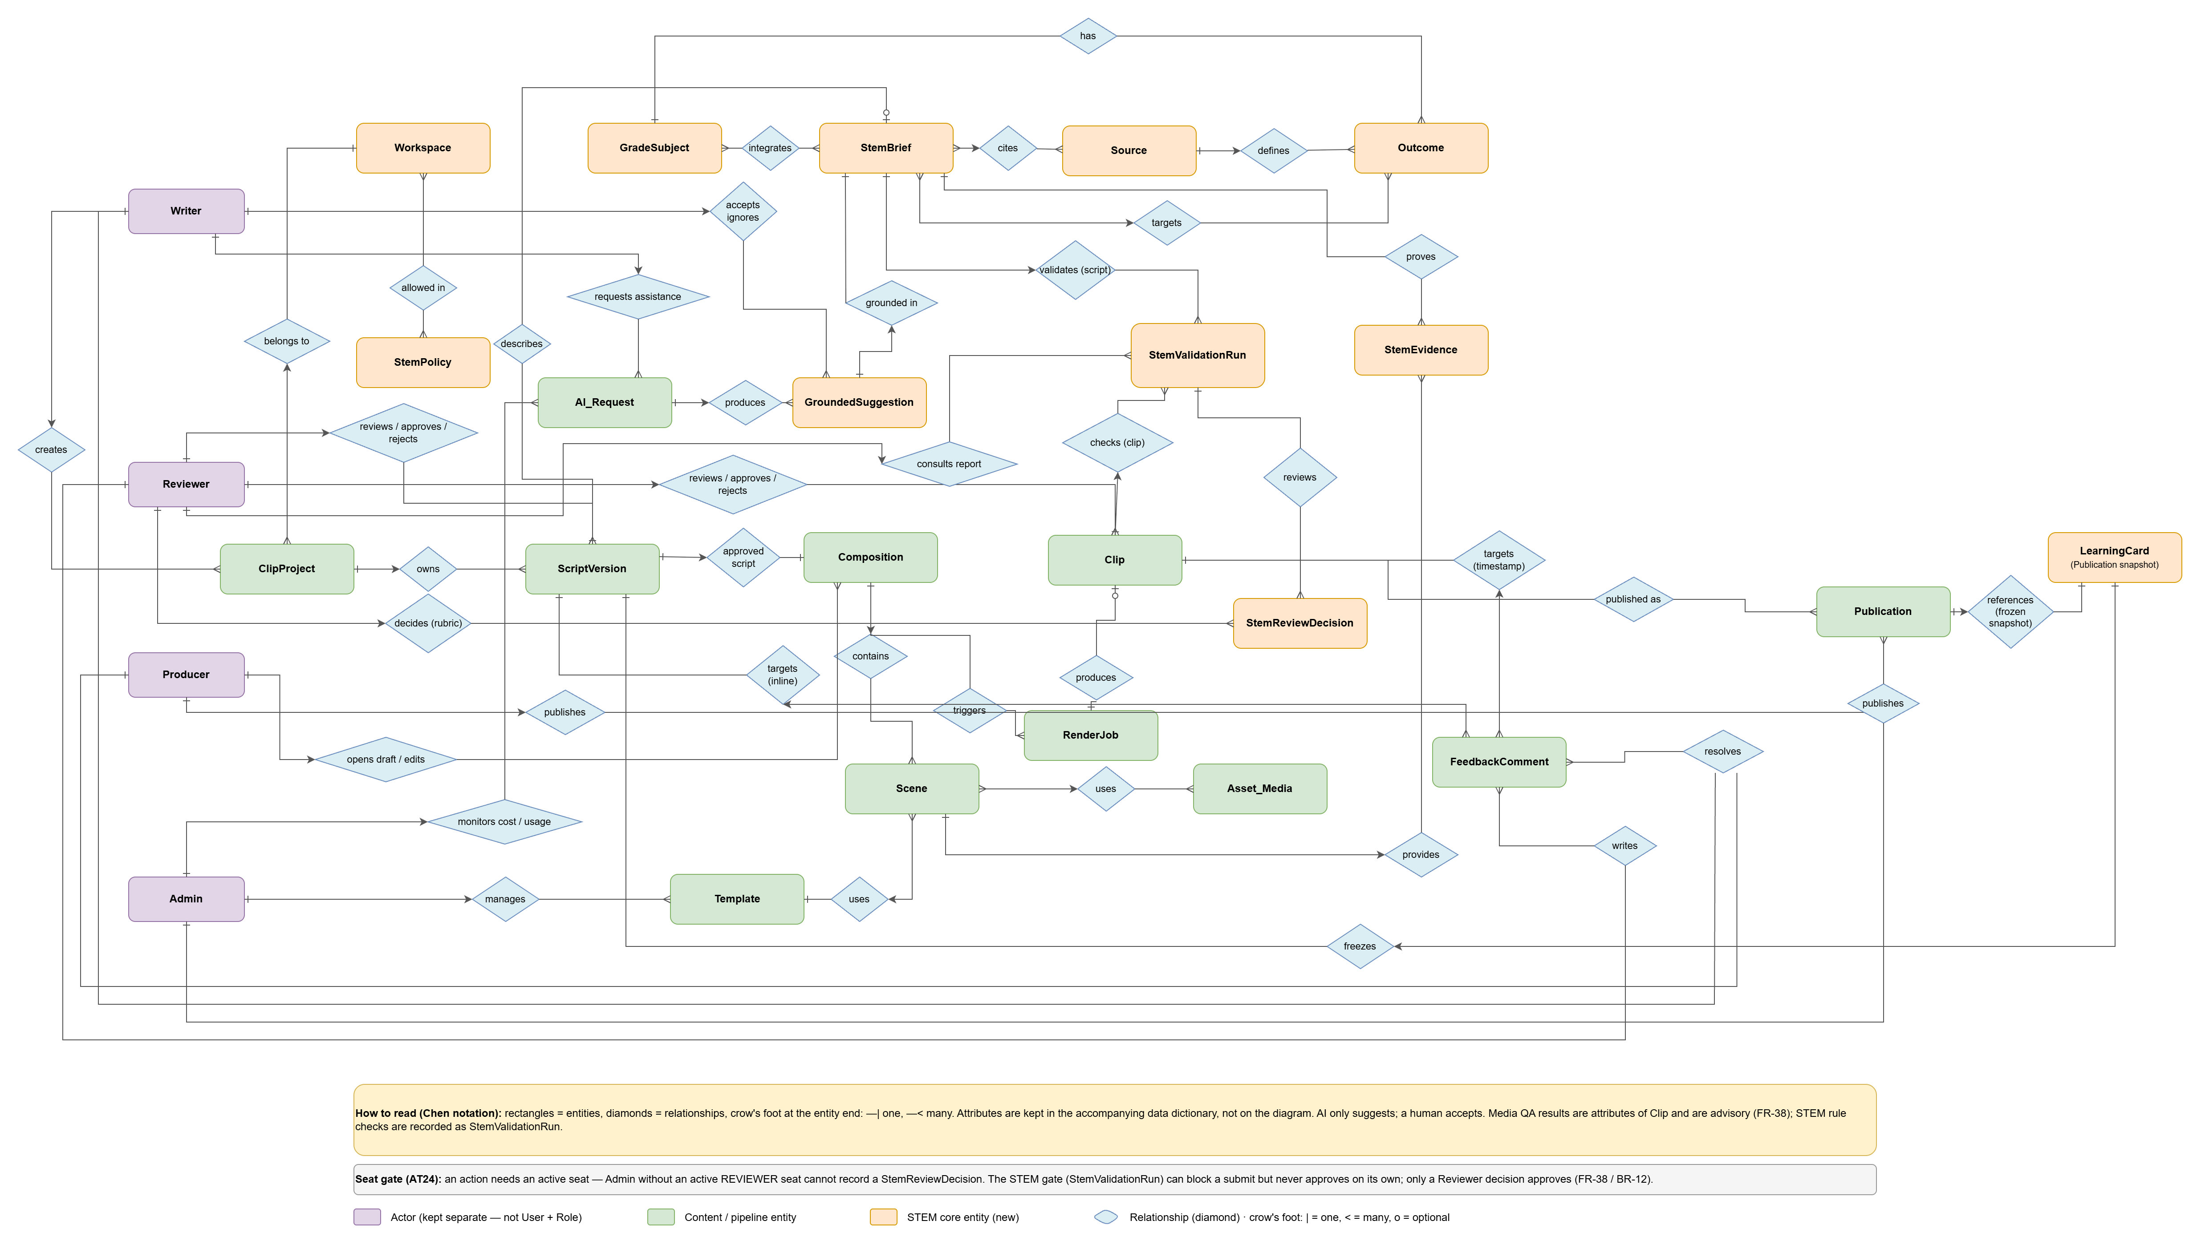
Figure 2. STEMotion Conceptual ERD - the four actors, eleven content and pipeline entities and eleven STEM core entities (Workspace, StemPolicy, GradeSubject, StemBrief, Source, Outcome, StemEvidence, GroundedSuggestion, StemValidationRun, StemReviewDecision, LearningCard), with the relationship each feature depends on.

6.2 Limitations & Exclusions
LI-01: Narration and captions are produced in Vietnamese only. Other languages are not supported in this release.
LI-02: Publishing targets a connected YouTube channel through the YouTube Data API only. TikTok, Facebook and other distribution channels are excluded.
LI-03: The platform renders programmatic motion graphics from the Remotion template library. Live-action footage, green-screen compositing, character rigging and 3D animation are out of scope.
LI-04: STEMotion is a web application for Chrome, Firefox and Edge 100 or later and Safari 15 or later. No native mobile or desktop application is planned.
LI-05: All AI output is advisory. The system never approves a script, passes a quality check, or publishes a clip on its own; a human Reviewer must approve every script and every rendered clip.
LI-06: The performance target covers clips of 60 to 90 seconds. Longer clips will render but are not covered by the render-time requirement.
LI-07: Writers author scripts and producers configure scenes from the existing template library. Creating a new Remotion template remains a development task and is not exposed in the browser (Manage Templates covers registration and metadata, not authoring).
LI-08: There is no integration with learning management or student information systems such as Moodle or Google Classroom, and no student-facing features; quizzes appear as a scene type inside a clip, not as graded activities.
LI-09: The platform has no billing, subscription or monetization module. It is built for use by an internal content team.
LI-10: Source assets such as images and datasets are uploaded by the team. STEMotion does not provide a licensed stock-media catalogue and does not verify the copyright status of uploaded material.

