Customer Support Analytics Dashboard
Author: Seavchhun Teng
Business Intelligence & Data Analytics Portfolio Project
Tools: Microsoft Excel, Power Query, R, Power BI
Dataset: Customer Support Tickets (Kaggle)

Table of Contents
1. Project Overview 1
1.1 Background 1
1.2 Objectives 1
1.3 Scope 1
2. Dataset 2
2.1 Dataset Source 2
2.2 Dataset Structure 2
2.3 Primary Key 3
2.4 Key Variables 3
3. Data Cleaning and Preparation 4
3.1 ETL Workflow 4
3.2 Reporting Period Fields 7
4.3 Response Time Calculation 7
3.4 Final Data Structure 8
3.5 Post-Cleaning Validation 8
4. Assumptions 9
5. Data Model 10
5.1 Overview 10
5.2 Calculated Measures 10
6. Dashboard Development 11
6.1 Dashboard Design Principles 11
6.2 Dashboard Structure 11
7. Limitations 13
8. Future Improvements 13
9. Tool Selection and Rationale 15

1. Project Overview

1.1 Background
Customer support teams generate large volumes of operational data through daily customer interactions. While this data contains valuable insights into service performance and customer satisfaction, raw operational datasets often contain inconsistencies, varying data formats, redundant information, and data quality issues that reduce their effectiveness for reporting and decision-making.
This project demonstrates an end-to-end business intelligence workflow by transforming a raw customer support dataset into a clean, structured dataset suitable for reporting and analysis. The project concludes with the development of an interactive Power BI dashboard designed to monitor operational performance, workforce productivity, and customer satisfaction.
The project follows a typical analytics lifecycle consisting of data cleaning, validation, transformation, modelling, visualisation, and reporting.

1.2 Objectives
The objectives of this project were to:
- Clean and standardise a raw customer support dataset.
- Validate data quality before dashboard development.
- Create reusable reporting fields and business metrics.
- Build an interactive Power BI dashboard for operational monitoring.
- Generate meaningful business insights to support decision-making.

1.3 Scope
The project includes:
- Data cleaning using Microsoft Excel Power Query.
- Post-cleaning validation using R.
- Data transformation and feature creation.
- Dashboard development using Power BI.
- Business reporting and insight generation.
The project does not include predictive modelling, machine learning, or natural language processing.

2. Dataset

2.1 Dataset Source
The dataset was obtained from Kaggle and contains customer support ticket records representing operational activities across multiple customer service channels.
The dataset consists of 85,907 customer support tickets recorded between July and August 2023.

2.2 Dataset Structure
The cleaned dataset contains:
Attribute | Value
Total Records | 85,907
Total Columns | 25
Character Variables | 18
Numeric Variables | 7
Reporting Period | July–August 2023

Table 1. The attibutes of the dataset.
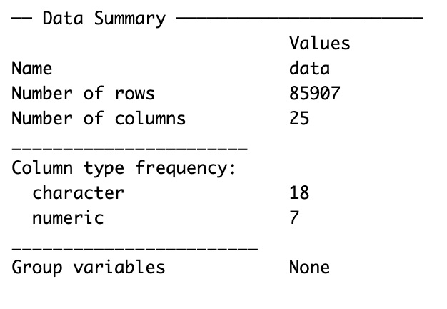
Figure 1. Dataset summary generated in R following the Power Query cleaning process.

2.3 Primary Key
The unique_id field was treated as the primary key throughout the project.
This identifier was used to:
- Identify duplicate records;
- Validate dataset integrity;
- Calculate ticket counts;
- Support dashboard KPIs;
- Ensure each ticket was represented by a single record.
Each unique_id is assumed to represent one unique customer support ticket.

2.4 Key Variables
The dataset contains operational, workforce and customer satisfaction information including:
- Unique ID
- Order ID
- Order Date & Time
- Issue Reported Timestamp
- Issue Responded Timestamp
- Survey Response Date
- Category
- Sub-category
- Product Category
- Customer City
- Agent Name
- Supervisor
- Manager
- Agent Shift
- Tenure Bucket
- Item Price
- Connected Handling Time
- Customer Satisfaction Score (CSAT)
*Refer to Customer_support_data_feature.docx for the full explanation of each variable.

3. Data Cleaning and Preparation

3.1 ETL Workflow
The raw dataset was imported into Microsoft Excel and transformed using Power Query. To preserve the integrity of the original dataset, all cleaning and transformation steps were performed in a separate query referencing the original Raw_Data query. This ensured that the original dataset remained unchanged throughout the project.
Power Query was selected because it provides a repeatable Extract, Transform and Load (ETL) workflow that allows transformations to be refreshed automatically if new data becomes available.
Following the completion of the Power Query transformations, the cleaned dataset was imported into R for post-cleaning validation. R was used to verify dataset dimensions, identify duplicate records, assess missing values, and investigate anomalies such as negative response times.
Column Name Standardisation
The original dataset contained inconsistent naming conventions, including spaces, mixed capitalisation, and punctuation. To improve readability and maintain consistency across Excel, Power Query, R and Power BI, all relevant columns were renamed using lowercase letters with underscores separating words.
Original Column | Standardised Column
Unique id | unique_id
Sub-category | sub_category
Customer Remarks | customer_remarks
Issue_reported at | issue_reported_at
Survey_response_Date | survey_response_date
Customer_City | customer_city
Product_category | product_category
Agent_name | agent_name
Tenure Bucket | tenure_bucket
Agent Shift | agent_shift
CSAT Score | csat_score
Table 2. Changed column names to a standard form for formulas and coding.
This naming convention simplifies field references and reduces the likelihood of errors when creating formulas, transformations, and DAX measures.
Duplicate Record Handling
The unique_id field was used as the primary identifier for duplicate detection.
Power Query’s duplicate removal function was applied using this field to ensure that each customer support ticket appeared only once in the cleaned dataset.
Following the cleaning process, duplicate validation was performed in R, confirming that no duplicate unique_id values remained in the final dataset.
Text Cleaning
Text fields were cleaned using Power Query’s Trim and Clean transformations.
The Trim transformation removed unnecessary leading and trailing spaces, while the Clean transformation removed hidden non-printable characters that could interfere with grouping, filtering and category comparisons.
The following fields were cleaned:
- unique_id
- channel_name
- category
- sub_category
- customer_remarks
- order_id
- customer_city
- product_category
- agent_name
- supervisor
- manager
- agent_shift
- tenure_bucket
These transformations improve consistency across categorical variables and reduce the risk of duplicate categories caused by formatting inconsistencies.
Blank Value Standardisation
Blank text values were converted to null values in the following fields:
- connected_handling_time
- customer_remarks
- order_date_time
- customer_city
- product_category
Replacing blank strings with null values provides a consistent representation of missing information and improves the reliability of data validation and reporting.
Data Type and Locale Standardisation
Appropriate data types were assigned to all fields to ensure accurate calculations and reporting.
The following datetime fields were converted using the English (New Zealand) locale:
- order_date_time
- issue_reported_at
- issue_responded
- survey_response_date
Using a consistent regional locale ensured that all date and time values were interpreted correctly, particularly where day and month values could otherwise be misread. Standardising these fields was essential for producing accurate response time calculations.
Numeric fields, including item_price and csat_score, were also assigned appropriate numeric data types.

3.2 Reporting Period Fields
Additional reporting fields were created from the issue_reported_at timestamp to support time-based analysis within Power BI.
The following fields were generated:
- reported_day
- reported_week
- reported_month
- reported_year
These derived fields enable users to analyse ticket trends across daily, weekly, monthly, and yearly reporting periods without requiring additional calculations during report interaction.

4.3 Response Time Calculation
A calculated field named response_time_minutes was created to measure the elapsed time between when a support issue was reported and when the first response was recorded.
Response time was calculated as the difference between:
- issue_responded
- issue_reported_at
The resulting duration was converted into total minutes, providing a continuous numerical variable suitable for calculating averages, comparisons, and rankings.
This calculation was performed only after both datetime fields had been standardised to the same regional locale to ensure consistent interpretation of timestamps.

3.4 Final Data Structure
Following all transformations, the dataset was reorganised into a logical column order, grouping related information together.
The final structure grouped:
- ticket identifiers;
- order and issue timestamps;
- customer information;
- product information;
- workforce information;
- customer satisfaction metrics;
- reporting period fields;
- calculated response time;
- customer remarks.
This structure improves dataset readability and simplifies downstream analysis in Excel, R and Power BI.

3.5 Post-Cleaning Validation
Following the completion of the Power Query transformations, the cleaned dataset was validated in R.
Validation confirmed:
- dataset dimensions;
- variable types;
- duplicate identifiers;
- missing values;
- response time anomalies.
Figure 2. A summary of the unique_id variable, including the missingness and uniqueness.
The validation confirmed that the cleaned dataset contained:
- 85,907 records;
- 25 variables;
- no duplicate unique_id values;
- no missing values.
Investigation of Negative Response Times
During validation, 3,128 records were identified with negative response time values.
A manual review of affected records indicated that many negative values were caused by inconsistencies in the recorded response timestamps rather than errors in the response time calculation or regional date formatting.
Issue Reported | Issue Responded
28/08/2023 11:50 PM | 28/08/2023 12:00 AM
Table 3. An example of mis-recorded timestamps that would lead to negative response time.
Based on the chronological sequence of events, the response timestamp would only be valid if recorded as 29/08/2023 12:00 AM. This suggests that some timestamps occurring around midnight were recorded using the same calendar date instead of the following day.
As the original timestamps could not be verified or corrected with confidence, no attempt was made to modify these records. The affected records were retained in the cleaned dataset to preserve data integrity but were excluded from response time KPI calculations used within Excel and Power BI.

4. Assumptions
As the dataset was obtained from a public source, several assumptions were required during analysis where supporting business documentation was unavailable.
Business Assumptions
- Each unique_id represents one unique customer support ticket.
- Each record represents a single customer interaction.
- Customer Satisfaction (CSAT) scores accurately represent customer feedback for the associated ticket.
- All tickets were treated equally because no documented ticket priority rules were provided.
Reporting Assumptions
- Weekly reporting is based on the Week of Year derived from the issue reported date.
- Reported month and reported year are derived from the issue reported timestamp.
- Dashboard trends represent activity based on when issues were reported rather than when responses were recorded.
Calculation Assumptions
- Response time is calculated as the elapsed time between the issue reported timestamp and the first recorded response.
- Negative response time values are treated as source data anomalies and excluded from response time KPI calculations.
- Manager, shift, and tenure performance is summarised using the average CSAT of individual agents to reduce bias from agents handling significantly different ticket volumes.

5. Data Model

5.1 Overview
Following data preparation, the cleaned dataset was imported into Power BI for modelling and dashboard development.
As the project consisted of a single cleaned dataset, no additional dimension tables were required. The final dataset acted as the primary fact table supporting all report pages, calculated measures, filters, and visualisations.

5.2 Calculated Measures
Several calculated measures were developed within Power BI to support interactive reporting. These measures form the basis of the dashboard KPIs and update dynamically based on report filters and slicer selections.
Key measures include:
Measure | Description
Total Tickets | Counts the total number of customer support tickets.
Average CSAT | Calculates the overall customer satisfaction score.
Average Response Time | Calculates the average response time while excluding negative values.
Resolution Rate | Calculates the proportion of tickets successfully resolved.

Table 4. Measures that were used in creating the models.

6. Dashboard Development

6.1 Dashboard Design Principles
The dashboard was designed to provide stakeholders with an intuitive overview of customer support operations while allowing users to explore workforce performance and service trends interactively.
The dashboard follows three key design principles:
- Present high-level KPIs before detailed analysis.
- Maintain consistent colours and layouts across pages.
- Minimise visual clutter to improve readability.

6.2 Dashboard Structure
The final dashboard consists of three interactive report pages.
Page 1 – Operational Overview
Purpose:
Provide a high-level summary of customer support operations.
Visuals include:
- Total Tickets
- Average CSAT
- Average Response Time
- Resolution Rate
- Ticket trends by month
This page provides management with an at-a-glance overview of operational performance and serves as the primary landing page of the dashboard.
Page 2 – Workforce Performance
Purpose:
Evaluate individual and organisational performance across customer support teams.

Visuals include:
- Agent ticket workload
- Average CSAT by tenure
- Average CSAT by shift
- Top ticket volume by agent
- Fastest average response time
- Slowest average response time
Interactive slicers and filters were incorporated to enable users to explore the data dynamically. Selecting values within one visual automatically updates related charts and KPIs, allowing users to investigate trends across different reporting periods and operational dimensions.
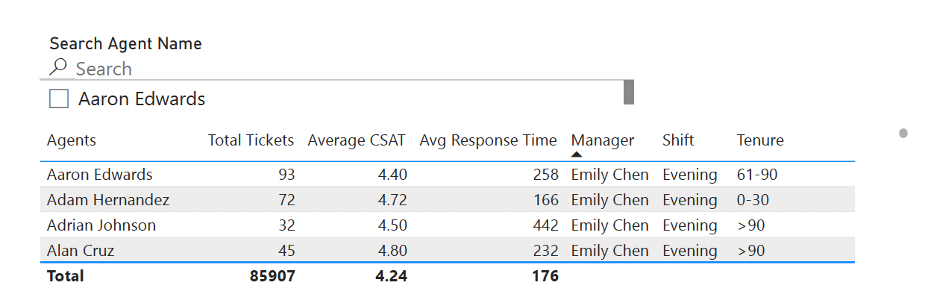
Figure 3. Searchable slicer that gives information about each agent.
This page enables managers to compare workforce performance and identify agents or teams requiring further investigation.
Page 3 – Category Analysis
Purpose:
Identify trends across service categories and customer enquiries.
Visuals include:
- Ticket volume by category
- Average response time by category
- Average CSAT by category
- Top ten subcategories
This page assists stakeholders in identifying high-volume service categories and potential operational bottlenecks.

7. Limitations
The following limitations should be considered when interpreting the dashboard results.
- The dataset covers only July and August 2023, limiting long-term trend analysis.
- The dataset is a publicly available synthetic dataset obtained from Kaggle and is intended for analytical demonstration rather than representing a real organisation.
- No Service Level Agreement (SLA) targets were provided, preventing SLA compliance analysis.
- No documented ticket priority rules were available, limiting prioritisation analysis.
- Response time anomalies existed within the source data and could not be corrected without making assumptions about the intended timestamps.
- Customer remarks were not analysed using text mining or sentiment analysis.

8. Future Improvements
This project demonstrates an end-to-end business intelligence workflow but could be extended in several ways.
Potential future enhancements include:
- Incorporating a longer reporting period to support seasonal and year-on-year trend analysis.
- Introducing SLA metrics to evaluate operational performance against business targets.
- Applying sentiment analysis to customer remarks using Python or R.
- Developing predictive models to forecast future ticket demand.
- Creating drill-through pages for ticket-level investigation.
- Automating the ETL process using scheduled data refreshes or cloud-based data pipelines.
- Expanding the data model to include dimension tables for customers, products, and support teams.

9. Tool Selection and Rationale
The project utilised several analytical tools. Each tool was selected based on its strengths within the Business Intelligence workflow, creating a repeatable process from raw data through to executive reporting.
Tool | Purpose
Microsoft Excel | Initial exploration, supporting analysis, and calculation verification.
Power Query | Data cleaning, transformation, feature engineering, and ETL processing.
R | Post-cleaning data validation, quality assessment, and anomaly detection.
Power BI | Data modelling, DAX measure development, interactive dashboard creation, and business reporting.
Each tool was chosen to perform tasks best suited to its capabilities, creating a repeatable workflow from raw data through to executive reporting.

