Customer Support Business Insights Report
Operational Reporting Project
Prepared from the Power BI dashboard analysis

Table of Contents
1. Executive Summary 1
2. Operational Overview 1
Overall performance 1
Monthly ticket distribution 1
3. Agent Performance 2
Uneven workload distribution 2
Fast response benchmarks 2
Large performance variation 2
Customer satisfaction by tenure 3
Customer satisfaction by shift 3
4. Category Performance 3
Returns and orders dominate demand 3
Category-level satisfaction 3
Response time differs by issue type 4
Most common customer issues 4
5. Recommendations 4
6. Reporting Limitations 5
7. Conclusion 5

1. Executive Summary
The analysis covers 85,907 customer support tickets and evaluates overall service performance, agent productivity, customer satisfaction, response times, and issue distribution. Overall performance is strong, with an average customer satisfaction score of 4.24 out of 5 and a reported resolution rate of 100%. The average response time is 176 minutes, although substantial variation exists between agents and ticket categories.
The strongest improvement opportunities are concentrated in returns and order-related enquiries, which make up most ticket demand. The analysis also identifies wide differences between the fastest and slowest agents, lower satisfaction among agents still in on-the-job training, and weaker performance in the miscellaneous “Others” category.

2. Operational Overview
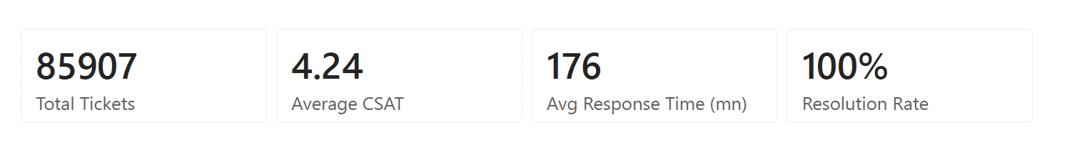
KPI | Result
Total tickets | 85,907
Average CSAT | 4.24 / 5
Average response time | 176 minutes
Resolution rate | 100%

Overall performance
The operation resolves all recorded tickets and maintains a high average CSAT score. This indicates that customers generally receive satisfactory outcomes.
Business implication: The next improvement priority should be reducing response times without weakening resolution quality or customer satisfaction.
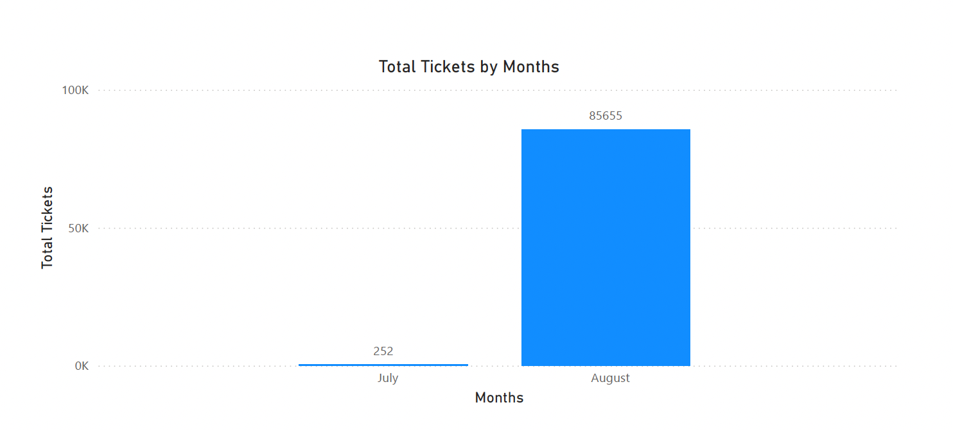

Monthly ticket distribution
August contains 85,655 tickets, while July contains only 252. Nearly the entire dataset is therefore concentrated in one month.
- Business implication: The difference should not be treated as real month-to-month growth because July appears to contain only a partial period. More complete historical data is required before making trend or seasonality conclusions.

3. Agent Performance
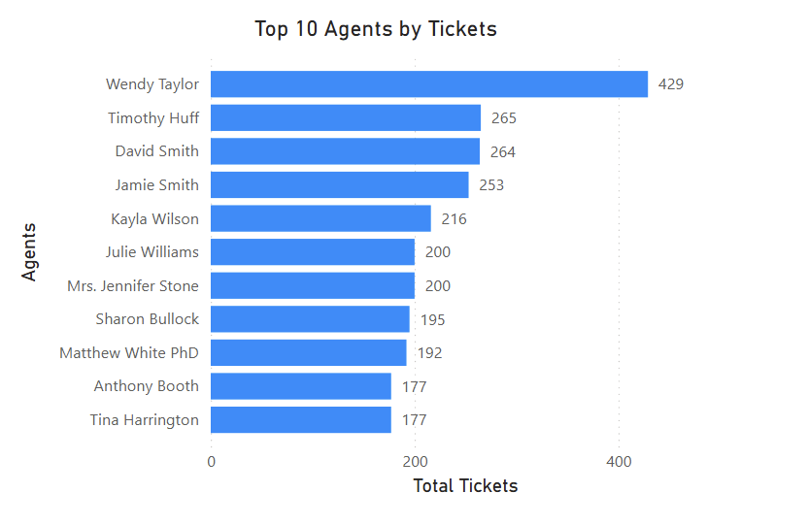

Uneven workload distribution
Wendy Taylor handled 429 tickets, compared with 265 for Timothy Huff, 264 for David Smith, 253 for Jamie Smith, 216 for Kayla Wilson, and 200 for Julie Williams among the visible leading agents. The highest-volume agent handled considerably more tickets than the other top performers.
- Business implication: Workload allocation should be reviewed to determine whether the difference reflects agent capacity, shift coverage, specialist assignment, or an imbalance that could increase fatigue and reduce service consistency.
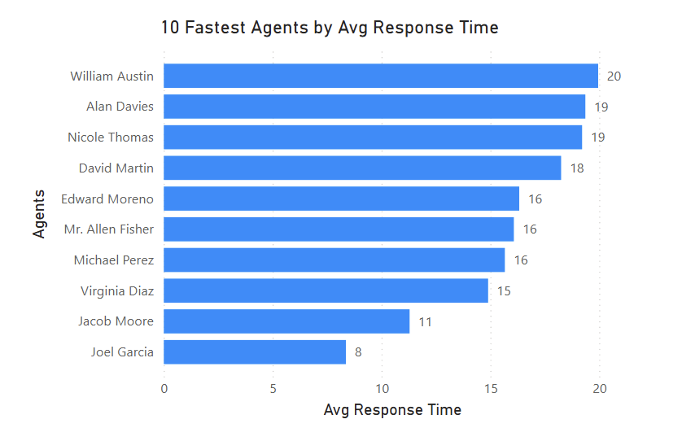

Fast response benchmarks
The fastest visible agents recorded average response times of approximately 16 to 20 minutes. This is far below the overall average of 176 minutes.
- Business implication: Their workflows, ticket mix, use of templates, system knowledge, and escalation practices should be reviewed as possible internal benchmarks.
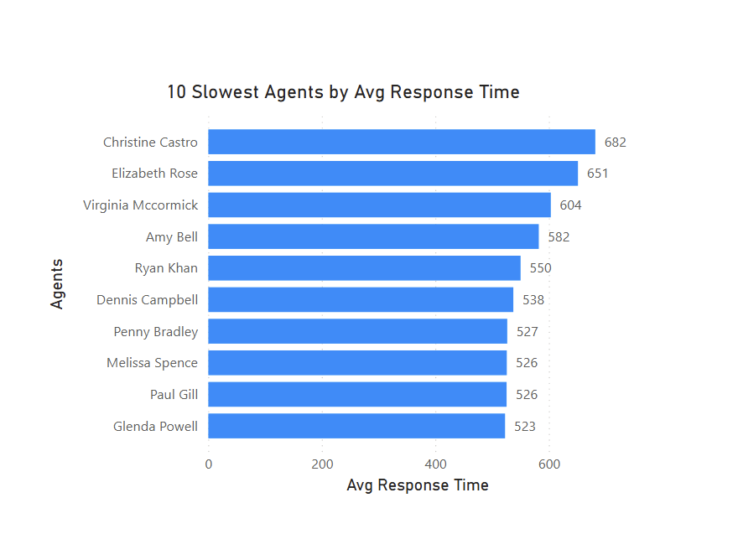

Large performance variation
The slowest visible agents recorded average response times between 523 and 682 minutes. Christine Castle had the highest visible average at 682 minutes, followed by Elizabeth Rose at 651 and Virginia McCarthy at 604.
- Business implication: The gap between the fastest and slowest agents is too large to explain from the dashboard alone. Managers should compare workload, ticket complexity, shift, tenure, and escalation patterns before deciding whether coaching or process changes are required. Investigating the reasons for these longer response time would provide a useful starting point for identifying process or training improvements.
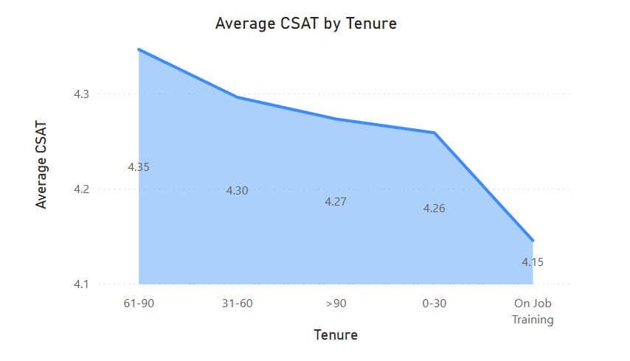

Customer satisfaction by tenure
Agents with 61–90 days of tenure achieved the highest average CSAT at 4.35. This was followed by 31–60 days at 4.30, more than 90 days at 4.27, and 0–30 days at 4.26. Agents in on-the-job training recorded the lowest result at 4.15.
- Business implication: Early-stage training should place additional emphasis on customer communication, issue ownership, and supported practice. The strong 61–90 day result suggests performance improves after agents gain practical experience.
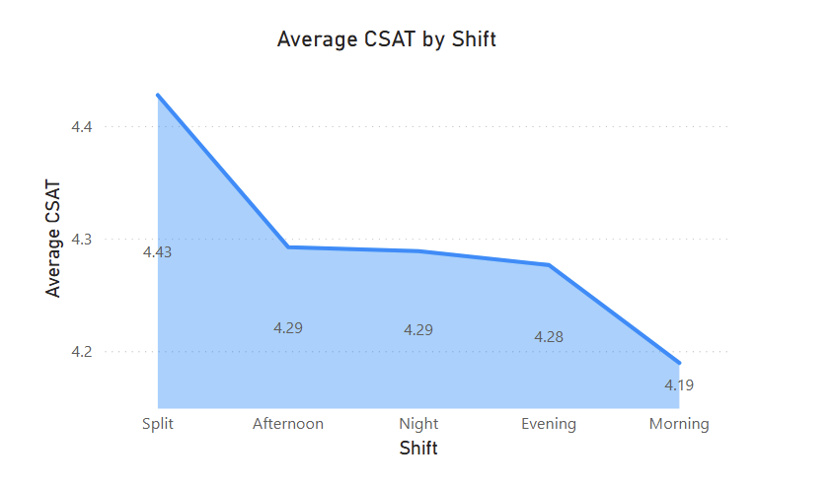

Customer satisfaction by shift
The split shift recorded the highest average CSAT at 4.43. Afternoon and night shifts both recorded 4.29, evening recorded 4.28, and morning recorded the lowest result at 4.19.
- Business implication: Morning operations should be reviewed for staffing levels, ticket mix, workload peaks, and handover quality. The difference is noticeable, but all shifts remain above 4.0.

4. Category Performance
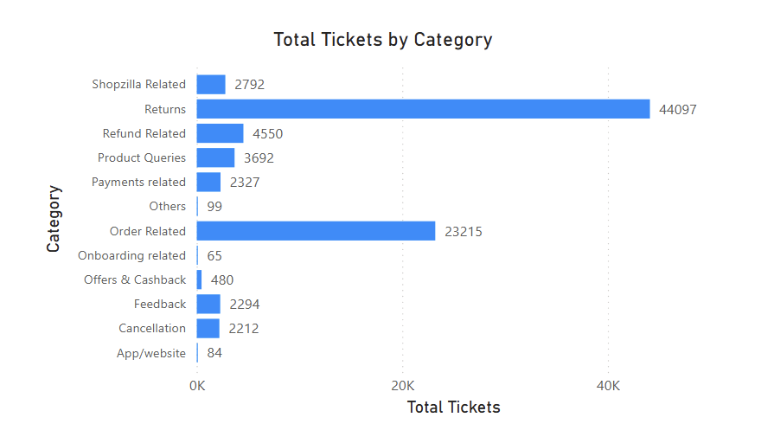

Returns and orders dominate demand
Returns generated 44,097 tickets and order-related issues generated 23,215. Together, these two categories account for most support demand. Other visible categories were refund related at 4,550, product queries at 3,692, Shopzilla related at 2,792, Feedback at 2,294, Cancellation at 2,212. While Offers & Cashback, Onboarding related, and Others were relatively low.
- Business implication: Process improvement should focus first on returns and order management because changes in these areas are likely to deliver the largest reduction in ticket volume and support workload.
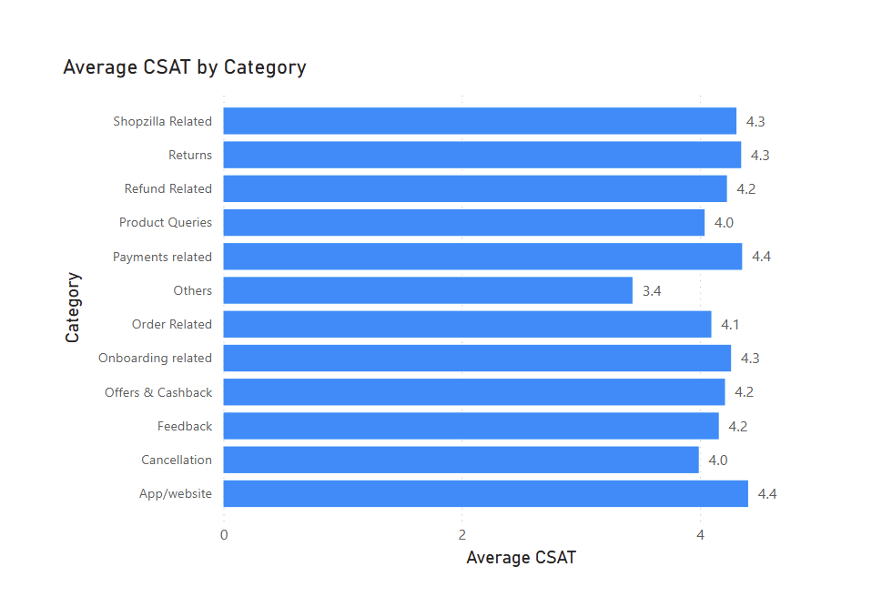

Category-level satisfaction
Payments related achieved the highest average CSAT at 4.4. Shopzilla related, returns, and onboarding related each recorded 4.3. Most of the categories have a score over 4.0 except Others.
- Business implication: The Others category requires attention because it has the lowest satisfaction score. It may contain unclear, misclassified, or unusually complex issues. A review of the underlying tickets would help determine whether new categories or clearer routing rules are needed.
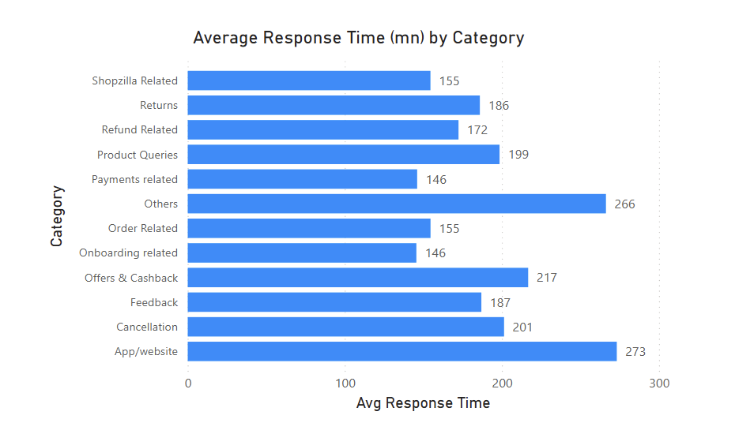

Response time differs by issue type
The Others category had the slowest average response time at 266 minutes, followed by App/website at 273, Offers & Cashback at 217, Cancellation at 187, Feedback at 187, product queries at 199 and returns at 186. Refund related averaged 172 minutes. Shopzilla related and order related both averaged 155 minutes, while payments related and onboarding related were fastest at 146 minutes.
- Business implication: Longer response times may reflect issue complexity, weaker routing, limited knowledge resources, or reliance on specialist support. Product queries and the Others category should be prioritised for deeper review. These may contribute to why Others category received the lowest CSAT scores.

5. Recommendations
- Prioritise returns and order-related process improvements because these categories generate most support demand.
- Improve self-service information for reverse pickups, return requests, delivery delays, and order status enquiries.
- Review the working practices of the fastest agents and convert suitable methods into team guidance or training.
- Investigate slow-response agents using ticket complexity, workload, tenure, shift, and escalation data before making performance judgments.
- Strengthen coaching for agents in on-the-job training, particularly around customer communication and issue ownership.
- Review morning-shift staffing and ticket allocation to understand its lower average CSAT.
- Reclassify or analyse tickets in the Others category to identify hidden recurring issues and improve routing.
- Expand the reporting period before drawing conclusions about monthly trends or seasonality.

6. Reporting Limitations
- July contains only 252 tickets, so July and August are not directly comparable as complete monthly periods.
- The dashboard shows averages, but averages alone do not reveal the distribution of response times or the impact of extreme values.
- Agent comparisons may be influenced by ticket complexity, shift assignment, category specialisation, and workload differences.
- The 100% resolution rate should be validated against the source definition to confirm whether all tickets were genuinely resolved or whether unresolved records were excluded.
- The dashboard does not establish the cause of performance differences; additional investigation is required before operational decisions are made.

7. Conclusion
The customer support operation demonstrates strong overall customer satisfaction and complete recorded ticket resolution. However, the dashboard also highlights major differences in agent response times, lower satisfaction during on-the-job training, and heavy demand from returns and order-related issues. The greatest business value is likely to come from improving return and delivery communication, strengthening early-stage agent support, and investigating the causes of unusually slow response times.
Source: Operational Dashboards (Power BI export), pages 1–3.

