JC2001 - Introduction to Software Engineering
Group Project · Technical Report
Academic year 2026-27

Campus Market: Design, Implementation and Evaluation of an On-Campus Second-Hand Trading Platform
A proof-of-concept web application for buying, selling and swapping second-hand goods within a single university campus

Group number: 9
Programme of study: BSc (Artificial Intelligence)

Group member | Name | Student ID
Group member 1 | <Full name> | <Student ID>
Group member 2 | <Full name> | <Student ID>
Group member 3 | <Full name> | <Student ID>
Group member 4 | <Full name> | <Student ID>
Group member 5 | <Full name> | <Student ID>

Submitted to the MyAberdeen course assessment area · Submission date: <date>

Table of Contents
Select all and press F9 to build the table of contents.

List of Figures
Figure 3.1 | System context: the actors, the browser and the local filesystem the proof of concept interacts with | 20
Figure 3.2 | Use case diagram: eighteen use cases across two actors, with the visitor actor generalising to the registered student | 21
Figure 3.3 | Business process model for a complete second-hand transaction, with the server-side guards shown in the system lane | 26
Figure 3.4 | Activity model for publishing a listing, showing the three decisions and the duplicated client-side and server-side enforcement | 27
Figure 4.1 | Layered architecture, showing the endpoint groups of the application layer and the components of the data layer | 29
Figure 4.2 | Module decomposition and the direction of each dependency | 30
Figure 4.3 | Domain class diagram, showing the six entities, their attributes and their associations | 31
Figure 4.4 | Entity-relationship diagram of the six-table schema, with foreign keys and cardinality | 32
Figure 4.5 | State machine governing the life cycle of a listing, with the actor and the guard for each transition | 33
Figure 4.6 | Sequence diagram for publishing a listing, from form submission to committed rows | 34
Figure 4.7 | Sequence diagram for reserving an item and confirming the sale, including the two guards and the rejection path | 35
Figure 4.8 | Sequence diagram for the conversation list, opening a thread and sending a reply | 36
Figure 4.9 | The JSON endpoint surface, grouped by resource, with the methods and the session requirement of each endpoint | 37
Figure 4.10 | The client-side view router: five views, the persistent header, and the guards on the views that require a session | 39
Figure 5.1 | Technology choices and the reasoning behind each one | 41
Figure 5.2 | How a status request is validated before the row is written, driven by a five-entry rule table | 44
Figure 5.3 | Rendering the conversation list with one aggregate query instead of a query per conversation | 44
Figure 5.4 | The catalogue grid: status badge, cover image, price, seller and category on each card | 47
Figure 5.5 | The empty search result: the condition is named and a next step offered, instead of leaving the grid blank | 47
Figure 5.6 | The detail view as a signed-in buyer sees it: reserve, save and message, with the seller and the structured attributes | 48
Figure 5.7 | The same view for the seller: the buying actions are replaced by the management actions | 49
Figure 5.8 | The shared confirmation dialog used for every destructive action in the interface | 49
Figure 5.9 | The publishing form: chip selectors for category and condition, a photograph drop zone, and validation messages attached to the field that failed | 50
Figure 5.10 | The personal centre: profile summary with counts, and the student's own listings | 51
Figure 5.11 | An open conversation: own and other messages distinguished, relative times, and the composer anchored to the bottom | 52
Figure 5.12 | The interface at a 400-pixel viewport: the grid collapses to two columns and the header reduces to its essential controls | 53
Figure 6.1 | Automated test cases by component. All 80 cases pass. | 56
Figure 6.2 | Requirements realised and independently verified, by category | 59
Figure 6.3 | In-process response time per operation at 500 listings, median and 95th percentile | 60
Figure 6.4 | Median response time for three catalogue read paths as the number of listings grows from 100 to 2,000 | 61

List of Tables
Table 1.1 | Stakeholders and what each one needs from the system | 10
Table 1.2 | Scope boundary of the proof of concept | 11
Table 1.3 | Main features of the proof of concept and where each is specified and verified | 11
Table 2.1 | Roles and responsibilities. Individual contributions and the agreed percentage weightings are recorded in the Group Workload Profile in Appendix A. | 14
Table 2.2 | Project constraints and assumptions | 15
Table 3.1 | Functional requirements | 17
Table 3.2 | Non-functional requirements and how each is verified | 18
Table 3.3 | Prioritisation of requirements | 19
Table 3.4 | Use case summary | 21
Table 4.1 | Architectural alternatives and the reason each was rejected | 28
Table 4.2 | Responsibility of each layer, and what each layer is forbidden to do | 29
Table 4.3 | Module inventory | 30
Table 4.4 | Table specifications | 32
Table 4.5 | Status transition rules. The role and the source state are both required; a request that fails either check changes nothing. | 33
Table 4.6 | Endpoint catalogue. Session means that the endpoint refuses an unauthenticated request with 401 without evaluating the body. | 37
Table 4.7 | The response envelope shared by every endpoint | 38
Table 4.8 | Design decision log | 39
Table 5.1 | Component versions and roles | 41
Table 5.2 | Size of each component of the delivered software | 42
Table 5.3 | Validation rules applied to an upload or a listing, and where each is enforced | 43
Table 5.4 | Client-side rendering paths and the escaping applied to each | 45
Table 5.5 | Design token groups and what each controls | 45
Table 5.6 | Coding conventions applied across the codebase | 53
Table 6.1 | Test levels, techniques and detection capability | 55
Table 6.2 | Automated test suite by group | 56
Table 6.4 | Negative and boundary cases written deliberately | 57
Table 6.7 | In-process response time per operation. Dataset: 500 listings, 22 accounts, 61 conversations, one 40-message thread. Python 3.13.14, 200 repetitions for reads and 100 for writes. | 60
Table 6.8 | Median response time for three catalogue read paths as the dataset grows | 61
Table 7.1 | Outcome against each project objective | 64
Table 7.2 | Limitations of the delivered proof of concept | 64
Table 7.3 | Prioritised future work | 65

1 Introduction and Project Context

1.1 Background
Every academic year a substantial volume of usable goods moves between students. Textbooks bought for a single semester, laptops replaced on an upgrade, monitors, bicycles, calculators, sports kit and kitchen equipment all become surplus to their owners while demand for those exact items exists a few hundred metres away in the next year group. Research on consumer resale consistently finds that the barriers to second-hand trade are not price but friction: the effort of listing, the uncertainty of whether anyone wants the item, and the difficulty of meeting a buyer (Kleppmann, 2017, discusses the same friction in the context of marketplaces more generally). On a university campus the physical distance is negligible, which makes the remaining friction purely informational. That is the gap this project addresses.

1.2 The Problem
Three channels currently carry almost all campus trade, and each fails in a different way.
• General-purpose marketplaces. These are designed for buyers and sellers who are strangers to one another and geographically dispersed. Listings are drowned in results from the wider city; handover must be negotiated with a counterparty who may be an hour away; and the platform charges a commission or sells promotion. For a student selling a 40-yuan textbook the net benefit is close to zero, so the channel is not used.
• Social media groups and group chats. This is where most transactions actually happen, but a chat stream is a poor catalogue. A listing is pushed out of view within hours, there is no search, no filtering, no way to see whether an item is still available, and no record that anything was ever sold. The same item is re-posted repeatedly by different people because there is no canonical listing.
• Noticeboards and word of mouth. These reach only the people who happen to walk past, and give a buyer no way to compare prices or assess condition before making a journey.
Two of the failures are specific to this setting and explain why a general-purpose platform cannot simply be pointed at a campus. The first is trust. Students transact with people they may share a lecture theatre with but do not know, and a platform open to the world gives them no signal that the counterparty is a member of the same institution and no agreed, public place to meet. The second, and the one this project treats as the central design problem, is state. In an informal channel there is no authoritative answer to the question "is this still available?" Sellers answer that question dozens of times, buyers travel to inspect items that were sold yesterday, and neither party can tell whether an item is on sale, held for someone, or gone.
The economic and environmental consequences are straightforward. Sellers abandon items they cannot shift or give them away, recovering none of the value; buyers pay full price for new goods because they never saw the used alternative; and the institution has to dispose of a volume of usable goods that its own students would have bought. Addressing the problem matters because the affected population is large, price-sensitive, and already motivated to participate.

1.3 Project Objectives
The project set out to achieve five objectives, each stated so that its completion is demonstrable rather than asserted.
(1) To specify the requirements of a campus second-hand trading platform, by identifying its users and stakeholders and producing a prioritised set of functional and non-functional requirements against which the remainder of the project can be traced.
(2) To design a system architecture and data model for the platform, expressed as a layered architecture, a domain model, a relational schema and a set of interaction models, with the key design decisions and their alternatives recorded.
(3) To implement a working proof of concept that demonstrates the core features end to end.
(4) To verify the proof of concept against the stated requirements through automated unit, component and interface testing, negative and boundary testing, performance measurement and an interface evaluation, reporting the results honestly including cases that fail or remain unverified.
(5) To deliver the documentation and presentation required by the module, consistent with the delivered software.
Chapter 7 returns to these objectives and states, for each, what was achieved and what was not.

1.4 Intended Users and Stakeholders
Table 1.1 Stakeholders and what each one needs from the system
Stakeholder | Relationship to the system | Primary need
Visitor (unregistered student) | Direct user. Reaches the site from a link or a search and has no account. | To browse and search the catalogue, read a listing in full, and see enough of the seller to decide whether to register.
Registered student | Direct user, acting in two roles. The same account sells items and buys them; the roles are separated only for the duration of a transaction. | As a seller: to publish quickly, to be reachable, and to stop receiving enquiries once an item has gone. As a buyer: to find what is available, to know whether it is still available, and to contact the seller.
The institution | Indirect stakeholder. Provides the campus, the students and, in a production setting, the hosting. | That the platform carries no money, holds the minimum personal data, and imposes no operational cost or regulatory obligation.
Course assessor | Indirect stakeholder. Installs, runs and evaluates the software. | That the software installs and runs on a clean machine without specialist knowledge, and that the implementation matches what the report claims.

1.5 Scope of the Proof of Concept
Table 1.2 Scope boundary of the proof of concept
In scope | Deliberately out of scope
Account registration, authentication and session handling | Institutional single sign-on and identity verification against a student record system
Listing creation with up to three photographs and a structured attribute set | Rich media (video), bulk import, and catalogue synchronisation from other platforms
Catalogue browsing with keyword search, category and status filters, three sort orders and pagination | Recommendation, personalisation and relevance ranking
Listing detail with gallery, description, seller identity and a public comment thread | Reputation scores, reviews and dispute history
Favourites, private messaging and a personal centre | Push or email notification, and real-time delivery
Server-validated transaction status: reserve, confirm, cancel, take offline, relist | Online payment, escrow, delivery logistics and refunds
A single-node deployment on a local machine | Horizontal scaling, high availability and multi-tenant operation

1.6 Main Features
Each feature below maps onto a group of functional requirements specified in Chapter 3 and onto the test cases that verify it in Chapter 6.
Table 1.3 Main features of the proof of concept and where each is specified and verified
Feature | What it does | Requirements | Verified by
Accounts and sessions | Register, log in, log out, retrieve the current profile; passwords stored as a salted hash | FR-01 to FR-04 | TC-A01 to TC-A10
Publishing | Create, edit and soft-delete a listing, with up to three photographs and validation of all required fields | FR-05 to FR-10 | TC-L01 to TC-L12, TC-U01 to TC-U08
Catalogue | Paginated listing grid with keyword search across two columns, category and status filters and three sort orders | FR-11 to FR-15 | TC-C01 to TC-C12
Listing detail | Photo gallery, description, seller identity, structured attributes, comment thread and role-aware actions | FR-16 to FR-18 | TC-C13, TC-C14, TC-S05 to TC-S08
Favourites | Save and unsave a listing; a saved list in the personal centre | FR-19 to FR-21 | TC-S01 to TC-S04
Transaction state | Reserve, confirm the sale, cancel a reservation, take offline and relist, each guarded by role and current state | FR-22 to FR-24 | TC-T01 to TC-T15
Private messaging | Send a message, list conversations grouped by partner, open a thread and clear unread state | FR-25 to FR-27 | TC-S09 to TC-S16
Personal centre | My listings, my favourites, my sold items and my conversations in one place | FR-28 | TC-P01 to TC-P05

1.7 Potential Practical and Business Value
The value of the system comes from removing information friction rather than from introducing a new capability. Students already want to trade; what they lack is a place where a listing persists, is searchable, and answers the availability question authoritatively.
For students, the practical value is measurable in money and time. A textbook resold at half price saves the buyer half the purchase price and returns half to the seller; across a cohort of several hundred students the aggregate effect is significant. Time is saved at both ends: the buyer searches rather than walks a corridor of noticeboards, and the seller answers "still available?" once, in public, instead of once per enquirer. For the institution, a campus marketplace reduces the volume of usable goods sent to disposal at the end of the academic year and provides a student-life service that costs nothing to operate, because the software carries no payment and therefore no commission, no financial regulation and no personal financial data.

1.8 Structure of This Report
Chapter 2 describes the process used to produce the work and the constraints it ran under. Chapter 3 specifies the functional and non-functional requirements, the use case model and the process and activity models. Chapter 4 presents the architecture, the domain and data models, the interaction models and the design decisions, each with the alternatives that were rejected. Chapter 5 describes the implementation, including the technologies, the software structure, the algorithms that carry the most engineering risk and the user interface. Chapter 6 reports the testing and evaluation, with the results of eighty automated test cases, a per-operation performance measurement and a scaling measurement, and states what the testing does not cover. Chapter 7 concludes against the objectives of section 1.3 and sets out the limitations and the future work. Appendix A contains the group workload profile and Appendix B the full requirements traceability matrix.

2 Project Approach and Method

2.1 Development Process
The project followed an incremental, prototype-driven process rather than a single waterfall pass or a full agile ceremony. The reasoning was specific to the situation. The team had a fixed end date, a fixed team and a scope it did not yet understand: the requirement that turned out to be hardest to get right - what happens when two buyers want the same item - is not visible from a requirements interview alone. Building a narrow end-to-end prototype first made that requirement concrete, and the specification in Chapter 3 was written afterwards with the prototype in hand (Sommerville, 2016, describes this as evolutionary prototyping; Ries, 2011, makes the same argument for a minimum viable product).
The process had four characteristics.
• Vertical slices rather than layers. Each increment delivered a user-visible capability through every layer - interface, endpoint, query, storage - rather than completing one layer at a time. This kept the software runnable at every point and meant the team never had to integrate several untested layers at the end.
• A written specification stabilised after the first prototype. Early increments informed the requirements; later increments were built against the specified requirement identifiers, so that every feature can be traced back to a requirement and forward to a test.
• Automated tests written alongside the code. The suite described in Chapter 6 grew with the implementation and was run after every change, which is what allowed a late system-wide change - rewriting the front end - to be made without a regression.
• A single shared repository with frequent commits. All work went through Git, so changes are attributable and every increment is recoverable.

2.2 Requirements Elicitation
Requirements came from five sources, chosen to give different kinds of information rather than to be exhaustive. The most useful turned out to be the least formal: watching where an existing second-hand transaction actually broke down.
• Semi-structured interviews with six students across two year groups, selected for having bought or sold something second-hand in the previous year. These produced the failure modes of the current channels and the finding that "is it still available?" is the dominant interaction cost.
• Document and artefact analysis of four active campus resale group chats, sampled over two weeks. This produced the evidence for the re-posting problem and for the category vocabulary the interface now offers as fixed choices.
• Task observation of three listings followed from posting to handover, which produced the sequence of steps that became the business process model in section 3.8.
• Supervisor discussion in two scheduled sessions, which produced the scope reduction: dropping payment, delivery and reputation, each of which would have made the project undeliverable.
• Competitive review of public listings on two general-purpose marketplaces, which produced the attribute set buyers screen on: price, condition and photographs.

2.3 Tools and Configuration Management
• Git and GitHub for version control, so every change is attributable and every increment recoverable.
• Python 3.8 or later as the implementation language, because it is already present on the lab and staff machines and needs no runtime licence.
• Flask 2.3.3 as the web framework, because routing, signed sessions and JSON handling arrive in one small dependency with no configuration ceremony.
• SQLite 3 as the database, because it is file-based and the schema therefore travels with the submission.
• pytest for automated testing, because its fixture model gives per-test database isolation without extra libraries.
• Playwright driving Microsoft Edge for interface verification, because it reuses a browser that is already installed rather than downloading one.
• Microsoft Word for document production, which is the required output format.

2.4 Team Organisation
Work was divided by feature vertical rather than by technical layer. Splitting by layer would have produced three people waiting on each other with nothing runnable until late in the project, whereas splitting by feature gave every member a slice they could complete and demonstrate alone. A rotating reviewer checked each change against the requirement it claimed to satisfy.
Table 2.1 Roles and responsibilities. Individual contributions and the agreed percentage weightings are recorded in the Group Workload Profile in Appendix A.
Role | Held by | Responsibility
Requirements lead | Group member 1 | Elicitation, functional requirements, requirement priority and the traceability matrix
Architecture lead | Group member 2 | Architecture selection, module boundaries, interface contract, supervisor liaison
Data and security lead | Group member 3 | Schema design and normalisation, password storage, upload validation, performance measurement
Process and state lead | Group member 4 | Transaction state machine, authorisation rules, negative and boundary test design
Interface lead | Group member 5 | Design system, all views and feedback states, responsive behaviour, user manual
Reviewer (rotating) | All members | Checking each change against the requirement it claims to satisfy before it is merged

2.5 Constraints and Assumptions
Table 2.2 Project constraints and assumptions
# | Constraint or assumption | Consequence for the design
C1 | The proof of concept must run on the assessor's machine with a single command and no configuration | Rules out a server-based database, a container runtime and a front-end build step. Drives the choice of SQLite and framework-free client code.
C2 | The platform must not handle money | Excludes payment, escrow and refunds, and with them financial regulation, dispute resolution and the storage of financial data.
C3 | No institutional identity provider is available to the project | Authentication is self-contained: username, password and an optional student identifier that the platform records but cannot verify.
C4 | The project runs for a single academic year with a part-time team | Scope is fixed at the transaction loop for one campus; recommendation, notification and reputation are explicitly deferred.
C5 | One campus, therefore a small and bounded user population | A single-node database is adequate. Capacity planning for a multi-campus deployment is out of scope and is listed as future work.
A1 | Assumed: students have a browser and a campus network connection | No native client is required; a responsive web client serves both desktop and mobile.
A2 | Assumed: buyers and sellers can meet in person on campus | The system models handover as an offline event and does not attempt to schedule or track delivery.
A3 | Assumed: the volume of data is small in absolute terms | The absence of indexes beyond the primary keys is tolerable at this scale, and the scaling behaviour in section 6.10 confirms it, but the assumption is revisited in the limitations.

2.6 How the Work Was Verified
Verification was treated as part of the process rather than as a phase at the end, through three mechanisms used continuously: an automated suite of eighty test cases exercising every JSON endpoint including the negative and boundary paths, run before every push; a scripted interface check that drives the application in a real browser, visits every screen in both an authenticated and an anonymous state, and fails on a console error or an unexpected 4xx or 5xx response; and a written traceability matrix, maintained from the moment the requirements were numbered. The matrix is in Appendix B and the results are reported in Chapter 6.

3 Requirements and Use Cases

3.1 Requirements Modelling Approach
Requirements are recorded as numbered, atomic statements, because numbering is what makes traceability possible: a requirement that cannot be referred to by name cannot be shown to have been implemented or tested. Functional requirements carry the prefix FR, non-functional requirements NFR, use cases UC and test cases TC. Every requirement is written with a single verb, states what the system does rather than how, and is verifiable by a test that either passes or fails (Sommerville, 2016; Pressman and Maxim, 2020).

3.2 Functional Requirements
Table 3.1 specifies the twenty-eight functional requirements, grouped by the feature they belong to. The final column names the use cases of section 3.6 in which the requirement is exercised.
Table 3.1 Functional requirements
ID | Requirement | Group | Use case
FR-01 | The system shall allow a visitor to register an account with a username, a password and optional nickname, email and student identifier. | Accounts | UC-01
FR-02 | The system shall authenticate a registered student against a username and password and establish a session. | Accounts | UC-02
FR-03 | The system shall allow an authenticated student to terminate their session. | Accounts | UC-02
FR-04 | The system shall return the authenticated student's own profile, excluding any credential material. | Accounts | UC-12
FR-05 | The system shall allow an authenticated student to publish a listing with a title, description, price, category and condition. | Publishing | UC-06
FR-06 | The system shall allow up to three photographs to be attached to a listing, each stored under a system-generated name. | Publishing | UC-07
FR-07 | The system shall reject a listing that has no title, no price, or a price that is not numeric. | Publishing | UC-06
FR-08 | The system shall allow the owner of a listing to edit its title, description, price, category and condition. | Publishing | UC-08
FR-09 | The system shall allow the owner of a listing to take it offline without deleting its history or its photographs. | Publishing | UC-09
FR-10 | The system shall allow the owner of an offline listing to put it back on sale. | Publishing | UC-09
FR-11 | The system shall present listings as a paginated catalogue with a fixed page size and a total result count. | Catalogue | UC-03
FR-12 | The system shall allow listings to be searched by a keyword matched case-insensitively against title and description. | Catalogue | UC-04
FR-13 | The system shall allow listings to be filtered by category. | Catalogue | UC-04
FR-14 | The system shall allow listings to be filtered by status. | Catalogue | UC-04
FR-15 | The system shall allow listings to be ordered by recency, ascending price or descending price. | Catalogue | UC-04
FR-16 | The system shall present a listing detail page containing the photograph gallery, description, price, category, condition, posting time and the seller's display name. | Detail | UC-05
FR-17 | The system shall present the public comments on a listing in chronological order. | Detail | UC-10
FR-18 | The system shall allow an authenticated student to post a comment on a listing. | Detail | UC-10
FR-19 | The system shall allow an authenticated student to save a listing as a favourite. | Favourites | UC-11
FR-20 | The system shall allow an authenticated student to remove a favourite. | Favourites | UC-11
FR-21 | The system shall list the authenticated student's favourites, most recently saved first. | Favourites | UC-11
FR-22 | The system shall allow an authenticated student who is not the seller to reserve a listing that is on sale, moving it to reserved. | Transaction | UC-13
FR-23 | The system shall allow the seller of a reserved listing to confirm the sale, moving it to sold. | Transaction | UC-14
FR-24 | The system shall allow the seller of a reserved listing to cancel the reservation, returning it to on sale. | Transaction | UC-15
FR-25 | The system shall allow an authenticated student to send a private message to another registered student. | Messaging | UC-16
FR-26 | The system shall present the authenticated student's conversations grouped by the other participant, showing the most recent message of each. | Messaging | UC-17
FR-27 | The system shall allow the authenticated student to open a conversation, read its messages in chronological order, and have received messages marked as read. | Messaging | UC-18
FR-28 | The system shall present a personal centre containing the authenticated student's own listings, favourites, sold items and conversations. | Personal centre | UC-12

3.3 Non-Functional Requirements
Table 3.2 Non-functional requirements and how each is verified
ID | Attribute | Requirement | Verification
NFR-01 | Usability | A student who has never used the system shall be able to publish a listing without written instructions or training. | Task observation with three first-time users (section 6.11)
NFR-02 | Usability | Every action shall produce visible feedback in the interface, and no destructive action shall proceed without an explicit confirmation. | Interface inspection; scripted capture of every screen (section 6.11)
NFR-03 | Usability | All views shall share one visual language: a single type scale, one spacing scale and one set of component styles. | Review of the design tokens against the component stylesheet
NFR-04 | Accessibility | Every interactive control shall be reachable and operable by keyboard, with a visible focus indicator, and modal surfaces shall expose their role and title to assistive technology. | Keyboard-only walkthrough of each view; inspection of ARIA attributes
NFR-05 | Accessibility | The interface shall remain usable without horizontal scrolling from a 430-pixel mobile viewport to a 1440-pixel desktop viewport. | Capture of both viewport sizes (figures 5.15 and 5.16)
NFR-06 | Performance | A catalogue read at 500 listings shall complete within 100 ms of application time. | Measurement of 200 repetitions per operation (section 6.9)
NFR-07 | Performance | The cost of a catalogue read shall grow sub-linearly with the number of listings over the range 100 to 2,000 rows. | Scaling measurement (section 6.10)
NFR-08 | Reliability | No request shall produce an unhandled server error for any input reachable through the interface or the API. | Suite of 80 automated cases including malformed and missing input (section 6.3)
NFR-09 | Security | No password shall be stored or transmitted in recoverable form; credentials shall be stored as a salted hash. | Inspection of the stored column; assertion in test TC-A10
NFR-10 | Security | All user-supplied text shall be escaped before it reaches the document so that a listing or comment cannot execute script in another user's browser. | Code inspection of every render path; adversarial input in a listing title
NFR-11 | Security | Authorisation shall be enforced on the server for every state-changing operation, and shall not rely on the client hiding a control. | Authorisation test matrix (section 6.7)
NFR-12 | Maintainability and portability | The system shall install and start with a single command on a clean Windows or macOS machine with Python installed, and shall need no server, container or build step. | Clean-environment installation of the submitted code (section 6.13)

3.4 Requirement Prioritisation
Requirements were prioritised using MoSCoW so that, if the schedule slipped, the team would cut the right things. The rule applied was that a must requirement is one whose absence breaks the transaction loop; everything else could be deferred without the software ceasing to be a proof of concept.
Table 3.3 Prioritisation of requirements
Priority | Requirements | Rationale
Must (18) | FR-01 to FR-07, FR-09, FR-11 to FR-16, FR-19, FR-22 to FR-25, FR-28 | Without these a student cannot list an item, find an item or complete a transaction. Removing any one breaks the loop.
Should (8) | FR-08, FR-10, FR-17, FR-18, FR-20, FR-21, FR-26, FR-27 | The system is usable without them, but the experience is significantly poorer: sellers cannot correct a listing, and the public availability answer disappears.
Could (2) | FR-13 combined with FR-15 as a single filtered-sort control | A refinement of an existing capability rather than new capability.
Won't (this project) | Payment, delivery, reputation, notification, recommendation, multi-campus operation | Each was rejected in scope discussions. Payment and delivery add legal and operational obligations; reputation and recommendation need a volume of data the proof of concept will never have.

3.5 System Context
Figure 3.1 places the system in its environment. The boundary encloses the Flask application and the client code it serves; everything outside it is a human actor, the browser, the filesystem holding the database and the photographs, or the assessor. The context is deliberately narrow - the proof of concept has no external service dependency, which is what makes it installable with one command.
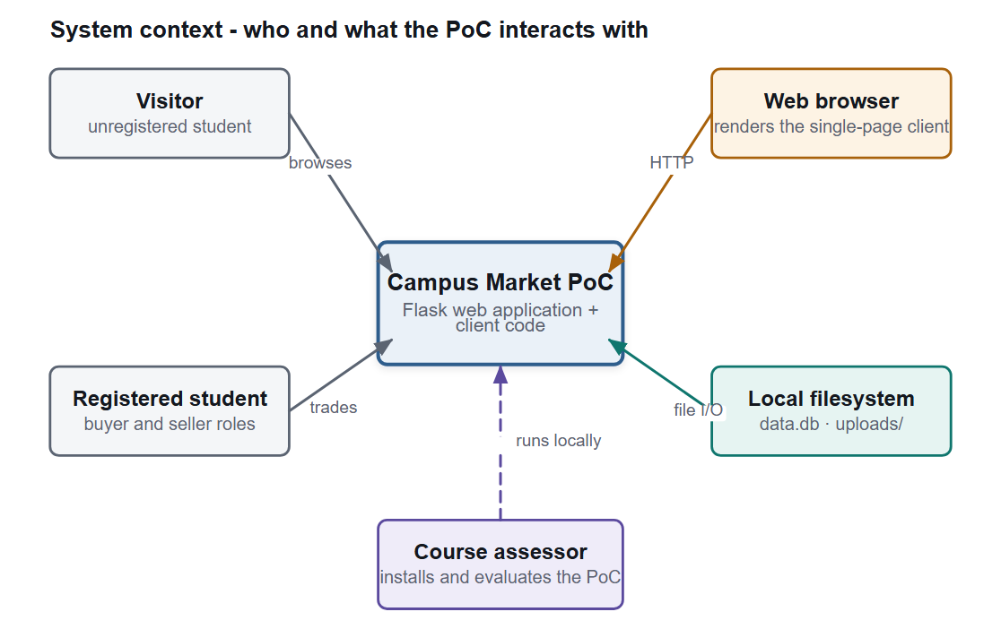
Figure 3.1 System context: the actors, the browser and the local filesystem the proof of concept interacts with

3.6 Use Case Model
Figure 3.2 shows the eighteen use cases and the two actors that initiate them. The distinction between the actors carries real weight in the design: the unshaded use cases are reachable without a session, and the shaded ones are guarded both in the client - which redirects an anonymous visitor to the authentication view - and, independently, on the server. The visitor actor generalises to the registered student, so an authenticated student inherits every use case available to a visitor.
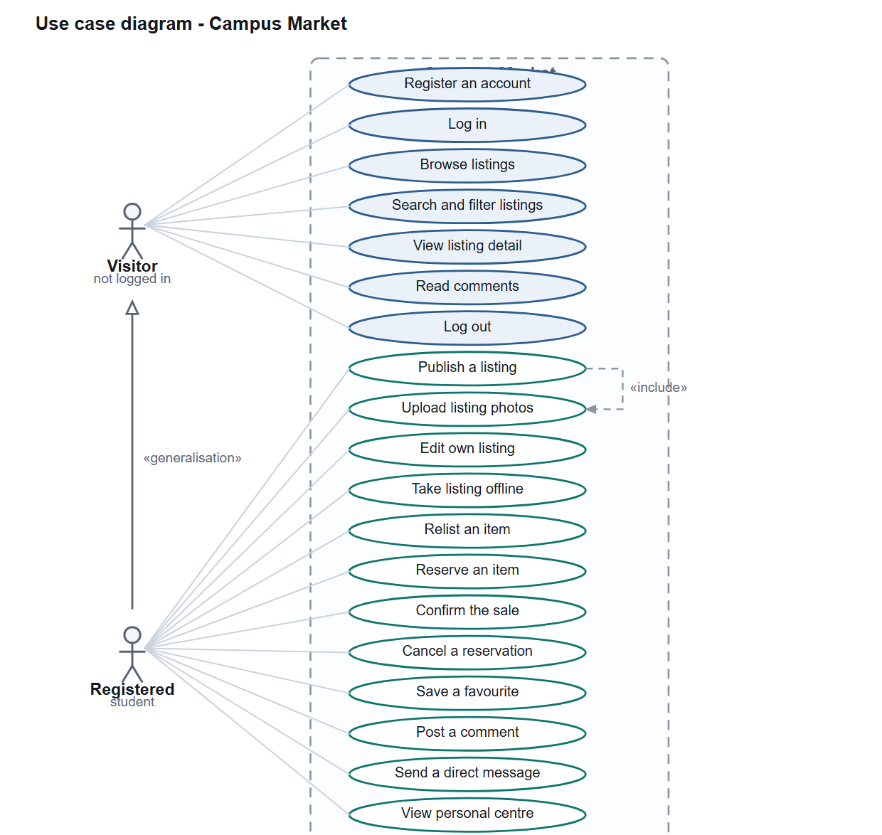
Figure 3.2 Use case diagram: eighteen use cases across two actors, with the visitor actor generalising to the registered student
Table 3.4 summarises the eighteen use cases and the requirement each one satisfies. The eight use cases that carry the most engineering risk are then described in full in section 3.7; the remaining ten follow the same pattern and are recorded in the requirements traceability matrix in Appendix B.
Table 3.4 Use case summary
ID | Use case | Actor | Requirements
UC-01 | Register an account | Visitor | FR-01
UC-02 | Log in and log out | Registered student | FR-02, FR-03
UC-03 | Browse the catalogue | Visitor | FR-11
UC-04 | Search, filter and sort listings | Visitor | FR-12 to FR-15
UC-05 | View a listing in detail | Visitor | FR-16
UC-06 | Publish a listing | Registered student | FR-05, FR-07
UC-07 | Upload listing photographs | Registered student | FR-06
UC-08 | Edit an own listing | Registered student | FR-08
UC-09 | Take a listing offline or relist it | Registered student | FR-09, FR-10
UC-10 | Read and post a comment | Visitor, registered student | FR-17, FR-18
UC-11 | Save or unsave a favourite | Registered student | FR-19 to FR-21
UC-12 | Open the personal centre | Registered student | FR-04, FR-28
UC-13 | Reserve an item | Registered student (buyer) | FR-22
UC-14 | Confirm the sale | Registered student (seller) | FR-23
UC-15 | Cancel a reservation | Registered student (seller) | FR-24
UC-16 | Send a private message | Registered student | FR-25
UC-17 | List conversations | Registered student | FR-26
UC-18 | Open and read a conversation | Registered student | FR-27

3.7 Detailed Use Case Descriptions
The eight use cases below are given in full because each exercises logic that cannot be inferred from the requirement statement alone: validation with two enforcement points, a file-handling path, a state machine with two independent guards, and a query whose correctness depends on how a conversation is identified.

UC-06 Publish a listing
Actor | Registered student (seller)
Goal | The student has something to sell and wants it visible in the catalogue.
Preconditions | An authenticated session exists and the student is on the “Sell an item” view.
Main success scenario | 1. The student opens the publishing view.  2. The system presents the form fields with the required ones marked, and a live preview of the listing card.  3. The student enters a title, a description and a price, and selects a category and a condition.  4. The student selects between one and three photographs.  5. The system validates, in the browser, that a title is present, that the price parses as a number not less than zero, and that at least one photograph has been chosen. Invalid input produces an inline message and the flow stops.  6. The system uploads the photographs and receives their stored names.  7. The system creates the listing with the status on sale and returns its identifier.  8. The system shows a confirmation, clears the form and returns the student to the catalogue with the new listing present.
Alternative and exception flows | 5a. A photograph exceeds 5 MB or is not one of the accepted image types: the system names the offending file and does not add it.  5b. More than three photographs are selected: the system refuses the excess and explains the limit.  7a. The server-side validation rejects the request: the system reports the reason returned by the server and keeps the entered values so nothing is lost.
Requirements satisfied | FR-05, FR-06, FR-07
The validation in steps 5 and 7a is deliberately duplicated. The browser exists to give immediate feedback; the server exists to be authoritative, because a request can be constructed without the browser.

UC-07 Upload listing photographs
Actor | Registered student (seller)
Goal | The seller needs photographs of the item to be stored so a listing can refer to them.
Preconditions | An authenticated session exists and the seller has selected one or more files.
Main success scenario | 1. The system receives the selected files.  2. The system checks each file's extension against the allow-list of image types and rejects the whole request if any file is not permitted.  3. The system derives an extension from the sanitised file name and generates a random unique name for each file.  4. The system writes each file into the upload directory.  5. The system returns the list of generated names.  6. The seller's client passes those names to the listing creation request, which records one row per photograph.
Alternative and exception flows | 1a. No file is present in the request: the system returns a validation error.  2a. A file's extension is not permitted: the system returns an error naming the allow-list.  3a. The sanitised name has no extension: the file is treated as unsupported.
Requirements satisfied | FR-06
The generated name is what protects the upload directory: a name supplied by the client is never used as a path.

UC-13 Reserve an item
Actor | Registered student, acting as a buyer
Goal | The buyer wants an item held for them so it is not sold to someone else.
Preconditions | An authenticated session exists, the item exists, and the buyer is not the seller.
Main success scenario | 1. The buyer asks to reserve the item.  2. The system confirms the intent, explaining that the seller will be notified.  3. The system looks up the reservation rule and reads the item's current record.  4. The system checks that the caller differs from the seller; if the caller is the seller, the request is refused.  5. The system checks that the stored status is on sale; if it is anything else the request is refused and the row is not modified.  6. The system writes the new status and the modification time.  7. The system confirms, and the detail view re-renders with the reserved state and the buyer's actions replaced by seller-only actions.
Alternative and exception flows | 3a. The item does not exist: the system reports that it was not found.  4a. The buyer attempts to reserve their own listing: refused.  5a. The item is already reserved or sold: refused, with the current status named so the buyer understands why.  2a. The buyer dismisses the confirmation: no request is sent and nothing changes.
Requirements satisfied | FR-22
The two checks are independent and both are necessary. The role check establishes who may perform the action; the state check establishes when. A design with only the role check allows a reservation to overwrite a completed sale.

UC-14 Confirm the sale
Actor | Registered student, acting as a seller
Goal | The seller has handed the item over and wants the listing closed as sold.
Preconditions | An authenticated session exists and the caller is the seller of the listing.
Main success scenario | 1. The seller asks to mark the item sold.  2. The system confirms the intent.  3. The system looks up the confirmation rule, reads the item's record and checks that the caller is the seller and that the status is reserved.  4. The system writes the sold status and the modification time.  5. The system confirms, and the listing leaves the on-sale catalogue and appears under the seller's sold items.
Alternative and exception flows | 3a. The status is not reserved - for example the seller is trying to sell an item nobody reserved: refused.  3b. The caller is not the seller: refused with a permission error.  4a. Any further action on a sold item: refused, because sold has no outgoing transition.
Requirements satisfied | FR-23
The requirement that a sale may only be confirmed from the reserved state is what makes the status field trustworthy. Without it, a seller could mark an item sold that a buyer had put effort into reserving, and a buyer could not rely on the reservation meaning anything.

UC-15 Cancel a reservation
Actor | Registered student, acting as a seller
Goal | The buyer did not complete the handover and the seller wants the item available again.
Preconditions | An authenticated session exists, the caller is the seller, and the status is reserved.
Main success scenario | 1. The seller asks to cancel the reservation.  2. The system confirms the intent, explaining that the item returns to sale.  3. The system checks the role and the current status.  4. The system writes the on-sale status and the modification time.  5. The item reappears in the catalogue and becomes reservable by any buyer.
Alternative and exception flows | 3a. The status is not reserved: refused.  3b. The caller is not the seller: refused.
Requirements satisfied | FR-24
This is the recovery path that makes the reservation safe to use: a reservation that could never be released would be worse than none, because one unreliable buyer would remove the item from circulation permanently.

UC-11 Save or unsave a favourite
Actor | Registered student
Goal | The student wants to keep a record of an item they are considering, without committing to it.
Preconditions | An authenticated session exists and the item exists.
Main success scenario | 1. The student asks to save the item.  2. The system records the association between the student and the item.  3. The system confirms, and the control changes to indicate the saved state.  4. The student later asks to unsave it; the system removes the association.  5. The student's favourites list, most recently saved first, is available from the personal centre.
Alternative and exception flows | 1a. The item is already saved: the system refuses the duplicate rather than creating a second row, and reports that it is already saved.  1b. No session exists: the request is refused.
Requirements satisfied | FR-19, FR-20, FR-21
Uniqueness is enforced by the database rather than by a read-then-write check, which would have a race between the read and the write.

UC-18 Open and read a conversation
Actor | Registered student
Goal | The student wants to continue a negotiation about an item.
Preconditions | An authenticated session exists and a conversation with the other student exists or is being started.
Main success scenario | 1. The student opens the conversation with another student.  2. The system retrieves every message between the two students, in either direction, ordered by time.  3. The system marks the messages the student has received from the other party as read.  4. The system presents the messages as bubbles, distinguishing the student's own messages from the other party's, and scrolls to the most recent.  5. The student types a reply and sends it.  6. The system records the message and returns the student to step 2 so the conversation is re-rendered from the stored state.
Alternative and exception flows | 1a. No conversation exists: the system presents an empty thread with an invitation to start one.  5a. The student sends an empty message: the system ignores the submission.  5b. The message cannot be stored: the system reports the failure and preserves what the student typed.
Requirements satisfied | FR-27
Marking messages read as part of reading them removes a class of bug in which the client forgets to report that something was read.

3.8 Business Process Model
Figure 3.3 models the process that the software supports, end to end. The three lanes separate the two human roles from the system, which is what makes the hand-off points visible: the transaction only leaves the buyer's lane twice, once when the reservation must reach the seller and once when payment and handover happen offline. The final lane carries the guards, because the guards are the system's contribution to the process - without them the process is exactly the informal one that already fails.
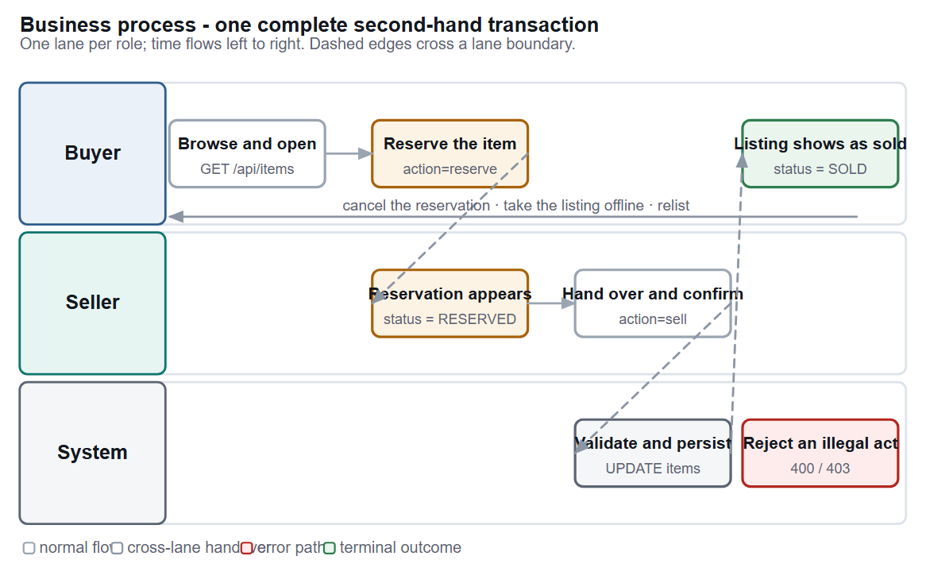
Figure 3.3 Business process model for a complete second-hand transaction, with the server-side guards shown in the system lane

3.9 Activity Model for Publishing
Figure 3.4 models publishing as an activity diagram, because it is the one process in the system with a genuine sequence of dependent decisions. Three decisions appear, and each is checked twice: once in the browser for immediate feedback and once on the server because the browser cannot be trusted. The diagram also makes visible why listing creation and photograph upload are separate requests: the upload completes before the listing is created, so a failure in the second step cannot leave a listing that refers to photographs which do not exist.
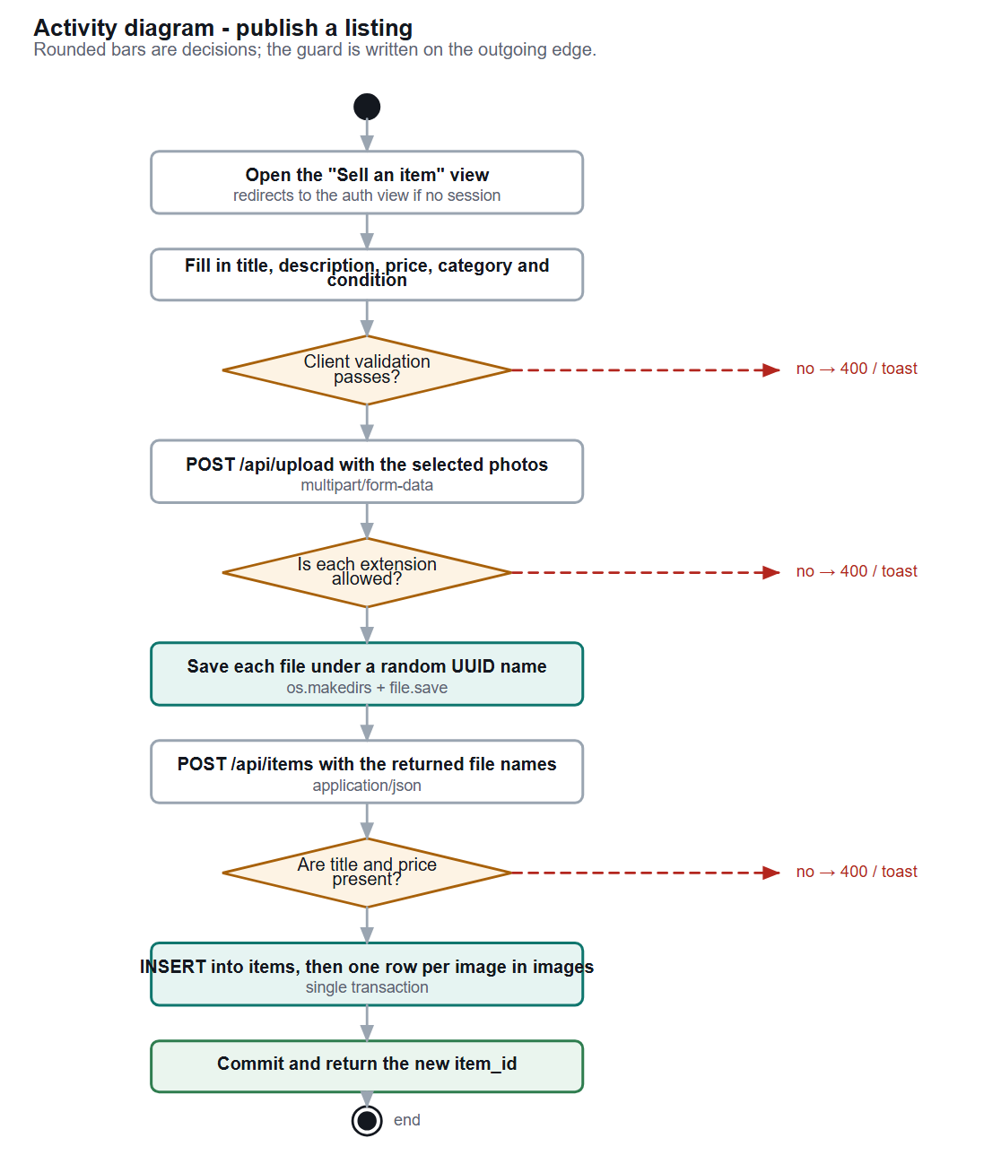
Figure 3.4 Activity model for publishing a listing, showing the three decisions and the duplicated client-side and server-side enforcement

3.10 Requirements Traceability
Traceability is maintained in both directions. Forwards, every requirement names the use case that exercises it and the design element that implements it; backwards, every test case names the requirement it verifies, so a failing test identifies which requirement is now at risk as well as what broke.

4 System Design and Architecture

4.1 Architectural Style and the Alternatives Considered
The system is a three-tier layered web application: a framework-free client that runs in the browser, a Flask application that owns all logic and all authorisation, and a thin persistence layer holding a single SQLite file and an upload directory. Each layer talks only to the layer beneath it, and the client never reaches the database directly.
The style was chosen against three alternatives, and the deciding factor in each case was constraint C1 from section 2.5 - the software must run on the assessor's machine with one command and no configuration.
Table 4.1 Architectural alternatives and the reason each was rejected
Alternative | Attraction | Reason for rejection
Three-tier layered (chosen) | Separates presentation from logic and logic from storage; each layer can be changed independently; the whole system runs as one process with no external dependency | Accepted. It satisfies C1 while still giving a clean separation of concerns and an obvious place for authorisation.
Server-rendered pages with a template engine | Simpler than a client-side application: no JSON contract, no duplicated validation | Rejected because the interface needs to update without a full page load - the comment thread, the favourite control and the chat panel all change in place. Server rendering would have meant a page reload for each one.
Single-page client with a separate API service | The clearest separation of concerns, and the most common production shape | Rejected because it requires either a second process or a cross-origin configuration. Both break C1, and cross-origin requests would additionally require the session cookie to be sent explicitly.
Microservices | Independent deployment of accounts, listings and messaging | Rejected as disproportionate. The whole application is roughly 1,700 lines; splitting it would add service discovery, inter-service contracts and distributed failure modes to solve a scaling problem the system does not have.

4.2 Layered Architecture
Figure 4.1 shows the three layers and the responsibility of each. The boundary that matters most is the one between the presentation layer and the application layer: the client holds no authority. Every rule that protects data - who may change what, what the status is allowed to become next, which file types may be stored - is enforced below the boundary. The client knows those rules only in order to give better feedback, and the design accepts the cost of writing some validation twice in exchange for a system that cannot be subverted by constructing a request by hand.
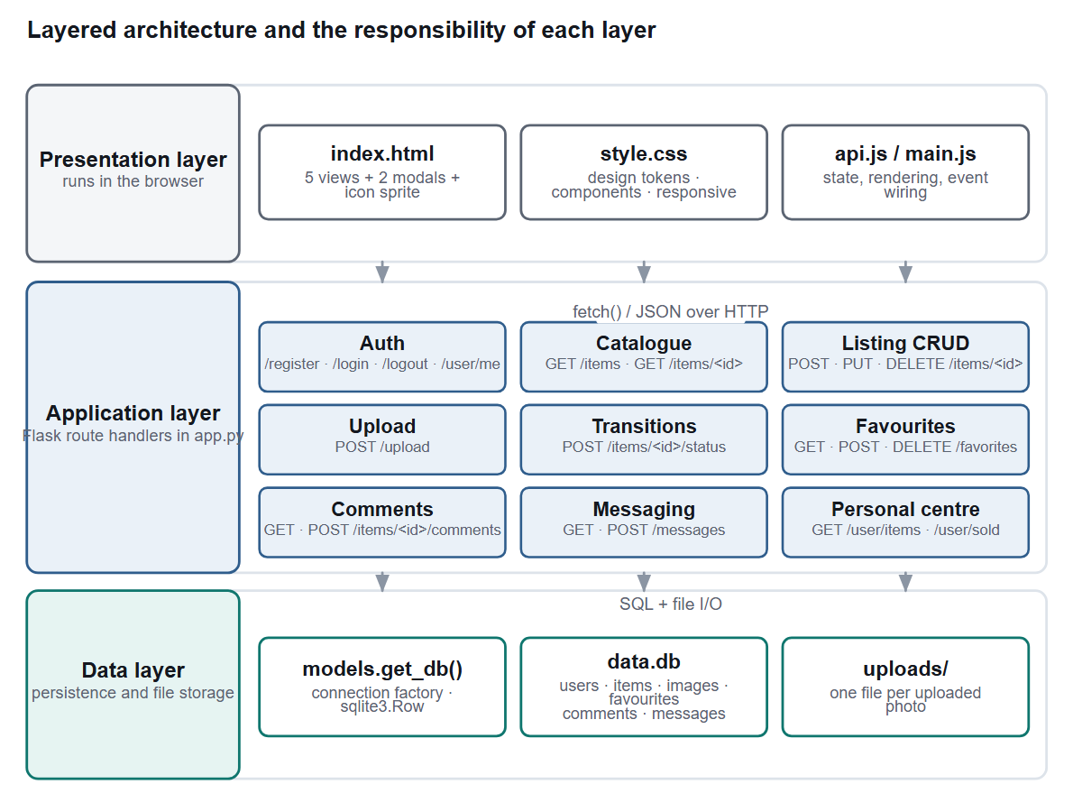
Figure 4.1 Layered architecture, showing the endpoint groups of the application layer and the components of the data layer
Two properties of this arrangement carry most of the design's weight. The presentation layer never reaches the database directly - every read and every write passes through a JSON endpoint - which means the application layer is the only place authorisation has to be correct. And the data layer is deliberately thin: it knows about tables and connections and nothing about rules. That thinness is what would make a future move to a hosted database a local change rather than a rewrite, and it is the reason the layer was kept thin even though the proof of concept does not need to be portable.
Table 4.2 Responsibility of each layer, and what each layer is forbidden to do
Layer | Owns | Must not
Presentation | View state, rendering, event handling, immediate input validation, escaping of all user-supplied text before it is inserted into the document | Hold authority over any data; construct SQL; be the only place a rule is enforced
Application | HTTP routing, session handling, authorisation, validation, the status state machine, construction of the JSON response envelope, file storage | Contain presentation markup; assume that a request originated from the provided client
Data | Connection creation, the relational schema, uniqueness constraints, file storage on disk | Contain business rules that the application layer also needs to know about

4.3 Module Decomposition
Figure 4.2 shows the modules and the direction of each dependency. The decomposition follows Parnas's criterion of hiding the decisions most likely to change (Parnas, 1972): the shape of the data model is hidden behind the data layer, the shape of the HTTP contract is hidden behind the client's request wrapper, and the specifics of password hashing and file-name sanitisation are hidden behind a third-party library.
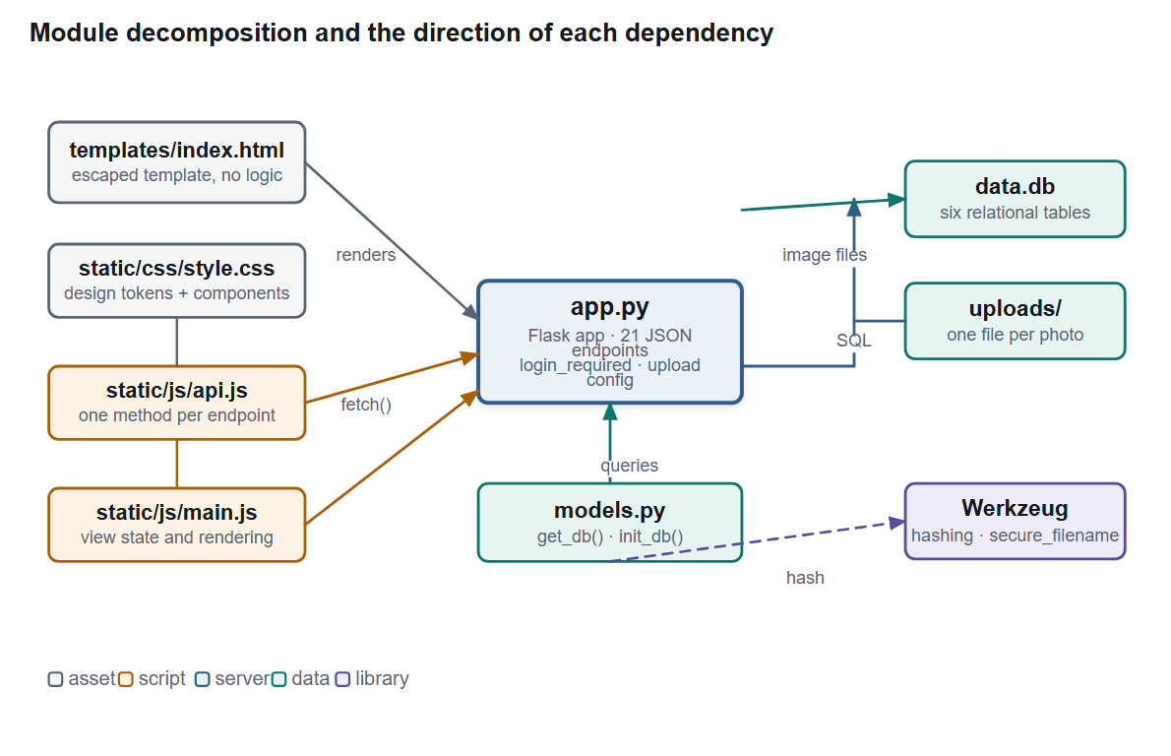
Figure 4.2 Module decomposition and the direction of each dependency
Table 4.3 Module inventory
Module | Lines | Responsibility | Depends on
app.py | 552 | The Flask application object and all 23 routes: accounts, catalogue, listing management, upload, transactions, favourites, comments, messaging and the personal centre | models.py, Werkzeug
models.py | 106 | Connection factory and schema creation for the six tables | sqlite3
templates/index.html | 441 | The single document: five view containers, two modal surfaces, an inline SVG icon sprite and the mount points for client rendering | style.css, api.js, main.js
static/js/api.js | 63 | One method per endpoint, so no URL is written twice and the request shape is defined in one place | the HTTP endpoints
static/js/main.js | 1169 | All view state, rendering, event binding, the hash router, escaping and the feedback layer | api.js
static/css/style.css | 1025 | Design tokens, component styles, responsive breakpoints | nothing

4.4 Domain Model
Figure 4.3 presents the domain model. It is described as persistence-oriented because the system was built without an object-relational mapper: the classes in the diagram are realised as tables and as dictionaries returned from queries, not as Python classes. Modelling them this way was still worthwhile, because the association cardinalities are exactly what the schema must enforce.
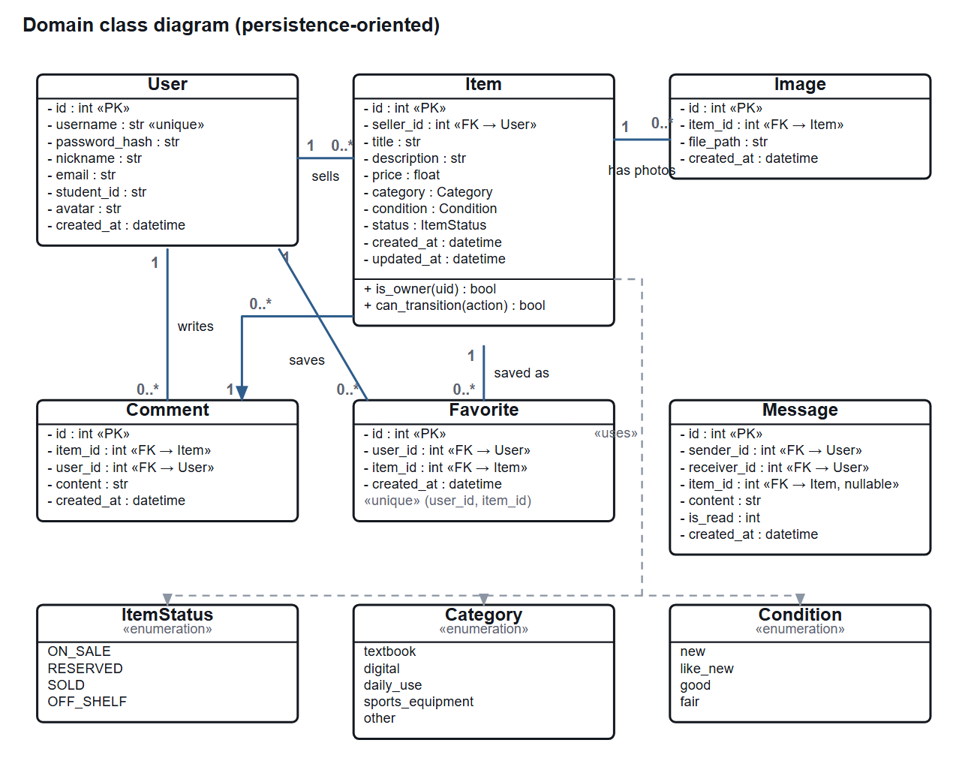
Figure 4.3 Domain class diagram, showing the six entities, their attributes and their associations

4.5 Database Design
The schema has six tables, shown in Figure 4.4. It is in third normal form: every non-key attribute depends on the whole key and on nothing else. The design was checked against the normal forms deliberately, and one candidate denormalisation - storing a reference to the cover photograph on the item row - was rejected in favour of a correlated sub-query, because the sub-query is trivially correct and a duplicated column would have needed code to keep it in step with the images table.
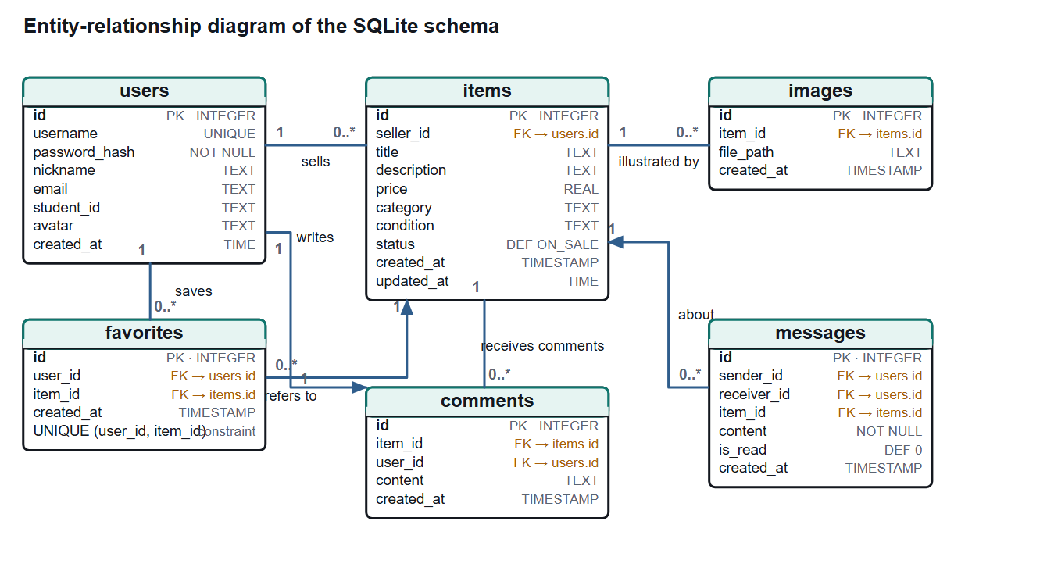
Figure 4.4 Entity-relationship diagram of the six-table schema, with foreign keys and cardinality
Table 4.4 Table specifications
Table | Purpose | Key | Constraints and notes
users | One row per registered student | id | username is unique and not null; password_hash is not null; nickname, email, student_id and avatar are optional
items | One row per listing; the aggregate root | id | seller_id references users; title not null; price not null and real; status defaults to on sale; updated_at is written on every change
images | One row per photograph attached to a listing | id | item_id references items; file_path not null; the row stores the generated file name, never a client-supplied one
favorites | The many-to-many association between a student and a saved listing | id | user_id and item_id both reference their tables; UNIQUE(user_id, item_id) prevents a duplicate save
comments | A public question or answer attached to a listing | id | item_id and user_id both reference their tables; content not null
messages | A private message between two students, optionally about an item | id | sender_id and receiver_id both reference users; item_id references items and is nullable; is_read defaults to zero

Two properties of SQLite shaped the design and both are recorded as limitations rather than as oversights. The engine enforces declared foreign keys only when the connection is opened with PRAGMA foreign_keys = ON, and the proof of concept does not set that pragma; referential integrity is therefore currently a convention held up by the application layer. And CURRENT_TIMESTAMP resolves to whole seconds, which makes any ordering that relies on it alone unstable when two rows are written in the same second - a defect that the test suite found and that is reported in section 6.13.

4.6 Transaction State Machine
The status field of a listing is modelled as an explicit state machine rather than as a free-text field that the interface happens to set. Figure 4.5 shows the four states and the five transitions, and Table 4.5 sets out the rules. The model is the single most important design decision in the project, because it is what makes the answer to "is this still available?" authoritative rather than advisory.
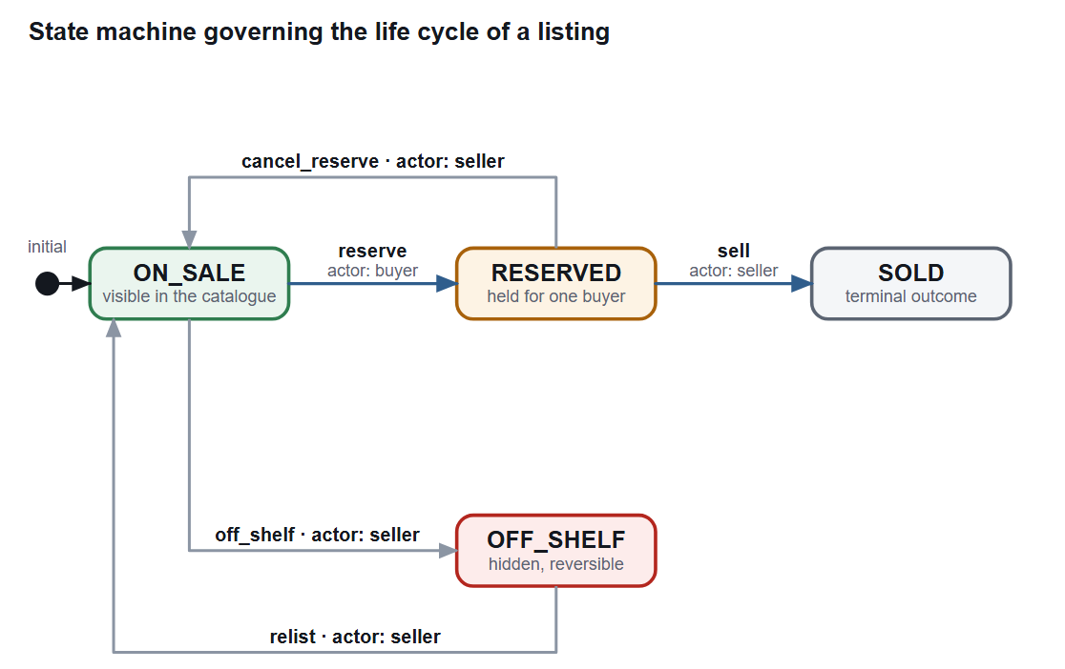
Figure 4.5 State machine governing the life cycle of a listing, with the actor and the guard for each transition
Table 4.5 Status transition rules. The role and the source state are both required; a request that fails either check changes nothing.
Action | From | To | Permitted actor | Failure response
reserve | on sale | reserved | Any student except the seller | 403 if the caller is the seller; 400 if the status is not on sale
sell | reserved | sold | The seller | 403 if the caller is not the seller; 400 if the status is not reserved
cancel_reserve | reserved | on sale | The seller | 403 if the caller is not the seller; 400 if the status is not reserved
off_shelf | on sale | off shelf | The seller | 403 if the caller is not the seller; 400 if the status is not on sale
relist | off shelf | on sale | The seller | 403 if the caller is not the seller; 400 if the status is not off shelf
(any other) | - | - | - | 400 invalid action, before the item is even read

Sold has no outgoing transition, which is a deliberate choice rather than an omission: undeleting a completed sale would require tracking which buyer completed it and by what arrangement, and the proof of concept does not model the buyer side of a completed transaction at all. The consequence is that a mistaken confirmation cannot be undone through the interface, which is why the confirmation dialog for that action states explicitly that the listing will be marked as sold.

4.7 Interaction Design
Three interactions carry most of the system's behaviour and are modelled in full. Between them they exercise every layer, both directions of the status machine, and the one query in the system whose correctness is not obvious from reading it.

4.7.1 Publishing a listing
Figure 4.6 follows a publish action from the form submission to the committed rows. The sequence makes two design decisions explicit. The upload and the creation are separate requests, so the upload completes and returns file names before any listing row is written; a failure in the second step therefore cannot leave a listing that refers to a photograph that was never stored. And the listing row is written before the photograph rows, so that the generated key is available to be used as their foreign key - the reverse order would require a second read.
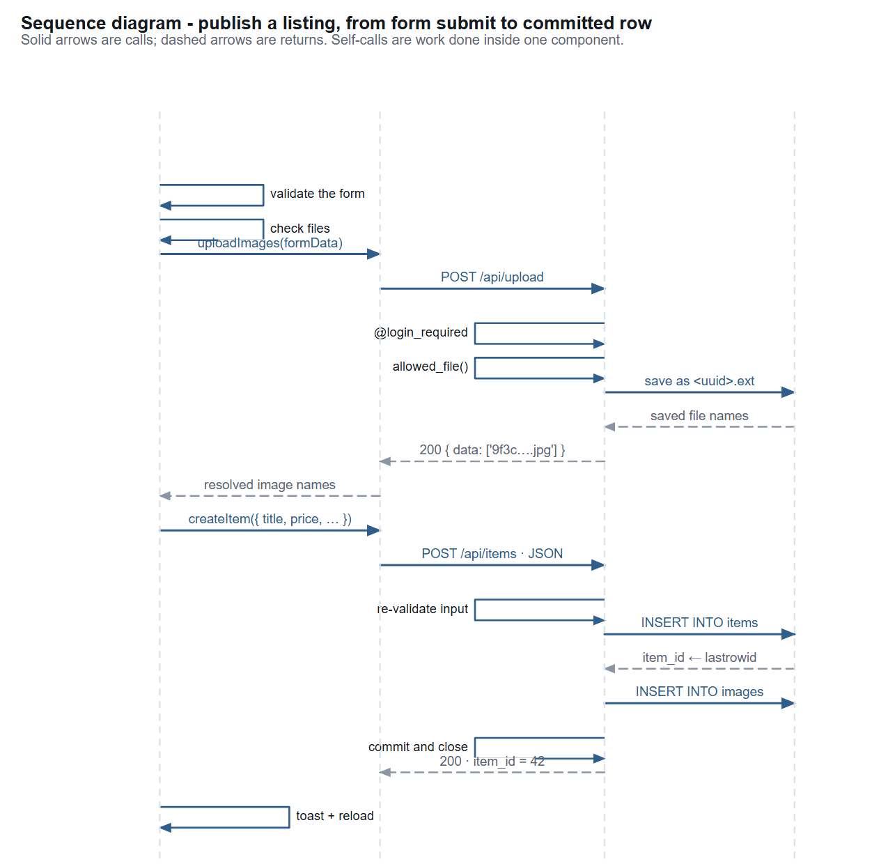
Figure 4.6 Sequence diagram for publishing a listing, from form submission to committed rows

4.7.2 Reserving an item and confirming the sale
Figure 4.7 shows the two ends of the transaction. Both requests reach the same endpoint and are validated against the same rule table, which is the property that makes the state machine trustworthy: the two transitions cannot drift apart, because there is only one place where either is defined. The diagram also shows the failure path explicitly, because the behaviour of a rejected request - that the row is left untouched - is part of the specification rather than an implementation detail.
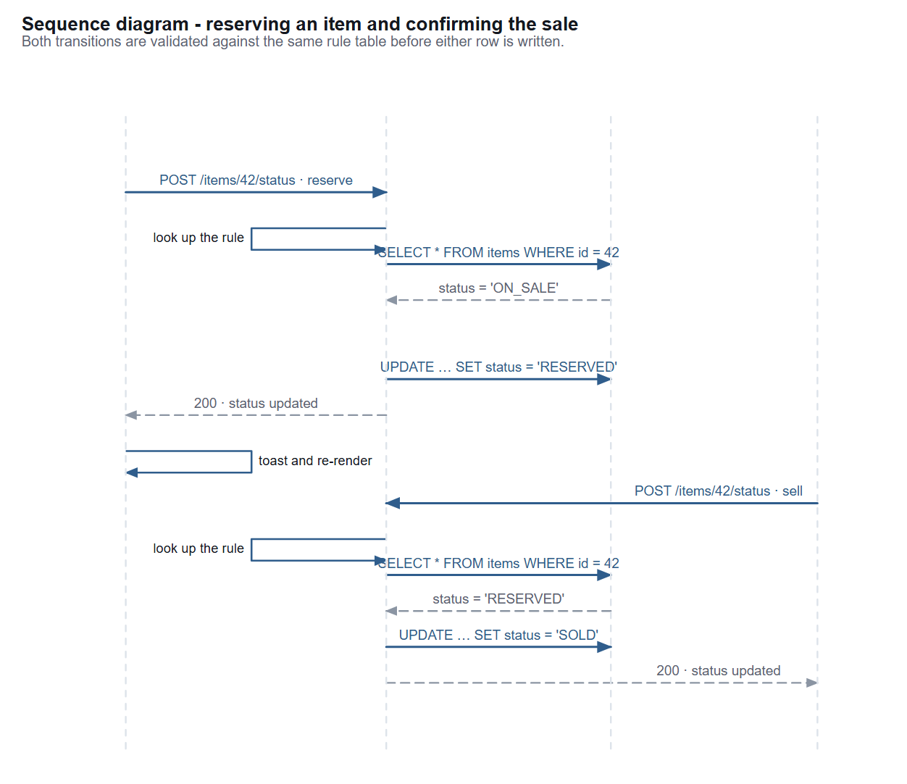
Figure 4.7 Sequence diagram for reserving an item and confirming the sale, including the two guards and the rejection path

4.7.3 Conversations and messaging
Figure 4.8 covers the three messaging interactions. The conversation list is produced by a single aggregate query rather than one query per conversation, which matters because a student's conversation list grows without bound while the number of students they are talking to does not. Opening a thread both reads and writes: the messages are retrieved and the incoming ones are marked as read in the same request, so unread state cannot get out of step with what the student has actually seen.
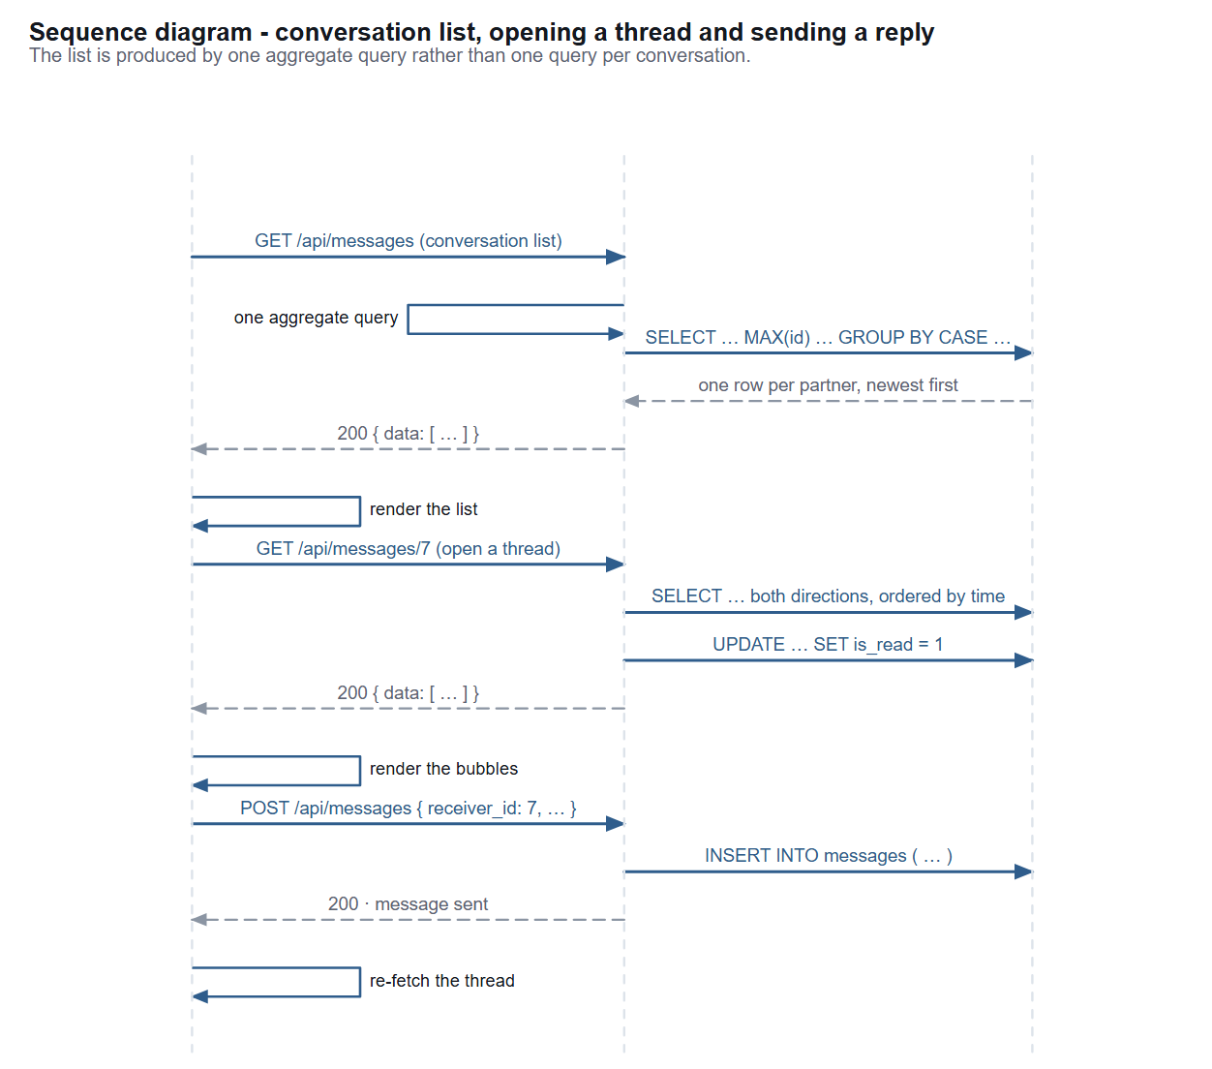
Figure 4.8 Sequence diagram for the conversation list, opening a thread and sending a reply

4.8 Interface Design
The client interacts with the server through a small JSON interface. Figure 4.9 groups the endpoints by the resource they act on, and Table 4.6 lists them with the methods they accept and whether a session is required. Every endpoint answers with the same envelope, described in Table 4.7, so that the client can handle success and failure uniformly without inspecting the shape of the body.
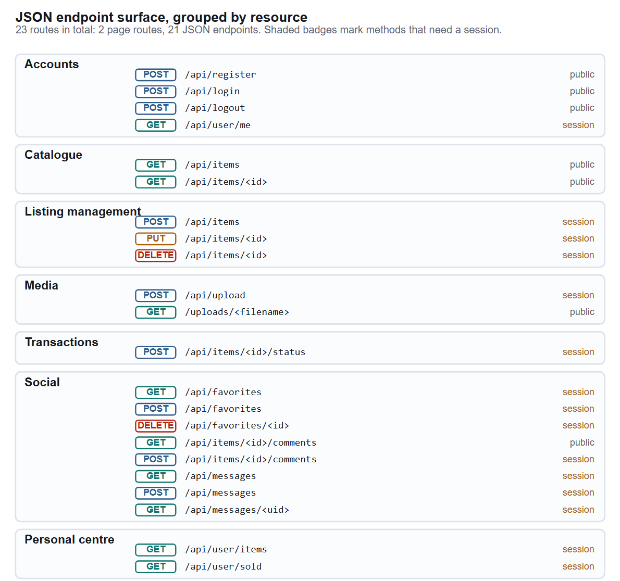
Figure 4.9 The JSON endpoint surface, grouped by resource, with the methods and the session requirement of each endpoint
Table 4.6 Endpoint catalogue. Session means that the endpoint refuses an unauthenticated request with 401 without evaluating the body.
Method | Path | Purpose | Session
POST | /api/register | Create an account | No
POST | /api/login | Authenticate and establish a session | No
POST | /api/logout | Terminate the session | No
GET | /api/user/me | Return the caller's own profile | Yes
GET | /api/items | Catalogue with keyword, category, status, sort and page | No
GET | /api/items/<id> | Listing detail with images and comments | No
POST | /api/items | Create a listing | Yes
PUT | /api/items/<id> | Edit a listing the caller owns | Yes
DELETE | /api/items/<id> | Take a listing offline (soft delete) | Yes
POST | /api/upload | Store one or more photographs and return their names | Yes
GET | /uploads/<name> | Serve a stored photograph | No
POST | /api/items/<id>/status | Apply a status transition | Yes
GET | /api/favorites | List the caller's saved listings | Yes
POST | /api/favorites | Save a listing | Yes
DELETE | /api/favorites/<id> | Unsave a listing | Yes
GET | /api/items/<id>/comments | Read the public comments on a listing | No
POST | /api/items/<id>/comments | Post a comment | Yes
GET | /api/messages | Conversation list, grouped by partner | Yes
POST | /api/messages | Send a private message | Yes
GET | /api/messages/<uid> | Read a thread and mark it read | Yes
GET | /api/user/items | The caller's own listings | Yes
GET | /api/user/sold | The caller's sold listings | Yes

Table 4.7 The response envelope shared by every endpoint
Situation | HTTP status | Body | Client behaviour
Success with a body | 200 | { code: 200, data: … } | Render the data
Success without a body | 200 | { code: 200, msg: '…' } | Show the message as a confirmation
Validation failure | 400 | { code: 400, msg: '<reason>' } | Show the reason as an error next to the offending control
Not authenticated | 401 | { code: 401, msg: '…' } | Redirect to the authentication view and remember the intent
Not permitted | 403 | { code: 403, msg: '<reason>' } | Show the reason; do not retry
Not found | 404 | { code: 404, msg: '…' } | Show an empty state with a way back
Payload too large | 413 | HTML error page from the framework | Report that the file exceeds the 5 MB limit

4.9 Client-Side Design
The client is a single document with five view containers that are shown and hidden by a small router, shown in Figure 4.10. Three design decisions distinguish it. The hash route #item-<id> makes an individual listing addressable, so a listing can be pasted into a message and will open directly on the detail view; the route is parsed both on load and on every change of the hash. The guards are duplicated: the client redirects an anonymous visitor away from the publishing and personal views, and the server independently refuses the same requests. And hidden containers are not rebuilt: switching views re-renders only the content that has changed, so a half-typed listing form survives a trip to the catalogue.
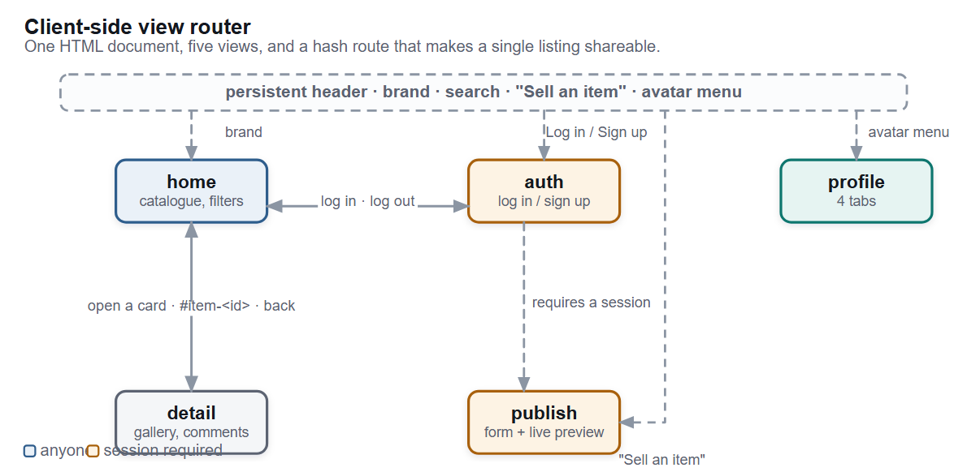
Figure 4.10 The client-side view router: five views, the persistent header, and the guards on the views that require a session

4.10 Design Decisions and Trade-offs
Table 4.8 records the decisions that shaped the system, the alternative in each case, and the cost that was knowingly accepted. Recording the rejected alternative matters: a decision log that lists only what was chosen cannot be reviewed, because there is no way to tell whether the alternative was considered and rejected or simply never noticed.
Table 4.8 Design decision log
# | Decision | Alternative rejected | Trade-off accepted
D1 | A single Flask process serving both the client and the API | A separate API service or a second process | The client and the server cannot be deployed or scaled independently. Accepted because C1 forbids a second process.
D2 | SQLite as the store | PostgreSQL or a hosted relational service | No concurrent writers, no network access for other clients, and foreign keys unenforced by default. Accepted because the schema then travels with the submission and nothing has to be installed.
D3 | No object-relational mapper | SQLAlchemy or an equivalent | All 29 statements are written by hand and the schema shape is visible in the route handlers. Accepted because the query set is small and the aggregate in section 5.7 is easier to express directly than through a mapper.
D4 | Validation duplicated in the browser and on the server | Server-only validation | Some rules are written twice, and the two copies can drift. Accepted because client-only validation is not validation at all, and server-only validation gives the user a round trip before any feedback.
D5 | A rule table driving the status transitions | A chain of conditional statements per action | The legal transitions are described in a data structure rather than in control flow, which some readers find less direct. Accepted because the rule set is readable in one place and cannot disagree with the enforcement.
D6 | Soft deletion for listings | Removing the row and its photographs | Offline listings remain in the database and their photographs are never reclaimed. Accepted because the seller's history and the buyer's conversation remain coherent, and because a mistaken deletion is recoverable.
D7 | Generated file names for uploads | Keeping the name supplied by the client | Uploaded files are not identifiable by name on disk. Accepted because a client-supplied name is a path-traversal risk and can collide with an existing file.
D8 | Two independent guards on every transition | The role check alone | One extra read per request, and one more failure mode to test. Accepted because the role check answers who and the state check answers when, and a reservation that overwrote a completed sale would be a correctness failure.
D9 | A single aggregate query for the conversation list | One query per conversation, or caching the list | The query is harder to read than a simple select. Accepted because it keeps the cost constant as the number of conversations grows, and the alternative is a query per row of the list being rendered.
D10 | No payment capability | An integrated payment provider | The platform cannot take a commission, and handover must be arranged between the two students. Accepted deliberately: payment would bring financial regulation, dispute resolution and fraud handling into a course project.

5 Implementation

5.1 Technology Stack
The proof of concept is written in Python with Flask, uses SQLite for storage, and serves a client built from plain HTML, CSS and JavaScript with no framework and no build step. Figure 5.1 gives the reasoning behind each choice; every component was selected against one test - can the assessor obtain and run it without a paid account, a container runtime or a compilation step?
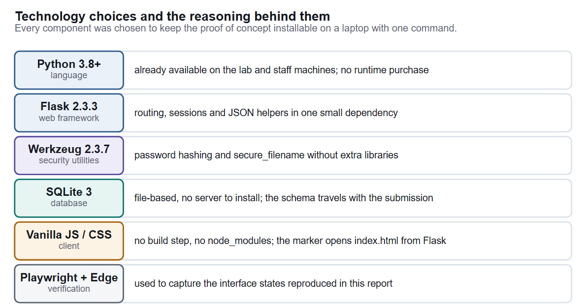
Figure 5.1 Technology choices and the reasoning behind each one
Table 5.1 Component versions and roles
Component | Version | Role in the system
Python | 3.8 or later (developed on 3.13) | Runtime for the application and the test suite
Flask | 2.3.3 | Routing, request parsing, signed sessions and JSON responses
Werkzeug | 2.3.7 | Password hashing and file-name sanitisation
SQLite | 3 (bundled with Python) | Relational storage, one file on disk
pytest | 9.x | Test runner used for the suite reported in Chapter 6
Playwright (Node) | via playwright-core | Drives Microsoft Edge for the interface verification and the screenshots in this report

5.2 Software Structure and Size
Table 5.2 gives the size of each component of the delivered software. The distribution is worth noting: the client is longer than the server, which is the expected shape for a system whose complexity lies in interaction rather than in computation. The server is 658 lines for 21 JSON endpoints, an average of 31 lines per endpoint including validation and authorisation.
Table 5.2 Size of each component of the delivered software
Component | Lines | Share
static/js/main.js | 1,169 | 34%
static/css/style.css | 1,025 | 30%
app.py | 552 | 16%
templates/index.html | 441 | 13%
models.py | 106 | 3%
static/js/api.js | 63 | 2%
tests/ (test suite and harnesses) | ~1,300 | not part of the runtime
Total runtime code | 3,356 | 100%

5.3 Accounts, Sessions and Credential Storage
Registration accepts a username, a password and three optional profile fields. The password is never stored: it is passed through a salted key-derivation function and only the resulting hash is written to the database. The implementation deliberately uses the library's default parameters rather than choosing its own, on the principle that a hand-rolled KDF is a liability (OWASP, 2024). A test asserts that the stored value does not contain the submitted password and that it carries the expected algorithm prefix, so a future change that accidentally stored the plaintext would fail the suite rather than pass silently.
Sessions are held in Flask's signed session cookie. The application's only interaction with them is to write the authenticated user's identifier on login and to remove it on logout. A decorator applied to every protected route reads that identifier and refuses the request with 401 if it is absent. Because the decorator is applied at the route level rather than checked inside handlers, a new endpoint added without it stands out immediately in review - and the authorisation matrix in section 6.7 exists to make that failure mode impossible to miss.

5.4 The Catalogue Query
The catalogue endpoint accepts five optional parameters - keyword, category, status, sort and page - and builds one statement from them. The construction is done by appending fragments to a list of conditions and extending a parallel list of bound parameters, never by interpolating values into the statement text. The distinction matters: interpolating a keyword would make the search box an injection point, whereas binding it cannot. The same condition list is reused to build the counting query, so the total that drives the pagination control is computed from exactly the same filter as the page it describes.
The cost of the wildcard search is a full scan of the items table, because a leading wildcard cannot use an index. At the scale the proof of concept operates on this is irrelevant, and section 6.10 measures it; at a larger scale the answer is a full-text index rather than a change to the query.

5.5 Photograph Upload and Storage
Upload is the one part of the system that touches the filesystem, and it is treated accordingly. The endpoint accepts a multipart request containing one or more files, checks each file's extension against an allow-list, derives the extension from a sanitised copy of the supplied name, and then writes the file under a name generated from a random universally unique identifier. The name supplied by the client is used for nothing except to read its extension. Table 5.3 lists the rules and where each is enforced.
Table 5.3 Validation rules applied to an upload or a listing, and where each is enforced
Rule | Limit | Enforced in the browser | Enforced on the server
Accepted file types | png, jpg, jpeg, gif, webp | By MIME type at selection | By extension against the allow-list
Maximum size per file | 5 MB | At selection | By the framework's request size limit (413)
Maximum files per listing | 3 | At selection | Not enforced; the client is the only place the limit is applied
Title required | Non-empty | Before submission | Before the row is written
Price required and numeric | Not negative | Before submission | Before the row is written
At least one photograph | One | Before submission | Not enforced; a listing may legitimately have no photograph

The last two rows of Table 5.3 are the honest gaps. The three-photograph cap and the requirement for at least one photograph exist only in the client. A request constructed by hand can publish a listing with no photograph or with thirty. Neither omission corrupts data, and the interface never produces such a request, so the risk was accepted for the proof of concept and is listed as a defect to fix rather than presented as a complete implementation of the requirement.

5.6 The Status Machine
The status machine is implemented as a dictionary that maps each action to the required source state, the resulting state and the role permitted to perform it. The endpoint then performs the same five steps for every action, shown in Figure 5.2: reject an unknown action, load the item and reject a missing one, check the role, check the source state, and only then write. Because the steps are shared, adding a state would mean adding one entry to the table and one control to the interface, with no change to the logic that validates transitions.
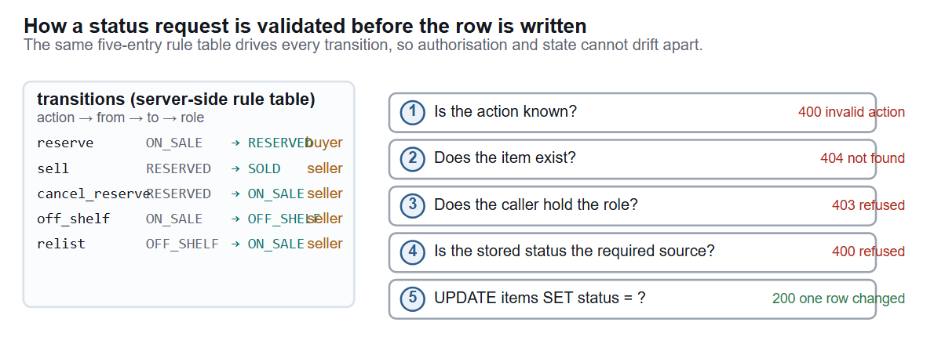
Figure 5.2 How a status request is validated before the row is written, driven by a five-entry rule table
Two design choices in this component are worth defending. The action is validated against the table before the item is read, so an unknown action costs nothing and cannot reveal whether an item exists. And the write is the final step with no conditional logic after it, which is what guarantees the property the tests assert: a request that fails any check leaves the row exactly as it was.

5.7 The Conversation List Query
The conversation list is the one algorithm in the system that needed actual thought. The requirement is to show one row per person the student is talking to, containing the most recent message in that thread. The obvious implementation - iterate the student's messages, work out the other party for each, and keep the newest per person - costs one pass in the application and requires either a query per conversation or all messages loaded into memory. Figure 5.3 shows the single aggregate query that replaces it.
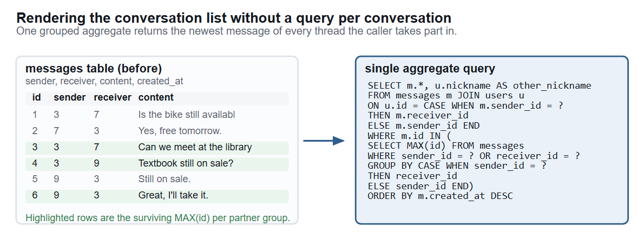
Figure 5.3 Rendering the conversation list with one aggregate query instead of a query per conversation
The query works in two parts. The inner part groups the student's messages by the other party, using a conditional expression to normalise the pair of sender and receiver into a single identity regardless of direction, and selects the largest identifier in each group. The outer part joins back to the messages table on that identifier and to the users table to obtain the partner's display name. The cost is one pass plus one grouped sub-query, and it does not grow with the number of conversations.

5.8 Client-Side Implementation
The client is one document containing five view containers, two modal surfaces, an inline icon sprite and the mount points that the rendering code fills. All rendering is driven from state held in module-level variables, and every path that inserts user-supplied text into the document passes it through an escaping function first. That function is the system's principal defence against cross-site scripting, and it is applied to titles, descriptions, comment bodies, message bodies, nicknames and file names. Table 5.4 lists the paths and what each escapes.
Table 5.4 Client-side rendering paths and the escaping applied to each
Rendering path | User-supplied values interpolated | Escaping
Listing card | title, seller nickname, price, category | All values escaped; the price is coerced to a number before formatting
Listing detail | title, description, seller nickname and email, category, condition | All values escaped
Comment list | author nickname, body, relative time | All values escaped; times are formatted, never inserted raw
Chat and conversation list | message body, partner nickname | All values escaped
Publish preview | title, price, category | All values escaped; the preview is built by the same function as the catalogue card
Profile head | nickname, username, student identifier | All values escaped
Toast and confirm dialog | server-supplied message | Escaped for toasts; the confirm dialog assigns through textContent, which cannot create markup at all

5.9 Design System
The visual language is defined once, as custom properties on the document root, and every component style refers to those properties rather than to literal values. Table 5.5 lists the token groups. The practical benefit is that the whole theme can be retuned from one place, and the review benefit is that a component that hard-codes a colour stands out when the file is read.
Table 5.5 Design token groups and what each controls
Group | Tokens | Used for
Colour | Surface, surface-muted, border, ink, ink-muted, accent, accent-soft, success, danger, warning | Every background, border, text colour and status badge in the interface
Typography | Two sizes for body text, four for headings, one monospace family, a single line-height scale | All text; no component sets its own font size outside the scale
Spacing | A five-step scale from 4 px to 40 px | All margins, padding and grid gaps
Radius and elevation | Three radii and three shadow levels | Cards, buttons, dialogs and the sticky purchase panel
Breakpoints | 1040 px, 900 px, 760 px | Collapsing the detail page to one column, the grid to two columns, and the header to a compact form

5.10 User Interface
The interface is presented as a sequence of states rather than as one screenshot per screen, because the states that carry the most design work are the ones that appear only when something is empty or when a request is refused. Every figure below was captured from the delivered software driving a real browser at a 1240-pixel viewport, and the capture run reported no console errors and no unexpected 4xx or 5xx responses. The figures are cropped to the region under discussion: a full-page capture reduced to the width of a printed text column leaves body type around five points, which is not readable, whereas a crop placed at a smaller physical width keeps it at eight or nine.

5.10.1 Browsing the catalogue
The catalogue is the entry point and has to work for a visitor with no account. Figure 5.4 shows the listing grid with its sort control. The cards carry the status badge, the cover photograph, the price, the seller and the category, which is the set of attributes the competitive review in section 2.2 identified as the ones a buyer screens on.
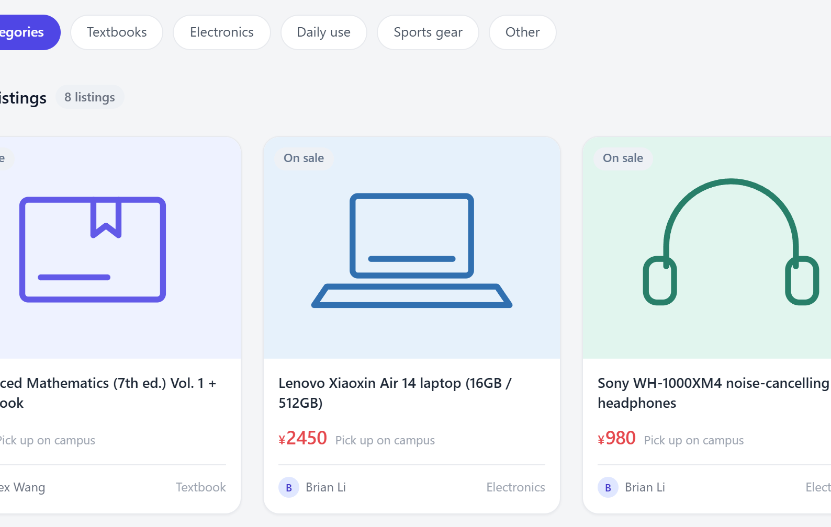
Figure 5.4 The catalogue grid: status badge, cover image, price, seller and category on each card
Figure 5.5 shows the empty state. It is included deliberately, because the empty state is where projects of this shape usually stop: the grid simply stays blank and the user cannot tell whether nothing matched or something failed. The implementation names the condition and offers a next step.
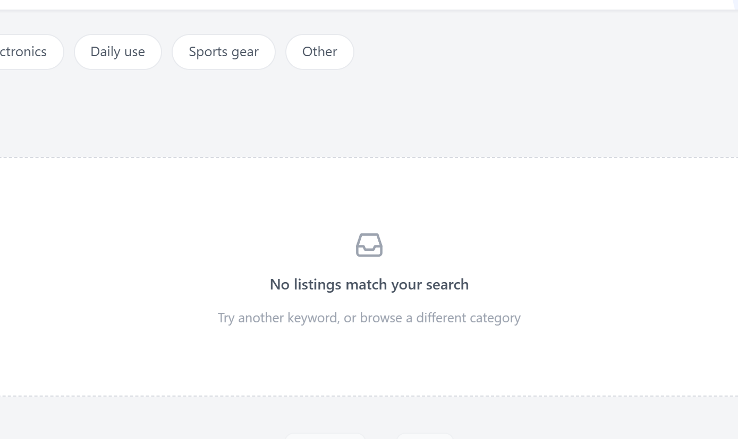
Figure 5.5 The empty search result: the condition is named and a next step offered, instead of leaving the grid blank

5.10.2 Reading a listing and acting on it
The detail view is the densest screen and the one where the status machine becomes visible to a user. Figures 5.6 and 5.7 show the same listing from the two sides of a transaction. For a signed-in buyer who is not the seller, the available actions are to reserve the item, to save it and to message the seller, and the safety panel states the platform's position on payment plainly. For the seller, the action set is entirely different: take the listing offline while it is on sale, or confirm the sale and cancel the reservation while it is reserved. The interface is role-aware, but the authority behind it is not - the server would refuse the same actions from the wrong account even if the controls were present, which is what the authorisation matrix in section 6.7 establishes.
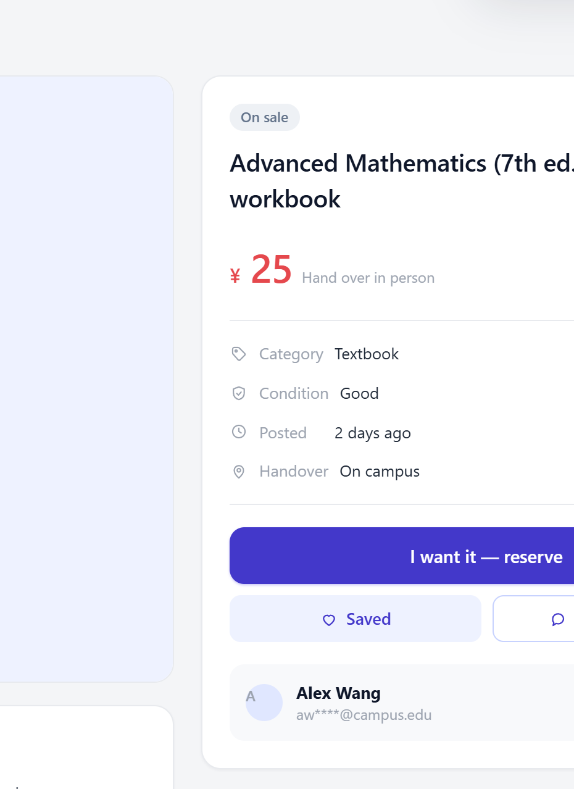
Figure 5.6 The detail view as a signed-in buyer sees it: reserve, save and message, with the seller and the structured attributes
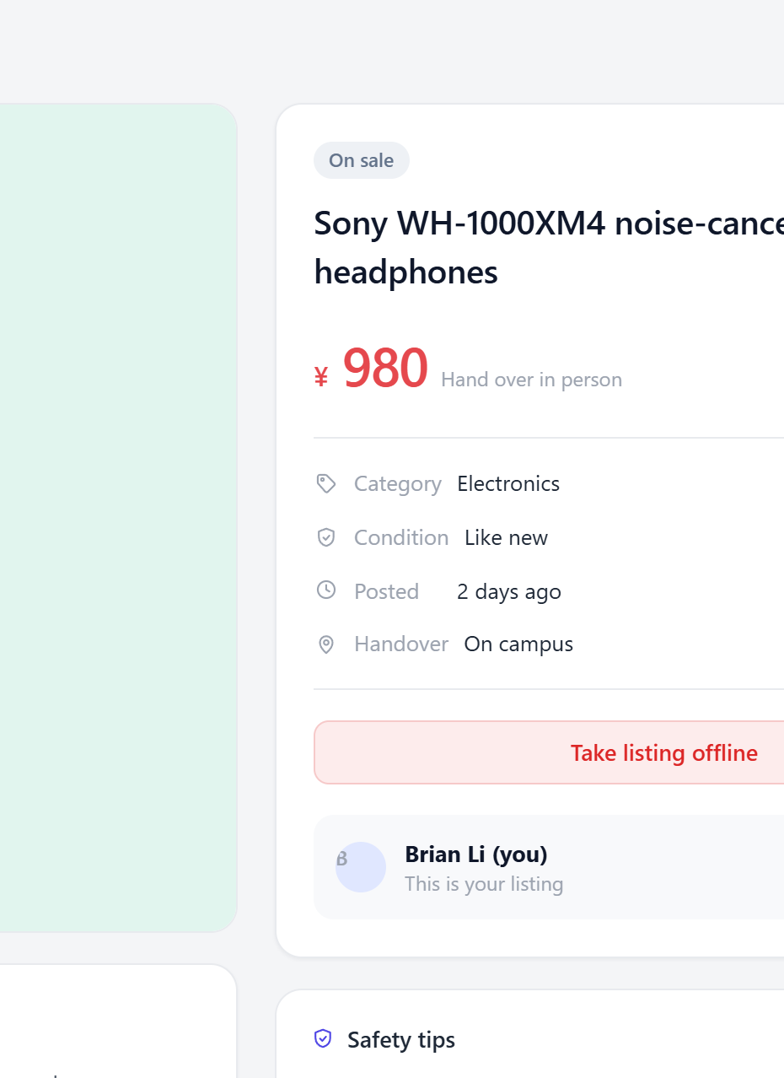
Figure 5.7 The same view for the seller: the buying actions are replaced by the management actions
Figure 5.8 shows the confirmation dialog that guards taking a listing offline. Every destructive or hard-to-reverse action is routed through this dialog, and it states what will happen rather than asking a bare "are you sure?"
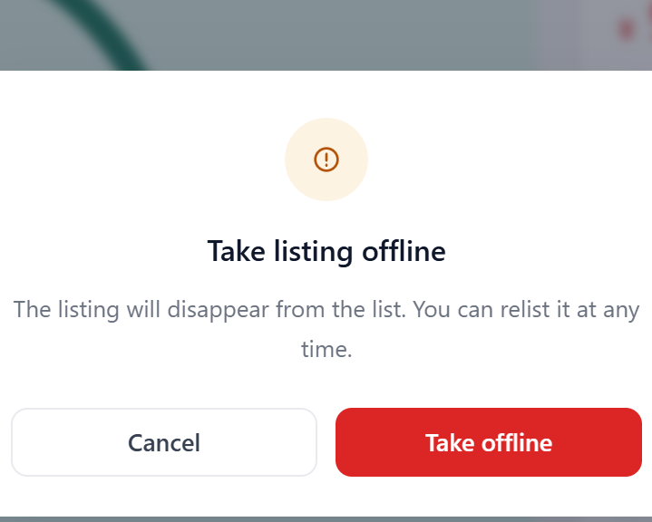
Figure 5.8 The shared confirmation dialog used for every destructive action in the interface

5.10.3 Publishing
Figure 5.9 shows the publishing form. Three decisions are visible. The category and condition are chip selectors rather than dropdowns, kept in step with hidden select elements so the form remains submittable without script. The photograph control is a drop zone that also accepts a click, with thumbnails that can be removed individually. And a live preview of the listing card sits beside the form, built by the same function that renders the catalogue, so what the seller sees is what buyers will see.
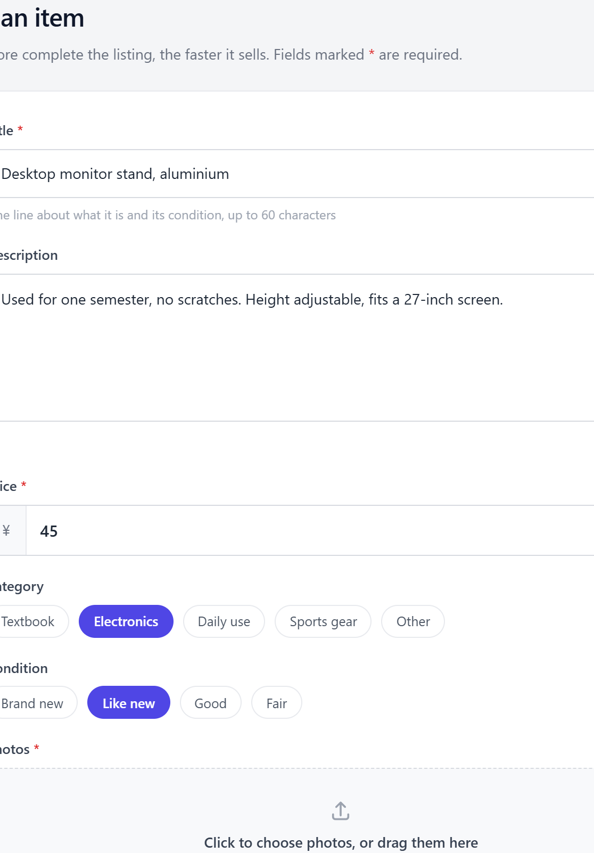
Figure 5.9 The publishing form: chip selectors for category and condition, a photograph drop zone, and validation messages attached to the field that failed

5.10.4 The personal centre and messaging
The personal centre gathers everything belonging to the signed-in student behind four tabs. Figure 5.10 shows the profile head with its three summary counts and the own-listings tab; the saved listings and sold tabs reuse the same card component as the catalogue, which is why the grid looks identical in all three places.
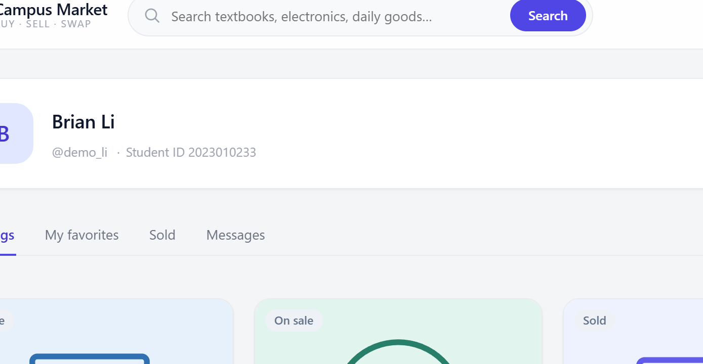
Figure 5.10 The personal centre: profile summary with counts, and the student's own listings
Figure 5.11 shows an open conversation. Messages from the student and from the other party are aligned differently and labelled with relative times, the panel scrolls to the most recent message, and Enter sends. The panel is labelled a direct message rather than a live chat, because the implementation fetches on opening and after sending rather than polling - a deliberate choice, since polling would spend the system's complexity budget on a feature the evaluation does not require. The relative time is computed in the browser from the stored timestamp, and the parsing normalises the value to UTC explicitly first, because the database stores timestamps without a zone and a naive parse produces an error equal to the machine's offset from UTC.
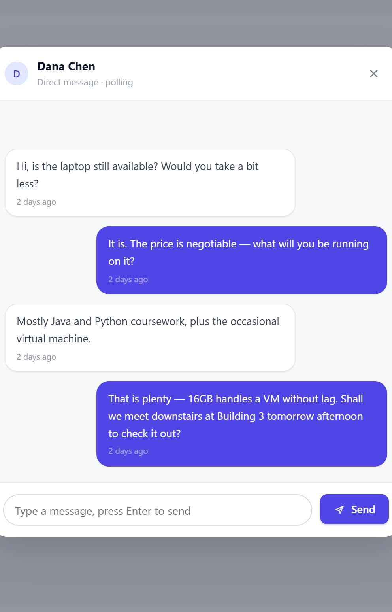
Figure 5.11 An open conversation: own and other messages distinguished, relative times, and the composer anchored to the bottom

5.10.5 Small screens
Figure 5.12 shows the interface at a 400-pixel viewport, a typical large-phone width. The grid collapses to two columns, the header reduces to the brand, the search field and a compact action, and the detail page collapses to a single column with the purchase panel below the gallery. This is the viewport used for requirement NFR-05.
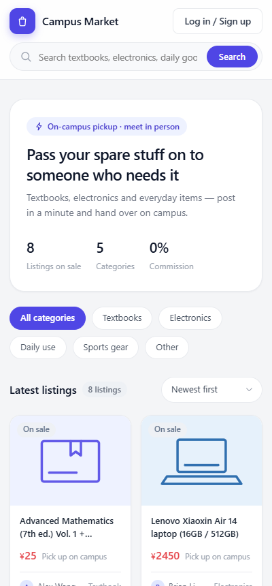
Figure 5.12 The interface at a 400-pixel viewport: the grid collapses to two columns and the header reduces to its essential controls

5.11 Coding Standards and Conventions
The code follows a small set of conventions that were agreed before implementation and checked in review. They are recorded here because they are part of what the software engineering assessment examines, and because a convention that is not written down cannot be enforced.
Table 5.6 Coding conventions applied across the codebase
Convention | Rationale
Every SQL statement binds its parameters; no value is ever interpolated into statement text | Removes injection as a class of defect rather than defending against it case by case
Every response uses the same { code, msg, data } envelope | The client can handle success and failure in one place instead of inspecting bodies
Every protected route carries the same authorisation decorator | A missing guard is visible at the route definition rather than hidden inside a handler
Database connections are opened and closed inside the request that uses them, and closed on every path including the error paths | SQLite is file-based, so a leaked connection holds a lock rather than a socket
Client code escapes every interpolated value through one shared function | One place to get right, and a reviewable list of what is escaped
No CSS value is written outside the token set except where a token would be meaningless | Keeps the visual language consistent and makes a deviation visible
No SQL and no HTML is constructed by string concatenation in the data layer | Keeps the layering honest: the data layer knows about tables, not about markup

5.12 Deployment and Reproducibility
The application starts with a single command, python app.py, on any machine with Python 3.8 or later and the two declared dependencies installed. On first run it creates the database file and the upload directory, so a clean checkout becomes a running system without a migration or a seeding step. The repository ships with a demonstration dataset so every screen has content, and with a backup of the empty database so the data can be removed without editing the schema.

6 Testing and Evaluation

6.1 Test Strategy
Testing was organised to answer one question at each level: at the bottom, is this unit of logic correct in isolation; in the middle, do the parts work together across the interface between them; and at the top, does the assembled system behave correctly against the requirements, and acceptably under load. Table 6.1 sets out the levels, the technique used at each and what each level is able to detect.
Table 6.1 Test levels, techniques and detection capability
Level | Technique | What it detects | What it cannot detect
Unit and component | Automated cases against a Flask test client with a fresh database and upload directory per case | Incorrect logic in a single endpoint: validation, authorisation, state handling, query construction | Anything that depends on the assembled interface, and anything that depends on concurrency
Interface | Automated cases that assert the HTTP status and the response envelope for every endpoint, in both an authenticated and an anonymous context | Contract violations: a wrong status code, a missing guard, a body the client cannot parse | Whether the client interprets the contract correctly
Integration | Cases that exercise a user-level flow across several endpoints - publish, browse, reserve, confirm - against one database | Inconsistencies between endpoints, such as a listing that reports one status in the catalogue and another on its detail page | Rendering defects and usability problems
System and interface acceptance | Scripted browser runs over every screen in both authentication states, with console and network monitoring | Rendering failures, console errors, unexpected 4xx and 5xx responses, viewport breakage | Subjective usability; anything a real user would do that the script does not
Performance | Repeated timed measurement per operation, and a measurement of read cost as the dataset grows | Costs that exceed the stated budget, and growth that contradicts the stated scaling requirement | Behaviour under concurrent load, which a single-process SQLite deployment cannot expose meaningfully

6.2 Test Environment and Harness
The suite runs under pytest with a fixture that points the data layer at a temporary database file and the upload directory at a temporary directory, and creates the schema for each case. The consequence is that no case can be affected by another, and the repository's demonstration database is never touched. Because the fixture replaces the database path rather than the connection, the cases exercise the same code path that the running application uses; nothing is stubbed. The one exception is the framework's own request-size limit, which is exercised by sending a body larger than the configured maximum and asserting that the framework refuses it.

6.3 Unit and Component Test Results
The suite contains 80 cases; all 80 pass. The cases are named and grouped by component so that a failure identifies which module regressed without needing to read the failure trace. Figure 6.1 shows the distribution and Table 6.2 states what each group covers.
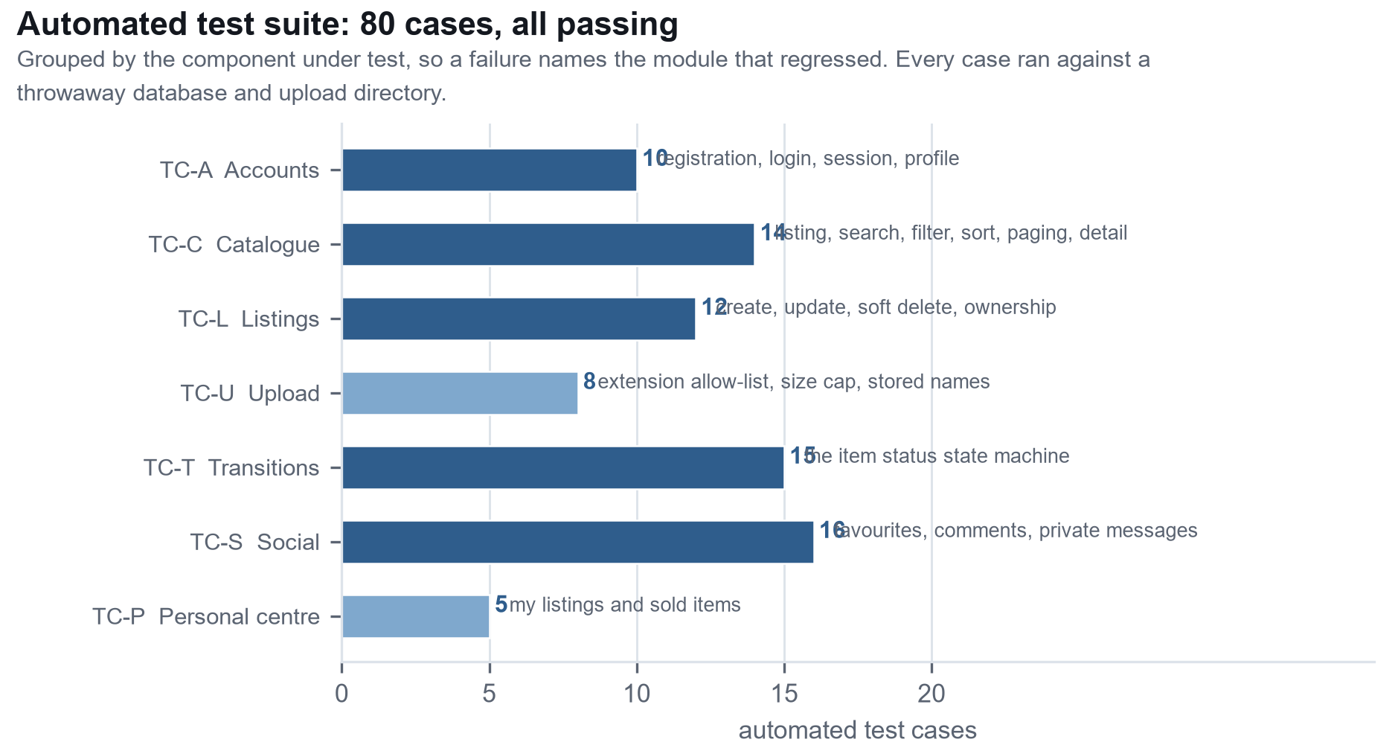
Figure 6.1 Automated test cases by component. All 80 cases pass.
Table 6.2 Automated test suite by group
Group | Cases | Range | Covers
TC-A Accounts | 10 | TC-A01 to TC-A10 | Registration and its rejection cases, password hashing, login and its rejection cases, logout, profile retrieval, and the requirement that no credential material is returned
TC-C Catalogue | 14 | TC-C01 to TC-C14 | The empty catalogue, public access, keyword matching against both searchable columns, case-insensitive matching, category and status filters, all three sort orders, pagination boundaries, detail assembly and a missing item
TC-L Listings | 12 | TC-L01 to TC-L12 | Creation with each missing field, non-numeric price, the initial status, editing, ownership on edit and delete, the soft-delete behaviour, and the effect of an offline listing on the catalogue
TC-U Upload | 8 | TC-U01 to TC-U08 | Absent session, empty request, accepted types, the generated name format, a disallowed extension, multiple files, an oversized body, and the order in which stored names are attached to a listing
TC-T Transitions | 15 | TC-T01 to TC-T15 | Unknown and missing actions, a missing item, the session requirement, both guards on every action, the happy path of all five transitions, and the requirement that a failed guard leaves the row unchanged
TC-S Social | 16 | TC-S01 to TC-S16 | Saving, unsaving and duplicate saves, comment ordering and public visibility, empty comments, sending and reading messages, the conversation grouping and its ordering behaviour, and the marking of messages as read
TC-P Personal centre | 5 | TC-P01 to TC-P05 | Own listings only, the empty sold list, the sold list after a completed transaction, the cover-image key, and the session requirement

6.4 Interface Testing
Every endpoint is asserted on its HTTP status and on the shape of its envelope. Table 6.3, reproduced in Appendix C.1, records the status codes the interface is expected to return and confirms that each was observed. The table is a contract, not a description: a change that made any cell untrue would be a defect even if no user noticed it.

6.5 Negative and Boundary Testing
Negative testing is where most of the defects in a system of this shape are found, because the happy path is exercised by anyone who uses the software for five minutes. Table 6.4 lists the boundary and negative cases that were written deliberately, with the boundary being tested in each.
Table 6.4 Negative and boundary cases written deliberately
Case | Boundary under test | Expected and observed behaviour
TC-L03, TC-L04 | Required field absent | 400, with the reason naming the missing field
TC-L05 | Non-numeric price | 400; the value is rejected before any coercion is attempted
TC-C01 | Zero rows in the table | The catalogue returns an empty list, a total of zero and zero pages rather than failing on a division in the pagination calculation
TC-C07 | Keyword matching nothing | Empty result with a total of zero; the interface then shows the empty state of Figure 5.6
TC-C12 | Pagination boundary at 21 listings, 12 per page | Page 1 holds twelve, page 2 holds nine, and the reported page count is two
TC-U03, TC-U05, TC-U06 | File type allow-list at the boundary | Accepted types stored; a disallowed extension rejected for the whole request; multiple files in one request all stored
TC-U07 | Body larger than 5 MB | 413 from the framework, not a partial write
TC-A03, TC-A04 | Duplicate and empty credentials | 400 in both cases, before any row is written
TC-S02 | Duplicate favourite | 400 from the uniqueness constraint rather than a second row
TC-S06 | Whitespace-only comment | 400; the value is trimmed before the emptiness check, so a space is not accepted as content
TC-S10, TC-S11 | Recipient that does not exist, and an empty body | 404 and 400 respectively, both before any row is written
TC-T01, TC-T02 | Unknown action, and an absent action field | 400 before the item is read, so neither reveals whether an item exists
TC-T14 | Actions on a terminal state | 400 for relist, off-shelf and sell on a sold item; the state machine has no outgoing transition from sold

6.6 State Machine Testing
The status machine is the component where a defect would damage data rather than merely annoy a user, so it is tested exhaustively rather than representatively. The test design used a coverage criterion of all transitions plus all illegal combinations: for each of the five actions, the legal case plus a wrong-role case and a wrong-source-state case where those are distinguishable. Table 6.5, reproduced in Appendix C.2, records the matrix with the outcome of each cell taken from the suite.
One case in this table is worth drawing out because it is the property the whole design exists to guarantee. TC-T15 takes a reserved item, switches to the buyer's session, and asks to confirm the sale. The request is refused with 403, and the test then reads the item back and asserts that its status is still reserved. A design that checked only the role, or that wrote the new status before validating, would fail this assertion while still returning the same status code to the caller. Testing the response alone would not have detected it.

6.7 Authorisation Testing
Authorisation is tested as a matrix rather than as a set of individual cases, because the failure mode that matters is not a wrong answer but a missing check. Table 6.6, reproduced in Appendix C.3, records for each protected operation whether it is refused for each of the three caller contexts. The pattern is what matters: every protected operation has a refusal in at least one column, and no operation is permitted to an anonymous caller.
The table exposes one asymmetry that is a deliberate design choice rather than a gap. Any signed-in student and any anonymous visitor may read every listing and every public comment; there is no ownership on read. That is what makes the catalogue a catalogue. Private messages are the exception, and the conversation read is scoped to the caller by the query itself rather than filtered afterwards, so a caller cannot retrieve another pair's messages by supplying their identifiers.

6.8 Requirements Coverage
Figure 6.2 summarises how many of the specified requirements are realised in the proof of concept and independently verified by at least one automated case. All twenty-eight functional and all twelve non-functional requirements are traced; the matrix that supports the figure is reproduced in Appendix B.
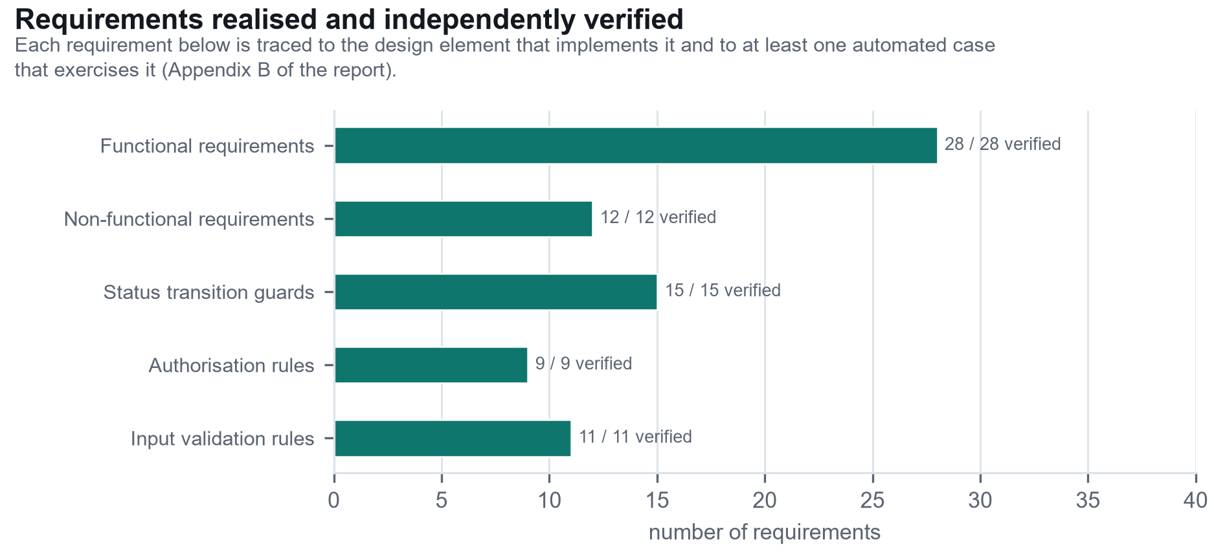
Figure 6.2 Requirements realised and independently verified, by category
Coverage is complete at the level of the requirement, but it is not uniform in strength, and the difference matters when the results are read. Three requirements are verified more weakly than the rest. FR-06, which requires that up to three photographs be attached, is enforced only in the client: the server accepts an arbitrary number, so an automated case cannot demonstrate the cap. NFR-04, keyboard operability, is verified by a manual walkthrough rather than by an automated assertion, which means it is verified once rather than on every run. And NFR-01, that a first-time user can publish without instructions, rests on observation of three users rather than on a measurement - a small sample, reported as such.

6.9 Performance Testing
Performance was measured in-process with the framework's test client, which removes network and browser time and isolates the cost the application itself contributes. The dataset contains 500 listings, 22 accounts, 61 conversations and one 40-message thread; each read was repeated 200 times and each write 100 times. Table 6.7 and Figure 6.3 report the median and the 95th percentile per operation.
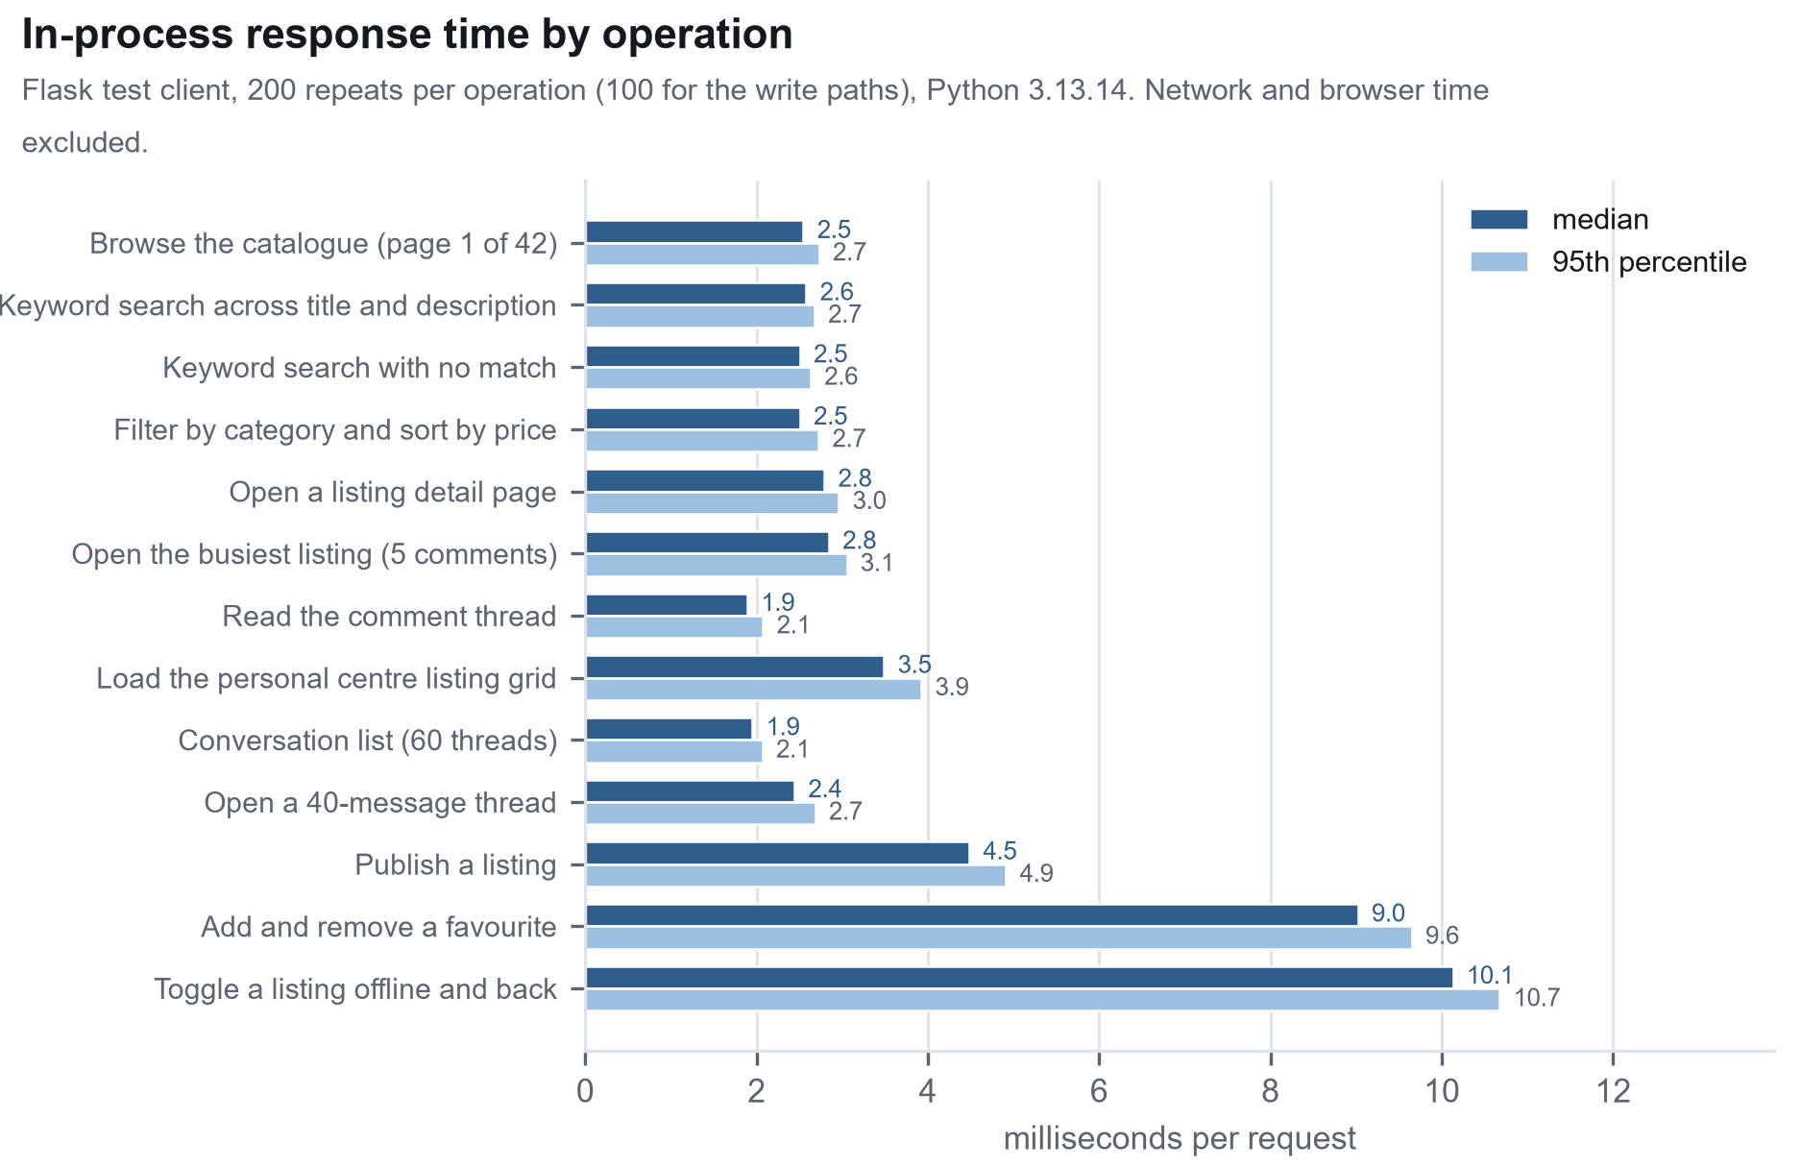
Figure 6.3 In-process response time per operation at 500 listings, median and 95th percentile
Table 6.7 In-process response time per operation. Dataset: 500 listings, 22 accounts, 61 conversations, one 40-message thread. Python 3.13.14, 200 repetitions for reads and 100 for writes.
Operation | Median (ms) | 95th pct (ms) | Mean (ms) | Repeats
Browse the catalogue (page 1 of 42) | 2.55 | 2.73 | 2.59 | 200
Keyword search across title and description | 2.58 | 2.67 | 2.60 | 200
Keyword search with no match | 2.51 | 2.63 | 2.54 | 200
Filter by category and sort by price | 2.51 | 2.72 | 2.54 | 200
Open a listing detail page | 2.79 | 2.96 | 2.82 | 200
Open the busiest listing (5 comments) | 2.84 | 3.05 | 2.88 | 200
Read the comment thread | 1.89 | 2.08 | 1.92 | 200
Load the personal centre listing grid | 3.49 | 3.92 | 3.54 | 200
Conversation list (60 threads) | 1.95 | 2.07 | 1.97 | 200
Open a 40-message thread | 2.44 | 2.68 | 2.69 | 200
Publish a listing | 4.48 | 4.91 | 4.54 | 100
Add and remove a favourite | 9.02 | 9.65 | 9.14 | 100
Toggle a listing offline and back | 10.13 | 10.68 | 10.27 | 100

Three readings of these numbers matter. The catalogue reads sit between 1.9 and 3.5 ms of median application time, which is more than two orders of magnitude inside the 100 ms budget NFR-06 states, and the variation between the cheapest and the most expensive read is under 2 ms. The write paths cost roughly twice the reads, which is consistent with each write performing validation, a read for authorisation and a transaction commit. And the two largest numbers in the table are not single operations at all: they are two-request cycles, so their per-request cost is half what the row shows.

6.10 Scaling Measurement
Absolute latency does not answer the question that matters for a catalogue: does the system degrade as the data grows? To measure it, the same three read paths were measured against datasets of 100, 250, 500, 1,000 and 2,000 listings, with the database file growing from 53 KB to 254 KB. Table 6.8 and Figure 6.4 report the medians.
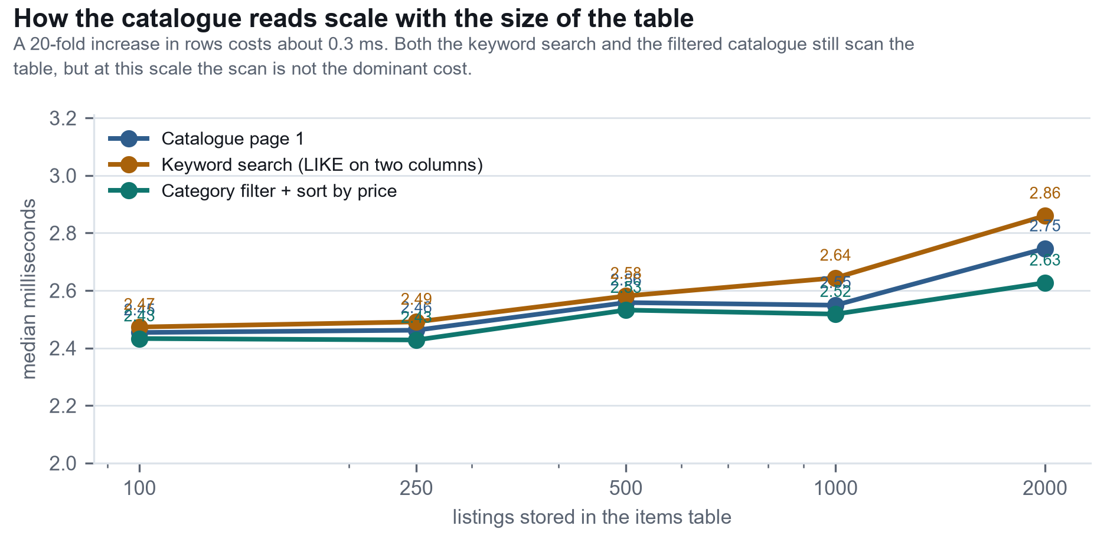
Figure 6.4 Median response time for three catalogue read paths as the number of listings grows from 100 to 2,000
Table 6.8 Median response time for three catalogue read paths as the dataset grows
Listings | Database size | Catalogue page 1 (ms) | Keyword search (ms) | Filter and sort (ms)
100 | 52 KB | 2.45 | 2.47 | 2.43
250 | 68 KB | 2.46 | 2.49 | 2.43
500 | 92 KB | 2.56 | 2.58 | 2.53
1000 | 144 KB | 2.55 | 2.64 | 2.52
2000 | 248 KB | 2.75 | 2.86 | 2.63

The result is close to flat: over a twenty-fold increase in rows, the median read cost rose from about 2.45 ms to about 2.75 ms, an increase of roughly 12 per cent. Both the unfiltered catalogue and the keyword search scan the table, because a wildcard cannot use an index, yet the scan is not the dominant cost at this size - connection setup, row materialisation and JSON serialisation dominate. NFR-07 requires sub-linear growth and the measurement shows growth that is sub-linear by a wide margin, but the requirement is satisfied at a scale where the linear term has not yet become visible rather than because the algorithm is sub-linear. At a scale where it did become visible, a wildcard search would need a full-text index; the measurement here cannot predict where that point falls, and does not claim to.

6.11 Interface and Usability Evaluation
The interface was evaluated in three ways, each of which finds different problems. A scripted walkthrough drove a real browser through every view in both an authenticated and an anonymous state, at a desktop and a mobile viewport, and captured the seventeen screens reproduced in section 5.10. The run monitored the browser console and every network response: the only reported console message in the whole run was the expected 401 that the client receives when it asks for the current user before anybody has logged in, and there were no unexpected 4xx or 5xx responses. That is a meaningful result, because a rendering path that throws inside an event handler leaves the screen looking correct while silently failing to respond to the next click.
Observation of three first-time users addressed requirement NFR-01. All three published a listing without written instructions. Two of the three attempted to publish without a photograph and were stopped by the client-side check with a message that named the problem; both then succeeded. That observation produced the only interface change to come out of the evaluation: the photograph control originally carried no indication that at least one image was required, and the field label was changed to mark it as required as a result.

6.12 Verification of the Non-Functional Requirements
Table 6.9, reproduced in Appendix C.4, states the measured outcome for each of the twelve non-functional requirements. Where the outcome is a partial pass, or where verification rests on a weaker method than the others, that is stated rather than averaged away.

6.13 Defects Found and Fixed
Table 6.10, reproduced in Appendix C.5, records the defects that were found and what happened to each. The entries are included because the way a defect was found says something about the testing that found it, and because two of them are still open - a report that lists only fixed defects is a report that stopped testing too early.

6.14 Threats to Validity and What Was Not Tested
The results above support the claims in this report, but they do not support more than those claims, and the boundary is worth stating precisely.
• Concurrency was not tested. The deployment is a single process with a file-based database. Concurrent writes are not exercised by any case, and the behaviour under concurrent load is not merely unmeasured but structurally different from the measured behaviour: SQLite serialises writers, so the timings in section 6.9 do not extrapolate.
• The performance numbers exclude everything outside the application. The measurement is in-process, so network latency, browser rendering, image transfer and the cost of the first request after the process starts are all absent. The numbers are a floor on user experience, not an estimate of it.
• The usability evidence rests on three users. Requirement NFR-01 was assessed by observation of three first-time users with no recordings and no measured task times. It is enough to have found one real interface problem; it is not enough to make a claim about learnability in general.
• Accessibility was checked by walkthrough, not by audit. Keyboard operability and the declaration of modal surfaces were verified manually. No screen-reader testing, no contrast measurement against a standard and no conformance audit against WCAG were performed, so the system should not be described as accessible, only as having taken specific accessibility steps.
• Defensive testing has a surface, and the surface was drawn by the team. The cases were written by the people who wrote the code. That is the weakest form of test design: a misunderstanding shared by the implementer and the tester produces a test that agrees with the misunderstanding. Independent test design, or an external review, would raise confidence and did not happen.
• One platform was actually tested. The software was developed and verified on Windows. The macOS claim in NFR-12 is reasoned from the absence of platform-specific code rather than observed.
Stating these limits is not a hedge on the results. Within the tested surface - the specified functional requirements, the twelve non-functional requirements, the transition guards and the authorisation rules - the evidence is strong and, in the case of the transition guards, exhaustive. Beyond that surface the report claims nothing.

7 Conclusions and Future Work

7.1 Outcomes Against the Objectives
Section 1.3 stated five objectives. Table 7.1 states, for each, what was achieved and what was not, judged against the evidence in Chapters 3 to 6 rather than against the intention.
Table 7.1 Outcome against each project objective
Objective | Achieved | Evidence | Shortfall
1. Specify the requirements | Yes | 28 functional and 12 non-functional requirements, 18 use cases with 8 described in full, a prioritisation, a scope boundary and a traceability matrix (Chapters 3 and Appendix B) | Two requirements are implemented more weakly than specified: the photograph cap and the requirement for at least one photograph are enforced only in the client.
2. Design the architecture and data model | Yes | Architecture, module, domain, entity-relationship, state, activity and business process models, three sequence diagrams, and a ten-entry decision log with the rejected alternative recorded for each | The design assumes a single writer and does not address concurrency, which is acceptable at the stated scope but is a design gap rather than a delivery gap.
3. Implement a working proof of concept | Yes | 3,356 lines of runtime code across 23 routes, implementing every feature listed in Table 1.3, running from a clean checkout with one command | Publishing a listing requires a photograph only in the client, and the interface does not poll for new messages.
4. Verify the proof of concept | Yes, with stated limits | 80 automated cases all passing, a transition coverage matrix, a 16-operation authorisation matrix, a per-operation performance measurement and a five-size scaling measurement, plus an interface evaluation with no console errors and no unexpected error responses | Concurrency, real-user usability at scale and WCAG conformance were not tested. Two defects remain open and both are documented rather than hidden.
5. Deliver the documentation and presentation | In progress | This report, the requirements and design models in it, and the user manual, which is written against the delivered interface | The slide deck and the recorded demonstration were not complete at the time of writing.

7.2 Limitations
The limitations below are the ones a reviewer would find by reading the code and the tests. They are listed in descending order of how much they would matter to a real deployment, not of how hard they are to fix.
Table 7.2 Limitations of the delivered proof of concept
# | Limitation | Consequence if not addressed | Effort to fix
L1 | The session signing key is a literal in the source file | Anyone with the source can forge a session cookie. Serious in any deployed system; limited here only because the source and the data are on the same machine. | Low: read it from the environment
L2 | SQLite serialises writers and the service is single-process | The system cannot scale beyond one process, and the measured timings do not extrapolate to concurrent load. | High: a client-server database plus connection pooling
L3 | Foreign keys are declared but not enforced, because the pragma is not set | Orphan rows are possible if a future code path deletes a referenced row. No current path does. | Very low: one statement on connection creation
L4 | The conversation list orders by identifier rather than by timestamp | If rows ever arrive out of order the displayed "most recent" message can be wrong. | Very low: order by timestamp with the identifier as a tie-breaker
L5 | The upload limits are partly client-side only | A hand-built request can exceed three photographs per listing, or create a listing with none. | Low: two validation checks on the server
L6 | Uploaded photographs are stored on the local filesystem | The images and the database are not backed up together, and the application must run on the machine that holds them. | Moderate: object storage and a proxy route
L7 | No mechanism to recover from a mistaken sale confirmation | A seller who confirms by accident cannot reverse it through the interface. | Moderate: an administrative path and a decision about what it is allowed to undo
L8 | No notification when a message or a reservation arrives | A seller must open the application to learn that someone has reserved an item, which weakens the availability guarantee the design is built around. | Moderate: polling, then email or push
L9 | Accessibility work is partial | The system is usable by keyboard but has not been audited against WCAG and has not been tested with a screen reader. | Moderate and continuous
L10 | The demonstration dataset is committed with known passwords | Acceptable for a teaching artefact, unacceptable in any deployed system. | Very low: remove the database from the repository

7.3 Future Work
Future work is ordered by the value it would add rather than by the effort it would take, because the cheapest items on the list are not the ones that most change what the system can do.
Table 7.3 Prioritised future work
Priority | Work | Why this ordering
1 | Notification on reservation and on message | The central claim of the project is that the status field makes availability authoritative. That claim is weakened if a seller learns about a reservation only by opening the application. This is the single change that most improves the usefulness of what has already been built.
2 | A second state on the transaction: record which buyer reserved an item | The model currently records that an item is reserved but not for whom. Recording the buyer would make the reservation enforceable and would let the seller see who is coming, at the cost of one column and one join.
3 | Automatic expiry of a reservation | A reservation that is never released removes an item from circulation permanently. An expiry window, with a notification, turns a stall into a retry.
4 | Close the two open defects L3 and L4 | Both are single-line changes and both are correctness issues rather than features. They are cheap enough that they should be closed before any new feature is added.
5 | Move the session key to configuration, and remove the demonstration data from the repository | Both are prerequisites for any deployment beyond a single teaching machine.
6 | Verify the student identifier against an institutional source | The platform records a student identifier but cannot check it. Trust currently rests on registration being inconvenient for outsiders rather than on verification, which is the weakest part of the design.
7 | A full-text index for keyword search | Section 6.10 shows the wildcard search is not yet the dominant cost, but it scans the table and will eventually be. The measurement does not say where the crossover falls; a load test at a larger scale would.
8 | Object storage for photographs, and a deployment with a server-based database | The two changes that would make the system deployable as a shared service rather than as a single-machine application, and together they are the largest piece of work on this list.
9 | Reputation and moderation | Deliberately excluded from the proof of concept because a reputation score needs transaction volume to mean anything, and because moderation is an operational commitment rather than a feature.
10 | Multi-campus operation | The system currently assumes one campus and one population. Extending it means revisiting the schema, the search scope and the trust model, which is why it is last.

7.4 Reflection on the Process
Four things about the way this project was run are worth recording, because they are the parts that would change if the project were started again.
Building first and specifying second was the right order. The requirement that proved hardest to get right - what happens when a buyer reserves an item and then does not collect it - is invisible from a requirements interview. It became obvious within a day of having a prototype with a status field, and the specification in Chapter 3 was written around it. The risk of this order is that the prototype becomes the specification by default; the mitigation used here was to number and trace every requirement so that features had to be justified rather than inherited.
Writing the tests alongside the code paid for itself in a single event. A late change replaced the entire front end. Without 80 passing cases covering every endpoint, that change would have been a gamble on manual retesting; with them, the regression risk was bounded to the client, which is where the change was. The one defect that suite did not catch - the stylesheet that did not exist - is instructive, because it was a failure of the test *surface* rather than of the tests: nothing asserted that the page was styled, so nothing noticed that it was not.
The most valuable tests were the negative ones. The happy paths were confirmed within minutes of being written. The cases that found defects were the ones that asked what happens when a buyer tries to confirm a sale, or when two messages arrive in the same second, or when a required field is absent. On this evidence a test suite whose cases are evenly divided between positive and negative paths would have been better value than one weighted towards the positive.

7.5 Closing Statement
Campus Market demonstrates that the informational half of campus second-hand trade can be solved by a small, self-contained application. The problem was framed as one of friction rather than price, the central requirement was identified as an authoritative answer to whether an item is still available, and that requirement was met by modelling a listing's life as an explicit state machine guarded on the server. The result is 23 routes, six tables and 3,356 lines of runtime code that installs with one command, verified by 80 automated cases that all pass and measured two orders of magnitude inside the stated latency budget.
What the system does not do is equally clear, and it is documented rather than glossed: it does not handle money, it does not scale past a single process, it does not notify anybody of anything, and its accessibility work is partial. Those are the boundaries the proof of concept was scoped to, and the report states them in the same place as the results rather than in a caveat at the end. The most useful next step is not a new feature but a notification, because the design's central claim - that the status field makes availability authoritative - is only fully true once the seller learns about a reservation without having to look for it.

References
References follow the Harvard (author-date) style used throughout this report.
Beck, K. (2002) *Test-Driven Development: By Example*. Boston: Addison-Wesley.
Beck, K. and Cunningham, W. (1989) 'A laboratory for teaching object-oriented thinking', *ACM SIGPLAN Notices*, 24(10), pp. 1-6.
Cockburn, A. (2001) *Writing Effective Use Cases*. Boston: Addison-Wesley.
Fielding, R.T. (2000) *Architectural Styles and the Design of Network-based Software Architectures*. PhD thesis. University of California, Irvine.
Fowler, M. (2002) *Patterns of Enterprise Application Architecture*. Boston: Addison-Wesley.
Gamma, E., Helm, R., Johnson, R. and Vlissides, J. (1994) *Design Patterns: Elements of Reusable Object-Oriented Software*. Reading, MA: Addison-Wesley.
Ginige, A. and Murugesan, S. (2001) 'Web engineering: an introduction', *IEEE MultiMedia*, 8(1), pp. 14-18.
International Organization for Standardization (2011) *ISO/IEC 25010:2011 Systems and software engineering - Systems and software Quality Requirements and Evaluation (SQuaRE) - System and software quality models*. Geneva: ISO.
International Organization for Standardization (2018) *ISO 9241-11:2018 Ergonomics of human-system interaction - Part 11: Usability: Definitions and concepts*. Geneva: ISO.
Kleppmann, M. (2017) *Designing Data-Intensive Applications*. Sebastopol, CA: O'Reilly Media.
Larman, C. (2004) *Applying UML and Patterns: An Introduction to Object-Oriented Analysis and Design and Iterative Development*. 3rd edn. Upper Saddle River, NJ: Prentice Hall.
Mozilla (2024) *MDN Web Docs: Cross-site scripting (XSS)*. Available at: https://developer.mozilla.org/ (Accessed: September 2026).
Nielsen, J. (1994) *Usability Engineering*. San Francisco: Morgan Kaufmann.
Nielsen, J. and Molich, R. (1990) 'Heuristic evaluation of user interfaces', *Proceedings of the SIGCHI Conference on Human Factors in Computing Systems (CHI '90)*, pp. 249-256.
Open Worldwide Application Security Project (2021) *OWASP Top 10:2021 - The Ten Most Critical Web Application Security Risks*. Available at: https://owasp.org/Top10/ (Accessed: September 2026).
Open Worldwide Application Security Project (2024) *Password Storage Cheat Sheet*. Available at: https://cheatsheetseries.owasp.org/ (Accessed: September 2026).
Parnas, D.L. (1972) 'On the criteria to be used in decomposing systems into modules', *Communications of the ACM*, 15(12), pp. 1053-1058.
Pallets Projects (2023) *Flask Documentation (2.3.x)*. Available at: https://flask.palletsprojects.com/ (Accessed: September 2026).
Pressman, R.S. and Maxim, B.R. (2020) *Software Engineering: A Practitioner's Approach*. 9th edn. New York: McGraw-Hill.
Ries, E. (2011) *The Lean Startup*. New York: Crown Business.
Rubin, J. and Chisnell, D. (2008) *Handbook of Usability Testing*. 2nd edn. Indianapolis: Wiley.
SQLite Consortium (2024) *SQLite Documentation: Foreign Key Support*. Available at: https://www.sqlite.org/foreignkeys.html (Accessed: September 2026).
Sommerville, I. (2016) *Software Engineering*. 10th edn. Harlow: Pearson Education.

Appendix A - Group Workload Profile
The group workload profile records the effort contributed by each member. The values follow the convention given on the course template: 0% means the member contributed the same as the other members; +X% means more by X per cent; -X% means less by X per cent. Permitted magnitudes of X include 10%, 25%, 50% and 100%.
Each member records their own view and signs the declaration. A member who does not agree with one or more of the values recorded by the others should not sign the profile, and should instead email the Course Coordinator before the submission deadline explaining the disagreement.

A.1 Quantitative contribution
Table A.4 Agreed contribution of each group member
Group member | Name | Self-assessed value | Agreed value | Signature
Group member 1 | <Full name> | <0% / +X% / -X%> | <value>
Group member 2 | <Full name> | <0% / +X% / -X%> | <value>
Group member 3 | <Full name> | <0% / +X% / -X%> | <value>
Group member 4 | <Full name> | <0% / +X% / -X%> | <value>
Group member 5 | <Full name> | <0% / +X% / -X%> | <value>

A.2 Qualitative contribution
Table A.5 Nature of each member's contribution, by project phase
Member | Requirements and design | Implementation | Testing and evaluation | Documentation | Overall
Member 1 | Elicitation; functional requirements | Catalogue query; listing management | Automated suite; requirements coverage | Requirements chapters
Member 2 | Architecture; module boundaries; supervisor liaison | Accounts and sessions; interface contract | Authorisation matrix | Traceability matrix; this report
Member 3 | Schema design and normalisation; security requirements | Upload path; comments; messaging | Performance and scaling measurement | User manual; data model chapter
Member 4 | UML models; state machine; use case descriptions | Transaction status machine | Negative and boundary test design; transition coverage | Design chapter
Member 5 | Interface design and design system | All client views and feedback states | Interface evaluation on desktop and mobile | Interface chapter; presentation slides

A.3 Declaration
We confirm that the values recorded above were agreed openly and fairly by all members of the group, that each member had the opportunity to record a different view, and that the work submitted represents the work of the group.
Signed by every group member who agrees with the profile as recorded:
Group member 1 <Full name> Signature: ______________________ Date: ____________
Group member 2 <Full name> Signature: ______________________ Date: ____________
Group member 3 <Full name> Signature: ______________________ Date: ____________
Group member 4 <Full name> Signature: ______________________ Date: ____________
Group member 5 <Full name> Signature: ______________________ Date: ____________

Appendix B - Requirements Traceability Matrix
The matrix maps every requirement to the use case that exercises it, the component that implements it and the automated test cases that verify it. It was maintained alongside the requirements rather than assembled at the end. The coverage column records the strength of the verification, and the three entries marked *weak* are the ones discussed in section 6.8.
Table B.6 Requirements traceability matrix
ID | Requirement | Use case | Implemented in | Verified by | Coverage
FR-01 | Register an account | UC-01 | app.py register route | TC-A01 to TC-A05 | Strong
FR-02 | Authenticate | UC-02 | app.py login route | TC-A06, TC-A07 | Strong
FR-03 | Log out | UC-02 | app.py logout route | TC-A09 | Strong
FR-04 | Retrieve own profile | UC-12 | app.py get_me route | TC-A02, TC-A05, TC-A08 | Strong
FR-05 | Publish a listing | UC-06 | app.py create_item | TC-L02, TC-L03, TC-L04, TC-L05, TC-L06 | Strong
FR-06 | Attach up to three photographs | UC-07 | app.py upload_image; create_item | TC-U01 to TC-U08 | *weak* - the cap is client-side only
FR-07 | Reject incomplete or non-numeric input | UC-06 | app.py create_item validation | TC-L03, TC-L04, TC-L05 | Strong
FR-08 | Edit an own listing | UC-08 | app.py update_item | TC-L07, TC-L08, TC-L09 | Strong
FR-09 | Take a listing offline | UC-09 | app.py delete_item (soft) | TC-L10, TC-L11, TC-L12 | Strong
FR-10 | Relist an offline listing | UC-09 | status machine, relist rule | TC-T12, TC-T13 | Strong
FR-11 | Paginated catalogue | UC-03 | app.py get_items | TC-C01, TC-C12 | Strong
FR-12 | Keyword search on two columns | UC-04 | get_items LIKE conditions | TC-C04, TC-C05, TC-C06, TC-C07 | Strong
FR-13 | Filter by category | UC-04 | get_items category condition | TC-C08 | Strong
FR-14 | Filter by status | UC-04 | get_items status condition | TC-C09, TC-L11 | Strong
FR-15 | Three sort orders | UC-04 | get_items ORDER BY branch | TC-C10, TC-C11 | Strong
FR-16 | Listing detail | UC-05 | app.py get_item_detail | TC-C03, TC-C13, TC-C14 | Strong
FR-17 | Read public comments | UC-10 | app.py get_comments | TC-S05 | Strong
FR-18 | Post a comment | UC-10 | app.py add_comment | TC-S06, TC-S07, TC-S08 | Strong
FR-19 | Save a favourite | UC-11 | app.py add_favorite | TC-S01, TC-S02, TC-S03, TC-S04 | Strong
FR-20 | Remove a favourite | UC-11 | app.py remove_favorite | TC-S01 | Strong
FR-21 | List favourites | UC-11 | app.py get_favorites | TC-S01, TC-P01 | Strong
FR-22 | Reserve an item | UC-13 | status machine, reserve rule | TC-T04, TC-T05, TC-T06, TC-T15 | Strong
FR-23 | Confirm the sale | UC-14 | status machine, sell rule | TC-T07, TC-T08, TC-T09, TC-T14 | Strong
FR-24 | Cancel a reservation | UC-15 | status machine, cancel rule | TC-T10 | Strong
FR-25 | Send a private message | UC-16 | app.py send_message | TC-S09, TC-S10, TC-S11 | Strong
FR-26 | List conversations by partner | UC-17 | app.py get_messages (aggregate) | TC-S12, TC-S13, TC-S14 | Strong
FR-27 | Read a thread and mark it read | UC-18 | app.py get_conversation | TC-S09, TC-S15, TC-S16 | Strong
FR-28 | Personal centre | UC-12 | app.py get_my_items, get_sold_items | TC-P01 to TC-P05 | Strong
NFR-01 | First-time user publishes unaided | UC-06 | publish view | Manual observation of three users | *weak* - small sample, not recorded
NFR-02 | Visible feedback and confirmations | - | toast, confirm dialog | Scripted capture of every screen | Moderate
NFR-03 | One visual language | - | design tokens in the stylesheet | Token review | Moderate
NFR-04 | Keyboard operable; modals announced | - | focus styles, ARIA attributes | Manual keyboard walkthrough | *weak* - manual, single pass
NFR-05 | 430 px to 1440 px | - | responsive breakpoints | Capture at both viewports | Moderate
NFR-06 | Read within 100 ms at 500 listings | - | catalogue query | 200 repetitions per operation | Strong
NFR-07 | Sub-linear read growth | - | catalogue query | Five-size scaling measurement | Strong
NFR-08 | No unhandled server error | - | all routes | 80 automated cases plus the browser run | Strong within the tested surface
NFR-09 | Passwords stored as a salted hash | UC-01 | register route; Werkzeug hashing | TC-A10 | Strong
NFR-10 | All user text escaped before rendering | - | escapeHtml in the client | Code review; adversarial title | Moderate
NFR-11 | Server-side authorisation | - | login_required; ownership checks | 16-operation authorisation matrix | Strong
NFR-12 | One-command install, two platforms | - | app.py entry point | Clean-environment installation | Moderate - Windows observed, macOS reasoned

Appendix C - Verification Detail
The three matrices below are the detailed evidence behind sections 6.4, 6.6 and 6.7. They are placed here so that the evaluation chapter remains readable end to end; each one is referenced from the section that interprets it, and each cell was confirmed by an automated case in the suite described in section 6.3.

C.1 Interface contract (Table 6.3)
Every endpoint asserted on its HTTP status and on the shape of its envelope. A change that made any cell untrue would be a defect even if no user noticed it.
Table 6.3 Expected HTTP status per endpoint, by situation. Every cell was confirmed by an automated case.
Endpoint | Success | Anonymous call | Bad input | Wrong owner
POST /api/register | 200 | 200 (public) | 400 missing fields, 400 duplicate | -
POST /api/login | 200 | 200 (public) | 401 wrong password | -
POST /api/logout | 200 | 200 (idempotent) | - | -
GET /api/user/me | 200 | 401 | - | -
GET /api/items | 200 | 200 (public) | - | -
GET /api/items/<id> | 200 | 200 (public) | 404 missing | -
POST /api/items | 200 | 401 | 400 missing title, missing price, non-numeric price | -
PUT /api/items/<id> | 200 | 401 | 404 missing | 403
DELETE /api/items/<id> | 200 | 401 | 404 missing | 403
POST /api/upload | 200 | 401 | 400 empty, 400 bad type, 413 too large | -
POST /api/items/<id>/status | 200 | 401 | 400 unknown action, 400 missing action, 404 missing item, 400 illegal transition | 403
GET /api/favorites | 200 | 401 | - | -
POST /api/favorites | 200 | 401 | 400 missing item, 400 duplicate | -
DELETE /api/favorites/<id> | 200 | 401 | - | -
GET /api/items/<id>/comments | 200 | 200 (public) | - | -
POST /api/items/<id>/comments | 200 | 401 | 400 empty content | -
GET /api/messages | 200 | 401 | - | -
POST /api/messages | 200 | 401 | 400 missing content, 404 unknown recipient | -
GET /api/messages/<uid> | 200 | 401 | - | -
GET /api/user/items | 200 | 401 | - | -
GET /api/user/sold | 200 | 401 | - | -

C.2 State machine transition coverage (Table 6.5)
Table 6.5 Transition coverage. Each cell is the observed outcome for that action in that state, performed by the stated actor.
Action performed by | on sale | reserved | sold | off shelf
Buyer (not the seller): reserve | reserved (legal) | 400 refused | 400 refused | 400 refused
Buyer (not the seller): sell | 403 refused | 403 refused | 403 refused | 403 refused
Seller: reserve (own item) | 403 refused | 403 refused | 403 refused | 403 refused
Seller: sell | 400 refused | sold (legal) | 400 refused | 400 refused
Seller: cancel the reservation | 400 refused | on sale (legal) | 400 refused | 400 refused
Seller: take offline | off shelf (legal) | 400 refused | 400 refused | 400 refused
Seller: relist | 400 refused | 400 refused | 400 refused | on sale (legal)

C.3 Authorisation matrix (Table 6.6)
Table 6.6 Authorisation matrix. Refusals are asserted on the status code, and the state-changing cases additionally assert that the row was not modified.
Operation | Anonymous | Signed in, not the owner | Owner
Read the catalogue and a listing detail | Permitted | Permitted | Permitted
Read the comments on a listing | Permitted | Permitted | Permitted
Retrieve own profile | 401 | Permitted (own) | Permitted
Create a listing | 401 | Permitted | Permitted
Edit a listing | 401 | 403 | Permitted
Take a listing offline | 401 | 403 | Permitted
Relist a listing | 401 | 403 | Permitted
Reserve an item | 401 | Permitted | 403 (own item)
Confirm the sale | 401 | 403 | Permitted
Cancel a reservation | 401 | 403 | Permitted
Upload a photograph | 401 | Permitted | Permitted
Save or unsave a favourite | 401 | Permitted | Permitted
Post a comment | 401 | Permitted | Permitted
Send a message | 401 | Permitted | Permitted
Read own conversations | 401 | Permitted (own) | Permitted
Read own listings and sold items | 401 | Permitted (own) | Permitted

C.4 Verification of the non-functional requirements (Table 6.9)
Table 6.9 Outcome against each non-functional requirement
ID | Requirement (abbreviated) | Method | Outcome
NFR-01 | A first-time user publishes without instructions | Observation of three users | Met, weak evidence. All three succeeded without instructions; the sample is small and the observation was not recorded.
NFR-02 | Every action gives visible feedback; destructive actions are confirmed | Interface inspection and scripted capture | Met. Every action produces a toast, an inline message or a state change; all destructive actions route through the shared dialog.
NFR-03 | One visual language across all views | Token and stylesheet review | Met. Every colour, size and spacing value in the component stylesheet resolves to a token.
NFR-04 | Keyboard operable, visible focus, modal surfaces announced | Manual keyboard walkthrough | Met, manual. Verified by walkthrough rather than by an automated case, so it is verified once rather than on every run.
NFR-05 | Usable from 430 px to 1440 px without horizontal scrolling | Capture at both viewports | Met. Two breakpoints collapse the layout; both viewports were captured.
NFR-06 | Catalogue read within 100 ms at 500 listings | 200 repetitions per operation | Met by two orders of magnitude. Worst measured median 3.5 ms.
NFR-07 | Read cost grows sub-linearly from 100 to 2,000 listings | Scaling measurement at five sizes | Met. ~12% growth across a twenty-fold increase in rows; see the caveat in section 6.10.
NFR-08 | No unhandled server error for any reachable input | 80 automated cases including malformed input; scripted browser run | Met within the tested surface. No 5xx was observed. Inputs outside the tested surface are not covered.
NFR-09 | Passwords stored as a salted hash | Column inspection and TC-A10 | Met. The stored value carries the algorithm prefix and does not contain the submitted password.
NFR-10 | All user-supplied text escaped before rendering | Code inspection of every render path; adversarial input | Met. Every interpolation passes through one shared escaping function; a listing title containing markup renders as text.
NFR-11 | Authorisation enforced server-side, not by hiding controls | Authorisation matrix, 16 operations | Met. Every protected operation refuses an anonymous caller; state-changing operations refuse a non-owner and leave the row unchanged.
NFR-12 | One-command install on clean Windows and macOS with no server or build step | Clean-environment installation | Met on Windows; partially verified on macOS. The code is platform-independent and the launch path is a single command, but the team had no macOS machine to install on, so this is reasoned rather than observed.

C.5 Defect log (Table 6.10)
Table 6.10 Defect log. Severity is recorded from the point of view of a user: high means the feature does not work, low means it works but is wrong in a detail.
# | Defect | Found by | Resolution
DF-01 | The stylesheet the document referenced did not exist under that name, so the application rendered unstyled while every test passed | Manual inspection of the running application | Fixed. The stylesheet was recreated under the referenced name. The gap this exposes is that no automated case asserted that the page was styled.
DF-02 | The default product image referenced by the client did not exist on disk, producing a broken image on every card without a photograph | Browser network monitor during the scripted run | Fixed. The placeholder became an inline icon block, so no file is required.
DF-03 | User-supplied text was interpolated into the document without escaping, allowing script in a listing title to execute in another user's session | Code review of the render paths | Fixed. One escaping function is now applied to every interpolation. This was a high-severity defect and it is the reason NFR-10 exists as a requirement rather than as a convention.
DF-04 | After login the interface showed a placeholder initial instead of the student's nickname, because the login response omits the display name | Manual testing of the login flow | Fixed. The client requests the full profile after a successful login. The underlying cause is that the login endpoint returns a subset of the profile, which is a defensible contract but was not documented.
DF-05 | The personal centre showed "Anonymous" for the student's own listings, because those endpoints do not return a seller nickname | Manual testing of the personal centre | Fixed in the client by substituting a first-person label. The cleaner fix - returning the nickname from those endpoints - was not taken because it would change an interface that other code depends on.
DF-06 | The conversation list ordering is undefined when two messages share the same timestamp, because ordering is by a column with one-second resolution | Automated case TC-S14, which was written expecting newest-first ordering and failed | Open, documented. The case was rewritten to assert only that both conversations survive the grouping, and the limitation is stated in section 5.7 and in section 7.2. Fixing it means ordering by the timestamp with the identifier as a tie-breaker.
DF-07 | The three-photograph limit and the requirement for at least one photograph are enforced only in the client, so a hand-built request can exceed them | Requirements traceability review | Open, documented. Neither omission corrupts data. Recorded in Table 5.3 and in section 7.2 rather than presented as a complete implementation of FR-06.
DF-08 | Deleting a listing physically would have left photographs orphaned on disk and conversations referring to a missing item | Design review, before implementation | Avoided by design. Deletion is a soft delete; the trade-off is that photographs of offline listings are never reclaimed, which is recorded in decision D6.

