GitHub: https://github.com/STEjovanovicFAN/501-A1 ← public repo you should have access

Refactorings:

1)
github commit: refactored ArcticTrack and DesertTrack into class Track
github commit id: b49e689bc62ec3a977cc943ab8e3b7fc0b06cd1f

Took out lines 1-30 in both DesertTrack and ArcticTrack, and placed them into the parent class Track on lines 112-124.

Duplication of the same methods in both the DesertTrack and the ArcticTrack class. Needed to be improved because it was a duplicate methods of the same functionality. This functionality stinks as both classes extend from a parent class Track and have the same method functionalities.

To refactor this I used the Extract Method in both classes and then the Pull Up Field to place it into the parent Track class, then a Form Template Method to generalize it.

Before (In both classes):

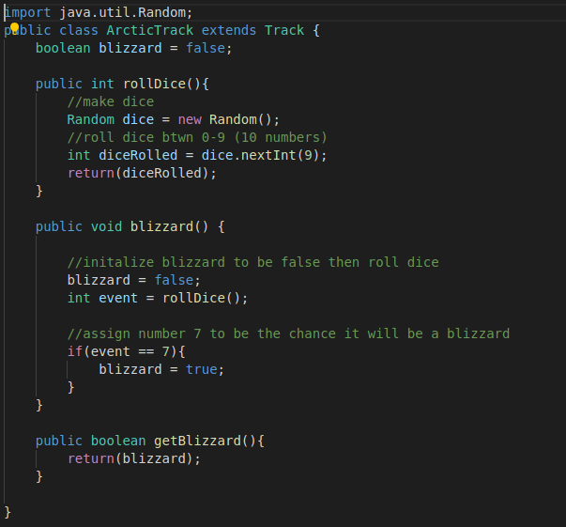

After (In class Track):

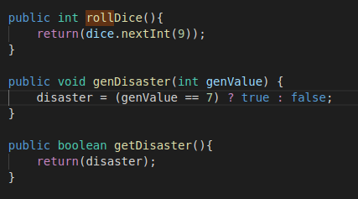

Tested rollDice method by ensuring that the value that’s returned is between and including the numbers 0 and 9. Tested genDisaster by inputting values to make the disaster true or false (ie only 7 can create the disaster).

The code is better after refactoring because not only is it more readable without extra steps, but it also removes 2 classes who’s functionality was identical. I don’t believe that this can be refactored any further.

2)
github commit: refactored isWon method to be more inline with what the comments and …
github commit id: 378ef519e0d90263321e6c577c5d9ec8b1468a39

Track class lines 124-147.

Bad smell was Worrisome comments. Comments don’t seem to do what the method is supposed to do. The method is trying to determine if the car won but it’s trying to loop through the entire array for no reason?

Extracted Method on comments as well as the method and Renamed Method it to make it’s purpose much clearer.

Before:

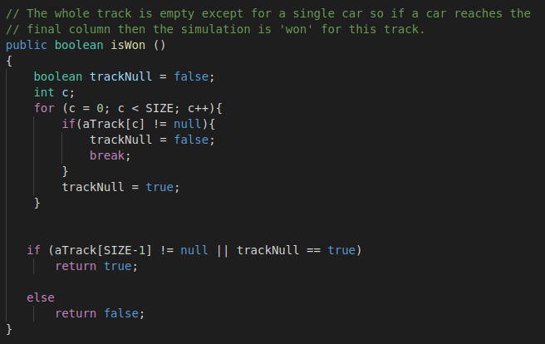

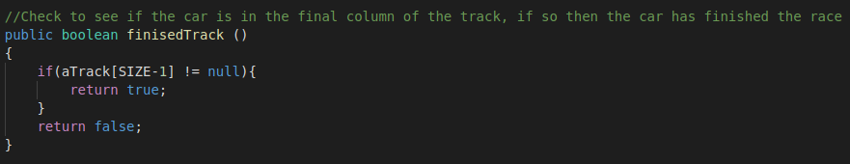
After:

Code was tested by checking the car position in a spot where it wasn’t the last column and where it was. Expected false if it was anything but the last column and true if it was the last column.

This code is better after refactoring because now the comments clearly align with what the method does. After this refactoring it doesn’t seem like we can do more refactorings to this snippet of code.

3)
github commit: refactoring a long method into more readable code
github commit id: 9c3fa83acb3d7fd3c80121e69c6d2ad31c21c474

Long Method start in class GameController.

This method start in class GameController is too long and can be broken into smaller methods. Long Method bad code smell.

The refactoring used was looking at the code and finding clumps to Extract Method on and break the code into smaller methods. Then used Replace Temp with Query to reference the methods instead of having the functionality inside the loop.

Broke into 2 methods, one was for the duplicated print statements and the other was for finding why the loop was broken and returning the result.

Before: Kind of hard to show because I can’t fit the entire loop is too big (lines 56-129)
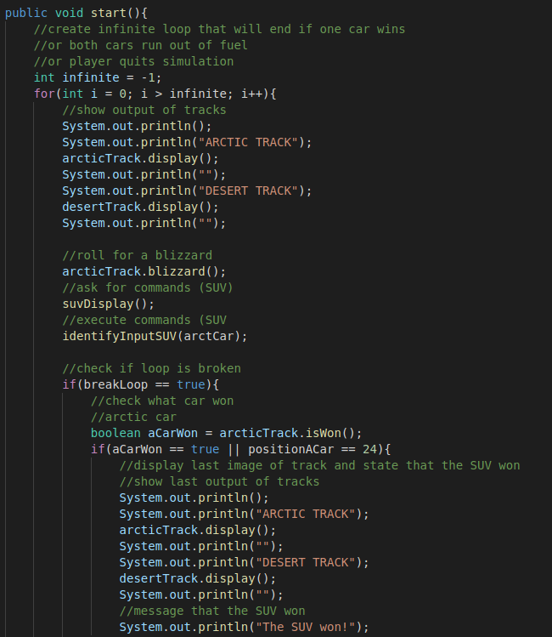

After (2 methods and reduced loop to lines 55-80) :

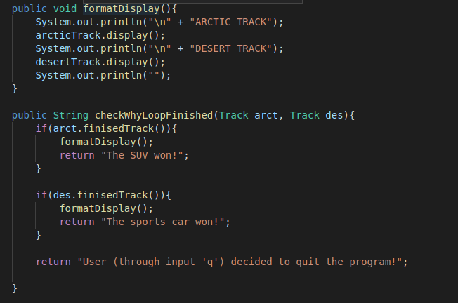

Code in class GameController was refactored from lines 56-129 to lines 55-103 in the same file.

Tested functionality of checkWhyLoopFinished by reorganizing the inputs to get all 3 different types of ways to exit the program. Check if the right output was given for the right ordering of the tracks as input.

Code is better after refactoring as now it’s easier to see what the loop is doing as apposed to before where it was a mess and hard to keep track of what was going on. Now by extracting some functionality out of the loop and into other methods we can easier understand what the loop is doing. Some further refactorings would be to try and remove the duplicate if statements that appear in the loop.

4)
github commit: refactoring Large Class, moving functionality to other class
github commit id: f8af4362e5cae7494bf4c7dbe9f49c8e7700ab50

Code in GameController class was refactored into the class GameControllerDisplayAndInputs.

Essentially the class GameController was a Large Class. It was trying to do too many different things such as game logic/flow, displaying output/controls, getting input, determining input, etc. It was too much functionality for just one class. The bad smell was is you take a look at the original file the class is over 400 lines long.

Used Extract Class to take out methods that dealt with displaying output and took in input and placed them into the class GameControllerDisplayAndInputs. Extract Method to separate the code out of those methods into 2 categories: the code that displayed to screen, and the code that took input. And Form Template Method to get rid of duplication.

Before(example of both display and input inside same method):
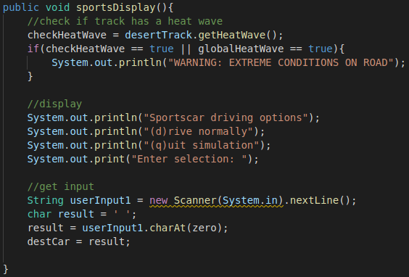

After (example extracted to class GameControllerDisplayAndInputs, and split into seperate functionality):
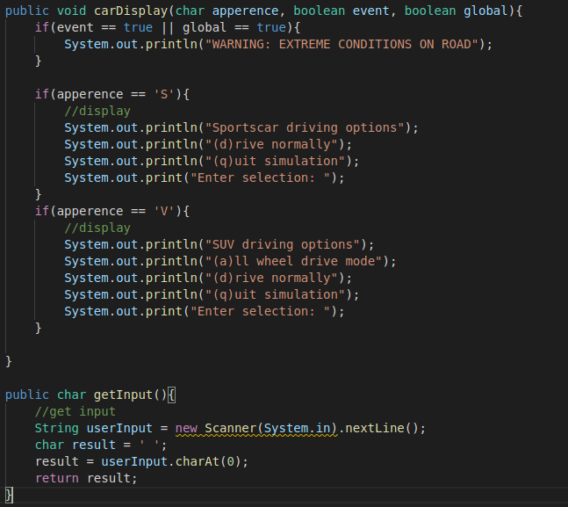
Junit tested the carDisplay by correctly checking if the output message is correct for all combinations. And tested the getInput method by testing the return value of an input that was greater than one, that it only returned a single character.

The code is better after refactoring because it reduces the list of functionality that GameController has, as well as makes GameController class more readable in what the game flow is. We could enable further refactoring on the GameController class by stripping more functionality from this class into separate classes however I’ve already spent like almost 3hours just on this refactoring and I don’t plan on spending more time on this haha...

5)

Refactoring code in class Sports line 32 and 34.

So on line 34 in the class Sports there’s a parameter initialization that is temporary that’s a bad smell. Therefore instead of having the logic there going to do Replace Temp with Query and call another method to do this calculation.

Replacing code with a function query that returns the result instead of doing it there. Extract Method into a newly created method.

Before:
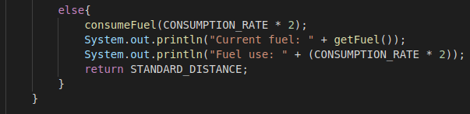

After:
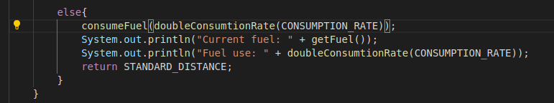
Tested this doubleConsumtionRate method by inputting a positive integer, negative integer, and 0 value and seeing if the output was double the input.

This code is better structured after this refactoring because instead of validating every time this temporary logic is used throughout the code we have that logic being called in one place. This ensures that this logic isn’t being deviated in other places in the code.

