Refactorings:

1) Before:

Throughout my program I do this conditional to check if the length of an array is zero. Replace temp var with Query.

After: conditional changed and new method created

conditional:

method:
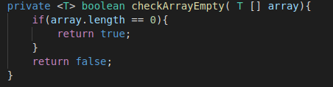

Makes it slightly more readable when determining what the conditional is doing.

Git commit id:

