1. Une image contenant texte

   Description générée automatiquementPresentation of the challenge

The aim of this project is to come up with a model/algorithm to produce predictions on T1_RETURN using the available information.  
  
You are expected to use said predictions to form a portfolio that will then be evaluated according to Information Ratio.

**As an output, you are asked to provide:**

* A short report on what you have done together with some results and conclusions, including a performance comparison among the models you propose, using Information Ratio as a metric.
* The source code used for producing your analysis and results.

The project will allow us to evaluate your skill set within programming, data preparation, modeling, and communication.

# Collect & transform data

First, we inspect data types:

Then, we inspect missing values:

Missing values don not show any evident pattern (temporal or other depedencies):

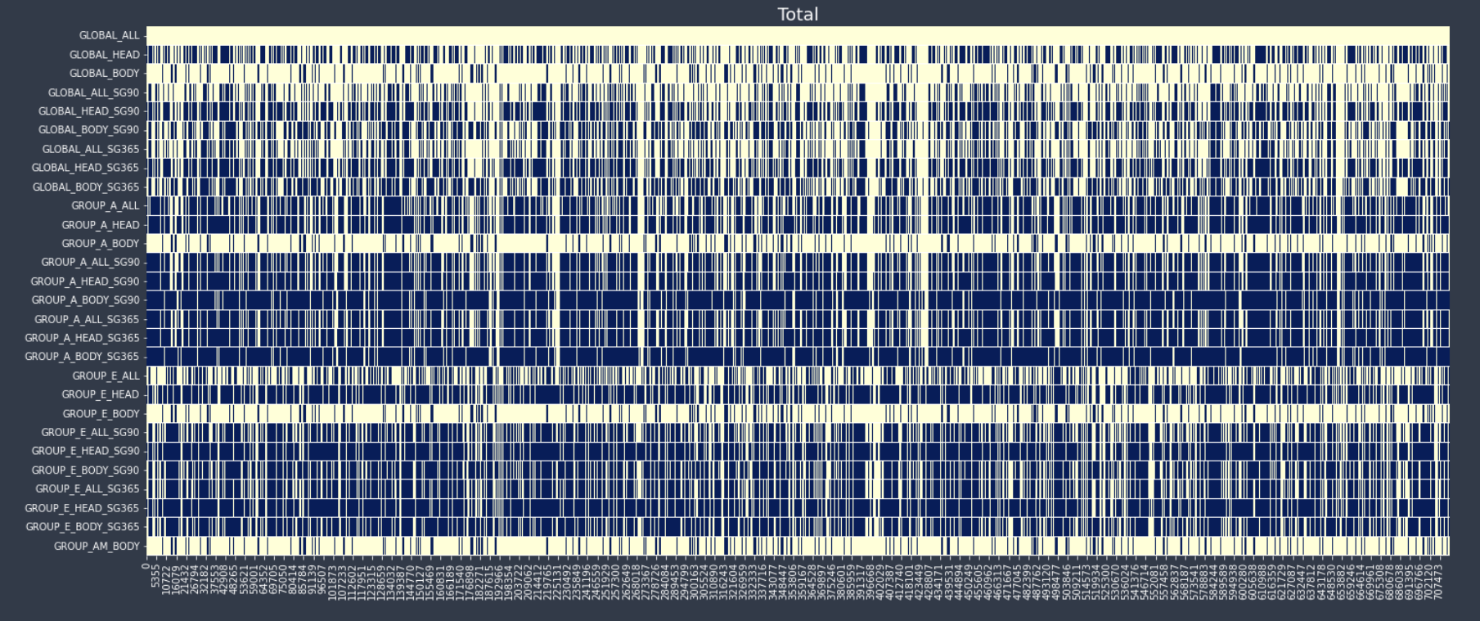

Features value seem to be fairly evenly distributed between -1 and 1

Features seems correlated with each other, and not correlated with T0_Return nor T1_Return

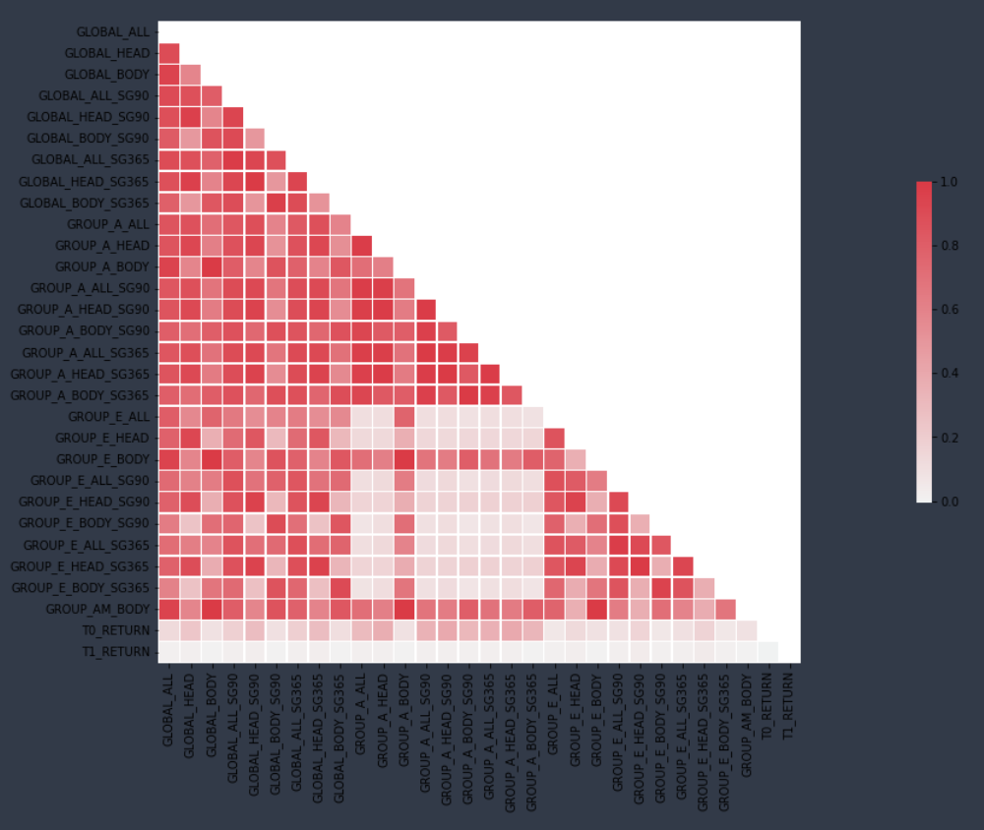

Distribution of return are quite normal, take extrem values appart

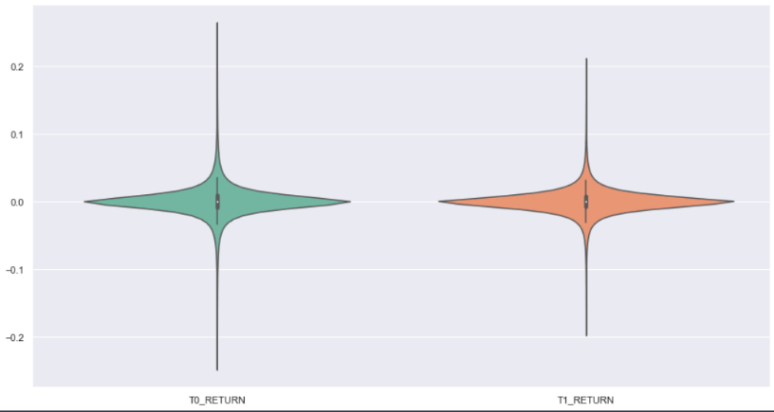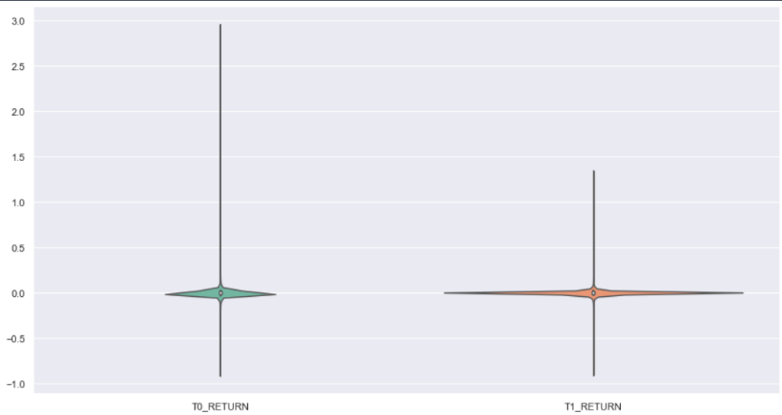

We plot prices of the assets having more than 756 points in ntime from 2005 to 2016 to have a first look at it:

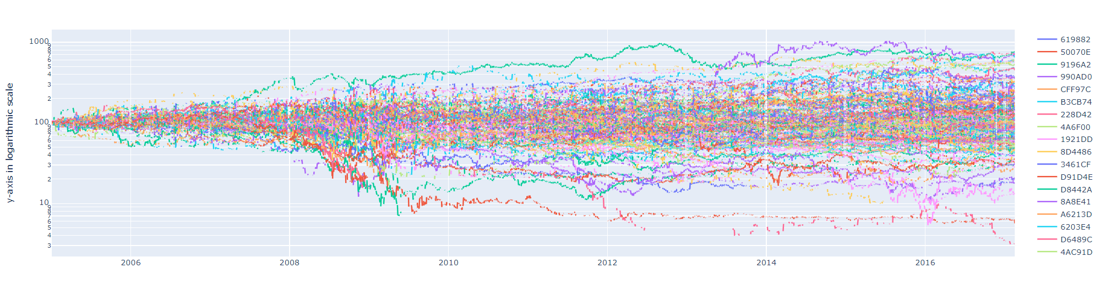

The range path is wide, and asset behave differently through time.

We can take note of the fact that there is a lot of missing date (times series are not complete).

# First model

First, we process the following:

* convert the date column to datetime,
* merge duplicated row,
* drop columns with 100% NA,
* keep only assets with a minimum of 3 years of data available on the whole period (2005-2016),
* convert returns to log-returns.

We run the XGBoost algorithm on the whole data. First results are not good as illustrated below:

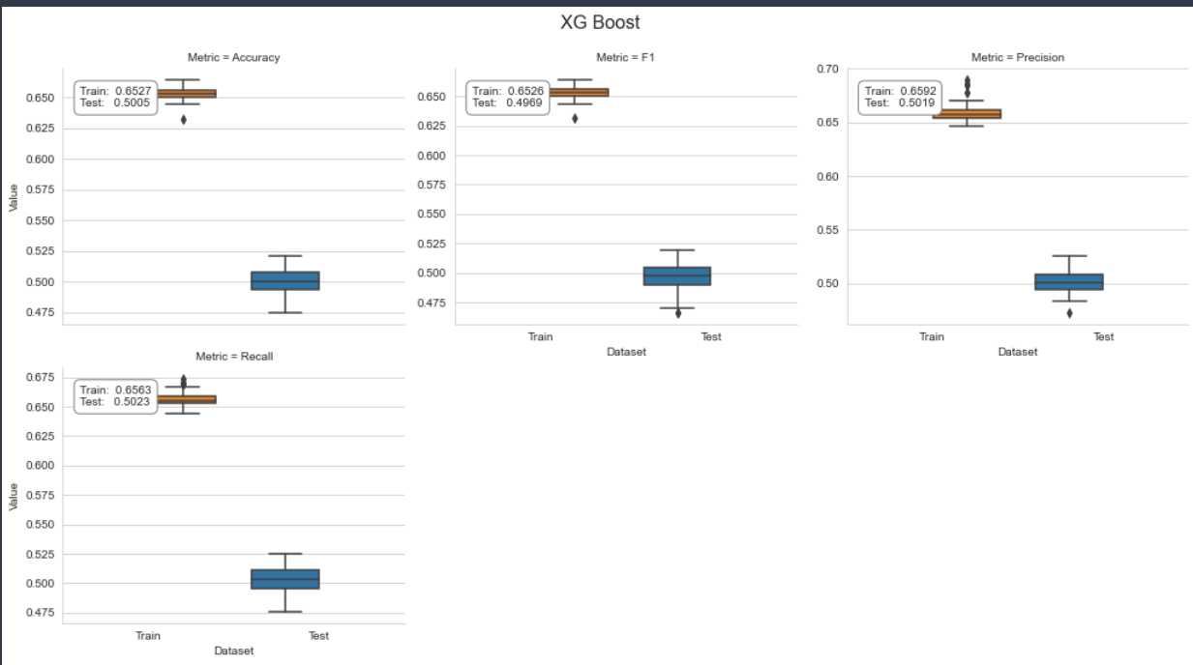

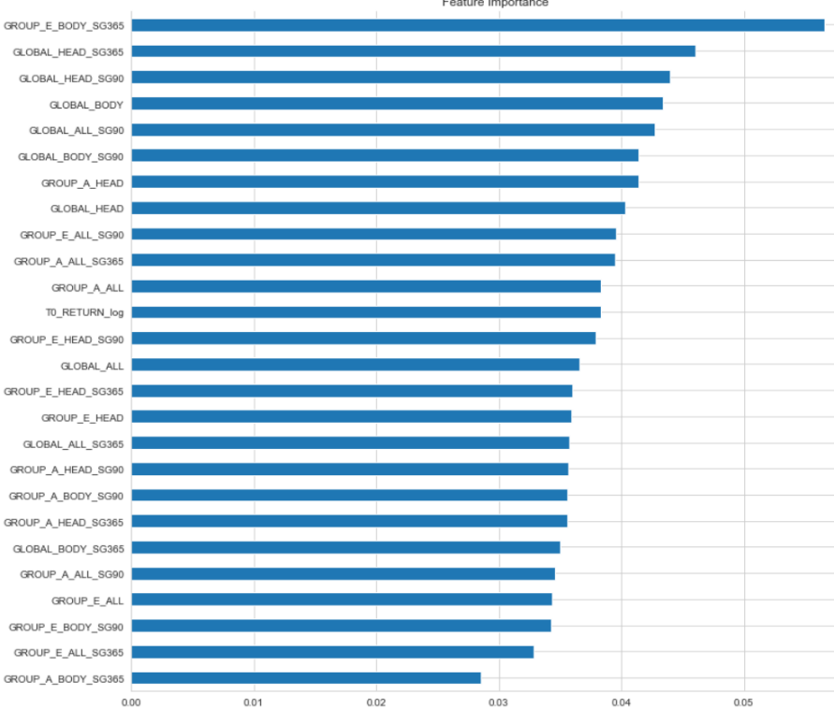Feature importance:

# Second Model