CdTe Detectors

Rhian Mair Wheater

26-Nov-2020



Data Acquisition Conditions

The detectors have all been tested under the following conditions unless stated otherwise:

* Applied bias voltage of-500
* Detector temperature maintained at28^{o}C
* Exposure to anAm-241 source for a duration of5 minutes

The data provided in this report includes:

* A per pixel linear energy calibration
* An evaluation of detector performance

General Comments on Performance

1606-0902-98

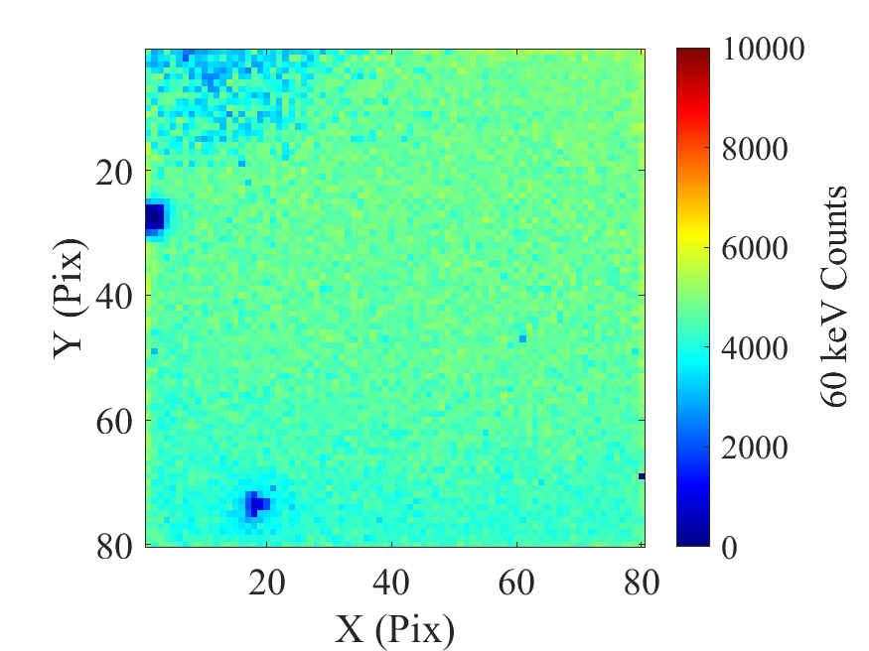

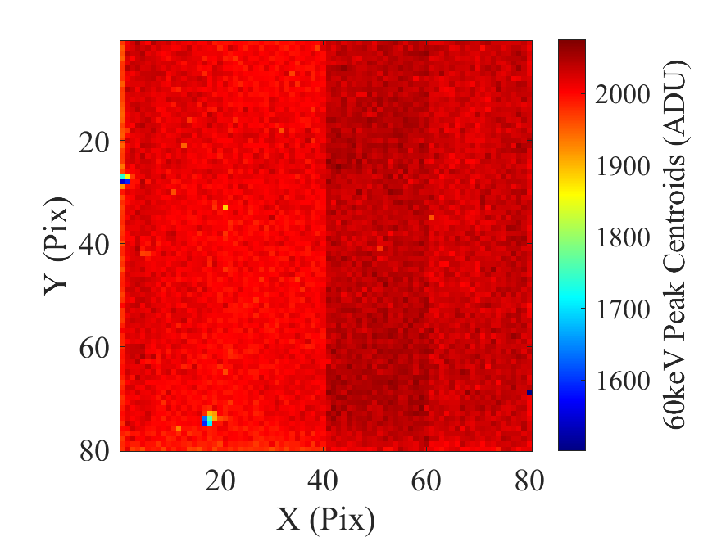

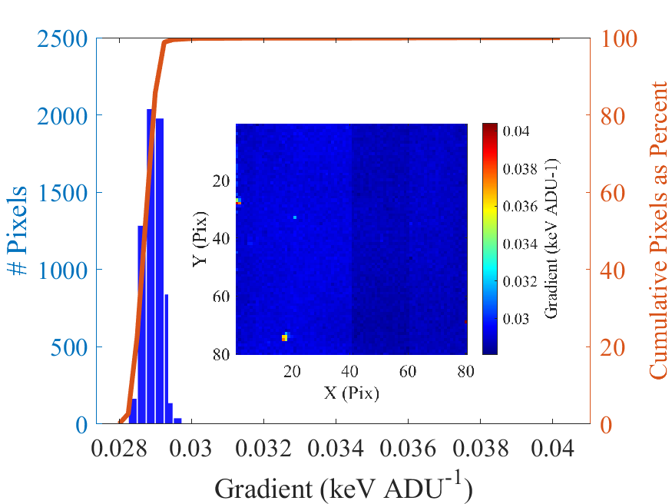

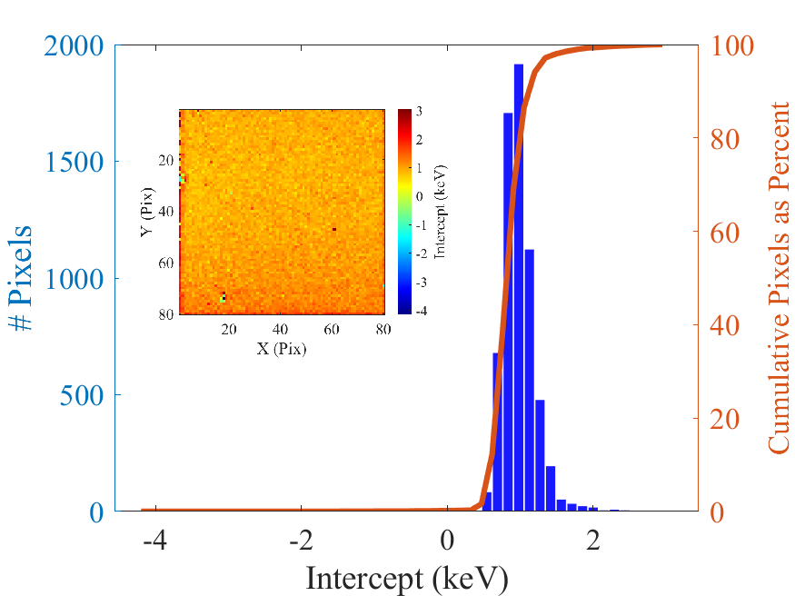

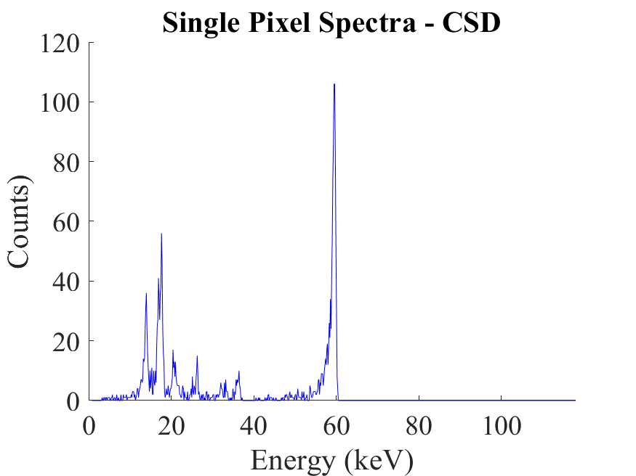

1606-0902-99

