CdTe Detectors

Rhian Mair Wheater

20-Nov-2020



Data Acquisition Conditions

The detectors have all been tested under the following conditions unless stated otherwise:

* Applied bias voltage of -500V
* Detector temperature maintained at 28oC
* Exposure to an Am-241 source for a duration of 5 minutes

The data provided in this report includes:

* A per pixel linear energy calibration
* An evaluation of detector performance

General Comments on Performance

Both detectors tested here appear very uniform, outputting high quality individual pixel spectra as well as global spectra. The calibration values for gradient and intercept are uniform across the majority of the detector in both cases. However in 1606-0902-98 there are regions of decreased charge collection efficiency at 60keV likely as a result of pixel saturation due to leakage current.

Under the applied conditions the mean value for FWHM per pixel at the 60keV peak was found to be 0.87keV (1.49%) and 0.91keV (1.51%) for the sensors 1606-0902-98 and 1606-0902-99 respectively.

1606-0902-98

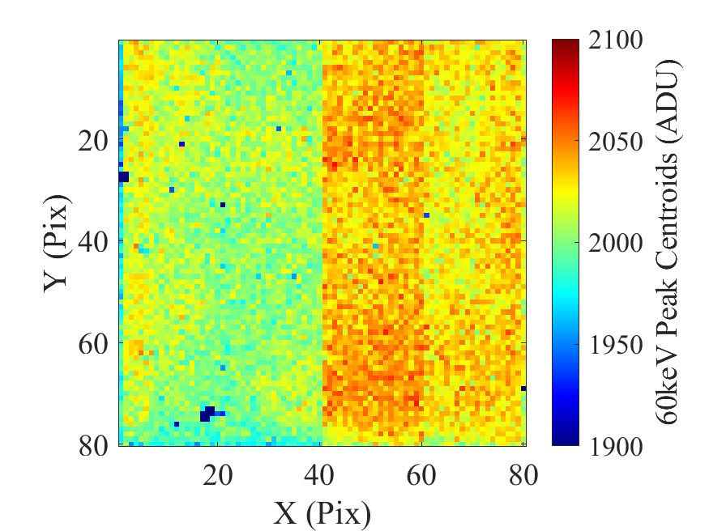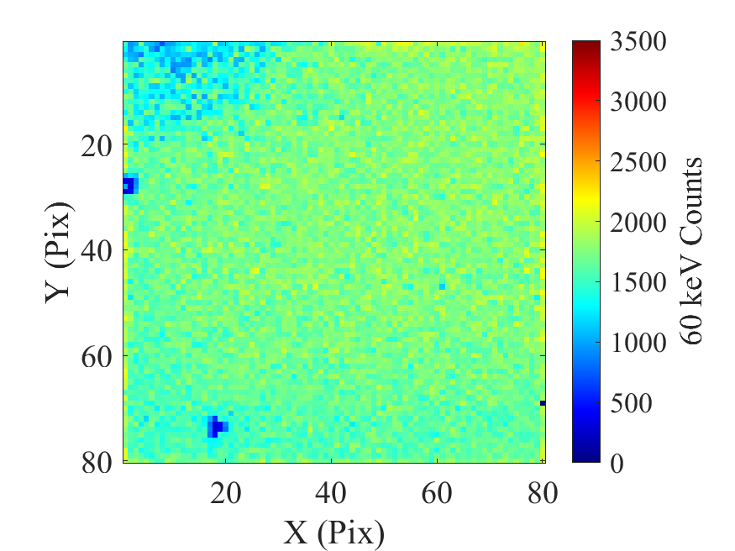

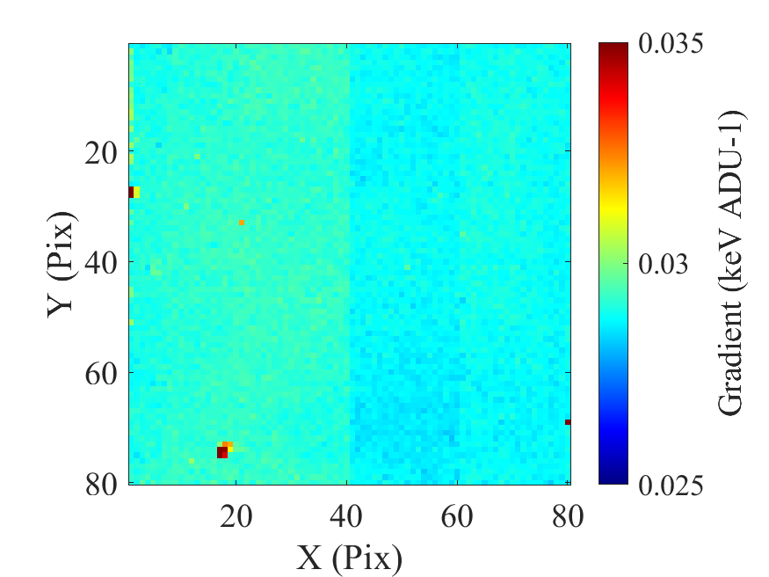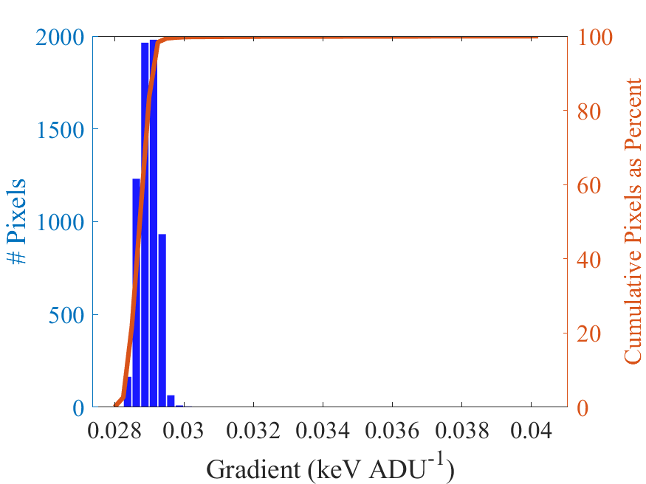

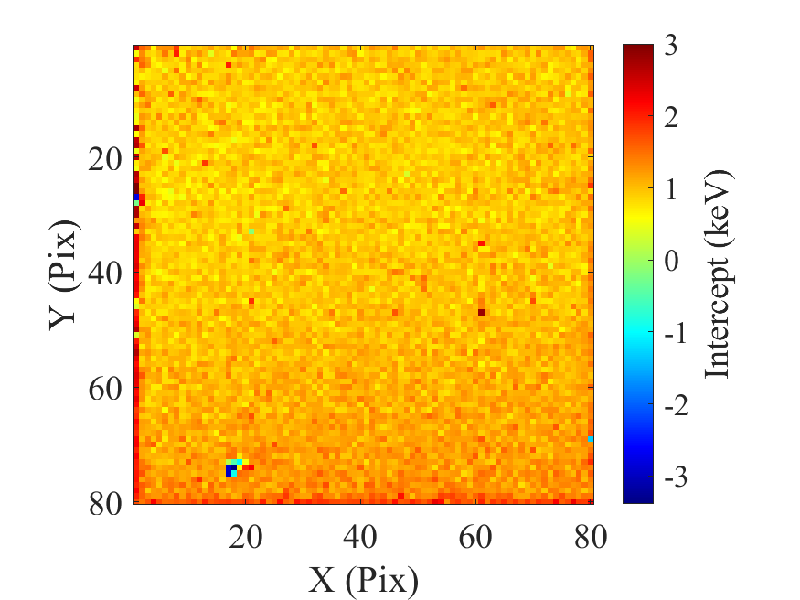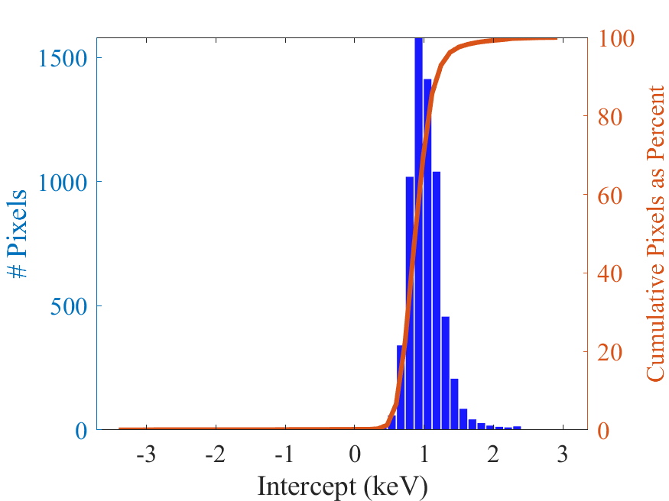

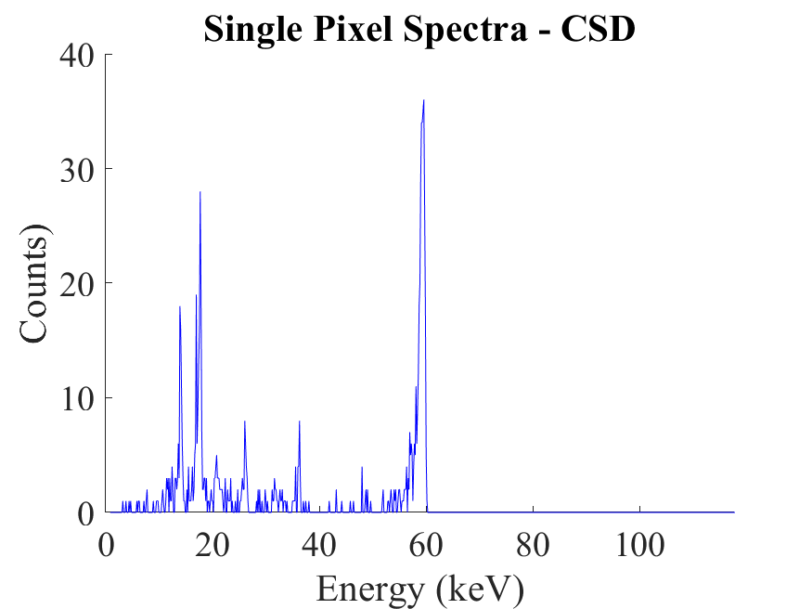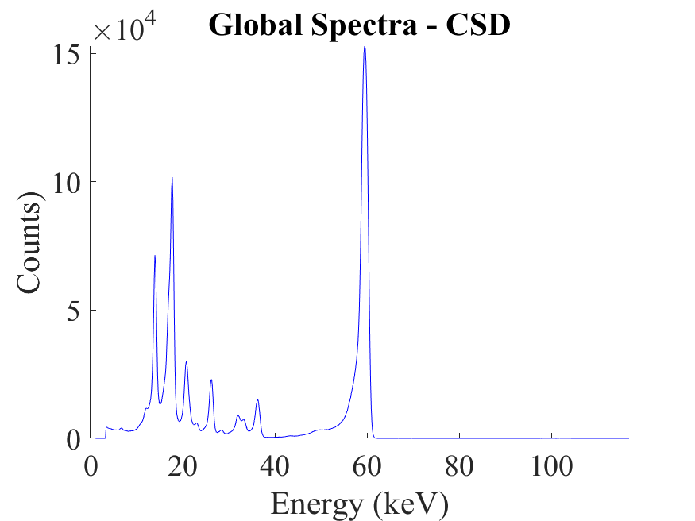

1606-0902-99

