HEXITEC Processing Verification

M. Veale

31/12/2020

Background

This document contains results from the processing of a HEXITEC calibration file, ‘Am241_600s_500V.bin’ using with my scripts written in Matlab. Two scripts are used, the first to produce the detector calibration and the second to playback the data using the calibration constants. A simple depiction of this processing pipeline can be seen in Figure 1:

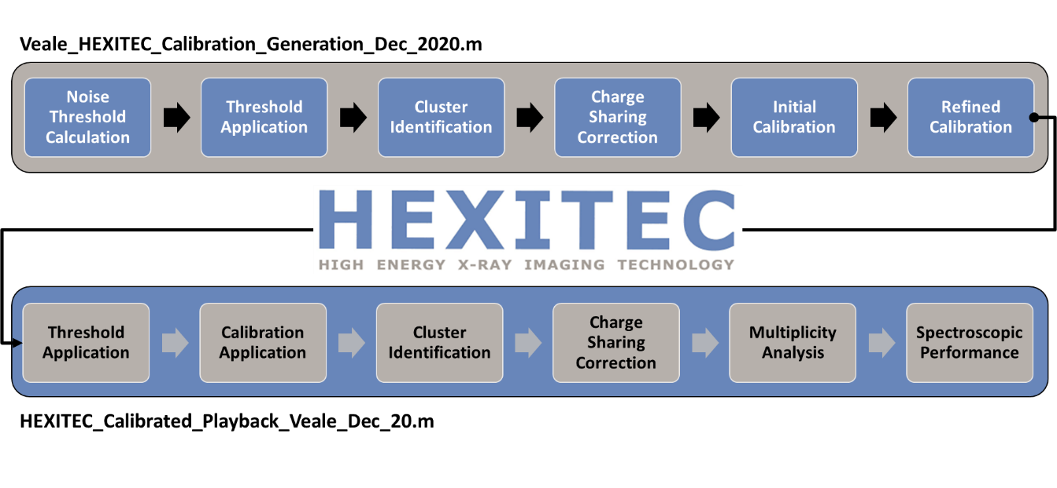
Figure 1: The HEXITEC data processing pipeline

The outputs of this analysis are broken down here in to four sections, threshold calculation, frame processing, energy calibration and the spectroscopic resolution of the detector. Copies of the scripts used for the data processing can be found on the HEXITEC Github.

Threshold Calculation

The script starts by playing back the first 50,000 frames of data in the file. For each pixel all values < 100 ADU are histogrammed and this noise distribution is used to define a low energy threshold. The process has a number of steps as described below and is shown in Figure 2:

- Identify the maximum amplitude of the noise distribution

- Find the position of the upper width at half maximum

- Threshold = n_{t} × UWHM

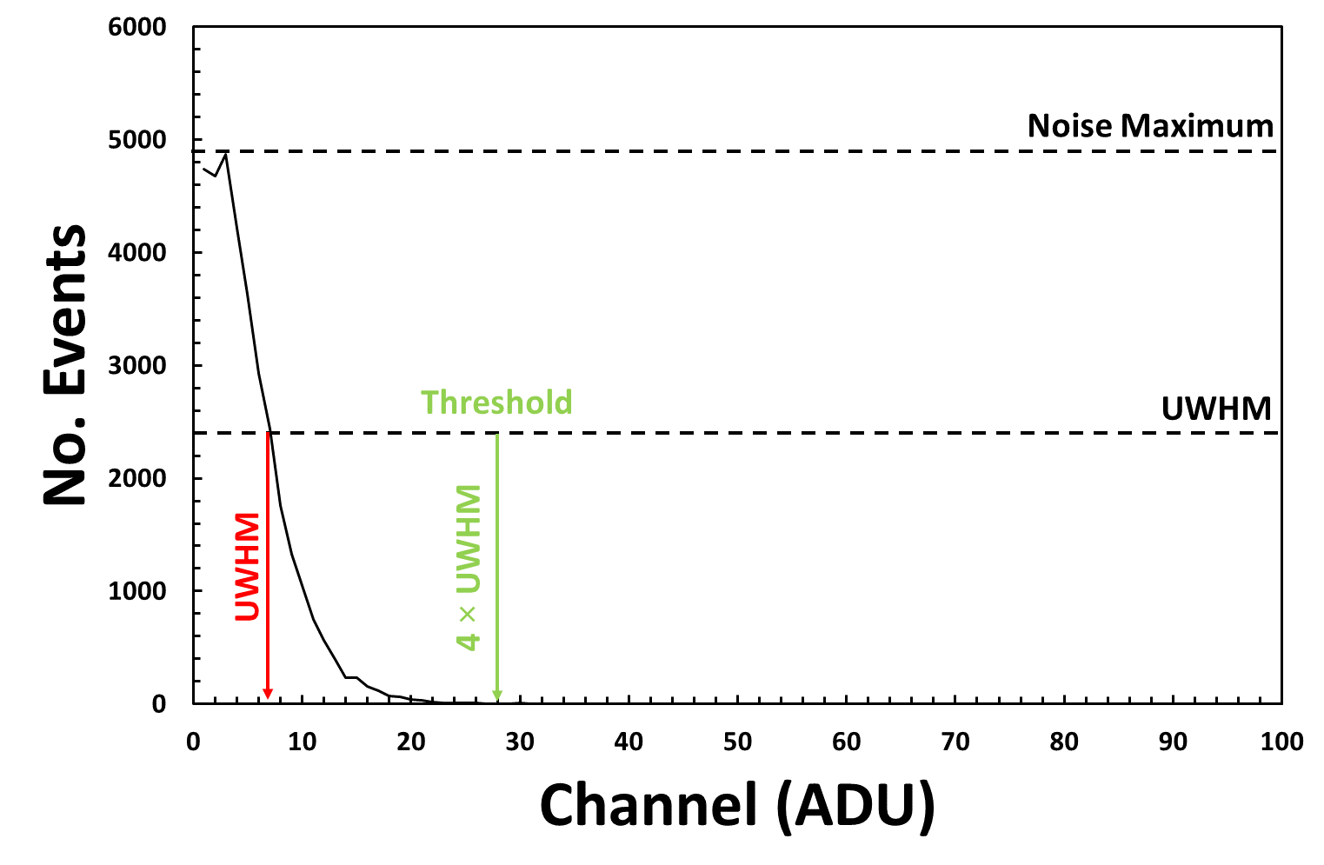
Figure 2: The calculation of the noise threshold for pixel [40,40]
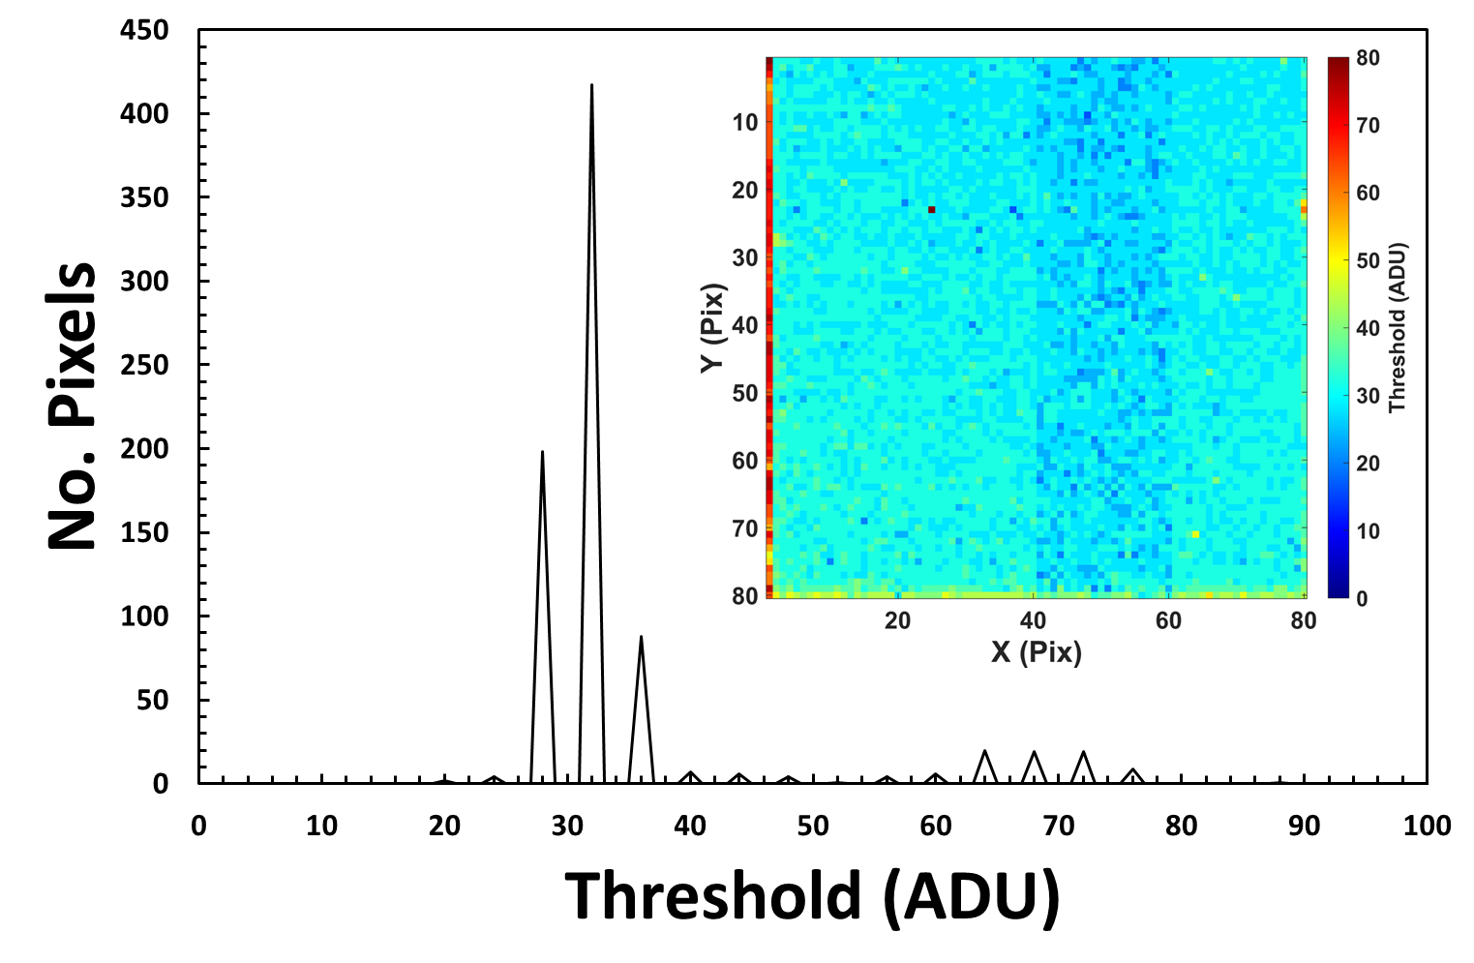
Figure 3: The distribution of pixel thresholds and (inset) a map of the noise threshold calculated for each pixel

This threshold calculation is repeated for each of the pixels and the resulting values can be seen in Figure 3. The average threshold across the entire detector is 35 ± 11ADU. It is worth noting that edge effects and ADC effects can be observed.

Frame Processing

Applying the Threshold

Having calculated the ideal threshold per pixel the frames can then be processed. A single frame is read from the data file in turn using the script ‘read80x80Frame.m’. The pixel value is inspected and compared to the noise threshold. If the value is below the noise threshold then it is removed, see Figure 4.
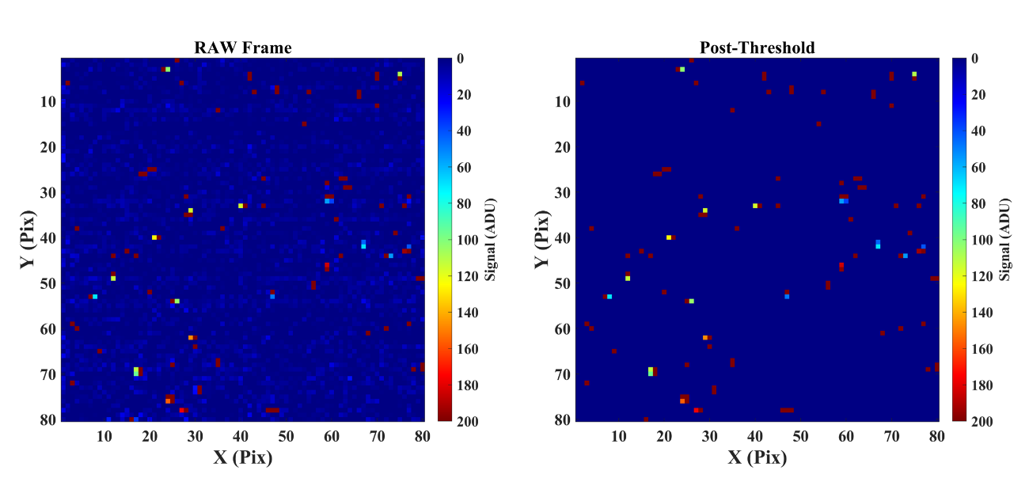
Figure 4: (Left) an example of a raw frame of data and (right) the same frame after thresholds are applied
Having applied the thresholds the remaining hits are identified and counted. Figure 4 shows the number of events above threshold for each of the frames for this data file. Occasionally a frame may be noisy (the frequency of this varies for each detector) and these may wish to be removed from the analysis. In this instance a noisy frame threshold of 200 hits was set, only one frame was removed.
Figure 5: The number of hits above threshold per frame

Identifying Charge Sharing Events

Each of the frames of data will contain events which have resulted in charge being shared over multiple pixels. For the purposes of calibration the highest possible energy resolution is required so a charge sharing discrimination (CSD) algorithm is used to identify and remove shared events.

Historically, charge sharing events have been identified in Matlab using a moving window of 3×3 (or occasionally 5×5) pixels that was scanned through the frame of data. If an isolated pixel shows a signal above threshold then the charge sharing discriminated spectrum associated with the pixel is appended with the hit intensity. If multiple pixels in that window were above threshold then they were identified as a charge sharing event and only the raw, uncorrected, spectrum was appended for the pixels involved in the event.

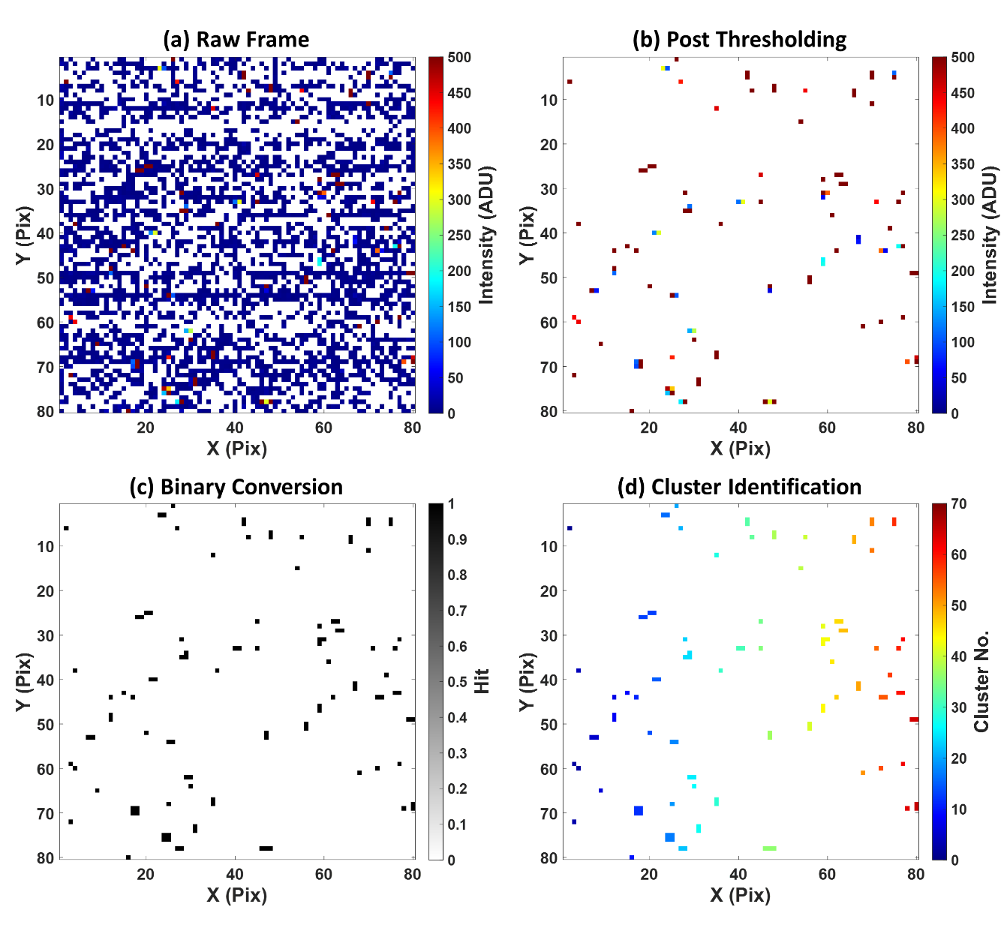
Figure 6: The process of cluster identification in the Matlab code. (a) A raw frame of data. (b) The same frame of data but after the application of the per-pixel low energy threshold. (c) The image after conversion to binary. (d) The clusters as identified by the bwconncomp function of the Matlab Imaging Toolbox. Zero values have been displayed as white in all four maps.
The advantage of this technique was that it used bespoke code, doesn’t require the use of any Matlab Toolboxes (until recently these were not available to all STFC users) and is simple. However, this technique is known to have issues especially for those pixels at the edge of the 3×3 window which can miss charge sharing events. This can be improved through the use of a larger window but this in turn increases the chance of accidently identifying separate events as charge sharing.

Now with all of Matlab’s toolboxes available to STFC users, it’s possible to make use of image processing toolbox which contains cluster finding algorithms that are ideal for the identification of charge sharing events. In this implementation the ‘bwconncomp’ function is utilised as it is described as being more memory efficient than the older ‘bwlabel’ function that is also available in the same toolbox.

In order to use the function the frame of data first needs some initial processing and this is illustrated in Figure 6. To begin with the per-pixel threshold is applied to the raw frame of data to remove any noise. This image is then converted to a binary image of 1’s (Hit) and 0’s (Empty) which is fed in to the bwconncomp function. The function then searches the frame for connected pixels, this includes diagonals, and outputs the number of clusters as well as a new frame of data where each cluster is labelled using a unique integer.

Finally, the number of clusters identified by the function and the labelled frame are used to extract the multiplicity of the events in the frame (the number of pixels involved in a cluster) and to append either the RAW, CSD or CSA (charge sharing addition) spectra. Figure 7 shows the multiplicity distribution calculated for the example frame of data, 51%, 40%, 5% and 5% of events occur in 1, 2, 3 and 4 pixel clusters respectively. The CSD spectrum of each pixel is created from only single pixel events, the effect of the removal of charge sharing events on a single pixel spectrum can be seen in Figure 8. The use of CSD removes significant numbers of low energy events as well as specific peaks in the spectrum due to the generation of Cd and Te florescence X-rays.

This analysis is repeated for every frame of data and Figure 9 shows the multiplicity distribution for the entire dataset. The vast majority of events have a multiplicity of 1 – 4 pixels (55.0%, 30.8%, 6.1% and 6.8% respectively) although events with much higher multiplicities are observed in lower numbers (m>6 represent <0.2% of events); these are likely due to cosmic rays that occasionally interact in the detector.

Using the multiplicity data it’s also possible to calculate the charge sharing percentage measured by each pixel, see Figure 10. In an ideal world the amount of shared events per pixel should be identical but variations in the detector material, electronic gain and noise, the array edges and the presence of faulty bonds can lead to spatial variations. The effects of a poorly bonded pixel can be seen in pixel [25, 23] where the surrounding pixels show much higher charge sharing due to the bad bond. It’s likely that the electric field is non-uniform in this region leading to increased charge sharing.
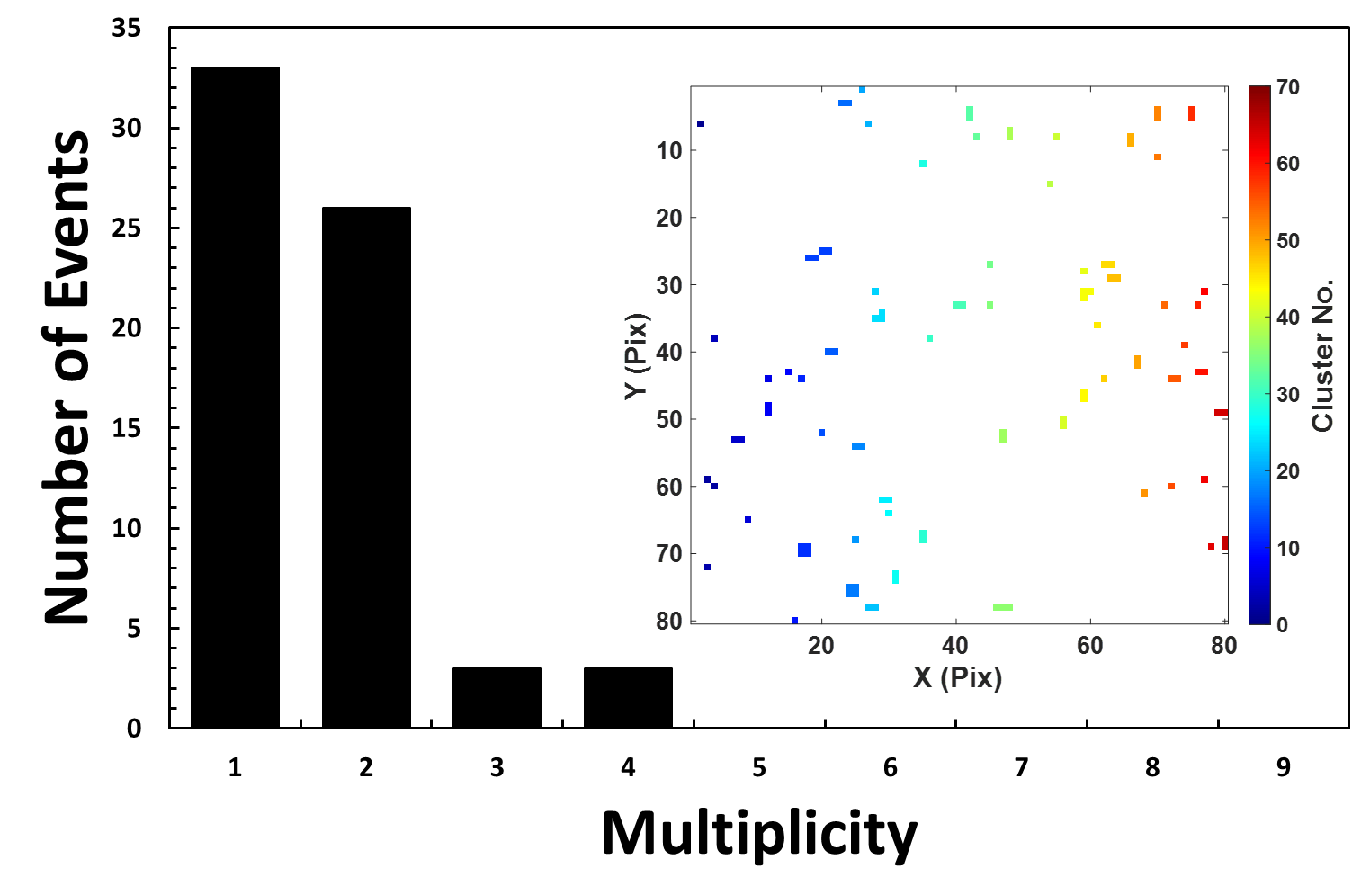
Figure 7: The distribution of event multiplicity for a single frame of data. (Inset) the identified clusters.

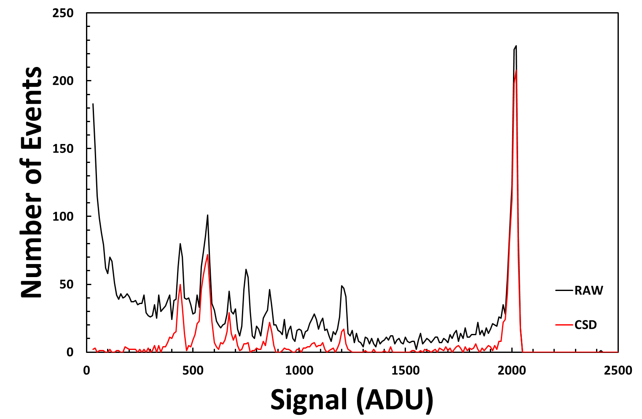

Figure 8: The RAW (black) and CSD (red) spectra as measured by Pixel [40,40]

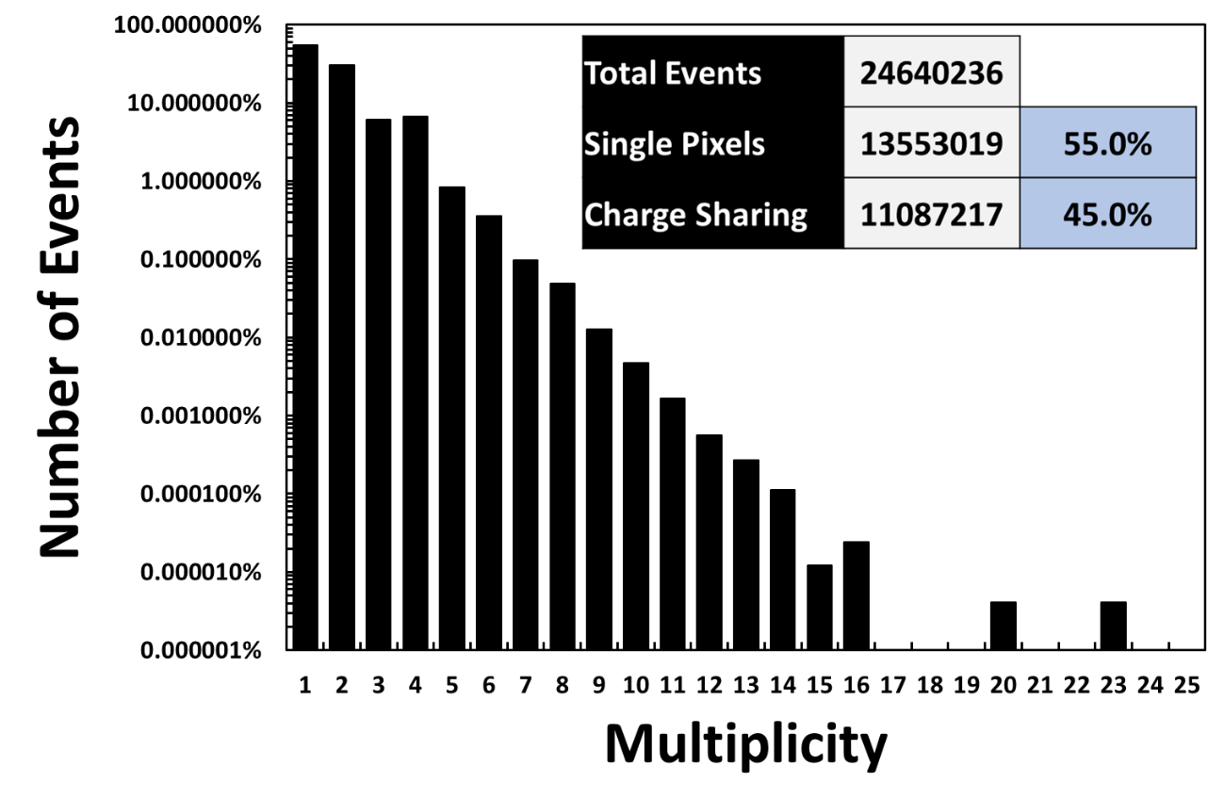
Figure 9: The distribution of event multiplicity across the entire dataset

Figure 10: The spatial variation in the percentage of charge sharing measured in each pixel

Per Pixel Energy Calibration

Having removed charge sharing events, each of the spectra are examined in turn using the following process:

- Interpolate the spectra by a factor of 10 for better fitting

- Identify the position of the main photo-peak at 59.54keV by searching in a coarse window of 1600 – 2500 ADU.

- The position of the 17.75 keV photo-peak is then located using a coarse search in the window 200 – 1000 ADU

- Generate a rough calibration using these two peaks.

- Using the rough calibration generate search windows for the 13.94 17.75 26.34 and 59.54 keV and find the peaks in these windows.

- The 4 peak centroids are then correlated with the peak energies using a linear fit and the gradient, intercept and r2 of the fit recorded

Figure 11 shows an example of the calibration of pixel [40,40] and Figure 12 shows the variation in the gradient and intercept across the detector as well as the r² value of the calibration. The average gradient per pixel was found to be 28.96 ± 0.02 eV ADU⁻¹ and the intercept was 1.23 ± 0.04 keV; the distribution of these values can be seen in Figure 13. The vast majority of calibration fits had r² values in excess of 0.9999 demonstrating that a linear fit, at least in this energy range, successfully fits the data.

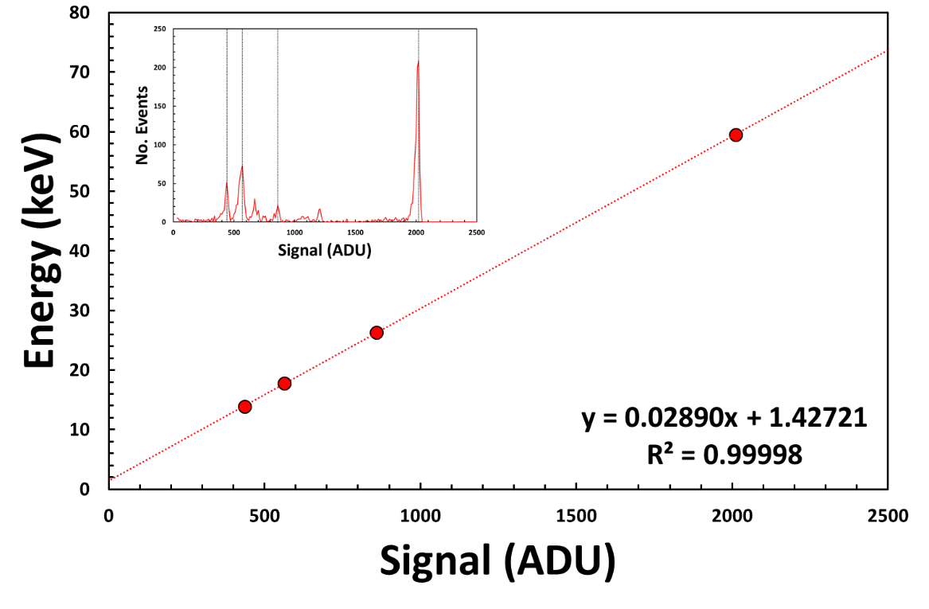
Figure 11: Calibration of pixel [40,40]
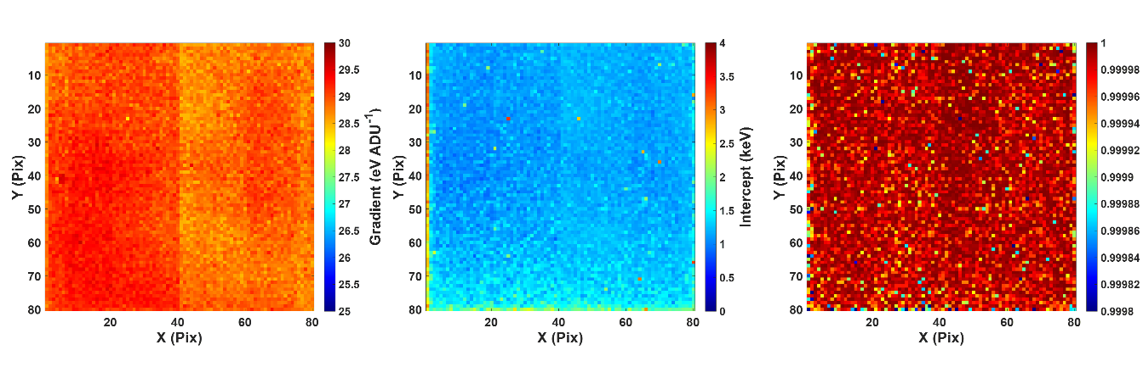
Figure 12: The spatial distribution of (left) the gradient, (middle) the intercept and (right) the r² of the fits
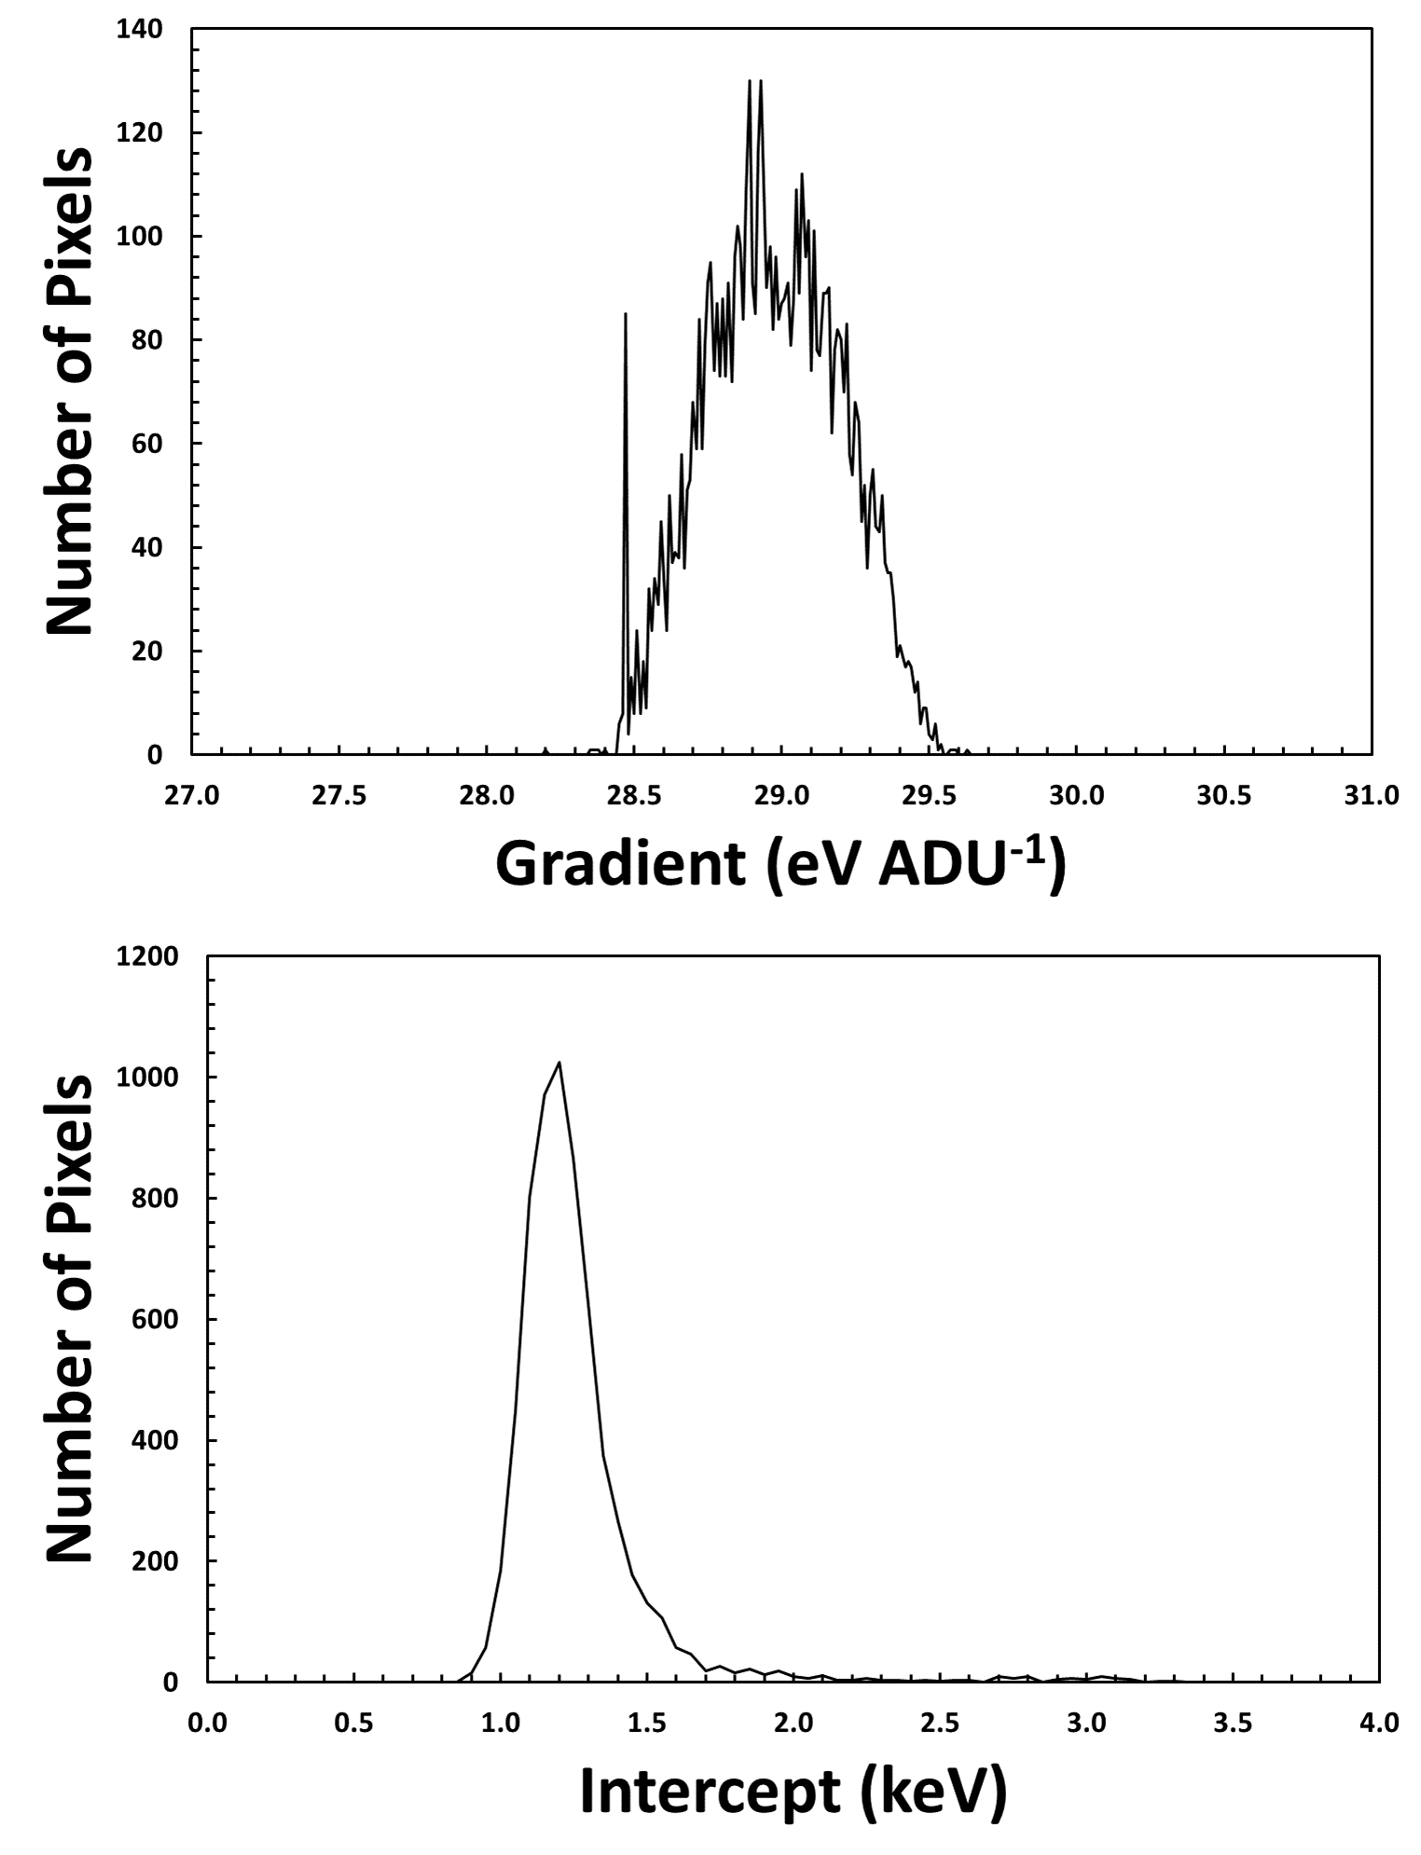
Figure 13: Histograms of (Top) the calibration gradients and (Bottom) the calibration intercepts

Spectroscopic Performance

Having calculated the calibration per pixel, the data was replayed and energy calibrated. Figure 14 shows an example of the spectroscopic performance of a single pixel as well as the summed spectrum of all the bulk pixels [3:77, 3:77].

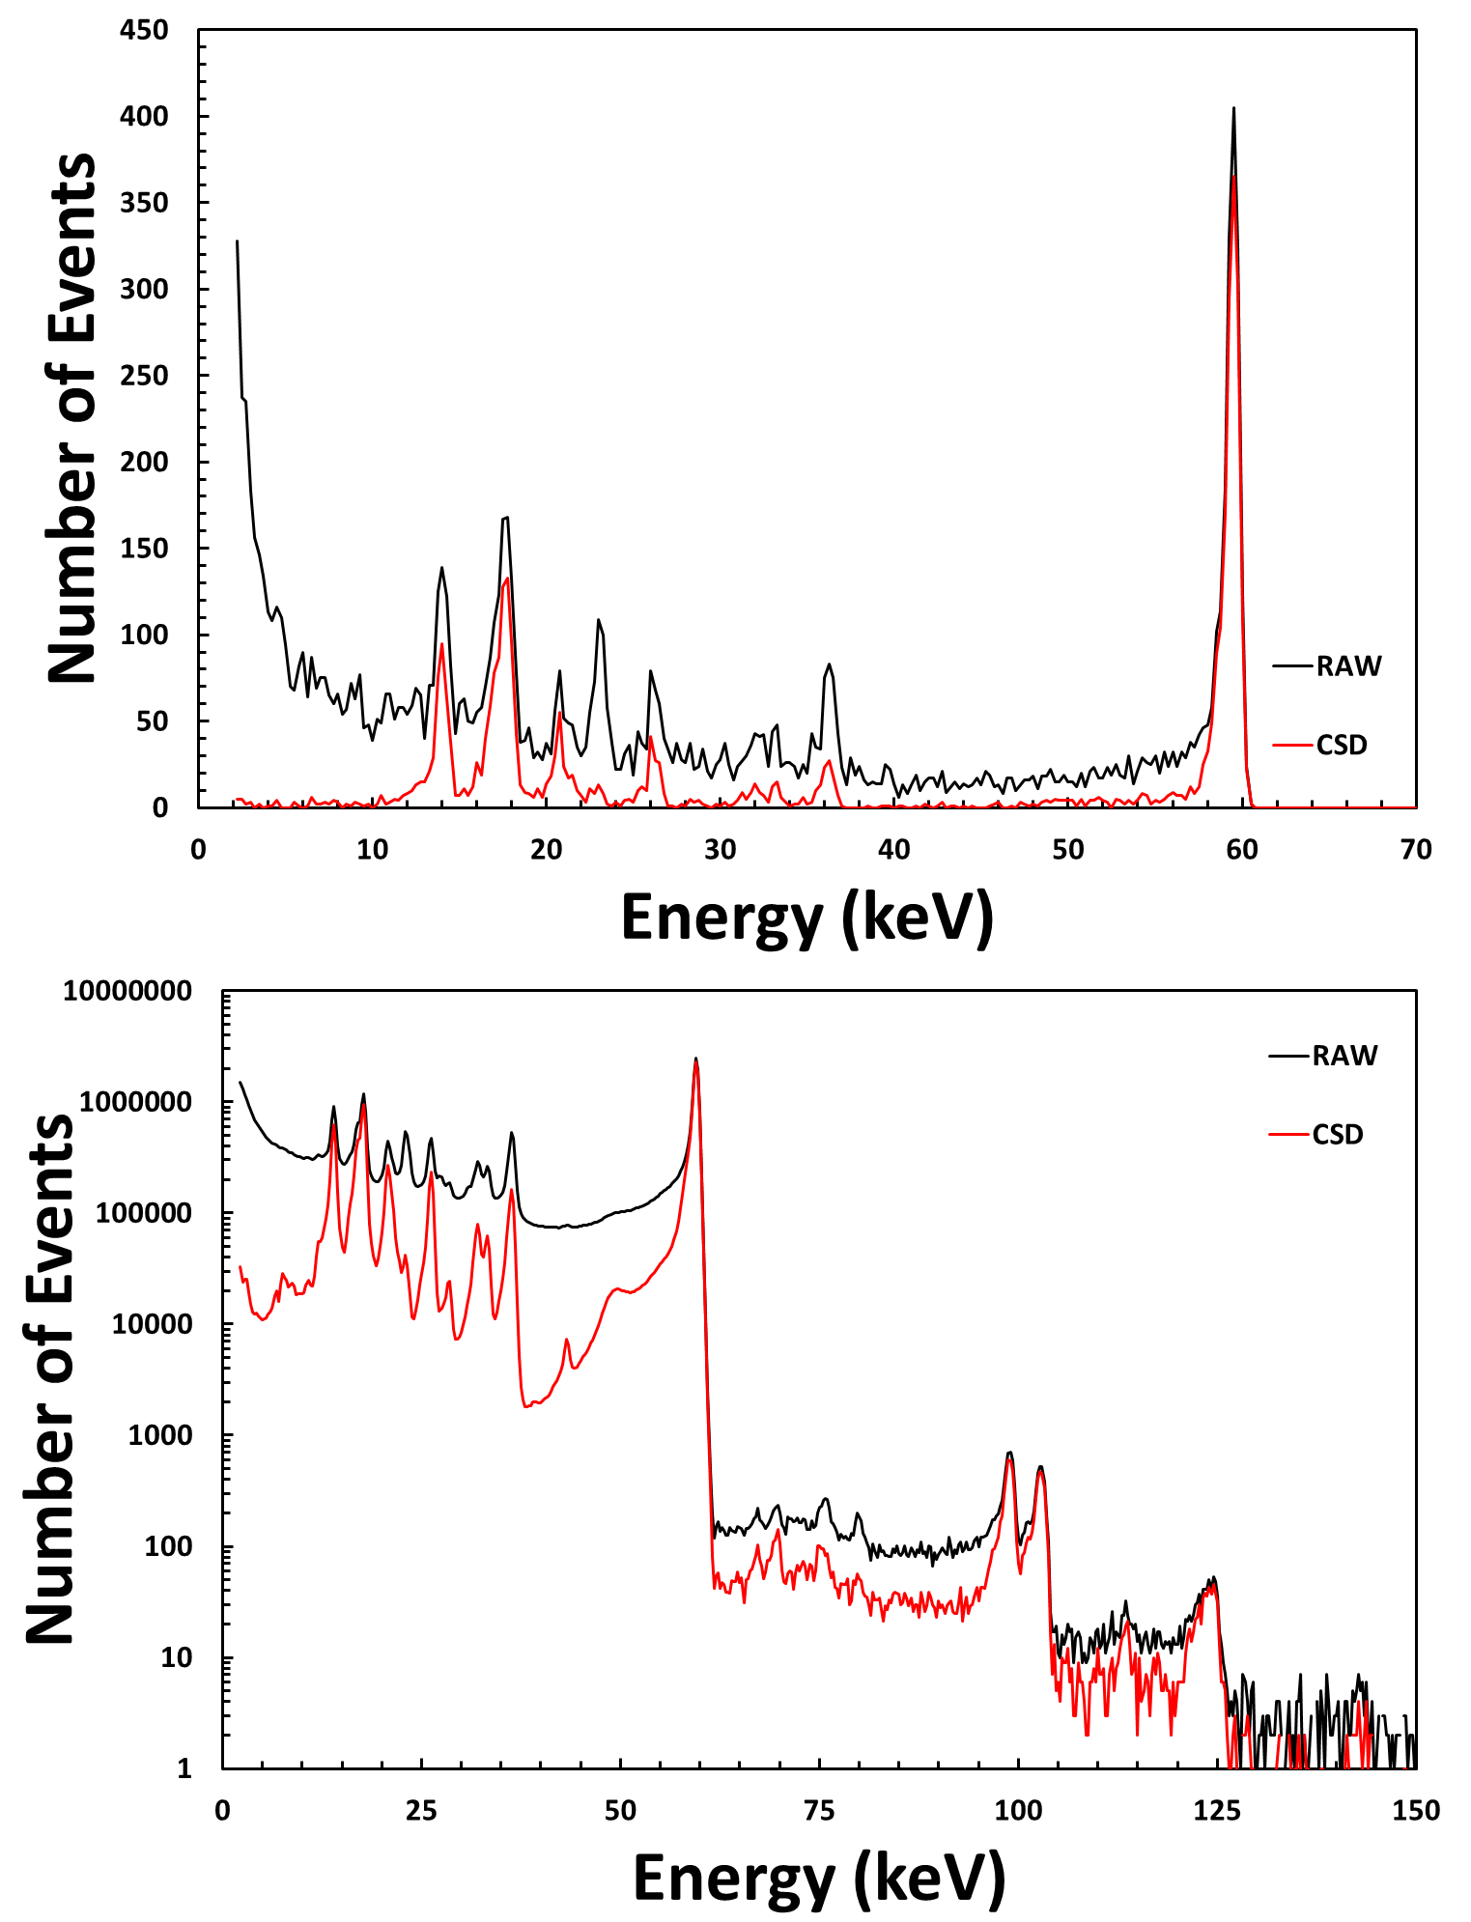

Figure 14: (Top) the spectrum recorded by Pixel [40,40] and (Bottom) the global spectrum measured by the detector. Spectra are shown with (red) and without (black) charge sharing correction.
For each of the calibrated spectra the FWHM of the main photo-peak at 59.54 keV was calculated by identifying the peak amplitude and then finding the positions of the half amplitude (LWHM & UWHM) positions. Figure 15 & Figure 16 show how the FWHM varies across the detector.

Figure 15: The spatial distribution of the FWHM of the 59.54 keV photo-peak

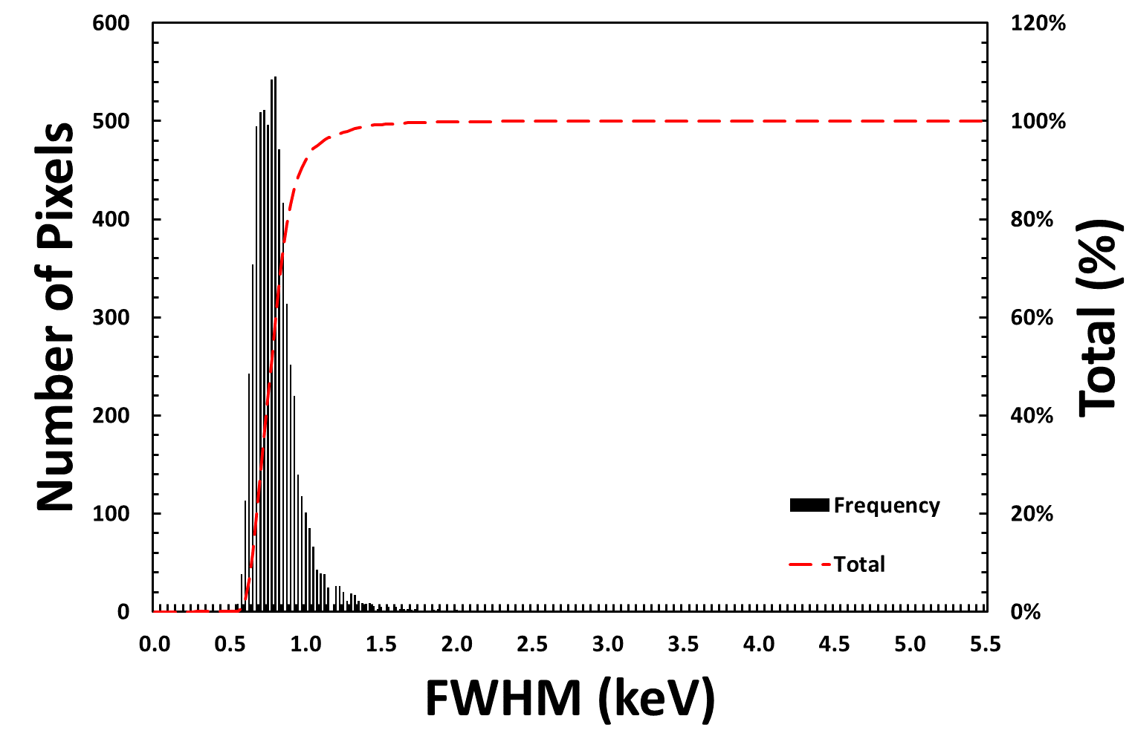

Figure 16: A histogram of the 59.54 keV photo-peak FWHM values
From this analysis the median FWHM value was found to be 0.78 ± 0.17 keV which is consistent with previous measurements with these detectors.

Charge Loss

Finally, the validity of the calibration can be observed in the application of a charge sharing addition processing. In charge sharing addition, shared events are summed together to recreate the energy of the original interaction; for this analysis only m = 2 events (sharing between two pixels) have been considered. The proportion of the total energy (E_{T}) that a given pixel receives will mostly depend on the position of the interaction relative to the inter-pixel gap.

Figure 17 shows how the total energy measured varies with the ratio of charge sharing between the two pixels. These distributions show some obvious features:

- Horizontal Bands: These bands represent the main photo-peaks of the sealed source.

- Hot Spots: A number of these hot spots can be observed, especially those in the 59.54 keV horizontal band. The spots in this particular band are due to charge sharing events which involve either a Cd or Te X-ray florescence event. As the probability of generating an XRF photon at this energy are high, this leads to preferred ratios for sharing that produce the hot spots in the image. Note that for the lower energy horizontal bands (< 25 keV) that these hot spots disappear; this is because the energy of these photons are below the K-edge of Cd and Te and are unable to generate an XRF photon.

It’s also worth noting that other hot spots exist at higher energies, for example at 120 keV. These spots are due to pile-up where two individual interactions happen to occur in neighbouring pixels and are mistakenly identified as charge sharing.

- Vertical Bands: There are multiple vertical curves or bands that move through the distribution. These curves can be caused by the pile-up between different photo-peaks with each other, with XRF photons or with charge sharing events.

This distribution also shows evidence for charge loss for some charge sharing events. If the horizontal bands at lower energies (< 25 keV) are studied they appear relatively flat compared to those at higher energies (59.54 keV) which, if the hot spots are ignored, show a dip in the total energy for ratios in the range -0.5 to 0.5. This drop in the total energy is a result of charge loss in the inter-pixel region caused by a combination of the low energy threshold and regions of low electric field that exist between pixels. This charge loss is most evident when looking at spectra after the use of the charge sharing addition algorithm. Figure 18 shows a comparison of the CSD and CSA spectra of Pixel [40, 40] and summed across all bulk pixels [3:77, 3:77].
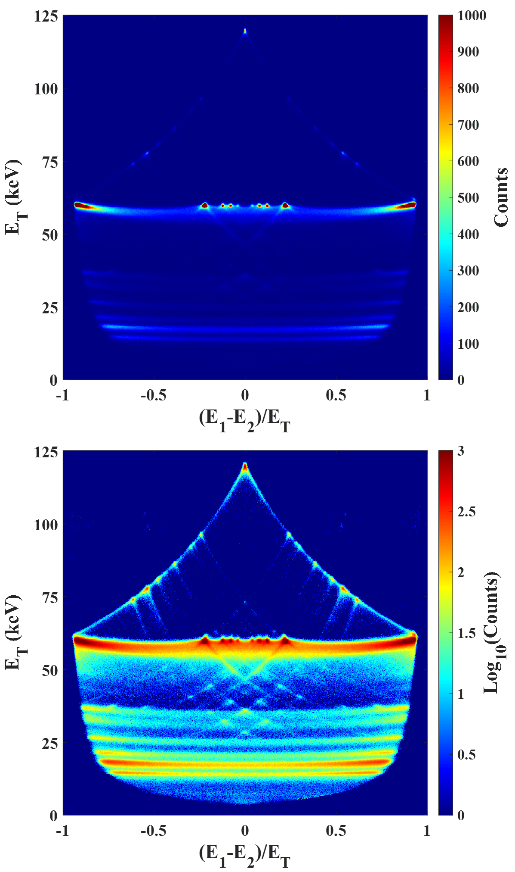

Figure 17: Maps showing the effect of charge sharing ratio on the total energy measured. Maps are shown on (Top) a linear scale and (Bottom) a log₁₀ scale
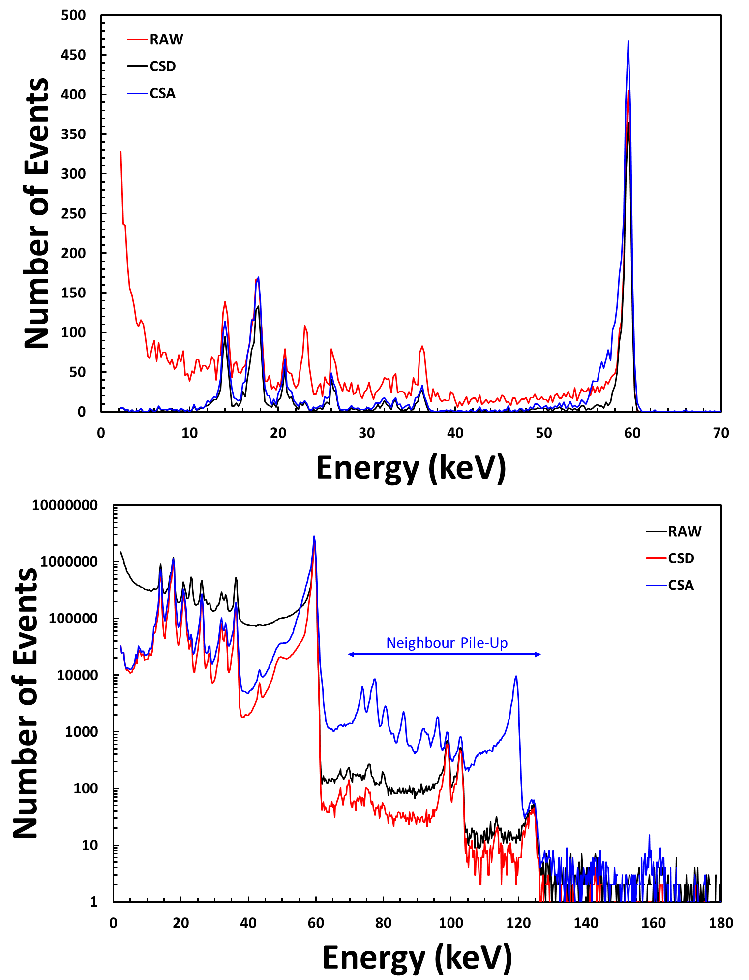

Figure 18: A comparison of the spectra produced using CSD (red), CSA (blue) and no charge sharing correction (black). Spectra are shown for the single pixel [40, 40] (top) and for all bulk pixels (bottom).
The CSA spectra shows a number of clear features, focusing first on the single pixel spectra, the use of the CSA algorithm recovers significant numbers of events in the 59.54 keV photo-peak. Summing over a window of 58 – 61 keV, the CSD and CSA peak contain 1663 and 3026 counts respectively demonstrating that the use of CSA almost doubles the counting efficiency of the detector. While the increase in efficiency for some applications is advantageous, there is also a clear degradation of the spectroscopic performance. On close examination of the 59.54 keV peak in the CSA spectrum there is now a prominent low energy tail.

The low energy counts that are observed are a result of charge loss that occurs in the region between pixels. The separation of the anode electrode in to individual pixels creates regions of non-uniform, lower, electric field. Charges drifting in these regions will move along longer paths at lower speeds which leads to additional charge loss. The depth of interaction, the point at which the X-ray interacts with respect to the pixel, will also have a significant effect on this charge loss. As indicated by the dotted line in the charge sharing distribution plot in Figure 19, a maximum of ~ 5 keV of energy is lost when interactions occur directly between two pixels.

It is notable that this same process does not affect the majority of charge sharing events that involve the generation of a Cd (23.17 keV) or Te (27.47 keV) XRF photon, as shown in Figure 19. In a large number of these events the original interaction will occur away from the inter-pixel region. The Cd and Te XRF photons have significant mean free paths in the CdTe material of 119 and 63 μm respectively. When generated these photons are emitted in to 4π and, due to the length of their mean free paths, they are likely to stop in the volume of the neighbouring pixel. In these instances the charge clouds created by the original photon and the XRF photon are formed away from the inter-pixel regions, hence no charge is lost.

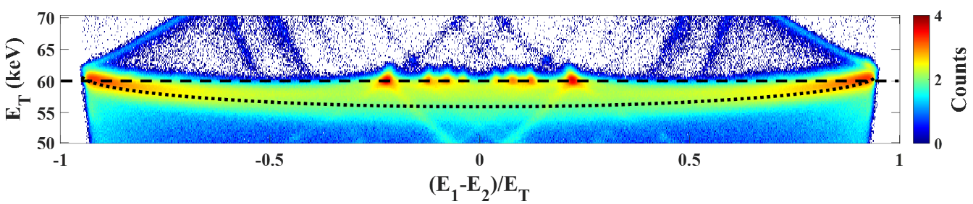

Figure 19: The distribution of charge sharing events for the 59.54 keV photo-peak. The dashed line indicates the full photo-peak energy while the dotted line illustrates charge loss in the inter-pixel region.
One of the other features that are clearly visible in the global spectrum is that there are significant numbers of events that are identified incorrectly as charge sharing events. These events can be seen in Figure 18 (bottom) and appear as a repetition of the input spectrum. These events are unavoidable in CSA corrected data and can be minimised either by keeping the frame occupancy very low or by artificially manipulating the CSA algorithm for certain energies although this introduces different artefacts in to the spectra.

https://github.com/STFC-DDG/HEXITEC/tree/Matt_Veale
For this detector an nt value of 4 works well although for noisier detectors this may need to be larger
https://uk.mathworks.com/help/images/ref/bwconncomp.html

