|  |
| --- |
| **LAB PROJECT REPORT**  Statistics for Business and Economics-II (ECO204)  Submitted by  **Student – 1 Name (Id - ….)**  **Student – 2 Name (Id - ….)**  **Date: 15th January 2023** |

# Case Study - 1

We have a data set of Armand’s Pizza Parlor. …….

|  |  |
| --- | --- |
| Variables | Explanations |
| **Sales** |  |
| **Population** |  |
|  |  |
|  |  |
|  |  |

**Question** 1 a),

**Answer**: Here is a scatter plot between population and sales

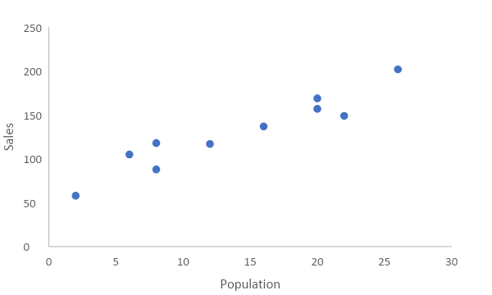

**Figure:** Scatter plot of Population and Sales of Armand’s Pizza Parlor data set.

The plot suggests there is a positive relationship between the student population and sales. This relationship makes sense because as we have more students in the area, the demand for Pizza might increase and this may drive more sales for Armand.

**Question** 1 b) ….

**Answer:** We can use simple linear regression model to study the relationship between Sales and Population. Here is the true regression model.

$$Y= β_{0}+ β_{1} X+ε$$

where,

$$Y :Sales \\ X :Population \\ β_{0} :True Intercept Coefficient \\ β_{1}:True slope coefficient \\ ε:Random noise term$$

The result of the estimation is following.

|  |  |
| --- | --- |
|  | ***Dependent Variable*** |
|  | Quarterly Sales (in 1000s) |
| Student Population (in 1000s) | 5*** |
|  | (0.580) |
| Constant | 60*** |
|  | (9.226) |
| Observations | 10 |
| $$R^{2}$$ | 0.903 |
| Residual Std. Error | 13.829 |
| F Statistic | 74.248*** |
| Note: | *p < 0.1, **p<0.05, ***p<0.01 |

**Table:** Regression Results for the Simple Linear Regression

The estimated regression equation

$$\hat{Sales}=60+5 Population$$

Here the estimated intercept coefficient ${\hat{β}}_{0}=60$ and the estimated slope coefficient is ${\hat{β}}_{1}=5$. The estimated intercept coefficient 60 means, if the student population is 0 then the sales would be 60,000 dollars. But this is a mechanical interpretation. We can say that even if there is no student population the company might still make some sales to other customers. The estimated slope coefficient 5 means, if there are 1,000 increases in the student population then on average sales ~~would increase by~~  is predicted to increase by 5,000 dollars.

Write about $R^{2}$…..

To do individual significance testing, the hypotheses are

$$H_{0} : β_{1}=0 \\ H_{a}: { β}_{1}≠0$$

Here from the regression results we see that at $α=0.01$ or at 1% significance level we can reject the null, so this means there is a significant relationship between Sales and Population.

**Question** 1 c) ….

|  |  |
| --- | --- |
|  | ***Dependent Variable*** |
|  | Quarterly Sales (in 1000s) |
| Student Population (in 1000s) | 5*** |
|  | (0.580) |
| Constant | 60*** |
|  | (9.22) |
| Observations | 10 |
| $$R^{2}$$ | (0.902) |
| Residual Standard Error | 13.82 |
| F statistic | 74.24*** |
| Note | *p<0.1, **p<0.05, ***p<0.01 |

Table : Regression Results