# USE CASE: MAKE REGISTRATION (A01)

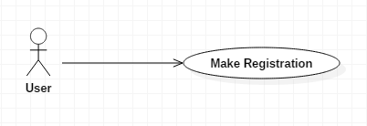

## BRIEF DESCRIPTION

This use case is initiated by the user. This use case will enable user to insert their username, password, phone number and email in registration form details in order user to access the system.

## PRE-CONDITIONS

User is not a member of the system.

## CHARACTERISTIC OF ACTIVATION

Event Driven (on user’s demand).

## CHARACTERISTIC OF ACTIVATION

Event Driven (on user’s demand).

## FLOW OF EVENTS

### Basic Flow (A01_01)

* User shall click register button at Home Menu on the screen.
* The system shall display new registration form on the screen.
* User shall insert username, password, email and phone number in registration form to register as a member.
* User shall click submit button to confirm his or her registration process.
* The system shall save user’s registration detail (**E1: Registration Incomplete**).

### Alternative Flow

Not Applicable.

### Exceptional Flow

**E-1: Registration Incomplete. (A01_02)**

The system shall display an error message “Registration Incomplete”. The system will check until user complete all the details that required in registration form in order to save the details in the system.

## POST-CONDITIONS

* User is a member of the system.

## RULE(S)

Not applicable.

## CONSTRAINT(S)

The user can only register once in the system.

# USE CASE: login system (A02)

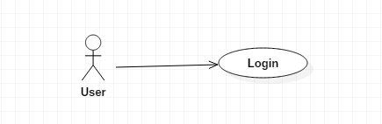

## BRIEF DESCRIPTION

This use case is initiated by the user. This use case is enable user to insert their email and password to login for accessing the main menu of system.

## PRE-CONDITIONS

User is not logged in, but is a member of the system which must have username and password from registration.

## CHARACTERISTIC OF ACTIVATION

Event Driven (on user’s demand).

## FLOW OF EVENTS

### Basic Flow (A02_01)

* User shall click login button at Home Menu of the system.
* The system shall display Login Menu on the screen.
* User shall insert their email and password then click at login button.
* The system shall authenticate the user with the given email and password **(E1: Invalid email or Password)**
* The system shall display Main Menu of system on the screen

### Alternative Flow

Not Applicable.

### Exceptional Flow

**E-1: Invalid username or password. (A02_04)**

The system shall display an error message “Invalid username or password” if user insert either email or password incorrectly and if user does not register yet, the system will prompt user to register first before login into the system.

## POST-CONDITIONS

* User is logged in the system.

## RULE(S)

User shall register first before login in order to accessing the system.

## CONSTRAINT(S)

User only can log in one account in one time.

# USE CASE: manage SEARCH (A03)

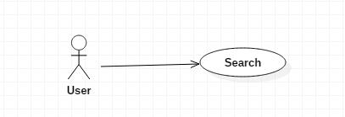

## BRIEF DESCRIPTION

This use case is initiated by the user. This use case is enable user to search the information that they want to view from the system.

## PRE-CONDITIONS

The user need to login first in order to search information from the system.

## CHARACTERISTIC OF ACTIVATION

Event Driven (on user’s demand).

## FLOW OF EVENTS

### Basic Flow (A02_01)

* User shall insert into the text field.
* User shall click on the search button in the screen.
* The system shall display the download link of pdf file that inserted just now.

### Alternative Flow

Not Applicable.

### Exceptional Flow

Not Applicable.

## POST-CONDITIONS

* User is logged in the system.

## RULE(S)

Not applicable.

## CONSTRAINT(S)

User only can search the data that exist in the system.

# USE CASE: SELECT CATEGORY (A04)

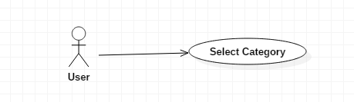

## BRIEF DESCRIPTION

This use case is initiated by the user. This use case is enable user to select category to view from the system.

## PRE-CONDITIONS

The user need to login first in order to select category to view from the system.

## CHARACTERISTIC OF ACTIVATION

Event Driven (on user’s demand).

## FLOW OF EVENTS

### Basic Flow (A02_01)

* User shall select the button based on the category.
* User shall click on the category button in the screen.
* The system shall display the price detail of category that selected just now.

### Alternative Flow

Not Applicable.

### Exceptional Flow

Not Applicable.

## POST-CONDITIONS

* User is logged in the system.

## RULE(S)

Not applicable.

## CONSTRAINT(S)

Not Applicable.

# USE CASE: DOWNLOAD FILE (A05)

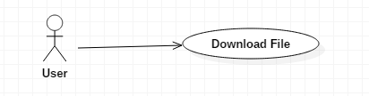

## BRIEF DESCRIPTION

This use case is initiated by the user. This use case is enable user to download the information that the website provide.

## PRE-CONDITIONS

The user need to login first in order to download information.

## CHARACTERISTIC OF ACTIVATION

Event Driven (on user’s demand).

## FLOW OF EVENTS

### Basic Flow (A02_01)

* User shall click on the download link in the screen.
* The system shall download the pdf file that selected by user.

### Alternative Flow

Not Applicable.

### Exceptional Flow

Not Applicable.

## POST-CONDITIONS

* User is logged in the system.

## RULE(S)

Not applicable.

## CONSTRAINT(S)

Not Applicable.

# USE CASE: Manage FEEDBACK (A06)



## BRIEF DESCRIPTION

This use case is initiated by the user. This use case is enable user to give their feedback about our website.

## PRE-CONDITIONS

The user need to login first in order to give their feedback.

## CHARACTERISTIC OF ACTIVATION

Event Driven (on user’s demand).

## FLOW OF EVENTS

### Basic Flow (A02_01)

* User shall click on the contact us button on the screen.
* The system shall display a contact us form on the screen.
* User shall fil in all the information such as name, phone number, email and comments
* User shall click on the Submit button once they complete all the info.
* The system will display data is inserted.

### Alternative Flow

Not Applicable.

### Exceptional Flow

Not Applicable.

## POST-CONDITIONS

* User is logged in the system.

## RULE(S)

Not applicable.

## CONSTRAINT(S)

The user can only give their feedback once in a day.

# USE CASE: view COMPANY BACKGROUND (A07)

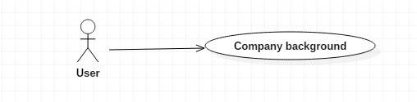

## BRIEF DESCRIPTION

This use case is initiated by the user. This use case is enable user to view the company background.

## PRE-CONDITIONS

The user need to login first in order to view the company background.

## CHARACTERISTIC OF ACTIVATION

Event Driven (on user’s demand).

## FLOW OF EVENTS

### Basic Flow (A02_01)

* User shall click on the about us button.
* The system shall display the information about the company background.

### Alternative Flow

Not Applicable.

### Exceptional Flow

Not Applicable.

## POST-CONDITIONS

* User is logged in the system.

## RULE(S)

Not applicable.

## CONSTRAINT(S)

User cannot edit the company background.