STIXTM Version 1.2.1 Part 5: TTP

Working Draft 01

02 September 2015

Technical Committee:

[OASIS Cyber Threat Intelligence (CTI) TC](https://www.oasis-open.org/committees/cti/)

Chair:

Richard Struse ([Richard.Struse@HQ.DHS.GOV](mailto:Richard.Struse@HQ.DHS.GOV)), [DHS Office of Cybersecurity and Communications (CS&C)](http://www.dhs.gov/office-cybersecurity-and-communications)

Editors:

Sean Barnum ([sbarnum@mitre.org](mailto:sbarnum@mitre.org)), [MITRE Corporation](http://www.mitre.org/)

Desiree Beck ([dbeck@mitre.org](mailto:dbeck@mitre.org)), [MITRE Corporation](http://www.mitre.org/)

Aharon Chernin ([achernin@soltra.com](mailto:achernin@soltra.com)), [Soltra](http://www.soltra.com/)

Rich Piazza ([rpiazza@mitre.org](mailto:rpiazza@mitre.org)), [MITRE Corporation](http://www.mitre.org/)

Additional artifacts:

This prose specification is one component of a Work Product which consists of:

* *STIXTM Version 1.2.1 Part 1: Overview*. [URI – added during publication]
* *STIXTM Version 1.2.1 Part 2: Common*. [URI]
* *STIXTM Version 1.2.1 Part 3: Core*. [URI]
* *STIXTM Version 1.2.1 Part 4: Indicator*. [URI]
* *STIXTM Version 1.2.1 Part 5: TTP*. (this document)
* *STIXTM Version 1.2.1 Part 6: Incident*. [URI]
* *STIXTM Version 1.2.1 Part 7: Threat Actor*. [URI]
* *STIXTM Version 1.2.1 Part 8: Campaign*. [URI]
* *STIXTM Version 1.2.1 Part 9: Course of Action*. [URI]
* *STIXTM Version 1.2.1 Part 10: Exploit Target*. [URI]
* *STIXTM Version 1.2.1 Part 11: Report*. [URI]
* *STIXTM Version 1.2.1 Part 12: Default Extensions*. [URI]
* *STIXTM Version 1.2.1 Part 13: Data Marking*. [URI]
* *STIXTM Version 1.2.1 Part 14: Vocabularies*. [URI]
* *STIXTM Version 1.2.1 Part 15: UML Model*. [URI]

Related work:

This specification is related to:

* *CybOXTM Version 2.1.1 (placeholder)*

Abstract:

The Structured Threat Information Expression (STIX) framework defines nine core constructs and the relationships between them for the purposes of modeling cyber threat information and enabling cyber threat information analysis and sharing. This specification document defines the Tactics, Techniques, and Procedures (TTP) construct, which captures the behavior or modus operandi of cyber adversaries.

Status:

This [Working Draft](https://www.oasis-open.org/policies-guidelines/tc-process#dWorkingDraft) (WD) has been produced by one or more TC Members; it has not yet been voted on by the TC or [approved](https://www.oasis-open.org/policies-guidelines/tc-process#committeeDraft) as a Committee Draft (Committee Specification Draft or a Committee Note Draft). The OASIS document [Approval Process](https://www.oasis-open.org/policies-guidelines/tc-process#standApprovProcess) begins officially with a TC vote to approve a WD as a Committee Draft. A TC may approve a Working Draft, revise it, and re-approve it any number of times as a Committee Draft.

URI patterns:

Initial publication URI:  
http://docs.oasis-open.org/cti/stix/v1.2.1/csd01/part5-ttp/stix-v1.2.1-csd01-part5-ttp.docx

Permanent “Latest version” URI:  
http://docs.oasis-open.org/cti/stix/v1.2.1/stix-v1.2.1-part5-ttp.docx

(Managed by OASIS TC Administration; please don’t modify.)

Copyright © OASIS Open 2015. All Rights Reserved.

All capitalized terms in the following text have the meanings assigned to them in the OASIS Intellectual Property Rights Policy (the "OASIS IPR Policy"). The full [Policy](https://www.oasis-open.org/policies-guidelines/ipr) may be found at the OASIS website.

This document and translations of it may be copied and furnished to others, and derivative works that comment on or otherwise explain it or assist in its implementation may be prepared, copied, published, and distributed, in whole or in part, without restriction of any kind, provided that the above copyright notice and this section are included on all such copies and derivative works. However, this document itself may not be modified in any way, including by removing the copyright notice or references to OASIS, except as needed for the purpose of developing any document or deliverable produced by an OASIS Technical Committee (in which case the rules applicable to copyrights, as set forth in the OASIS IPR Policy, must be followed) or as required to translate it into languages other than English.

The limited permissions granted above are perpetual and will not be revoked by OASIS or its successors or assigns.

This document and the information contained herein is provided on an "AS IS" basis and OASIS DISCLAIMS ALL WARRANTIES, EXPRESS OR IMPLIED, INCLUDING BUT NOT LIMITED TO ANY WARRANTY THAT THE USE OF THE INFORMATION HEREIN WILL NOT INFRINGE ANY OWNERSHIP RIGHTS OR ANY IMPLIED WARRANTIES OF MERCHANTABILITY OR FITNESS FOR A PARTICULAR PURPOSE.

Portions copyright © United States Government 2012-2015.  All Rights Reserved.  
  
STIX™, TAXII™, AND CybOX™ (STANDARD OR STANDARDS) AND THEIR COMPONENT PARTS ARE PROVIDED “AS IS” WITHOUT ANY WARRANTY OF ANY KIND, EITHER EXPRESSED, IMPLIED, OR STATUTORY, INCLUDING, BUT NOT LIMITED TO, ANY WARRANTY THAT THESE STANDARDS OR ANY OF THEIR COMPONENT PARTS WILL CONFORM TO SPECIFICATIONS, ANY IMPLIED WARRANTIES OF MERCHANTABILITY, FITNESS FOR A PARTICULAR PURPOSE, OR FREEDOM FROM INFRINGEMENT, ANY WARRANTY THAT THE STANDARDS OR THEIR COMPONENT PARTS WILL BE ERROR FREE, OR ANY WARRANTY THAT THE DOCUMENTATION, IF PROVIDED, WILL CONFORM TO THE STANDARDS OR THEIR COMPONENT PARTS. IN NO EVENT SHALL THE UNITED STATES GOVERNMENT OR ITS CONTRACTORS OR SUBCONTRACTORS BE LIABLE FOR ANY DAMAGES, INCLUDING, BUT NOT LIMITED TO, DIRECT, INDIRECT, SPECIAL OR CONSEQUENTIAL DAMAGES, ARISING OUT OF, RESULTING FROM, OR IN ANY WAY CONNECTED WITH THESE STANDARDS OR THEIR COMPONENT PARTS OR ANY PROVIDED DOCUMENTATION, WHETHER OR NOT BASED UPON WARRANTY, CONTRACT, TORT, OR OTHERWISE, WHETHER OR NOT INJURY WAS SUSTAINED BY PERSONS OR PROPERTY OR OTHERWISE, AND WHETHER OR NOT LOSS WAS SUSTAINED FROM, OR AROSE OUT OF THE RESULTS OF, OR USE OF, THE STANDARDS, THEIR COMPONENT PARTS, AND ANY PROVIDED DOCUMENTATION. THE UNITED STATES GOVERNMENT DISCLAIMS ALL WARRANTIES AND LIABILITIES REGARDING THE STANDARDS OR THEIR COMPONENT PARTS ATTRIBUTABLE TO ANY THIRD PARTY, IF PRESENT IN THE STANDARDS OR THEIR COMPONENT PARTS AND DISTRIBUTES IT OR THEM “AS IS.”

Table of Contents

1 Introduction 4

1.1 STIXTM Specification Documents 4

1.2 Document Conventions 5

1.2.1 Fonts 5

1.2.2 UML Package References 5

1.2.3 UML Diagrams 5

1.2.3.1 Class Properties 6

1.2.3.2 Diagram Icons and Arrow Types 6

1.2.3.3 Color Coding 7

1.2.4 Property Table Notation 7

1.2.5 Property and Class Descriptions 7

1.3 Terminology 8

1.4 Normative References 8

2 Background 9

2.1 TTP-Related Component Data Models 9

3 STIXTM TTP Data Model 10

3.1 TTPVersionType Enumeration 13

3.2 BehaviorType Class 13

3.2.1 AttackPatternsType Class 15

3.2.1.1 AttackPatternType Class 15

3.2.2 MalwareType Class 17

1.1.1.1 MalwareInstanceType Class 17

3.2.3 ExploitsType Class 19

3.2.3.1 ExploitType Class 20

3.3 ResourceType Class 21

3.3.1 ToolsType Class 22

3.3.2 InfrastructureType Class 22

3.3.3 PersonasType Class 24

3.4 VictimTargetingType Class 24

3.5 ExploitTargetsType Class 26

3.6 RelatedTTPsType Class 27

4 Conformance 29

Appendix A. Acknowledgments 30

Appendix B. Revision History 32

# Introduction

[All text is normative unless otherwise labeled]

The Structured Threat Information Expression (STIXTM) framework defines nine top-level component data models: Observable[1], Indicator, Incident, TTP, ExploitTarget, CourseOfAction, Campaign, ThreatActor, and Report. This document serves as the specification for the STIX Tactics, Techniques, and Procedures (TTP) data model.

As defined within the STIX language, a TTP construct characterizes adversarial mode of operations (often referred to as the adversary’s “Tactics, Techniques, and Procedures”), such as the victims targeted, the attack patterns and malware used, and the resources (infrastructure, tools, and personas) leveraged. Because the TTP construct describes adversary behavior, which is a central objective of STIX, it is one of the most commonly used and expressive constructs.

In Section **1.1** we discuss additional specification documents, in Section **1.2** we provide document conventions, and in Section **1.3** we provide terminology. References are given in Section **1.4**. In Section **2**, we give background information necessary to fully understand the Course of Action data model. We present the TTP data model specification details in Section **3** and conformance information in Section **4**.

## STIXTM Specification Documents

The STIX specification consists of a formal UML model and a set of textual specification documents that explain the UML model. Specification documents have been written for each of the key individual data models that compose the full STIX UML model.

The *STIXTM Version 1.2.1 Part 1: Overview* document provides a comprehensive overview of the full set of STIX data models, which in addition to the nine top-level component data models mentioned in the Introduction, includes a core data model, a common data model, a cross-cutting data marking data model, various extension data models, and a set of default controlled vocabularies. *STIXTM Version 1.2.1 Part 1: Overview* also summarizes the relationship of STIX to other languages, and outlines general STIX data model conventions.

**Figure 1‑1** illustrates the set of specification documents that are available. The color black is used to indicate the specification overview document, altered shading differentiates the overarching Core and Common data models from the supporting data models (vocabularies, data marking, and default extensions), and the color white indicates the component data models. The solid grey color denotes the overall STIX Language UML model. This TTP specification document is highlighted in its associated color (see Section **1.2.3.3**). For a list of all STIX documents and related information sources, please see *STIXTM Version 1.2.1 Part 1: Overview*.

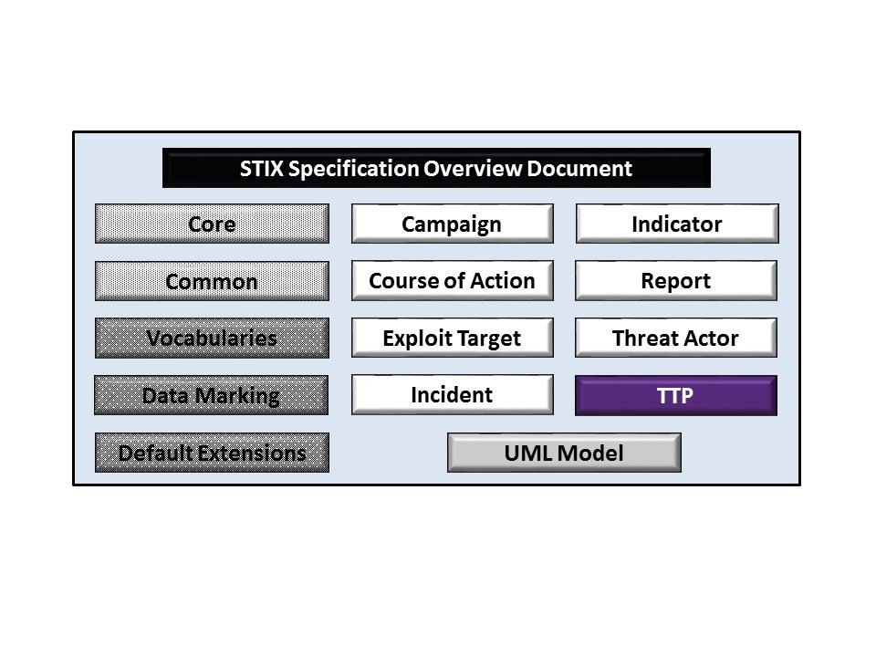

Figure 1‑1. STIXTM Language v1.2.1 specification documents

## Document Conventions

The following conventions are used in this document.

### Fonts

The following font and font style conventions are used in the document:

* Capitalization is used for STIX high level concepts, which are defined in *STIXTM Version 1.2.1 Part 1: Overview*.

Examples: Indicator, Course of Action, Threat Actor

* The Courier New font is used for writing UML objects.

Examples: RelatedIndicatorsType, stixCommon:StatementType

Note that all high level concepts have a corresponding UML object. For example, the Course of Action high level concept is associated with a UML class named, CourseOfActionType.

* The ‘*italic’* font (withsingle quotes) is used for noting actual, explicit values for STIX Language properties. The *italic* font (without quotes) is used for noting example values.

Example:  *‘PackageIntentVocab-1.0,’ high, medium, low*

### UML Package References

Each STIX data model is captured in a different UML package (e.g., Core package, Campaign package, etc.) where the packages together compose the full STIX UML model. To refer to a particular class of a specific package, we use the format package_prefix:class, where package_prefix corresponds to the appropriate UML package. *STIXTM Version 1.2.1 Part 1: Overview* contains a list of the packages used by the TTP data model, along with the associated prefix notations, descriptions, examples.

Note that in this specification document, we do not explicitly specify the package prefix for any classes that originate from the TTP data model.

### UML Diagrams

This specification makes use of UML diagrams to visually depict relationships between STIX Language constructs. Note that the diagrams have been extracted directly from the full UML model for STIX; they have not been constructed purely for inclusion in the specification documents.  Typically, diagrams are included for the primary class of a data model, and for any other class where the visualization of its relationships between other classes would be useful.  This implies that there will be very few diagrams for classes whose only properties are either a data type or a class from the STIX Common data model.  Other diagrams that are included correspond to classes that specialize a superclass and abstract or generalized classes that are extended by one or more subclasses.

In UML diagrams, classes are often presented with their attributes elided, to avoid clutter. The fully described class can usually be found in a related diagram. A class presented with an empty section at the bottom of the icon indicates that there are no attributes other than those that are visualized using associations.

#### Class Properties

Generally, a class property can be shown in a UML diagram as either an attribute or an association (i.e., the distinction between attributes and associations is somewhat subjective). In order to make the size of UML diagrams in the specifications manageable, we have chosen to capture most properties as attributes and to capture only higher level properties as associations, especially in the main top-level component diagrams. In particular, we will always capture properties of UML data types as attributes. For example, properties of a class that are identifiers, titles, and timestamps will be represented as attributes.

#### Diagram Icons and Arrow Types

Diagram icons are used in a UML diagram to indicate whether a shape is a class, enumeration or data type, and decorative icons are used to indicate whether an element is an attribute of a class or an enumeration literal. In addition, two different arrow styles indicate either a directed association relationship (regular arrowhead) or a generalization relationship (triangle-shaped arrowhead). The icons and arrow styles we use are shown and described in **Table 1‑1**.

Table 1‑1. UML diagram icons

|  |  |
| --- | --- |
| **Icon** | **Description** |
|  | This diagram icon indicates a class. If the name is in italics, it is an abstract class. |
|  | This diagram icon indicates an enumeration. |
|  | This diagram icon indicates a data type. |
|  | This decorator icon indicates an attribute of a class. The green circle means its visibility is public. If the circle is red or yellow, it means its visibility is private or protected. |
|  | This decorator icon indicates an enumeration literal. |
|  | This arrow type indicates a directed association relationship. |
|  | This arrow type indicates a generalization relationship. |

#### Color Coding

The shapes of the UML diagrams are color coded to indicate the data model associated with a class. The colors used in the TTP specification are illustrated in **Figure 1‑2**.

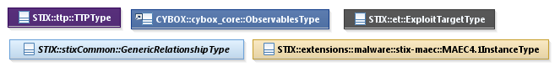

Figure 1‑2. Data model color coding

### Property Table Notation

Throughout Section **3**, tables are used to describe the properties of each data model class. Each property table consists of a column of names to identify the property, a type column to reflect the datatype of the property, a multiplicity column to reflect the allowed number of occurrences of the property, and a description column that describes the property. Package prefixes are provided for classes outside of the TTP data model (see Section **1.2.2**).

Note that if a class is a specialization of a superclass, only the properties that constitute the specialization are shown in the property table (i.e., properties of the superclass will not be shown). However, details of the superclass may be shown in the UML diagram.

In addition, properties that are part of a “choice” relationship (e.g., Prop1 OR Prop2 is used but not both) will be denoted by a unique letter subscript (e.g., API_CallA, CodeB) and single logic expression in the Multiplicity column.  For example, if there is a choice of property API_CallA and CodeB, the expression “A(1)|B(0..1)” will indicate that the API_Call property can be chosen with multiplicity 1 or the Code property can be chosen with multiplicity 0 or 1.

### Property and Class Descriptions

Each class and property defined in STIX is described using the format, “The X property verbY.” For example, in the specification for the STIX Indicator, we write, “The id property specifies a globally unique identifier for the kill chain instance.” In fact, the verb “specifies” could have been replaced by any number of alternatives: “defines,” “describes,” “contains,” “references,” etc.

However, we thought that using a wide variety of verb phrases might confuse a reader of a specification document because the meaning of each verb could be interpreted slightly differently. On the other hand, we didn’t want to use a single, generic verb, such as “describes,” because although the different verb choices may or may not be meaningful from an implementation standpoint, a distinction could be useful to those interested in the modeling aspect of STIX.

Consequently, we have chosen to use the three verbs, defined as follows, in class and property descriptions:

|  |  |
| --- | --- |
| **Verb** | **STIX Definition** |
| captures | Used to record and preserve information without implying anything about the structure of a class or property. Often used for properties that encompass general content. This is the least precise of the three verbs. |
|  | *Examples:*  The Source property characterizes the source of the sighting information. Examples of details captured include identitifying characteristics, time-related attributes, and a list of the tools used to collect the information.  The Description property captures a textual description of the Indicator. |
| characterizes | Describes the distinctive nature or features of a class or property. Often used to describe classes and properties that themselves comprise one or more other properties. |
|  | *Examples:*  The Confidence property characterizes the level of confidence in the accuracy of the overall content captured in the Incident.  The ActivityType class characterizes basic information about an activity a defender might use in response to a Campaign. |
| specifies | Used to clearly and precisely identify particular instances or values associated with a property. Often used for properties that are defined by a controlled vocabulary or enumeration; typically used for properties that take on only a single value. |
|  | *Example:*  The version property specifies the version identifier of the STIX Campaign data model used to capture the information associated with the Campaign. |

## Terminology

The key words “MUST”, “MUST NOT”, “REQUIRED”, “SHALL”, “SHALL NOT”, “SHOULD”, “SHOULD NOT”, “RECOMMENDED”, “MAY”, and “OPTIONAL” in this document are to be interpreted as described in [RFC2119].

## Normative References

[RFC2119] Bradner, S., “Key words for use in RFCs to Indicate Requirement Levels”, BCP 14, RFC 2119, March 1997. <http://www.ietf.org/rfc/rfc2119.txt>.

# Background

In this section, we provide high level information about the TTP data model that is necessary to fully understand the TTP data model specification details given in Section **3**.

## TTP-Related Component Data Models

As will be explicitly detailed in Section **3**, a STIX TTP leverages the Exploit Target data model (as indicated by the outward-oriented arrow). **Figure 2‑1** illustrates the relationship between the TTP and the other core constructs. As stated in Section **1.1**, each of these components is defined in a separate specification document.

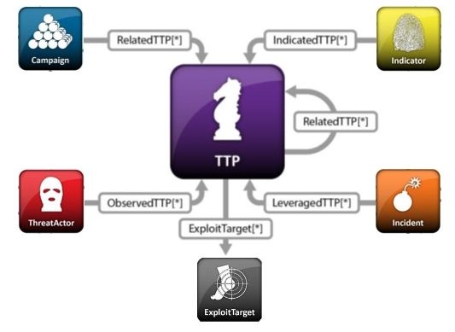

Figure 2‑1. High level view of the Campaign data model

In this section, we give a high level summary of the relationship between the TTP data model and the Exploit Target data model to which a TTP may refer. We also make note of the fact that the TTP data model can be self-referential. Other relationships are defined in the specification of the component from which they originate.

* **TTP**

The TTP data model is self-referential, enabling one TTP to reference other TTPs that are asserted to be related. Self-referential relationships between TTPs may indicate general associativity or can be used to indicate relationships between different versions of the same TTP.

* **Exploit Target**

A STIX Exploit Target conveys information about a vulnerability, weakness, or misconfiguration in software, systems, networks, or configurations that may be targeted for exploitation by an adversary. Please see *STIXTM Version 1.2.1 Part 10: Exploit Target* for details.

The TTP data model references the Exploit Target data model in order to identify possible targets for exploitation by the TTP.

# 

# STIXTM TTP Data Model

The primary class of the STIX TTP package is the TTPType class, which characterizes adversarial mode of operations (often referred to as the adversary’s “Tactics, Techniques, and Procedures”). The TTPType class captures information that includes the victims targeted, the attack patterns and malware used, and the resources (infrastructure, tools, and personas) leveraged. Similar to the primary classes of all the component data models in STIX, the TTPType class extends a base class defined in the STIX Common data model; more specifically, it extends the TTPBaseType base class, which provides the essential identifier (id) and identifier reference (idref) properties.

The relationship between the TTPType class and the TTPBaseType base class, as well as the properties of the TTPType class, are illustrated in the UML diagram given in **Figure 3‑1**.

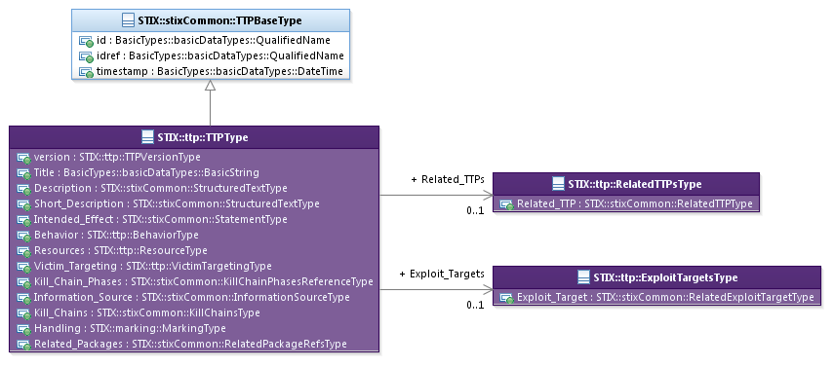

Figure 3‑1. UML diagram of the TTPType class

The property table, which includes property descriptions and corresonds to the UML Lmodel above, is given in **Table 3‑1**.

All classes defined in the TTP data model are described in detail in Sections **3.1** through Section **3.6**. Details are not provided for classes defined in non-TTP data models; instead, the reader is refered to the corresponding data model specification as indicated by the package prefix specified in the Type column of the table.

Table 3‑1. Properties of the TTPType class

|  |  |  |  |
| --- | --- | --- | --- |
| **Name** | **Type** | **Multiplicity** | **Description** |
| **version** | TTPVersionType | 0..1 | The version property specifies the version identifier of the STIX TTP data model for STIX v1.2.1 used to capture the information associated with the TTP. |
| **Title** | basicDataTypes:BasicString | 0..1 | The Title property captures a title for the TTP and reflects what the content producer thinks the TTP as a whole should be called. The Title property is typically used by humans to reference a particular TTP; however, it is not suggested for correlation. |
| **Description** | stixCommon:  StructuredTextType | 0..* | The Description property captures a textual description of the TTP. Any length is permitted. Optional formatting is supported via the structuring_format property of the StructuredTextType class. |
| **Short_Description** | stixCommon:  StructuredTextType | 0..* | The Short_Description property captures a short textual description of the TTP.  This property is secondary and should only be used if the Description property is already populated and another, shorter description is available. |
| **Intended_Effect** | stixCommon:  StatementType | 0..* | The Intended_Effect property characterizes the suspected intended effect of the TTP, which includes a Value property that specifies the type of the effect. Examples of potential types include *theft*, *disruption*, and *unauthorized access* (these specific values are only provided to help explain the Value property: they are neither recommended values nor necessarily part of any existing vocabulary). The content creator may choose any arbitrary value or may constrain the set of possible values by referencing an externally-defined vocabulary or leveraging a formally defined vocabulary extending from the stixCommon:ControlledVocabularyStringType class. The STIX default vocabulary class for use in the Value property is ‘*IntendedEffectVocab-1.0*’ (which is different than the default vocabulary provided for the StatementType class). |
| **Behavior** | BehaviorType | 0..1 | The Behavior property characterizes forms of adversarial behavior by capturing the attack patterns, malware, and/or exploits that the adversary may leverage. |
| **Resources** | ResourceType | 0..1 | The Resources property characterizes adversarial resources by capturing the tools, infrastructure, or personas that the adversary may leverage. |
| **Victim_Targeting** | VictimTargetingType | 0..1 | The Victim_Targeting property characterizes the sort of victims that an adversary may target including details of identity, systems, and/or information types targeted. |
| **Exploit_Targets** | ExploitTargetsType | 0..1 | The Exploit_Targets property specifies a set of one or more Exploit Targets potentially targeted by the TTP. |
| **Related_TTPs** | RelatedTTPsType | 0..1 | The Related_TTPs property specifies a set of one or more other TTPs related to this TTP. |
| **Kill_Chain_Phases** | stixCommon:  KillChainPhasesReferenceType | 0..1 | A cyber kill chain is a phase-based model to describe the stages of an attack, and a cyber kill chain phase is an individual phase within a kill chain definition. The Kill_Chain_Phases property specifies a set of one or more kill chain phases (from one or more kill chains defined elsewhere) for which the TTP is asserted to be representative. The kill chain property is further defined in the STIX Common specification document. |
| **Information_Source** | stixCommon:  InformationSourceType | 0..1 | The Information_Source property characterizes the source of the TTP information. Examples of details captured include identitifying characteristics, time-related attributes, and a list of the tools used to collect the information. |
| **Kill_Chains** | stixCommon:KillChainsType | 0..1 | A cyber kill chain is a phase-based model to describe the stages of an attack. The Kill_Chains property specifies a set of one or more specific kill chain definitions. The kill chain property is further defined in the STIX Common specification document. |
| **Handling** | marking:MarkingType | 0..1 | The Handling property specifies data handling markings for the properties of this TTP. The marking scope is limited to the TTP and the content is contains. Note that data handling markings can also be specified at a higher level. |
| **Related_Packages** | stixCommon:  RelatedPackagesRefsType | 0..1 | The Related_Packages property specifies a set of one or more Packages for which the TTP may be relevant. |

## TTPVersionType Enumeration

The TTPVersionType enumeration is an inventory of all versions of the TTP data model for STIX Version 1.2.1. The enumeration literals are given in **Table 3‑2**.

Table 3‑2. Literals of the TTPVersionType enumeration

|  |  |
| --- | --- |
| **Enumeration Literal** | **Description** |
| **stix-1.2.1** | TTP data model for STIX v1.2.1 |

## BehaviorType Class

The BehaviorType class characterizes adversarial behavior by capturing details of cyber attack patterns, malware or exploits that the adversary may leverage.

The UML diagram corresponding to the BehaviorType class is shown in **Figure 3‑2**.

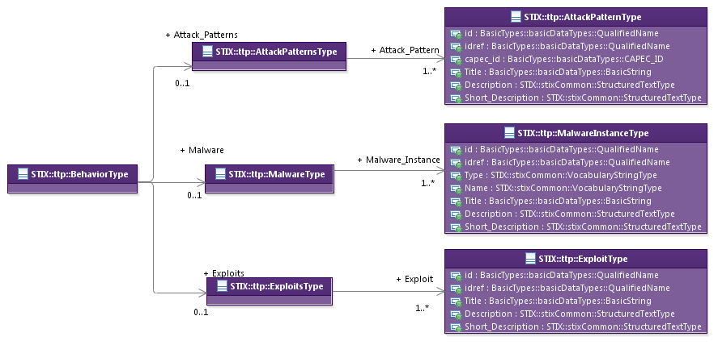

Figure 3‑2. UML diagram of the BehaviorType class

The property table given in **Table 3‑3** corresponds to the UML diagram shown in **Figure 3‑2,** and the associated classes defining the property types are discussed in Sections **3.2.1** through **3.2.3**.

Table 3‑3. Properties of the BehaviorType class

|  |  |  |  |
| --- | --- | --- | --- |
| **Name** | **Type** | **Multiplicity** | **Description** |
| **Attack_Patterns** | AttackPatternsType | 0..1 | The Attack_Patterns property specifies a set of one or more attack patterns that an adversary may leverage. |
| **Malware** | MalwareType | 0..1 | The Malware property specifies a set of one or more instances of malware that an adversary may leverage. |
| **Exploits** | ExploitsType | 0..1 | The Exploits property specifies a set of one or more exploits that an adversary may leverage. |

### AttackPatternsType Class

The AttackPatternsType class specifies a set of one or more attack patterns that an adversary may leverage.

The property of the AttackPatternsType class is shown in **Table 3‑4**.

Table 3‑4. Properties of the AttackPatternsType class

|  |  |  |  |
| --- | --- | --- | --- |
| **Name** | **Type** | **Multiplicity** | **Description** |
| **Attack_Pattern** | AttackPatternType | 1..* | The Attack_Pattern property specifies a single Attack Pattern that an adversary may leverage. |

#### AttackPatternType Class

The AttackPatternType class characterizes an individual attack pattern[2] through the capture of information such as a textual description and a Common Attack Pattern Enumeration and Classification (CAPEC) reference. The AttackPatternType class is intended to be extended as appropriate to enable the structured description of an attack pattern. STIX v1.2.1 defines a default extension to the AttackPatternType class to leverage the Common Attack Pattern Enumeration and Classification (CAPEC) data model.

The UML diagram corresponding to the SuggestedCOAsType class is shown in **Figure 3‑3**. Please see *STIXTM Version 1.2.1 Part 12: Default Extensions* for extension-related details.

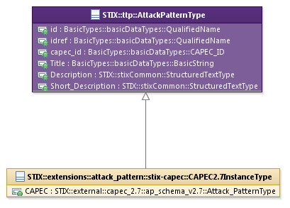

Figure 3‑3. UML diagram of the AttackPatternType class

The property table given in **Table 3‑5** corresponds to the UML diagram given in **Figure 3‑3**.

Table 3‑5. Properties of the AttackPatternType class

|  |  |  |  |
| --- | --- | --- | --- |
| **Name** | **Type** | **Multiplicity** | **Description** |
| **id** | basicDataTypes:QualifiedName | 0..1 | The id property specifies a globally unique identifier for the attack pattern. |
| **idref** | basicDataTypes:QualifiedName | 0..1 | The idref property specifies an identifier reference to an attack pattern specified elsewhere. When the idref property is used, the id property MUST NOT also be specified and the other properties of the AttackPatternType class SHOULD NOT hold any content. |
| **capec_id** | basicDataTypes:CAPEC_ID | 0..1 | The capec_id property specifies a particular attack pattern (via identifier) in the Common Attack Pattern Enumeration and Classification (CAPEC) registry. |
| **Title** | basicDataTypes:BasicString | 0..1 | The Title property captures a title for the attack pattern and reflects what the content producer thinks the attack pattern as a whole should be called. The Title property is typically used by humans to reference a particular attack pattern; however, it is not suggested for correlation. |
| **Description** | stixCommon:StructuredTextType | 0..* | The Description property captures a textual description of the attack pattern. Any length is permitted. Optional formatting is supported via the structuring_format property of the StructuredTextType class. |
| **Short_Description** | stixCommon:StructuredTextType | 0..* | The Short_Description property captures a short textual description of the attack pattern.  This property is secondary and should only be used if the Description property is already populated and another, shorter description is available. |

### MalwareType Class

The MalwareType class characterizes a set of one or more malware instances that an adversary may leverage.

The property of the MalwareType class is shown in **Table 3‑6**.

Table 3‑6. Properties of the MalwareType class

|  |  |  |  |
| --- | --- | --- | --- |
| **Name** | **Type** | **Multiplicity** | **Description** |
| **Malware_Instance** | MalwareInstanceType | 1..* | The Malware_Instance property characterizes a single malware instance that an adversary may leverage. |

#### MalwareInstanceType Class

The MalwareInstanceType class characterizes a malware instance through the capture of basic information such as the type, name, and description of the malware. A malware instance may characterize anything from a specific malware sample to an entire family. The MalwareInstanceType class is intended to be extended as appropriate to enable the structured description of a malware instance. STIX v1.2.1 defines a default extension to the MalwareInstanceType class to leverage the Malware Attribute Enumeration and Classification (MAEC) data model.

The UML diagram corresponding to the MalwareInstanceType class is shown in **Figure 3‑4**. Please see *STIXTM Version 1.2.1 Part 12: Default Extensions* for extension-related details.

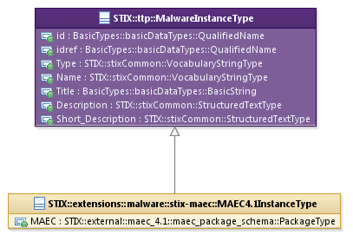

Figure 3‑4. UML diagram of the MalwareInstanceType class

The property table given in **Table 3‑7** corresponds to the UML diagram given in **Figure 3‑4**.

Table 3‑7. Properties of the MalwareInstanceType class

|  |  |  |  |
| --- | --- | --- | --- |
| **Name** | **Type** | **Multiplicity** | **Description** |
| **id** | basicDataTypes:  QualifiedName | 0..1 | The id property specifies a globally unique identifier for the malware instance. |
| **idref** | basicDataTypes:  QualifiedName | 0..1 | The idref property specifies an identifier reference to a malware instance specified elsewhere. When the idref property is used, the id property MUST NOT also be specified and the other properties of the MalwareInstanceType class SHOULD NOT hold any content. |
| **Type** | stixCommon:  VocabularyStringType | 0..* | The Type property specifies the type of the malware instance being characterized. Examples of potential types include *bot,* e*xploit kit*, and *ransomware* (these specific values are only provided to help explain the property: they are neither recommended types nor necessarily part of any existing vocabulary). The content creator may choose any arbitrary value or may constrain the set of possible values by referencing an externally-defined vocabulary or leveraging a formally defined vocabulary extending from the stixCommon:ControlledVocabularyStringType class. The STIX default vocabulary class for use in the property is ‘*MalwareTypeVocab-1.0.*’ |
| **Name** | stixCommon:  VocabularyStringType | 0..* | The Name property is used to specify a single name or alias that identifies the malware instance. The content creator may choose any arbitrary name or may constrain the set of possible names by referencing an externally-defined vocabulary or leveraging a formally defined vocabulary extending from the stixCommon:ControlledVocabularyStringType class. No default vocabulary class for use in the property has been defined for STIX 1.2. |
| **Title** | basicDataTypes:  BasicString | 0..1 | The Title property captures a title for the malware instance and reflects what the content producer thinks the malware instance as a whole should be called. The Title property is typically used by humans to reference a particular malware instance; however, it is not suggested for correlation. |
| **Description** | stixCommon:  StructuredTextType | 0..* | The Description property captures a textual description of the malware instance. Any length is permitted. Optional formatting is supported via the structuring_format property of the StructuredTextType class. |
| **Short_Description** | stixCommon:  StructuredTextType | 0..* | The Short_Description property captures a short textual description of the malware instance.  This property is secondary and should only be used if the Description property is already populated and another, shorter description is available. |

### ExploitsType Class

The ExploitsType class specifies a set of one or more exploits that an adversary may leverage.

The property of the ExploitsType class is shown in **Table 3‑8**.

Table 3‑8. Properties of the ExploitsType class

|  |  |  |  |
| --- | --- | --- | --- |
| **Name** | **Type** | **Multiplicity** | **Description** |
| **Exploit** | ExploitType | 1..* | The Exploit property specifies a single exploit that an adversary may leverage. |

#### ExploitType Class

The ExploitType class characterizes an individual exploit instance through the capture of basic information such as the title and description of the exploit. The ExploitType class is intended to be extended to enable the structured description of an exploit instance. However, no extension is provided by STIX v 1.2; producers wanting to represent structured exploit instance information are encouraged to develop such an extension.

The properties of the ExploitType class are shown in **Table 3‑9**.

Table 3‑9. Properties of the ExploitType class

|  |  |  |  |
| --- | --- | --- | --- |
| **Name** | **Type** | **Multiplicity** | **Description** |
| **id** | basicDataTypes:BasicString | 0..1 | The id property specifies a globally unique identifier for the exploit instance. |
| **idref** | basicDataTypes:BasicString | 0..1 | The idref property specifies an identifier reference to an exploit instance specified elsewhere. When the idref property is used, the id property MUST NOT also be specified and the other properties of the ExploitType class SHOULD NOT hold any content. |
| **Title** | basicDataTypes:BasicString | 0..1 | The Title property captures a title for the exploit instance and reflects what the content producer thinks the exploit instance as a whole should be called. The Title property is typically used by humans to reference a particular exploit instance; however, it is not suggested for correlation. |
| **Description** | stixCommon:StructuredTextType | 0..* | The Description property captures a textual description of the exploit instance. Any length is permitted. Optional formatting is supported via the structuring_format property of the StructuredTextType class. |
| **Short_Description** | stixCommon:StructuredTextType | 0..* | The Short_Description property captures a short textual description of the exploit instance.  This property is secondary and should only be used if the Description property is already populated and another, shorter description is available. |

## ResourceType Class

The ResourceType class characterizes resources the adversary may leverage.

The UML diagram corresponding to the ResourceType class is shown in **Figure 3‑5**.

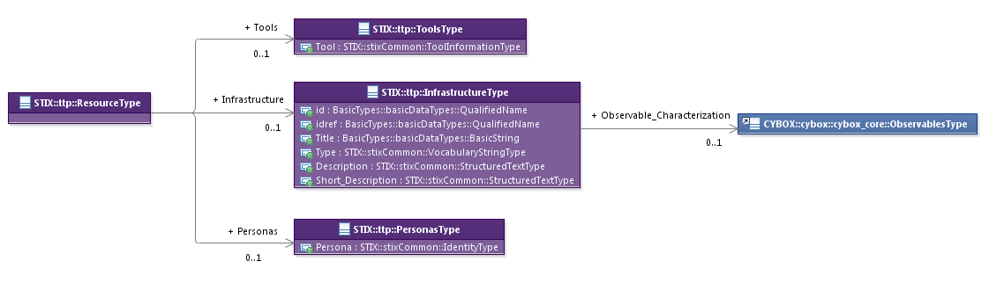

Figure 3‑5. UML diagram of the ResourceType class

The property table given in **Table 3‑10** corresponds to the UML diagram given in **Figure 3‑5**.

Table 3‑10. Properties of the ResourceType class

|  |  |  |  |
| --- | --- | --- | --- |
| **Name** | **Type** | **Multiplicity** | **Description** |
| **Tools** | ToolsType | 0..1 | The Tools property specifies a set of one or more tools that an adversary may leverage. |
| **Infrastructure** | InfrastructureType | 0..1 | The Infrastructure property characterizes infrastructure that an adversary may leverage. |
| **Personas** | PersonasType | 0..1 | The Personas property specifies a set of one or more personas that an adversary may leverage. Different personas are often used as a method of masquerade. |

### ToolsType Class

The ToolsType class specifies a set of one or more tools that an adversary may leverage. Tools specified may cover a wide range of types (DDOS tools, exploit kits, packers, communications tools, etc.). While ToolsType may be appropriate for characterizing the use of a particular malware as an attack tool including details of specific version or configuration, it is not appropriate for characterizing the structure or behavior of malware which is more appropriately characterized using MalwareInstanceType.

The property of the ToolsType class is shown in **Table 3‑11**.

Table 3‑11. Properties of the ToolsType class

|  |  |  |  |
| --- | --- | --- | --- |
| **Name** | **Type** | **Multiplicity** | **Description** |
| **Tool** | stixCommon:  ToolInformationType | 1..* | The Tool property characterizes a single adversarial tool. Note that the STIX Common ToolInformationType class includes a Type property that specifies the type of the tool. Examples of potential tool types include *pentester*, *port scanner*, and *password cracker* (these specific values are only provided to help explain the Type property: they are neither recommended types nor necessarily part of any existing vocabulary). The content creator may choose any arbitrary value or may constrain the set of possible values by referencing an externally-defined vocabulary or leveraging a formally defined vocabulary extending from the stixCommon:ControlledVocabularyStringType class. The STIX default vocabulary class for use in the Type property is ‘*AttackerToolTypeVocab-1.0.*’ |

### InfrastructureType Class

The InfrastructureType class characterizes adversarial infrastructure that an adversary may leverage.

Properties of the InfrastructureType class are shown in **Table 3‑12**.

Table 3‑12. Properties of the InfrastructureType class

|  |  |  |  |
| --- | --- | --- | --- |
| **Name** | **Type** | **Multiplicity** | **Description** |
| **id** | basicDataTypes:  BasicString | 0..1 | The id property specifies a globally unique identifier for the infrastructure. |
| **idref** | basicDataTypes:  BasicString | 0..1 | The idref property specifies an identifier reference to an infrastructure specified elsewhere. When the idref property is used, the id property MUST NOT also be specified and the other properties of the InfrastructureType class SHOULD NOT hold any content. |
| **Title** | basicDataTypes:  BasicString | 0..1 | The Title property captures a title for the infrastructure and reflects what the content producer thinks the infrastructure as a whole should be called. The Title property is typically used by humans to reference a particular infrastructure; however, it is not suggested for correlation. |
| **Type** | stixCommon:  VocabularyStringType | 0..* | The Type property specifies the type of infrastructure being characterized. Examples of potential types include *anonymization*, *domain registration*, and *hosting* (these specific values are only provided to help explain the property: they are neither recommended values nor necessarily part of any existing vocabulary). The content creator may choose any arbitrary value or may constrain the set of possible values by referencing an externally-defined vocabulary or leveraging a formally defined vocabulary extending from the stixCommon:ControlledVocabularyStringType class. The STIX default vocabulary class for use in the property is ‘*AttackerInfrastructureTypeVocab-1.0.*’ |
| **Description** | stixCommon:  StructuredTextType | 0..* | The Description property captures a textual description of the infrastructure. Any length is permitted. Optional formatting is supported via the structuring_format property of the StructuredTextType class. |
| **Short_Description** | stixCommon:  StructuredTextType | 0..* | The Short_Description property captures a short textual description of the infrastructure. This property is secondary and should only be used if the Description property is already populated and another, shorter description is available. |
| **Observable_Characterization** | cybox:ObservablesType | 0..1 | The Observable_Characterization property characterizes the adversarial infrastructure through specification of a structured cyber Observables pattern. |

### PersonasType Class

The PersonasType class specifies a set of one or more personas that an adversary may leverage.

The property of the PersonasType class is shown in **Table 3‑13**.

Table 3‑13. Properties of the PersonasType class

|  |  |  |  |
| --- | --- | --- | --- |
| **Name** | **Type** | **Multiplicity** | **Description** |
| **Persona** | stixCommon:IdentityType | 1..* | The Persona property characterizes a persona identity potentially used in malicious activity. Personas are typically used to masquerade as another party. For situations calling for more than a simple name, the underlying class may be extended using a more complete structure such as the CIQIdentity3.0InstanceType subclass as defined in *STIXTM Version 1.2.1 Part 12: Default Extensions*. |

## VictimTargetingType Class

The VictimTargetingType class characterizes victim targeting information by capturing information about the people, organizations, systems and/or data potentially targeted by the adversary.

The UML diagram corresponding to the VictimTargetingType class is shown in **Figure 3‑6**.

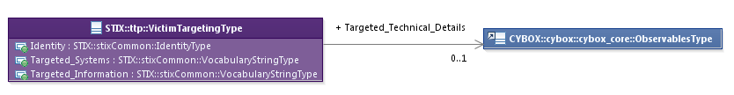

Figure 3‑6. UML diagram of the VictimTargetingType class

The property table given in **Table 3‑14** corresponds to the UML diagram given in **Figure 3‑6**.

Table 3‑14. Properties of the VictimTargetingType class

|  |  |  |  |
| --- | --- | --- | --- |
| **Name** | **Type** | **Multiplicity** | **Description** |
| **Identity** | stixCommon:  IdentityType | 0..1 | The Identity property characterizes traits common to the people or organizations that are targeted. For situations calling for more than a simple name, the underlying class may be extended using a more complete structure such as the CIQIdentity3.0InstanceType subclass as defined in *STIXTM Version 1.2.1 Part 12: Default Extensions*. |
| **Targeted_Systems** | stixCommon:  VocabularyStringType | 0..* | The Targeted_Systems property specifies a type of system that may be targeted by the adversary. Examples of potential types include *web layer, third-party services,* and *user workstations* (these specific values are only provided to help explain the property: they are neither recommended values nor necessarily part of any existing vocabulary). The content creator may choose any arbitrary value or may constrain the set of possible values by referencing an externally-defined vocabulary or leveraging a formally defined vocabulary extending from the stixCommon:ControlledVocabularyStringType class. The STIX default vocabulary class for use in the property is ‘*SystemTypeVocab-1.0*.’ |
| **Targeted_Information** | stixCommon:  VocabularyStringType | 0..* | The Targeted_Information property specifies a type of information that may be targeted by the adversary. Examples of potential types include *customer PII*, *mobile phone contacts*, and *authentication cookies* (these specific values are only provided to help explain the property: they are neither recommended values nor necessarily part of any existing vocabulary). The content creator may choose any arbitrary value or may constrain the set of possible values by referencing an externally-defined vocabulary or leveraging a formally defined vocabulary extending from the stixCommon:ControlledVocabularyStringType class. The STIX default vocabulary class for use in the property is ‘*InformationTypeVocab-1.0.*’ |
| **Targeted_Technical_Details** | cybox:ObservablesType | 0..1 | The Targeted_Technical_Details property characterizes details of specific technologies targeted by the adversary. It is implemented through specification of a structured cyber Observables pattern using the CybOX ObservablesType class. |

## ExploitTargetsType Class

The ExploitTargetsType class specifies a set of one or more Exploit Targets potentially targeted by the TTP. It extends the GenericRelationShipListType superclass defined in the STIX Common data model, which specifies the scope (whether the elements of the set are related individually or as a group).

The UML diagram corresponding to the ExploitTargetsType class is shown in **Figure 3‑7**.

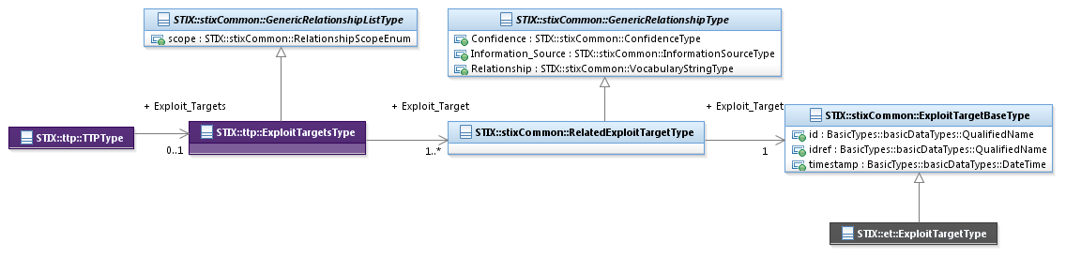

Figure 3‑7. UML diagram of the ExploitTargetsType class

The property table given in **Table 3‑15** corresponds to the UML diagram shown in **Figure 3‑7**.

Table 3‑15. Properties of the ExploitTargetsType class

|  |  |  |  |
| --- | --- | --- | --- |
| **Name** | **Type** | **Multiplicity** | **Description** |
| **Exploit_Target** | stixCommon:  RelatedExploitTargetType | 1..* | The Exploit_Target property specifies an Exploit Target potentially targetd by the TTP and characterizes the relationship between the Exploit Target and the TTP by capturing information such as the level of confidence that the Exploit Target and the TTP are related, the source of the relationship information, and the type of relationship. |

## RelatedTTPsType Class

The RelatedTTPsType class specifies a set of one or more other TTPs asserted to be related to this TTP and therefore is a self-referential relationship. It extends the GenericRelationshipListType superclass defined in the STIX Common data model, which specifies the scope (whether the elements of the set are related individually or as a group).

The UML diagram corresponding to the RelatedTTPsType class is shown in **Figure 3‑8**.

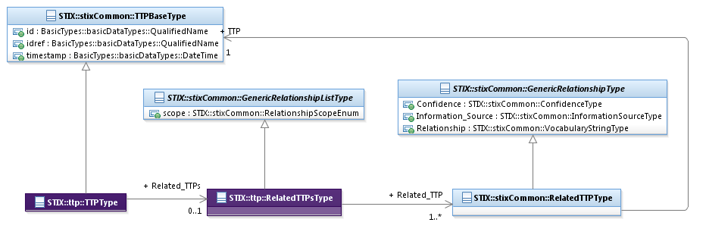

Figure 3‑8. UML diagram of the RelatedTTPsType class

The property table given in **Table 3‑16** corresponds to the UML diagram shown in **Figure 3‑8**.

Table 3‑16. Properties of the RelatedTTPsType class

|  |  |  |  |
| --- | --- | --- | --- |
| **Name** | **Type** | **Multiplicity** | **Description** |
| **Related_TTP** | stixCommon:RelatedTTPType | 1..* | The Related_TTP property specifies another TTP associated with this TTP and characterizes the relationship between the TTPs by capturing information such as the level of confidence that the TTPs are related, the source of the relationship information, and type of the relationship. A relationship between TTPs may represent assertions of general associativity or different versions of the same TTP. |

# Conformance

Implementations have discretion over which parts (components, properties, extensions, controlled vocabularies, etc.) of STIX they implement (e.g., Indicator/Suggested_COAs).

[1] Conformant implementations must conform to all normative structural specifications of the UML model or additional normative statements within this document that apply to the portions of STIX they implement (e.g., Implementers of the entire TTP component must conform to all normative structural specifications of the UML model or additional normative statements within this document regarding the TTP component).

[2] Conformant implementations are free to ignore normative structural specifications of the UML model or additional normative statements within this document that do not apply to the portions of STIX they implement (e.g., Non-implementers of any particular properties of the TTP component are free to ignore all normative structural specifications of the UML model or additional normative statements within this document regarding those properties of the TTP component).

The conformance section of this document is intentionally broad and attempts to reiterate what already exists in this document. The STIX 1.2 Specifications, which this specification is based on, did not have a conformance section. Instead, the STIX 1.2 Specifications relied on normative statements and the non-mandatory implementation of STIX profiles. STIX 1.2.1 represents a minimal change from STIX 1.2, and in that spirit no requirements have been added, modified, or removed by this section.

1. Acknowledgments

The following individuals have participated in the creation of this specification and are gratefully acknowledged:

Participants:

Dean Thompson, Australia and New Zealand Banking Group (ANZ Bank)

Bret Jordan, Blue Coat Systems, Inc.

Adnan Baykal, Center for Internet Security (CIS)

Jyoti Verma, Cisco Systems

Liron Schiff, Comilion (mobile) Ltd.

Jane Ginn, Cyber Threat Intelligence Network, Inc. (CTIN)

Richard Struse, DHS Office of Cybersecurity and Communications (CS&C)

Marlon Taylor, DHS Office of Cybersecurity and Communications (CS&C)

David Eilken, Financial Services Information Sharing and Analysis Center (FS-ISAC)

Sarah Brown, Fox-IT

Ryusuke Masuoka, Fujitsu Limited

Eric Burger, Georgetown University

Jason Keirstead, IBM

Paul Martini, iboss, Inc.

Jerome Athias, Individual

Terry MacDonald, Individual

Alex Pinto, Individual

Patrick Maroney, Integrated Networking Technologies, Inc.

Wouter Bolsterlee, Intelworks BV

Joep Gommers, Intelworks BV

Sergey Polzunov, Intelworks BV

Rutger Prins, Intelworks BV

Andrei Sîrghi, Intelworks BV

Raymon van der Velde, Intelworks BV

Jonathan Baker, MITRE Corporation

Sean Barnum, MITRE Corporation

Mark Davidson, MITRE Corporation

Ivan Kirillov, MITRE Corporation

Jon Salwen, MITRE Corporation

John Wunder, MITRE Corporation

Mike Boyle, National Security Agency

Jessica Fitzgerald-McKay, National Security Agency

Takahiro Kakumaru, NEC Corporation

John-Mark Gurney, New Context Services, Inc.

Christian Hunt, New Context Services, Inc.

Daniel Riedel, New Context Services, Inc.

Andrew Storms, New Context Services, Inc.

John Tolbert, Queralt, Inc.

Igor Baikalov, Securonix

Bernd Grobauer, Siemens AG

Jonathan Bush, Soltra

Aharon Chernin, Soltra

Trey Darley, Soltra

Paul Dion, Soltra

Ali Khan, Soltra

Natalie Suarez, Soltra

Cedric LeRoux, Splunk Inc.

Brian Luger, Splunk Inc.

Crystal Hayes, The Boeing Company

Brad Butts, U.S. Bank

Mona Magathan, U.S. Bank

Adam Cooper, United Kingdom Cabinet Office

Mike McLellan, United Kingdom Cabinet Office

Chris O'Brien, United Kingdom Cabinet Office

Julian White, United Kingdom Cabinet Office

Anthony Rutkowski, Yaana Technologies, LLC

The authors would also like to thank the larger STIX Community for its input and help in reviewing this document.

1. Revision History

|  |  |  |  |
| --- | --- | --- | --- |
| **Revision** | **Date** | **Editor** | **Changes Made** |
| wd01 | 21 August 2015 | Sean Barnum Desiree Beck Aharon Chernin Rich Piazza | Initial transfer to OASIS template |

1. The CybOXTM Observable data model is actually defined in the CybOX Language, not in STIX.
2. Attack Patterns are descriptions of common elements, approaches and techniques used in attacks against vulnerable cyber-enabled capabilities.