STIX Version 1.2.1 Part 8: Campaign

Working Draft 01

04 September 2015

Technical Committee:

[OASIS Cyber Threat Intelligence (CTI) TC](https://www.oasis-open.org/committees/cti/)

Chair:

Richard Struse ([Richard.Struse@HQ.DHS.GOV](mailto:Richard.Struse@HQ.DHS.GOV)), [DHS Office of Cybersecurity and Communications (CS&C)](http://www.dhs.gov/office-cybersecurity-and-communications)

Editors:

Sean Barnum ([sbarnum@mitre.org](mailto:sbarnum@mitre.org)), [MITRE Corporation](http://www.mitre.org/)

Desiree Beck ([dbeck@mitre.org](mailto:dbeck@mitre.org)), [MITRE Corporation](http://www.mitre.org/)

Aharon Chernin ([achernin@soltra.com](mailto:achernin@soltra.com)), [Soltra](http://www.soltra.com/)

Rich Piazza ([rpiazza@mitre.org](mailto:rpiazza@mitre.org)), [MITRE Corporation](http://www.mitre.org/)

Additional artifacts:

This prose specification is one component of a Work Product which consists of:

* *STIX Version 1.2.1 Part 1: Overview*. [URI – added during publication]
* *STIX Version 1.2.1 Part 2: Common*. [URI]
* *STIX Version 1.2.1 Part 3: Core*. [URI]
* *STIX Version 1.2.1 Part 4: Indicator*. [URI]
* *STIX Version 1.2.1 Part 5: TTP*. [URI]
* *STIX Version 1.2.1 Part 6: Incident*. [URI]
* *STIX Version 1.2.1 Part 7: Threat Actor*. [URI]
* *STIX Version 1.2.1 Part 8: Campaign*. (this document)
* *STIX Version 1.2.1 Part 9: Course of Action*. [URI]
* *STIX Version 1.2.1 Part 10: Exploit Target*. [URI]
* *STIX Version 1.2.1 Part 11: Report*. [URI]
* *STIX Version 1.2.1 Part 12: Default Extensions*. [URI]
* *STIX Version 1.2.1 Part 13: Data Marking*. [URI]
* *STIX Version 1.2.1 Part 14: Vocabularies*. [URI]
* *STIX Version 1.2.1 Part 15: UML Model*. [URI]

Related work:

This specification is related to:

* *CybOX Version 2.1.1 (placeholder)*

Abstract:

The Structured Threat Information Expression (STIX) framework defines nine core constructs and the relationships between them for the purposes of modeling cyber threat information and enabling cyber threat information analysis and sharing. This specification document defines the Campaign construct, which encompasses one or more Threat Actors pursuing an Intended Effect as observed through sets of Incidents and/or TTP, potentially across organizations.

Status:

This [Working Draft](https://www.oasis-open.org/policies-guidelines/tc-process#dWorkingDraft) (WD) has been produced by one or more TC Members; it has not yet been voted on by the TC or [approved](https://www.oasis-open.org/policies-guidelines/tc-process#committeeDraft) as a Committee Draft (Committee Specification Draft or a Committee Note Draft). The OASIS document [Approval Process](https://www.oasis-open.org/policies-guidelines/tc-process#standApprovProcess) begins officially with a TC vote to approve a WD as a Committee Draft. A TC may approve a Working Draft, revise it, and re-approve it any number of times as a Committee Draft.

URI patterns:

Initial publication URI:  
http://docs.oasis-open.org/cti/stix/v1.2.1/csd01/part8-campaign/stix-v1.2.1-csd01-part8-campaign.docx

Permanent “Latest version” URI:  
http://docs.oasis-open.org/cti/stix/v1.2.1/stix-v1.2.1-part8-campaign.docx

(Managed by OASIS TC Administration; please don’t modify.)

Copyright © OASIS Open 2015. All Rights Reserved.

All capitalized terms in the following text have the meanings assigned to them in the OASIS Intellectual Property Rights Policy (the "OASIS IPR Policy"). The full [Policy](https://www.oasis-open.org/policies-guidelines/ipr) may be found at the OASIS website.

This document and translations of it may be copied and furnished to others, and derivative works that comment on or otherwise explain it or assist in its implementation may be prepared, copied, published, and distributed, in whole or in part, without restriction of any kind, provided that the above copyright notice and this section are included on all such copies and derivative works. However, this document itself may not be modified in any way, including by removing the copyright notice or references to OASIS, except as needed for the purpose of developing any document or deliverable produced by an OASIS Technical Committee (in which case the rules applicable to copyrights, as set forth in the OASIS IPR Policy, must be followed) or as required to translate it into languages other than English.

The limited permissions granted above are perpetual and will not be revoked by OASIS or its successors or assigns.

This document and the information contained herein is provided on an "AS IS" basis and OASIS DISCLAIMS ALL WARRANTIES, EXPRESS OR IMPLIED, INCLUDING BUT NOT LIMITED TO ANY WARRANTY THAT THE USE OF THE INFORMATION HEREIN WILL NOT INFRINGE ANY OWNERSHIP RIGHTS OR ANY IMPLIED WARRANTIES OF MERCHANTABILITY OR FITNESS FOR A PARTICULAR PURPOSE.

Table of Contents

1 Introduction 4

1.1 STIX Specification Documents 4

1.2 Document Conventions 5

1.2.1 Fonts 5

1.2.2 UML Package References 5

1.2.3 UML Diagrams 5

1.2.3.1 Class Properties 5

1.2.3.2 Diagram Icons and Arrow Types 6

1.2.3.3 Color Coding 6

1.2.4 Property Table Notation 6

1.2.5 Property and Class Descriptions 7

1.3 Terminology 8

1.4 Normative References 8

2 Background Information 9

2.1 Campaign-Related Component Data Models 9

3 STIX Campaign Data Model 11

3.1 CampaignVersionType Enumeration 14

3.2 NamesType Class 15

3.3 RelatedTTPsType Class 15

3.4 RelatedIncidentsType Class 16

3.5 RelatedIndicatorsType Class (deprecated) 17

3.6 AttributionType Class 19

3.7 AssociatedCampaignsType Class 20

4 Conformance 22

Appendix A. Acknowledgments 23

Appendix B. Revision History 25

# Introduction

[All text is normative unless otherwise labeled]

The Structured Threat Information Expression (STIX) framework defines nine top-level component data models: Observable[1], Indicator, Incident, TTP, ExploitTarget, CourseOfAction, Campaign, ThreatActor, and Report. This document serves as the specification for the STIX Campaign Version data model.

As defined within the STIX language, a Campaign construct is an instance of a Threat Actor (adversary), whether characterized or not, pursuing an Intended Effect as observed through sets of Incidents and/or TTP, potentially across organizations. In addition to Threat Actor, Intended Effect, Incident, and TTP information, a Campaign construct may also comprise a variety of additional information, including status of the Campaign, a textual description, and alias names for the Campaign.

In Section **1.1** we discuss additional specification documents, in Section **1.2** we provide document conventions, and in Section **1.3** we provide terminology. References are given in Section **1.4**. In Section **2**, we give background information to help the reader better understand the specification details that are provided later in the document. We present the Threat Actor data model specification details in Section **3** and conformance information in Section **4**.

## STIX Specification Documents

The STIX specification consists of a formal UML model and a set of textual specification documents that explain the UML model. Specification documents have been written for each of the key individual data models that compose the full STIX UML model.

The *STIX Version 1.2.1 Part 1: Overview* document provides a comprehensive overview of the full set of STIX data models, which in addition to the nine top-level component data models mentioned in the Introduction, includes a core data model, a common data model, a cross-cutting data marking data model, various extension data models, and a set of default controlled vocabularies. *STIX Version 1.2.1 Part 1: Overview* also summarizes the relationship of STIX to other languages, and outlines general STIX data model conventions.

**Figure 1‑1** illustrates the set of specification documents that are available. The color black is used to indicate the specification overview document, altered shading differentiates the overarching Core and Common data models from the supporting data models (vocabularies, data marking, and default extensions), and the color white indicates the component data models. The solid grey color denotes the overall STIX Language UML model. This Campaign specification document is highlighted in its associated color (see Section **1.2.3.3**). For a list of all STIX documents and related information sources, please see *STIX Version 1.2.1 Part 1: Overview*.

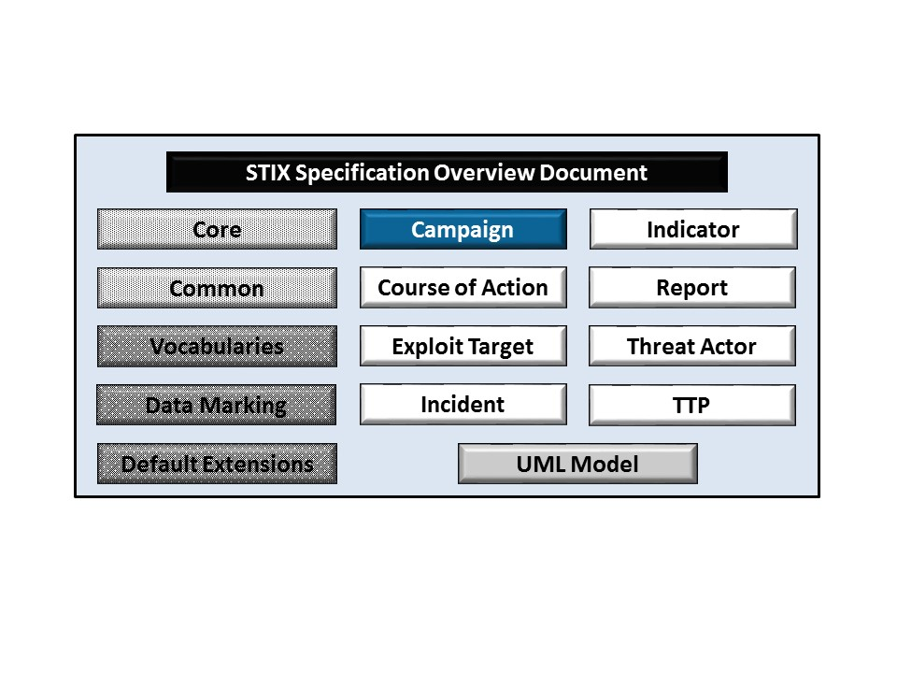

Figure ‑. STIX Language v1.2.1 specification documents

## Document Conventions

The following conventions are used in this document.

### Fonts

The following font and font style conventions are used in the document:

* Capitalization is used for STIX high level concepts, which are defined in *STIX Version 1.2.1 Part 1: Overview*.

Examples: Indicator, Course of Action, Threat Actor

* The Courier New font is used for writing UML objects.

Examples: RelatedIndicatorsType, stixCommon:StatementType

Note that all high level concepts have a corresponding UML object. For example, the Course of Action high level concept is associated with a UML class named, CourseOfActionType.

* The ‘*italic’* font (withsingle quotes) is used for noting actual, explicit values for STIX Language properties. The *italic* font (without quotes) is used for noting example values.

Example:  *‘PackageIntentVocab-1.0,’ high, medium, low*

### UML Package References

Each STIX data model is captured in a different UML package (e.g., Core package, Campaign package, etc.) where the packages together compose the full STIX UML model. To refer to a particular class of a specific package, we use the format package_prefix:class, where package_prefix corresponds to the appropriate UML package. *STIX Version 1.2.1 Part 1: Overview* contains a list of the packages used by the Campaign data model, along with the associated prefix notations, descriptions, examples.

Note that in this specification document, we do not explicitly specify the package prefix for any classes that originate from the Campaign data model.

### UML Diagrams

This specification makes use of UML diagrams to visually depict relationships between STIX Language constructs. Note that the diagrams have been extracted directly from the full UML model for STIX; they have not been constructed purely for inclusion in the specification documents.  Typically, diagrams are included for the primary class of a data model, and for any other class where the visualization of its relationships between other classes would be useful.  This implies that there will be very few diagrams for classes whose only properties are either a data type or a class from the STIX Common data model.  Other diagrams that are included correspond to classes that specialize a superclass and abstract or generalized classes that are extended by one or more subclasses.

In UML diagrams, classes are often presented with their attributes elided, to avoid clutter. The fully described class can usually be found in a related diagram. A class presented with an empty section at the bottom of the icon indicates that there are no attributes other than those that are visualized using associations.

#### Class Properties

Generally, a class property can be shown in a UML diagram as either an attribute or an association (i.e., the distinction between attributes and associations is somewhat subjective). In order to make the size of UML diagrams in the specifications manageable, we have chosen to capture most properties as attributes and to capture only higher level properties as associations, especially in the main top-level component diagrams. In particular, we will always capture properties of UML data types as attributes. For example, properties of a class that are identifiers, titles, and timestamps will be represented as attributes.

#### Diagram Icons and Arrow Types

Diagram icons are used in a UML diagram to indicate whether a shape is a class, enumeration, or a data type, and decorative icons are used to indicate whether an element is an attribute of a class or an enumeration literal. In addition, two different arrow styles indicate either a directed association relationship (regular arrowhead) or a generalization relationship (triangle-shaped arrowhead). The icons and arrow styles we use are shown and described in **Table 1‑1**.

Table ‑. UML diagram icons

|  |  |
| --- | --- |
| **Icon** | **Description** |
|  | This diagram icon indicates a class. If the name is in italics, it is an abstract class. |
|  | This diagram icon indicates an enumeration. |
|  | This diagram icon indicates a data type. |
|  | This decorator icon indicates an attribute of a class. The green circle means its visibility is public. If the circle is red or yellow, it means its visibility is private or protected. |
|  | This decorator icon indicates an enumeration literal. |
|  | This arrow type indicates a directed association relationship. |
|  | This arrow type indicates a generalization relationship. |

#### Color Coding

The shapes of the UML diagrams are color coded to indicate the data model associated with a class.  The colors used in the Campaign specification are illustrated via exemplars in **Figure 1‑2**.

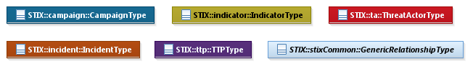

Figure ‑. Data model color coding

### Property Table Notation

Throughout Section **3**, tables are used to describe the properties of each data model class. Each property table consists of a column of names to identify the property, a type column to reflect the datatype of the property, a multiplicity column to reflect the allowed number of occurrences of the property, and a description column that describes the property. Package prefixes are provided for classes outside of the Campaign data model (see Section **1.2.2**).

Note that if a class is a specialization of a superclass, only the properties that constitute the specialization are shown in the property table (i.e., properties of the superclass will not be shown). However, details of the superclass may be shown in the UML diagram.

In addition, properties that are part of a “choice” relationship (e.g., Prop1 OR Prop2 is used but not both) will be denoted by a unique letter subscript (e.g., API_CallA, CodeB) and single logic expression in the Multiplicity column.  For example, if there is a choice of property API_CallA and CodeB, the expression “A(1)|B(0..1)” will indicate that the API_Call property can be chosen with multiplicity 1 or the Code property can be chosen with multiplicity 0 or 1.

### Property and Class Descriptions

Each class and property defined in STIX is described using the format, “The X property verbY.” For example, in the specification for the STIX Campaign, we write, “The id property specifies a globally unique identifier for the Campaign instance.” In fact, the verb “specifies” could have been replaced by any number of alternatives: “defines,” “describes,” “contains,” “references,” etc.

However, we thought that using a wide variety of verb phrases might confuse a reader of a specification document because the meaning of each verb could be interpreted slightly differently. On the other hand, we didn’t want to use a single, generic verb, such as “describes,” because although the different verb choices may or may not be meaningful from an implementation standpoint, a distinction could be useful to those interested in the modeling aspect of STIX.

Consequently, we have chosen to use the three verbs, defined as follows, in class and property descriptions:

|  |  |
| --- | --- |
| **Verb** | **STIX Definition** |
| captures | Used to record and preserve information without implying anything about the structure of a class or property. Often used for properties that encompass general content. This is the least precise of the three verbs. |
|  | *Examples*:  The Source property characterizes the source of the sighting information. Examples of details captured include identitifying characteristics, time-related attributes, and a list of the tools used to collect the information.  The Description property captures a textual description of the Indicator. |
| characterizes | Describes the distinctive nature or features of a class or property. Often used to describe classes and properties that themselves comprise one or more other properties. |
|  | *Example*:  The Confidence property characterizes the level of confidence in the accuracy of the overall content captured in the Incident.  The ActivityType class characterizes basic information about an activity a defender might use in response to a Campaign. |
| specifies | Used to clearly and precisely identify particular instances or values associated with a property. Often used for properties that are defined by a controlled vocabulary or enumeration; typically used for properties that take on only a single value. |
|  | *Example*:  The version property specifies the version identifier of the STIX Campaign data model used to capture the information associated with the Campaign. |

## Terminology

The key words “MUST”, “MUST NOT”, “REQUIRED”, “SHALL”, “SHALL NOT”, “SHOULD”, “SHOULD NOT”, “RECOMMENDED”, “MAY”, and “OPTIONAL” in this document are to be interpreted as described in [RFC2119].

## Normative References

[RFC2119] Bradner, S., “Key words for use in RFCs to Indicate Requirement Levels”, BCP 14, RFC 2119, March 1997. <http://www.ietf.org/rfc/rfc2119.txt>.

# Background Information

In this section, we provide high level information about the Campaign data model that is necessary to fully understand the Campaign data model specification details given in Section **3**.

## Campaign-Related Component Data Models

As will be explicitly detailed in Section **3**, a STIX Campaign leverages four other core STIX constructs, namely Threat Actor, TTP, Incident, and Indicator (as indicated by the outward-oriented arrows). As stated in Section **1.1**, each of these components is defined in a separate specification document. **Figure 2‑1** illustrates the relationship between the Campaign and the other core constructs.

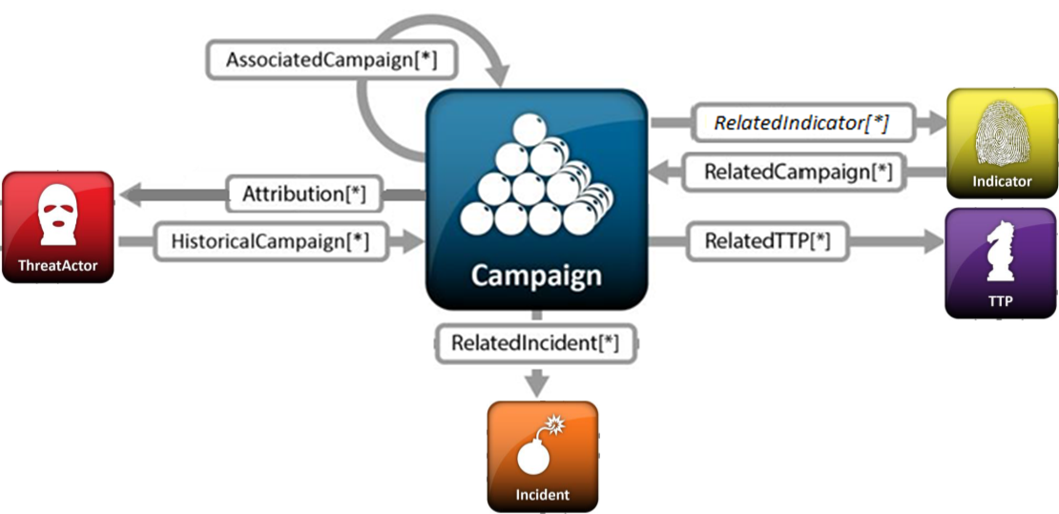

Figure ‑. High level view of the Campaign data model

In this section, we give a high level summary of the relationship between the Campaign data model and the other components to which a Campaign may refer. We also make note of the fact that the Campaign data model can be self-referential. Other relationships shown in the diagram are defined in the specification of the component that they originate from.

* **Campaign**

The Campaign data model is self-referential, enabling one Campaign to reference other Campaigns that are asserted to be related. Self-referential relationships between Campaigns may indicate general associativity or can be used to indicate relationships beween different versions of the same Campaign.

* **Indicator**

A STIX Indicator conveys specific Observable patterns combined with contextual information intended to represent artifacts and/or behaviors of interest within a cyber security context. Please see *STIX Version 1.2.1 Part 4: Indicator* for details.

STIX Version 1.2.1 of the Campaign data model references the Indicator data model as a means of referring to indicators relevant to the Campaign. Beginning in STIX Version 1.1, this reference relationship was deprecated; however, it remains in STIX v1.2.1 for backward compatibility. The relationship will be removed in STIX Version 2.0.

Under STIX Version 1.2.1 – unless backward compatibility is necessary – relationships between Indicators and Campaigns SHOULD be captured from the Indicator to Campaign direction (i.e., Indicators SHOULD reference associated Campaigns rather than the other way around). **Figure 2‑1** shows the deprecated direction using italics.

* **Incident**

An STIX Incident corresponds to sets of related security events affecting an organization, along with information discovered or decided during an incident response investigation. Please see *STIX Version 1.2.1 Part 6: Incident* for details.

The Campaign data model references the Incident data model in order to identify sets of observed Incidents that are part of the Campaign (or in some way related to the Campaign).

* **Tactics, Techniques and Procedures (TTP)**

A STIX Tactics, Techniques, and Procedures (TTP) are representations of the behavior or modus operandi of cyber adversaries. Please see *STIX Version 1.2.1 Part 5: TTP* for details.

The Campaign data model references the TTP data model as a means to identify sets of specific TTPs leveraged within a Campaign (or in some way related to a Campaign).

* **Threat Actor**

A STIX Threat Actor is a characterization of a malicious actor (i.e., adversary) that represents a cyber attack threat. A variety of information can be captured in a Threat Actor construct, including identity, motivations, intended effect, and sophistication level. Please see *STIX Version 1.2.1 Part 7: Threat Actor* for details.

The Campaign data model references the Threat Actor data model as necessary to identify the Threat Actors who are potentially responsible for the Campaign (for the purpose of attribution) or who are in some way related to the Campaign. A reference of the Threat Actor data model may also be used in a Campaign to capture the suspected intended effect of the Threat Actor.

# 

# STIX Campaign Data Model

The primary class of the STIX Campaign package is the CampaignType class, which characterizes a cyber threat campaign by capturing an asserted relationship between the threat actors who are involved, the TTPs used, and the incidents that comprise parts of the campaign in addition to other intrinsic properties. Similar to the primary classes of all of the component data models in STIX, the CampaignType class extends a base class defined in the STIX Common data model; more specifically, it extends the CampaignBaseType base class, which provides the essential identifier (id) and identifier reference (idref) properties.

The relationship between the CampaignType class and the CampaignBaseType base class, as well as the properties of the CampaignType class, are illustrated in the UML diagram given in **Figure 3‑1**.

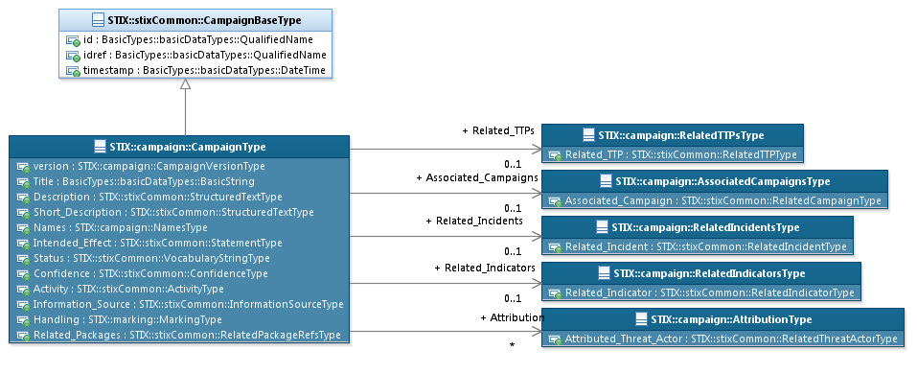

Figure ‑. UML diagram of the CampaignType class

The property table, which includes property descriptions and corresponds to the UML diagram given in **Figure 3‑1**, is provided in **Table 3‑1**.

All classes defined in the Campaign data model are described in detail in Sections **3.1** through **3.7**. Details are not provided for classes defined in non-Campaign data models; instead, the reader is refered to the corresponding data model specification as indicated by the package prefix specified in the Type column of the table.

Table ‑. Properties of the CampaignType class

|  |  |  |  |
| --- | --- | --- | --- |
| **Name** | **Type** | **Multiplicity** | **Description** |
| **version** | CampaignVersionType | 0..1 | The version property specifies the version number of the STIX Campaign data model for STIX v1.2.1 used to capture the information associated with the Campaign. |
| **Title** | basicDataTypes:BasicString | 0..1 | The Title property captures a title for the Campaign and reflects what the content producer thinks the Campaign as a whole should be called. The Title property is typically used by humans to reference a particular Campaign; however, it is not suggested for correlation. |
| **Description** | stixCommon:StructuredTextType | 0..* | The Description property captures a textual description of the Campaign. Any length is permitted. Optional formatting is supported via the structuring_format property of the StructuredTextType class. |
| **Short_Description** | stixCommon:StructuredTextType | 0..* | The Short_Description property captures a short textual description of the Campaign.  This property is secondary and should only be used if the Description property is already populated and another, shorter description is available. |
| **Names** | NamesType | 0..1 | The Names property specifies a set of one or more names (i.e., aliases) used to identify the Campaign. An organization may use names that are created internally or externally (outside the organization). Note that the purpose of the Names property is different than that of the Title property: while the Title property is used to title the Campaign construct instance, the Names property gives the names of the set of activity that the Campaign describes. |
| **Intended_Effect** | stixCommon:StatementType | 0..* | The Intended_Effect property characterizes the suspected effect that the Campaign is intended to have on its target(s), which includes a Value property that specifies the type of the effect. Examples of potential types include *theft*, *disruption*, and *unauthorized access* (these specific values are only provided to help explain the Value property: they are neither recommended values nor necessarily part of any existing vocabulary). The content creator may choose any arbitrary value or may constrain the set of possible types by referencing an externally-defined vocabulary or leveraging a formally defined vocabulary extending from the stixCommon:ControlledVocabularyStringType class. The STIX default vocabulary class for use in the Value property is ‘*IntendedEffectVocab-1.0*’ (which is different than the default vocabulary provided for the StatementType class). |
| **Status** | stixCommon:  VocabularyStringType | 0..1 | The Status property specifies the status of the Campaign. Examples of potential statuses include *ongoing*, *historical,* and *future* (these specific values are only provided to help explain the property: they are neither recommended values nor necessarily part of any existing vocabulary). The content creator may choose any arbitrary value or may constrain the set of possible values by referencing an externally-defined vocabulary or leveraging a formally defined vocabulary extending from the stixCommon:ControlledVocabularyStringType class. The STIX default vocabulary class for use in the property is ‘*CampaignStatusVocab-1.0*’. |
| **Related_TTPs** | RelatedTTPsType | 0..1 | The Related_TTPs property specifies a set of one or more TTPs leveraged within the Campaign (or in some way related to a Campaign). |
| **Related_Incidents** | RelatedIncidentsType | 0..1 | The RelatedIncidents property specifies a set of one or more Incidents that are part of the Campaign (or in some way related to the Campaign). |
| **Related_Indicators** | RelatedIndicatorsType | 0..1 | The Related_Indicators property specifies a set of one or more Indicators relevant to the Campaign. *Note: as discussed in Section* ***3.5****, this property is deprecated and is planned for removal in STIX Campaign Version 2.0.* |
| **Attribution** | AttributionType | 0..* | The Attribution property specifies attribution information in the form of a set of one or more Threat Actors who are asserted to be responsible for the Campaign. *Multiple groups can be captured by defining multiple Attribution elements*. |
| **Associated_Campaigns** | AssociatedCampaignsType | 0..1 | The Associated_Campaigns property specifies a set of one or more other Campaigns related to this Campaign. |
| **Confidence** | stixCommon:ConfidenceType | 0..1 | The Confidence property characterizes the level of confidence in the accuracy of the collection of information captured for the Campaign. |
| **Activity** | stixCommon:ActivityType | 0..* | The Activity property characterizes a defender activity associated with the Campaign. Its underlying abstract class must be extended to include the chosen format of activity characterization. |
| **Information_Source** | stixCommon:  InformationSourceType | 0..1 | The Information_Source property characterizes the source of the Campaign information. Examples of details captured include identitifying characteristics, time-related attributes, and a list of the tools used to collect the information. |
| **Handling** | marking:MarkingType | 0..1 | The Handling property specifies data handling markings for the properties of this Campaign. The marking scope is limited to the campaign and the content it contains. Note that data handling markings can also be specified at a higher level. |
| **Related_Packages** | stixCommon:  RelatedPackagesRefsType | 0..1 | The Related_Packages property specifies a set of one or more STIX Packages that are related to the Campaign.  DEPRECATED: This property is deprecated and will be removed in the next major version of STIX. Its use is strongly discouraged except for legacy applications. |

## CampaignVersionType Enumeration

The CampaignVersionType enumeration is an inventory of all versions of the Campaign data model for STIX Version 1.2.1. The enumeration literals are given in **Table 3‑2**.

Table ‑. Literals of the CampaignVersionType enumeration

|  |  |
| --- | --- |
| **Enumeration Literal** | **Description** |
| **stix-1.2.1** | Campaign data model for STIX v1.2.1 |

## NamesType Class

The NamesType class specifies a set of one or more names used to identify the Campaign. Note that an equivalent NamesType class is defined in the STIX Common data model; this duplication is due to backward-compatiblity issues and will be corrected in the next major release of STIX[2]. At that time, the campaign:NamesType class will be removed, and Campaign names will be defined via the stixCommon:NamesType class.

The property of the NamesType class is shown in **Table 3‑3**.

Table ‑. Properties of the NamesType class

|  |  |  |  |
| --- | --- | --- | --- |
| **Name** | **Type** | **Multiplicity** | **Description** |
| **Name** | stixCommon:  VocabularyStringType | 1..* | The Name property is used to specify a single name or alias that identifies the Campaign. The content creator may choose any arbitrary value or may constrain the set of possible values by referencing an externally-defined vocabulary or leveraging a formally defined vocabulary extending from the stixCommon:ControlledVocabularyStringType class. No default vocabulary class has been defined for STIX 1.2. |

## RelatedTTPsType Class

The RelatedTTPsType class specifies a set of one or more TTPs asserted to be leveraged within the Campaign (or in some way related to a Campaign). It extends the GenericRelationshipListType superclass defined in the STIX Common data model, which specifies the scope (whether the elements of the set are related individually or as a group).

The UML diagram corresponding to the RelatedTTPsType class is shown in **Figure 3‑2**.

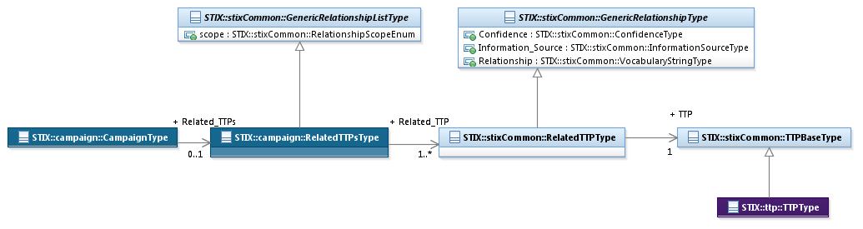

Figure ‑. UML diagram of the RelatedTTPsType class

**Table 3‑4** shows the properties of the RelatedTTPsType specialization and is associated with the UML diagram given in **Figure 3‑2**.

Table ‑. Properties of the RelatedTTPsType class

|  |  |  |  |
| --- | --- | --- | --- |
| **Name** | **Type** | **Multiplicity** | **Description** |
| **Related_TTP** | stixCommon:RelatedTTPType | 1..* | The Related_TTP property specifies a TTP leveraged within the Campaign (or in some way related to a Campaign) and characterizes the relationship between the Campaign and the TTP by capturing information such as the level of confidence that the Campaign and the TTP are related, the source of the relationship information, and the type of relationship. |

## RelatedIncidentsType Class

The RelatedIncidentsType class specifies a set of one or more Incidents asserted as part of the Campaign (or in some way related to the Campaign). It extends the GenericRelationshipListType superclass defined in the STIX Common data model, which specifies the scope (whether the elements of the set are related individually or as a group).

The UML diagram corresponding to the RelatedIncidentsType class is shown in **Figure 3‑3**.

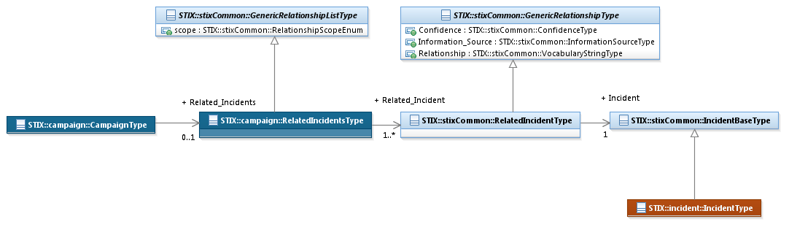

Figure ‑. UML diagram of the RelatedIncidentsType class

**Table 3‑5** shows the properties of the RelatedIncidentType specialization and is associated with the UML diagram of **Figure 3‑3**.

Table ‑. Properties of the RelatedIncidentsType class

|  |  |  |  |
| --- | --- | --- | --- |
| **Name** | **Type** | **Multiplicity** | **Description** |
| **Related_Incident** | stixCommon:RelatedIncidentType | 1..* | The Related_Incident property specifies an Incident asserted as part of the Campaign (or in some way related to the Campaign) and characterizes the relationship between the Campaign and the Incident by capturing information such as the level of confidence that the Campaign and the Incident are related, the source of the relationship information, and the type of relationship. |

## RelatedIndicatorsType Class (deprecated)

The RelatedIndicatorsType class specifies a set of one or more Indicators asserted as relevent to a Campaign. It extends the GenericRelationshipListType superclass defined in the STIX Common data model, which specifies the scope (whether the elements of the set are related individually or as a group).

The UML diagram corresponding to the RelatedIndicatorsType class is shown in **Figure 3‑4**.

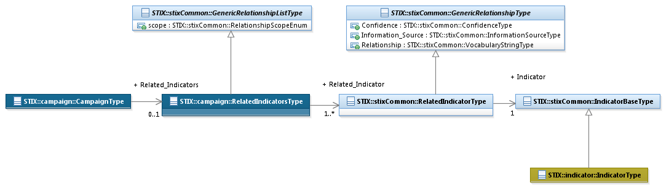

Figure ‑. UML diagram of the RelatedIndicatorsType class

***NOTE****: The Related_Indicators property of the CampaignType was deprecated in STIX Version 1.1, and it is slated for removal in STIX Version 2.0 (it remains in the Campaign data model for backward compatibility). Therefore, because no other property requires it, the RelatedIndicatorsType class will be removed in STIX Version 2.0 of the Campaign data model. Unless legacy code or content require the use of the Related_Indicators property, Relationships between Indicators and Campaigns in STIX v1.2.1 SHOULD be represented using the Related_Campaigns property of the indicator:IndicatorType class.*

**Table 3‑6** (shaded to indicate deprecation) shows the properties of the RelatedIncidentType specialization and is associated with the UML diagram of **Figure 3‑4**.

Table ‑. Properties of the RelatedIndicatorsType class (deprecated)

|  |  |  |  |
| --- | --- | --- | --- |
| **Name** | **Type** | **Multiplicity** | **Description** |
| **Related_Indicator** | stixCommon:RelatedIncidentType | 1..* | The Related_Indicator property specifies an Indicator asserted as relevant to this Campaign and characterizes the relationship between the Indicator and the Campaign by capturing information such as the level of confidence that the Indicator and the Campaign are related, the source of the relationship information, and the type of relationship. |

## AttributionType Class

The AttributionType class specifies a set of one or more Threat Actors asserted as related to a Campaign from an attribution perspective. It extends the GenericRelationshipListType superclass defined in the STIX Common data model, which specifies the scope (whether the elements of the set are related individually or as a group).

The UML diagram corresponding to the AttributionType class is shown in **Figure 3‑5**.

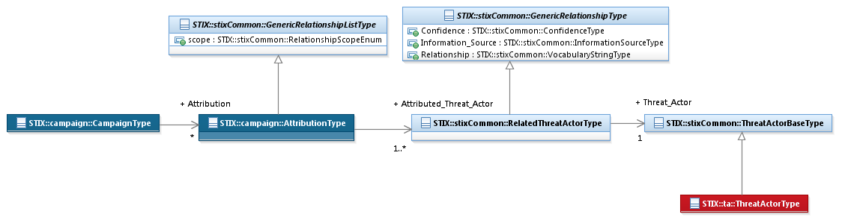

Figure ‑. UML diagram of the AttributionType class

**Table 3‑7** shows the properties of the AttributionType specialization and is associated with the UML diagram in **Figure 3‑5**.

Table ‑. Properties of the Attribution class

|  |  |  |  |
| --- | --- | --- | --- |
| **Name** | **Type** | **Multiplicity** | **Description** |
| **Attributed_Threat_Actor** | stixCommon:RelatedThreatActorType | 1..* | The Attributed_Threat_Actor property specifies a Threat Actor asserted as related to the Campaign and characterizes the relationship between the Threat Actor and the Campaign by capturing information such as the level of confidence that the Threat Actor and the Campaign are related, the source of the relationship information, and the type of the relationship. |

## AssociatedCampaignsType Class

The AssociatedCampaignType class specifies a set of one or more other Campaigns asserted as related to this Campaign and therefore is a self-referential relationship. It extends the GenericRelationshipListType superclass defined in the STIX Common data model, which specifies the scope (whether the elements of the set are related individually or as a group).

The UML diagram corresponding to the AssociatedCampaignsType class is shown in **Figure 3‑6**.

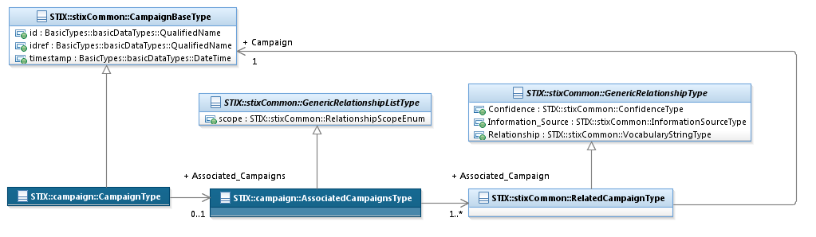

**Figure 3‑6**. UML Diagram of the AssociatedCampaignsType class

**Table 3‑8** shows the properties of the AssociatedCampaignType specialization and is associated with the UML diagram in **Figure 3‑6**.

Table ‑. Properties of the AssociatedCampaigns class

|  |  |  |  |
| --- | --- | --- | --- |
| **Name** | **Type** | **Multiplicity** | **Description** |
| **Associated_Campaign** | stixCommon:RelatedCampaignType | 1..* | The Associated_Campaign property specifies another Campaign associated with this Campaign and characterizes the relationship between the Campaigns by capturing information such as the level of confidence that the Campaigns are related, the source of the relationship information, and type of the relationship. A relationship between Campaigns may represent assertions of general associativity or different versions of the same Campaign. |

# Conformance

Implementations have discretion over which parts (components, properties, extensions, controlled vocabularies, etc.) of STIX they implement (e.g., Indicator/Suggested_COAs).

[1] Conformant implementations must conform to all Normative Statements that apply to the portions of STIX they implement (e.g., Implementers of the entire TTP component must conform to all Normative Statements regarding the TTP component).

[2] Conformant implementations are free to ignore Normative Statements that do not apply to the portions of STIX they implement (e.g., Non-implementers of any particular properties of the TTP component are free to ignore all Normative Statements regarding those properties of the TTP component).

The conformance section of this document is intentionally broad and attempts to reiterate what already exists in this document. The STIX 1.2 Specifications, which this specification is based on, did not have a conformance section. Instead, the STIX 1.2 Specifications relied on normative statements and the non-mandatory implementation of STIX profiles. STIX 1.2.1 represents a minimal change from STIX 1.2, and in that spirit no requirements have been added, modified, or removed by this section.

1. Acknowledgments

The following individuals have participated in the creation of this specification and are gratefully acknowledged:

Participants:

Dean Thompson, Australia and New Zealand Banking Group (ANZ Bank)

Bret Jordan, Blue Coat Systems, Inc.

Adnan Baykal, Center for Internet Security (CIS)

Jyoti Verma, Cisco Systems

Liron Schiff, Comilion (mobile) Ltd.

Jane Ginn, Cyber Threat Intelligence Network, Inc. (CTIN)

Richard Struse, DHS Office of Cybersecurity and Communications (CS&C)

Marlon Taylor, DHS Office of Cybersecurity and Communications (CS&C)

David Eilken, Financial Services Information Sharing and Analysis Center (FS-ISAC)

Sarah Brown, Fox-IT

Ryusuke Masuoka, Fujitsu Limited

Eric Burger, Georgetown University

Jason Keirstead, IBM

Paul Martini, iboss, Inc.

Jerome Athias, Individual

Terry MacDonald, Individual

Alex Pinto, Individual

Patrick Maroney, Integrated Networking Technologies, Inc.

Wouter Bolsterlee, Intelworks BV

Joep Gommers, Intelworks BV

Sergey Polzunov, Intelworks BV

Rutger Prins, Intelworks BV

Andrei Sîrghi, Intelworks BV

Raymon van der Velde, Intelworks BV

Jonathan Baker, MITRE Corporation

Sean Barnum, MITRE Corporation

Mark Davidson, MITRE Corporation

Ivan Kirillov, MITRE Corporation

Jon Salwen, MITRE Corporation

John Wunder, MITRE Corporation

Mike Boyle, National Security Agency

Jessica Fitzgerald-McKay, National Security Agency

Takahiro Kakumaru, NEC Corporation

John-Mark Gurney, New Context Services, Inc.

Christian Hunt, New Context Services, Inc.

Daniel Riedel, New Context Services, Inc.

Andrew Storms, New Context Services, Inc.

John Tolbert, Queralt, Inc.

Igor Baikalov, Securonix

Bernd Grobauer, Siemens AG

Jonathan Bush, Soltra

Aharon Chernin, Soltra

Trey Darley, Soltra

Paul Dion, Soltra

Ali Khan, Soltra

Natalie Suarez, Soltra

Cedric LeRoux, Splunk Inc.

Brian Luger, Splunk Inc.

Crystal Hayes, The Boeing Company

Brad Butts, U.S. Bank

Mona Magathan, U.S. Bank

Adam Cooper, United Kingdom Cabinet Office

Mike McLellan, United Kingdom Cabinet Office

Chris O'Brien, United Kingdom Cabinet Office

Julian White, United Kingdom Cabinet Office

Anthony Rutkowski, Yaana Technologies, LLC

The authors would also like to thank the larger STIX Community for its input and help in reviewing this document.

1. Revision History

|  |  |  |  |
| --- | --- | --- | --- |
| **Revision** | **Date** | **Editor** | **Changes Made** |
| wd01 | 21 August 2015 | Sean Barnum Desiree Beck Aharon Chernin Rich Piazza | Initial transfer to OASIS template |

1. The CybOX Observable data model is actually defined in the CybOX Language, not in STIX.
2. Essentially, the first version of the NamesType class was defined within the Campaign data model to allow users to capture the names by which a campaign is known. However, when the relationship between a Campaign and an Indicator was moved from the Campaign data model to the Indicator data model, users still needed the ability to refer to a Campaign by name. Existing policy of not having one component data model (Indicator) depend on another (Campaign) meant that an equivalent NamesType class was added to the STIX Common data model. In the next major version of STIX, it is expected that the NamesType class will be removed from the Campaign data model and that all Campaign names will be defined via the STIX Common NamesType class.