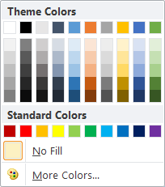

1 - Fill Color

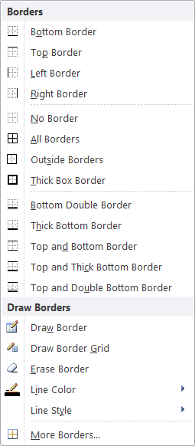

- Borders

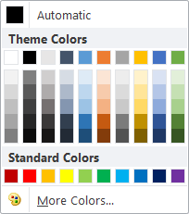

- Font Color

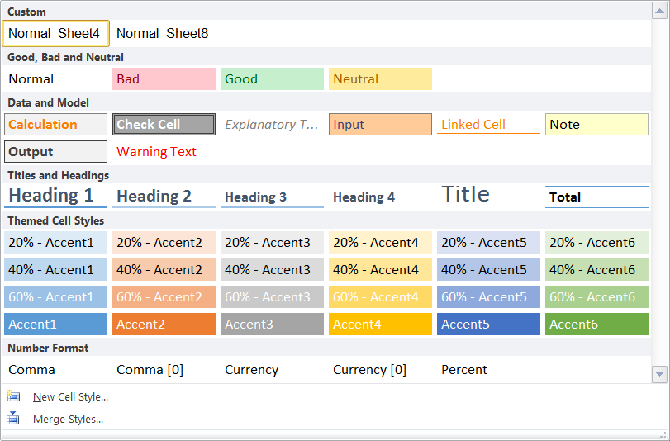

Number Formats

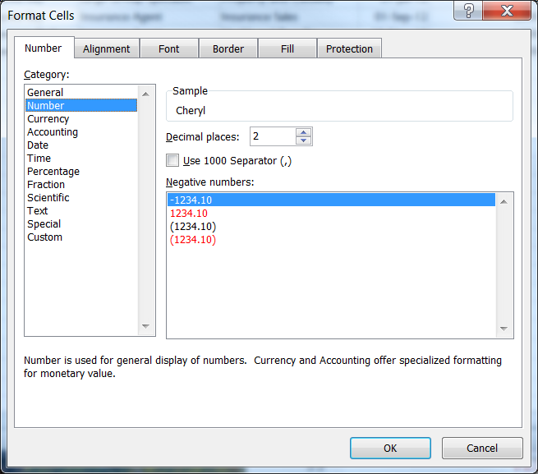

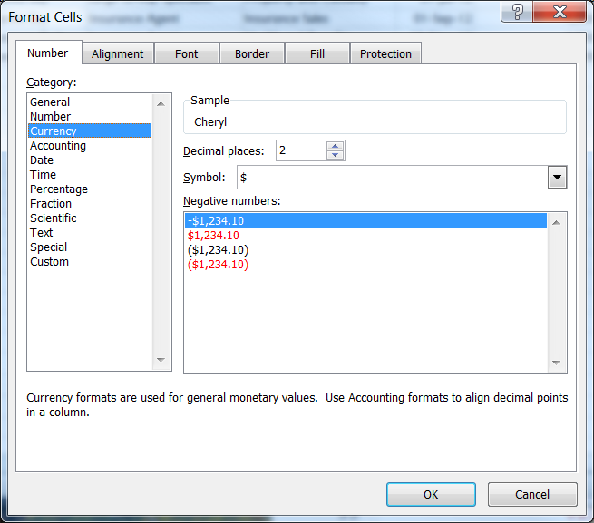

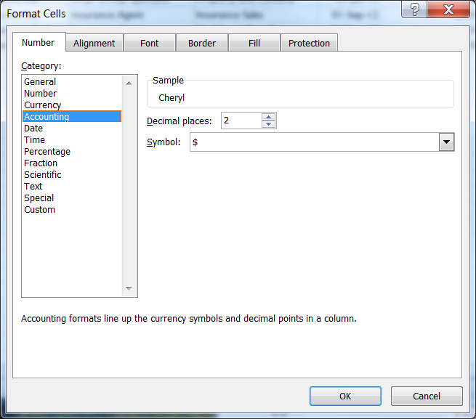

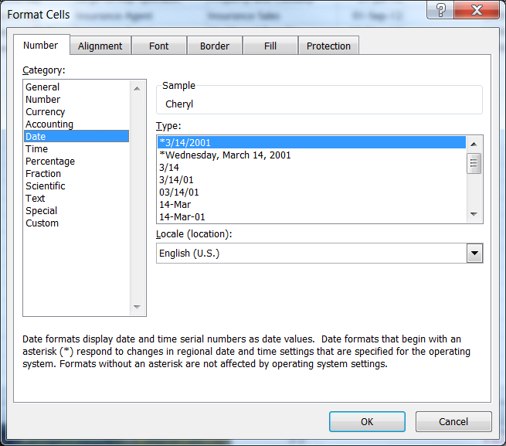

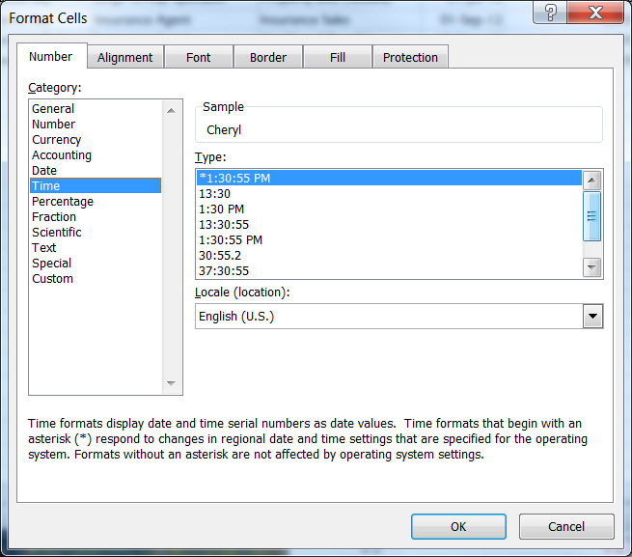

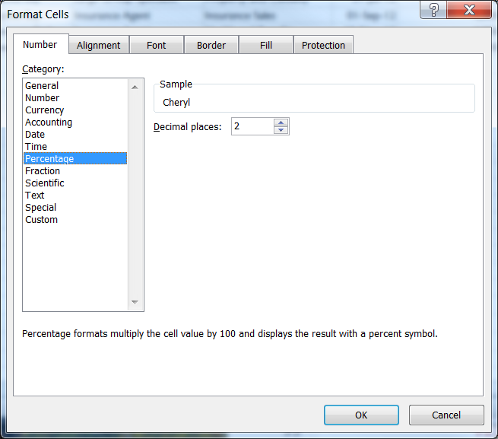

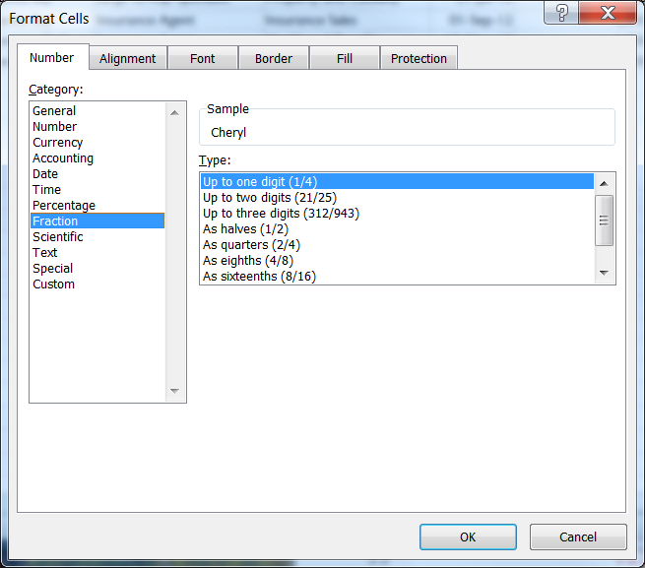

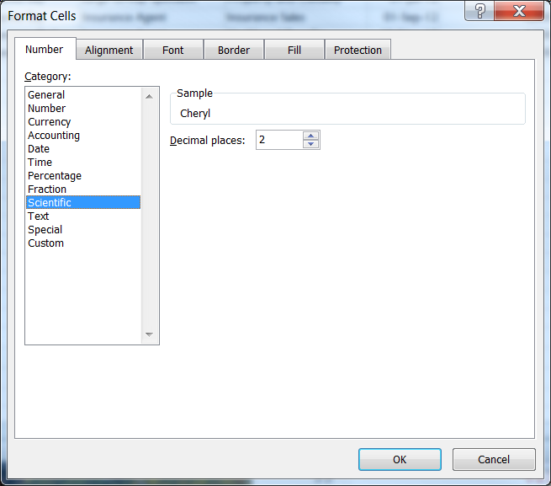

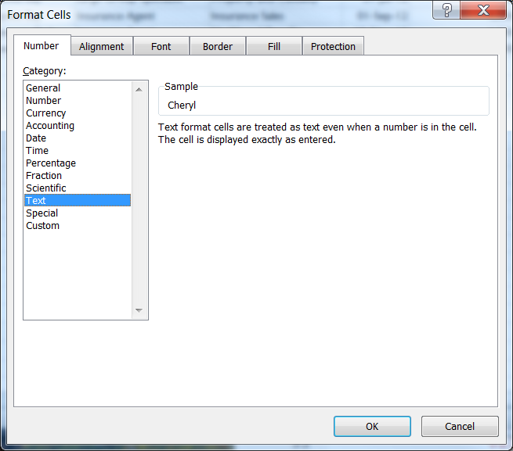

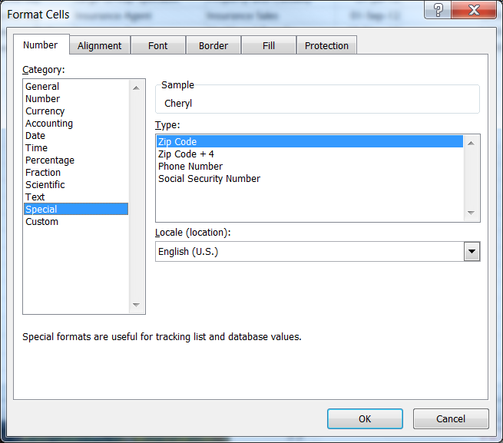

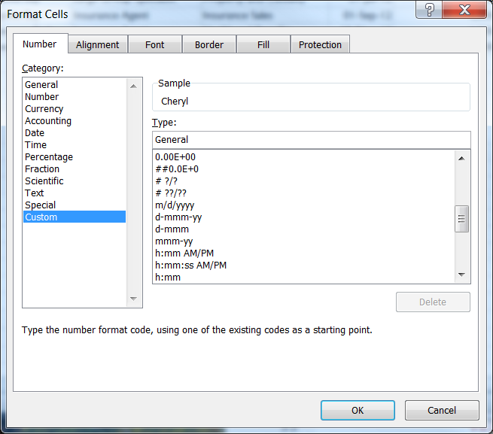

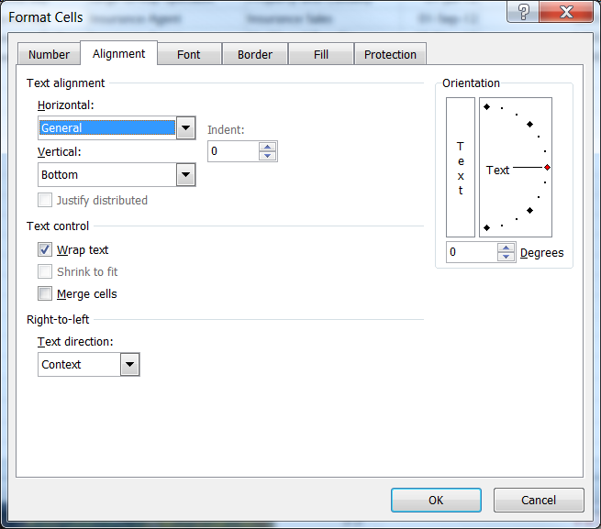

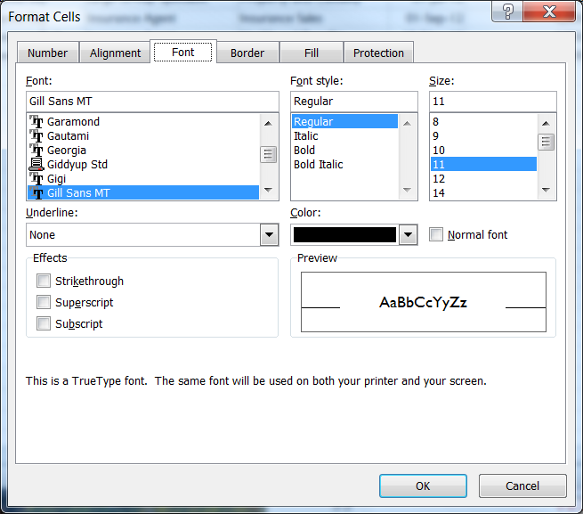

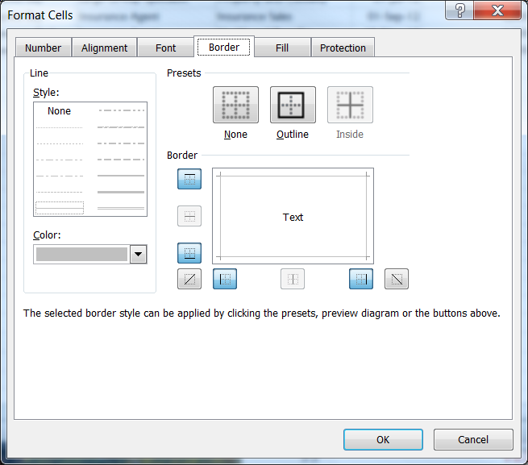

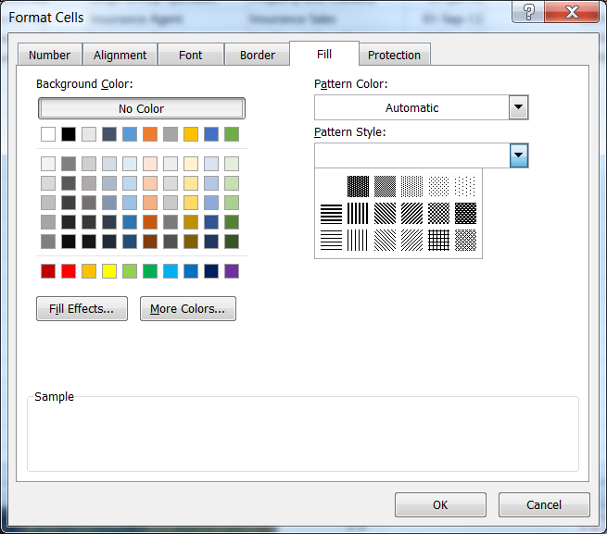

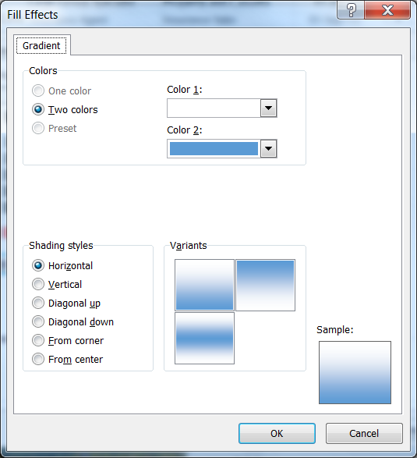

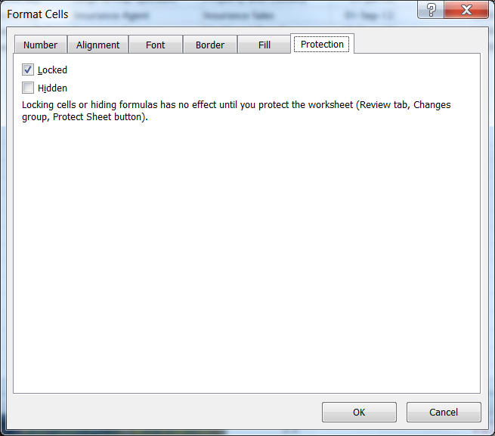

|  |  |
| --- | --- |
| **Format** | **Description** |
| **General** | The default number format that Excel applies when you type a number. For the most part, numbers that are formatted with the **General** format are displayed just the way you type them. However, if the cell is not wide enough to show the entire number, the **General** format rounds the numbers with decimals. The **General** number format also uses scientific (exponential) notation for large numbers (12 or more digits). |
| **Number** | Used for the general display of numbers. You can specify the number of decimal places that you want to use, whether you want to use a thousands separator, and how you want to display negative numbers. |
| **Currency** | Used for general monetary values and displays the default currency symbol with numbers. You can specify the number of decimal places that you want to use, whether you want to use a thousands separator, and how you want to display negative numbers. |
| **Accounting** | Also used for monetary values, but it aligns the currency symbols and decimal points of numbers in a column. |
| **Date** | Displays date and time serial numbers as date values, according to the type and locale (location) that you specify. Date formats that begin with an asterisk (**\***) respond to changes in regional date and time settings that are specified in Control Panel. Formats without an asterisk are not affected by Control Panel settings. |
| **Time** | Displays date and time serial numbers as time values, according to the type and locale (location) that you specify. Time formats that begin with an asterisk (**\***) respond to changes in regional date and time settings that are specified in Control Panel. Formats without an asterisk are not affected by Control Panel settings. |
| **Percentage** | Multiplies the cell value by 100 and displays the result with a percent (**%**) symbol. You can specify the number of decimal places that you want to use. |
| **Fraction** | Displays a number as a fraction, according to the type of fraction that you specify. |
| **Scientific** | Displays a number in exponential notation, replacing part of the number with E+*n*, where E (which stands for Exponent) multiplies the preceding number by 10 to the *n*th power. For example, a 2-decimal **Scientific** format displays 12345678901 as 1.23E+10, which is 1.23 times 10 to the 10th power. You can specify the number of decimal places that you want to use. |
| **Text** | Treats the content of a cell as text and displays the content exactly as you type it, even when you type numbers. |
| **Special** | Displays a number as a postal code (ZIP Code), phone number, or Social Security number. |
| **Custom** | Allows you to modify a copy of an existing number format code. Use this format to create a custom number format that is added to the list of number format codes. You can add between 200 and 250 custom number formats, depending on the language version of Excel that is installed on your computer. |

Create a custom number format

[[Show All](javascript:AlterAllDivs('block');)Show All](javascript:AlterAllDivs('block');)

[[Hide All](javascript:AlterAllDivs('none');)Hide All](javascript:AlterAllDivs('none');)

Excel provides many options for displaying numbers as percentages, currency, dates, and so on. If these built-in formats do not meet your needs, you can customize a built-in number format to create your own. To learn more about how to change number format codes, you may want to review the guidelines for customizing a number format before you get started.

**Review guidelines for customizing a number format**

To create a custom number format, you start by selecting one of the built-in number formats as a starting point. You can then change any one of the code sections of that format to create your own custom number format.

A number format can have up to four sections of code, separated by semicolons. These code sections define the format for positive numbers, negative numbers, zero values, and text, in that order.

**<POSITIVE>;<NEGATIVE>;<ZERO>;<TEXT>**

For example, you can use these code sections to create the following custom format:

**[Blue]#,##0.00_);Red;0.00;"sales "@**

You do not have to include all code sections in your custom number format. If you specify only two code sections for your custom number format, the first section is used for positive numbers and zeros, and the second section is used for negative numbers. If you specify only one code section, it is used for all numbers. If you want to skip a code section and include a code section that follows it, you must include the ending semicolon for the section that you skip.

The following guidelines should be helpful for customizing any of these number format code sections.

**Guidelines for including text and adding spacing**

* **Display both text and numbers** To display both text and numbers in a cell, enclose the text characters in double quotation marks (**" "**) or precede a single character with a backslash (**\)**. Include the characters in the appropriate section of the format codes. For example, type the format **$0.00" Surplus";$-0.00" Shortage"** to display a positive amount as "$125.74 Surplus" and a negative amount as "$-125.74 Shortage." Note that there is one space character before both "Surplus" and "Shortage" in each code section.

The following characters are displayed without the use of quotation marks.

|  |  |
| --- | --- |
| $ | Dollar sign |
| + | Plus sign |
| ( | Left parenthesis |
| : | Colon |
| ^ | Circumflex accent (caret) |
| ' | Apostrophe |
| { | Left curly bracket |
| < | Less-than sign |
| = | Equal sign |
| - | Minus sign |
| / | Slash mark |
| ) | Right parenthesis |
| ! | Exclamation point |
| & | Ampersand |
| ~ | Tilde |
| } | Right curly bracket |
| > | Greater-than sign |
|  | Space character |

* **Include a section for text entry** If included, a text section is always the last section in the number format. Include an "at" character (**@**) in the section where you want to display any text that you type in the cell. If the @ character is omitted from the text section, text that you type will not be displayed. If you want to always display specific text characters with the typed text, enclose the additional text in double quotation marks (**" "**). For example, **"gross receipts for "@**

If the format does not include a text section, any non-numeric value that you type in a cell with that format applied is not affected by the format. In addition, the entire cell is converted to text.

* **Add spaces** To create a space that is the width of a character in a number format, include an underscore character (**_**), followed by the character that you want to use. For example, when you follow an underscore with a right parenthesis, such as **_)**, positive numbers line up correctly with negative numbers that are enclosed in parentheses.
* **Repeat characters** To repeat the next character in the format to fill the column width, include an asterisk (**\***) in the number format. For example, type **0*-** to include enough dashes after a number to fill the cell, or type **\*0** before any format to include leading zeros.

**Guidelines for using decimal places, spaces, colors, and conditions**

* **Include decimal places and significant digits** To format fractions or numbers that contain decimal points, include the following digit placeholders, decimal points, and thousand separators in a section.

|  |  |
| --- | --- |
|  |  |
| 0 (zero) | This digit placeholder displays insignificant zeros if a number has fewer digits than there are zeros in the format. For example, if you type **8.9**, and you want it to be displayed as **8.90**, use the format **#.00**. |
| # | This digit placeholder follows the same rules as the 0 (zero). However, Excel does not display extra zeros when the number that you type has fewer digits on either side of the decimal than there are # symbols in the format. For example, if the custom format is **#.##**, and you type **8.9** in the cell, the number **8.9** is displayed. |
| ? | This digit placeholder follows the same rules as the 0 (zero). However, Excel adds a space for insignificant zeros on either side of the decimal point so that decimal points are aligned in the column. For example, the custom format **0.0?** aligns the decimal points for the numbers **8.9** and **88.99** in a column. |
| . (period) | This digit placeholder displays the decimal point in a number. |

* If a number has more digits to the right of the decimal point than there are placeholders in the format, the number rounds to as many decimal places as there are placeholders. If there are more digits to the left of the decimal point than there are placeholders, the extra digits are displayed. If the format contains only number signs (#) to the left of the decimal point, numbers less than 1 begin with a decimal point; for example, .47.

|  |  |  |
| --- | --- | --- |
| **To display** | **As** | **Use this code** |
| 1234.59 | 1234.6 | ####.# |
| 8.9 | 8.900 | #.000 |
| .631 | 0.6 | 0.# |
| 12 1234.568 | 12.0 1234.57 | #.0# |
| 44.398 102.65 2.8 | 44.398 102.65 2.8 (with aligned decimals) | ???.??? |
| 5.25 5.3 | 5 1/4 5 3/10 (with aligned fractions) | # ???/??? |

* **Display a thousands separator** To display a comma as a thousands separator or to scale a number by a multiple of 1,000, include the following separator in the number format.

|  |  |  |
| --- | --- | --- |
| , (comma) | Displays the thousands separator in a number. Excel separates thousands by commas if the format contains a comma that is enclosed by number signs (#) or by zeros. A comma that follows a digit placeholder scales the number by 1,000. For example, if the format is **#.0,**, and you type **12,200,000** in the cell, the number **12.200.0** is displayed. | |
| **To display** | **As** | **Use this code** |
| 12000 | 12,000 | #,### |
| 12000 | 12 | #, |
| 12200000 | 12.2 | 0.0,, |

* **Specify colors** To specify the color for a section of the format, type the name of one of the following eight colors enclosed in square brackets in the section. The color code must be the first item in the section.

|  |
| --- |
| [Black] |
| [Green] |
| [White] |
| [Blue] |
| [Magenta] |
| [Yellow] |
| [Cyan] |
| [Red] |

* **Specify conditions** To specify number formats that will be applied only if a number meets a condition that you specify, enclose the condition in square brackets. The condition consists of a [comparison operator (comparison operator: A sign that is used in comparison criteria to compare two values. Operators include: = Equal to, > Greater than, < Less than, >= Greater than or equal to, <= Less than or equal to, and <> Not equal to.)](javascript:AppendPopup(this,'814611583_1')) and a value. For example, the following format displays numbers that are less than or equal to 100 in a red font and numbers that are greater than 100 in a blue font.

**[Red][<=100];[Blue][>100]**

To apply [conditional formats (conditional format: A format, such as cell shading or font color, that Excel automatically applies to cells if a specified condition is true.)](javascript:AppendPopup(this,'427164406_2')) to cells (for example, color shading that depends on the value of a cell), on the **Home** tab, in the **Styles** group, click **Conditional Formatting**.

**Guidelines for currency, percentages, and scientific notation format**

* **Include currency symbols** To type one of the following currency symbols in a number format, press NUM LOCK and use the numeric keypad to type the ANSI code for the symbol.

|  |  |
| --- | --- |
| **To enter** | **Press this code** |
| ¢ | ALT+0162 |
| £ | ALT+0163 |
| ¥ | ALT+0165 |
| Euro | ALT+0128 |

* Note Custom formats are saved with the workbook. To have Excel always use a specific currency symbol, you must change the currency symbol that is selected in the Regional Options in Control Panel before you start Excel.
* **Display percentages** To display numbers as a percentage of 100 — for example, to display .08 as 8% or 2.8 as 280% — include the percent sign (**%**) in the number format.
* **Display scientific notations** To display numbers in scientific (exponential) format, use the following exponent codes in a section.

|  |  |
| --- | --- |
| E (E-, E+, e-, e+) | Displays a number in scientific (exponential) format. Excel displays a number to the right of the "E" or "e" that corresponds to the number of places that the decimal point was moved. For example, if the format is **0.00E+00**, and you type **12,200,000** in the cell, the number **1.22E+07** is displayed. If you change the number format to **#0.0E+0**, the number **12.2E+6** is displayed. |

**Guidelines for date and time formats**

* **Display days, months, and years** To display numbers as date formats (such as days, months, and years), use the following codes in a section.

|  |  |  |
| --- | --- | --- |
| m | Displays the month as a number without a leading zero. | |
| mm | Displays the month as a number with a leading zero when appropriate. | |
| mmm | Displays the month as an abbreviation (Jan to Dec). | |
| mmmm | Displays the month as a full name (January to December). | |
| mmmmm | Displays the month as a single letter (J to D). | |
| d | Displays the day as a number without a leading zero. | |
| dd | Displays the day as a number with a leading zero when appropriate. | |
| ddd | Displays the day as an abbreviation (Sun to Sat). | |
| dddd | Displays the day as a full name (Sunday to Saturday). | |
| yy | Displays the year as a two-digit number. | |
| yyyy | Displays the year as a four-digit number. | |
| **To display** | **As** | **Use this code** |
| Months | 1–12 | m |
| Months | 01–12 | mm |
| Months | Jan–Dec | mmm |
| Months | January–December | mmmm |
| Months | J–D | mmmmm |
| Days | 1–31 | d |
| Days | 01–31 | dd |
| Days | Sun–Sat | ddd |
| Days | Sunday–Saturday | dddd |
| Years | 00–99 | yy |
| Years | 1900–9999 | yyyy |

* **Display hours, minutes, and seconds** To display time formats (such as hours, minutes, and seconds), use the following codes in a section.

|  |  |  |
| --- | --- | --- |
| h | Displays the hour as a number without a leading zero. | |
| [h] | Displays elapsed time in hours. If you are working with a formula that returns a time in which the number of hours exceeds 24, use a number format that resembles **[h]:mm:ss**. | |
| hh | Displays the hour as a number with a leading zero when appropriate. If the format contains **AM** or **PM**, the hour is based on the 12-hour clock. Otherwise, the hour is based on the 24-hour clock. | |
| m | Displays the minute as a number without a leading zero.  Note The **m** or **mm** code must appear immediately after the **h** or **hh** code or immediately before the **ss** code; otherwise, Excel displays the month instead of minutes. | |
| [m] | Displays elapsed time in minutes. If you are working with a formula that returns a time in which the number of minutes exceeds 60, use a number format that resembles **[mm]:ss**. | |
| mm | Displays the minute as a number with a leading zero when appropriate.  Note The **m** or **mm** code must appear immediately after the **h** or **hh** code or immediately before the **ss** code; otherwise, Excel displays the month instead of minutes. | |
| s | Displays the second as a number without a leading zero. | |
| [s] | Displays elapsed time in seconds. If you are working with a formula that returns a time in which the number of seconds exceeds 60, use a number format that resembles **[ss]**. | |
| ss | Displays the second as a number with a leading zero when appropriate. If you want to display fractions of a second, use a number format that resembles **h:mm:ss.00**. | |
| AM/PM, am/pm, A/P, a/p | Displays the hour using a 12-hour clock. Excel displays **AM**, **am**, **A**, or **a** for times from midnight until noon and **PM**, **pm**, **P**, or **p** for times from noon until midnight. | |
| **To display** | **As** | **Use this code** |
| Hours | 0–23 | h |
| Hours | 00–23 | hh |
| Minutes | 0–59 | m |
| Minutes | 00–59 | mm |
| Seconds | 0–59 | s |
| Seconds | 00–59 | ss |
| Time | 4 AM | h AM/PM |
| Time | 4:36 PM | h:mm AM/PM |
| Time | 4:36:03 P | h:mm:ss A/P |
| Time | 4:36:03.75 | h:mm:ss.00 |
| Elapsed time (hours and minutes) | 1:02 | [h]:mm |
| Elapsed time (minutes and seconds) | 62:16 | [mm]:ss |
| Elapsed time (seconds and hundredths) | 3735.80 | [ss].00 |