QR碼掃描器

QR碼掃描器使用攝影機取得影像，掃描商品上的QR碼，取得商品的編號，在資料庫中取得資訊。使用VB程式語言和兩個函示庫：

* EMGU.CV（攝影機影像）
* ZXing.Net（QR碼解讀）

# 程式表單

程式表單包含三個元件：PictureBox用於顯示攝影機影像、Button用於啟動掃描器、TextBox用於顯示商品資訊、Timer用於重複取得相機影像掃描影像。

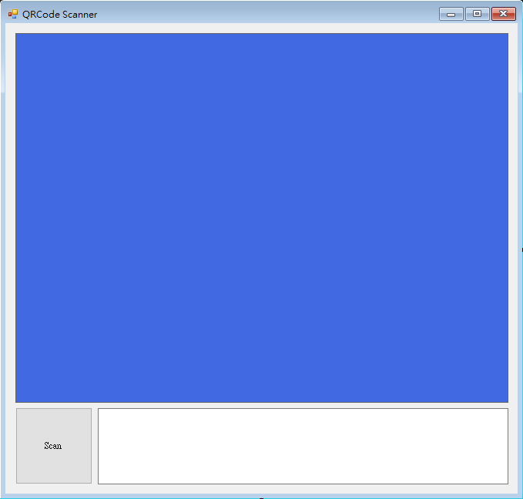

# 攝影機

取得攝影機影像使用EMGU.CV這個函示庫，啟動攝影機只需定義新的VideoCapture變數：

|  |
| --- |
| Dim cap As New VideoCapture |

取的攝影機影像並將影像顯示在PictureBox上：

|  |
| --- |
| PictureBox1.Image = cap.QueryFrame.Bitmap() |

# QR碼掃描

掃描QR碼使用ZXing.Net這個函示庫，先定義解碼器BarcodeReader：

|  |
| --- |
| Dim barcodeReader As New BarcodeReader |

解碼攝影機影像取得結果：

|  |
| --- |
| Dim result As Result = barcodeReader.Decode(PictureBox1.Image)  If result IsNot Nothing Then  Timer1.Enabled = False  Dim decoded As String = result.ToString().Trim()  End If |

# 商品資訊

將商品資訊儲存於CSV檔案中，檔案內容格式如下：

|  |
| --- |
| 0001,台灣啤酒,50  0002,長壽香菸,60  0003,可口可樂,30  0004,品客洋芋片,55  0005,麥香奶茶,10 |

每一行為一個商品，商品資訊以逗號隔開，商品資訊包含：編號、名稱和價格。

讀取商品資訊檔案以每次讀取一行檔案，再以逗號分隔取得各個資訊；分別將商品的兩資訊儲存至兩個清單Dictionary裡，Dictionary是一個由鍵（key，商品編號）和值（value，商品名稱和價格）組成的清單：

|  |
| --- |
| Dim nameList As New Dictionary(Of String, String)  Dim priceList As New Dictionary(Of String, String)  Dim streamReader As IO.StreamReader = My.Computer.FileSystem.OpenTextFileReader(".\\products.csv")  Dim line As String  Do  line = streamReader.ReadLine()  If line Is Nothing Then Exit Do  Dim splitLine As String() = line.Split(",")  Dim id As String = splitLine(0)  Dim name As String = splitLine(1)  Dim price As String = splitLine(2)  nameList.Add(id, name)  priceList.Add(id, price)  Loop |

透過QR碼掃描的結果，將商品資訊顯示於TextBox上：

|  |
| --- |
| If nameList.ContainsKey(decoded) Then  Try  TextBox1.Text = "商品: " + nameList.Item(decoded) + vbCrLf + "價格: $" + priceList.Item(decoded)  Catch ex As Exception  MsgBox(ex.Message)  End Try  Else  TextBox1.Text = "查無此商品"  End If |

# 主程式

主程式執行開始時須先載入商品資訊，VB的程式表單執行開始時載入會觸發Form1_Load功能，在這個功能中讀取商品資訊檔案：

|  |
| --- |
| Private Sub Form1_Load(sender As Object, e As EventArgs) Handles MyBase.Load  Dim streamReader As IO.StreamReader = My.Computer.FileSystem.OpenTextFileReader(".\\products.csv")  Dim line As String  Do  line = streamReader.ReadLine()  If line Is Nothing Then Exit Do  Dim splitLine As String() = line.Split(",")  Dim id As String = splitLine(0)  Dim name As String = splitLine(1)  Dim price As String = splitLine(2)  nameList.Add(id, name)  priceList.Add(id, price)  Loop  End Sub |

主程式需反覆掃描直到讀取到QR碼需要使用Timer這個元件，Timer為一個時間觸發元件，在設定的毫秒時間格會觸發對應的程式。

按下掃描按鈕會觸發Button1_Click功能，在這個功能中設定Timer觸發頻率並開啟Timer：

|  |
| --- |
| Private Sub Button1_Click(sender As Object, e As EventArgs) Handles Button1.Click  TextBox1.Text = ""  Timer1.Interval = 100  Timer1.Enabled = True  End Sub |

這邊設定Timer頻率為100毫秒，每100毫秒會觸發Timer1_Tick功能，在每次的觸發中取得攝影機影像並掃描QR碼，如果取得QR碼解碼結果，停止Timer並顯示商品資訊：

|  |
| --- |
| Private Sub Timer1_Tick(sender As Object, e As EventArgs) Handles Timer1.Tick  Try  PictureBox1.Image = cap.QueryFrame.Bitmap()  Catch ex As Exception  MsgBox(ex.Message)  End Try  Dim result As Result = barcodeReader.Decode(PictureBox1.Image)  If result IsNot Nothing Then  Timer1.Enabled = False  Dim decoded As String = result.ToString().Trim()  If nameList.ContainsKey(decoded) Then  Try  TextBox1.Text = "商品: " + nameList.Item(decoded) + vbCrLf + "價格: $" + priceList.Item(decoded)  Catch ex As Exception  MsgBox(ex.Message)  End Try  Else  TextBox1.Text = "查無此商品"  End If  End If  End Sub |

# 程式碼

|  |
| --- |
| Imports Emgu.CV  Imports ZXing  Public Class Form1  Dim cap As New VideoCapture  Dim barcodeReader As New BarcodeReader  Dim nameList As New Dictionary(Of String, String)  Dim priceList As New Dictionary(Of String, String)  Private Sub Form1_Load(sender As Object, e As EventArgs) Handles MyBase.Load  Dim streamReader As IO.StreamReader = My.Computer.FileSystem.OpenTextFileReader(".\\products.csv")  Dim line As String  Do  line = streamReader.ReadLine()  If line Is Nothing Then Exit Do  Dim splitLine As String() = line.Split(",")  Dim id As String = splitLine(0)  Dim name As String = splitLine(1)  Dim price As String = splitLine(2)  nameList.Add(id, name)  priceList.Add(id, price)  Loop  End Sub  Private Sub Timer1_Tick(sender As Object, e As EventArgs) Handles Timer1.Tick  Try  PictureBox1.Image = cap.QueryFrame.Bitmap()  Catch ex As Exception  MsgBox(ex.Message)  End Try  Dim result As Result = barcodeReader.Decode(PictureBox1.Image)  If result IsNot Nothing Then  Timer1.Enabled = False  Dim decoded As String = result.ToString().Trim()  If nameList.ContainsKey(decoded) Then  Try  TextBox1.Text = "商品: " + nameList.Item(decoded) + vbCrLf + "價格: $" + priceList.Item(decoded)  Catch ex As Exception  MsgBox(ex.Message)  End Try  Else  TextBox1.Text = "查無此商品"  End If  End If  End Sub  Private Sub Button1_Click(sender As Object, e As EventArgs) Handles Button1.Click  TextBox1.Text = ""  Timer1.Interval = 100  Timer1.Enabled = True  End Sub  End Class |