**Can I upgrade to Windows 11?**

An existing Windows 10 device can be upgraded to Windows 11 if it meets the following criteria:

* The device is running a currently supported version of Windows 10. If the device isn't currently running a supported version of Windows 10, upgrade to a supported version of Windows 10.
* The device meets the minimum hardware specifications to run Windows 11.

Specific timing for Windows 11 upgrade rollouts varies by device. Additionally, certain features have specific hardware requirements. For more information, see Windows 11 specs, features, and computer requirements.

To see if a Windows 10 device is eligible to upgrade to Windows 11, follow one of these options:

* Download and run the PC Health Check app.
* Select Start and then select Settings > Update & Security > Windows Update . In the Windows Update window that opens, select the Check for updates button.
* Select the following Windows Update shortcut:

[Windows Update](ms-settings:windowsupdate)

​​​​​​​In the Windows Update window that opens, select the Check for updates button.

**Find Windows 11 specs, features and computer requirements**Hardware icon

**System requirements**

These are the minimum system requirements for installing Windows 11 on a PC. If your device does not meet these requirements, you may not be able to install Windows 11 on your device and might want to consider purchasing a new PC. If you are unsure whether your PC meets these requirements, you can check with your PC Original Equipment Manufacturer (OEM) or, if your device is already running Windows 10, you can use the PC Health Check app to assess compatibility. Note that this app does not check for graphics card or display, as most compatible devices will meet those requirements listed below.

Your device must be running Windows 10, version 2004 or later, to upgrade. Free updates are available through Windows Update in Settings>Update and Security.

**Processor** 1 gigahertz (GHz) or faster with 2 or more cores on a compatible 64-bit processor or System on a Chip (SoC).

**RAM** 4 gigabytes (GB)

**Storage** 64 GB or larger storage device. See More information on storage space to keep Windows 11 up-to-date for more details.

**System firmware** UEFI, Secure Boot capable. Check here for information on how your PC might be able to meet this requirement.

**TPM** Trusted Platform Module (TPM) version 2.0. Check here for instructions on how your PC might be enabled to meet this requirement.

**Graphics card** Compatible with DirectX 12 or later with WDDM 2.0 driver.

**Display** High definition (720p) display that is greater than 9” diagonally, 8 bits per colour channel.

**Minimum system requirements for Copilot+ PCs**

Copilot+ PCs are a new class of Windows 11 AI PCs that are powered by a turbocharged neural processing unit (NPU)—a specialized computer chip for AI-intensive processes like real-time translations and image generation— that can perform more than 40 trillion operations per second (TOPS).

To run unique Copilot+ PC experiences, customers will need to acquire new hardware. In addition to the minimum system requirements for Windows 11, Copilot+ PCs must include the following:

* **Processor**: A compatible processor or System on a Chip (SoC) with an NPU capable of performing 40+ TOPS. This currently includes:
  + AMD Ryzen™ AI 300 series
  + Intel® Core™ Ultra 200V series
  + Snapdragon® X series
* **RAM**: 16 GB DDR5/LPDDR5
* **Storage**: 256 GB SSD/UFS

Specific features, plus apps and hardware that you add to your Copilot+ PC may have additional hardware, software or other requirements and these requirements may change over time.

**Internet connection and Microsoft account**

* Windows 11 Pro for personal use and Windows 11 Home require internet connectivity and a Microsoft account during initial device set-up.
* Switching a device out of Windows 11 Home in S mode also requires internet connectivity. Learn more about S mode here.
* For all Windows 11 editions, internet access is required to perform updates and to download and take advantage of some features. On Copilot+ PCs, many unique features, once downloaded, will run without internet access. A Microsoft account is required for some features, including on Copilot+ PCs.

Run winver cmd in Run dialog box

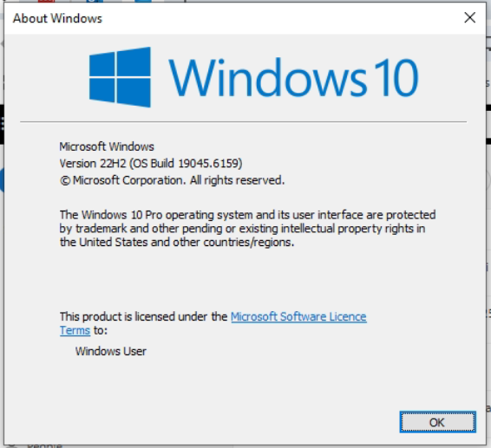

Then Download Win-11 Installation Assistance, if its running smoothly, there is no issue to install win-11. If not, if its throw error message, then need to run PC Health Check

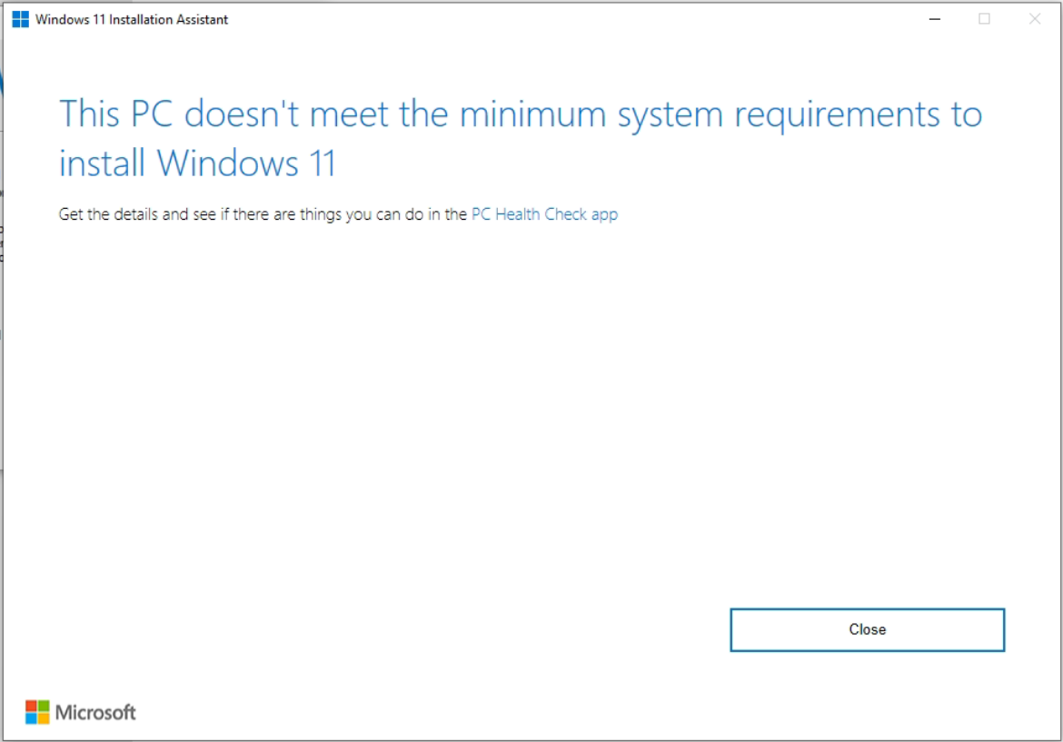

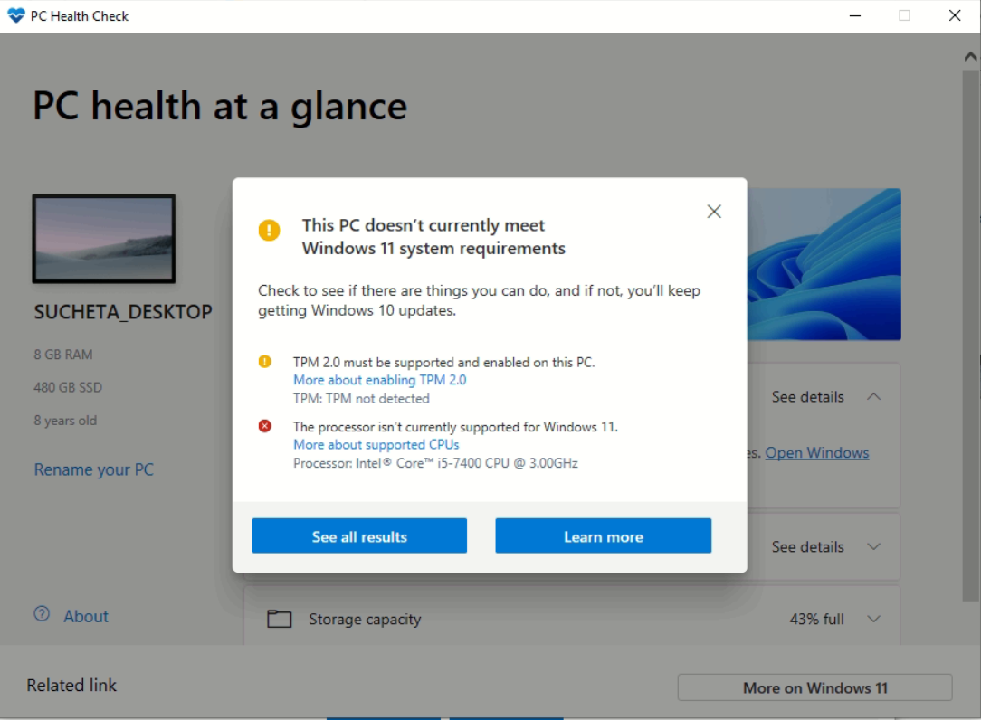

**Enable TPM 2.0 on your PC**

Most PCs that have shipped in the last 5 years are capable of running Trusted Platform Module version 2.0 (TPM 2.0). TPM 2.0 is required to run Windows 11, as an important building block for security-related features. TPM 2.0 is used in Windows 11 for a number of features, including Windows Hello for identity protection and BitLocker for data protection.

Note: This article is intended for users who are not able to upgrade to Windows 11 because their PC is not currently enabled with TPM 2.0 or their PC is capable of running TPM 2.0 but is not set up to do so. If you are unfamiliar with this level of technical detail, we recommend that you consult your PC manufacturer’s support information for more instructions specific to your device.

How to know if my PC can run TPM 2.0

In some cases, PCs that are capable of running TPM 2.0 are not set up to do so. If you are considering upgrading to Windows 11, check to ensure TPM 2.0 is enabled on your device. Most retail PC motherboards used by people building their own PC, for example, ship with TPM turned off by default even though it is almost always available to be enabled.

**Option 1: Use the Windows Security app**

Run Settings > Update & Security > Windows Security > Device Security

If you do not see a Security processor section on this screen your PC may have a TPM that is disabled. see How to enable TPM for more information or check your PC manufacturer’s support information for instructions. to enable the TPM. If you are able to enable a TPM, complete the next step to verify that it is a TPM 2.0.

If you see an option for Security processor details under Security processor, select that and verify that your Specification version is 2.0. If it is less than 2.0, your device does not meet the Windows 11 requirements.

**Option 2: Use the Microsoft Management Console**

Press [Windows Key] + R or select Start > Run.

Type “tpm.msc” (do not use quotation marks) and choose OK.

If you see a message saying a “Compatible TPM cannot be found,” your PC may have a TPM that is disabled. See How to enable TPM for more information or check your PC manufacturer’s support information for instructions to enable the TPM. If you are able to enable the TPM, complete the next step to verify that it is a TPM 2.0.

If you see a message confirming TPM is ready to use, check Specification Version under TPM Manufacturer Information to verify it is 2.0. If it is less than 2.0 your device does not meet the Windows 11 requirement.

**How to enable TPM**

If you need to enable TPM, these settings are managed via the UEFI BIOS (PC firmware) and vary based on your device. You can access these settings by choosing: Settings > Update & Security > Recovery > Restart now.

From the next screen, choose Troubleshoot > Advanced options > UEFI Firmware Settings > Restart to make the changes. These settings are sometimes contained in a sub-menu in the UEFI BIOS labeled Advanced, Security, or Trusted Computing. The option to enable the TPM may be labeled Security Device, Security Device Support, TPM State, AMD fTPM switch, AMD PSP fTPM, Intel PTT, or Intel Platform Trust Technology.

If you are unsure how to make any needed changes to the TPM settings, we recommend that you check your PC manufacturer’s support information or contact their support organization. Below are links to information from some PC manufacturers to help you get started:

**Getting ready for the Windows 11 upgrade**

Windows 11 is a new Windows experience, bringing you closer to what you love. With intuitive navigation and easy organization, Windows 11 has a whole new look, more apps, and efficient ways to be creative and productive.

This guide helps you get ready for Windows 11 and make the move. When you sign in with a Microsoft account, your files and favorites come with you to Windows 11, helping you quickly get back to doing what you love.

**Decide which device to use to run Windows 11.**

* Set up your Microsoft account to transfer files and favorites.
* Back up your files.
* Install Windows 11.
* Get help with Windows 11 installation problems.
* Get familiar with top productivity tools on Windows 11.
* Decide which device to use to run Windows 11

Windows 11 can run on PCs that meet the minimum hardware requirements. It might come pre-installed on new PCs, or you might be able to upgrade PCs currently running Windows 10.

Note: Some Windows 10 features aren't available in Windows 11. System requirements to experience some Windows 11 features and apps might exceed the Windows 11 minimum system requirements. Find Windows 11 specs, features, and computer requirements.

To check if your current Windows 10 PC can run Windows 11, download the PC Health Check app once it becomes available. Download PC Health Check.

For more about system requirements, see Windows 11 specs, features, and computer requirements.

**2 different types of devices running Windows 11**

If you're running a version of Windows that is out of support, or if your PC doesn't meet the minimum system requirements to run Windows 11, consider moving to a new Windows 11 device. Find a PC that meets your needs.