
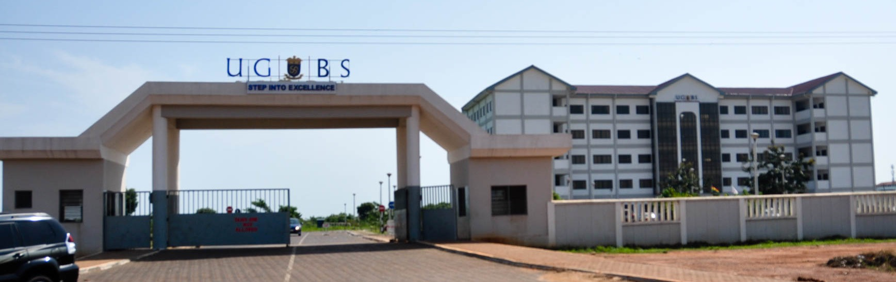
MSc BUSINESS ANALYTICS · TEXT ANALYTICS GROUP PROJECT
News Topic Modelling
Unsupervised discovery of themes in the 20 Newsgroups corpus using TF-IDF, Latent Dirichlet Allocation (LDA) and Non-negative Matrix Factorization (NMF)
GROUP 14 · TECHNICAL REPORT
No. | Full name | Student ID
1 | Fianu Adze Kofi Dovlo | 22418771
2 | Nana Ama Banafo | 22420379
3 | Stephen Ofori-Boateng | 22417816
4 | Kwame Ababio | 22424321
5 | Obiri-Yeboah Boateng Kwame | 22418785

Programme: MSc Business Analytics, University of Ghana Business School
Submitted: October 2026
Live application: https://group14-news-topic-modelling.streamlit.app/

SUMMARY
This report applies unsupervised topic modelling to the 20 Newsgroups corpus (18,331 Usenet posts, 18,185 after cleaning). After regular-expression cleaning, tokenisation, stopword removal, lemmatisation and de-duplication, every post was converted to a 5,000-word TF-IDF vector. Two topic models, LDA and NMF, each with 15 topics, were fitted to the same matrix and compared on topic coherence, topic diversity and topic purity, where purity uses the hidden newsgroup labels only after training, as a proxy for interpretability. NMF produced the more coherent (-1.59 versus -2.21) and purer (0.329 versus 0.277) topics, and diversity was tied (0.933). The ranking held in seven further LDA runs with different seeds and settings. We recommend NMF for routing documents by topic and LDA when a probabilistic topic mixture is needed. The whole pipeline is deployed as a seven-page Streamlit application.

1. Background

1.1 Motivation
News organisations, discussion forums and customer-service teams receive more text than any team can read or sort by hand. Topic modelling addresses this by grouping unlabelled documents into recurring themes automatically, so that patterns can be monitored without a person first labelling examples of every category. Text analytics more generally turns unstructured text into structured data through natural language processing, machine learning and visualisation, which is the objective of this assignment.

1.2 The assigned case and the data
Group 14 was assigned News Topic Modelling with TF-IDF as the text representation, LDA and NMF as the two algorithms, and topic coherence, topic diversity and topic interpretability as the evaluation criteria. The dataset is the 20 Newsgroups collection (Lang, 1995) distributed with scikit-learn (Pedregosa et al., 2011): Usenet posts spread across 20 discussion groups covering computing, science, sport, motoring, politics and religion, plus a for-sale group. We loaded every post and removed headers, footers and quoted replies, because otherwise a model can learn sender domains and signatures instead of subject matter. This left 18,331 non-empty posts. After cleaning and de-duplication, 18,185 posts remained, with between 602 (talk.religion.misc) and 974 (soc.religion.christian) posts per category.

1.3 Objectives
- Build a fully unsupervised pipeline: the real newsgroup labels are hidden from both models and used only afterwards as an answer key.
- Fit two topic models on identical input with the same number of topics, so the comparison is fair.
- Evaluate them with coherence, diversity and purity, compare them, and select the better model.
- Interpret the topics, state the limitations, and deliver the work as an interactive Streamlit application.

2. Approach (Methodology)

2.1 Pipeline overview
Figure 1 shows the ten stages. Stages 1 to 7 prepare the text, stage 8 converts it to numbers, stage 9 fits the two models, and stage 10 scores them. All stages are implemented in one Python module (text_analytics.py) and displayed by a Streamlit app (app.py).
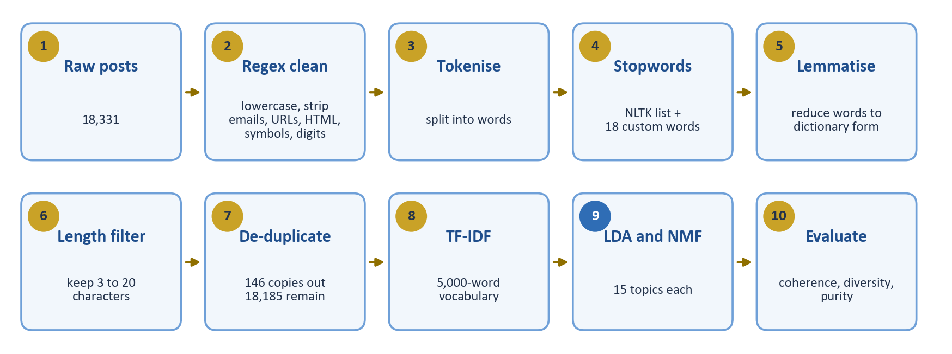
Figure 1. The analysis pipeline, from 18,331 raw posts to scored topic models.

2.2 Data cleaning with regular expressions
Raw posts contain addresses, links, markup and symbols that identify a sender rather than a subject. Table 1 lists the cleaning rules, applied in this order to every post.
Table 1. Regular-expression cleaning rules.
Rule | Pattern | Why it is needed
Lowercase | text.lower() | "Hockey" and "hockey" become one word.
Email addresses | \S+@\S+ | Addresses identify senders, not topics.
Web links | http\S+|www\.\S+ | Links carry no subject words.
HTML tags | <.*?> | Some posts contain leftover markup.
Punctuation | [^\w\s] | Keeps only letters, digits, underscores and spaces.
Underscore runs | _+ replaced by a space | Signature dividers such as ____ survive the previous rule, because \w counts the underscore as a word character.
Digits | \d+ | Numbers rarely signal a topic.
Whitespace | \s+ replaced by one space | Tidies the text after the deletions.

2.3 Text preprocessing
The cleaned text then passes through four further steps. Tokenisation splits each post into words using NLTK. Stopword removal deletes common English filler words and 18 project-specific words (would, one, get, like, know, dont, also, think, could, im, thing, say, well, may, make, use, used, using) that dominated early test topics. Lemmatisation reduces words to dictionary form with the WordNet lemmatiser; because it treats words as nouns by default, its main effect is on plurals (for example pens becomes pen). A length filter keeps only tokens of 3 to 20 characters, which removes stray letters and corrupted strings. Finally, exact duplicate posts are removed after cleaning. Table 2 follows one real post (from sci.med) through the steps.
Table 2. One post at each preprocessing stage.
Stage | Result
Original | How about Kirlian imaging ? I believe the FAQ for sci.skeptics (sp?) has a nice write-up on this. They would certainly be most supportive on helping you to build such a device and connect to a 120Kvolt supply so that you can take a serious look at your "aura"... :-)
After regex cleaning | how about kirlian imaging i believe the faq for sciskeptics sp has a nice writeup on this they would certainly be most supportive on helping you to build such a device and connect to a kvolt supply so that you can take a serious look at your aura
After stopword removal | kirlian imaging believe faq sciskeptics sp nice writeup certainly supportive helping build device connect kvolt supply take serious look aura
Final (lemmatised, length-filtered) | kirlian imaging believe faq sciskeptics nice writeup certainly supportive helping build device connect kvolt supply take serious look aura ("sp" was removed by the length filter)

2.4 Exploratory text analytics
After preprocessing, the corpus contains 1,600,123 words (96,304 distinct). Posts are short: the median is 40 words, the mean 88, and the longest 6,126 (Figure 2). The most frequent words are generic (people, time, year, system, new, file), which already hints that a large share of posts carry little topical signal.
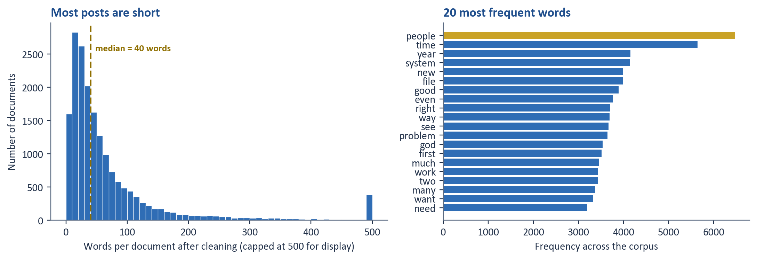
Figure 2. Document lengths after cleaning (left) and the 20 most frequent words (right).
Exploring the data before modelling exposed three problems that no model would have flagged on its own (Table 3). Each was fixed before the final run.
Table 3. Data-quality problems found during exploration.
Problem | Symptom | Fix
Underscore artefacts | Old signature dividers (____) survived punctuation removal and appeared as fake words. | A dedicated regex that replaces runs of underscores.
A corrupted token | One garbled, repeating string (an encoding error) appeared thousands of times and dominated word counts. | Keep only tokens of 3 to 20 characters.
146 duplicate posts | One prolific poster's repeated content formed its own artificial topic. | Remove exact duplicates after cleaning (18,331 to 18,185 posts).

A fourth, smaller issue appeared during evaluation: 47 posts contain none of the 5,000 model words, so their TF-IDF row is all zeros. Taking the highest-scoring topic of an all-zero row would silently place them in topic 0, so these posts are marked as unassigned and excluded from purity.

2.5 Text representation: TF-IDF
Computers need numbers, so each post is converted to a TF-IDF vector. TF-IDF (term frequency times inverse document frequency) gives a word a high score when it is frequent in one post but rare across the corpus, and a low score when it appears everywhere. We used scikit-learn's smoothed, L2-normalised variant and three filters: words in more than 90% of posts are ignored (too generic), words in fewer than 5 posts are ignored (too rare to be reliable), and only the 5,000 highest-scoring words are kept. The result is a 18,185 by 5,000 matrix in which 0.92% of the entries are non-zero. No train/test split was made: topic modelling is unsupervised and describes the data in hand rather than predicting labels for new data, so both models were fitted on the whole corpus.

2.6 Topic models: LDA and NMF
Both models were fitted to the same TF-IDF matrix with the same number of topics (15), so any difference in results comes from the algorithm and not from the input. Fifteen is a compromise: the corpus has 20 labelled categories, but several overlap heavily (for example the computing groups), and the topic count was not tuned separately for each model.
Table 4. Model configuration.
 | LDA (Model 1) | NMF (Model 2)
Idea | Probabilistic: each post is a mixture of topics, each topic a distribution over words (Blei, Ng and Jordan, 2003). | Factorises the TF-IDF matrix into two smaller non-negative matrices, so topics are only ever added together (Lee and Seung, 2001).
Topics | 15 | 15
Iterations | 20 passes (max_iter=20) | Up to 500 (max_iter=500)
Start | Random, seed 42 | nndsvd (deterministic), seed 42
Parallelism | n_jobs=1 for repeatable results | Not applicable

Each post is assigned to its highest-scoring topic. This assignment is used only to evaluate interpretability and never feeds back into training.

2.7 Evaluation
No single number captures topic quality in unsupervised learning, so we used three.
- Coherence. For each pair of a topic's top 10 words (45 pairs), score log((D(w1,w2)+1) / D(w2)), where D counts the posts containing the word(s); average over pairs and topics. Closer to 0 means the words genuinely appear together. This is a UMass-style measure (Mimno et al., 2011). Our version divides by the lower-ranked word of the pair; the textbook version divides by the higher-ranked word. The app reports both. We implemented it ourselves rather than adding a dependency (gensim) that has historically lagged behind new Python releases.
- Diversity. The share of unique words among all topics' top words. A value of 1.0 means no word is repeated across topics.
- Purity. Using the hidden labels only afterwards, the share of a topic's posts that come from its single largest real category, and overall purity as the weighted average. It is a practical stand-in for "would a person recognise this as one subject?", but it is capped by overlapping real categories and can mislead for large, vague topics.

2.8 Implementation and reproducibility
The pipeline runs inside a seven-page Streamlit app deployed on Streamlit Community Cloud ( https://group14-news-topic-modelling.streamlit.app/ ): Home, Corpora Viewer, Text Preprocessing (a step-by-step view of any chosen post), Exploratory Text Analytics, Topic Explorer, Model Evaluation, and Try It Yourself, where pasted or uploaded text is cleaned and assigned a topic by both models. The heavy computation is cached so it runs once per server start. To make results repeatable, we fixed the random seed, set LDA to a single worker (with several workers LDA's topics change with the number of CPU cores, so a laptop and a server would disagree), and pinned the library versions (Python 3.12, scikit-learn 1.8.0, NLTK 3.9.2).

3. Results

3.1 Overall model comparison
Table 5. Headline evaluation results (18,185 posts, 15 topics per model).
Metric | LDA | NMF | Better
Average topic coherence, project formula (closer to 0 is better) | -2.2067 | -1.5915 | NMF
Average topic coherence, standard UMass (closer to 0 is better) | -2.4690 | -1.7646 | NMF
Topic diversity (higher is better) | 0.9333 | 0.9333 | Tie
Overall topic purity (higher is better) | 0.2767 | 0.3290 | NMF

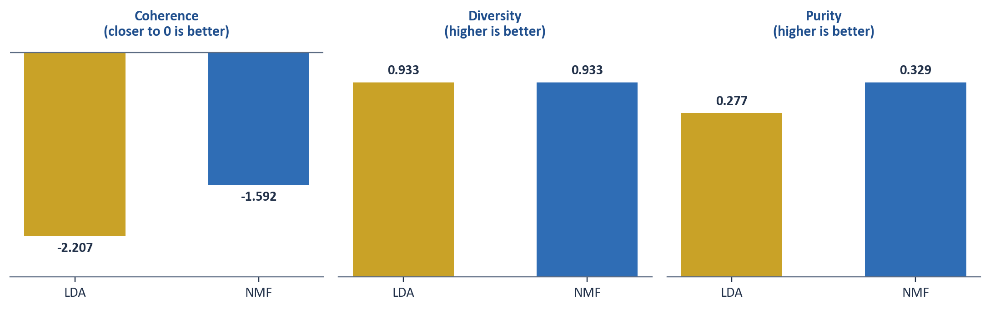
Figure 3. The three headline metrics. Gold is LDA and blue is NMF.
NMF wins on two of the three measures. Its topics' top words appear together more reliably (-1.59 versus -2.21; the textbook formula gives -1.76 versus -2.47, the same ranking), and its topics match the real categories more closely (purity 0.329 versus 0.277). Diversity is a tie at 0.933.

3.2 The topics the models found
Table 6. Selected NMF topics, from most to least interpretable.
# | Our label | Top words | Dominant category | Purity | Posts
11 | Cars and bikes | car, engine, mile, bike, dealer, ford, speed, tire | rec.autos | 0.697 | 656
7 | Cryptography | key, chip, clipper, encryption, phone, bit, escrow, algorithm | sci.crypt | 0.684 | 699
12 | Armenian-Turkish conflict | armenian, turkish, muslim, genocide, turkey, armenia, turk, russian | talk.politics.mideast | 0.664 | 443
5 | Religion | god, jesus, christian, bible, believe, christ, sin, faith | soc.religion.christian | 0.561 | 1,136
2 | Sport | game, team, player, hockey, year, baseball, win, play | rec.sport.hockey | 0.554 | 1,307
0 | Catch-all (generic words) | time, good, year, ive, problem, much, really, got | rec.motorcycles* | 0.162 | 3,341

Table 7. Selected LDA topics (from the final run used in the app).
# | Our label | Top words | Dominant category | Purity | Posts
6 | Armenian-Turkish conflict | armenian, turkish, turkey, muslim, turk, genocide, greek, armenia | talk.politics.mideast | 0.610 | 82
1 | Sport | game, team, player, year, season, hockey, play, last | rec.sport.hockey | 0.462 | 1,687
7 | For sale | sale, offer, shipping, condition, power, sell, price, asking | misc.forsale | 0.456 | 621
8 | Waco standoff | fbi, fire, koresh, batf, gun, msg, child, compound | talk.politics.guns | 0.356 | 827
4 | Crypto mixed with hardware | drive, key, chip, disk, phone, scsi, encryption, clipper | sci.crypt | 0.290 | 841
9 | Catch-all (generic words) | people, time, year, government, right, good, much, space | sci.med* | 0.145 | 4,956

*For catch-all topics the dominant category is nominal only: it is simply the real newsgroup that contributed the most posts to an unfocused pile. LDA's catch-all is not about medicine and NMF's is not about motorcycles. The complete list of all 15 topics for both models is in Appendix A.

3.3 A shared weakness: the catch-all topic
Both models produce one very large topic built from everyday words (people, time, year, good, much). LDA's holds 4,956 posts (27% of the corpus) and NMF's 3,341 (18%) (Figure 4). This one topic is the main reason purity is far from 1.0 for both models, and NMF's smaller catch-all is part of why it scores higher. A related artefact remains in NMF Topic 13 (202 posts, purity 0.658, nominally sci.med): its top words (bank, chastity, skepticism, intellect, surrender, shameful, gordon) come from a quotation one frequent poster attached to every message, not from medicine.
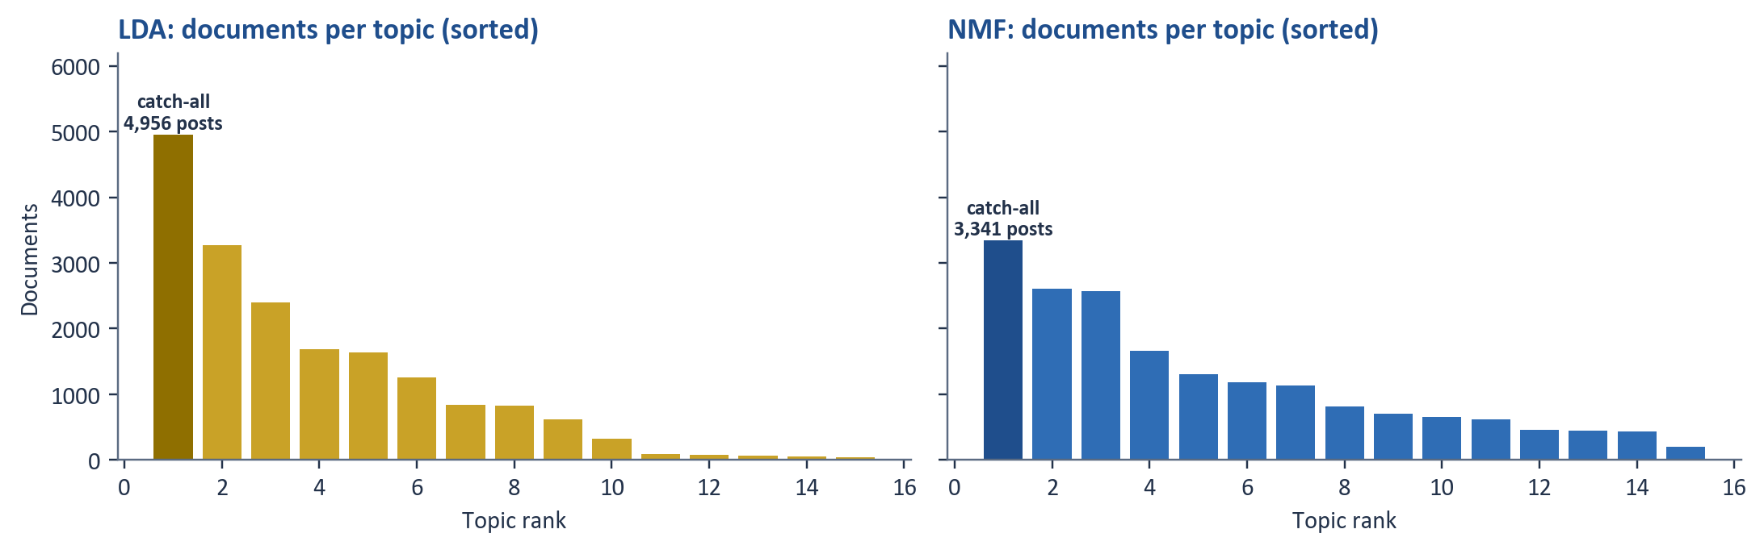
Figure 4. Documents per topic, sorted by size. The tallest bar in each panel is the catch-all topic.

3.4 Robustness: is the ranking a fluke?
LDA is a randomised algorithm, so we repeated it with five random seeds and with seed 42 under two worker settings (seven runs). NMF with nndsvd initialisation is deterministic and gives the same answer each time. Figure 5 shows that NMF had better coherence and better purity than LDA in all seven runs: LDA's coherence ranged from -2.17 to -2.37 (NMF -1.59) and its purity from 0.227 to 0.281 (NMF 0.329). LDA's diversity matched or exceeded NMF's in six of the seven runs (0.927 to 0.960 against 0.933), so the diversity result is a tie rather than a win for either model. LDA's exact numbers move from run to run; the ranking on coherence and purity does not. This is also why the app fixes the seed and the number of workers.
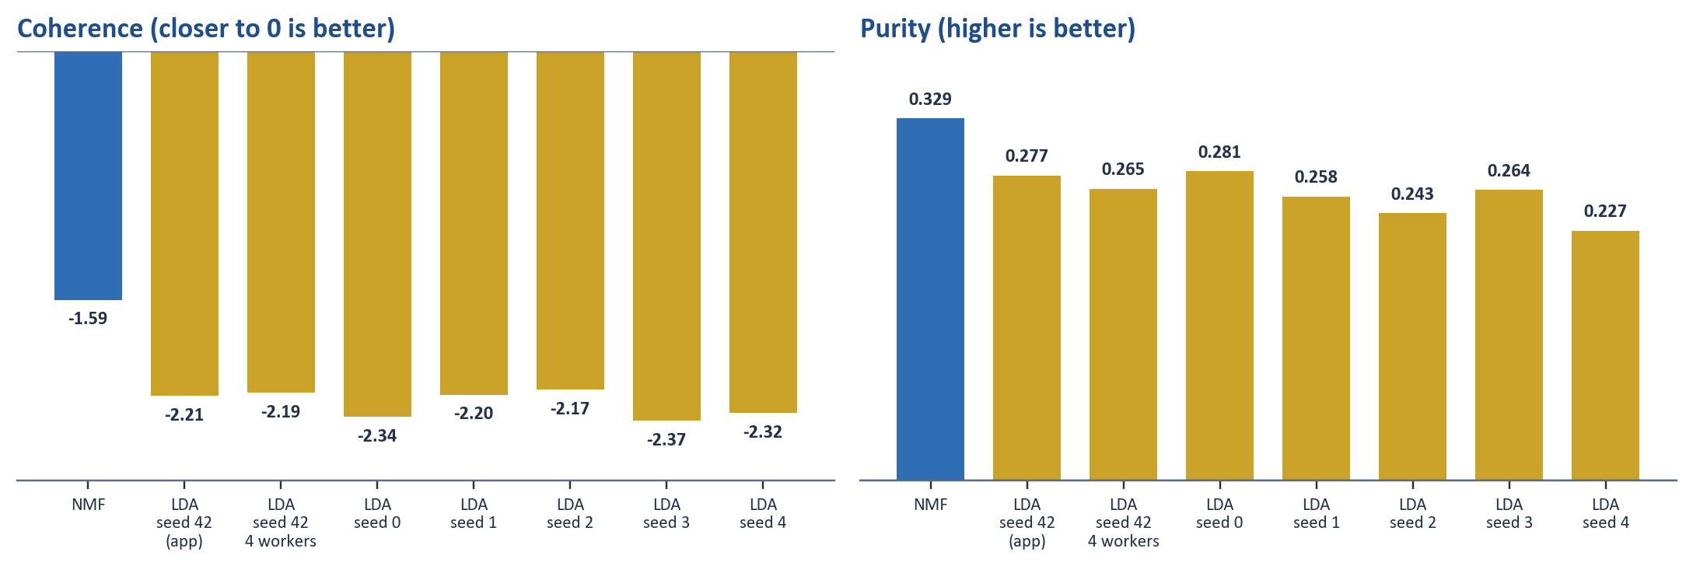
Figure 5. Seven LDA runs (gold) against NMF (blue). s = random seed, 4w = four workers; the final app uses seed 42 with one worker.

4. Interpretation

4.1 Which model should be used?
We recommend NMF for this corpus. Its topics are more internally consistent and closer to the real categories, and they read like subjects a person recognises instantly: cars, cryptography, the Armenian-Turkish conflict, religion and sport. That makes NMF the better choice if the output feeds something like a document-routing system, where each document needs one clear label.
LDA keeps a genuine advantage in other settings. It returns a probability distribution over topics for every post, so it can say that a document is 60% politics and 30% economics, which NMF's scores do not provide in the same form. A team that needs soft topic membership, or the widest vocabulary spread, could reasonably choose LDA.

4.2 What the results say about the corpus
Both models found the topics whose newsgroups have a distinctive vocabulary of their own (cryptography, cars, the Armenian-Turkish conflict, religion, sport). They struggled where categories overlap: for example NMF Topic 8 (2,604 posts, purity 0.228) blends gun-rights discussion with general politics and Middle-East vocabulary. The giant catch-all topic shows that much of Usenet is ordinary conversational English that carries no strong topic signal under any category label. The ceiling on purity is therefore not only a modelling problem: some of the 20 categories are not linguistically distinct, and a meaningful share of posts say little about their subject.

4.3 Why the data cleaning mattered
The three problems in Table 3 were more serious than expected. Before de-duplication, one person's repeated posts formed a topic that was about nobody's subject. Before the underscore and corrupted-token fixes, garbage occupied vocabulary slots that belonged to real words, and with only 5,000 slots every wasted one counts. The signature quotation behind NMF Topic 13 and the 47 posts with no usable words show that cleaning is never finished, and that at least one more iteration is available.

4.4 Limitations
- Custom coherence. Our formula is a UMass variant. It is fair for comparing LDA with NMF inside this project, but its values should not be compared with other studies. The app also reports the textbook version, and the ranking is the same.
- Purity. It is judged against the dataset's own category boundaries, some of which overlap, and it can be misleading for large vague topics. It puts a ceiling on achievable purity for any model.
- Topic count. Fifteen topics were fixed for both models and not tuned. A different number could change the balance of the metrics and might break up the catch-all topic.
- LDA input. The brief requires TF-IDF, so LDA was fitted on TF-IDF weights, although LDA is usually fitted on raw word counts. In a side experiment (three seeds, not part of the main comparison) LDA on raw counts reached coherence of -1.68 to -1.80 and purity of 0.34 to 0.38, higher purity than NMF though still lower coherence. The main comparison therefore reflects both algorithms on the same TF-IDF input, which may understate LDA.
- Single dataset and run environment. All numbers come from one dataset. Results can differ slightly on other computers even with pinned library versions, so figures quoted in presentations should be taken from the live app.

4.5 Recommendations and future work
1. Use NMF as the main model for downstream tasks such as routing documents by topic; keep LDA for soft, multi-topic breakdowns.
2. Split the catch-all topic: increase the number of topics, or add a stopword pass aimed at its filler words, and re-measure purity.
3. Add a cleaning pass for repeated signature quotations, the cause of NMF Topic 13. It is the same problem as the duplicate posts, but harder to catch because the surrounding text differs each time.
4. Re-run coherence with gensim as an independent check, and test LDA on raw word counts with a tuned number of topics.

References
Blei, D. M., Ng, A. Y., & Jordan, M. I. (2003). Latent Dirichlet allocation. Journal of Machine Learning Research, 3, 993-1022.
Lang, K. (1995). NewsWeeder: Learning to filter netnews. In Proceedings of the Twelfth International Conference on Machine Learning (pp. 331-339). Morgan Kaufmann.
Lee, D. D., & Seung, H. S. (2001). Algorithms for non-negative matrix factorization. Advances in Neural Information Processing Systems, 13.
Mimno, D., Wallach, H., Talley, E., Leenders, M., & McCallum, A. (2011). Optimizing semantic coherence in topic models. In Proceedings of the 2011 Conference on Empirical Methods in Natural Language Processing (EMNLP).
Pedregosa, F., et al. (2011). Scikit-learn: Machine learning in Python. Journal of Machine Learning Research, 12, 2825-2830.

Appendix A. Complete topic tables
Purity is the share of a topic's posts that come from its most common real category. "Coh." is the topic's coherence (project formula; closer to 0 is better). Rows in gold are the catch-all topics.
Table A1. All 15 NMF topics.
# | Top 10 words | Dominant category | Purity | Posts | Coh.
0 | time, good, year, ive, problem, much, really, got, see, back | rec.motorcycles | 0.162 | 3,341 | -1.38
1 | window, application, font, run, manager, problem, driver, running, version, mouse | comp.os.ms-windows.misc | 0.511 | 460 | -1.85
2 | game, team, player, hockey, year, baseball, win, play, season, fan | rec.sport.hockey | 0.554 | 1,307 | -1.47
3 | drive, scsi, disk, hard, ide, controller, floppy, meg, mac, problem | comp.sys.ibm.pc.hardware | 0.390 | 616 | -1.86
4 | thanks, please, email, anyone, advance, looking, reply, address, info, post | comp.graphics | 0.101 | 1,668 | -1.65
5 | god, jesus, christian, bible, believe, christ, sin, faith, belief, church | soc.religion.christian | 0.561 | 1,136 | -1.13
6 | file, format, directory, convert, gif, ftp, bmp, disk, postscript, program | comp.os.ms-windows.misc | 0.329 | 429 | -1.72
7 | key, chip, clipper, encryption, phone, bit, escrow, algorithm, government, number | sci.crypt | 0.684 | 699 | -1.78
8 | people, right, government, gun, law, state, israel, arab, israeli, many | talk.politics.guns | 0.228 | 2,604 | -1.56
9 | card, driver, video, monitor, color, bus, vga, bit, mode, board | comp.sys.ibm.pc.hardware | 0.329 | 820 | -1.89
10 | sale, price, new, offer, shipping, condition, sell, asking, email, interested | misc.forsale | 0.481 | 1,188 | -1.85
11 | car, engine, mile, bike, dealer, ford, speed, tire, owner, oil | rec.autos | 0.697 | 656 | -2.14
12 | armenian, turkish, muslim, genocide, turkey, armenia, turk, russian, azeri, population | talk.politics.mideast | 0.664 | 443 | -0.96
13 | bank, njxp, chastity, skepticism, intellect, surrender, shameful, gordon, soon, patient | sci.med | 0.658 | 202 | -0.94
14 | program, system, image, software, graphic, available, data, space, version, code | comp.windows.x | 0.188 | 2,569 | -1.71

Table A2. All 15 LDA topics.
# | Top 10 words | Dominant category | Purity | Posts | Coh.
0 | wax, iii, gilmour, mfm, edmonton, clark, fielder, chain, spelling, question | rec.motorcycles | 0.150 | 40 | -3.78
1 | game, team, player, year, season, hockey, play, last, baseball, fan | rec.sport.hockey | 0.462 | 1,687 | -1.46
2 | kent, cheer, migraine, subscribe, clayton, marc, homosexual, pink, spell, sex | comp.windows.x | 0.111 | 54 | -3.60
3 | thanks, please, email, anyone, file, looking, advance, info, ftp, list | comp.graphics | 0.255 | 1,252 | -1.57
4 | drive, key, chip, disk, phone, scsi, encryption, clipper, system, hard | sci.crypt | 0.290 | 841 | -2.31
5 | god, people, christian, jesus, believe, israel, church, jew, religion, life | soc.religion.christian | 0.267 | 3,267 | -1.48
6 | armenian, turkish, turkey, muslim, turk, genocide, greek, armenia, serb, serdar | talk.politics.mideast | 0.610 | 82 | -1.24
7 | sale, offer, shipping, condition, power, sell, price, asking, detector, circuit | misc.forsale | 0.456 | 621 | -2.23
8 | fbi, fire, koresh, batf, gun, msg, child, compound, people, surrender | talk.politics.guns | 0.356 | 827 | -2.52
9 | people, time, year, government, right, good, much, space, state, even | sci.med | 0.145 | 4,956 | -1.40
10 | part, try, end, doug, yep, blah, forgot, sco, mad, keywords | comp.os.ms-windows.misc | 0.281 | 64 | -2.46
11 | window, file, problem, program, driver, work, color, system, thanks, application | comp.windows.x | 0.291 | 2,396 | -1.75
12 | ticket, simms, sale, bos, simm, pit, adaptor, pin, offer, det | misc.forsale | 0.352 | 88 | -3.18
13 | car, bike, engine, mile, new, good, ride, dod, motorcycle, battery | rec.motorcycles | 0.359 | 1,633 | -2.13
14 | card, mhz, bus, monitor, scsi, video, meg, ram, speed, board | comp.sys.mac.hardware | 0.345 | 330 | -1.99

Appendix B. Reproducing the results
The code, the pinned library versions and the deployment steps are in the project folder. To run the app on a laptop:
pip install -r requirements.txt
streamlit run app.py
The first start takes several minutes because the dataset is downloaded and both models are trained; afterwards every page is instant. The robustness experiment of Section 3.4 can be repeated with robustness_check.py, which trains LDA with different seeds and scores it exactly as in the app.

