|  |  |
| --- | --- |
|  |  |



**Dharmsinh Desai University, Nadiad**

**Faculty of Technology**

**Department of Computer Engineering**

**B. Tech. CE Semester – VI**

**Subject: System Design Practice**

**Project Title: Billify**

**By:**

**1)Prijen Khokhani, Roll no : CE060, ID : 17CEUOG010**

**2)Deval Italiya, Roll no : CE043, ID : 17CEUOS070**

**3)Kaushal Italiya, Roll no : CE044, ID : 17CEUOS072**

**Guided By : Prof. Jigar M Pandya**



**Dharmsinh Desai University, Nadiad**

Faculty of Technology, Department of Computer Engineering

**CERTIFICATE**

This is to certify that System Design Practice entitled “Billify” is the bonafied report of work carried out by

1)Deval Italiya (17CEUOS070)

2)Prijen Khokhani(17CEUOG010)

3)Kaushal Italiya(17CEUOS072)

Of Department of Computer Engineering ,Semester VI , academic year 2019-2020, under our supervision and guidance.

Guide HOD

**Prof. Jigar M Pandya** **Dr. C. K. Bhensdadia**

Department of Computer Engineering, Department of Computer Engineering,

Faculty of Technology, Faculty of Technology,

**Dharmsinh Desai University ,**  **Dharmsinh Desai University.**

**Nadiad - 387001 Nadiad – 387001**

**Date : 24/04/2020 Date : 24/4/2020**

# Contents:

**1. Abstract 5**

**2. Introduction 6**

**1. Brief Introduction 6**

**2. Technology/Platform/Tools used 6**

**3. Software Requirement Specifications 7**

**4. Design 10**

**I. Use case diagram 10**

**II. Class diagram. 11**

**III. Sequence diagram 12**

**IV. Activity diagram 13**

**V. State diagram 14**

**Vl. ER diagram 15**

**5.Data Dictionary 16**

**6.Implementation Detail 19**

**I. Modules created and brief description of each modules. 19**

**Il. Function prototypes which implements major functionality. 21**

**7.Testing 21**

**8.Screen-Shots 22**

**9.Conclusion 31**

**10.Limitation and Future extension 32**

**10.Bibliography 33**

**Abstract**

Toady we all know that people are used to go out for dinner,trip,some personal work,professional work with their friends, family etc.So, in such kind situation it may happen that any one or more person may pay some payment.So,then in such kind of situation people have remember all things that he/she has pay something for some else and owes from him/her or they themselves owe for someone.So, for this kind of confusion we come with one wonderful solutions.

Billify is solution for such scenario.Just add all your friends in this app.You may create group for common scenarion if it is.Then just mention that people and add expenses.They will be automatically notified by this app and not get confused for anykind such situation. Billify can handle a variety of payment scenarios: When one person pays or multiple people have paid, it can split payments evenly based on the amounts or allow you to select individual amounts for each person to pay.

**Introduction**

The app tracks borrowing and lending over time. And, until the balance is settled up, each person’s outstanding balance may go up and down. Billify sends reminders at the end of the month so everyone can pay what they owe and go into a new month with a fresh start. On the homepage, you’ll find a tally of the amount you owe and you can settle your balance at any time – you don’t have to wait until the end of the month. Payments can be settled with Paypal or Paytm directly from the app, or if the person who owes you pays in cash, you can record a cash payment to clear up the outstanding balance.

We’ve all been to group dinners and the server brings out just one check – or the restaurant has a

policy of not splitting up checks for large groups. Tab solves the headache of figuring out what

each person owes. Each person in the group can pay for the items they ordered without having to

send the server back to separate the ticket.

**Tools and Technologies**

**Tools**

-Android Studio

**Technologies**

-Firebase Database

-Firebase Cloud Function

-Firestore

-Google Api

-Facebook Api

-Github Repository

**Software Requirement Specifications**

R.1.1 Authenticate user

Description:User can Sign up,login.

R.1.1.1 Sign out

Input:email,password,confirm password,username

Output:Send verification email

R.1.1.2 Verify user

Input:verify link

Output:Generate unique token

R.1.1.3 Login

Input:email,password

Output:Login successfully

R.1.1.4 Forgot password

Input:email

Output:Sent link successfully

R.1.1.5 Reset password

Input:paasword,confirm password

Output:Reset successfully

R.1.2 Manage friends

R.1.2.1 Request friends

Input:friends number or email

Output:sent request

R.1.2.2 Delete friends

Input:friends number or email

Output:delete friends

R.1.2.3 Acctept request

Input:command

Output:accept succefully

R.1.3 Manage group

R.1.3.1 Create group

Input:group name,friends number

Output:created successfully

R.1.3.2 Edit group

Description: Change group name,add new friends and delete friends

R.1.3.2.1 Change group name

Input: Enter new name

Output: Named changed successfully

R.1.3.2.2 Add friends

Input: Enter the number of friends

Output: Friends added successfully

R.1.3.2.3 Remove friends

Input: Enter the number of friend

Output: Removed successfully

R.1.3.3 Delete group

Input: Select group

Output: Deleted successfully

R.1.4 Manage expenses

Descritpion: Manage the expenses of friends and groups

R.1.4.1 Manage Friends Expenses

R.1.4.1.1 Add expense

Description: User can add equally or unequally expense also it can select option of who owns.

Input: Expense amount,Friends number,Enter the message

Output: expense added successfully

R.1.4.1.2 Edit expense

Input: Enter new amount,Edit friends

Output: Edited successfully

R.1.4.1.3 Delete expense

Input: Select expense

Output: Deleted successfully

R.1.4.2 Manage group expenses

R.1.4.2.1 Add expense

Description: User can add equally or unequally expense also it can select option of who owns.

Input: Expense amount and enter the message

Output: expense added successfully

R.1.4.2.2 Edit expense

Input: Enter new amount,Edit friends amount

Output: Edited successfully

R.1.4.2.3 Delete expense

Input: Select expense

Output: Deleted successfully

R.1.5 Settle Up

Description: User can settle up indivisually

Input: Click on settle up and write message

Output: Sette up successfully

R.1.6 Back up

Description:User can take backup his/her data as per requirement

Input:select back up

Output:backup data succefully

R.1.7 Expense history

R.1.7.1 view history

Input:select view

Output:Display history

R.1.7.2 Search history

Input:search record

Output:view particular record

**Design**

**Usecase Diagram :**

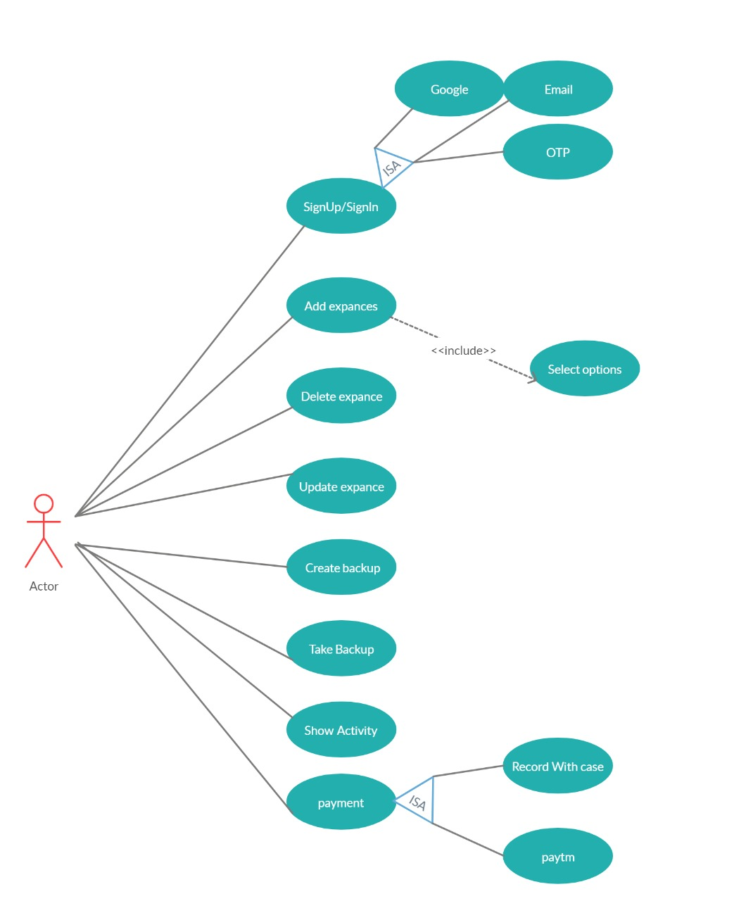

**Class Diagram :**

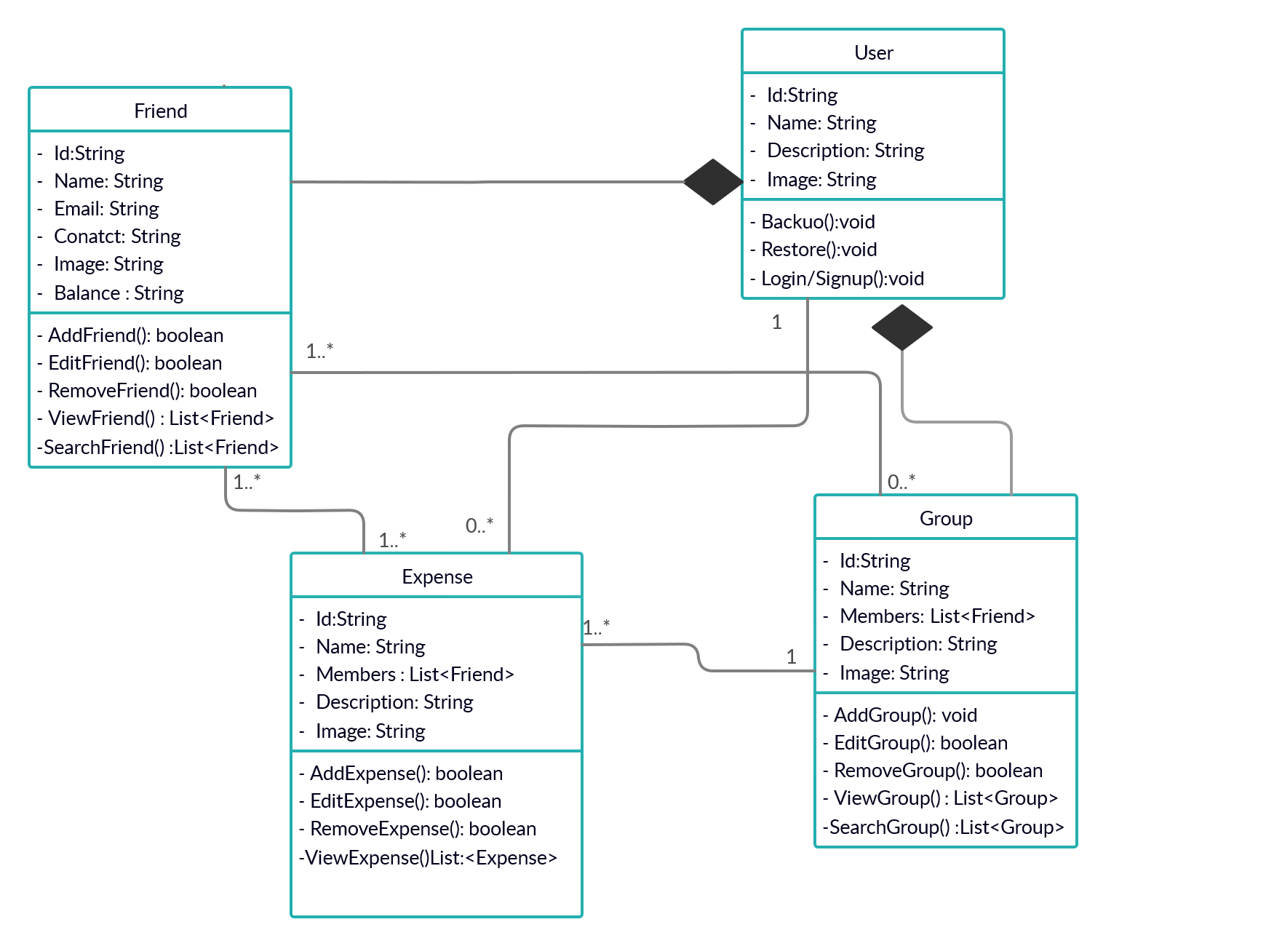

**Sequence Diagram :**

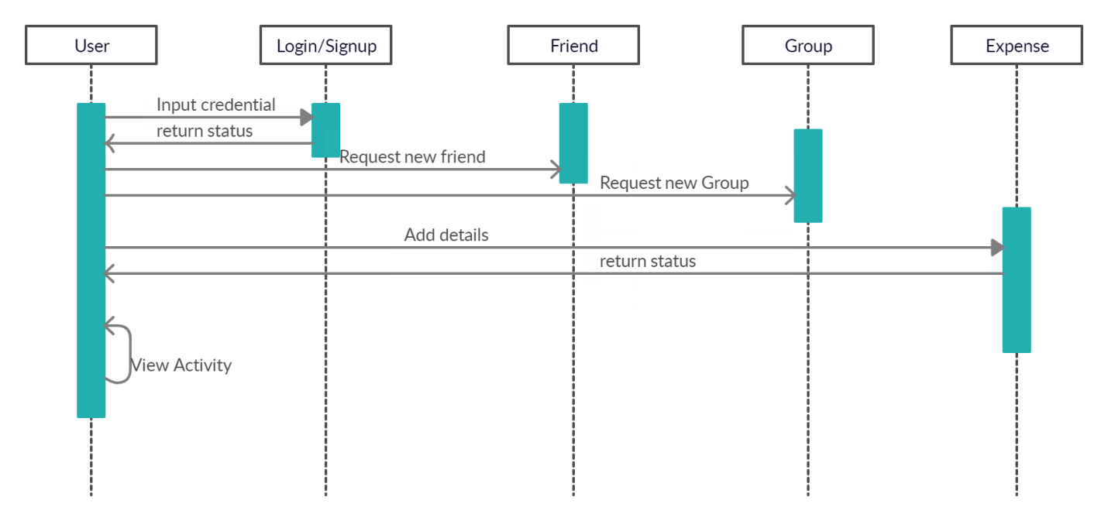

**Activity Diagram :**

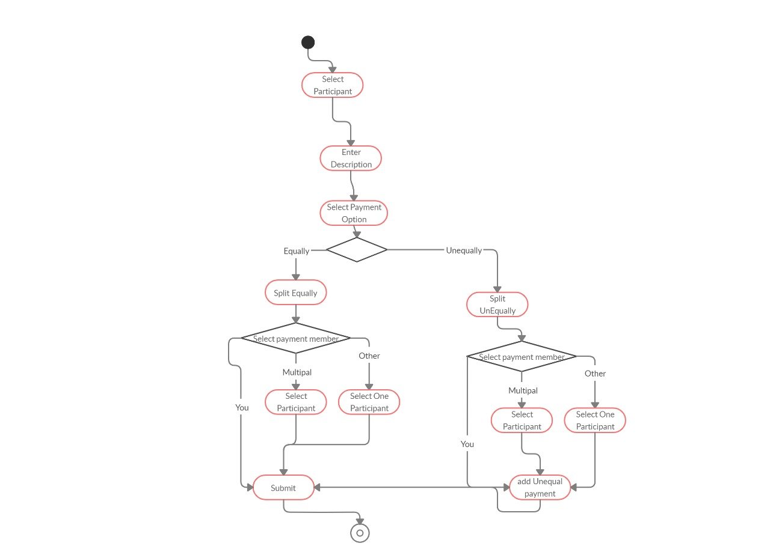

**State Diagram :**

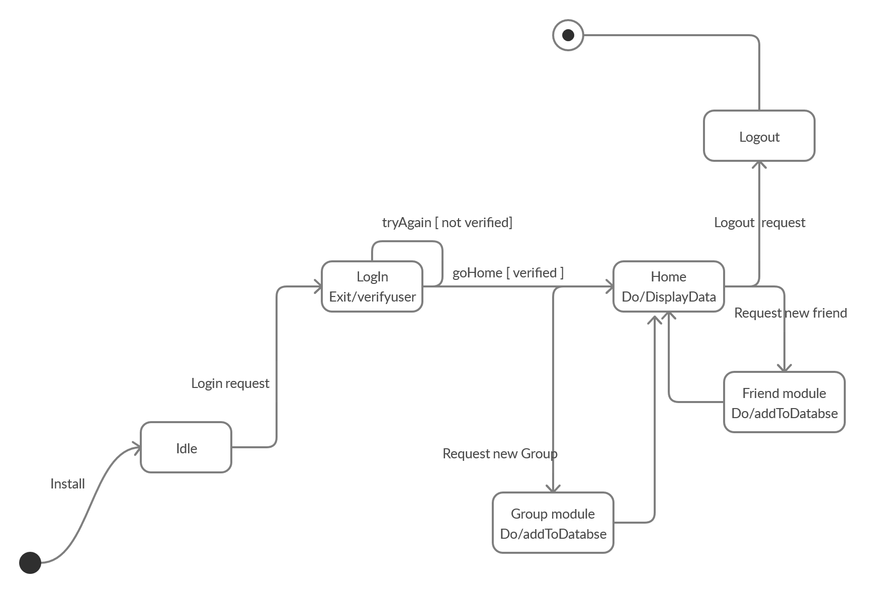

**E-R Diagram :**

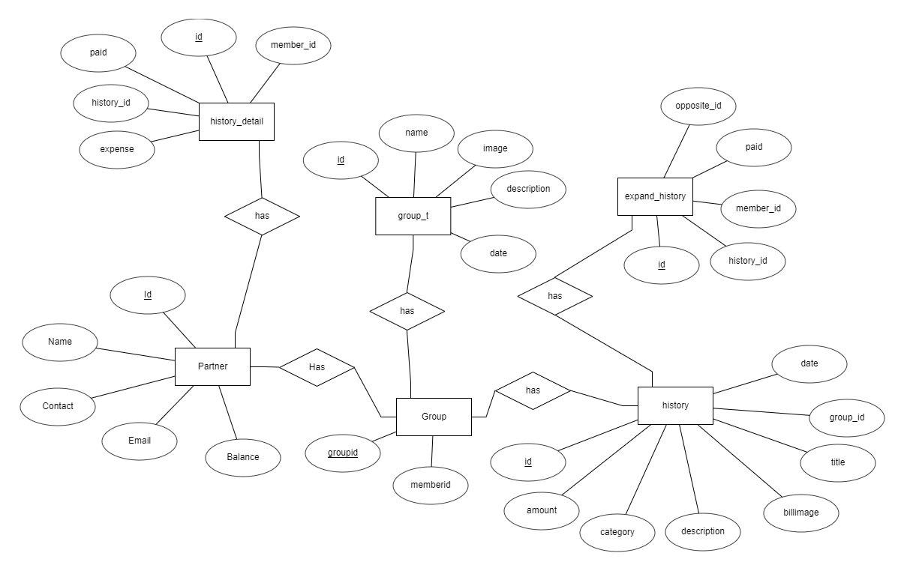

**Data dictionary :**

**Partner**

|  |  |  |  |  |  |  |  |
| --- | --- | --- | --- | --- | --- | --- | --- |
| **Sr_no.** | **Name** | **Data Type** | **Width** | **Required** | **Unique** | **PK/FK** | **Referenced Table** |
| **1** | **Id** | **Text** | **20** | **YES** | **YES** | **PK** | **-** |
| **2** | **Name** | **Text** | **50** | **YES** | **-** | **-** | **-** |
| **3** | **Profile** | **Text** | **50** | **YES** | **-** | **-** | **-** |
| **4** | **Contact** | **Integer** | **-** | **YES** | **-** | **-** | **-** |
| **5** | **Email** | **Text** | **50** | **YES** | **YES** | **-** | **-** |
| **6** | **Balance** | **NUMBER** | **10** | **YES** | **-** | **-** | **-** |

**History_detail**

|  |  |  |  |  |  |  |  |
| --- | --- | --- | --- | --- | --- | --- | --- |
| **Sr_no.** | **Name** | **Data Type** | **Width** | **Required** | **Unique** | **PK/FK** | **Referenced Table** |
| **1** | **Id** | **Text** | **20** | **YES** | **YES** | **PK** | **-** |
| **2** | **History_id** | **Text** | **50** | **YES** | **-** | **FK** | **History** |
| **3** | **Member_id** | **Text** | **50** | **YES** | **-** | **FK** | **Partner** |
| **3** | **Paid** | **Number** | **10** | **YES** | **-** | **-** | **-** |
| **4** | **Expence** | **Number** | **50** | **YES** | **-** | **-** | **-** |

**Expand_history**

|  |  |  |  |  |  |  |  |
| --- | --- | --- | --- | --- | --- | --- | --- |
| **Sr_no.** | **Name** | **Data Type** | **Width** | **Required** | **Unique** | **PK/FK** | **Referenced Table** |
| **1** | **Id** | **Text** | **20** | **YES** | **YES** | **PK** | **-** |
| **2** | **History_id** | **Text** | **50** | **YES** | **-** | **FK** | **History** |
| **3** | **Member_id** | **Text** | **50** | **YES** | **-** | **FK** | **Partner** |
| **4** | **Paid** | **Number** | **50** | **YES** | **-** | **-** | **-** |
| **5** | **Opposite_id** | **Text** | **10** | **YES** | **-** | **-** | **-** |

**Group_t**

|  |  |  |  |  |  |  |  |
| --- | --- | --- | --- | --- | --- | --- | --- |
| **Sr_no.** | **Name** | **Data Type** | **Width** | **Required** | **Unique** | **PK/FK** | **Referenced Table** |
| **1** | **Id** | **Text** | **20** | **YES** | **YES** | **PK** | **-** |
| **2** | **Name** | **Text** | **50** | **YES** | **-** | **-** | **-** |
| **3** | **Image** | **Text** | **50** | **YES** | **-** | **-** | **-** |
| **4** | **Description** | **Text** | **50** | **YES** | **-** | **-** | **-** |
| **5** | **Date** | **Text** | **20** | **YES** | **-** | **-** | **-** |

**Group_member**

|  |  |  |  |  |  |  |  |
| --- | --- | --- | --- | --- | --- | --- | --- |
| **Sr_no.** | **Name** | **Data Type** | **Width** | **Required** | **Unique** | **PK/FK** | **Referenced Table** |
| **1** | **Group_id** | **Text** | **20** | **YES** | **YES** | **PK** | **-** |
| **2** | **Member_id** | **Text** | **50** | **YES** | **-** | **FK** | **Partner** |

**History**

|  |  |  |  |  |  |  |  |
| --- | --- | --- | --- | --- | --- | --- | --- |
| **Sr_no.** | **Name** | **Data Type** | **Width** | **Required** | **Unique** | **PK/FK** | **Referenced Table** |
| **1** | **Id** | **Text** | **20** | **YES** | **YES** | **PK** | **-** |
| **2** | **Amount** | **Number** | **50** | **YES** | **-** | **-** | **-** |
| **3** | **Date** | **Text** | **50** | **YES** | **-** | **-** | **-** |
| **4** | **Billimage** | **Text** | **50** | **YES** | **-** | **-** | **-** |
| **5** | **Group_id** | **Text** | **50** | **YES** | **-** | **FK** | **Group** |
| **6** | **Description** | **Text** | **50** | **YES** | **-** | **-** | **-** |
| **7** | **Title** | **Text** | **50** | **YES** | **-** | **-** | **-** |
| **8** | **Category** | **Text** | **50** | **YES** | **-** | **-** | **-** |

**Implementation Detail**

**Authentication Module:**

**Sign Up Activity**

This activity is used to store user’s data to the database and enables the user to login to system. All the fields in this module contains validations.

Input : User’s Information

Output: User Registration and redirect to login page

**Sign In Activity**

This activity is takes users credentials and then verifies it with registered users, If user is not registered invalid credential is shown and if user is registered then it will match the database and user will login. All the fields in this module contains validations.

Input : User’s Credentials

Output: Logging user

**Forget Password Activity**

In this activity user gives its email id and if the email id is valid and match the database. Then it send the link to the that registered email.

Input : User’s email

Output: Check your mailbox

**Manage Friends Module:**

**All Friends Activity**

In this activity all the friends will be shown with their expenses.

Input : All Friends

Output: Show the List

**Add Friend Activity**

In this user can add new friends. User can add his friend by his contact or email id.

If that contact or email will be valid and that will be in database then it will send the request to that friend.

Input : User’s email or contact

Output: Friend is added

**Manage Group Module:**

**All Groups Activity**

In this activity all the group will be shown with their expenses.

Input : All group

Output: Show the List

**Add Group Activity**

In this activity user can create new group. For the user have add their friends name and name of the group.

Input : Add Friends

Output: Group is created

**Expense Module:**

Manage **Expense Activity**

Using this activity user can add new expenses,can edit and delete also . For that user have add all the valid information and name of friends. In this there is option for how to split. By that if user wants to add different amount in all the friends then it can choose split unequal. There is also option for who paid, using that user can choose multiple pairs.

Input : Add amount and friends

Output: Expense Added

**Backup Module:**

**Create Backup Activity**

If the user wants to take the backup of all expenses. Then using create backup user can create the backup.

Input : Click get Backup

Output: Created succefully

Function **Protoype :**

* Loginfragment()
* signupfragmet()
* MainActivity()
* AddExpenseActivity()
* AddInGroup()
* display_History()
* display_groups()
* delete_expense()
* display_friends()

**Testing**

* For each indivisual component we have applied unit testing .
* After that with database we have done integration testing for crud operation method of friends, groups, expenses,history etc.
* Then we have tested system for online database(Firebase).
* At the end of project, we have tested whole system with end-end testing.

**Screen-Shots**

**Login Module**

SigninSignup

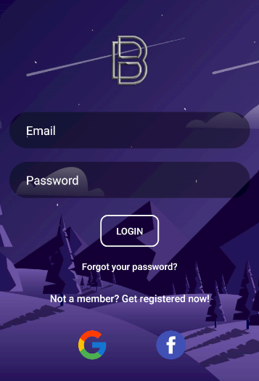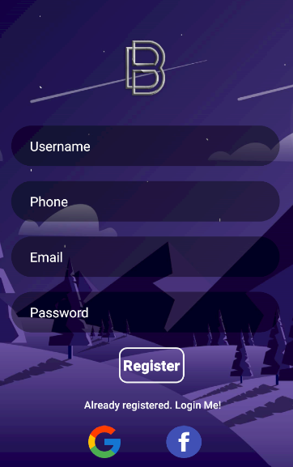

Forgot Password

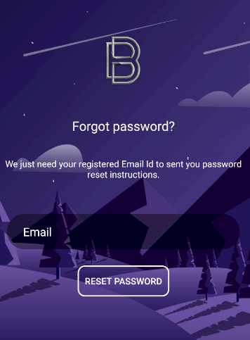

**Manage Friend Module**

Add Friend

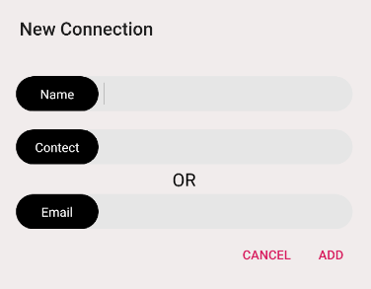

Show All Friends

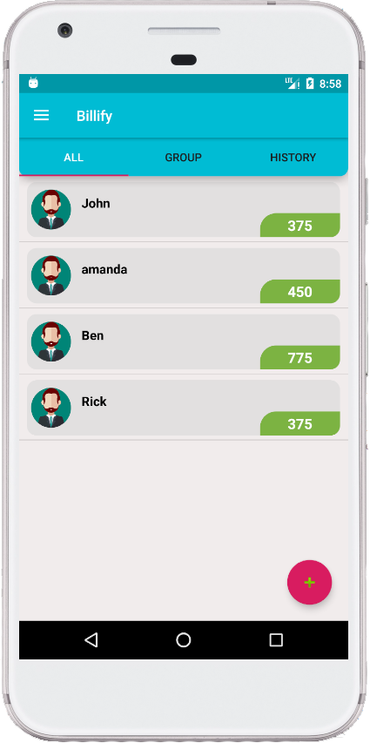

**Manage Group Module**

Add Group Show Groups

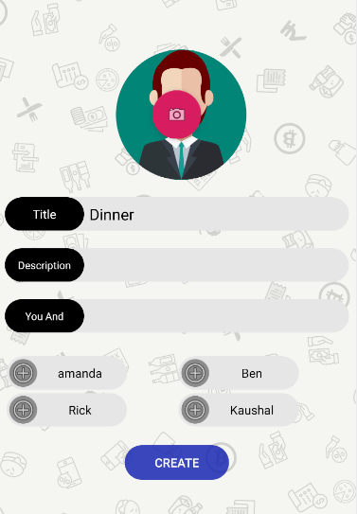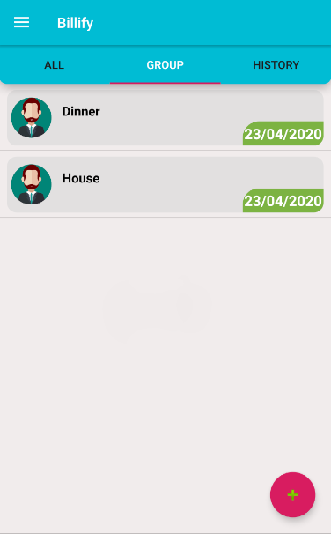

**Expenses Module**

Add Expense

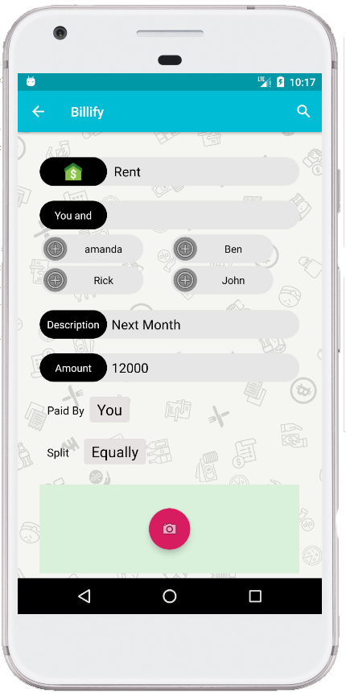

Add Expense Help

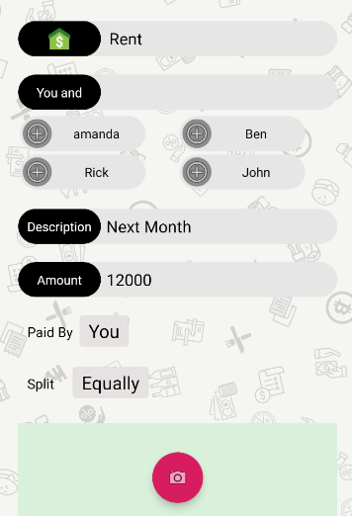

**History**

Show History History Detail

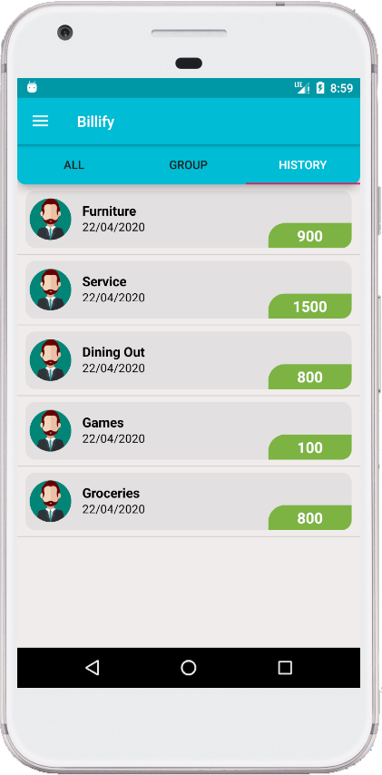 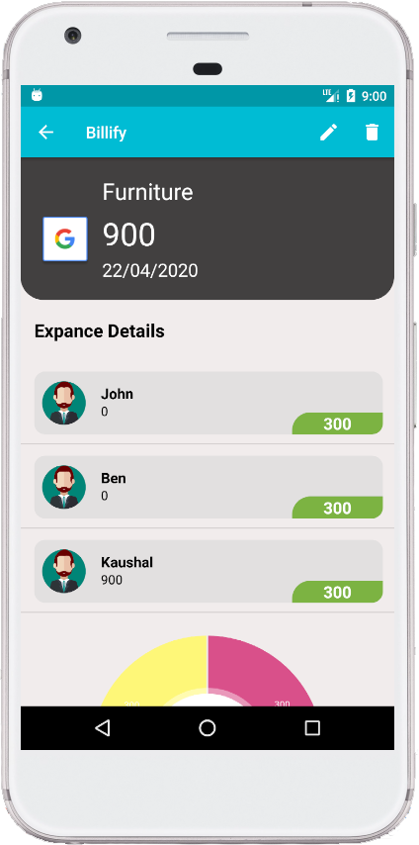

**Dark Mode**

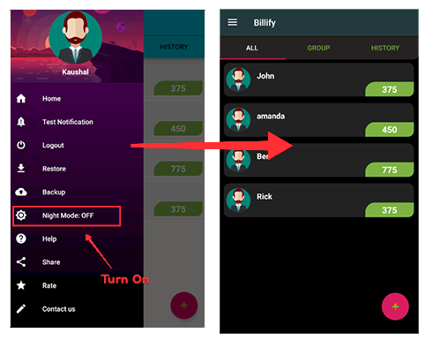

After Dark Mode Applied

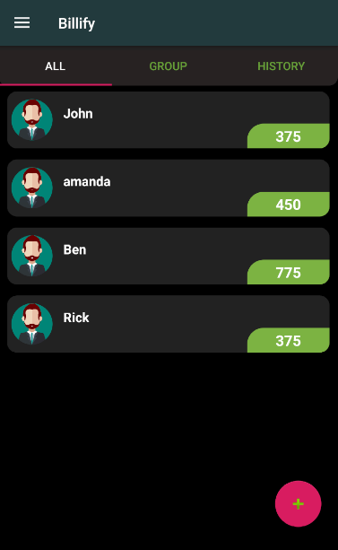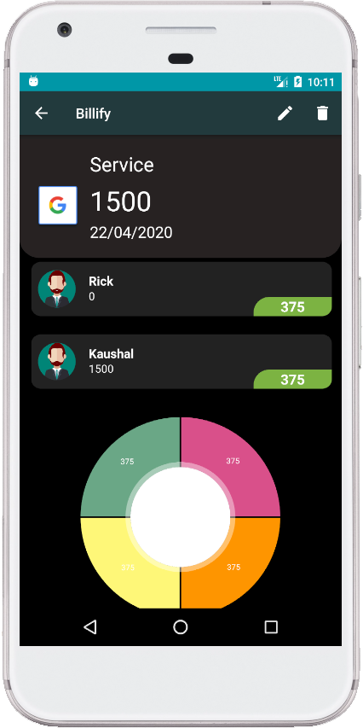

**Conclusion**

The functionality implemented in the system was done after understanding all the system modules according to the requirements.

Functionalities that are successfully implemented in the system are:

**Main Features**

**-**Split expenses

**-**Group expense

**-**History

-Backup/Restore

-Notification

**Advantages**

**-**Easy expense management

**-**Analysis of expenses

**-**Split expense on one tap

-Group for daily expense

After the implementation and coding of system, comprehensive testing was performed on the system to determine the loopholes and possible flaws in the system.

**Limitation and Future extension**

**Limitations**

-Anyone can update or delete payment without any other participants permission.

-Any group member can add new members.

-Payment directly through this app

-This app is available for only android users.

**Future Extension**

-Payment mode through this will be implemented

-For ios platform and web also availble in nearer future.

-Performance of this app will be optimised in future.

**Bibliography**

**Reference**

<https://developer.android.com/guide>

<https://developers.facebook.com/docs>

<https://console.developers.google.com/cloud-resource-manager>

<https://firebase.google.com/>

# Thank You