US customer feedbacks:

1. Any optimization in SAW for HPC or cloud clusters for parallelization?
   1. RnD has a SAW wdl version for internal use, which supports parallelization. I informed them about this need again and they will look into this. Let’s set up a meeting with RnD so they can also gather some information from you.
2. MacOS version of ImageStudio and StereoMap
3. Unable to sign up at the official bioinformatics tool website for downloading installation files. (SJ team tried and didn’t get email verification either). <https://en.stomics.tech/register>
   1. Can you try again and take a screenshot? There is currently no verification email. If signed up successfully, there should be a notification on the screen. -- I just tried today 08112023, both the employee login and signing up as guest is working now.
4. <https://www.stomics.tech/> and <https://cloud.stomics.tech> are now extremely slow to load.
   1. [www.stomics.tech](http://www.stomics.tech) is not for global STOmics website. It’s the Chinese page so it might get extremely slowl. Please use https://en.stomics.tech
   2. I informed fengzhen about the slow loading of <https://cloud.stomics.tech>. Let’s follow up on this at next week’s TS meeting.
5. Any RnD work/knowledge on targeted transcript enrichment? (depletion of highly-expressed but unwanted transcripts, or enrichment of targets)
   1. Yes, they are currently working on targeted enrichment methods on both FF and FFPE samples.
6. On the SAP projects page, the circled dropdown option is difficult to see and know it’s a dropdown. Customer had trouble seeing their data when the default page takes them to a wrong option, and they specifically complained about this confusion.
   1. Qing you could use this form to provide comment and feedback regarding STOmics Cloud user experience: <https://iyf3bl5g8b.feishu.cn/share/base/form/shrcndYJk3YlAL3XxcA3LbqkwHh>
   2. You’ll be able

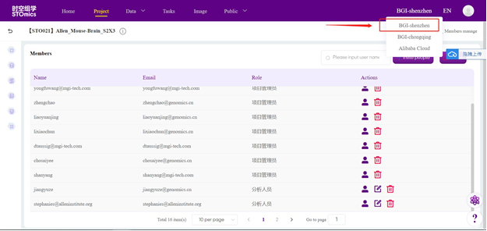

1. SAP usage monitoring