# Shortest path algorithm using dynamic programming

The assignment is to complete a simulator app where we use an algorithm to find the least-cost path between one corner to the other corner.

Since the duck can only move to East or South, this means every node in the graph has max two incoming nodes: from North or West.

Let’s call the destination node A, the node on North B and the node on West C. If we know the least-cost path to B and least-cost path to C, then knowing the least-cost path to A is easy; that is just we choose the minimum between B and C, and choose that to move to A.

We repeat the same with B and C. We repeat it until we find the starting node. The cost to reach from start to start is obviously zero or the same as the number in that node.

In the code I used recursion with memoization in the first function. In the second I just built the least-cost path in an array using iteration in the 2D cost array.  
  
**1)**

Here’s the least-cost path found with the code:

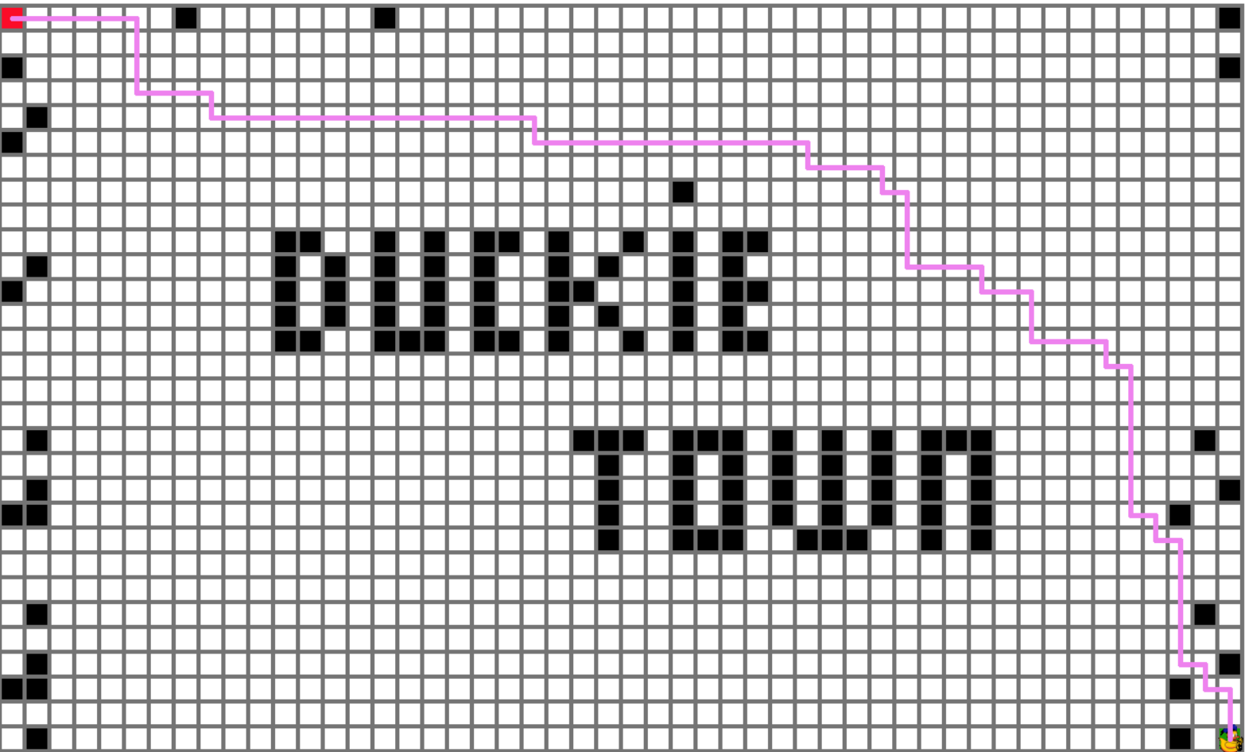

**2)**

The least consuming path is using ca 2.151 % of the battery. So with 2.5 % battery Donald can reach the charging station.