**Mobokart**

Ecommerce webstore

**Frontend Designs**

/login

/register

/checkout

/homepage

/cart

**Code**

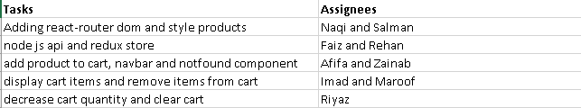

**Testing**

1. Registration page
2. Login page
3. UI testing
4. Cart testing
5. Checkout page