LAPORAN PERHITUNGAN STRUKTUR
Struktur Baja Lift Gedung D

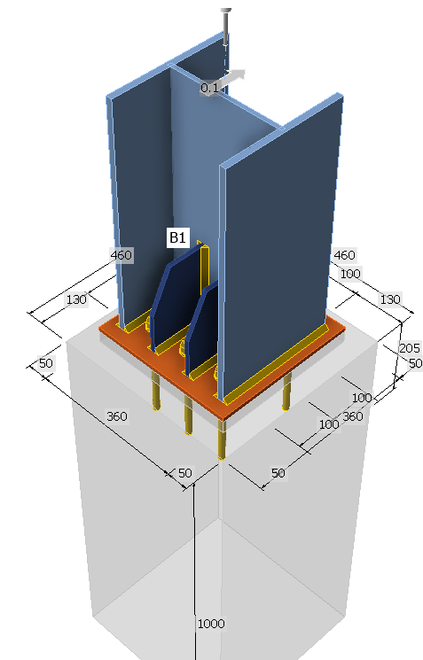
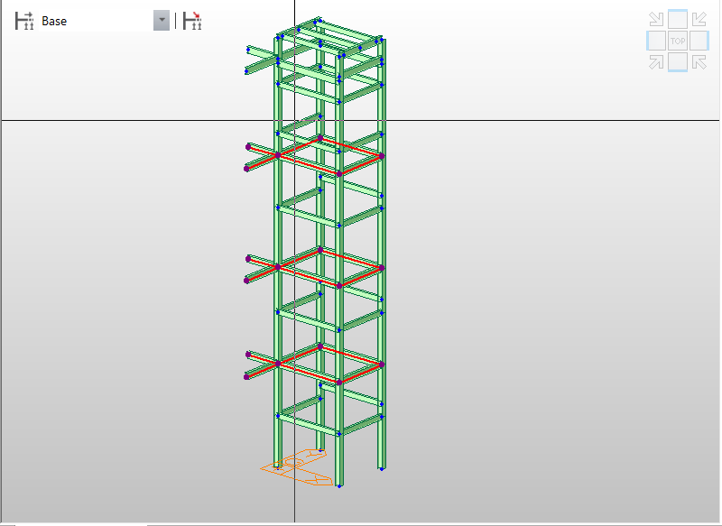
LAPORAN PERHITUNGAN STRUKTUR
Struktur Baja Lift Gedung D
Proyek | Renovasi dan Perluasan Gedung D (Deputi-I) Kantor Pusat
Pekerjaan | Struktur Lift Gedung D (Shop Drawing SD-STR-GDD-0006-01 s.d. -09)
Kontraktor | PT. Jaya Konstruksi
Konsultan MK | PT. Infratama Yakti
Peraturan acuan | SNI 1727:2020 (Beban Desain Minimum); SNI 1729:2020 (Struktur Baja); ASME A17.1 (lendutan balok mesin lift)
Status | DRAFT, data mesin lift masih asumsi dan menunggu data vendor

1. PENDAHULUAN
Laporan ini memuat perhitungan (a) beban mati tambahan akibat plat lantai beton tebal 130 mm yang akan dipasang di area landing lift dan (b) beban hidup mesin lift kapasitas 1200 kg yang digantung pada balok di bagian atas struktur lift. Perhitungan meliputi distribusi beban ke balok, gaya dalam, dan kontrol indikatif profil baja WF250×125×6×9.
Balok yang ditinjau adalah balok yang ditandai merah pada model 3D, yaitu rangka balok WF250 di lantai landing (EL +3950, +7950, +11950) dan balok mesin di bagian atas (EL +15317 dan +16400).
Gambar 1. Model 3D struktur lift, balok yang ditinjau ditandai merah

2. DATA PERENCANAAN

2.1 Geometri (dari shop drawing)
Parameter | Nilai | Sumber
Jarak as 1 ke as 2 | 2900 mm | Lembar 2, 4
Jarak as A ke as B | 2350 mm | Lembar 2, 4
Bentang pendek plat landing (lx) | 1625 mm | Lembar 4 (4125 − 2350 − 150)
Bentang panjang plat landing (ly) | 2900 mm | Lembar 4
Kolom | H300×300×10×15 | Lembar 2
Balok landing dan balok mesin | WF250×125×6×9 | Lembar 4, 5
Tebal plat lantai | 130 mm | Permintaan

2.2 Material dan properti penampang
Parameter | Nilai
Mutu baja (asumsi, setara BJ 37) | fy = 240 MPa, E = 200.000 MPa
Berat jenis beton bertulang | 24 kN/m³
WF250×125×6×9 | q = 29,6 kg/m = 0,290 kN/m; Ix ≈ 4050 cm⁴; Zx ≈ 352 cm³; ry ≈ 2,79 cm
WF200×100×5,5×8 | q = 21,3 kg/m = 0,209 kN/m

2.3 Asumsi
- Plat lantai 130 mm hanya berada di area landing (antara balok as-B dan balok beton). Area dalam shaft tetap terbuka.
- Rasio ly/lx = 1,78 < 2, sehingga plat bekerja dua arah. Balok as-B menerima beban trapesium, balok di as-1 dan as-2 menerima beban segitiga.
- Tebal bondek dan data lift selain kapasitas 1200 kg (dari owner) adalah asumsi tipikal dan harus diganti dengan data vendor.
- Berat sendiri baja diperhitungkan sebagai beban terbagi rata pada balok.

3. BEBAN MATI TAMBAHAN PLAT LANTAI
No | Komponen | Perhitungan | Beban (kN/m²)
1 | Plat beton t = 130 mm | 0,13 m × 24 kN/m³ | 3,12
2 | Bondek 0,75 mm (asumsi) | Asumsi | 0,10
3 | Spesi t = 3 cm | 3 cm × 0,21 kN/m²/cm | 0,63
4 | Keramik/finishing t = 1 cm | 1 cm × 0,24 kN/m²/cm | 0,24
 | Total beban mati tambahan (qD) |  | 4,09

Beban hidup lantai landing (opsional, area publik/lobi, SNI 1727:2020): qL = 4,79 kN/m².

4. DISTRIBUSI BEBAN PLAT KE BALOK

4.1 Balok as-B (bentang 2,9 m), beban trapesium
Beban puncak qp = q × lx / 2
qp(D) = 4,09 × 1,625 / 2 = 3,323 kN/m
Ekuivalen momen: qeq,M = qp × (3 − (lx/ly)²) / 3 = 3,323 × (3 − 0,314) / 3 = 2,975 kN/m
Total beban: Wt = qp × (ly − lx/2) = 3,323 × (2,90 − 0,8125) = 6,94 kN
Ekuivalen geser: qeq,V = Wt / ly = 2,392 kN/m

4.2 Balok as-1 dan as-2 (bentang 1,625 m), beban segitiga
Beban puncak di tengah = 3,323 kN/m
Total beban = ½ × 3,323 × 1,625 = 2,70 kN per balok
Reaksi tiap ujung = 1,35 kN; Mmaks = qp·L²/12 = 0,73 kNm

4.3 Rekapitulasi beban plat pada balok
Balok | Jenis beban | Beban mati (D) | Beban hidup (L)
As-B (2,9 m) | Puncak trapesium | 3,323 kN/m | 3,892 kN/m
 | Ekuivalen momen | 2,975 kN/m | 3,485 kN/m
 | Ekuivalen geser | 2,392 kN/m | 2,801 kN/m
 | Berat sendiri WF250 | 0,290 kN/m | -
As-1 dan as-2 (1,625 m) | Puncak segitiga | 3,323 kN/m | 3,892 kN/m
 | Total per balok | 2,70 kN | 3,16 kN

4.4 Kontrol indikatif balok as-B
wu = 1,2 (qeq,M(D) + qsw) + 1,6 qeq,M(L) = 1,2 × (2,975 + 0,290) + 1,6 × 3,485 = 9,49 kN/m
Mu = wu × L² / 8 = 9,49 × 2,9² / 8 = 9,98 kNm
Vu = wu,V × L / 2 = 7,70 × 2,9 / 2 = 11,17 kN
Dibandingkan dengan φMp = 76,0 kNm, rasio Mu/φMp = 0,13 sehingga balok as-B aman terhadap beban plat lantai.

5. BEBAN HIDUP MESIN LIFT (KAPASITAS 1200 KG)

5.1 Data beban lift
Item | Massa (kg) | Gaya (kN) | Jenis | Keterangan
Kapasitas Q | 1200 | 11,77 | Hidup | Data owner
Berat sangkar P | 1500 | 14,71 | Hidup (lift) | Asumsi
Counterweight = P + 0,5Q | 2100 | 20,60 | Hidup (lift) | Asumsi
Tali, kabel, governor | 200 | 1,96 | Hidup (lift) | Asumsi
Total beban lift | 5000 | 49,05
Mesin traksi + base frame | 600 | 5,89 | Mati | Asumsi

5.2 Faktor impak
Untuk beban elevator dan penumpunya, SNI 1727:2020 Pasal 4.6 (mengadopsi ASCE 7) mensyaratkan penambahan 100% sebagai beban impak, sehingga faktor = 2,0. Mohon sub-pasal dan kalimat persisnya diverifikasi pada dokumen resmi SNI. Jika vendor sudah memberi beban dinamik yang memuat impak, faktor ini tidak boleh dikalikan lagi.
Beban lift ber-impak = 2,0 × 49,05 = 98,10 kN

5.3 Pembagian ke balok mesin
Mesin ditumpu oleh 2 balok WF250 secara simetris dan beban dianggap terpusat di tengah bentang (L = 2,9 m).
PL = 98,10 / 2 = 49,05 kN per balok (sudah termasuk impak)
PD = 5,89 / 2 = 2,94 kN per balok
Berat sendiri balok = 0,290 kN/m

6. GAYA DALAM DAN KONTROL BALOK MESIN WF250×125×6×9

6.1 Gaya dalam (kombinasi 1,2D + 1,6L)
Pu = 1,2 × 2,94 + 1,6 × 49,05 = 82,01 kN
Mu = Pu·L/4 + 1,2·w·L²/8 = 59,46 + 0,37 = 59,8 kNm
Vu = Pu/2 + 1,2·w·L/2 = 41,01 + 0,50 = 41,5 kN

6.2 Kapasitas dan kontrol
Kontrol | Demand | Kapasitas | Rasio | Status
Lentur (sayap tekan terkekang) | 59,8 kNm | φMp = 76,0 kNm | 0,79 | OK
Geser | 41,5 kN | φVn = 194 kN | 0,21 | OK

Zx = 125×9×241 + 6×232²/4 = 352 cm³; φMp = 0,9 × Zx × fy = 76,0 kNm
φVn = 0,9 × 0,6 × fy × d × tw = 0,9 × 0,6 × 240 × 250 × 6 = 194 kN
Pservis = 24,52 + 2,94 = 27,47 kN
δ = P·L³/(48EI) + 5wL⁴/(384EI) = 1,72 + 0,03 = 1,76 mm > 1,74 mm

6.3 Output Reaksi Tumpuan Pada Titik Penempatan Base Plate
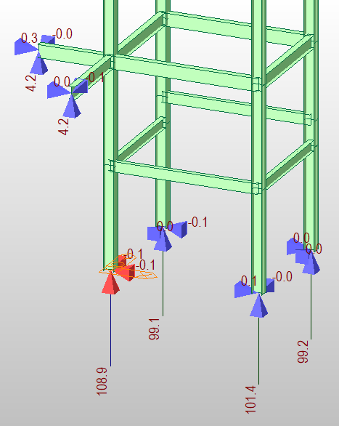
Berikut adalah output reaksi tumpuan yang terjadi , yang nantinya akan di masukkan ke dalam software IDEA Statica untuk di lakukan proses Analisa.

6.4 Analisis Join Base Plate & DInabolt

Project item Base Plate
Name | BASE PLATE KOLOM & BALOK
Description
Analysis | Stress, strain/ loads in equilibrium
Design code | AISC 360-22 (LRFD) / ACI 318-25
Design
Members
Geometry
Name | Cross-section | β – Direction  [°] | γ - Pitch  [°] | α - Rotation  [°] | Offset ex  [mm] | Offset ey  [mm] | Offset ez  [mm]
B1 | 2 - H 300x300x10 | 0.0 | 90.0 | 0.0 | 0 | 0 | 0
Supports and forces
Name | Support | Forces in | X  [mm]
B1 / end |  | Node | 0
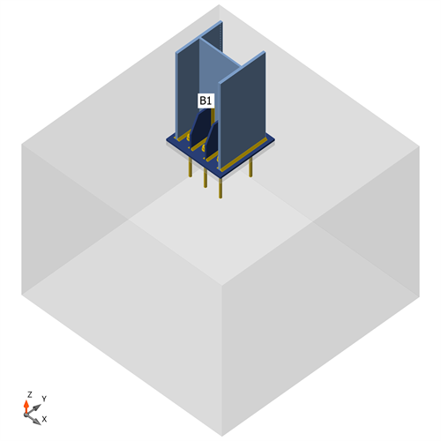
BASE PLATE , Axonometric view
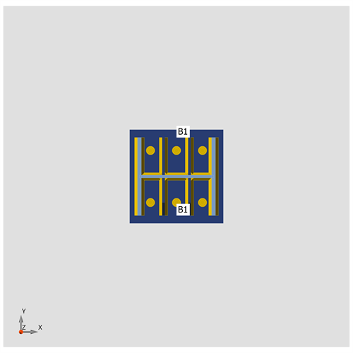
BASE PLATE , Z direction view
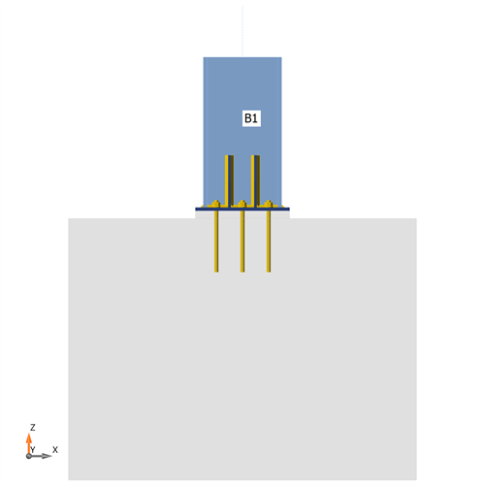
BASE PLATE , Y direction view
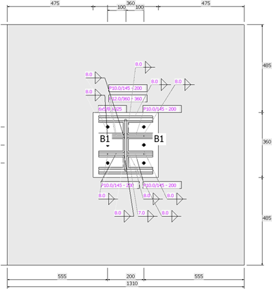
Base plate (BP1)

Cross-sections
Name | Material
2 - H 300x300x10 | SS 400
Cross-sections
Name | Material | Drawing
2 - H 300x300x10 | SS 400 | 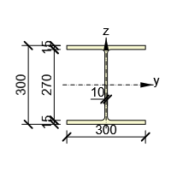
Anchors
Name | Diameter  [mm] | f_{y}  [MPa] | f_{u}  [MPa] | Gross area  [mm²]
5/8 A325 | 16 | 634.3 | 827.4 | 198
Load effects (forces in equilibrium)
Name | Member | N  [kN] | Vy  [kN] | Vz  [kN] | Mx  [kNm] | My  [kNm] | Mz  [kNm]
LE3 | B1 / End | 108.9 | 0.1 | 0.0 | 0.0 | 0.0 | 0.0
Unbalanced forces
Name | X  [kN] | Y  [kN] | Z  [kN] | Mx  [kNm] | My  [kNm] | Mz  [kNm]
LE3 | 0.0 | 0.1 | 108.9 | 0.0 | 0.0 | 0.0
Foundation block
Item | Value | Unit
CB 1
Dimensions | 1310 x 1330 | mm
Depth | 1000 | mm
Anchor | 5/8 A325
Anchoring length | 205 | mm
Shear force transfer | Anchors
Mortar joint | 30 | mm
Check
Summary
Name | Value | Check status
Analysis | 100.0% | OK
Plates | 0.0 < 5.0% | OK
Anchors | 82.1 < 100% | OK
Welds | 9.7 < 100% | OK
Concrete block | Not calculated
Buckling | 5649.73
Plates
Name | t_{p}  [mm] | Loads | σ_{Ed}  [MPa] | ε_{Pl}  [%] | σ_{c,Ed}  [MPa] | Status
B1-bfl 1 | 15.0 | LE3 | 38.2 | 0.0 | 0.0 | OK
B1-tfl 1 | 15.0 | LE3 | 37.7 | 0.0 | 0.0 | OK
B1-w 1 | 10.0 | LE3 | 23.3 | 0.0 | 0.0 | OK
BP1 | 12.0 | LE3 | 105.1 | 0.0 | 0.0 | OK
RIB1a | 10.0 | LE3 | 33.2 | 0.0 | 0.0 | OK
RIB1b | 10.0 | LE3 | 35.7 | 0.0 | 0.0 | OK
RIB1c | 10.0 | LE3 | 33.3 | 0.0 | 0.0 | OK
RIB1d | 10.0 | LE3 | 35.4 | 0.0 | 0.0 | OK
Design data
Material | F_{y}  [MPa] | ε_{lim}  [%]
SS 400 | 248.2 | 5.0
Detailed result for B1-bfl 1
Design values used in the analysis
 | 223.4 | MPa
Where:
– characteristic yield strength
– resistance factor for steel material AISC 360-22 – B3.1

Detailed result for B1-tfl 1
Design values used in the analysis
 | 223.4 | MPa
Where:
– characteristic yield strength
– resistance factor for steel material AISC 360-22 – B3.1

Detailed result for B1-w 1
Design values used in the analysis
 | 223.4 | MPa
Where:
– characteristic yield strength
– resistance factor for steel material AISC 360-22 – B3.1

Detailed result for BP1
Design values used in the analysis
 | 223.4 | MPa
Where:
– characteristic yield strength
– resistance factor for steel material AISC 360-22 – B3.1

Detailed result for RIB1a
Design values used in the analysis
 | 223.4 | MPa
Where:
– characteristic yield strength
– resistance factor for steel material AISC 360-22 – B3.1

Detailed result for RIB1b
Design values used in the analysis
 | 223.4 | MPa
Where:
– characteristic yield strength
– resistance factor for steel material AISC 360-22 – B3.1

Detailed result for RIB1c
Design values used in the analysis
 | 223.4 | MPa
Where:
– characteristic yield strength
– resistance factor for steel material AISC 360-22 – B3.1

Detailed result for RIB1d
Design values used in the analysis
 | 223.4 | MPa
Where:
– characteristic yield strength
– resistance factor for steel material AISC 360-22 – B3.1

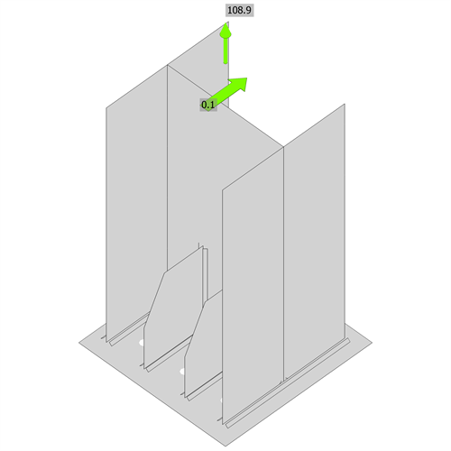  Strain check, LE3 | 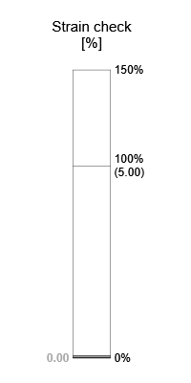

Anchors
Shape | Item | Loads | N_{f}  [kN] | V  [kN] | ϕN_{cbg}  [kN] | ϕV_{cbg}  [kN] | ϕV_{cp}  [kN] | Ut_{t}  [%] | Ut_{s}  [%] | Ut_{ts}  [%] | Detailing | Status
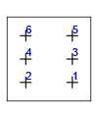 | A1 | LE3 | 18.8 | 0.0 | 132.6 | 113.2 | 246.3 | 82.1 | 0.1 | 72.0 | OK | OK
 | A2 | LE3 | 18.8 | 0.1 | 132.6 | 0.0 | 246.3 | 82.1 | 0.2 | 72.0 | OK | OK
 | A3 | LE3 | 16.8 | 0.1 | 132.6 | 113.2 | 246.3 | 82.1 | 0.2 | 72.0 | OK | OK
 | A4 | LE3 | 16.8 | 0.1 | 132.6 | 0.0 | 246.3 | 82.1 | 0.2 | 72.0 | OK | OK
 | A5 | LE3 | 18.8 | 0.0 | 132.6 | 113.2 | 246.3 | 82.1 | 0.1 | 72.0 | OK | OK
 | A6 | LE3 | 18.8 | 0.1 | 132.6 | 0.0 | 246.3 | 82.1 | 0.2 | 72.0 | OK | OK
Design data
Grade | ϕN_{sa}  [kN] | ϕV_{sa}  [kN]
5/8 A325 - 1 | 84.4 | 37.6
Detailed result for A1
Following checks of anchors loaded in tension are not provided and should be checked using information in relevant Technical Product Specification (based on the 5 percent fractile of tests performed and evaluated according to ACI 355.2):
- Pull-out failure of fastener (for post-installed mechanical anchors) - ACI 318-25 – 17.6.3
- Bond strength of adhesive anchor (for post-installed bonded anchors) - ACI 318-25 – 17.6.5
- Concrete splitting failure during installation should be evaluated by ACI 355.2 requirements
Concrete blow-out failure is provided only for anchors with washer plates and headed studs.

Anchor tensile resistance (ACI 318-25 – 17.6.1)
 | 84.4 | kN | ≥ |  | 18.8 | kN
Where:
– resistance factor
– tensile stress area
– specified tensile strength of anchor steel:
, where:
634.3 MPa – specified yield strength of anchor steel
827.4 MPa – specified ultimate strength of anchor steel

Concrete breakout resistance of anchor in tension (ACI 318-25 – 17.6.2)
The check is performed for group of anchors that form common tension breakout cone: A1, A2, A3, A4, A5, A6
 | 132.6 | kN | ≥ |  | 108.9 | kN
Where:
– sum of tension forces of anchors with common concrete breakout cone area
– resistance factor
– concrete breakout cone area for group of anchors
– concrete breakout cone area for single anchor not influenced by edges
– Strength modification factor ψa for anchors in tension
– modification factor for eccentrically loaded group of anchors
, where:
1.00 – modification factor that depends on eccentricity in x-direction
0 mm – tension load eccentricity in x-direction
1.00 – modification factor that depends on eccentricity in y-direction
0 mm – tension load eccentricity in y-direction
205 mm – depth of embedment, where:
205 mm – embedment depth
565 mm – maximum distance from the anchor to one of the three closest edges
200 mm – maximum spacing between anchors
– modification factor for edge distance:
, where:
555 mm – minimum distance from the anchor to the edge
205 mm – depth of embedment
– modification factor for concrete conditions
– breakout compression field factor
, one of the following criteria is met:
– basic concrete breakout strength of a single anchor in tension:
, where:
7.0 – coefficient taking into account the installation process
1.00 – modification factor for lightweight concrete
27.6 MPa – concrete compressive strength
205 mm – depth of embedment

Shear resistance (ACI 318-25 – 17.7.1)
 | 37.6 | kN | ≥ |  | 0.0 | kN
Where:
– reduction factor for steel strength in shear in case of mortar joint
– resistance factor
– tensile stress area
– specified tensile strength of anchor steel:
, where:
634.3 MPa – specified yield strength of anchor steel
827.4 MPa – specified ultimate strength of anchor steel

Concrete shear breakout check (ACI 318-25 – 17.7.2)
The check is performed for group of anchors that form common shear breakout cone: A1, A3, A5
 | 113.2 | kN | ≥ |  | 0.1 | kN
Where:
– sum of shear forces of anchors on common base plate
– resistance factor
– projected concrete failure area of an anchor or group of anchors
– projected concrete failure area of one anchor when not limited by corner influences, spacing or member thickness
– Strength modification factor ψa for anchors in shear
– modification factor for anchor groups loaded eccentrically in shear:
, where:
0 mm – shear load eccentricity
555 mm – edge distance in direction of the load
555 mm – edge distance in direction of the load
– modification factor for edge effect:
, where:
555 mm – edge distance in direction of the load
555 mm – edge distance in direction of the load
565 mm – edge distance in direction perpendicular to the load
– modification factor for concrete conditions
– modification factor for anchors located in a shallow concrete member:
, where:
1000 mm – thickness of member in which an anchor is anchored measured parallel to anchor axis
– modification factor for anchors loaded at an angle with the concrete edge
, where:
0.0 ° – angle between direction of shear force and direction perpendicular to concrete edge
– basic concrete breakout strength of a single anchor in shear:
, where:
127 mm – effective length
15.9 mm – anchor diameter
1.00 – modification factor for lightweight concrete
27.6 MPa – concrete compressive strength
555 mm – edge distance in direction of the load
555 mm – edge distance in direction of the load

Concrete pryout resistance (ACI 318-25 – 17.7.3)
The check is performed for group of anchors on common base plate
 | 246.3 | kN | ≥ |  | 0.1 | kN
Where:
– resistance factor
– concrete pry-out factor
– concrete cone tension break-out resistance in case all anchors are in tension
– sum of shear forces of anchors on common base plate

Interaction of tensile and shear forces in steel (ACI 318-25 – 17.8.4)
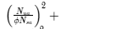 | 0.05 | ≤ | 1.0
Where:
– design tension force
– fastener tensile strength
– design shear force
– fastener shear strength

Interaction of tensile and shear forces in concrete (ACI 318-25 – 17.8.3)
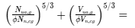 | 0.72 | ≤ | 1.0
Where:
– the largest utilization value for tension failure modes
– the largest utilization value for shear failure modes
– concrete breakout failure of anchor in tension
– concrete pullout failure
– concrete blowout failure
– concrete edge failure
– concrete pryout failure

Detailed result for A2
Following checks of anchors loaded in tension are not provided and should be checked using information in relevant Technical Product Specification (based on the 5 percent fractile of tests performed and evaluated according to ACI 355.2):
- Pull-out failure of fastener (for post-installed mechanical anchors) - ACI 318-25 – 17.6.3
- Bond strength of adhesive anchor (for post-installed bonded anchors) - ACI 318-25 – 17.6.5
- Concrete splitting failure during installation should be evaluated by ACI 355.2 requirements
Concrete blow-out failure is provided only for anchors with washer plates and headed studs.

Anchor tensile resistance (ACI 318-25 – 17.6.1)
 | 84.4 | kN | ≥ |  | 18.8 | kN
Where:
– resistance factor
– tensile stress area
– specified tensile strength of anchor steel:
, where:
634.3 MPa – specified yield strength of anchor steel
827.4 MPa – specified ultimate strength of anchor steel

Concrete breakout resistance of anchor in tension (ACI 318-25 – 17.6.2)
The check is performed for group of anchors that form common tension breakout cone: A1, A2, A3, A4, A5, A6
 | 132.6 | kN | ≥ |  | 108.9 | kN
Where:
– sum of tension forces of anchors with common concrete breakout cone area
– resistance factor
– concrete breakout cone area for group of anchors
– concrete breakout cone area for single anchor not influenced by edges
– Strength modification factor ψa for anchors in tension
– modification factor for eccentrically loaded group of anchors
, where:
1.00 – modification factor that depends on eccentricity in x-direction
0 mm – tension load eccentricity in x-direction
1.00 – modification factor that depends on eccentricity in y-direction
0 mm – tension load eccentricity in y-direction
205 mm – depth of embedment, where:
205 mm – embedment depth
565 mm – maximum distance from the anchor to one of the three closest edges
200 mm – maximum spacing between anchors
– modification factor for edge distance:
, where:
555 mm – minimum distance from the anchor to the edge
205 mm – depth of embedment
– modification factor for concrete conditions
– breakout compression field factor
, one of the following criteria is met:
– basic concrete breakout strength of a single anchor in tension:
, where:
7.0 – coefficient taking into account the installation process
1.00 – modification factor for lightweight concrete
27.6 MPa – concrete compressive strength
205 mm – depth of embedment

Shear resistance (ACI 318-25 – 17.7.1)
 | 37.6 | kN | ≥ |  | 0.1 | kN
Where:
– reduction factor for steel strength in shear in case of mortar joint
– resistance factor
– tensile stress area
– specified tensile strength of anchor steel:
, where:
634.3 MPa – specified yield strength of anchor steel
827.4 MPa – specified ultimate strength of anchor steel

Concrete pryout resistance (ACI 318-25 – 17.7.3)
The check is performed for group of anchors on common base plate
 | 246.3 | kN | ≥ |  | 0.1 | kN
Where:
– resistance factor
– concrete pry-out factor
– concrete cone tension break-out resistance in case all anchors are in tension
– sum of shear forces of anchors on common base plate

Interaction of tensile and shear forces in steel (ACI 318-25 – 17.8.4)
 | 0.05 | ≤ | 1.0
Where:
– design tension force
– fastener tensile strength
– design shear force
– fastener shear strength

Interaction of tensile and shear forces in concrete (ACI 318-25 – 17.8.3)
 | 0.72 | ≤ | 1.0
Where:
– the largest utilization value for tension failure modes
– the largest utilization value for shear failure modes
– concrete breakout failure of anchor in tension
– concrete pullout failure
– concrete blowout failure
– concrete edge failure
– concrete pryout failure

Detailed result for A3
Following checks of anchors loaded in tension are not provided and should be checked using information in relevant Technical Product Specification (based on the 5 percent fractile of tests performed and evaluated according to ACI 355.2):
- Pull-out failure of fastener (for post-installed mechanical anchors) - ACI 318-25 – 17.6.3
- Bond strength of adhesive anchor (for post-installed bonded anchors) - ACI 318-25 – 17.6.5
- Concrete splitting failure during installation should be evaluated by ACI 355.2 requirements
Concrete blow-out failure is provided only for anchors with washer plates and headed studs.

Anchor tensile resistance (ACI 318-25 – 17.6.1)
 | 84.4 | kN | ≥ |  | 16.8 | kN
Where:
– resistance factor
– tensile stress area
– specified tensile strength of anchor steel:
, where:
634.3 MPa – specified yield strength of anchor steel
827.4 MPa – specified ultimate strength of anchor steel

Concrete breakout resistance of anchor in tension (ACI 318-25 – 17.6.2)
The check is performed for group of anchors that form common tension breakout cone: A1, A2, A3, A4, A5, A6
 | 132.6 | kN | ≥ |  | 108.9 | kN
Where:
– sum of tension forces of anchors with common concrete breakout cone area
– resistance factor
– concrete breakout cone area for group of anchors
– concrete breakout cone area for single anchor not influenced by edges
– Strength modification factor ψa for anchors in tension
– modification factor for eccentrically loaded group of anchors
, where:
1.00 – modification factor that depends on eccentricity in x-direction
0 mm – tension load eccentricity in x-direction
1.00 – modification factor that depends on eccentricity in y-direction
0 mm – tension load eccentricity in y-direction
205 mm – depth of embedment, where:
205 mm – embedment depth
565 mm – maximum distance from the anchor to one of the three closest edges
200 mm – maximum spacing between anchors
– modification factor for edge distance:
, where:
555 mm – minimum distance from the anchor to the edge
205 mm – depth of embedment
– modification factor for concrete conditions
– breakout compression field factor
, one of the following criteria is met:
– basic concrete breakout strength of a single anchor in tension:
, where:
7.0 – coefficient taking into account the installation process
1.00 – modification factor for lightweight concrete
27.6 MPa – concrete compressive strength
205 mm – depth of embedment

Shear resistance (ACI 318-25 – 17.7.1)
 | 37.6 | kN | ≥ |  | 0.1 | kN
Where:
– reduction factor for steel strength in shear in case of mortar joint
– resistance factor
– tensile stress area
– specified tensile strength of anchor steel:
, where:
634.3 MPa – specified yield strength of anchor steel
827.4 MPa – specified ultimate strength of anchor steel

Concrete shear breakout check (ACI 318-25 – 17.7.2)
The check is performed for group of anchors that form common shear breakout cone: A1, A3, A5
 | 113.2 | kN | ≥ |  | 0.1 | kN
Where:
– sum of shear forces of anchors on common base plate
– resistance factor
– projected concrete failure area of an anchor or group of anchors
– projected concrete failure area of one anchor when not limited by corner influences, spacing or member thickness
– Strength modification factor ψa for anchors in shear
– modification factor for anchor groups loaded eccentrically in shear:
, where:
0 mm – shear load eccentricity
555 mm – edge distance in direction of the load
555 mm – edge distance in direction of the load
– modification factor for edge effect:
, where:
555 mm – edge distance in direction of the load
555 mm – edge distance in direction of the load
565 mm – edge distance in direction perpendicular to the load
– modification factor for concrete conditions
– modification factor for anchors located in a shallow concrete member:
, where:
1000 mm – thickness of member in which an anchor is anchored measured parallel to anchor axis
– modification factor for anchors loaded at an angle with the concrete edge
, where:
0.0 ° – angle between direction of shear force and direction perpendicular to concrete edge
– basic concrete breakout strength of a single anchor in shear:
, where:
127 mm – effective length
15.9 mm – anchor diameter
1.00 – modification factor for lightweight concrete
27.6 MPa – concrete compressive strength
555 mm – edge distance in direction of the load
555 mm – edge distance in direction of the load

Concrete pryout resistance (ACI 318-25 – 17.7.3)
The check is performed for group of anchors on common base plate
 | 246.3 | kN | ≥ |  | 0.1 | kN
Where:
– resistance factor
– concrete pry-out factor
– concrete cone tension break-out resistance in case all anchors are in tension
– sum of shear forces of anchors on common base plate

Interaction of tensile and shear forces in steel (ACI 318-25 – 17.8.4)
 | 0.04 | ≤ | 1.0
Where:
– design tension force
– fastener tensile strength
– design shear force
– fastener shear strength

Interaction of tensile and shear forces in concrete (ACI 318-25 – 17.8.3)
 | 0.72 | ≤ | 1.0
Where:
– the largest utilization value for tension failure modes
– the largest utilization value for shear failure modes
– concrete breakout failure of anchor in tension
– concrete pullout failure
– concrete blowout failure
– concrete edge failure
– concrete pryout failure

Detailed result for A4
Following checks of anchors loaded in tension are not provided and should be checked using information in relevant Technical Product Specification (based on the 5 percent fractile of tests performed and evaluated according to ACI 355.2):
- Pull-out failure of fastener (for post-installed mechanical anchors) - ACI 318-25 – 17.6.3
- Bond strength of adhesive anchor (for post-installed bonded anchors) - ACI 318-25 – 17.6.5
- Concrete splitting failure during installation should be evaluated by ACI 355.2 requirements
Concrete blow-out failure is provided only for anchors with washer plates and headed studs.

Anchor tensile resistance (ACI 318-25 – 17.6.1)
 | 84.4 | kN | ≥ |  | 16.8 | kN
Where:
– resistance factor
– tensile stress area
– specified tensile strength of anchor steel:
, where:
634.3 MPa – specified yield strength of anchor steel
827.4 MPa – specified ultimate strength of anchor steel

Concrete breakout resistance of anchor in tension (ACI 318-25 – 17.6.2)
The check is performed for group of anchors that form common tension breakout cone: A1, A2, A3, A4, A5, A6
 | 132.6 | kN | ≥ |  | 108.9 | kN
Where:
– sum of tension forces of anchors with common concrete breakout cone area
– resistance factor
– concrete breakout cone area for group of anchors
– concrete breakout cone area for single anchor not influenced by edges
– Strength modification factor ψa for anchors in tension
– modification factor for eccentrically loaded group of anchors
, where:
1.00 – modification factor that depends on eccentricity in x-direction
0 mm – tension load eccentricity in x-direction
1.00 – modification factor that depends on eccentricity in y-direction
0 mm – tension load eccentricity in y-direction
205 mm – depth of embedment, where:
205 mm – embedment depth
565 mm – maximum distance from the anchor to one of the three closest edges
200 mm – maximum spacing between anchors
– modification factor for edge distance:
, where:
555 mm – minimum distance from the anchor to the edge
205 mm – depth of embedment
– modification factor for concrete conditions
– breakout compression field factor
, one of the following criteria is met:
– basic concrete breakout strength of a single anchor in tension:
, where:
7.0 – coefficient taking into account the installation process
1.00 – modification factor for lightweight concrete
27.6 MPa – concrete compressive strength
205 mm – depth of embedment

Shear resistance (ACI 318-25 – 17.7.1)
 | 37.6 | kN | ≥ |  | 0.1 | kN
Where:
– reduction factor for steel strength in shear in case of mortar joint
– resistance factor
– tensile stress area
– specified tensile strength of anchor steel:
, where:
634.3 MPa – specified yield strength of anchor steel
827.4 MPa – specified ultimate strength of anchor steel

Concrete pryout resistance (ACI 318-25 – 17.7.3)
The check is performed for group of anchors on common base plate
 | 246.3 | kN | ≥ |  | 0.1 | kN
Where:
– resistance factor
– concrete pry-out factor
– concrete cone tension break-out resistance in case all anchors are in tension
– sum of shear forces of anchors on common base plate

Interaction of tensile and shear forces in steel (ACI 318-25 – 17.8.4)
 | 0.04 | ≤ | 1.0
Where:
– design tension force
– fastener tensile strength
– design shear force
– fastener shear strength

Interaction of tensile and shear forces in concrete (ACI 318-25 – 17.8.3)
 | 0.72 | ≤ | 1.0
Where:
– the largest utilization value for tension failure modes
– the largest utilization value for shear failure modes
– concrete breakout failure of anchor in tension
– concrete pullout failure
– concrete blowout failure
– concrete edge failure
– concrete pryout failure

Detailed result for A5
Following checks of anchors loaded in tension are not provided and should be checked using information in relevant Technical Product Specification (based on the 5 percent fractile of tests performed and evaluated according to ACI 355.2):
- Pull-out failure of fastener (for post-installed mechanical anchors) - ACI 318-25 – 17.6.3
- Bond strength of adhesive anchor (for post-installed bonded anchors) - ACI 318-25 – 17.6.5
- Concrete splitting failure during installation should be evaluated by ACI 355.2 requirements
Concrete blow-out failure is provided only for anchors with washer plates and headed studs.

Anchor tensile resistance (ACI 318-25 – 17.6.1)
 | 84.4 | kN | ≥ |  | 18.8 | kN
Where:
– resistance factor
– tensile stress area
– specified tensile strength of anchor steel:
, where:
634.3 MPa – specified yield strength of anchor steel
827.4 MPa – specified ultimate strength of anchor steel

Concrete breakout resistance of anchor in tension (ACI 318-25 – 17.6.2)
The check is performed for group of anchors that form common tension breakout cone: A1, A2, A3, A4, A5, A6
 | 132.6 | kN | ≥ |  | 108.9 | kN
Where:
– sum of tension forces of anchors with common concrete breakout cone area
– resistance factor
– concrete breakout cone area for group of anchors
– concrete breakout cone area for single anchor not influenced by edges
– Strength modification factor ψa for anchors in tension
– modification factor for eccentrically loaded group of anchors
, where:
1.00 – modification factor that depends on eccentricity in x-direction
0 mm – tension load eccentricity in x-direction
1.00 – modification factor that depends on eccentricity in y-direction
0 mm – tension load eccentricity in y-direction
205 mm – depth of embedment, where:
205 mm – embedment depth
565 mm – maximum distance from the anchor to one of the three closest edges
200 mm – maximum spacing between anchors
– modification factor for edge distance:
, where:
555 mm – minimum distance from the anchor to the edge
205 mm – depth of embedment
– modification factor for concrete conditions
– breakout compression field factor
, one of the following criteria is met:
– basic concrete breakout strength of a single anchor in tension:
, where:
7.0 – coefficient taking into account the installation process
1.00 – modification factor for lightweight concrete
27.6 MPa – concrete compressive strength
205 mm – depth of embedment

Shear resistance (ACI 318-25 – 17.7.1)
 | 37.6 | kN | ≥ |  | 0.0 | kN
Where:
– reduction factor for steel strength in shear in case of mortar joint
– resistance factor
– tensile stress area
– specified tensile strength of anchor steel:
, where:
634.3 MPa – specified yield strength of anchor steel
827.4 MPa – specified ultimate strength of anchor steel

Concrete shear breakout check (ACI 318-25 – 17.7.2)
The check is performed for group of anchors that form common shear breakout cone: A1, A3, A5
 | 113.2 | kN | ≥ |  | 0.1 | kN
Where:
– sum of shear forces of anchors on common base plate
– resistance factor
– projected concrete failure area of an anchor or group of anchors
– projected concrete failure area of one anchor when not limited by corner influences, spacing or member thickness
– Strength modification factor ψa for anchors in shear
– modification factor for anchor groups loaded eccentrically in shear:
, where:
0 mm – shear load eccentricity
555 mm – edge distance in direction of the load
555 mm – edge distance in direction of the load
– modification factor for edge effect:
, where:
555 mm – edge distance in direction of the load
555 mm – edge distance in direction of the load
565 mm – edge distance in direction perpendicular to the load
– modification factor for concrete conditions
– modification factor for anchors located in a shallow concrete member:
, where:
1000 mm – thickness of member in which an anchor is anchored measured parallel to anchor axis
– modification factor for anchors loaded at an angle with the concrete edge
, where:
0.0 ° – angle between direction of shear force and direction perpendicular to concrete edge
– basic concrete breakout strength of a single anchor in shear:
, where:
127 mm – effective length
15.9 mm – anchor diameter
1.00 – modification factor for lightweight concrete
27.6 MPa – concrete compressive strength
555 mm – edge distance in direction of the load
555 mm – edge distance in direction of the load

Concrete pryout resistance (ACI 318-25 – 17.7.3)
The check is performed for group of anchors on common base plate
 | 246.3 | kN | ≥ |  | 0.1 | kN
Where:
– resistance factor
– concrete pry-out factor
– concrete cone tension break-out resistance in case all anchors are in tension
– sum of shear forces of anchors on common base plate

Interaction of tensile and shear forces in steel (ACI 318-25 – 17.8.4)
 | 0.05 | ≤ | 1.0
Where:
– design tension force
– fastener tensile strength
– design shear force
– fastener shear strength

Interaction of tensile and shear forces in concrete (ACI 318-25 – 17.8.3)
 | 0.72 | ≤ | 1.0
Where:
– the largest utilization value for tension failure modes
– the largest utilization value for shear failure modes
– concrete breakout failure of anchor in tension
– concrete pullout failure
– concrete blowout failure
– concrete edge failure
– concrete pryout failure

Detailed result for A6
Following checks of anchors loaded in tension are not provided and should be checked using information in relevant Technical Product Specification (based on the 5 percent fractile of tests performed and evaluated according to ACI 355.2):
- Pull-out failure of fastener (for post-installed mechanical anchors) - ACI 318-25 – 17.6.3
- Bond strength of adhesive anchor (for post-installed bonded anchors) - ACI 318-25 – 17.6.5
- Concrete splitting failure during installation should be evaluated by ACI 355.2 requirements
Concrete blow-out failure is provided only for anchors with washer plates and headed studs.

Anchor tensile resistance (ACI 318-25 – 17.6.1)
 | 84.4 | kN | ≥ |  | 18.8 | kN
Where:
– resistance factor
– tensile stress area
– specified tensile strength of anchor steel:
, where:
634.3 MPa – specified yield strength of anchor steel
827.4 MPa – specified ultimate strength of anchor steel

Concrete breakout resistance of anchor in tension (ACI 318-25 – 17.6.2)
The check is performed for group of anchors that form common tension breakout cone: A1, A2, A3, A4, A5, A6
 | 132.6 | kN | ≥ |  | 108.9 | kN
Where:
– sum of tension forces of anchors with common concrete breakout cone area
– resistance factor
– concrete breakout cone area for group of anchors
– concrete breakout cone area for single anchor not influenced by edges
– Strength modification factor ψa for anchors in tension
– modification factor for eccentrically loaded group of anchors
, where:
1.00 – modification factor that depends on eccentricity in x-direction
0 mm – tension load eccentricity in x-direction
1.00 – modification factor that depends on eccentricity in y-direction
0 mm – tension load eccentricity in y-direction
205 mm – depth of embedment, where:
205 mm – embedment depth
565 mm – maximum distance from the anchor to one of the three closest edges
200 mm – maximum spacing between anchors
– modification factor for edge distance:
, where:
555 mm – minimum distance from the anchor to the edge
205 mm – depth of embedment
– modification factor for concrete conditions
– breakout compression field factor
, one of the following criteria is met:
– basic concrete breakout strength of a single anchor in tension:
, where:
7.0 – coefficient taking into account the installation process
1.00 – modification factor for lightweight concrete
27.6 MPa – concrete compressive strength
205 mm – depth of embedment

Shear resistance (ACI 318-25 – 17.7.1)
 | 37.6 | kN | ≥ |  | 0.1 | kN
Where:
– reduction factor for steel strength in shear in case of mortar joint
– resistance factor
– tensile stress area
– specified tensile strength of anchor steel:
, where:
634.3 MPa – specified yield strength of anchor steel
827.4 MPa – specified ultimate strength of anchor steel

Concrete pryout resistance (ACI 318-25 – 17.7.3)
The check is performed for group of anchors on common base plate
 | 246.3 | kN | ≥ |  | 0.1 | kN
Where:
– resistance factor
– concrete pry-out factor
– concrete cone tension break-out resistance in case all anchors are in tension
– sum of shear forces of anchors on common base plate

Interaction of tensile and shear forces in steel (ACI 318-25 – 17.8.4)
 | 0.05 | ≤ | 1.0
Where:
– design tension force
– fastener tensile strength
– design shear force
– fastener shear strength

Interaction of tensile and shear forces in concrete (ACI 318-25 – 17.8.3)
 | 0.72 | ≤ | 1.0
Where:
– the largest utilization value for tension failure modes
– the largest utilization value for shear failure modes
– concrete breakout failure of anchor in tension
– concrete pullout failure
– concrete blowout failure
– concrete edge failure
– concrete pryout failure

Welds
Item | Edge | Xu | t_{w}  [mm] | w  [mm] | L  [mm] | L_{c}  [mm] | Loads | F_{n}  [kN] | ϕR_{n}  [kN] | Ut  [%] | Ut_{c}  [%] | Detailing | Status
BP1 | B1-bfl 1 | E70xx | ◢ 8.0 ◣ | ◢ 11.3 ◣ | 298 | 18 | LE3 | 3.7 | 41.6 | 9.0 | 0.0 | OK | OK
 |  | E70xx | ◢ 8.0 ◣ | ◢ 11.3 ◣ | 298 | 18 | LE3 | 2.1 | 33.3 | 6.2 | 0.0 | OK | OK
BP1 | B1-tfl 1 | E70xx | ◢ 8.0 ◣ | ◢ 11.3 ◣ | 298 | 18 | LE3 | 2.0 | 32.7 | 6.1 | 0.0 | OK | OK
 |  | E70xx | ◢ 8.0 ◣ | ◢ 11.3 ◣ | 298 | 18 | LE3 | 3.1 | 38.1 | 8.1 | 0.0 | OK | OK
BP1 | B1-w 1 | E70xx | ◢ 7.0 ◣ | ◢ 9.9 ◣ | 283 | 18 | LE3 | 0.8 | 34.5 | 2.2 | 0.0 | OK | OK
 |  | E70xx | ◢ 7.0 ◣ | ◢ 9.9 ◣ | 283 | 18 | LE3 | 0.7 | 33.1 | 2.2 | 0.0 | OK | OK
BP1 | RIB1a | E70xx | ◢ 8.0 ◣ | ◢ 11.3 ◣ | 144 | 10 | LE3 | 1.8 | 25.4 | 7.2 | 0.0 | OK | OK
 |  | E70xx | ◢ 8.0 ◣ | ◢ 11.3 ◣ | 144 | 10 | LE3 | 1.9 | 24.9 | 7.7 | 0.0 | OK | OK
B1-w 1 | RIB1a | E70xx | ◢ 8.0 ◣ | ◢ 11.3 ◣ | 199 | 10 | LE3 | 1.6 | 23.5 | 6.8 | 0.0 | OK | OK
 |  | E70xx | ◢ 8.0 ◣ | ◢ 11.3 ◣ | 199 | 10 | LE3 | 1.6 | 23.5 | 6.8 | 0.0 | OK | OK
BP1 | RIB1b | E70xx | ◢ 8.0 ◣ | ◢ 11.3 ◣ | 144 | 10 | LE3 | 2.3 | 23.3 | 9.7 | 0.0 | OK | OK
 |  | E70xx | ◢ 8.0 ◣ | ◢ 11.3 ◣ | 144 | 10 | LE3 | 2.1 | 23.9 | 8.9 | 0.0 | OK | OK
B1-w 1 | RIB1b | E70xx | ◢ 8.0 ◣ | ◢ 11.3 ◣ | 199 | 10 | LE3 | 1.6 | 23.5 | 6.7 | 0.0 | OK | OK
 |  | E70xx | ◢ 8.0 ◣ | ◢ 11.3 ◣ | 199 | 10 | LE3 | 1.6 | 23.5 | 6.7 | 0.0 | OK | OK
BP1 | RIB1c | E70xx | ◢ 8.0 ◣ | ◢ 11.3 ◣ | 144 | 10 | LE3 | 1.6 | 25.8 | 6.4 | 0.0 | OK | OK
 |  | E70xx | ◢ 8.0 ◣ | ◢ 11.3 ◣ | 144 | 10 | LE3 | 1.6 | 26.0 | 6.2 | 0.0 | OK | OK
B1-w 1 | RIB1c | E70xx | ◢ 8.0 ◣ | ◢ 11.3 ◣ | 199 | 10 | LE3 | 1.6 | 23.5 | 6.7 | 0.0 | OK | OK
 |  | E70xx | ◢ 8.0 ◣ | ◢ 11.3 ◣ | 199 | 10 | LE3 | 1.6 | 23.5 | 6.7 | 0.0 | OK | OK
BP1 | RIB1d | E70xx | ◢ 8.0 ◣ | ◢ 11.3 ◣ | 144 | 10 | LE3 | 1.9 | 25.6 | 7.6 | 0.0 | OK | OK
 |  | E70xx | ◢ 8.0 ◣ | ◢ 11.3 ◣ | 144 | 10 | LE3 | 2.0 | 25.5 | 7.7 | 0.0 | OK | OK
B1-w 1 | RIB1d | E70xx | ◢ 8.0 ◣ | ◢ 11.3 ◣ | 199 | 10 | LE3 | 1.6 | 23.5 | 6.7 | 0.0 | OK | OK
 |  | E70xx | ◢ 8.0 ◣ | ◢ 11.3 ◣ | 199 | 10 | LE3 | 1.6 | 23.5 | 6.8 | 0.0 | OK | OK
Design data
Material | F_{exx}  [MPa]
E70xx | 482.6
Detailed result for BP1 / B1-bfl 1 - 1
Weld resistance check (AISC 360-22 – J2-4)
 | 41.6 | kN | ≥ |  | 3.7 | kN
Where:
– nominal stress of weld material:
, where:
482.6 MPa – electrode classification number, i.e. minimum specified tensile strength
54.3° – angle of loading measured from the weld longitudinal axis
– effective area of weld critical element
– resistance factor for welded connections

Detailed result for BP1 / B1-bfl 1 - 2
Weld resistance check (AISC 360-22 – J2-4)
 | 33.3 | kN | ≥ |  | 2.1 | kN
Where:
– nominal stress of weld material:
, where:
482.6 MPa – electrode classification number, i.e. minimum specified tensile strength
19.0° – angle of loading measured from the weld longitudinal axis
– effective area of weld critical element
– resistance factor for welded connections

Detailed result for BP1 / B1-tfl 1 - 1
Weld resistance check (AISC 360-22 – J2-4)
 | 32.7 | kN | ≥ |  | 2.0 | kN
Where:
– nominal stress of weld material:
, where:
482.6 MPa – electrode classification number, i.e. minimum specified tensile strength
16.2° – angle of loading measured from the weld longitudinal axis
– effective area of weld critical element
– resistance factor for welded connections

Detailed result for BP1 / B1-tfl 1 - 2
Weld resistance check (AISC 360-22 – J2-4)
 | 38.1 | kN | ≥ |  | 3.1 | kN
Where:
– nominal stress of weld material:
, where:
482.6 MPa – electrode classification number, i.e. minimum specified tensile strength
39.2° – angle of loading measured from the weld longitudinal axis
– effective area of weld critical element
– resistance factor for welded connections

Detailed result for BP1 / B1-w 1 - 1
Weld resistance check (AISC 360-22 – J2-4)
 | 34.5 | kN | ≥ |  | 0.8 | kN
Where:
– nominal stress of weld material:
, where:
482.6 MPa – electrode classification number, i.e. minimum specified tensile strength
42.8° – angle of loading measured from the weld longitudinal axis
– effective area of weld critical element
– resistance factor for welded connections

Detailed result for BP1 / B1-w 1 - 2
Weld resistance check (AISC 360-22 – J2-4)
 | 33.1 | kN | ≥ |  | 0.7 | kN
Where:
– nominal stress of weld material:
, where:
482.6 MPa – electrode classification number, i.e. minimum specified tensile strength
36.4° – angle of loading measured from the weld longitudinal axis
– effective area of weld critical element
– resistance factor for welded connections

Detailed result for BP1 / RIB1a - 1
Weld resistance check (AISC 360-22 – J2-4)
 | 25.4 | kN | ≥ |  | 1.8 | kN
Where:
– nominal stress of weld material:
, where:
482.6 MPa – electrode classification number, i.e. minimum specified tensile strength
63.9° – angle of loading measured from the weld longitudinal axis
– effective area of weld critical element
– resistance factor for welded connections

Detailed result for BP1 / RIB1a - 2
Weld resistance check (AISC 360-22 – J2-4)
 | 24.9 | kN | ≥ |  | 1.9 | kN
Where:
– nominal stress of weld material:
, where:
482.6 MPa – electrode classification number, i.e. minimum specified tensile strength
59.4° – angle of loading measured from the weld longitudinal axis
– effective area of weld critical element
– resistance factor for welded connections

Detailed result for B1-w 1 / RIB1a - 1
Weld resistance check (AISC 360-22 – J2-4)
 | 23.5 | kN | ≥ |  | 1.6 | kN
Where:
– nominal stress of weld material:
, where:
482.6 MPa – electrode classification number, i.e. minimum specified tensile strength
53.0° – angle of loading measured from the weld longitudinal axis
– effective area of weld critical element
– resistance factor for welded connections

Detailed result for B1-w 1 / RIB1a - 2
Weld resistance check (AISC 360-22 – J2-4)
 | 23.5 | kN | ≥ |  | 1.6 | kN
Where:
– nominal stress of weld material:
, where:
482.6 MPa – electrode classification number, i.e. minimum specified tensile strength
53.0° – angle of loading measured from the weld longitudinal axis
– effective area of weld critical element
– resistance factor for welded connections

Detailed result for BP1 / RIB1b - 1
Weld resistance check (AISC 360-22 – J2-4)
 | 23.3 | kN | ≥ |  | 2.3 | kN
Where:
– nominal stress of weld material:
, where:
482.6 MPa – electrode classification number, i.e. minimum specified tensile strength
46.2° – angle of loading measured from the weld longitudinal axis
– effective area of weld critical element
– resistance factor for welded connections

Detailed result for BP1 / RIB1b - 2
Weld resistance check (AISC 360-22 – J2-4)
 | 23.9 | kN | ≥ |  | 2.1 | kN
Where:
– nominal stress of weld material:
, where:
482.6 MPa – electrode classification number, i.e. minimum specified tensile strength
50.5° – angle of loading measured from the weld longitudinal axis
– effective area of weld critical element
– resistance factor for welded connections

Detailed result for B1-w 1 / RIB1b - 1
Weld resistance check (AISC 360-22 – J2-4)
 | 23.5 | kN | ≥ |  | 1.6 | kN
Where:
– nominal stress of weld material:
, where:
482.6 MPa – electrode classification number, i.e. minimum specified tensile strength
53.5° – angle of loading measured from the weld longitudinal axis
– effective area of weld critical element
– resistance factor for welded connections

Detailed result for B1-w 1 / RIB1b - 2
Weld resistance check (AISC 360-22 – J2-4)
 | 23.5 | kN | ≥ |  | 1.6 | kN
Where:
– nominal stress of weld material:
, where:
482.6 MPa – electrode classification number, i.e. minimum specified tensile strength
53.5° – angle of loading measured from the weld longitudinal axis
– effective area of weld critical element
– resistance factor for welded connections

Detailed result for BP1 / RIB1c - 1
Weld resistance check (AISC 360-22 – J2-4)
 | 25.8 | kN | ≥ |  | 1.6 | kN
Where:
– nominal stress of weld material:
, where:
482.6 MPa – electrode classification number, i.e. minimum specified tensile strength
68.1° – angle of loading measured from the weld longitudinal axis
– effective area of weld critical element
– resistance factor for welded connections

Detailed result for BP1 / RIB1c - 2
Weld resistance check (AISC 360-22 – J2-4)
 | 26.0 | kN | ≥ |  | 1.6 | kN
Where:
– nominal stress of weld material:
, where:
482.6 MPa – electrode classification number, i.e. minimum specified tensile strength
71.3° – angle of loading measured from the weld longitudinal axis
– effective area of weld critical element
– resistance factor for welded connections

Detailed result for B1-w 1 / RIB1c - 1
Weld resistance check (AISC 360-22 – J2-4)
 | 23.5 | kN | ≥ |  | 1.6 | kN
Where:
– nominal stress of weld material:
, where:
482.6 MPa – electrode classification number, i.e. minimum specified tensile strength
53.7° – angle of loading measured from the weld longitudinal axis
– effective area of weld critical element
– resistance factor for welded connections

Detailed result for B1-w 1 / RIB1c - 2
Weld resistance check (AISC 360-22 – J2-4)
 | 23.5 | kN | ≥ |  | 1.6 | kN
Where:
– nominal stress of weld material:
, where:
482.6 MPa – electrode classification number, i.e. minimum specified tensile strength
53.7° – angle of loading measured from the weld longitudinal axis
– effective area of weld critical element
– resistance factor for welded connections

Detailed result for BP1 / RIB1d - 1
Weld resistance check (AISC 360-22 – J2-4)
 | 25.6 | kN | ≥ |  | 1.9 | kN
Where:
– nominal stress of weld material:
, where:
482.6 MPa – electrode classification number, i.e. minimum specified tensile strength
66.3° – angle of loading measured from the weld longitudinal axis
– effective area of weld critical element
– resistance factor for welded connections

Detailed result for BP1 / RIB1d - 2
Weld resistance check (AISC 360-22 – J2-4)
 | 25.5 | kN | ≥ |  | 2.0 | kN
Where:
– nominal stress of weld material:
, where:
482.6 MPa – electrode classification number, i.e. minimum specified tensile strength
65.1° – angle of loading measured from the weld longitudinal axis
– effective area of weld critical element
– resistance factor for welded connections

Detailed result for B1-w 1 / RIB1d - 1
Weld resistance check (AISC 360-22 – J2-4)
 | 23.5 | kN | ≥ |  | 1.6 | kN
Where:
– nominal stress of weld material:
, where:
482.6 MPa – electrode classification number, i.e. minimum specified tensile strength
53.6° – angle of loading measured from the weld longitudinal axis
– effective area of weld critical element
– resistance factor for welded connections

Detailed result for B1-w 1 / RIB1d - 2
Weld resistance check (AISC 360-22 – J2-4)
 | 23.5 | kN | ≥ |  | 1.6 | kN
Where:
– nominal stress of weld material:
, where:
482.6 MPa – electrode classification number, i.e. minimum specified tensile strength
53.6° – angle of loading measured from the weld longitudinal axis
– effective area of weld critical element
– resistance factor for welded connections

Concrete block
Item | Loads | A₁  [mm²] | A₂  [mm²] | σ  [MPa] | ϕf_{p,max}  [MPa] | Ut  [%] | Status
CB 1 | LE3 | 0 | 0 | 0.0 | 0.0 | - | OK
Detailed result for CB 1
Concrete block compressive resistance check (AISC 360-22 – J8)
Concrete block bearing check was not performed due to non existing stress areas containing compression center.
Buckling
Loads | Shape | Factor  [-]
LE3 | 1 | 5649.73
 | 2 | 5924.33
 | 3 | 8689.03
 | 4 | 8720.23
 | 5 | 8728.89
 | 6 | 8764.64

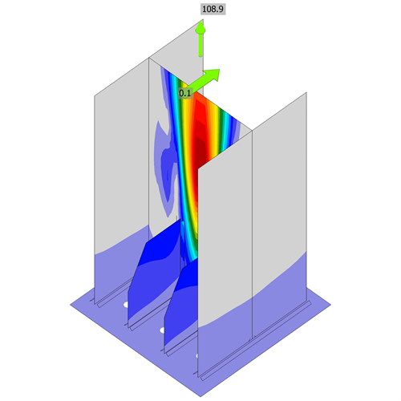  First buckling mode shape, LE3 | 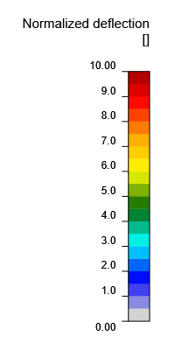

Symbol explanation
Symbol | Explanation
t_{p} | Plate thickness
σ_{Ed} | Equivalent stress
ε_{Pl} | Plastic strain
σ_{c,Ed} | Contact stress
F_{y} | Yield strength
ε_{lim} | Limit of plastic strain
N_{f} | Tension force
V | Resultant of bolt shear forces Vy and Vz in shear planes
ϕN_{cbg} | Concrete breakout strength in tension - ACI 318-25 – 17.6.2
ϕV_{cbg} | Concrete breakout strength in shear - ACI 318-25 – 17.7.2
ϕV_{cp} | Concrete pryout strength in shear - ACI 318-25 – 17.7.3
Ut_{t} | Utilization in tension
Ut_{s} | Utilization in shear
Ut_{ts} | Utilization in tension and shear
ϕN_{sa} | Steel strength of anchor in tension - ACI 318-25 – 17.6.1
ϕV_{sa} | Steel strength of anchor in shear - ACI 318-25 – 17.7.1
t_{w} | Throat thickness of weld
w | Leg size of weld
L | Length of weld
L_{c} | Length of weld critical element
F_{n} | Force in weld critical element
ϕR_{n} | Weld resistance - AISC 360-22 – J2-4
Ut | Utilization
Ut_{c} | Weld capacity estimation
◢ | Fillet weld
F_{exx} | Ultimate strength as rated by electrode classification number
A₁ | Loaded area
A₂ | Supporting area
σ | Average stress in concrete
ϕf_{p,max} | Concrete bearing resistance

Code settings
Item | Value | Unit | Reference
Friction coefficient - concrete | 0.40 | - | ACI 349-01 – B.6.1.4
Friction coefficient in slip-resistance | 0.30 | - | AISC 360-22 – J3.9
Limit plastic strain | 0.05 | -
Detailing | Yes
Distance between bolts [d] | 2.66 | - | AISC 360-22 – J3.4
Concrete breakout resistance check | Both
Base metal capacity check at weld fusion face | No |  | AISC 360-22 – J2-2
Deformation at bolt hole at service load is design consideration | Yes |  | AISC 360-22 – J3.11
Cracked concrete | Yes |  | ACI 318-25 – 17
Local deformation check | Yes
Local deformation limit | 0.03 | - | CIDECT DG 1, 3 – 1.1
Geometrical nonlinearity (GMNA) | Yes |  | Analysis with large deformations for hollow section joints

Design
Members
Geometry
Name | Cross-section | β – Direction  [°] | γ - Pitch  [°] | α - Rotation  [°] | Offset ex  [mm] | Offset ey  [mm] | Offset ez  [mm]
B1 | 1 - I 250x125x7.5 | 0.0 | 0.0 | 0.0 | 0 | 0 | 0
Supports and forces
Name | Support | Forces in | X  [mm]
B1 / end |  | Node | 0
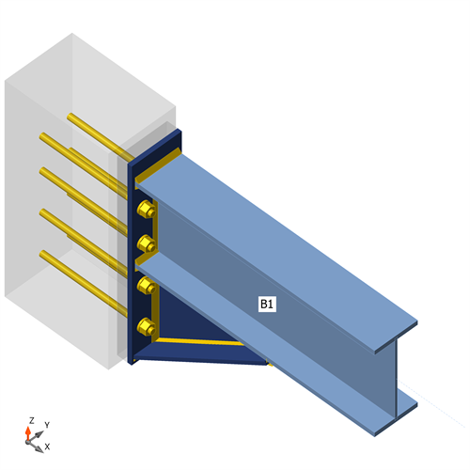
CON1, Axonometric view
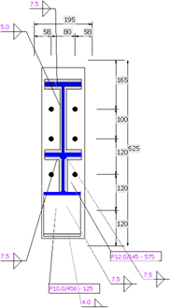
Base plate (BP1)

Cross-sections
Name | Material
1 - I 250x125x7.5 | A36
Cross-sections
Name | Material | Drawing
1 - I 250x125x7.5 | A36 | 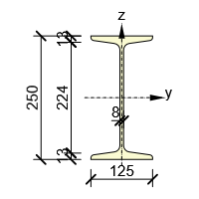
Anchors
Name | Diameter  [mm] | f_{y}  [MPa] | f_{u}  [MPa] | Gross area  [mm²]
16 A325M | 16 | 660.0 | 830.0 | 201
Load effects (forces in equilibrium)
Name | Member | N  [kN] | Vy  [kN] | Vz  [kN] | Mx  [kNm] | My  [kNm] | Mz  [kNm]
LE1 | B1 / End | 0.3 | 0.0 | -4.2 | 0.0 | 0.0 | 0.0
Unbalanced forces
Name | X  [kN] | Y  [kN] | Z  [kN] | Mx  [kNm] | My  [kNm] | Mz  [kNm]
LE1 | 0.3 | 0.0 | -4.2 | 0.0 | 0.0 | 0.0
Foundation block
Item | Value | Unit
CB 1
Dimensions | 195 x 625 | mm
Depth | 300 | mm
Anchor | 16 A325M
Anchoring length | 250 | mm
Shear force transfer | Anchors
Mortar joint | 30 | mm
Check
Summary
Name | Value | Check status
Analysis | 100.0% | OK
Plates | 0.0 < 5.0% | OK
Anchors | 61.6 < 100% | OK
Welds | 1.1 < 100% | OK
Concrete block | 0.1 < 100% | OK
Buckling | 564.54
Plates
Name | t_{p}  [mm] | Loads | σ_{Ed}  [MPa] | ε_{Pl}  [%] | σ_{c,Ed}  [MPa] | Status
B1-bfl 1 | 13.0 | LE1 | 6.8 | 0.0 | 0.0 | OK
B1-tfl 1 | 13.0 | LE1 | 6.7 | 0.0 | 0.0 | OK
B1-w 1 | 7.5 | LE1 | 6.9 | 0.0 | 0.0 | OK
BP1 | 12.0 | LE1 | 2.9 | 0.0 | 0.0 | OK
RIB1 | 7.5 | LE1 | 2.3 | 0.0 | 0.0 | OK
SP1 | 10.0 | LE1 | 2.0 | 0.0 | 0.0 | OK
Design data
Material | F_{y}  [MPa] | ε_{lim}  [%]
A36 | 248.2 | 5.0
Symbol explanation
t_{p} | Plate thickness
σ_{Ed} | Equivalent stress
ε_{Pl} | Plastic strain
σ_{c,Ed} | Contact stress
F_{y} | Yield strength
ε_{lim} | Limit of plastic strain

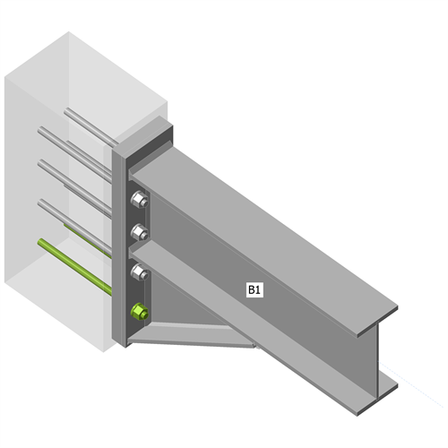
Overall check

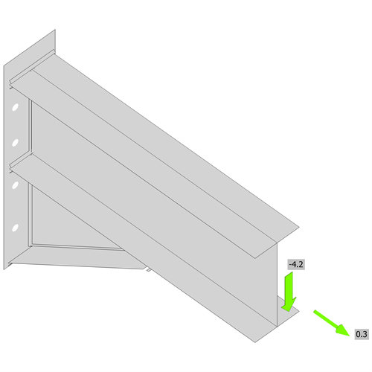
Strain check, LE1

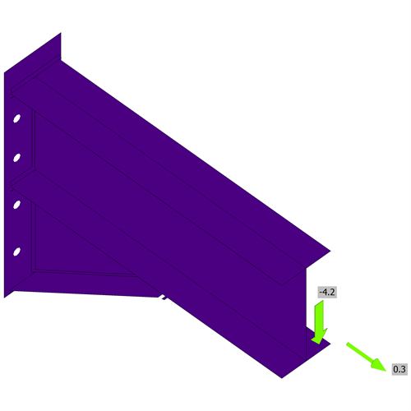  Equivalent stress, LE1 | 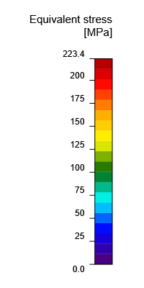

Anchors
Shape | Item | Loads | N_{f}  [kN] | V  [kN] | ϕN_{cbg}  [kN] | ϕV_{cbg}  [kN] | ϕV_{cp}  [kN] | Ut_{t}  [%] | Ut_{s}  [%] | Ut_{ts}  [%] | Detailing | Status
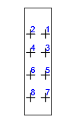 | A1 | LE1 | 0.0 | 0.5 | 0.0 | 0.0 | 56.7 | 0.0 | 7.4 | 1.3 | OK | OK
 | A2 | LE1 | 0.0 | 0.5 | 0.0 | 0.0 | 56.7 | 0.0 | 7.4 | 1.3 | OK | OK
 | A3 | LE1 | 0.2 | 0.5 | 28.2 | 0.0 | 56.7 | 2.9 | 7.4 | 1.6 | OK | OK
 | A4 | LE1 | 0.2 | 0.5 | 28.2 | 0.0 | 56.7 | 2.9 | 7.4 | 1.6 | OK | OK
 | A5 | LE1 | 0.2 | 0.5 | 28.2 | 0.0 | 56.7 | 2.9 | 7.4 | 1.6 | OK | OK
 | A6 | LE1 | 0.2 | 0.5 | 28.2 | 0.0 | 56.7 | 2.9 | 7.4 | 1.6 | OK | OK
 | A7 | LE1 | 0.0 | 0.5 | 0.0 | 6.8 | 56.7 | 0.0 | 61.6 | 44.6 | OK | OK
 | A8 | LE1 | 0.0 | 0.5 | 0.0 | 6.8 | 56.7 | 0.0 | 61.6 | 44.6 | OK | OK
Design data
Grade | ϕN_{sa}  [kN] | ϕV_{sa}  [kN]
16 A325M - 1 | 91.2 | 40.7
Symbol explanation
N_{f} | Tension force
V | Resultant of bolt shear forces Vy and Vz in shear planes
ϕN_{cbg} | Concrete breakout strength in tension - ACI 318-25 – 17.6.2
ϕV_{cbg} | Concrete breakout strength in shear - ACI 318-25 – 17.7.2
ϕV_{cp} | Concrete pryout strength in shear - ACI 318-25 – 17.7.3
Ut_{t} | Utilization in tension
Ut_{s} | Utilization in shear
Ut_{ts} | Utilization in tension and shear
ϕN_{sa} | Steel strength of anchor in tension - ACI 318-25 – 17.6.1
ϕV_{sa} | Steel strength of anchor in shear - ACI 318-25 – 17.7.1
Welds
Item | Edge | Xu | t_{w}  [mm] | w  [mm] | L  [mm] | L_{c}  [mm] | Loads | F_{n}  [kN] | ϕR_{n}  [kN] | Ut  [%] | Ut_{c}  [%] | Detailing | Status
BP1 | B1-bfl 1 | E70xx | ◢ 7.5 ◣ | ◢ 10.6 ◣ | 124 | 21 | LE1 | 0.1 | 49.6 | 0.2 | 0.0 | OK | OK
 |  | E70xx | ◢ 7.5 ◣ | ◢ 10.6 ◣ | 124 | 21 | LE1 | 0.1 | 44.4 | 0.2 | 0.0 | OK | OK
BP1 | B1-tfl 1 | E70xx | ◢ 7.5 ◣ | ◢ 10.6 ◣ | 124 | 21 | LE1 | 0.1 | 36.5 | 0.2 | 0.0 | OK | OK
 |  | E70xx | ◢ 7.5 ◣ | ◢ 10.6 ◣ | 124 | 21 | LE1 | 0.1 | 50.0 | 0.2 | 0.0 | OK | OK
BP1 | B1-w 1 | E70xx | ◢ 5.0 ◣ | ◢ 7.1 ◣ | 236 | 21 | LE1 | 0.2 | 24.1 | 0.7 | 0.0 | OK | OK
 |  | E70xx | ◢ 5.0 ◣ | ◢ 7.1 ◣ | 236 | 21 | LE1 | 0.2 | 24.1 | 0.7 | 0.0 | OK | OK
BP1 | RIB1 | E70xx | ◢ 7.5 ◣ | ◢ 10.6 ◣ | 249 | 19 | LE1 | 0.1 | 40.8 | 0.2 | 0.0 | OK | OK
 |  | E70xx | ◢ 7.5 ◣ | ◢ 10.6 ◣ | 249 | 19 | LE1 | 0.1 | 40.9 | 0.2 | 0.0 | OK | OK
B1-bfl 1 | RIB1 | E70xx | ◢ 7.5 ◣ | ◢ 10.6 ◣ | 379 | 19 | LE1 | 0.1 | 36.7 | 0.2 | 0.0 | OK | OK
 |  | E70xx | ◢ 7.5 ◣ | ◢ 10.6 ◣ | 379 | 19 | LE1 | 0.1 | 37.2 | 0.2 | 0.0 | OK | OK
BP1 | SP1 | E70xx | ◢ 4.0 | ◢ 5.7 | 125 | 25 | LE1 | 0.1 | 31.5 | 0.3 | 0.0 | OK | OK
SP1 | RIB1 | E70xx | ◢ 4.0 ◣ | ◢ 5.7 ◣ | 451 | 19 | LE1 | 0.1 | 17.9 | 0.3 | 0.0 | OK | OK
 |  | E70xx | ◢ 4.0 ◣ | ◢ 5.7 ◣ | 451 | 19 | LE1 | 0.1 | 17.5 | 0.3 | 0.0 | OK | OK
B1-bfl 1 | SP1 | E70xx | ◢ 5.0 | ◢ 7.1 | 121 | 20 | LE1 | 0.4 | 31.7 | 1.1 | 0.0 | OK | OK
Design data
Material | F_{exx}  [MPa]
E70xx | 482.6
Symbol explanation
t_{w} | Throat thickness of weld
w | Leg size of weld
L | Length of weld
L_{c} | Length of weld critical element
F_{n} | Force in weld critical element
ϕR_{n} | Weld resistance - AISC 360-22 – J2-4
Ut | Utilization
Ut_{c} | Weld capacity estimation
◢ | Fillet weld
F_{exx} | Ultimate strength as rated by electrode classification number
Concrete block
Item | Loads | A₁  [mm²] | A₂  [mm²] | σ  [MPa] | ϕf_{p,max}  [MPa] | Ut  [%] | Status
CB 1 | LE1 | 22678 | 54495 | 0.0 | 23.6 | 0.1 | OK
Symbol explanation
A₁ | Loaded area
A₂ | Supporting area
σ | Average stress in concrete
ϕf_{p,max} | Concrete bearing resistance
Ut | Utilization
Buckling
Loads | Shape | Factor  [-]
LE1 | 1 | 564.54
 | 2 | 577.88
 | 3 | 629.06
 | 4 | 674.95
 | 5 | 823.36
 | 6 | 848.17

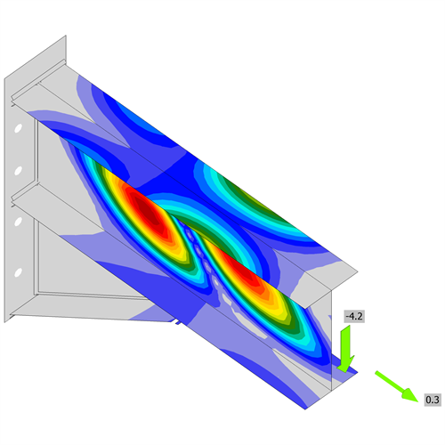
First buckling mode shape, LE1

Code settings
Item | Value | Unit | Reference
Friction coefficient - concrete | 0.40 | - | ACI 349-01 – B.6.1.4
Friction coefficient in slip-resistance | 0.30 | - | AISC 360-22 – J3.9
Limit plastic strain | 0.05 | -
Detailing | Yes
Distance between bolts [d] | 2.66 | - | AISC 360-22 – J3.4
Concrete breakout resistance check | Both
Base metal capacity check at weld fusion face | No |  | AISC 360-22 – J2-2
Deformation at bolt hole at service load is design consideration | Yes |  | AISC 360-22 – J3.11
Cracked concrete | Yes |  | ACI 318-25 – 17
Local deformation check | Yes
Local deformation limit | 0.03 | - | CIDECT DG 1, 3 – 1.1
Geometrical nonlinearity (GMNA) | Yes |  | Analysis with large deformations for hollow section joints

7. KESIMPULAN DAN REKOMENDASI
- Beban mati tambahan plat lantai 130 mm (termasuk spesi dan finishing) adalah 4,09 kN/m². Balok as-B menerima beban trapesium dengan ekuivalen momen 2,975 kN/m dan balok as-1/as-2 menerima beban segitiga dengan total 2,70 kN per balok.
- Beban lift 1200 kg ber-impak sebesar 98,10 kN, atau 49,05 kN per balok mesin. Dengan beban mati mesin 2,94 kN per balok, diperoleh Mu = 59,8 kNm dan Vu = 41,5 kN.
- Kekuatan lentur dan geser WF250×125×6×9 mencukupi (rasio 0,79 dan 0,21), dengan syarat sayap tekan terkekang lateral.
- Jumlah dinabolt yang di gunakan sudah aman dalam menahan reaksi yang berkerja padanya.

