Thursday, February 26, 2026
Sales Department SAGEMCOM
Follow-up by : Franck Lagadec To : Mr SAFI
Cell : +33 6 65 08 03 57
franck.lagadec@avocarbon.com

Our reference: 20260226-Water NAM GEN2-wire harness-SAGEMCOM
Your reference: RFQ/Water NAM GEN2 Wire harness

Copies : I. Ben Alaya

SUBJECT : commercial offer AVOCarbon TUNISIA-SAME

Dear Mr. SAFI,
Thank you for your RFQ. We are pleased to submit our commercial offer for the supply of Wire Harness WATER – NEM GEN2, manufactured according to your drawing 11D010301100 A1 (see Annex 1 and reference picture below).
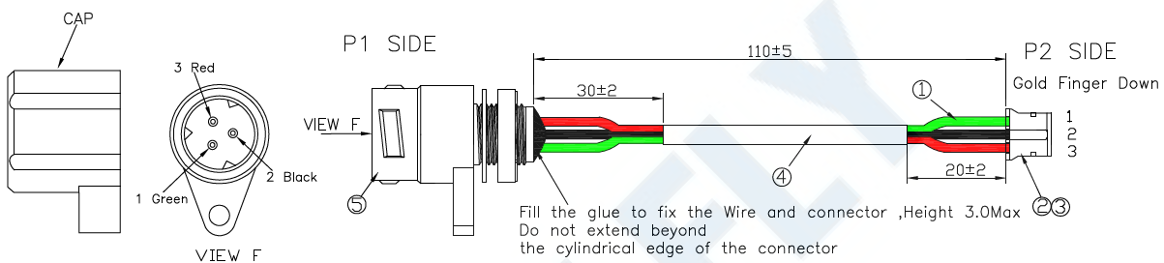
Product picture for reference
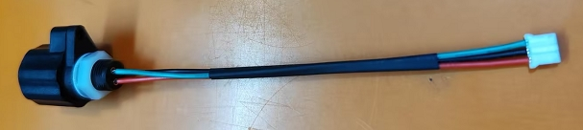
1) Scope and assumptions
Product: Wire harness WATER NEM GEN2 – Drawing 11D010301100 A1
SOP: To be defined jointly (upon PO confirmation / industrialization kick-off)
Validation batch: 20,000 pcs for process and product validation
Serial volume assumption: 1,000,000 pcs/year (≈ 20,000 pcs/week)
2) Pricing
- Prices are based on SAGEMCOM shared price for connector as below :

A. Validation batch (Pilot)
- Quantity: 20,000 pcs
- Unit price: 4,59 €/pc
Material balance (MOQ):
If the project does not continue into serial production, SAGEMCOM will take over/cover the remaining unused raw material purchased for supplier MOQ, for a total amount of 5,475 €.
If the project continues into serial production, this material will be consumed in serial and no additional charge will apply.
B. Serial production
- Quantity: 1,000,000 pcs/year
- Unit price: 4,45 €/pc (based on the assumptions in section 1)
- PO-Blanket order commitment of 500Kpcs min.
3) Packaging
Parts will be packed bulk in C12 cardboard boxes, on wooden pallets.
- 240 pcs/box
4) Lead time & deliveries
Lead time is understood as starting from receipt of payment related to each Purchase Order (prepayment)
- Serial deliveries and Pilot (20,000 pcs) : 20 weeks standard leadtime (After Receipt of Payment) can be organized on a weekly or monthly cadence based on your planning.
5) Incoterm
FCA – AVO Carbon site, El-Fahs, Tunisia (Incoterms® 2020).
6) Commercial terms – Payment
- 100% prepaid at PO
Inventory commitment
- AVO Carbon commits to 10 days of finished goods inventory (based on agreed rolling forecast).
General conditions
- AVO Carbon Group standard selling conditions apply.
- Offer validity: 1 month from date of issue.

We remain fully available to review the offer assumptions (SOP, delivery cadence, industrialization plan) and to launch the 20,000 pcs validation batch as soon as possible.
Best Regards,


Franck Lagadec European Sales Management
Key Account Manager

Annex1 : Drawing 11D010301100 A1
