Our website is <https://stttl.github.io/4200.github.io/>

**Static Visualizations**

**Line Chart Comparing Hourly Usage Frequency of Classic and Electric Bikes**

The "Usage Frequency by Time of Day" graph employs a dual-line design to concisely illustrate the hourly distribution of classic versus electric bike rides. Utilizing contrasting colors—blue for classic and orange for electric—optimizes visual differentiation. The hourly time segmentation along the x-axis and the proportional y-axis scaling deliver an at-a-glance understanding of peak usage times, underscoring the design's efficiency in communicating temporal trends in bike-sharing.

**Histogram of Trip Distance Distribution for Classic and Electric Bikes**

The histogram visualizes the trip distance distribution for classic and electric bikes with intuitive design simplicity. By using stacked bars in distinct colors, blue for classic and orange for electric, the graph efficiently communicates the predominance of classic bike usage over varying distances. The clear demarcation of trip distances along the x-axis and the corresponding ride frequency on the y-axis allows for immediate comparison and trend identification, showcasing the design’s effectiveness in illustrating usage patterns within bike-sharing data.

**Scatterplot of Trip Distance Percentage Distribution for Electric Bikes**

This scatterplot, titled "Percentage of Electric Bike Rides by Distance," employs a minimalist design to elucidate the relationship between trip distance and electric bike usage. Individual data points are plotted to illustrate the percentage of electric bikes used at varying distances, with clarity and precision. The sparse use of color focuses attention on the data itself, accentuating the trend that electric bikes are favored for longer distances—a nuanced insight that the preceding histogram could not capture as distinctly. The visual arrangement allows for the percentages to be examined on a granular level, affirming the design’s capacity to reveal subtler trends within the bike-sharing landscape.

**New York City Bike Route Network Visualized with D3.js**

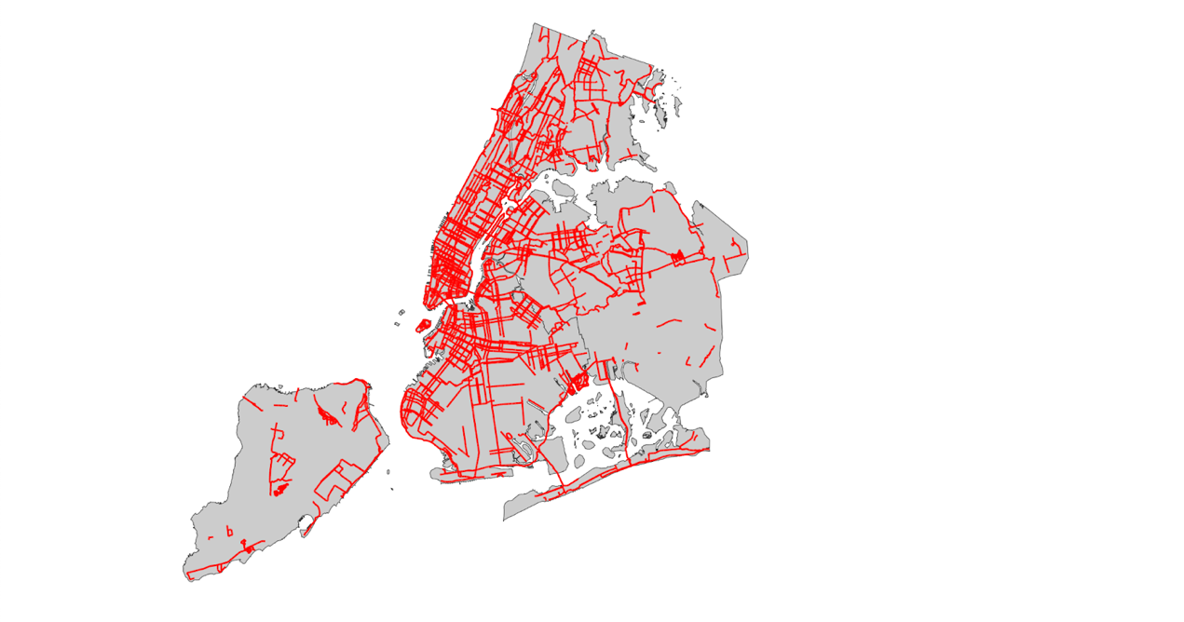

This geospatial visualization maps New York City's bike routes with striking clarity, employing red lines against a muted base map to highlight the network's density and reach. The design choice to use a high-contrast color scheme ensures that the routes stand out, providing a clear visual distinction between areas with heavy bike traffic and those less frequented. By doing so, this map offers an immediate understanding of the city's bike transit infrastructure, emphasizing routes that might benefit from the integration of electric bikes to support longer-distance commuting and ease urban congestion.

**Interactive Distribution Map of Classic and Electric Bikes in New York City**

The design behind this map visualization leverages color-coded markers to distinguish between classic (blue) and electric (red) bikes within the Hoboken vicinity, overlayed on a detailed OpenStreetMap base. By adopting a familiar cartographic layout, the map provides an intuitive user experience, enabling the viewer to easily navigate and interpret the data within the context of real-world geography.

The choice of vibrant blue and red for the markers not only grabs attention but also serves a functional purpose; it allows for quick differentiation between the two types of bikes at a glance. This visual distinction is particularly effective for identifying patterns, such as clusters of electric bike usage that may correlate with longer distances or specific points of interest.

#### Interactive Distribution Map of Classic and Electric Bike Routes

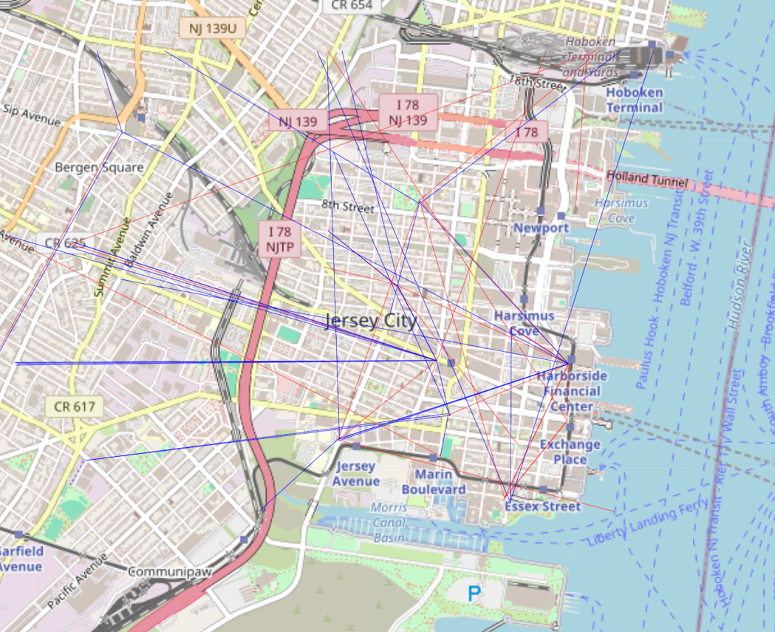

The interactive distribution map displayed showcases a thoughtful design aimed at conveying the distinct commuting patterns of classic and electric bike users within an urban environment. The clear differentiation between the vibrant blue and red polylines allows for immediate visual distinction between the two types of routes, illustrating the unique traffic flows and frequency of each bike type. Such a design facilitates the analysis of spatial distribution and route popularity, underscoring the electric bikes’ ability to sustain longer commutes and navigate diverse terrains, potentially reshaping urban transit dynamics. This map serves not only as a tool for immediate visual analysis but also as a compelling argument for the strategic integration of e-bikes into the city's broader transportation planning. By providing this level of interactivity and clarity, the map engages stakeholders and prompts considerations for infrastructure improvements, from expanding bike-sharing stations to enhancing the connectivity of cycling routes with public transit hubs.