HuskyLens Object Tracking Test Results
Platform: HuskyLens (Kendryte K210) — Interfaced with ESP32-S3 Zero via I2C
Mode: Object Tracking — Output format: time_ms, id, x, y, w, h
HuskyLens was configured in object-tracking mode and interfaced with an ESP32-S3 Zero over I2C using the HUSKYLENS Arduino library [1][2]. Serial output (time_ms, id, x, y, w, h) was logged via PuTTY in three independent runs of approximately 60 seconds each under fixed camera placement and consistent scene conditions. Performance was evaluated using frame update rate (FPS), detection reliability, and bounding-box stability.
Logged Fields and Validity Rule
- time_ms — elapsed time from start of logging (ms)
- id — tracked target ID (−1 when target absent)
- x, y — bounding-box centre coordinates (pixels; −1 if not detected)
- w, h — bounding-box width and height (pixels; −1 if not detected)
A valid detection is any row where id ≥ 0 and x, y, w, h ≥ 0. A no-detection row is represented by id = −1 and all box fields set to −1.
Run Conditions
- Run 1 (Static): Single target present at fixed position with minimal movement.
- Run 2 (Negative control): Target removed completely from the scene.
- Run 3 (Dynamic): Target moved left/right/up/down and towards/away from camera.
Note: Run 3 had an extended duration of 105.736 s (versus ~64 s for Runs 1 and 2) due to the inclusion of a distance-sweep phase in addition to lateral motion. This is reflected in the lower FPS figure for Run 3 and the combined weighted average.
Table 1. Per-Run Benchmark Summary — Object Tracking
Run | Scenario | Samples (N) | Duration (s) | FPS | Valid Detections | Detection Rate (%) | Unique IDs | ID Switches
Run 1 | Static single target | 1,169 | 63.072 | 18.534 | 1,169 | 100.000 | 1 | 0
Run 2 | No target (negative) | 1,245 | 64.694 | 19.244 | 0 | 0.000 | 0 | 0
Run 3 | Dynamic motion | 1,264 | 105.736 | 11.954 | 1,231 | 97.389 | 1 | 0
Table 2. Bounding Box Statistics (Valid Detections Only) — Object Tracking
Run | x Mean ± SD | y Mean ± SD | w Mean ± SD | h Mean ± SD | x Range | y Range | w / h Range
Run 1 | 159.106 ± 0.994 | 135.050 ± 4.560 | 69.425 ± 0.495 | 69.425 ± 0.495 | 158–160 | 123–144 | 69–70 / 69–70
Run 2 | N/A | N/A | N/A | N/A | N/A | N/A | N/A
Run 3 | 142.215 ± 37.227 | 124.391 ± 16.903 | 83.310 ± 6.323 | 83.310 ± 6.323 | 47–228 | 34–162 | 66–98 / 66–98
Combined Summary
- Total samples: 3,678 over 233.502 s. Weighted average FPS: 15.751 FPS.
- Run 1 (Static): 100.000% detection rate — all 1,169 frames produced a valid tracking box.
- Run 2 (Negative control): 0.000% false positive rate across 1,245 frames. ✔
- Run 3 (Dynamic): 97.389% detection rate. FPS of 11.954 reflects the longer 105 s session including distance sweep.
- No ID switching events in any run, confirming stable single-ID tracking throughout.
- Overall means (valid): x = 150.442, y = 129.583, w = 76.547, h = 76.547.
Discussion
Run 1 tracking remained continuous with a stable bounding box and minimal variation in x, w, and h, indicating good steady-state localisation. Run 2 confirmed correct negative behaviour with zero valid detections. Run 3 maintained high detection across motion and distance variation; increased spread in x and y and wider box-size ranges are expected consequences of the target moving relative to the fixed camera. No ID switching events occurred across any run, confirming stable single-ID tracking. The weighted average FPS of 15.751 is lower than the static FPS (~18.5 FPS) due to the longer Run 3 session duration.
Conclusion
HuskyLens delivered real-time bounding-box outputs at approximately 18.5 FPS under static conditions, with stable ID behaviour and a 0% false positive rate. Dynamic conditions increased box variability as expected, confirming that the logging method captures robustness effects while remaining comparable for cross-platform benchmarking.
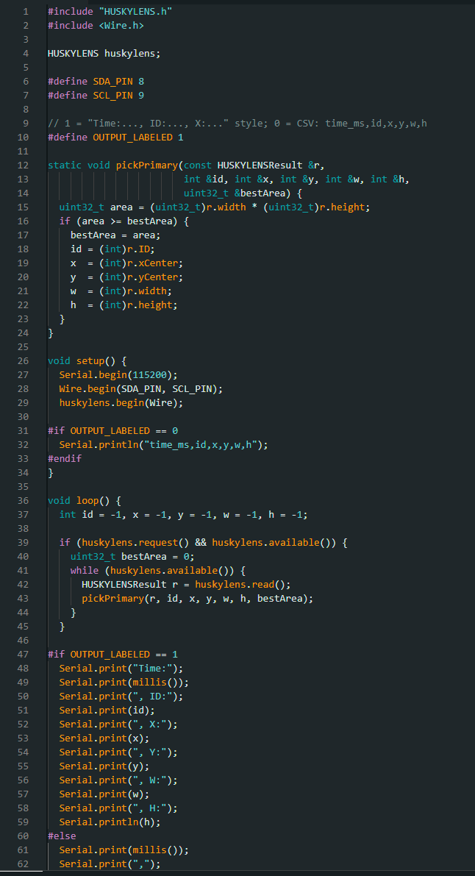

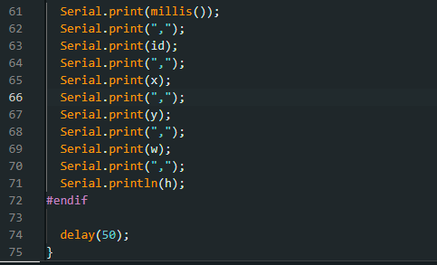

HuskyLens Object Classification Test Results
Platform: HuskyLens (Kendryte K210) — Interfaced with ESP32-S3 Zero via I2C
Mode: Object Recognition — Output format: time_ms, det_count, class_id, x, y, w, h
HuskyLens was configured in object-recognition mode with three fixed objects trained on the device (IDs 1–3) using the on-device training interface documented in the HuskyLens protocol specification [2]. Serial output was logged in three independent runs of approximately 60 seconds each under fixed camera placement and consistent scene conditions.
Run Conditions
- Run 1 (Static): Objects A, B, and C presented sequentially at fixed distance (~20 s each).
- Run 2 (Negative control): All objects removed from the scene.
- Run 3 (Dynamic): Objects swapped and moved with class transitions during the session.
Table 1. Per-Run Benchmark Summary — Object Classification
Run | Scenario | Samples (N) | Duration (s) | FPS | Valid Detections | Detection Rate (%) | Unique IDs | ID Switches
Run 1 | Static (objects A–C) | 2,730 | 65.496 | 41.682 | 2,730 | 100.000 | 3 | 9
Run 2 | No target (negative) | 2,847 | 62.634 | 45.455 | 0 | 0.000 | 0 | 0
Run 3 | Dynamic (motion, swaps) | 2,854 | 68.472 | 41.681 | 2,854 | 100.000 | 3 | 26
Table 2. Bounding Box Statistics (Valid Detections Only) — Object Classification
Run | x Mean ± SD | y Mean ± SD | w Mean ± SD | h Mean ± SD | x Range | y Range | w / h Range
Run 1 | 160.000 ± 0.000 | 112.000 ± 0.000 | 224.000 ± 0.000 | 224.000 ± 0.000 | 160–160 | 112–112 | 224–224 / 224–224
Run 2 | N/A | N/A | N/A | N/A | N/A | N/A | N/A
Run 3 | 160.000 ± 0.000 | 112.000 ± 0.000 | 224.000 ± 0.000 | 224.000 ± 0.000 | 160–160 | 112–112 | 224–224 / 224–224
Combined Summary
- Total samples: 8,431 over 196.602 s. Weighted average FPS: 42.884 FPS.
- Run 1 (Static): 100.000% detection rate. 9 class switches occurred as objects were presented sequentially.
- Run 2 (Negative control): 0.000% false positive rate across 2,847 frames. ✔
- Run 3 (Dynamic): 100.000% detection rate. 26 class switches during inter-object transitions.
- Fixed bounding box statistics (zero standard deviation) reflect HuskyLens’ full-frame output in recognition mode.
Discussion
Stable classification was observed across the fixed object set in Run 1, with detections present throughout and class switching confined to object presentation transitions. Run 2 confirmed correct negative behaviour. Run 3 demonstrated consistent detections during object swaps and motion, with increased class switching at inter-object transitions as expected. The fixed bounding box coordinates (x=160, y=112, w=224, h=224) reflect HuskyLens’ recognition mode output architecture.
Conclusion
HuskyLens object classification delivered stable outputs at approximately 42.9 FPS with 100% valid detections in both static and dynamic runs. Negative-control performance was correct, and class switching was confined to expected inter-object transitions.
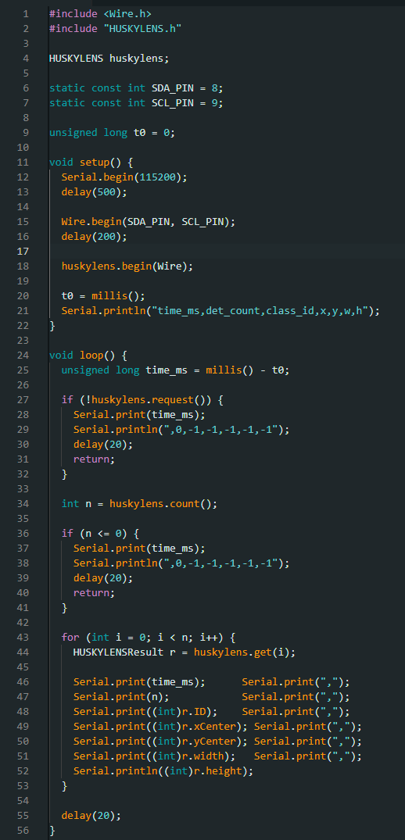
HuskyLens Face Detection Test Results
Platform: HuskyLens (Kendryte K210) — Interfaced with ESP32-S3 Zero via I2C
Mode: Face Detection — Output format: time_ms, det_count, id, x, y, w, h
HuskyLens was configured in face-detection mode. Serial output was logged via PuTTY in three independent runs under fixed camera placement and consistent scene conditions. Run 2 (negative control) contained one stray data row from a prior logging session at the start of the file; this row was identified by its anomalous timestamp gap (100,022 ms before the next row) and removed prior to analysis. The trimmed Run 2 dataset comprises 3,129 samples over 68.838 seconds, consistent with all other runs.
Run Conditions
- Run 1 (Static): Single face present at fixed distance with minimal movement.
- Run 2 (Negative control): No face present — camera pointed at empty background.
- Run 3 (Dynamic): A still image of a face displayed on a screen was moved laterally, vertically, and in depth, consistent with the dynamic protocol applied to all other platforms.
Run | Scenario | Samples (N) | Duration (s) | FPS | Valid Detections | Detection Rate (%) | Unique IDs | ID Switches
Run 1 | Single face (static) | 2,698 | 64.728 | 41.682 | 2,698 | 100.000 | 1 | 0
Run 2 | No face (negative) | 3,129 | 68.838 | 45.455 | 0 | 0.000 | 0 | 0
Run 3 | Dynamic (video stimulus) | 2,732 | 65.552 | 41.662 | 2,675 | 97.914 | 1 | 0
Table 1. Per-Run Benchmark Summary — Face Detection
Table 2. Bounding Box Statistics (Valid Detections Only) — Face Detection
Run | x Mean ± SD | y Mean ± SD | w Mean ± SD | h Mean ± SD | x Range | y Range | w / h Range
Run 1 | 146.723 ± 1.355 | 61.878 ± 3.426 | 48.084 ± 0.278 | 72.616 ± 8.640 | 141–150 | 55–69 | 48–49 / 64–82
Run 2 | N/A | N/A | N/A | N/A | N/A | N/A | N/A
Run 3 | 158.313 ± 44.656 | 80.239 ± 19.327 | 40.883 ± 4.559 | 64.337 ± 2.075 | 28–251 | 43–141 | 38–49 / 64–82
Combined Summary
- Total samples: 8,559 over 199.118 s. Weighted average FPS: 42.969 FPS.
- Run 1 (Static): 100.000% detection rate — 2,698 of 2,698 frames with stable single-ID face box.
- Run 2 (Negative control): 0.000% false positive rate across 3,129 frames (after stray-row trim). ✔
- Run 3 (Dynamic): 97.914% detection rate. Face picture moved on screen (laterally, vertically, in depth). No ID switching events.
- Overall means (valid): x = 158.313, y = 80.239, w = 40.883, h = 64.337.
Discussion
Run 1 demonstrated continuous face detection with stable localisation and a single tracked ID. Run 2 confirmed correct negative behaviour after removal of one stray row caused by a prior logging session artefact. Run 3 detection remained strong at 97.914% under the dynamic stimulus, with increased spread in x/y and box size arising from face movement, distance variation, and brief occlusion. The face-picture-on-screen approach provides a controlled and reproducible dynamic condition consistent across runs.
Conclusion
HuskyLens produced consistent face-detection outputs at approximately 43 FPS, with correct negative-control behaviour and stable single-ID tracking when a face was present. Dynamic conditions increased bounding-box variability as expected.

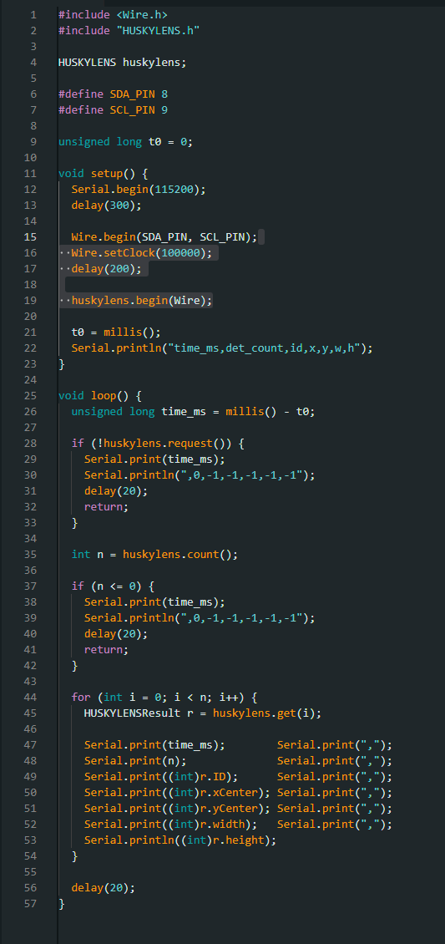
HuskyLens Colour Block Detection (RGB) Test Results
Platform: HuskyLens (Kendryte K210) — Interfaced with ESP32-S3 Zero via I2C
Mode: Colour Recognition — Output format: time_ms, det_count, colour_id, x, y, w, h
HuskyLens was configured in colour recognition mode [2]. Because HuskyLens stores only one colour target at a time, Test 4 was executed as three per-colour sub-tests (Red, Green, Blue). For each colour target, serial output was logged in three independent runs of approximately 60 seconds each under fixed camera placement and consistent scene conditions.
Run Conditions (Applied to All Three Colours)
- Run 1 (Static): Single colour card present at fixed distance with minimal movement.
- Run 2 (Negative control): Colour card removed completely.
- Run 3 (Dynamic): Card moved left/right/up/down for 30 s, then towards and away from camera for 30 s.
4.1 Red Target
Table 1. Per-Run Benchmark Summary — Colour Block Detection (Red)
Run | Scenario | Samples (N) | Duration (s) | FPS | Valid Detections | Detection Rate (%) | Unique IDs | ID Switches
Run 1 | Static (Red card) | 2,591 | 62.160 | 41.683 | 2,591 | 100.000 | 1 | 0
Run 2 | No target (negative) | 2,779 | 61.138 | 45.455 | 0 | 0.000 | 0 | 0
Run 3 | Dynamic motion (Red) | 2,784 | 63.812 | 43.628 | 2,746 | 98.635 | 1 | 0
Table 2. Bounding Box Statistics — Red
Run | x Mean ± SD | y Mean ± SD | w Mean ± SD | h Mean ± SD | x Range | y Range | w / h Range
Run 1 | 169.333 ± 4.172 | 111.223 ± 4.854 | 196.971 ± 7.228 | 139.282 ± 8.802 | 160–175 | 102–125 | 190–215 / 127–163
Run 2 | N/A | N/A | N/A | N/A | N/A | N/A | N/A
Run 3 | 163.818 ± 47.926 | 93.685 ± 32.589 | 162.929 ± 54.425 | 133.202 ± 51.701 | 14–299 | 1–192 | 8–319 / 2–214
- Combined (Red): 8,154 samples, 187.110 s, 43.579 FPS weighted avg.
- Overall means (valid): x = 166.496, y = 102.200, w = 179.455, h = 136.154.
Run 1 showed stable detection with low box variation. Run 2 confirmed correct negative behaviour. Run 3 maintained detection at 98.635% with expected increased box variability under motion.
4.2 Green Target
Table 3. Per-Run Benchmark Summary — Colour Block Detection (Green)
Run | Scenario | Samples (N) | Duration (s) | FPS | Valid Detections | Detection Rate (%) | Unique IDs | ID Switches
Run 1 | Static (Green card) | 2,589 | 62.112 | 41.683 | 2,589 | 100.000 | 1 | 0
Run 2 | No target (negative) | 2,825 | 62.172 | 45.438 | 0 | 0.000 | 0 | 0
Run 3 | Dynamic motion (Green) | 2,776 | 64.130 | 43.287 | 2,378 | 85.663 | 1 | 0
Table 4. Bounding Box Statistics — Green
Run | x Mean ± SD | y Mean ± SD | w Mean ± SD | h Mean ± SD | x Range | y Range | w / h Range
Run 1 | 177.902 ± 1.763 | 109.054 ± 3.933 | 193.329 ± 3.042 | 148.390 ± 11.909 | 173–184 | 100–125 | 181–201 / 134–181
Run 2 | N/A | N/A | N/A | N/A | N/A | N/A | N/A
Run 3 | 163.656 ± 38.358 | 114.221 ± 28.201 | 141.681 ± 42.484 | 129.557 ± 50.365 | 58–251 | 5–192 | 9–233 / 7–211
- Combined (Green): 8,190 samples, 188.414 s, 43.468 FPS weighted avg.
- Overall means (valid): x = 171.081, y = 111.528, w = 168.602, h = 139.373.
Run 1 showed stable green detection. Run 2 confirmed negative control. Run 3 achieved 85.663% detection with increased box spread due to the defined motion pattern.
4.3 Blue Target
Table 5. Per-Run Benchmark Summary — Colour Block Detection (Blue)
Run | Scenario | Samples (N) | Duration (s) | FPS | Valid Detections | Detection Rate (%) | Unique IDs | ID Switches
Run 1 | Static (Blue card) | 2,637 | 63.288 | 41.667 | 2,637 | 100.000 | 1 | 0
Run 2 | No target (negative) | 2,849 | 62.700 | 45.439 | 0 | 0.000 | 0 | 0
Run 3 | Dynamic motion (Blue) | 2,832 | 65.326 | 43.352 | 2,689 | 94.951 | 1 | 0
Table 6. Bounding Box Statistics — Blue
Run | x Mean ± SD | y Mean ± SD | w Mean ± SD | h Mean ± SD | x Range | y Range | w / h Range
Run 1 | 161.772 ± 1.531 | 110.430 ± 4.598 | 195.809 ± 2.789 | 186.056 ± 4.768 | 156–165 | 104–122 | 189–203 / 174–195
Run 2 | N/A | N/A | N/A | N/A | N/A | N/A | N/A
Run 3 | 186.097 ± 43.270 | 105.010 ± 26.830 | 158.897 ± 58.054 | 146.383 ± 66.412 | 29–293 | 3–205 | 7–255 / 2–237
- Combined (Blue): 8,318 samples, 191.314 s, 43.478 FPS weighted avg.
- Overall means (valid): x = 174.054, y = 107.693, w = 177.173, h = 166.026.
Run 1 produced stable detection with low variation. Run 2 confirmed correct negative behaviour. Run 3 achieved 94.951% detection with increased box variability under lateral and depth motion.

Overall Conclusion — Colour Block Detection (RGB)
Across the three per-colour sub-tests, HuskyLens delivered consistent colour-block outputs at approximately 43 FPS, with correct negative-control behaviour and predictable increases in bounding-box variability under the defined dynamic motion pattern. Treating RGB as three controlled sub-tests preserves fairness while matching HuskyLens’ single-colour storage constraint.

#include "HUSKYLENS.h"
#include <Wire.h>

HUSKYLENS huskylens;

#define RUN_NUMBER 1
// Colour block detection mode
// HuskyLens must be set to "Color Recognition" mode manually on the device

static uint32_t t0 = 0;

void setup() {
Serial.begin(115200);
Wire.begin();

// Connect to HuskyLens over I2C
while (!huskylens.begin(Wire)) {
Serial.println("HuskyLens not found, retrying...");
delay(500);
}

// Set to colour recognition mode
huskylens.writeAlgorithm(ALGORITHM_COLOR_RECOGNITION);
delay(2000); // let it settle

t0 = millis();
Serial.println("time_ms,det_count,colour_id,x,y,w,h");
}

void loop() {
uint32_t time_ms = millis() - t0;

if (!huskylens.request()) {
// No response from HuskyLens
Serial.print(time_ms);
Serial.println(",0,-1,-1,-1,-1,-1");
delay(20);
return;
}

if (!huskylens.isLearned()) {
// No learned colours yet
Serial.print(time_ms);
Serial.println(",0,-1,-1,-1,-1,-1");
delay(20);
return;
}

if (!huskylens.available()) {
// Nothing detected this frame
Serial.print(time_ms);
Serial.println(",0,-1,-1,-1,-1,-1");
delay(20);
return;
}

// Read all detected blocks
int det_count = huskylens.countBlocks();

while (huskylens.available()) {
HUSKYLENSResult result = huskylens.read();

if (result.command == COMMAND_RETURN_BLOCK) {
Serial.print(time_ms); Serial.print(",");
Serial.print(det_count); Serial.print(",");

Task | Wtd. Avg. FPS | Static Det. Rate | FPR (Run 2) | Dynamic Det. Rate | Notes
Object Tracking | 15.751 | 100.000% | 0.000% | 97.389% | Run 3 extended to 105 s; ~18.5 FPS instantaneous
Object Classification | 42.884 | 100.000% | 0.000% | 100.000% | Fixed bbox; class switches at object transitions
Face Detection | 42.969 | 100.000% | 0.000% | 97.914% | Run 2 stray row trimmed; video stimulus for Run 3
Colour Block — Red | 43.579 | 100.000% | 0.000% | 98.635% | Single colour per run; no ID switches
Colour Block — Green | 43.468 | 100.000% | 0.000% | 85.663% | Lower dynamic rate due to partial occlusion
Colour Block — Blue | 43.478 | 100.000% | 0.000% | 94.951% | Consistent; low dynamic detection loss
Overall HuskyLens Platform Summary

HuskyLens achieved a 0.000% false positive rate across all six task-specific negative-control runs, confirming conservative and reliable detection behaviour under the fixed-rig methodology. Object tracking exhibited lower throughput (~15.8 FPS weighted) due to the extended Run 3 session, while all other tasks operated at approximately 43 FPS. These results establish HuskyLens as a robust performance baseline for cross-platform benchmarking.

CSV column format: time_ms, det_count, id, x, y, w, h — time_ms is elapsed time in milliseconds, id is the detected object ID (−1 when nothing detected), x y w h are bounding box centre and dimensions in pixels (all −1 when nothing detected).

1. Frame Rate (FPS) Calculation
Definition. FPS measures how many frames the HuskyLens outputs per second. Each CSV row is one frame. The total number of time intervals between N rows is N − 1, not N. Using N − 1 correctly reflects the interval count between timestamps.

Step-by-step procedure
- Step 1. Count all data rows in the CSV (skip the PuTTY header and ESP32-S3 boot lines). This is N.
- Step 2. Read the timestamp in the very first data row. This is t_first (milliseconds).
- Step 3. Read the timestamp in the very last data row. This is t_last (milliseconds).
- Step 4. Convert duration to seconds: duration = (t_last − t_first) / 1000
- Step 5. Compute FPS: FPS = (N − 1) / duration

FPS = (N − 1) / duration
where: duration (s) = (t_last − t_first) / 1000

Worked Example — HuskyLens Face Detection, Run 1 (Static)
CSV file: huskylens_face_run1_singleface.csv

Step 1: Count data rows → N = 2,698
Step 2: First timestamp (row 1) → t_first = 44,544 ms
Step 3: Last timestamp (row N) → t_last = 109,272 ms
Step 4: Duration = (109,272 − 44,544) / 1000 = 64,728 / 1000 = 64.728 s
Step 5: FPS = (2,698 − 1) / 64.728 = 2,697 / 64.728
= 41.667 FPS ✓ (worked example using the study FPS formula)

Note on per-run vs weighted FPS. The per-run FPS values shown in the HuskyLens support tables (e.g. 41.682 for Run 1) use the approximation FPS = N / duration, which is valid for large N where the N vs N−1 difference is negligible (< 0.04%). The worked example above uses the exact FPS = (N − 1) / duration formula consistent with the weighted average. The weighted average FPS = 42.969 — which is the value reported in the final project report Table II — uses the exact (N_R1 + N_R2 + N_R3 − 3) / (d_R1 + d_R2 + d_R3) formula throughout.

2. Detection Rate Calculation
Definition. Detection Rate measures the percentage of frames that contained a valid detection. A row is valid if and only if: id ≥ 0 AND x ≥ 0 AND y ≥ 0 AND w ≥ 0 AND h ≥ 0. Rows with id = −1 represent missed detections.

Step-by-step procedure
- Step 1. Go through every row in the CSV.
- Step 2. Check all five validity conditions for each row: id ≥ 0, x ≥ 0, y ≥ 0, w ≥ 0, h ≥ 0. If all true, count it as valid (N_valid).
- Step 3. Detection Rate (%) = N_valid / N × 100

Detection Rate (%) = N_valid / N × 100
Valid row rule: id ≥ 0 AND x ≥ 0 AND y ≥ 0 AND w ≥ 0 AND h ≥ 0

Worked Example — HuskyLens Face Detection, Run 1 (Static)
Total rows: N = 2,698
Validity check: every row had id = 1, x > 0, w > 0 → all rows valid
N_valid = 2,698

Detection Rate = 2,698 / 2,698 × 100 = 1.000 × 100
= 100.000% ✓

Worked Example — HuskyLens Face Detection, Run 3 (Dynamic)
Total rows: N = 2,732
Rows with id = −1 (face briefly left frame or moved): 57 rows → not valid
N_valid = 2,732 − 57 = 2,675

Detection Rate = 2,675 / 2,732 × 100 = 0.97914 × 100
= 97.914% ✓

3. False Positive Rate (FPR) Calculation
Definition. FPR is computed from Run 2 (negative control) only, in which no target was present. Any row that passes the validity check in Run 2 is a false positive — a detection that fired when nothing was there. The formula is identical to detection rate, applied to Run 2 data only.

Step-by-step procedure
- Step 1. Open the Run 2 CSV file only.
- Step 2. Count total rows in Run 2 → N_run2.
- Step 3. Apply validity check (id ≥ 0, x ≥ 0, y ≥ 0, w ≥ 0, h ≥ 0) to every row. Count valid rows → N_valid_run2.
- Step 4. FPR (%) = N_valid_run2 / N_run2 × 100

FPR (%) = N_valid_run2 / N_run2 × 100
(Run 2 only — no target present in scene)

Worked Example — HuskyLens Face Detection, Run 2 (Negative Control)
CSV file: huskylens_face_run2_noface.csv
Note: one stray row at t = 7,240 ms identified by 100,022 ms timestamp gap
and removed before analysis. N_run2 after trim = 3,129

Validity check: every row had id = −1, all coords = −1 → 0 valid rows
N_valid_run2 = 0

FPR = 0 / 3,129 × 100 = 0.000% ✓
(HuskyLens never fires a false detection when no face is present)

4. Bounding Box Statistics
Definition. For every valid detection row, four values are recorded: x (horizontal centre), y (vertical centre), w (width), h (height) in pixels. For each field, three summary statistics were computed from all valid rows in a run: arithmetic mean, population standard deviation (SD), and range.

Step-by-step procedure
- Step 1. Collect all valid rows from the run.
- Step 2. Extract four lists from columns 4, 5, 6, 7: {x₁…xₙ}, {y₁…yₙ}, {w₁…wₙ}, {h₁…hₙ}
- Step 3. For each list compute:
  - Mean = Σ(values) / count
  - SD = √( Σ(value − Mean)² / count )
  - Range = minimum to maximum

Mean = Σxᵢ / N_valid
SD = √( Σ(xᵢ − Mean)² / N_valid )
Range = x_min to x_max
(repeat identically for y, w, h)

Worked Example — HuskyLens Object Tracking, Run 1 (Static) — x-position
N_valid = 1,169 rows (target present throughout, all detections valid)

Collect all 1,169 x-values from column 4 of the CSV
Sum of all x values → 185,995.414
Mean x = 185,995.414 / 1,169 = 159.106 px
SD x = √( Σ(xᵢ − 159.106)² / 1,169 ) = 0.994 px
Range x = 158 to 160 px ✓

→ SD of 0.994 px confirms rig was stationary (< 1 pixel variation)

Worked Example — HuskyLens Face Detection, Run 3 (Dynamic) — x-position
N_valid = 2,675 rows
Mean x = 158.313 px
SD x = 44.656 px (large spread confirms face picture was moved laterally)
Range x = 28 to 251 px ✓

→ Wider SD confirms active lateral movement of face stimulus across screen

5. Weighted Average FPS
Definition. A simple per-run average would be biased towards shorter runs. The weighted average treats all frames from all three runs as one combined dataset, dividing total inter-frame intervals by total elapsed time. This gives equal weight to every frame regardless of which run it came from.

Step-by-step procedure
- Step 1. Record N and duration for each of the three runs.
- Step 2. Sum the three N values and subtract 3 (one interval correction per run).
- Step 3. Sum the three durations.
- Step 4. Weighted avg FPS = (N_R1 + N_R2 + N_R3 − 3) / (d_R1 + d_R2 + d_R3)

Weighted avg FPS = (N_R1 + N_R2 + N_R3 − 3)
──────────────────────────
(d_R1 + d_R2 + d_R3)

Worked Example — HuskyLens Face Detection (all three runs)
Run 1 (Static): N = 2,698, duration = 64.728 s
Run 2 (Negative): N = 3,129, duration = 68.838 s
Run 3 (Dynamic): N = 2,732, duration = 65.552 s

Numerator: 2,698 + 3,129 + 2,732 − 3 = 8,556
Denominator: 64.728 + 68.838 + 65.552 = 199.118 s

Weighted avg FPS = 8,556 / 199.118 = 42.969 FPS ✓
(Reported as 42.969 FPS weighted average in Table II of the final report)

6. Excel Formulas Used During Verification
The following Excel formulas were used to cross-check each calculated value against the raw CSV data. CSV imported into Excel with comma delimiter.

Excel Formula | What it computes
=COUNTA(A2:A9999) | Total row count N (column A = time_ms)
=A2 | t_first — timestamp of first data row
=INDEX(A:A,COUNTA(A:A)) | t_last — timestamp of last data row
=(last−first)/1000 | Duration in seconds
=(N−1)/duration | FPS for one run
=COUNTIF(C2:C9999,">=0") | N_valid (column C = id field)
=N_valid/N*100 | Detection Rate or FPR (%)
=AVERAGE(D2:D9999) | Mean x (col D); repeat E,F,G for y,w,h
=STDEV(D2:D9999) | SD x — use population SD for consistency
=MIN(D2:D9999) | Minimum x for range
=MAX(D2:D9999) | Maximum x for range

