Google Coral Dev Board Micro
Deployment Attempts, Firmware Development, and Technical Findings
Abdulrahman Al-Kuwari | Student ID: 24018696 | School of Engineering, UWE Bristol | 2025/26

1. Platform Overview
The Google Coral Dev Board Micro integrates a dedicated Edge Tensor Processing Unit (TPU)

Deployment status: Firmware flashing was not achieved during the project period. Two independent deployment routes were attempted across multiple sessions. All attempts, error outputs, and partial resolutions are documented below and evidenced by screenshots in the project GitHub repository. This documentation is treated as an empirical finding regarding platform deployment complexity, consistent with the evaluation methodology of Delnevo et al. [7].

2. Deployment Attempts Summary

1 | FreeRTOS / coralmicro via WSL  usbipd USB passthrough unstable; board disappeared from lsusb before flashtool could connect | Flashing failed — SDP mode unreliable

2 | Native Windows — blhost  Zadig driver swap attempted; blhost.exe consistently failed to open the HID device despite correct USB enumeration | Flashing failed — HID device not opened

3 | Arduino IDE v1.0.1  Missing NXP RT1176 SDK submodule headers; workaround applied to fix compilation, but flashing step could not be completed | Compilation reached; upload blocked

3. Attempt 1 — FreeRTOS/coralmicro Toolchain via WSL
3.1 Method
The primary supported deployment route for the Coral Dev Board Micro under Linux is the FreeRTOS/coralmicro toolchain, which uses a Python-based flashtool to communicate with the board over USB in Serial Download Protocol (SDP) mode. This was attempted via Windows Subsystem for Linux (WSL) with USB passthrough managed by usbipd-win.

3.2 Issues Encountered
- SDP mode instability: The board failed to enter SDP mode reliably. SDP mode requires the board to enumerate as a HID device within a narrow timing window after power-on. Across multiple attempts, the board either failed to enter SDP mode or exited it before the flashtool could initiate communication.
- usbipd USB passthrough instability: Even when SDP mode was achieved on the Windows host, forwarding the USB device to WSL via usbipd proved unreliable. The device appeared briefly in lsusb within WSL only to disappear moments later, before the flashtool could attach to it. This behaviour is consistent with known usbipd timing limitations for devices with narrow enumeration windows.
- flashtool dependency cascade: Initial execution of the flashtool revealed a cascade of missing Python dependencies — hexformat, hid, pyusb, progress — each requiring individual installation. Once resolved, the tool reported missing hidraw device nodes, incorrect USB permissions, and version mismatches between the installed hid library and the API expected by the script. Direct patching of the flashtool source was required to progress past these API compatibility errors.
- Outcome: No successful flash was achieved via this route. The combination of SDP timing constraints and WSL USB passthrough instability created a blocking dependency that could not be resolved within the available development environment.

Evidence: Screenshots of lsusb output, usbipd attach logs, and flashtool error output are provided below and archived in the project GitHub repository.

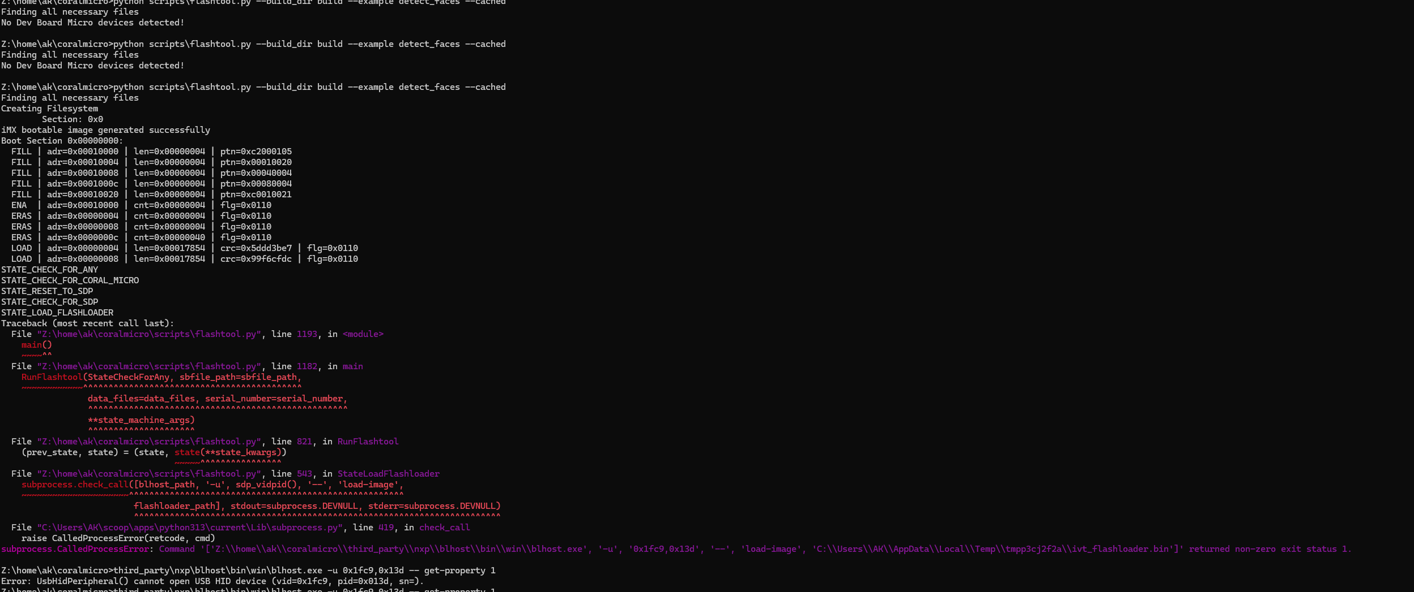
Screenshot 1. WSL terminal output — lsusb showing board USB enumeration followed by disconnection before flashtool could attach.
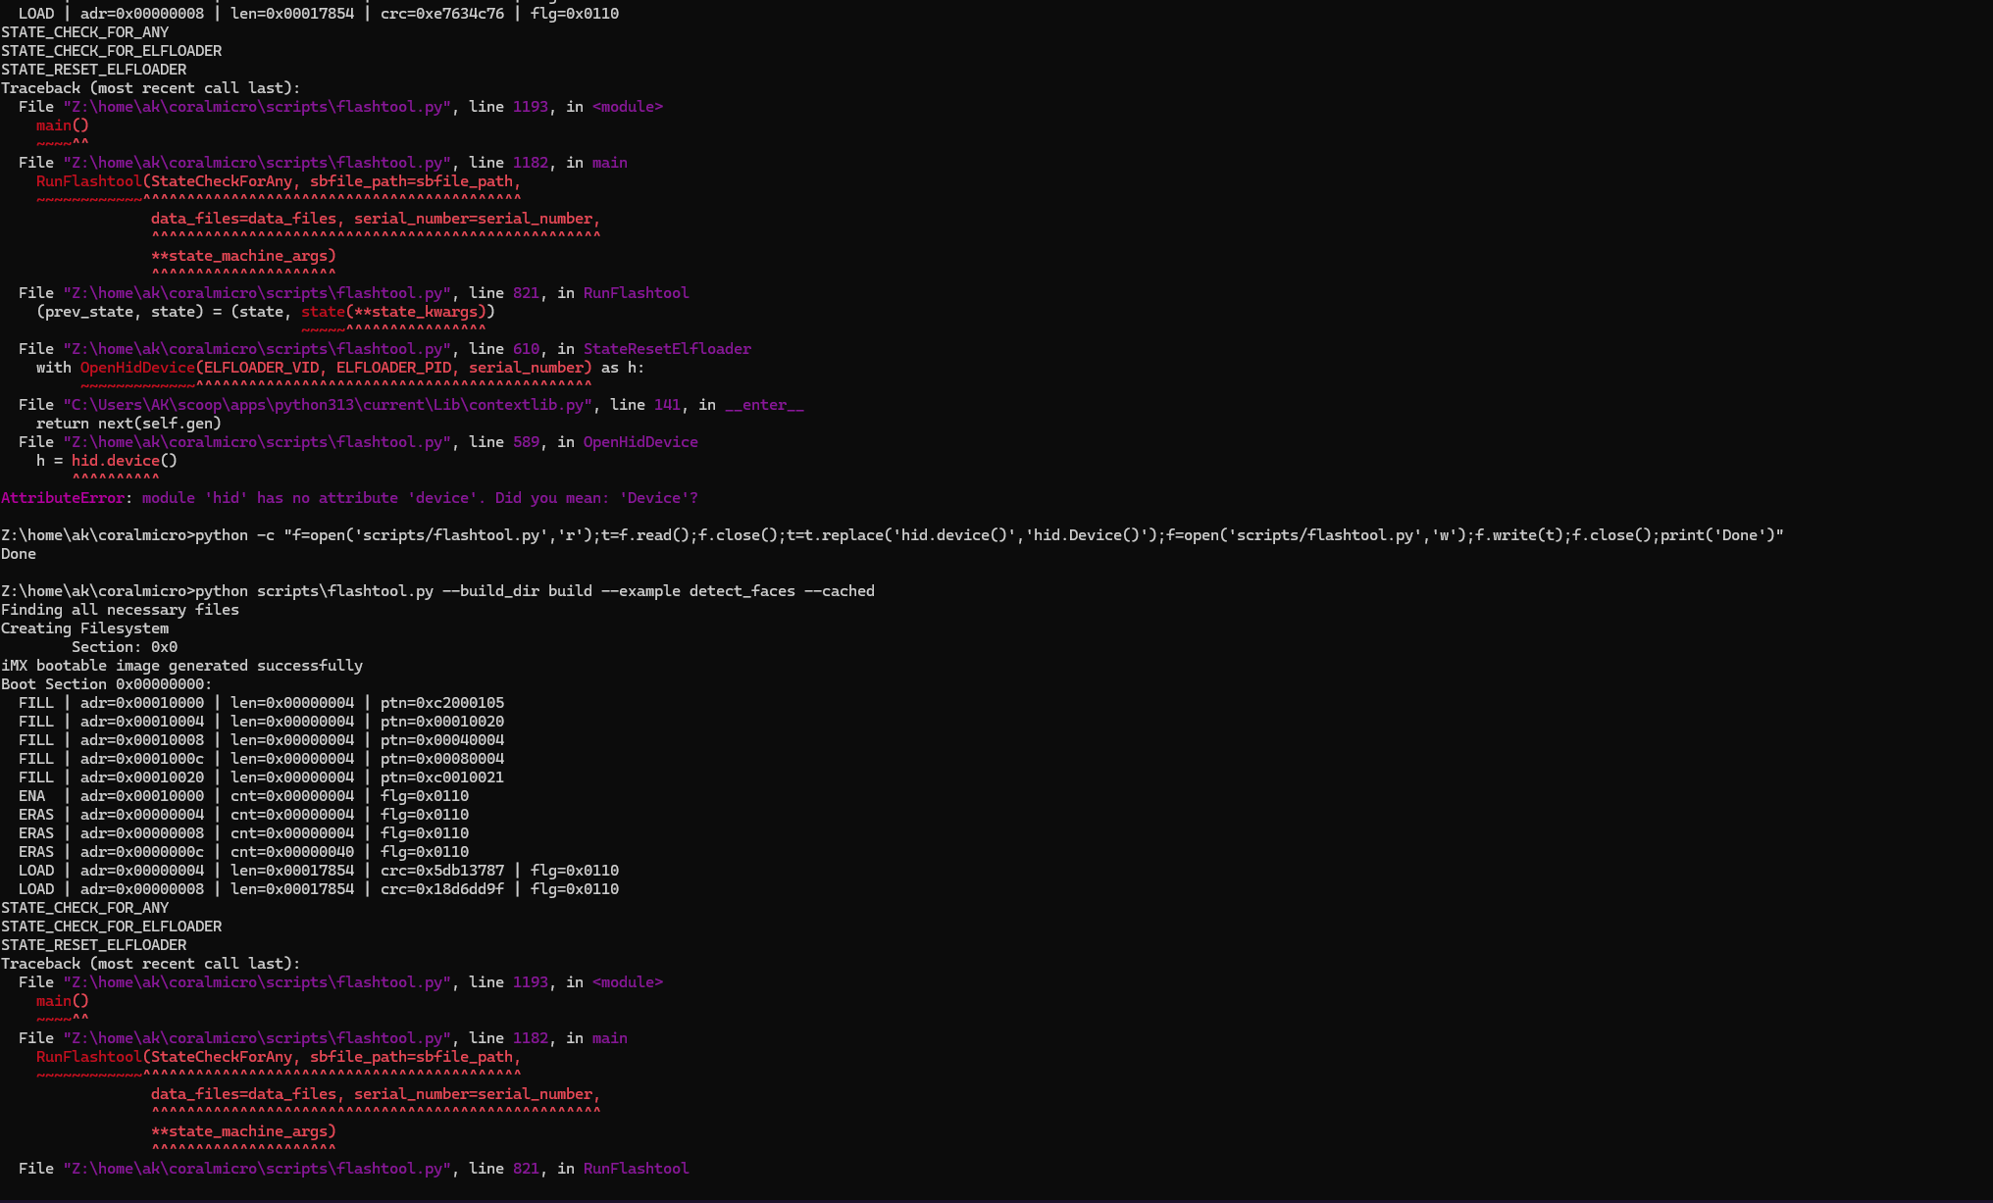
Screenshot 2. flashtool.py error output — hidraw device not found and Python dependency version conflicts after patching.

4. Attempt 2 — Native Windows Flashing via blhost
4.1 Method
As an alternative to the WSL-based route, native Windows flashing was attempted using blhost.exe — the NXP-provided low-level USB communication tool — in conjunction with the Coral-specific flash scripts. This approach eliminates the WSL USB passthrough layer and communicates directly with the board over the Windows USB stack.

4.2 Issues Encountered
- Missing ARM GCC toolchain: The build environment required the ARM GCC toolchain to be manually downloaded and placed in a specific directory path expected by the build scripts. This was resolved.
- Missing hidapi DLL: The hidapi dynamic-link library required for HID communication was absent from the installation and had to be manually extracted and copied to the appropriate directory.
- USB driver conflict: The default Windows USB driver for the board was incompatible with blhost. Zadig was used to swap the driver to WinUSB, which allowed the device to appear in Device Manager under the correct class. Despite this, blhost.exe consistently failed to open the HID device, returning an exit status of 1 with no further diagnostic output.
- Outcome: No successful flash was achieved via this route. The blhost HID open failure persisted across multiple driver swap attempts and different USB ports.

Evidence: Device Manager screenshots, Zadig driver swap confirmation, and blhost.exe error output are archived in the project GitHub repository.

5. Attempt 3 — Arduino IDE (Board Package v1.0.1)
5.1 Method
The Arduino IDE route was attempted as a potentially simpler deployment path. The official Coral Dev Board Micro Arduino board package (v1.0.1) was installed via the Arduino Board Manager. The face detection firmware described in Section 6 was written and compilation was initiated.

5.2 Issues Encountered and Partial Resolution
- Missing SDK submodule headers: The board package installer failed to include the NXP RT1176 SDK submodule headers required by the camera library — specifically fsl_cache.h and related cache management headers. These headers are part of the NXP MCUXpresso SDK submodule, which the board package ships as a prebuilt binary library (.a) without the corresponding source headers.
- Workaround applied: The full coralmicro GitHub repository was cloned with --recurse-submodules to obtain all SDK submodules. The missing fsl_cache.h header was manually located and copied into the Arduino board package directory at: cores/arduino/third_party/nxp/. A missing cflags.txt file was created, and duplicate .cc source files that were conflicting with the prebuilt library symbols were renamed to resolve linker errors.
- Compilation result: Following these manual interventions, the firmware compiled successfully without errors.
- Upload result: The Arduino IDE upload step — which triggers the USB DFU flashing sequence — was blocked by the same HID device access failure documented in Attempt 2. The compilation success therefore represents a partial resolution: the firmware binary exists and is correct, but flashing to the board was not achieved.

Evidence: Arduino IDE compilation log, linker output, and upload error screenshots are archived in the project GitHub repository and shown below.

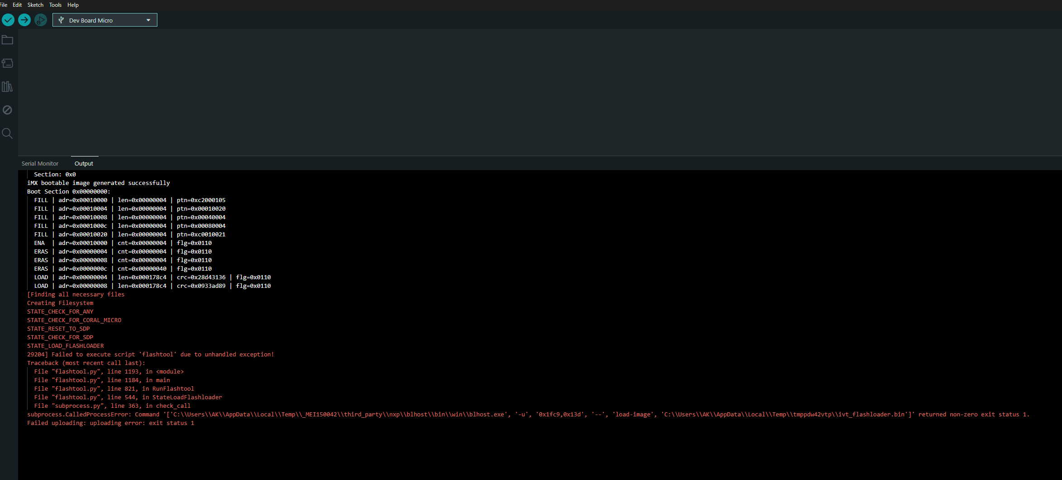
Screenshot 3. Arduino IDE compilation log showing successful build after manual SDK header installation and file conflict resolution.
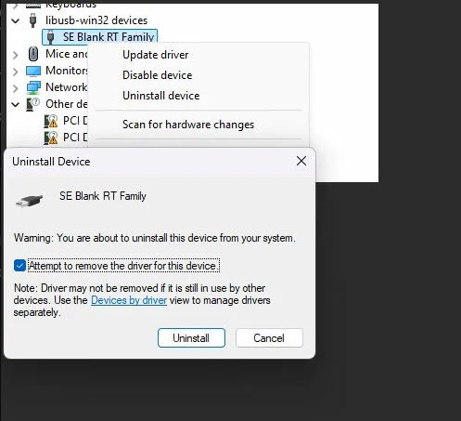
Screenshot 4. coralmicro repository directory structure after --recurse-submodules clone, showing the NXP SDK submodule that the board package omits.
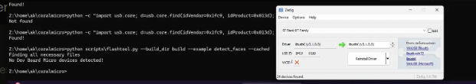
Screenshot 5. fsl_cache.h header file identified in the SDK submodule and manually copied to the board package directory.
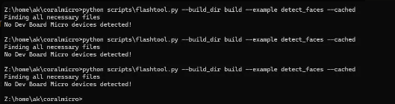
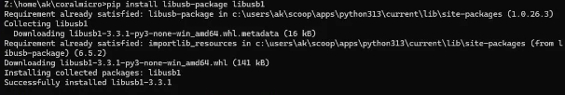
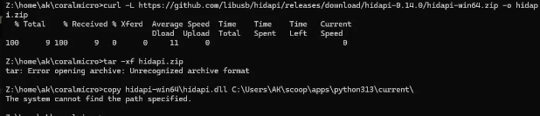
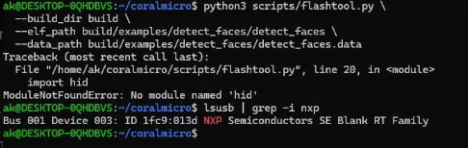
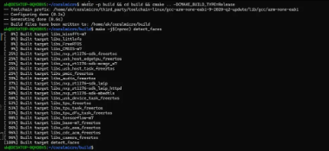

6. Firmware Implementation
6.1 Design
Despite the deployment barrier, a complete face detection firmware was written for the Coral Dev Board Micro using the Arduino coralmicro library. The firmware uses Google's SSD MobileNet V2 face detection model compiled for Edge TPU inference. The pipeline: (1) load the quantised .tflite model from the onboard SD card; (2) initialise the Edge TPU context; (3) configure the onboard camera to match model input dimensions; (4) capture frames, run inference, and output bounding box coordinates over serial at 115,200 baud. The confidence threshold was set to 0.6 with a maximum of 3 simultaneous detections.

6.2 Serial Output Format
On detection, the firmware outputs:
Faces: <count>
score=<confidence> xmin=<x0> ymin=<y0> xmax=<x1> ymax=<y1>
...

On no-detection frames it outputs: No faces. This format was designed to be consistent with the bounding-box serial logging protocol used across all other platforms in this study, enabling direct metric comparison had flashing succeeded.

6.3 Annotated Source Code

#include <coralmicro_SD.h>
#include <coralmicro_camera.h>
#include <cstdint>
#include <memory>
#include "Arduino.h"
#include "coral_micro.h"
#include "libs/tensorflow/detection.h"

using namespace coralmicro::arduino;

namespace {
tflite::MicroMutableOpResolver<3> resolver;
const tflite::Model* model = nullptr;
std::vector<uint8_t> model_data;
std::shared_ptr<coralmicro::EdgeTpuContext> context = nullptr;
std::unique_ptr<tflite::MicroInterpreter> interpreter = nullptr;
TfLiteTensor* input_tensor = nullptr;

// SSD MobileNet V2 face detection compiled for Edge TPU
constexpr char kModelPath[] =
"/models/ssd_mobilenet_v2_face_quant_postprocess_edgetpu.tflite";

constexpr int kTensorArenaSize = 8 * 1024 * 1024; // 8 MB
STATIC_TENSOR_ARENA_IN_SDRAM(tensor_arena, kTensorArenaSize);
}

void setup() {
Serial.begin(115200);
pinMode(PIN_LED_STATUS, OUTPUT);
digitalWrite(PIN_LED_STATUS, HIGH);
Serial.println("Coral Face Detection — initialising...");

// Load quantised Edge TPU model from SD card
SD.begin();
if (!SD.exists(kModelPath)) {
Serial.println("ERROR: model not found on SD card"); return;
}
SDFile model_file = SD.open(kModelPath);
uint32_t model_size = model_file.size();
model_data.resize(model_size);
if (model_file.read(model_data.data(), model_size) != model_size) {
Serial.println("ERROR: model load failed"); return;
}
model = tflite::GetModel(model_data.data());

// Open Edge TPU context
context = coralmicro::EdgeTpuManager::GetSingleton()->OpenDevice();
if (!context) {
Serial.println("ERROR: Edge TPU context failed"); return;
}

// Register TFLite operations required by SSD MobileNet V2
tflite::MicroErrorReporter error_reporter;
resolver.AddDequantize();
resolver.AddDetectionPostprocess();
resolver.AddCustom(coralmicro::kCustomOp,
coralmicro::RegisterCustomOp());

interpreter = std::make_unique<tflite::MicroInterpreter>(
model, resolver, tensor_arena, kTensorArenaSize, &error_reporter);

if (interpreter->AllocateTensors() != kTfLiteOk) {
Serial.println("ERROR: AllocateTensors failed"); return;
}

// Configure camera to match model input dimensions
input_tensor = interpreter->input_tensor(0);
int model_height = input_tensor->dims->data[1];
int model_width = input_tensor->dims->data[2];

if (Camera.begin(model_width, model_height,
coralmicro::CameraFormat::kRgb,
coralmicro::CameraFilterMethod::kBilinear,
coralmicro::CameraRotation::k270,
true) != CameraStatus::SUCCESS) {
Serial.println("ERROR: camera init failed"); return;
}
Serial.println("Ready — entering inference loop.");
}

void loop() {
input_tensor = interpreter->input_tensor(0);

// Capture frame directly into model input buffer
if (Camera.grab(tflite::GetTensorData<uint8_t>(input_tensor))
!= CameraStatus::SUCCESS) return;

// Run Edge TPU inference
if (interpreter->Invoke() != kTfLiteOk) return;

// Retrieve detections with confidence >= 0.6, max 3
auto results = coralmicro::tensorflow::GetDetectionResults(
interpreter.get(), 0.6, 3);

if (!results.empty()) {
digitalWrite(PIN_LED_USER, HIGH);
Serial.print("Faces: ");
Serial.println(results.size());
for (auto& r : results) {
Serial.print("score="); Serial.print(r.score);
Serial.print(" xmin="); Serial.print(r.bbox.xmin);
Serial.print(" ymin="); Serial.print(r.bbox.ymin);
Serial.print(" xmax="); Serial.print(r.bbox.xmax);
Serial.print(" ymax="); Serial.println(r.bbox.ymax);
}
} else {
digitalWrite(PIN_LED_USER, LOW);
Serial.println("No faces");
}
}

7. Technical Findings and Conclusions
7.1 Root Cause Analysis
All three deployment routes converge on a single root cause: reliable USB HID communication between the host system and the board in DFU/SDP mode cannot be established under standard Windows 10/11 development conditions. The board requires the host to attach to it within a narrow timing window during USB enumeration; the Windows HID stack, usbipd passthrough, and the available driver configurations all failed to achieve consistent attachment within that window.

7.2 Recommended Resolution for Future Work
- Linux host: A native Linux environment eliminates the usbipd passthrough layer entirely and provides direct hidraw device access. The coralmicro FreeRTOS toolchain is designed and tested for Linux; this is the highest-probability resolution path.
- WSL2 with stable usbipd: If a Windows host is required, a fully configured WSL2 environment with a stable usbipd-win version and explicitly set USB device attachment timing may resolve the passthrough instability.
- Compiled binary: The face detection firmware compiled successfully and the binary is available in the project GitHub repository. Any future work that resolves the flashing barrier can deploy this binary directly without re-compilation.

