**Recommending a Strategy**

Ideas for today and tomorrow

**Concerned Questions**

* Are Freshers introduced to college ?
* Are seniors really prepared for placements ?
* Can’t we use our seniors notes ?
* Why to rush for lost things ?
* Do hobby need not to be recognized ?
* Where is common platform for student ?
* Why to make telegram group each time issues are raised ?
* Why alumni are not connected ?

**Goals and Objectives**

* To build a healthy network of students where one can build connectivity, raise voice, clear doubt, show talents, feel the competition, prepare themselves for corporate.
* To help students prepare for aptitude, logical, verbal and programming skills to get placed in top companies.
* Instead of dumping old notes, sharing notes to juniors helps in saving environment and money too.
* Making lost stuffs such as keys, calculator etc, finding easy.
* Finding your interests will fast-track your current career, and have the added bonus of opening up doors to totally undiscovered jobs with your new skills.

**Key features**

* **BUY AND SELL**
* **NOTES**
* **LOST AND FOUND**
* **FRIENDFEED**
* **CLUBS**
* **PLACEMENTS**
* **VOICE OUT**
* **COMPETITION**



LOST AND FOUND

FRIENDFEED

BUY AND SELL

NOTES

FRIENDFEED

COMPETITION



**BUY AND SELL**

VOICE OUT

COMPETITION

PLACEMENT

CLUBS

* We can see many less used things are wasted every year as **CAED tools, books, calculator, Mechanical workshop dress, daily uses stuffs.** Instead of selling it to local vendor at low prices or just wasting it, we can give it to junior at minimal prices or free.
* In this section if someone has to sell their stuff he needs to upload the details ,it will get updated in UI and if someone has to buy it can contact seller on the given details. From this juniors can contact seniors without knowing them. One can delete item if sold and can update for newer item.
* **This way we can save our resources and economy as well.** Why not? Instead of investing money on these things we can use it for something better.

**NOTES**

* Here, there will be two section, First one will be for administration (Teachers) where they will be updating the study material, Syllabus, Circular of their particular subjects and Second one will be for users (Students) who will get updated and don’t have to rush around for such stuff.
* We will be dividing the section in the following hierarchy :

Department-->Semester-->Section.

* Let suppose some student is from CSE department 4th semester B Section, what he has to do? First he has to select department as “CSE” and inside that he has to select Semester as “4th” and then select section as ” B ”.

**LOST AND FOUND**

* We can see many things are lost, on an average everyday. If someone finds it, they give it to guard, warden, staff or some authority near to them. But the victim don’t know whom to ask for it though it can be easily found.
* So, to resolve these problem this section might be helpful. **What one can do?** If someone finds anything on the way he just need to update it with their contact details and victim can look into the application and can easily contact the person and get his things back.
* This section will contain two part, one will be “Lost” where one can update if their stuffs are lost and other will be “Found” where someone can update about the things they found and anyone can check any part based on their requirement.

**FRIENDFEED**

* This section will consist of **past out seniors, alumni as well as current students**. It will be kind of **questioning answering section**. If someone (current students) wants to know about corporate environment, what to study?, from where to study?, about carrier in different fields, about placement, about any company interview experience, want guidance can be entertained here and if someone knows its answer they can answer it or based on alumni profile one can contact them in private chat.
* By this, nobody will be in confusion that **what they should do in any situation** and they can clear their doubt in the early stage only until it get matured. By this, time will also be saved and one will be clear with their goal.
* As we know **not all students are in contact with some good seniors** so it can be a good place to help them out and get their doubts clear. **It can also be helpful to be in contact with our Alumni.**

**CLUBS**

* This section will contain **information about different clubs** including tech and non-tech. what they do?, about their team and different useful information that one should know to get the clear picture of any club. Clubs will also be updating about **upcoming events they are going to conduct.**
* It will be very much helpful for freshers to easily **explore their interest and get into the respective team** without any rush. Initially what happen, many juniors don’t know about clubs and events and they loose the chance. This section will ensure that everyone is getting information about whatever any clubs are doing.
* This will also **reduce the effort of any clubs with initial advertisement**. They don’t have to rush for sharing posters in different class groups . It can be a common platform for doing these thing.

**PLACEMENT**

* Here we will be doing the following things:
* **First Testing Students that how much they know**, it will be fully AI based system. Let’s suppose there are 4 topics for placement. Addition, Subtraction, Multiplication, Division and for each topic there are certain subtopics in common as applying these operation on integers, decimal, fractional number etc.
* Overall we are having 12 topics (4 topic each having 3 sub-topic). So, we can frame 12 different types of questions to **test someone from all side**. But it was very small set of questions in reality there are more than 10 subjects each comprising of more than 10 topics followed 10 subtopics , In total we will be having 1000 different set of questions(just a dummy example). And **Is it possible to take test for all these set of question?**
* **Answer is NO**. So what can we do? We can create a hierarchy of subtopic based on their toughness. Let’s suppose in above example we can keep the hierarchy as integer followed by decimal and fraction number**(Integer-->Decimal-->Fraction)**.
* Now, **how testing will be done?** First from addition we will be testing each subtopic as operation on integer, decimal and fractional number, if each case is passed then in subtraction, multiplication and division we will be testing on integer only(skipping operation on decimal and fractional number), assuming one can easily pass the operation on other cases**(Question set reduced from 12 to 6)**.
* And if someone fails in doing addition on decimal number (2nd subtopic of 1st topic), we can keep the track of it as subtopics to be tested in next topic, now we can skip this part and complete the rest cases of first step. Now in 2nd step we can test the case one has failed in previous step if one passed this step then we will skip this subtopics in further steps. And track it as, one has to learn addition on decimal number and not in subtraction. This way we can decrease the set of questions and one can be tested  efficiently. **Now as we know the weak and strong point of someone it will be easy to guide them,** So comes the second part.  
    
  **In second part we will be setting ones timetable based on their goals and time one have**.
* If someone have 2 hours daily for next 6 months and want to complete DSA then we will be setting 4 questions on daily basis. And if someone have 2 hours daily for next 1 year and want to complete DSA then we will be setting 2 questions on daily basis. And if someone have 2 hours daily for next two year and want to complete DSA then we will be setting 1 questions on daily basis. However everyone is going to complete the whole set of questions(Approximately 730 set of questions).
* **In 3rd part we will be setting the questions, assigning project and work based on their performance in test.** This will also be AI based as that of testing. In this way one don’t have to waste time on practicing things which has already been done and can start from wherever they stand.

**VOICE OUT**

* **There are two sides to every coin one is good side and other is bad one** and yes its important for a system to run smoothly. In the same way in college also one may face problems with the existing system, it might be regarding **hostel mess, library’s book stock** etc. And some might have an suggestion to improve these things. So this section can be helpful in resolving such things.
* It will be working as if someone is having any issue they can put here and other can support or oppose it according to their wish. And the authority can look into it and can take appropriate decision accordingly.
* This will also be beneficial for system **as everything will be transparent** and you also be knowing that what is going on around the campus among students.

**COMPETITION**

* There are many talents in college which are not yet recognized . So many pages of **painters, photographer, singer, dancer, Poet, vlogger, techie, cook, programmer, developer, speaker** you can see on Instagram, Facebook, YouTube, twitter and different social media platform. They put their contents on regular basis and yet not recognized.
* We can have our own social media platform where these people can showcase their art, creativity, ideas. We can have competition at certain interval and can choose the best by audience choice and **the best one will be featured on app’s main UI or prizes will be given.**
* This way not only some face will be recognized rather a healthy competitive society can also be created in college. **We can catch the audience from other media platform and hence can also reduce distraction.**
* **We will be having two section in this**, first one will be for creator who don’t have to pay entry fee and second one will be for audience who have to pay Rs. 5/year as entry fee and these collected money will be given to creator as a prize for competition. This way we can manage this section smoothly.

**WORK IN PROGRESS…**

**REGISTRATION AND LOGIN PAGE**

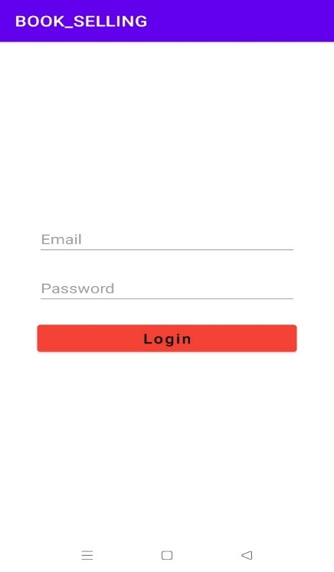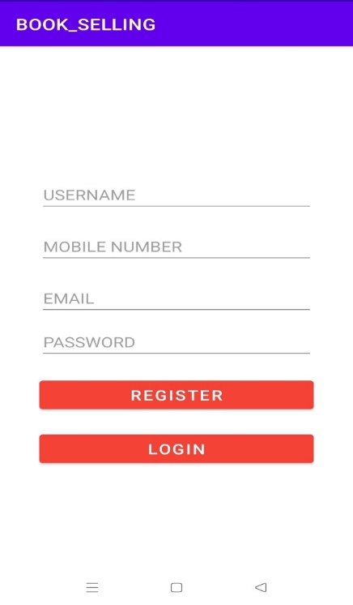

**MAIN USER INTERFACE**

* This will be the main UI of an application.
* On Header it will contain the face of collage and some advertisement can also be done here.
* It contains the different section of an application which can be navigated from here. Basically it contain 8 sections .

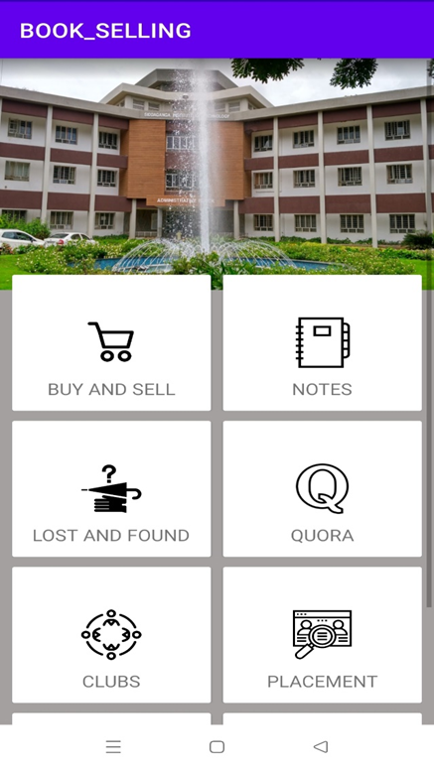

**BUY AND SELL**

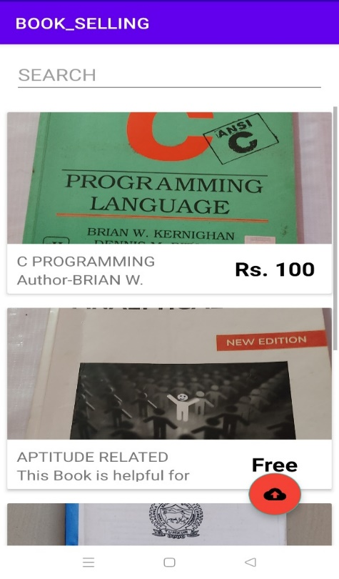

**WHAT WE WANT**

* This application should be made compulsory for all the students of college.
* A creative team and a guide to work on this application.

**THANK YOU**