**Outline Component**

Setup

1. Open project settings. Navigate to the Rendering->Postprocessing section. Set Custom Depth-Stencil Pass to: Enabled with Stencil. A screenshot of a computer

   Description automatically generated
2. Add a Post Processing Volume to your level. A screenshot of a computer

   Description automatically generated
3. Select the newly created post processing volume in your world outliner, open the details panel and look for the Post Process Materials. Add ‘MI_OutlineColored’ to the array.
4. In the same details panel, look for the Post Process Volume Settings and enable ‘Infinite Extent’.

Usage

1. Add the Outline component in your actor components pane.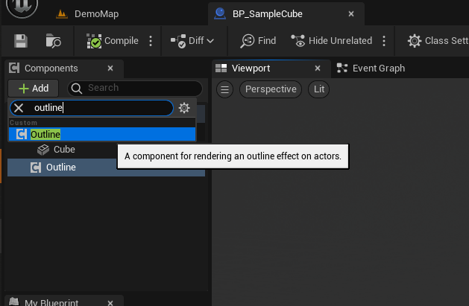
2. Select the newly added outline component and edit the default values in the class defaults.

1. The outline component comes with many useful functions as seen in the image. They are self-explanatory.

1. Further, if you want to edit the outline thickness, fill amount or colors. Open the ‘MI_OutlineColored’ material asset from the content browser and go to the details panel to find the overridable parameters.

