**INTRODUCTION**

The HEALTH-KIT is a modern three level health and fitness club. We provides you the best passionate personal trainers, top fitness classes and strong desire to serve for our members needs,wants and desire. The HEALTH-KIT is the ideal club to achieve your health and fitness goals.

**FITNESS IS NOT ABOUT BEING BETTER THAN SOMEONE ELSE..**

**IT'S ABOUT BEING BETTER THAN YOU USED TO**

[gallery ids="67,48,71" type="columns" orderby="rand"]

[gallery ids="68,53,48,70" type="rectangular"]

**HEALTH-KIT COACHING**

HEALTH-KIT coaching is the most trusted fitness and nutrition coaching program available online. It provides a

* A personal coach who listens to your needs & wants and helps you to solve your problems.
* An expert plan that works for your body and adjusts with your schedule.
* And peace of mind that you're doing the right things to get the best results.

**Fat melts away. Muscle gets uncovered. Strength increases. Little aches and pains all but disappear.**

This will only happen when you stop stressing of  trying to do everything on your own. Instead of  put your trust in a proven process.

**THE DEFINITION OF INSANITY IS DOING THE SAME THING OVER AND OVER AND EXPECTING A DIFFERENT RESULT.**

We’re all ready to take the stress off your plate, give you a personalized plan, and help you finally get the body you want and deserve.

But the next step is yours.

## ****CO-FOUNDERS****

AROOJ IDREES

AIMEN IMTIAZ

MAHAM MARIA

**Founder Gym**

co-founded by Arooj Idrees,Aimen Imtiaz and Maham Maria, is unveiling its online platform to support and train.

Arooj Idrees says, "Fitness is like a relationship you can't cheat and expect it to work"

Aimen Imtiaz says, "There are different muscles you’re going to have to exercise. And you can always get stronger. We want to break the traditional paradigm that you take these accelerators and incubators and then you’re good to go. Becoming a founder is an ongoing process.”

Maham Maria says, "Similar to the gym, it’s about taking the right classes, doing the right exercises and having the best equipment".

### ****MEET THE HEATH-KIT COACHING TEAM****

Each coach is certified through the most-respected fitness organizations or has a nutrition certification or a degree in nutrition.  
  
**LOUIS (FITNESS AND DIET COACH)**

Louis is a psychology researcher, and a life-long fitness and diet coach.

#### ****BJ (HEAD COACH****)

BJ is an exercise coach, field-tested nutrition and diet coach, former sports science lab research assistant, and a life-long lover of movement.

#### ****NATALIE (NUTRITION COACH)****

Natalie is a  Nutrition coach and certified yoga instructor. Her undergraduate degree is in Health Sciences. She’s ready to help you achieve rock-star confidence with your diet.

#### ****JULES (ASSISTANT COACH)****

Jules is a certified strength and conditioning specialist, with a degree in exercise and sport science. Her specialties include sport-specific, post-rehab, fat loss.

#### ****EMILY (NUTRITION COACH)****

Emily is passionate about healthy living, and her approach focuses on guiding, educating, and inspiring others to live fit and eat well in a way that works for your life. She specializes in a whole-foods approach to cooking and food .

# Exercises for Women for weight loss (For Every Part Of Women's Body!)

**Discover the best workout for women**

There's a popular saying among fitness experts: "The best exercise is the one you're not doing." The message is to achieve the best results, you need to regularly challenge your body in new ways. So while classic movements like the push-up, lunge, and squat are the staples of any good workout plan, varying the way you perform these exercises every 4 weeks can help you avoid plateaus, beat boredom, and speed fat loss. We are providing you some worko

## ABS: MOUNTAIN CLIMBER WITH HANDS ON SWISS BALL

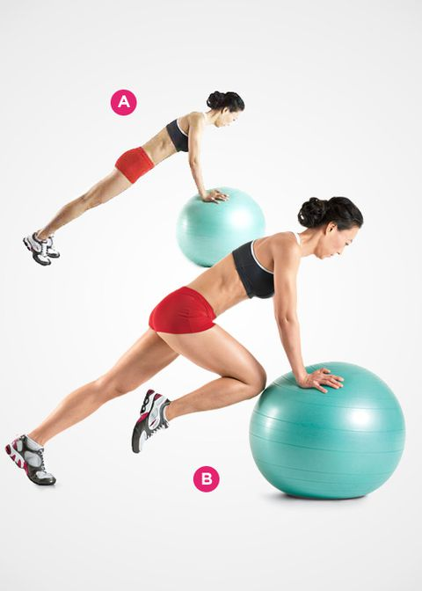

**The benefit:**It's one of the simplest yet most effective ways to tighten your tummy. In fact, you'll barely have to move a muscle.

**How to do it:** Assume a push-up position with your arms completely straight, but place your hands on a Swiss ball instead of the floor. Your body should form a straight line from your head to your ankles. Tighten your core and hold it that way for the duration of the exercise [A]. Lift one foot off the floor and slowly raise your knee as close to your chest as you can without changing your lower-back posture. Then repeat with your other leg. Alternate back and forth for 30 seconds. If that's too hard, place your hands on the floor or a bench, instead of a Swiss ball.

## GLUTES: HIP RAISE

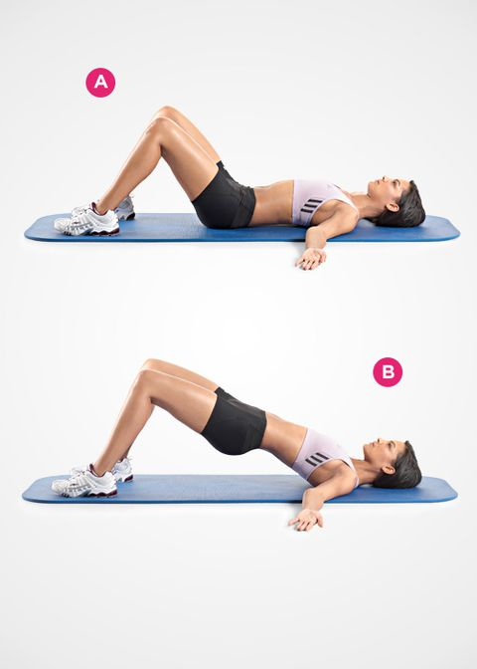

**The benefit:** It targets the muscles of your rear end, which can help make your belly flatter. The reason: When your glutes are weak—as they are in most women—the top of your pelvis tilts forward. This not only places stress on your lower back, but it causes your tummy to stick out—even if you don't have an ounce of fat. Your fix: the hip raise.

**How to do it:** Lie on your back on the floor with your knees bent and your feet flat on the floor [A]. Now brace your core, squeeze your glutes, and raise your hips so your body forms a straight line from your shoulders to your knees [B]. Pause for 3 to 5 seconds—squeezing your glutes tightly the entire time—then lower back to the start.

## QUADRICEPS: OFFSET DUMBBELL LUNGE

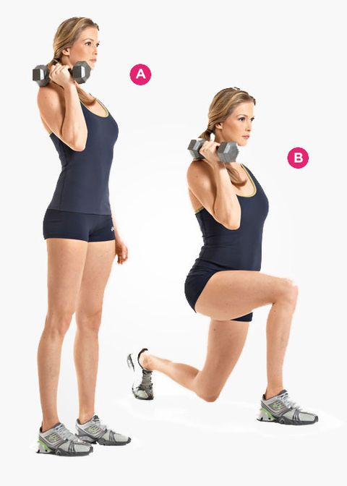

**The benefit:**Holding a weight on just one side of your body increases the demand placed on your core to keep your body stable. The result: Your hips and abs have to work harder, and you'll also improve your balance. And better yet, you'll burn tons of calories.

**How to do it:** Hold a dumbbell in your right hand next to your shoulder, with your arm bent [A]. Step forward with your right leg and lower your body until your right knee is bent at least 90 degrees and your left knee nearly touches the floor [B]. Push yourself back to the starting position. That's 1 rep. Do all your reps, then repeat with your left leg, while holding the weight in your left hand.

## HAMSTRINGS: SINGLE-LEG DUMBBELL STRAIGHT-LEG DEADLIFT

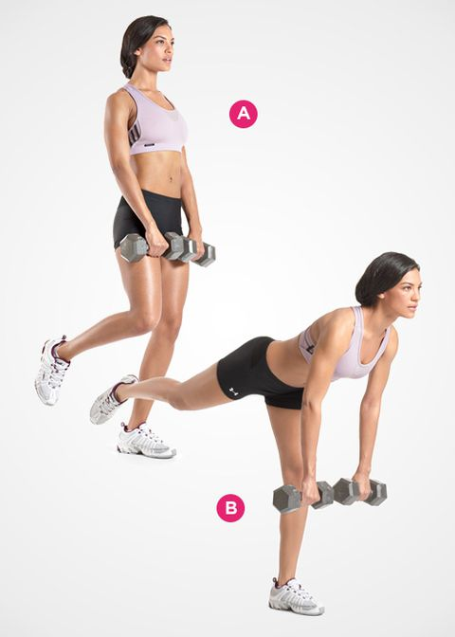

**The benefit:**Besides targeting your hamstrings, this exercise works your glutes and core. It also helps eliminate muscle imbalances between your legs, reducing your risk of injury. And as a bonus, it can even improve the flexibility of your hamstrings.

**How to do it:** Grab a pair of dumbbells with an overhand grip, and hold them at arm's length in front your thighs. Stand with your feet shoulder-width apart and knees slightly bent. Now raise one leg off the floor [A]. Without changing the bend in your knee, bend at your hips (keep your lower back arched), and lower your torso until it's almost parallel to the floor [B]. Pause, then squeeze your glutes, thrust your hips forward, and raise your torso back to the start. Do all your reps, then repeat with your other leg.

## CALVES: SINGLE-LEG DONKEY CALF RAISE



**The benefit:**This simple exercise helps shape your calves in the comfort of your living room.

**How to do it:** Place the ball of one foot on a step, block, or 25-pound weight plate. Cross your other foot behind your ankle. Grasp a sturdy object for support. Then keeping your back naturally arched, bend at your hips and lower your torso until your upper body is almost parallel to the floor [A]. Lift your heel as high as you can [B]. Pause, lower your heel, and repeat. Complete as many reps as you can—or for a duration of 60 seconds—then switch legs.

## CHEST: SINGLE-ARM DUMBBELL BENCH PRESS

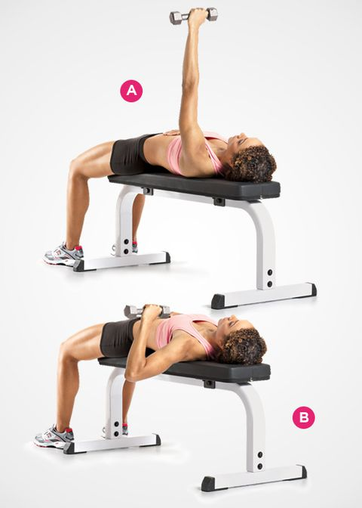

**The benefit:** This exercise works your glutes and abs as hard as it works your chest and triceps. So you'll tighten your hips and core as you tone your upper body.

**How to do it:** Grab a dumbbell in your left hand and lie on your back on a flat bench, holding the dumbbell over your chest with your arm straight. Your palm should be facing out, but turned slightly inward. Place your right hand on your abs [B]. Lower the dumbbell to the side of your chest. Pause, then press the weight back to the start. Want an even greater challenge? Slide over so that only your right butt cheek and right shoulder blade are on the bench. (Don't let your hips sag; you'll have to place your left foot wider to maintain your balance.) Do all your repetitions, then repeat on your right side.

## SHOULDERS: SCAPTION AND SHRUG

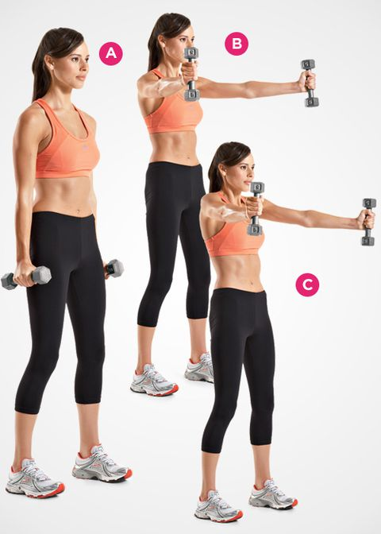

**The benefit:** When you raise the dumbbells to start this exercise, you target the front of your shoulders as well as your rotator cuff. Then comes the shrug. This part of the move helps better balance the muscles that rotate your shoulder blades. The end result: Great-looking shoulders and better posture.

**How to do it:** Stand holding a pair of dumbbells with your feet shoulder-width apart. Let the dumbbells hang at arm's length next to your sides, your palms facing each other [A]. Without changing the bend in your elbows, raise your arms until they're parallel to the floor, keeping them at a 30-degree angle to your body (so that they form a "Y") [B]. At the top of the movement, shrug your shoulders upward [C]. Pause, then reverse the movement to return to the start, and repeat.

## TRICEPS: SWISS-BALL LYING TRICEPS EXTENSION

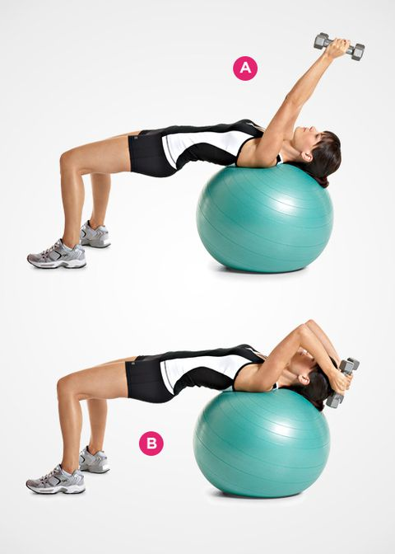

**The benefit:** Lying on a Swiss ball forces your core to work harder to keep you stable. So you work your abs as you shape the backs of your arms.

**How to do it:** Grab a pair of dumbbells and lie on your back on a Swiss ball so that your middle and upper back are firmly on the ball. Raise your hips so that your body forms a straight line from your knees to your shoulders. Hold the dumbbells over your forehead, with your arms straight and your palms facing each other [A]. Without moving your upper arms, bend your elbows to lower the dumbbells until your forearms are beyond parallel to the floor [B]. Pause, then lift the weights back to the start by straightening your arms.

## BICEPS: SPLIT STANCE DUMBBELL CURL

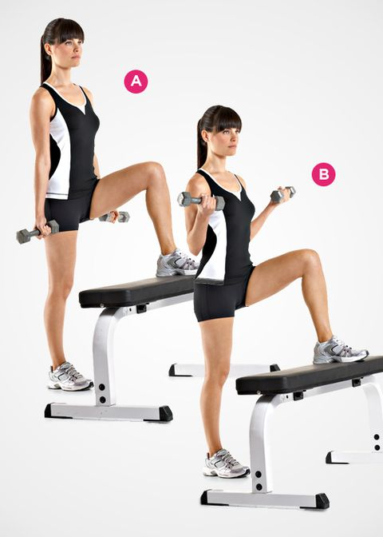

**The benefit:** Placing one foot in front of you on a bench forces your hip and core muscles to work harder in order to keep your body stable. That way, you engage more muscles and burn more calories than you would if you did the exercise in a regular standing position.

**How to do it:** Grab a pair of dumbbells and place one foot in front of you on a bench or step that's just higher than knee level. Let the dumbbells hang at arm's length next to your sides, your palms facing forward [B]. Without moving your upper arms, bend your elbows and curl the dumbbells as close to your shoulders as you can [B]. Pause, then slowly lower the weights back to the starting position. Each set, switch the foot that you place on the bench.

## FOREARMS: PLATE PINCH CURL

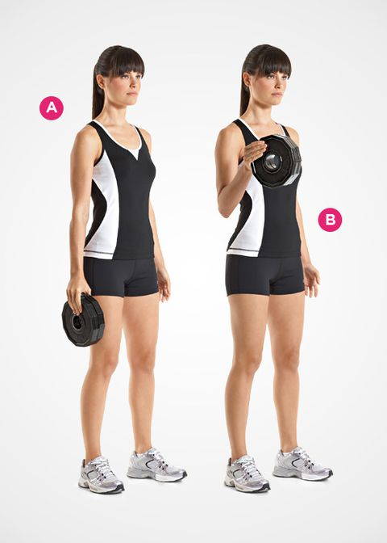

**The benefit:** Strengthens the muscles of your forearms, hands, fingers, and thumbs, while also shaping your biceps. Bonus: Makes you better at opening jars, too.

**How to do it:** Grab a pair of light weight plates in your right hand. Hold the two plates together with your fingers and thumb by pinching the smooth side of the plates. Let the plates hang at arm's length next to your side [A]. Without moving your upper arm, bend your elbow and curl the weights as close to your shoulder as you can [B]. Slowly lower the weights back to the starting position and repeat.

## UPPER BACK: SWISS-BALL L RAISE

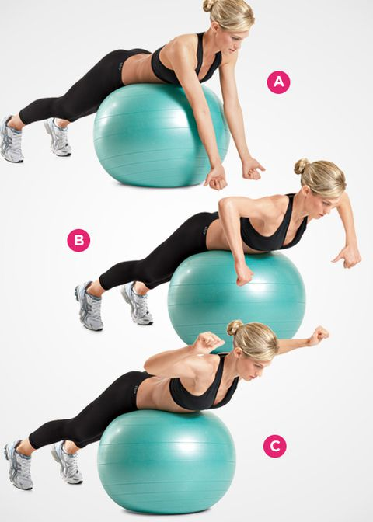

**The benefit:** This exercise targets your upper back. By working these key muscles, you'll improve your posture, shape the back of your shoulders, and look great in a backless dress.

**How to do it:** Lie facedown on top of a Swiss ball so that your back is flat and your chest is off the ball. Let your arms hang straight down from your shoulders, your palms facing behind you [A]. Keeping your elbows flared out, lift your upper arms as high as you can by bending your elbows and squeezing your shoulder blades together. Your upper arms should be perpendicular to your torso [B]. Without changing your elbow position, rotate your forearms up and back as far as you can [C]. Pause, then reverse the movement. If you can do more than 12 repetitions, use dumbbells.

## LATS: BAND-ASSISTED CHINUP

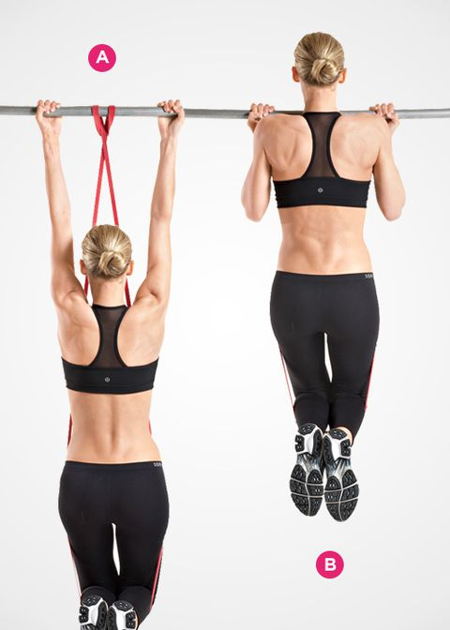

**The benefit:** This exercise allows you to do full chin-ups, even if you've never managed a single one. Plus, it more accurately mimics the movement than lat pull-downs or the assisted chin-up machine. All you need is a chin-up bar and a large rubber band called a Super Band.

**How to do it:** Loop one end of a SuperBand around a chinup bar and then pull it through the through the other end of the band, cinching it tightly to the bar. (The thicker the band you buy, the more assistance it will provide.) Grab the bar with a shoulder-width, underhand grip, and place your knees in the loop of the band. Hang at arm's length [A]. Perform a chinup by pulling the top of your chest to the bar [B]. Pause, then slowly lower your body back to the starting position.

## LOWER BACK: MCGILL CURLUP

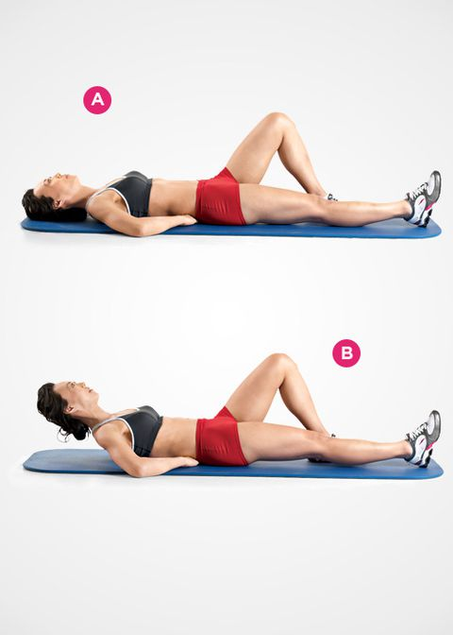

**The benefit:**This exercise works your entire abdominal muscle complex while keeping your lower back in its naturally arched position. So it minimizes stress on your spine while increasing the endurance of the muscles, which helps prevent lower-back pain.

**How to do it:** Lie on your back on the floor with your right leg straight and flat on the floor. Your left knee should be bent and your left foot flat. Place your hands palms down on the floor underneath the natural arch in your lower back [A]. Slowly raise your head and shoulders off the floor without bending your lower back or spine, and hold this position for 7 to 8 seconds, breathing deeply the entire time [B] switch legs and repeat.

### ****YOGA****

[gallery ids="50,51,52,53,54" type="circle"]

**The benefit:**

benefits of yoga include:

Increased flexibility, Increased muscle strength and tone, Improved respiration, energy and vitality, Maintaining a balanced metabolism, Weight reduction, Cardio and circulatory health, Improved athletic performance and Protection from injury.

**How to do it:**

**Triangle pose**: Engage your core and align your shoulders with your hips.

**Tree pose**: Lower your shoulders and place the sole of your foot above or below your knee.  
**Chair pose**: Raise your chest toward the sky and keep your shoulders down and back.

### ZUMBA:

[gallery ids="47,48,55,56" type="circle" columns="2"]

**The benefit:**

benefits of zumba include: Calorie and fat burning , Improved coordination, Full body workout, loss weight, Aerobic benefits,  increase the strength of your heart, It gets you hooked on exercise , Everyone can join in , Increased confidence , Mood boosting and It’s social.

**How to do it:**it is like a dance you can do any steps you like. In this you only have to move your body and feel free.