**Database Group 5**

**The CRAM Reservation System**

*Final Phase Documentation*

Appalachian State University

Database 3430

Dr. Rahman Tashakkori

Sina Tashakkori, Chris Hegre, Nathan Hernandez, Jennifer Lindley

May 2nd, 2013

**Project Description:**

Classroom Reservations with Automated Management (CRAM) is a user-friendly tool which allows students, groups, and teachers to reserve classrooms in buildings across campus without having to go through secretaries or heads of departments. This tool is being created because of a direct need noticed by faculty, staff, and students. Some features of CRAM are: room searches based on size of group, equipment in room, or time available; other features include automatic reservations and canceling of reservations, off-campus online access, and email reminders of reservations. Our database will contain various tables: BUILDING, ACCOUNT, DEPARTMENT, EQUIPMENT, RESERVATION, and ROOM. This database, used to manage each of the reservations, will be the heart of CRAM and used to store all pertinent data.

**Project Objective:**

The objective of the project is to allow students and faculty to reserve rooms for a specific occasion in an on-campus building. The database will keep track of what rooms are owned by a specific department and notify department heads when a room reservation are made.

**Group Responsibilities:**

Team Leader - Sina

Development Manager - Chris

Planning Manager- Jennifer

Quality/Process Manager - Every member

Support Manager – Nathan

**Group Communicator:**

Jennifer Lindley

**Conceptual Schema**

**BUILDING**

|  |  |  |  |  |  |
| --- | --- | --- | --- | --- | --- |
| bldg_name | bldg_address | bldg_state | bldg_zip | bldg_longitutde | bldg_latitude |

|  |  |  |  |  |  |  |
| --- | --- | --- | --- | --- | --- | --- |
| acct_username | acct_password | acct_salt | acct_type | acct_first_name | acct_last_name | acct_phone_number |

**ACCOUNT**

**DEPARTMENT**

|  |  |  |  |
| --- | --- | --- | --- |
| dpt_name | dpt_prefix | dpt_college | dpt_phone_number |

**ROOM**

|  |  |  |  |  |  |
| --- | --- | --- | --- | --- | --- |
| room_number | room_doors | room_seats | room_connected | room_handicap | room_lab |

**EQUIPMENT**

|  |  |
| --- | --- |
| eqpt_name | eqpt_quantity |

**RESERVATION**

|  |  |  |  |  |
| --- | --- | --- | --- | --- |
| resv_id | resv_start | resv_end | resv_size | resv_reason |

**Ajax Functional Design:**

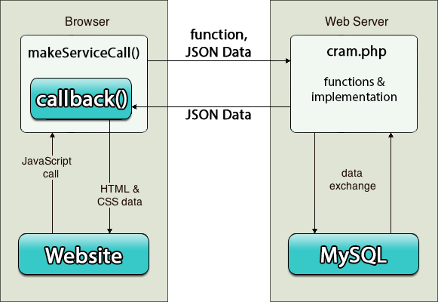

**Software and Applications:**

The following software was used: LucidDiagrams, phpMyAdmin, Microsoft Office, Google Chrome, Google Chrome Developer Tools, Notepad++, MySQL, GrooveShark

**Languages:**

HTML, CSS, PHP, JavaScript, MySQL, jQuery, jQueryUI, JavaScript Date Format

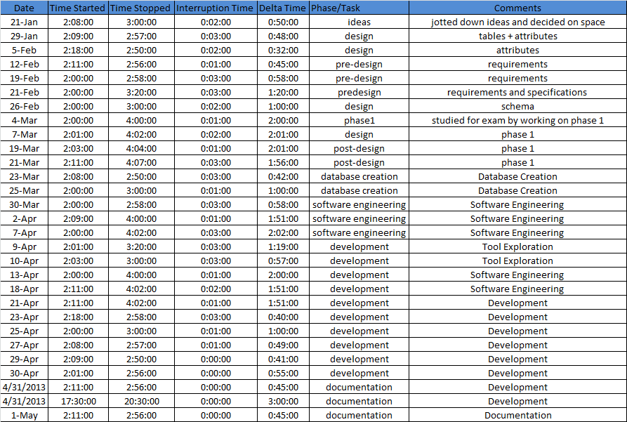 **Nathan’s Timelogs**

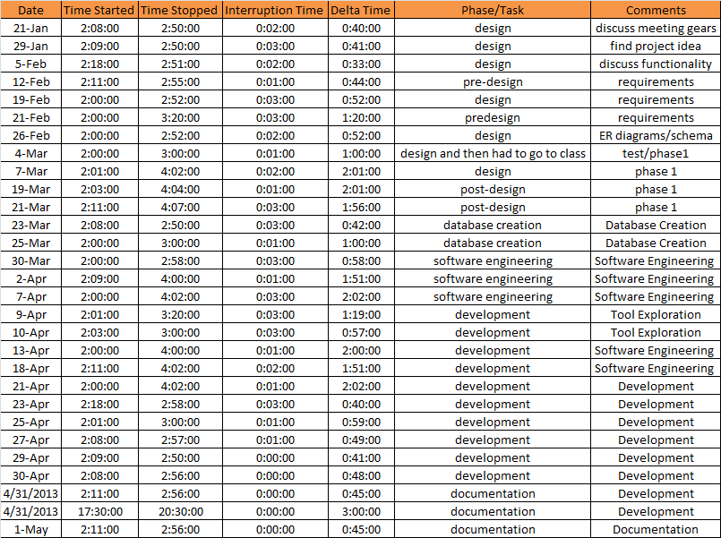**Chris’ Timelogs**

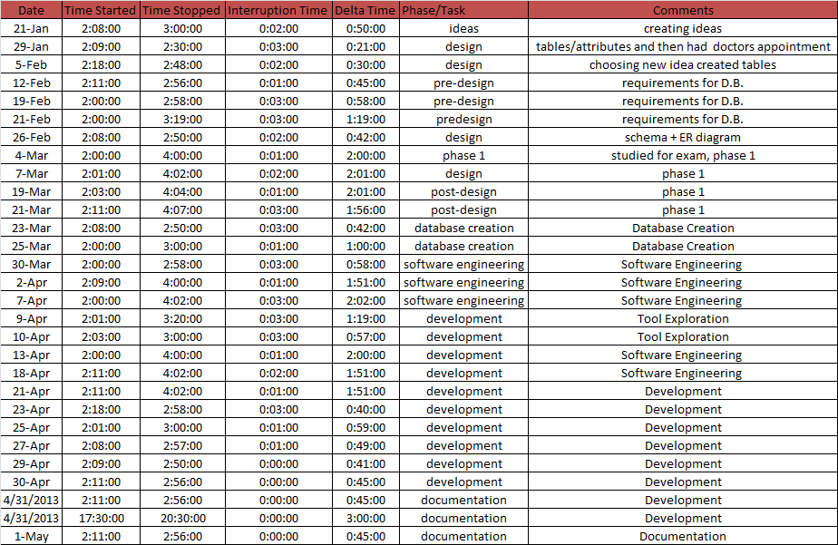**Jennifer’s Timelogs**

**Sina’s Timelogs**

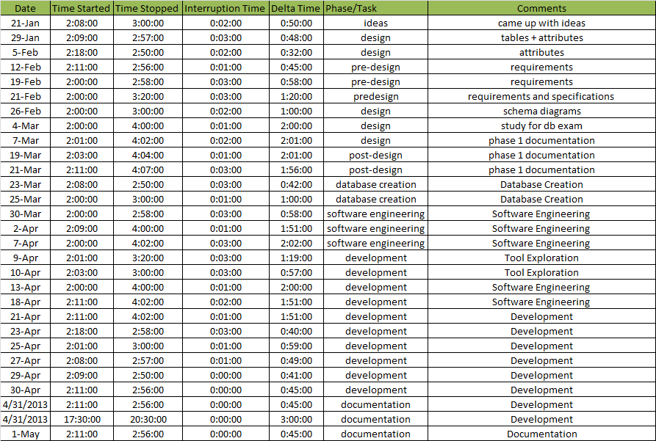

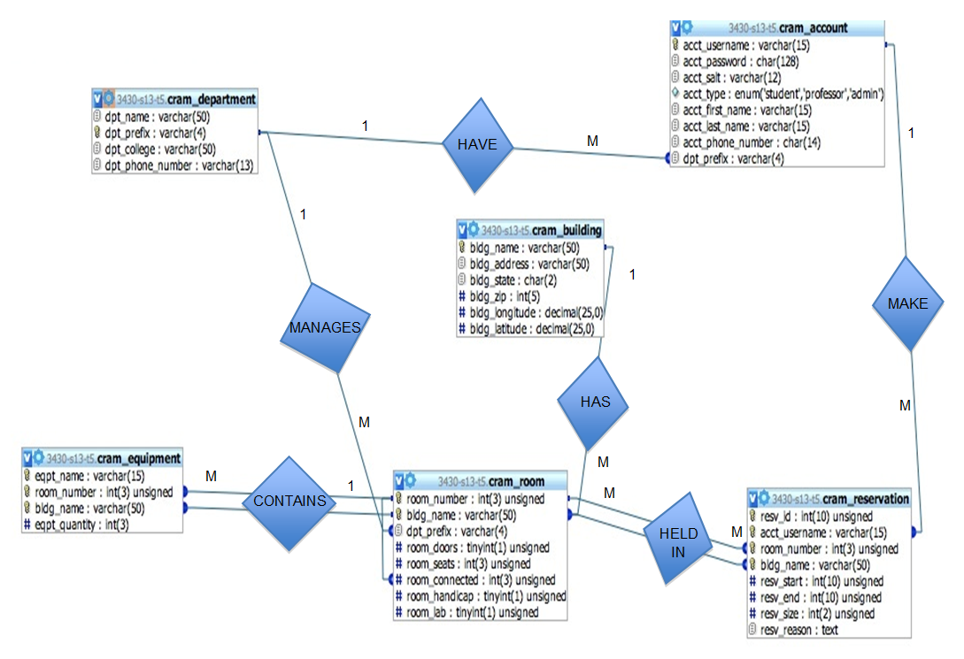

**ER Diagram**

**Project Planning & Timeline:**

|  |  |
| --- | --- |
| 21-Jan | Come up with idea for project |
| 29-Jan | Plan tables and discuss design of database |
| 5-Feb | List attributes and table placement. |
| 12-Feb | Work on requirements and specifications |
| 19-Feb | Work on requirements and specifications |
| 21-Feb | Work on requirements and specifications |
| 26-Feb | Create schema and ER diagram |
| 4-Mar | Group study for database exam |
| 7-Mar | Work on Phase 1 |
| 19-Mar | Work on Phase 1 |
| 21-Mar | Work on Phase 1 |
| 26-Mar | Database Creation |
| 28-Mar | Database Creation |
| 4-Apr | Database Creation |
| 9-Apr | Software Engineering |
| 11-Apr | Software Engineering |
| 16-Apr | Software Engineering |
| 18-Apr | Software Engineering |
| 23-Apr | Software Development |
| 25-Apr | Software Development |
| 30-Apr | Software Development |
| 2-May | Software Development |
| 7-May | Testing |
| 9-May | Testing |
| 10-May | Demo project, submit, final exam and party time |

**Client Interview:**

We met with a client, Rahman Tashakkori, these days as a group: 21-Jan, 29-Jan, 5-Feb, 12-Feb, 19-Feb, 21-Feb, 26-Feb, 4-Mar, 7-Mar, 19-Mar. We met at this time: 2:00pm-2:30pm.

When consulting with the client, several requests and concerns were raised. An initial concern was the focus of the database which initially entailed a spaceport marketplace application for children. The client convinced us that a there existed a more relevant and important database application that we could build. We then changed our focus to building a database for room reservation on campus. The client also requested a revision in our ER diagram step to not include Reservations as a table but instead as a relationship between Room and Accounts.

The client also suggested that Accounts does not and should not include the BannerID of a student due to University privacy issues. Based on that advice, the user will have to register via Username and Password.

**Important Resource Links:**

http://stackoverflow.com/questions/2113382/jquery-ajax-functions-error-message-source

http://stackoverflow.com/questions/2113382/jquery-ajax-functions-error-message-source

http://encosia.com/use-jquery-to-catch-and-display-aspnet-ajax-service-errors/

http://stackoverflow.com/questions/10498376/javascript-confirm-box

http://csstricks.com

http://student.cs.appstate.edu/classes

http://w3pschools.com

http://tizag.com

http://docs.oracle.com

**List of Questions:**

What is the purpose of the DB?

Is there a way to check room availability in a building?

Is it user friendly?

How does it work?

How do we manage room availability?

What is a group?

Can several groups occupy one room?

Online user interface?

Who needs the room?

Class?

Team?

Club?

Group?

Room priority?

Is the room request appropriate?

Who approved the meeting?

Time limits on room occupation?

Time/Room?

Equipment in room?

Seats?

Scheduling (M/W/F? bi-monthly?)

Reservation System?

Who has reserved the room?

Which department manages the room?

Reason to use room?

Automatic reservation with override capabilities?

Is food/beverages allowed in the room?

Restricted rooms (grad labs, printing rooms, offices, etc.)?

Office hours reservations?

Automatic re-arrangement when a class is overridden (email room owner)?

**Catalog:**

Building

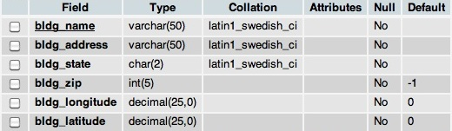

Department

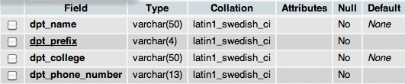

Room

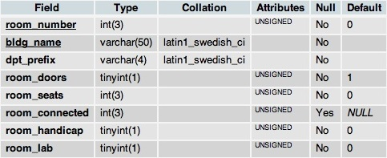

Equipment

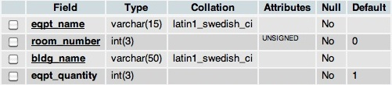

Account

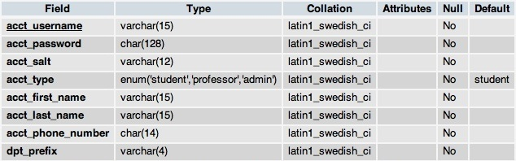

Reservation

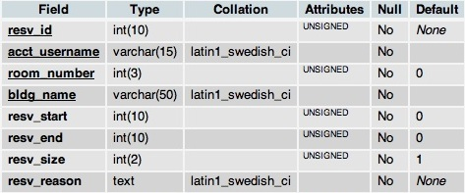

**Summary**

CRAM is designed to further education by providing students and facility the ability to reserve classrooms using their ASU login user name and password. Facility members have the ability to delete any student’s classroom reservation as long as the room is within their department. On the other hand, students may not delete another student’s reservation. To reserve a room, a student/facility selects the building name, room, date, start time, ending, and enters group size, and the reason the room is being reserved. Overrides can be performed by people with higher priorities and CRAM will automatically send email notifications to the person(s) who had reserved the room originally.