Assignment 2
dotnet
Shaunagh Kelly (50004051)
serc
Contents
Instructions 2
Add product 2
Get Product 2
Add Order 2
Get Order 2
Add Order details 2
Get Order Details 2
Get Order Total 2
Test Plan 3
Unit test report 5
Test Strategy 6
Product 6
Order 6
Order Details 6
Order Total 7

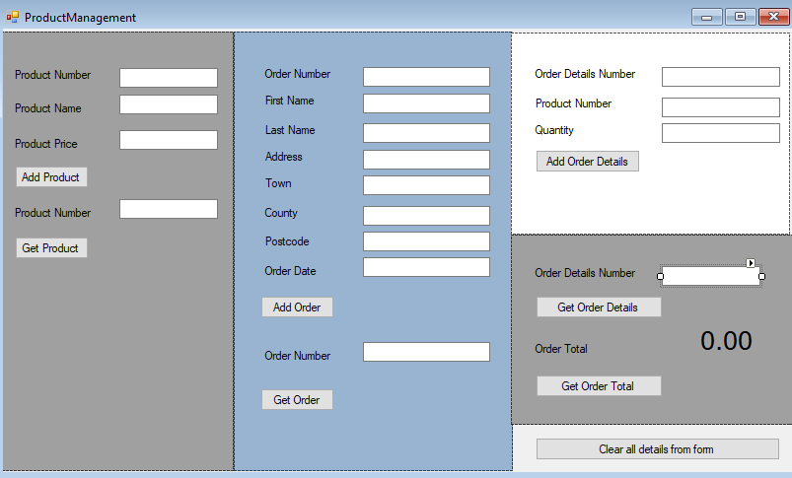

Instructions

Add product
- Enter product number
- Product name
- Product price
- Click “Add product”
- Product number generated

Get Product
- Enter Product number second Product Number box
- Click “Get Product”
- Product details returned

Add Order
- First Name
- Second name
- Address
- Town
- County
- Postcode
- Order date - I would like to have made the system automatically fille this in
- Click “Add order”
- Order Number is generated
- Form is cleared

Get Order
- Enter Order number in second “Order Number” text box
- Click “Get Order”
- Order details returned

Add Order details
- Enter Product number in third pane - This I would have liked to generate a drop down with the list of objects from the OrderFunctionality class
- Enter quantity
- Click “Add order details”
- Order Details Number is generated
- Form is cleared

Get Order Details
- Enter Order Details number in second “Order Details Number” text box
- Click “Get Order Details”
- Order details returned

Get Order Total
- Enter Order Details number in second “Order Details Number” text box
- Click “Get Order Total”
- Order total returned – see test plan

Test Plan

Unit tests are added as each function has been created. This is to confirm each unit behaves as expected. The end to end tests will be completed manually.
To run unit tests under package manager add Nunit3 and Nunit3 adapter
And search for and install Resharper.
- Click on Extensions
- Resharper
- Unit Tests
- Run all tests
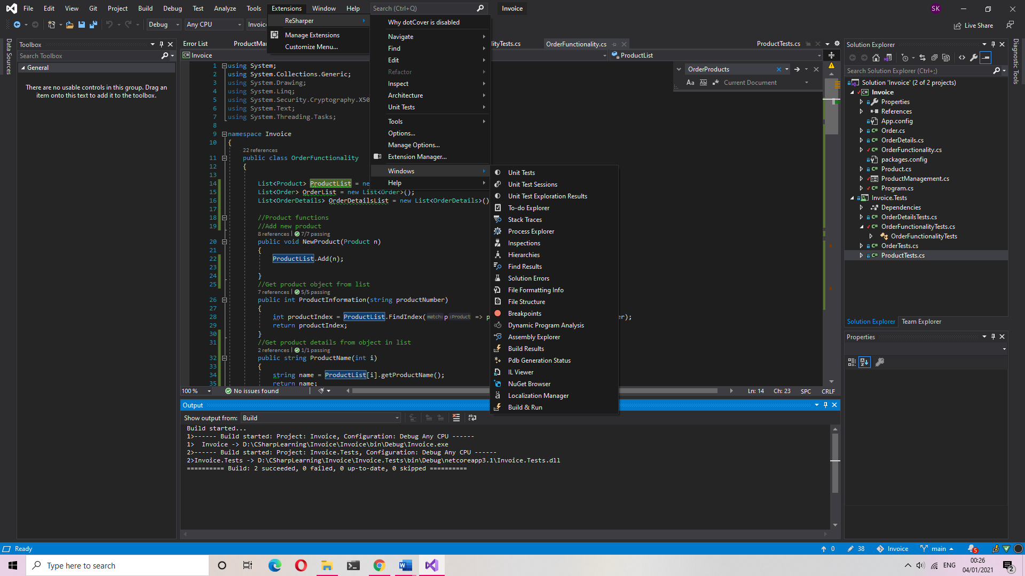

Unit test report
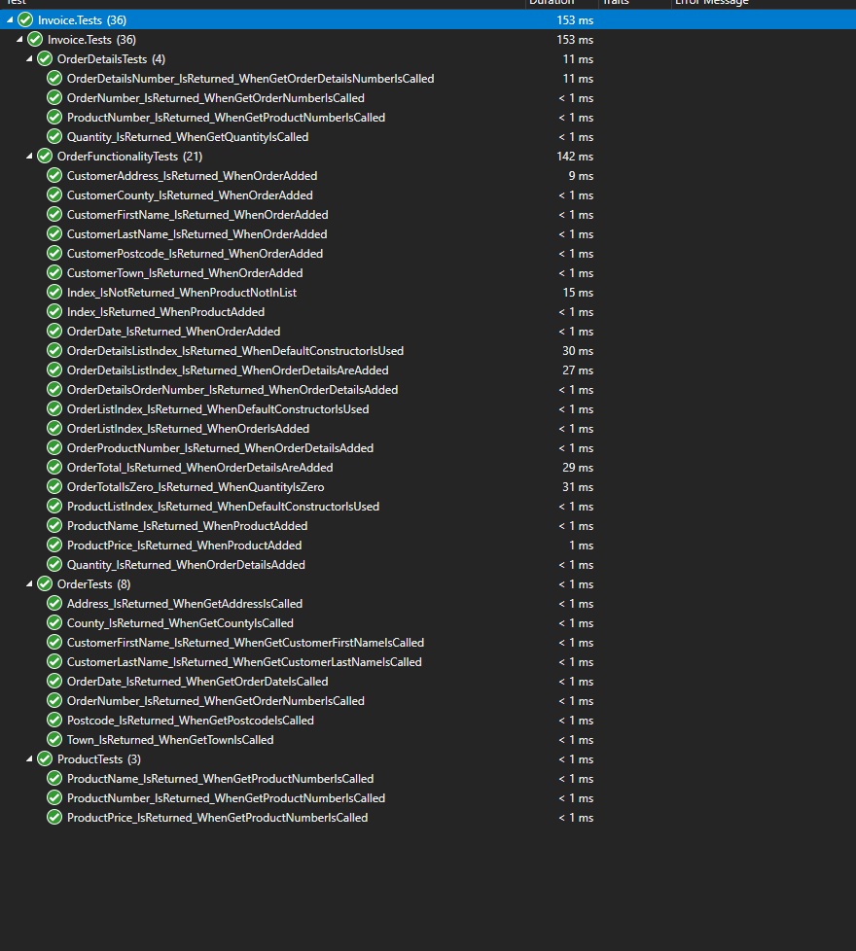

Test Strategy

Use guards to prevent user from inputting data that would cause the system to crash.
- Where required fields are empty do not proceed
- Block user from editing product/order/order details numbers when adding to array
- Try/catch block around get functions to prevent program from crashing
- Use of message boxes to direct user
- Set text boxes to only allow decimals in monetary fields or integers in quantity fields

Product

Add product to system with all fields missing | Pop up displayed to user “Please enter all values” | Passed
Add product to system with one field missing | Pop up displayed to user “Please enter all values” | Passed
Add product with all fields present | No error and product number incremented and form cleared | Passed
Get product that does not exist | Error returned to user "Product not Found, check product number and retry" | Passed
Get product that does exist | Details are displayed on form | Passed

Order
Add order to system with all fields missing | Pop up displayed to user “Please enter all values” | Passed
Add order to system with one field missing | Pop up displayed to user “Please enter all values” | Passed
Add order with all fields present | No error and order number incremented and form cleared | Passed
Get order that does not exist | Pop up displayed to user “Order not Found, check order number and retry” | Passed
Get order that does exist | Details are displayed on form | Passed

Order Details

Add order details to system with all fields missing | Pop up displayed to user “Please enter all values” | Passed
Add order details to system with one field missing | Pop up displayed to user “Please enter all values” | Passed
Add order details with all fields present | No error and order number incremented and form cleared | Passed
Get order that does not exist | Pop up displayed to user “Order details not Found, check order number and retry” | Passed
Get order details that does exist | Details are displayed on form | Passed

Order Total

Get order total for order details number that does not exist | Pop up displayed to user “Order details not Found, check order number and retry” | Passed
Get order details that does exist | Order total is updated on form | FAILS  This is NOT working – I have a function in the OrderFunctionailty class and unit tests that do work. I cannot figure out why the page is not returning the total – but it looks like either it cannot find the product from the ProductList OR the Order Details from the OrderDetailsList array list.

