For the project we were tasked with creating a program that would read in a text file and save off the frequency of each product in the file. To start this I decided to use the recommendation of the instructions and use a map. This map I decided to initialize with strings and ints to count the freq. 

In the constor decided to pass in a ifstream reference to allow me to loop through the file contents to load up the map. This is done by this logic here.

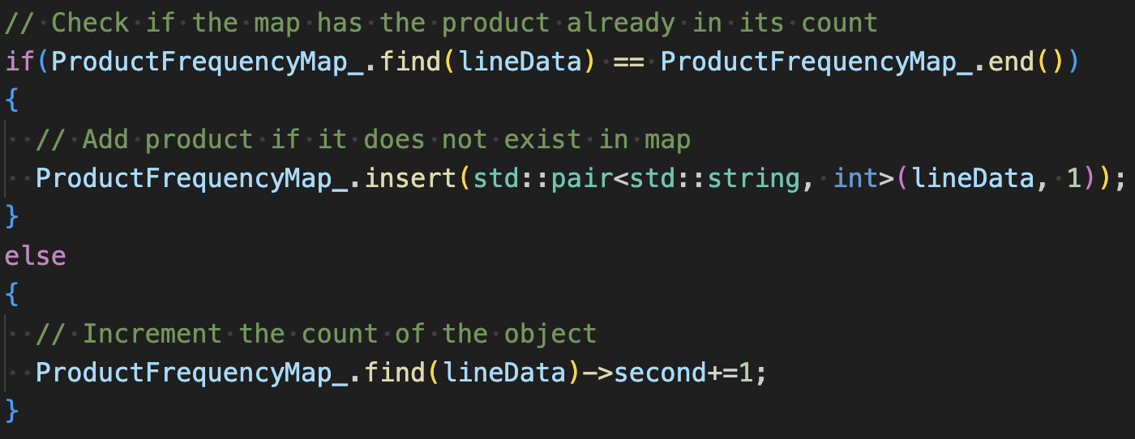

This will confirm that it is only ever adding new products and incrementing an existing count if one exists in the map for the product. Then to make sure that the frequencies are saved, after the map is filled we then call createDataFile to output the frequencies to frequency.dat without inputs from users. After this, the main for the user begins. The menu is then printed and then the prompted answer from the user will be passed into printProductFrequncy. This will then use a switch to decide what way the user requested the data to be output to the screen. After outputting the requested way, or printing an input error message it will then reprint the menu to the screen and re-request input from the user. At this point the user can loop through all options or leave at any time by hitting 4.