Title: Customization and Implementation of
OTECH P-Management System

Presented by: Simon Temesgen
Full stack Web developer
Date: Jun 30 2024

Contents
Objective ………………………………………………………………………2
Scope …………………………………………………………………………..2
System architecture ……………………………………………………….3
Project folder structure …………………………………………………..4
Description of folder components …………………………………….5
Hosting OTECH P-Management………………………………………..9
Customization highlights ………………………………………………..10
System workflow exploration…………………………………………….11

Objective:
- Customization: Transform OpenProject into a branded solution customized for OTECH's project management needs.
- Improved User Experience: Enhance the user interface and navigation to streamline project management workflows.
- Feature Customization: Align features and functionalities with OTech's specific project management requirements.

Scope:
The scope of the project includes:
- System Customization: Customize OpenProject to incorporate OTech’s branding, workflows, and specific project management requirements.
- Deployment: Ensuring the customized system is thoroughly tested and deployed on linux server.

System Architecture
Ruby on Rails follows the MVC architecture pattern
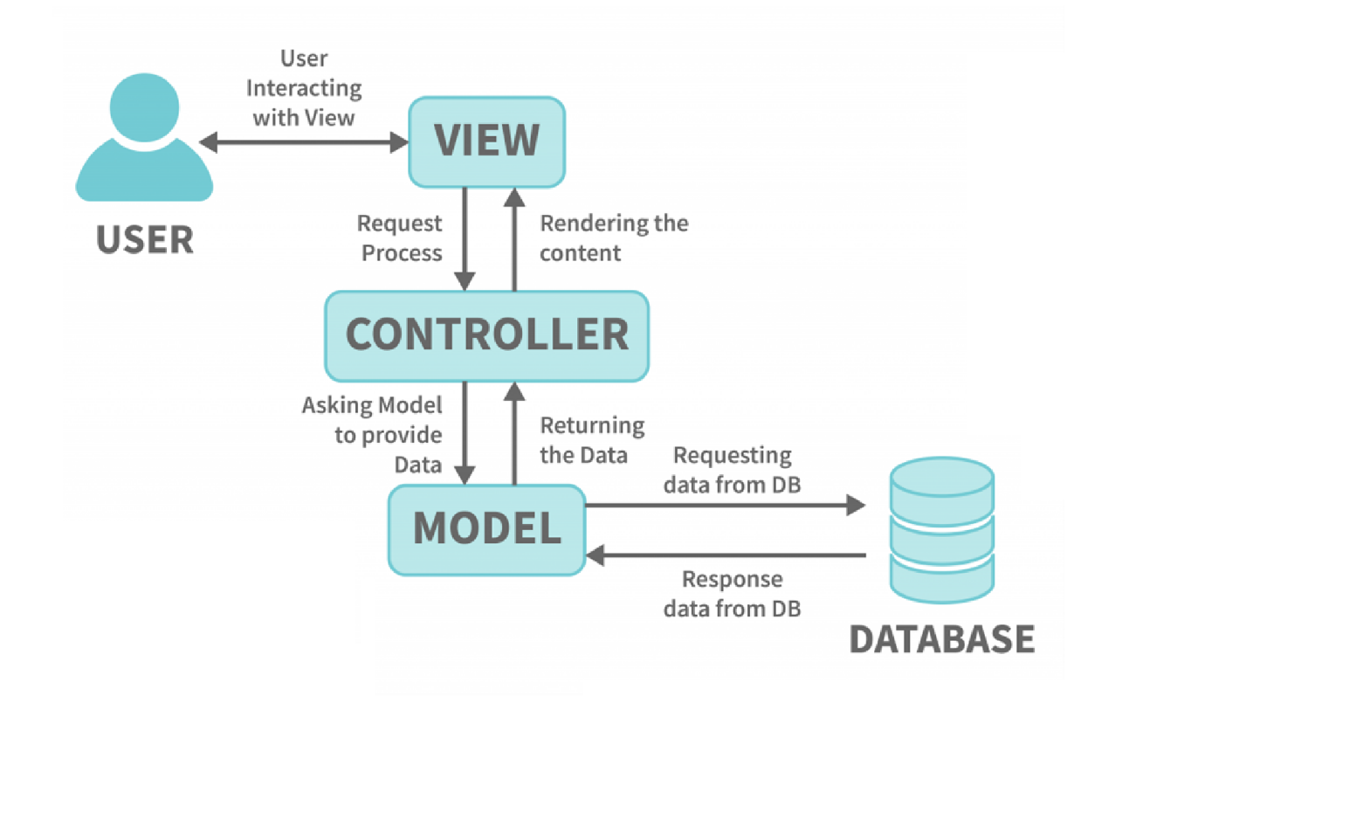

Project folder structure
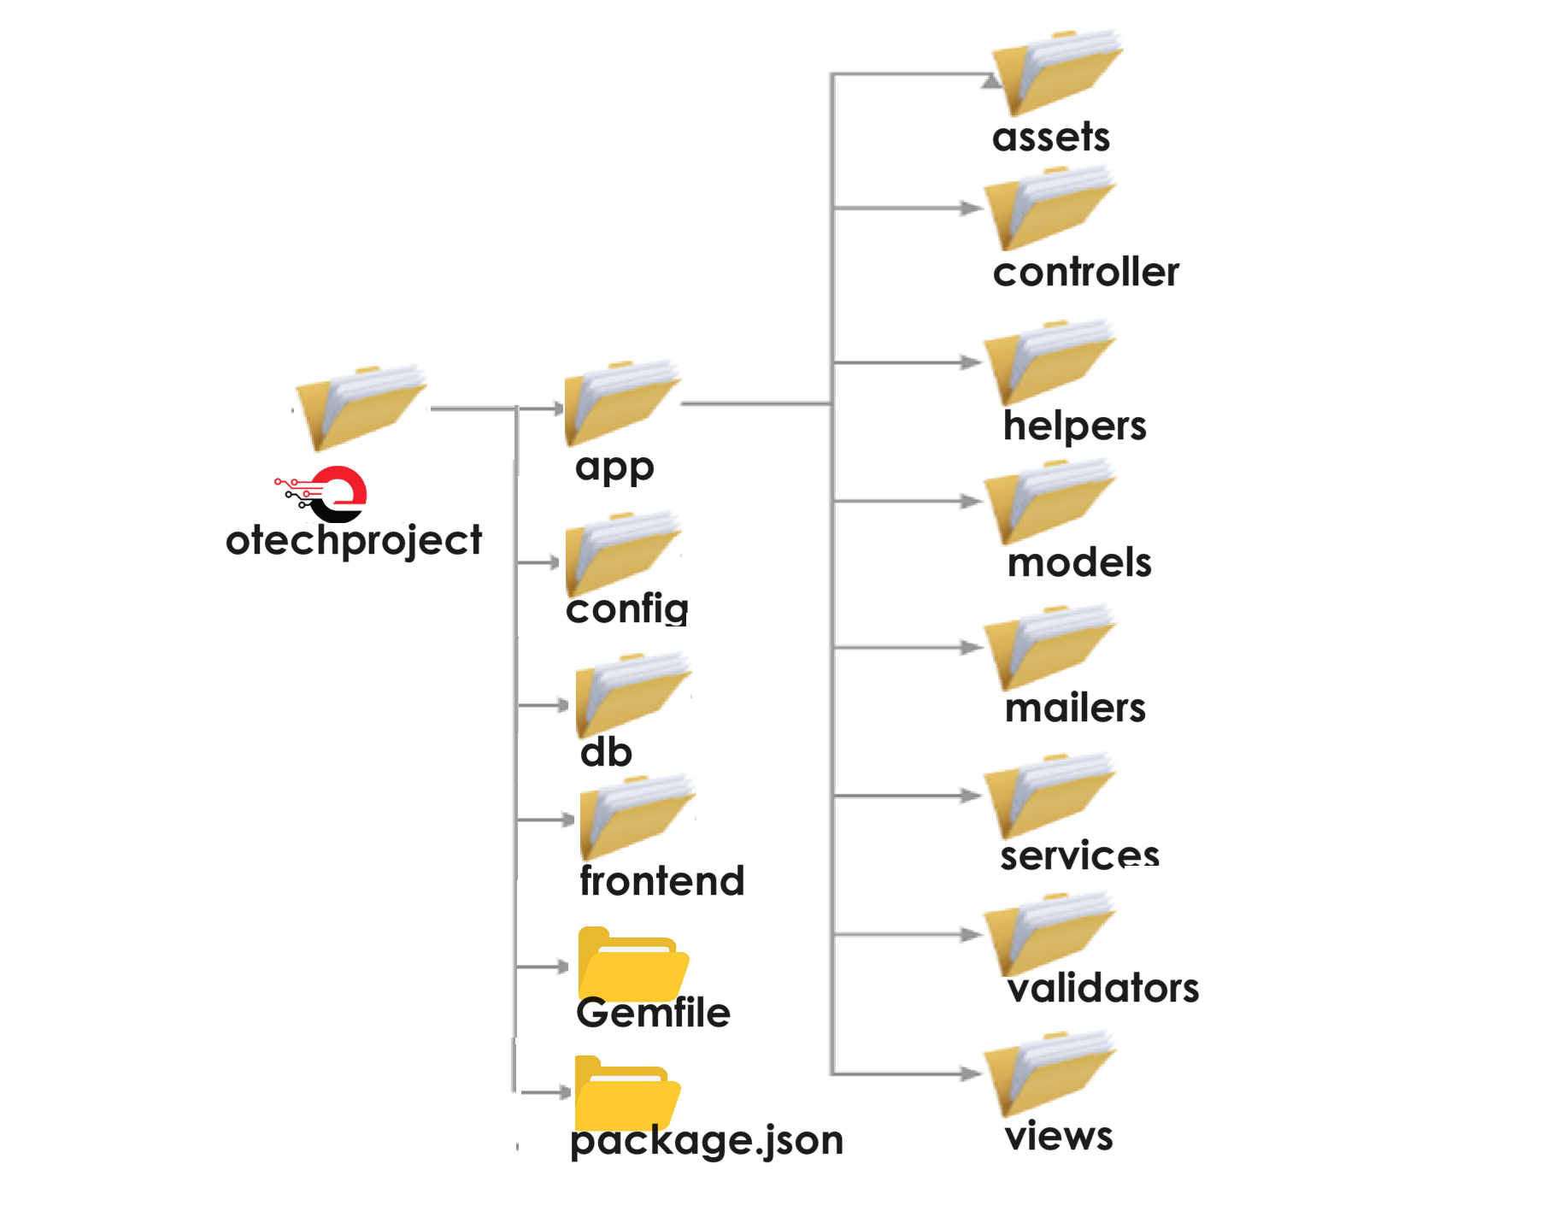

Description of folder components
app/ : This is where the main application code is located. It contains subdirectories for different components of the application:
- assets/: Contains asset files like images, JavaScript, and stylesheets
- controllers/: Contains controller files that handle requests and responses.
- helpers/: Contains helper modules used to assist views
- models/: contain models that define project management entities like projects, tasks, users,
- views/: Contains view templates (html,erb) used to render the UI
- mailers/: Contains mailer classes responsible for sending emails.
- services/: Contains service objects for business logic that doesn’t fit in models or controllers.

config/: Contains configuration files and subdirectories for various settings
- application.rb : This is the main configuration file for the Rails application. It sets up the Rails environment and loads all other configuration files.
- environment/: contains environment specific settings
- environment.rb: setup rails environment.
≈ Equivalent to Java Springboot application.properties
- locales/ :This directory contains localization files. These files are used to provide translations for different languages supported by the application
- puma.rb : This file contains configuration settings for the Puma web server, which is often used to run Rails applications.
- routes.rb: defines the routes for the application. It maps URLs to controller actions. ≈ In java routes are defined with in controller classes like GetMapping,PostMapping,PutMapping used to mapp http request to specific methods
- database.yml: This file contains the database configuration for different environments (development, test, production). It specifies the database adapter, database name, username, password, host, and other database-specific
settings.
db/: Contains database-related files
- migrate/: database migration files for schema changes
- schema.rb: Database schema
- seeds.rb: Data seeding script
Gemfile: Defines gem dependencies for the application
package.json: lists the angular js libraries

Models: contain models that define project management entities like projects, tasks, users,Are responsible for interacting with the database.
Its subclass of ActiveRecord::Base,they inherit a lot of functionality from ActiveRecord library
In rails ApplicationRecord, in springboot we call it @Entity

≈ ActiveRecord(Ruby ORM) In java we call it (Repository or DAO)
ActiveRecord
Is the module for handling business logic and database communication. It plays the role of model in our MVC architecture.

Services: In Rails are often used for complex operations, third-party API integrations
They make the code easier to understand and maintain.
Code reusability across different parts of the application,
Dependency Injection:
Rails can use dependency injection libraries like dry-container
≈ Spring Boot has built-in support for dependency injection using the @Autowired
ActionController :Is the component that handles browser requests and facilitates communication between the model and the view. controllers will inherit from this class.
Key responsibilities
Routing: It maps incoming HTTP requests to controller actions.
Parameters Handling: It handles parameters passed in HTTP requests.
Rendering Views: It renders views to the user, either as HTML, JSON, XML
≈ In Springboot Java,its equivalent to @Controller class or @RestController
1) Routing: It maps HTTP requests to handler methods using @RequestMapping or its specialized forms like @GetMapping, @PostMapping, etc.
2) Parameters Handling: It handles request parameters using annotations like @RequestParam, @PathVariable, etc.
3)Rendering Views: It returns views to the user using ModelAndView.

Views
ActionView is the component that handles the presentation of pages returned to the client. Views inherit from this class.
View responsibilities:
Template Rendering: Renders HTML templates to generate the user interface.
Layouts and Partials: Supports layouts and partials for reusable views.
Helpers: Provides helper methods for commonly used view tasks (e.g., form helpers, URL helpers).
Form Builders: Helps in creating forms with proper naming conventions and data binding.
Localization and Internationalization: Supports localization and internationalization of views.
≈ In Springboot Java views are rendered using Thymeleaf or JSP

Hosting OTECH P-Management
To host OTECH P-Management, I followed these requirements for setting up on a Linux server:
- Operating System: Linux server
- CPU: 4 VCPU
- RAM: 8GB
- HDD: 50GB (expandable)
- Server Access:
Logged in via SSH using ssh openproject@172.10.10.83.
- Server Preparation: Updated and upgraded packages with sudo apt update and sudo apt upgrade -y.
- Environment Setup: Installed necessary dependencies to run otechProject.
This included ,
- installing ruby,
- rails,
- node,
- npm,
- postgresql,
- push local changes to github and then clone otechproject to linux server,
- configure database .
- Configuration: Customized critical files like
- puma.rb,
- production.rb,
- .env,
- webpack-server.js,
- procfile.dev,
- definition.rb,
- cli_to_rails_proxy.js,
- frontend_asset_helper.rb, and
- package.json.
- Deployment: After these adjustments, the project went live on the 172.10.10.83:3000/4200

Customization Highlights
- Logo and Branding:
  - Updated Logo: Replaced the original OpenProject logo with a new logo branded as "OTECH P-Management" to reflect the customized branding identity.
- User Interface Enhancements:
  - Favicon Icon: Changed the favicon icon to match the new branding theme, ensuring consistency across the application.
  - Header and Navigation:
    - Adjusted header colors, font colors, and hover effects to align with the new branding guidelines, enhancing visual appeal and usability.
    - Customized the appearance of the search button to improve usability and match the new design aesthetic.
  - Login Form: Redesigned the login form to improve user experience and visual coherence with the updated branding.
- Visual Design:
  - Body Background: Updated the background color of the application to complement the new branding colors, providing a cohesive look and feel.
  - Side Menu: Redesigned the side menu for better navigation and user interaction, ensuring ease of access to key functionalities.
- Text and Content Customization:
  - Brand Identity: Replaced all instances of "OpenProject" with “OTech P-Management” throughout the application to reinforce the customized branding identity.
- Feature Customization:
  - Feature Optimization: Removed unnecessary features like the news section and other elements that were not essential to streamline the application and focus on core functionalities.

System workflow exploration
- Accessing the System: Logged into OTECH P-Management using default credentials.
- User Management: Explored user management functionalities to understand user creation, roles assignment, and permissions.
- Creating User Accounts: Created multiple user accounts to populate the system with various roles.
- Project management :
- Creating new Master projects
- Creating new subprojects
- Created workpackages
- Assigning tasks

