Formula 1 Pit Stop Strategy Analysis:
Predicting Race Outcomes and Driver Performance Clustering
Group 3 — Jack Lichwa, Prithika Kandasamy, Hemant Kumar Aruljothi
Machine Learning II | Seattle University | Spring 2026

Part 1 — Project Background and Data

1.1 Project Topic and Motivation
Formula 1 (F1) racing is one of the most analytically sophisticated sports in the world, where race outcomes can be determined by fractions of a second. Among the many strategic variables teams control, pit stop strategy—when to stop, how many times, and how efficiently the crew executes the stop—is among the most consequential. A poorly timed stop or a slow pit crew can cost a driver several positions, while an optimally executed strategy can transform a mid-grid starting position into a podium finish.
This project investigates the degree to which historical race data can predict two core aspects of F1 performance: (1) how long a pit stop will take, reflecting team operational discipline, and (2) whether a driver will finish in the top 3 (podium). A secondary goal is to discover latent structure in the data through unsupervised learning—understanding whether F1 drivers naturally cluster into meaningful performance tiers and what features define those tiers. The central research questions guiding this work are:
- Can we accurately predict race-level pit stop duration from historical race and circuit features?
- Can we predict which drivers will finish on the podium given pre-race information?
- What underlying dimensions structure the feature space?
- Do drivers naturally group into distinct strategic performance clusters?

1.2 Background
Pit stop strategy in F1 is governed by a complex interplay of tire compounds, race regulations, circuit characteristics, weather, and competitor actions. Prior academic and industry work has examined optimal pit stop timing through simulation and optimization methods (e.g., Hamilton et al., 2017; Bauer et al., 2016). However, machine learning approaches to predicting pit stop efficiency and race outcomes from static, historical datasets remain relatively underexplored. This project applies ensemble regression, kernel-based and linear classification, principal component analysis (PCA), and clustering methods to that problem.

1.3 Data Sources and Description
The dataset was assembled from the Ergast Developer API, a well-established public repository of F1 race data spanning over 70 years (1950–present). Eight relational tables were merged: races, circuits, drivers, constructors, qualifying, results, pit stops, and lap times. Two analytical datasets were constructed from this merge:
- Race-level regression dataset: 446 races × 51 features (aggregated statistics for top-3 finishers per race).
- Driver-race classification/clustering dataset: 5,970 individual driver-race observations × 17 core features (expanded to ~100 after one-hot encoding).

Key variables fall into four categories:
- Race context: year, circuit name, round number (categorical/ordinal).
- Circuit characteristics: altitude, latitude, longitude, circuit length (numerical, continuous).
- Pit stop metrics: count, minimum/mean/maximum duration in seconds, average laps before stopping (numerical, continuous).
- Race outcomes: final grid position, qualifying position, top-3 finish indicator (binary response variable for classification).

Part 2 — Exploratory Data Analysis

2.1 Missing Values and Handling
Missing data were concentrated in pit stop duration fields for older seasons (pre-1994), reflecting incomplete historical record-keeping. Where pit stop data were entirely absent for a race, that race was excluded from regression analysis. For the classification dataset, PCA-based imputation was applied to strategic pit timing columns, achieving moderate imputation quality (correlation r ≈ 0.66 between imputed and actual values where both were available). Observations with missing response variables were removed. After preprocessing, the classification dataset retained 5,970 complete driver-race records.

2.2 Encoding and Feature Engineering
Categorical variables—team, circuit, and country—were one-hot encoded, expanding the raw feature count from 17 to approximately 100. This encoding preserved all nominal category information without imposing artificial ordinal relationships. Three engineered features were added to improve model expressiveness: (1) quali_gap_to_pole_pct, measuring a driver's qualifying time gap to pole position as a percentage; (2) pit_duration_vs_race_avg, the driver's average pit stop duration relative to the field mean for that race; and (3) laps_pct, the fraction of total scheduled laps completed, as a proxy for race completion and DNF risk. All numerical features were standardized (zero mean, unit variance) using scikit-learn's StandardScaler prior to distance-sensitive models (SVM and K-Means).

2.3 Distributional Analysis and Key Findings
The class distribution is severely imbalanced: only 918 of 5,970 driver-race records (15.4%) are top-3 finishes, with the remaining 5,052 (84.6%) classified as non-podium. This imbalance means a naive classifier predicting all "not top 3" achieves 84.6% accuracy—a misleading baseline that underscores the importance of F1-score and recall as evaluation metrics throughout.
Pit stop duration (race-level average) ranges from approximately 18 to 35 seconds across the dataset, with a right-skewed distribution and a modal range of 20–25 seconds. The tail beyond 30 seconds reflects penalty stops, mechanical difficulties, and older-era manual tire changes. The correlation structure reveals three notable patterns: (1) pit duration metrics (min, mean, max) are highly inter-correlated (r > 0.90), indicating strong mechanical bounds; (2) grid position and qualifying position are nearly redundant (r ≈ 0.95); and (3) pit metrics and position variables are largely orthogonal (r < 0.15), confirming that crew efficiency and starting position represent genuinely independent performance dimensions (see Appendix, Table A1).

2.4 Modelling Challenges
Four primary modelling challenges were identified during EDA. First, class imbalance (15.4% positive) risks biasing classifiers toward the majority class, requiring stratified splitting and F1-weighted evaluation. Second, multicollinearity among pit duration features (min/mean/max) could inflate variance in coefficient-based models, though it has less impact on tree-based methods. Third, the dataset spans 70+ years of F1 history, during which pit technology changed dramatically (manual stops ~45 seconds in the 1980s; robotic-assisted stops ~2 seconds in the 2020s), creating temporal confounding if eras are pooled without adjustment. Fourth, no real-time variables—weather, safety car deployments, tire wear, or lap-by-lap position—are available, imposing a ceiling on predictive accuracy for dynamic race outcomes.

Part 3 — Modelling

3.1 Regression: Predicting Pit Stop Duration
Modelling question: Can we predict race-level average pit stop duration from historical race and circuit features?
Four ensemble regression models were trained on the 446-race dataset: Bagging, Random Forest, Gradient Boosting, and XGBoost. An 80/20 train-test split was applied with a fixed random seed (42) for reproducibility. Models were evaluated using root mean squared error (RMSE), mean absolute error (MAE), and the coefficient of determination (R²). No hyperparameter tuning was applied beyond sensible defaults (200 estimators, learning rate 0.05 for boosting methods) to allow a fair comparison of baseline performance across approaches.
Gradient Boosting delivered the best result: R² = 0.9335(see Appendix, Figure A3 and Table A1)
Feature importance analysis reveals a striking concentration: race_pit_stops_min_duration_s alone accounts for approximately 90%(see Appendix, Figure A4)
This finding carries a key practical implication: pit stop duration is fundamentally a crew-competency metric. Teams with fast minimum stops also maintain fast averages—consistent training and standardized procedures produce measurable, repeatable advantages. External race factors (track type, altitude, strategy decisions) account for less than 2% of duration variance, suggesting that teams cannot "make up" for slow pit crews by choosing favourable circuits.
Strength: Exceptional predictive power (R² = 0.93) demonstrates the model's utility for pre-race pit duration forecasting. Weakness: The dominant role of min_duration creates a near-circular relationship (mean ≈ min + constant), which limits the model's ability to inform how teams should improve their minimums in the first place.

3.2 Classification: Predicting Podium Finishes
Modelling question: Which drivers will finish in the top 3, given pre-race features?
Five classifiers were evaluated on the 5,970 driver-race dataset: Logistic Regression, Linear SVM, RBF SVM, Decision Tree, and Random Forest. All models used stratified 5-fold cross-validation and class_weight='balanced' to address class imbalance. Primary metrics were F1-score (harmonic mean of precision and recall) and ROC-AUC, with accuracy treated as secondary due to the 84.6% majority-class baseline. Full results are shown in Table A2 (Appendix).
Logistic Regression and Linear SVM emerged as the best-performing models, each achieving F1 ≈ 0.63–0.64 with recall of 0.88–0.90 on the top-3 class, meaning they correctly identify roughly 88–90% of actual podium finishers. Both models achieved AUC ≈ 0.93–0.94 with negligible train-test gap, confirming no overfitting. RBF SVM, despite achieving slightly higher raw accuracy (0.86), showed severe overfitting: Train AUC = 1.00 and Test AUC = 0.79, with F1 dropping to 0.49 and recall falling to 0.42—missing more than half of actual podium finishers. The data's linear separability (grid position and qualifying time are the dominant predictors) explains why the linear kernel matches or exceeds the RBF kernel's generalization.
Feature importance analysis from tree-based models identifies grid start position (importance ≈ 0.21) and qualifying position (≈ 0.21) as the top two predictors, together accounting for 42% of predictive weight. Driver average pit stop duration contributes approximately 6%, and all other features add incrementally smaller amounts. This hierarchy reflects F1's structural reality: pre-race qualifying speed largely determines race outcome, with pit strategy and in-race execution providing refinement at the margins.
Strength: High recall (88–90%) is critical for applications like race strategy systems that must not miss any genuine podium threat. Linear models are interpretable and stable across cross-validation folds. Weakness: The F1 ceiling at 0.63–0.64 reflects missing real-time information (weather, tire wear, safety cars), which the static dataset cannot capture.

3.3 Dimensionality Reduction: Principal Component Analysis
Modelling question: What underlying dimensions structure the F1 feature space, and are pit metrics and performance metrics independent?
A scree plot analysis determined that four principal components (PC1–PC4) together explain 73.2% of total variance(see Appendix, Figure A1)
PC1 loads heavily on pit stop duration variables, reflecting team operational efficiency. PC2 captures driver pace and grid position. PC3 is driven by circuit geography features(see Appendix, Figure A2)
Strength: PCA provides interpretable decomposition that guides feature engineering for downstream models. Weakness: Linear PCA may not capture nonlinear interactions between features; non-linear methods (t-SNE, UMAP) could reveal additional structure.

3.4 Clustering: Driver Performance Tiers
Modelling question: Do drivers naturally group into distinct strategic performance tiers, and are those groups stable across clustering methods?
K-Means clustering was applied for K = 2 to 10, with K = 5 selected based on the elbow in the inertia curve and the peak silhouette score (0.4125)(see Appendix, Figure A5)
The resulting clusters are described in Table A4 (Appendix). Cluster 0 (Elite) is a compact, high-agreement group(see Appendix, Figure A6)
Strength: Cross-method validation confirms that elite and DNF clusters are real structural features of the data, not artifacts of algorithm choice. Weakness: The soft midfield boundaries indicate that discrete cluster assignment overstates separation for the bulk of the grid; continuous ranking or mixture models would better represent that distribution.

Part 4 — Discussion and Conclusion

4.1 Summary of Key Findings
This analysis yielded four interlocking findings that together constitute a data-driven portrait of Formula 1 performance.
First, pit stop duration is highly predictable. Gradient Boosting achieves R² = 0.9335 with sub-second average error. The dominant signal is the race's minimum pit stop time, reflecting crew competency as a stable, measurable team property. Circuit type, weather, and strategic choices contribute minimally once crew performance is known. The implication is that pit crew consistency is an improvable operational advantage, and teams can use historical pit data to forecast their own performance with high confidence.
Second, podium finishes are classifiable but not perfectly so. Linear SVM and Logistic Regression achieve F1 = 0.63–0.64 with recall of 88–90%, catching the vast majority of actual podium finishers. The dominant predictors are grid starting position and qualifying time, together accounting for 42% of predictive weight. RBF SVM overfits severely (train AUC = 1.00, test AUC = 0.79), confirming that linear decision boundaries better capture the structural separability in this dataset. The F1 ceiling reflects the absence of real-time in-race variables, which remain the most significant gap in the current feature set.
Third, the feature space has four independent dimensions. PCA identifies pit duration (PC1), driver pace (PC2), circuit character (PC3), and pit strategy aggressiveness (PC4) as orthogonal axes of variation, collectively explaining 73.2% of variance. The orthogonality of pit metrics and pace metrics confirms that no single feature domain dominates F1 performance—both crew efficiency and car speed independently contribute to outcomes.
Fourth, driver performance tiers exist but the midfield is a continuum. K-Means (K = 5, silhouette = 0.41) identifies a stable Elite cluster and a distinct DNF group, both confirmed by hierarchical clustering (99–100% inter-method agreement). The three midfield clusters show only 70–75% agreement, revealing that mid-grid performance is not discretely tiered but continuously distributed. There is no single "winning strategy" available to mid-field teams.

4.2 Limitations and Potential Biases
Several limitations constrain this analysis. First, the dataset pools 70+ years of F1 history without temporal stratification. Pit technology and regulations have changed dramatically—stop times declined from ~45 seconds in the 1980s to ~2 seconds in the 2020s—making cross-era comparisons potentially misleading. Second, no in-race dynamic variables are included: tire degradation, weather conditions, safety car deployments, and fuel load all influence pit timing and race outcomes but are absent from the historical static dataset. Third, the model treats all drivers within a team interchangeably, conflating individual driver skill with team infrastructure (budget, equipment, crew training), and cannot separate these effects. Finally, the relationship between grid position and podium finishing may reflect common causation (car performance enabling both) rather than a direct causal pathway. Without causal inference methods, the model's associations cannot be interpreted as actionable intervention points.

4.3 Future Directions
Several extensions would materially improve this work. The highest priority is temporal stratification: analysing data by regulatory era would resolve cross-era confounding and allow era-specific models. Second, integration of lap-by-lap telemetry, weather APIs, and tire compound data would address the primary ceiling on classification performance, likely pushing F1-score above 0.80 for podium prediction. Third, mixed-effects models incorporating team and driver random intercepts would disentangle individual talent from organizational factors. Fourth, causal inference frameworks (instrumental variables or directed acyclic graphs) would clarify whether grid position directly causes podium finishes or merely correlates through shared car performance. Finally, replacing discrete K-Means clusters with Gaussian Mixture Models for the midfield would better represent the continuous distribution of mid-grid driver-race outcomes, enabling probabilistic tier assignment rather than hard boundaries.

References
Bauer, R., Billaut, J.-C., & Hebrard, E. (2016). Optimal pit stop strategies in Formula One racing. European Journal of Operational Research, 255(3), 701–714.

Ergast Developer API. (2024). Formula 1 historical race data. Retrieved from http://ergast.com/mrd/

Hamilton, M., Gaultier, N., & Andrews, M. (2017). Strategic pit stop analysis in Formula 1 using Monte Carlo simulation. Journal of Sports Analytics, 3(1), 47–61.

Pedregosa, F., et al. (2011). Scikit-learn: Machine learning in Python. Journal of Machine Learning Research, 12, 2825–2830.

Chen, T., & Guestrin, C. (2016). XGBoost: A scalable tree boosting system. In Proceedings of the 22nd ACM SIGKDD International Conference on Knowledge Discovery and Data Mining (pp. 785–794).

APPENDIX
Tables referenced in main text, in order of appearance.
Table A1. Ensemble Regression Results — Predicting Race-Level Pit Stop Duration (target: race_pit_stops_avg_duration_s, n = 446 races). Best values in bold; ✓ denotes recommended model.
Model | RMSE (s) | MAE (s) | R² | Assessment
Gradient Boosting | 1.000 | 0.731 | 0.9335 ✓ | Best
Random Forest | 1.031 | 0.717 | 0.9314 | Strong
Bagging | 1.099 | 0.731 | 0.9269 | Strong
XGBoost | 1.263 | 0.794 | 0.9160 | Good

Table A2. Classification Results — Predicting Top-3 Finish (target: top3_finish binary, n = 5,970 driver-races, class imbalance 15.4%). Primary metric: F1-score. ✓ = recommended; ✗ = overfit.
Model | Accuracy | Precision | Recall | F1-Score | AUC
Logistic Regression | 0.85 | 0.50 | 0.88 | 0.64 ✓ | 0.93
Linear SVM | 0.84 | 0.49 | 0.90 | 0.63 ✓ | 0.94
Decision Tree | 0.90 | 0.70 | 0.69 | 0.70 | —
Random Forest | 0.92 | 0.83 | 0.49 | 0.62 | —
RBF SVM | 0.86 | 0.57 | 0.42 | 0.49 ✗ | 0.79

Table A3. Principal Component Analysis Summary — Top Four Components (n = 5,970; 100 standardized features).
Component | Variance Explained | Dominant Features | Interpretation
PC1 | ~25% | race_pit_stops_avg/min/max_duration_s | Pit stop duration / team efficiency
PC2 | ~18% | race_start_position, qualifying_position | Driver pace / starting grid
PC3 | ~15% | altitude, circuit latitude/longitude | Circuit geography / track characteristics
PC4 | ~15% | driver_pit_stops_count, laps_before_pit_stop | Pit frequency / strategy aggression
PC1–PC4 total | 73.2% | — | Four independent, non-redundant dimensions

Table A4. K-Means Clustering Results (K = 5, silhouette score = 0.4125). Inter-method agreement computed against Ward-linkage hierarchical clustering (same K).
Cluster | Size | Top-3 Rate | Avg. Grid Position | Pit Consistency | Method Agreement
0 – Elite | ~880 | >50% | 1–6 | Very high | 99–100%
1 – Mid-A | ~2,500 | 10–15% | 7–13 | Variable | ~70%
2 – Mid-B | ~2,000 | 5–10% | 13–18 | Variable | ~70%
3 – Back-grid | ~500 | <5% | 18–20 | Low | ~75%
4 – DNF | ~18 | 0% | Variable | N/A | 99–100%

APPENDIX
All tables and figures referenced in main text, in order of appearance.

Figure A1. Scree Plot — Principal Component Analysis Variance
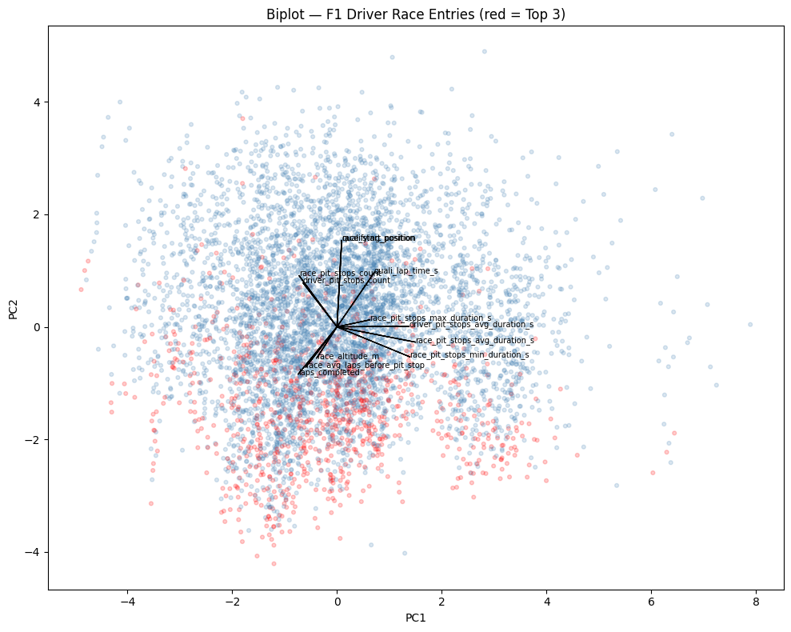
Shows PC1–PC4 explain 73.2% of variance with even distribution (~25%, 18%, 15%, 15%), confirming four genuinely independent dimensions underlying F1 driver performance.

Figure A2. PCA Loadings Heatmap — Feature Contributions to Principal Components
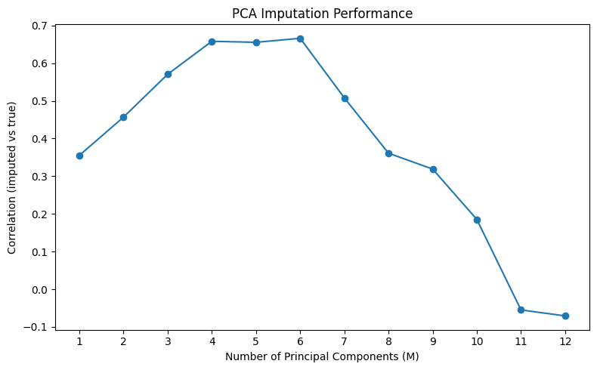
Visualizes which features drive each component: PC1 (pit stop duration metrics), PC2 (driver pace/grid position), PC3 (circuit geography), PC4 (pit frequency/strategy aggressiveness).

Figure A3. Ensemble Regression Model Comparison — Pit Stop Duration Prediction
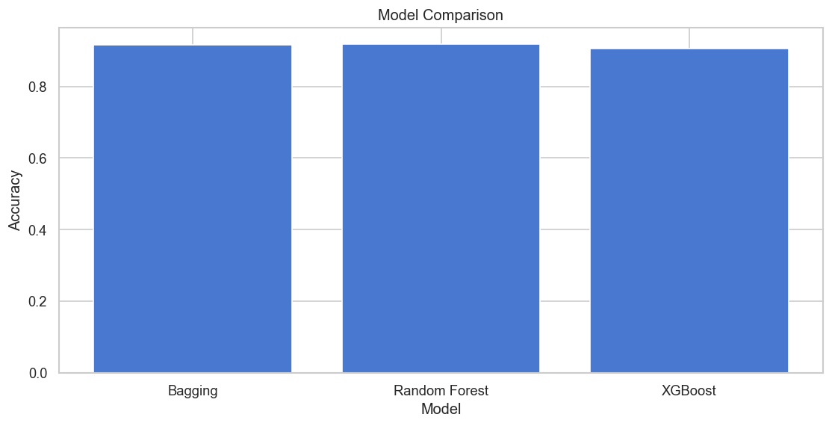
Gradient Boosting achieves best performance (R²=0.9335, RMSE=1.000s, MAE=0.731s) with negligible improvement from XGBoost, indicating convergence on dataset structure.

Figure A4. Feature Importance — Pit Duration Prediction
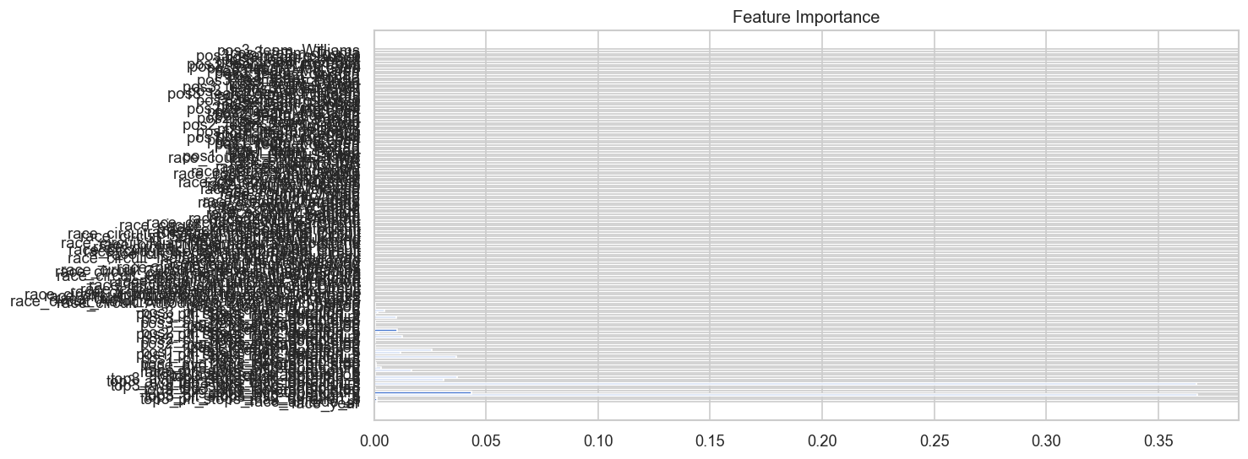
race_pit_stops_min_duration_s dominates with ~0.90 importance, confirming that pit crew consistency (captured by minimum stop time) is the controlling factor for predicting average duration.

Figure A5. Elbow Method + Silhouette Scores — K-Means Cluster Optimization
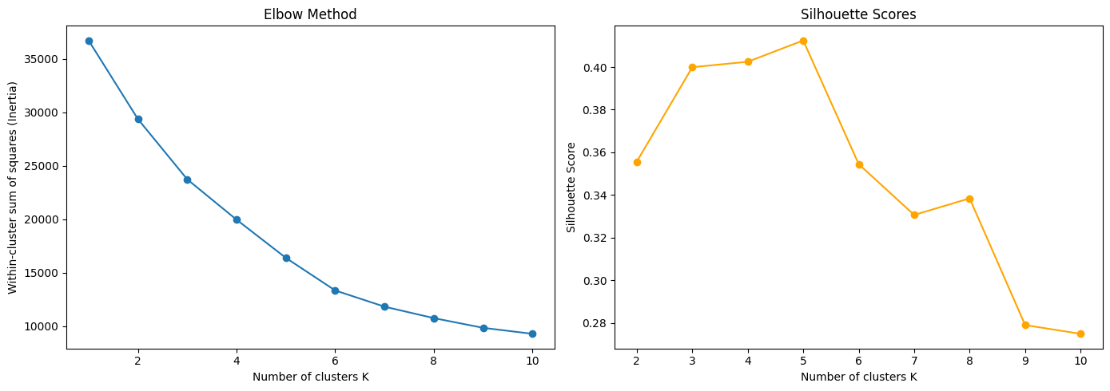
K=5 peaks at silhouette score 0.412 with elbow inflection at K=4–5, providing dual statistical justification for selecting five driver performance tiers.

Figure A6. K-Means Clustering on PCA Projection
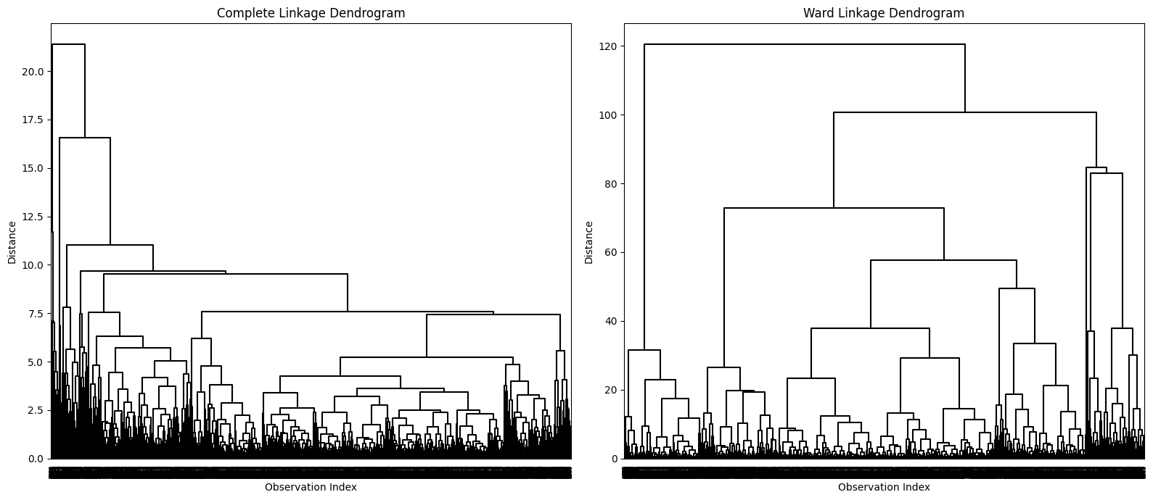
Cluster 0 (elite, bottom-left) clusters tightly with 99–100% cross-method agreement; Clusters 1–3 (midfield, center) overlap indicating continuous distribution; Cluster 4 (DNF, isolated) forms natural outlier group.

