Deterrent Effects of DUI Punishment at the 0.08 BAC Threshold: Evidence from a Regression Discontinuity Design
Course:
BUAN 5310 – Econometrics
Instructor:
Nicholas Huntington-Klein
Group Members:
- Liliya Dimova
- Brenda Hernandez Barragan
- Cesar Lagos Davila
- Xuanzhi Lu
- Tien Nguyen
- Zion Yates
Date:
March 2026

1. Introduction
In 2022, the United States Department of Transportation reported a sobering statistic: 13,524 individuals lost their lives in motor vehicle crashes involving at least one alcohol-impaired driver. This figure accounts for 32% of all traffic fatalities nationwide for that year (NHTSA, 2024). The state of Washington mirrors this national crisis; in 2022 alone, 3,402 deaths were attributed to alcohol-related incidents, a trend that has remained alarmingly persistent through 2024 (Washington Criminal Justice Data, 2024). These statistics raise critical questions regarding the efficacy of current government interventions. In Washington, the legal Blood Alcohol Concentration (BAC) limit for adults is set at 0.08%. Currently, a DUI conviction carries a sliding scale of penalties: Fines from $350 to $5,000; License Suspension will be suspended from 90 days to 4 years with potential jail time depending on severity and prior offenses; And lastly, the conviction remains on a driving record for 7 years.
In contrast, our neighbor, Canada, enforces more stringent measures. Canadian penalties range from a minimum $1,000 fine and a one-year license suspension for first-time offenders to 120 days in prison and potential permanent license revocation for repeat offenders (Defend Your DUI, n.d.).
Given that Washington’s penalties are notably gentler than Canada’s, we might need to evaluate whether our current system effectively deters recidivism. Does the threat of these specific consequences actually prevent a driver from reoffending? Furthermore, should Washington consider lowering the 0.08% BAC threshold to increase public safety? To address these questions, this study analyzes a dataset of around200,000 traffic stops in Washington starting from 1999, to examine whether drivers just above 0.08 BAC cutoff are less likely to reoffend than those just below it.

2. Data
The dataset used in this analysis contains traffic stop observations from Washington State and includes BAC measurements, accident indicators, demographic variables, and recidivism outcomes. The main outcome variable is recidivism, which is a binary variable indicating whether the driver committed another DUI offense after the initial stop.
Two BAC variables are provided in the dataset: bac1 and bac2. These represent the results of two alcohol tests administered to the driver. To handle the presence of two BAC tests, we use the minimum recorded BAC value between bac1 and bac2 for each observation. This allows us to define the running variable using the highest available BAC reading.
The dataset also includes several additional variables. The variable acc indicates whether an accident occurred at the scene of the stop. Demographic variables such as male, white, and aged provide information on sex, race, and age. These variables help describe the sample and support the overall analysis.
The dataset used in our regression contains 214,558 observations.

3. Methodology
To estimate the effect of harsher DUI punishment on future recidivism, we use a regression discontinuity design (RDD). This method is appropriate because Washington State applies stricter punishment once a driver’s blood alcohol concentration (BAC) reaches the legal cutoff of 0.08. Since punishment changes sharply at this threshold, drivers just below and just above the cutoff can be compared to estimate the causal effect of punishment on future DUI behavior.
This design is considered a sharp regression of discontinuity design because treatment is assigned directly based on whether the BAC level crosses the legal threshold. In this setting, the treatment variable is the stricter DUI punishment that begins at 0.08 BAC.
The main assumption behind this approach is that drivers cannot precisely manipulate their BAC around the legal threshold. If this assumption holds, then drivers near the cutoff should be very similar in all respects except for the punishment they receive. This allows us to interpret any discontinuity in recidivism at the cutoff as evidence of the effect of punishment.

4. RDD Design

4.1 Running Variable
We construct the running variable by taking the minimum of bac1 and bac2 for each observation. We then center this variable at the legal threshold of 0.08, creating bac_centered.

4.2 Treatment Assignment
To determine whether an observation receives the treatment, we create a binary variable indicating whether the BAC value crosses the legal threshold. If BAC ≥ 0.08, the variable takes the value 1, indicating that the stricter DUI punishment is triggered.
This setup corresponds to a sharp regression of discontinuity design. In Washington State law, the threshold is rigid, meaning that drivers who cross the 0.08 limit receive harsher punishment. Because treatment assignment is determined directly by the cutoff, the RDD framework is appropriate for estimating the causal effect of punishment.

4.3 Bandwidth and Bin Size
A ±0.05 window around the cutoff was selected to focus on observations that are most comparable to the legal threshold. Values outside of this range are less useful for comparison because individuals with BAC levels far from the cutoff are more likely to differ systematically from those close to it. For example, a person with a BAC of 0.079 and another with a BAC of 0.081 are very similar in terms of intoxication level, so restricting the sample to values near the cutoff helps isolate the effect of the punishment.
Initially, bins of size 0.002 were used during the exploratory stage of the analysis. However, while graphing the results, this created artificial bunching due to rounding in BAC values. To improve the visualization, a smaller bin size of 0.001 was used, which generated a smoother distribution.
The histogram showed a right-skewed but smooth distribution around the cutoff. Importantly, there was no visible bunching just below the threshold, which suggests that drivers were not manipulating their BAC measurements to avoid crossing the legal limit.

4.4 Equation Design
In our analysis, we choose 0.08 BAC as our threshold because of the historical context and legislative limitations put in place by the Washington state legislature, which took effect in 1999. From here we started our analysis by creating a scatterplot average rate of recidivism vs. average BAC level. Our scatter plot showed us that around 0.08 BAC threshold there is a jump in the recidivism rate. This also gives us the idea of how we should develop our design for our equation.
We selected the variables we created for our model (Recidivism = β0 + β1 (Punishment) + β2 (BAC centered) + β3 (Acc) + β4 (Punishment × BAC centered) in our model based on the causal diagram. To study the effect of punishment on recidivism, we consider factors that influence whether a driver falls beyond the threshold to receive a punishment. Drivers may be stopped for many reasons, but blood alcohol concentration is an important factor in determining punishment. BAC may also affect recidivism directly.
Accidents as they can be caused by BAC level affect whether you receive punishment and its severity. While being stopped allows officer to test your for your BAC level if you are suspected of driving under the influence. We control these variables to better isolate the causal effect of punishment on recidivism.
The scatterplot shows a positive linear relationship between the centered BAC level and the rate of recidivism on both sides of the cutoff. The fitted lines indicate an upward trend on each side of the cutoff. From this, we can conclude that a higher BAC level is associated with higher recidivism rates. However, there is a clear downward jump at the cutoff, where observations just above the threshold have a lower average recidivism rate than those just below it.
Based on this pattern, we used a linear discontinuity model. The model includes BAC centered, Punishment, and an interaction term between them. The Punishment variable captures the discontinuity at the cutoff, which is our treatment effect. While the interaction term allows the slope of the relationship to differ on either side of the threshold. A linear model is used instead of a quadratic model because the fitted lines in the graph appear approximately linear and do not show large curves in the data.

4.5 Causal Diagram
The causal diagram shows how BAC influences punishment and future recidivism. In this study, BAC is the running variable, and crossing the legal threshold of 0.08 determines whether a driver receives the stricter DUI punishment. The regression discontinuity design focuses on estimating the causal effect of punishment on recidivism by comparing drivers just below and just above the cutoff. Other factors, such as accidents and police stops, may also be related to driving outcomes, but the main identification comes from the BAC threshold.

5. Graphical Evidence

5.1 Distribution of BAC around the cutoff

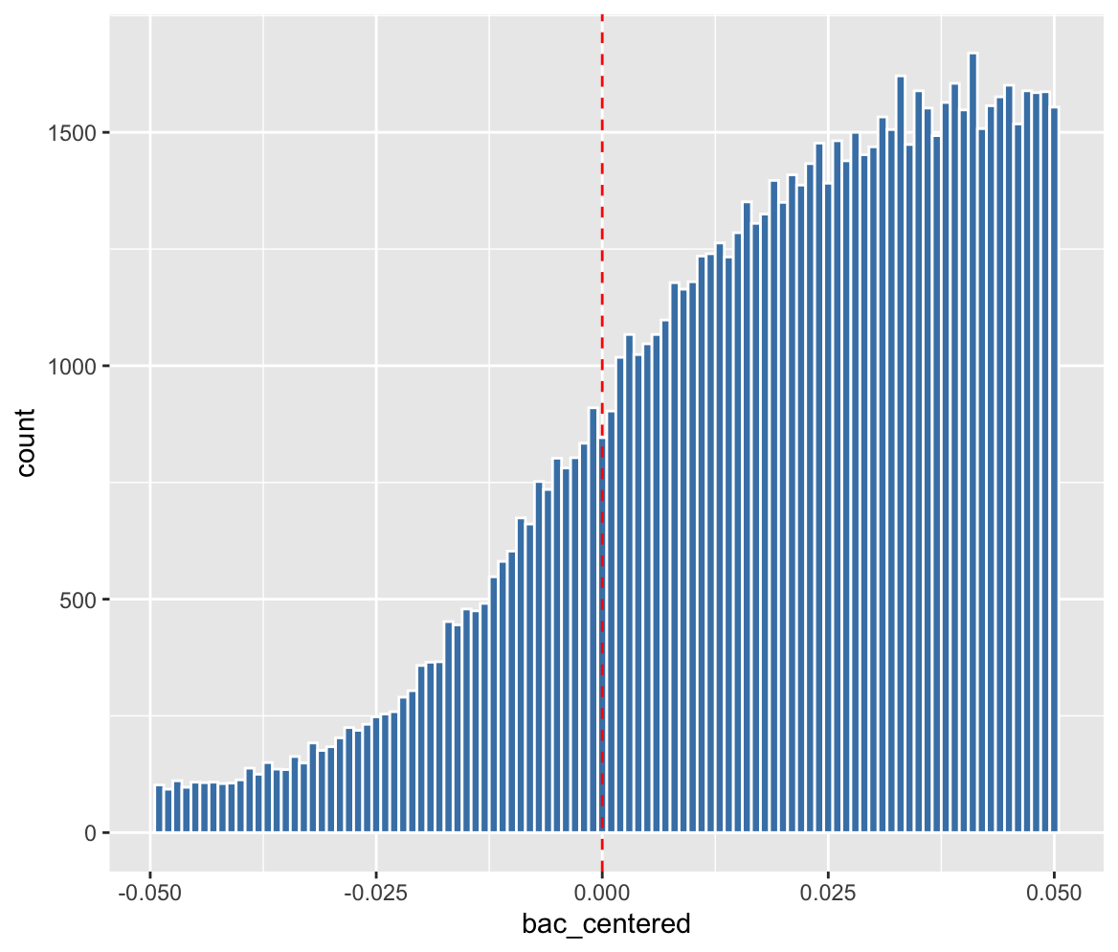
The histogram shows the distribution of BAC values around the legal cutoff at 0.08. The vertical dashed red line marks the threshold where stricter punishment begins. The distribution appears relatively smooth around the cutoff, without a clear jump or bunching just below the threshold. This suggests that drivers are not manipulating their BAC levels to avoid crossing the legal limit. Because of this, observations just below and just above the cutoff can be considered comparable, which supports the validity of the regression discontinuity design.

5.2 Recidivism around the BAC cutoff
The scatterplot shows the relationship between BAC levels and the probability of recidivism. The vertical dashed line marks the legal cutoff at BAC = 0.08. A visible drop in recidivism occurs just after the cutoff, suggesting that stricter punishment may reduce the probability of future DUI offenses.
To formally estimate the treatment effect at the cutoff, we estimate the following local linear regression discontinuity model.

6. Regression Model Output
Variable | Estimate | Std. Error | t-value | Pr(>|t|) | Significance
(Intercept) | 0.115926 | 0.002894 | 40.062676 | < 2.2e-16 | ***
Punishment (Treatment) | -0.020213 | 0.003190 | -6.337357 | 2.3420e-10 | ***
BAC (Centered at 0.08) | -0.034321 | 0.083885 | -0.409140 | 6.8244e-01
Accident | -0.009051 | 0.001982 | -4.566740 | 4.9564e-06 | ***
Interaction (Punishment × BAC) | 0.369573 | 0.085524 | 4.321265 | 1.5521e-05 | ***

Recidivism = β0 + β1 (Punishment) + β2 (BAC centered) + β3 (Acc) + β4 (Punishment × BAC centered)
- Intercept = β0 x 100 = 0.1196 x 100 = 11.59%
- Punishment effect = β1 x 100 = -0.020213 x 100 = -2%
- Control slope = β2 x 100 = -0.034321 x 100 = -3.4%, the trend for people below the 0.08 limit
- Interaction term = β4 x 100 = 0.369573 x 100 = 36.95%, the change in the slope for the group that was punished

7. Results and Interpretation
The intercept (0.1159) represents the baseline probability of recidivism for drivers who are just below the 0.08 BAC threshold and did not receive the stricter DUI punishment. This means that drivers around the legal limit have about an 11.96% chance of committing another DUI offense in the future.
The coefficient for Punishment (-0.020213) shows that drivers who cross the 0.08 BAC limit and receive the stricter DUI punishment are about 2.02 percentage points less likely to commit another DUI in the future. This suggests that the punishment at the legal threshold may discourage repeated drunk driving behavior.
The coefficient for bac_centered (-0.034321) represents the trend in recidivism for drivers below the cutoff. It shows that as drivers approach the cutoff, their probability for recidivism slightly decreases. An explanation for this might be that drivers that were close to getting the treatment were now aware of the harshness of the punishment, making them hesitant to drive in the same conditions in the future.
The interaction term (Punishment × bac_centered = 0.369573) shows that the relationship between BAC and recidivism changes once the punishment threshold is crossed. In other words, the slope of recidivism with respect to BAC is different for drivers above the legal limit compared to those below it.
The results are statistically significant since the p-value for the punishment coefficient is extremely small. Overall, the results suggest that the 0.08 BAC cutoff has a deterrent effect, meaning that drivers who receive the stricter punishment at the threshold are somewhat less likely to commit another DUI in the future.

8. Conclusion and Policy Implications
As examining whether DUI BAC threshold of 0.08 within Washington State will effectively mitigate future violations on the road, there have been comparisons between drivers just above and just below the legal limit as the evaluation. The evidence presented in the paper indicates that the 0.08 threshold has a positive impact on drivers as because it successfully discourages them to offend the regulation in future driving, which is also very much aligned to general common sense and our own assumption before carrying out the study.
To better interpret our findings, it is significant to make some issues more explanatory. First, the estimated coefficient on the treatment variable is -0.0256 and statistically significant. As the dependent variable measures negative driving behavior on the road (like future violations), here a negative coefficient shows a discouraging effect of the current WA DUI policy. Second, we divided the treatment coefficient by the intercept and multiplying by 100, as to convert the effect into a percentage rate, easier for us to compare it with the baseline recidivism rate (around 11.96%). And lastly, the magnitude of our estimated treatment effect is socially and economically meaningful. The results suggest that receiving DUI penalties reduces the possibility of future recidivism by approximately 2.56 percentage points. Compared to the baseline recidivism rate (11.96%), it shows a successful reduction of around 21 percent, which suggests that the current 0.08 BAC threshold can mitigate future violations while driving on the road. On the other hand, the regression discontinuity design we used only indicates effects for drivers near the BAC cutoff, which means that the estimated result may not capture those drivers with substantially higher levels of intoxication, or to different policy environments, etc.
Based on the estimated deterrent effect of the 0.08 BAC threshold, the results of this study suggest that DUI enforcement can successfully discourage driving violations in the future. Drivers who receive DUI penalties show a weaker likelihood to commit sequential offenses, suggesting that legal obligations may mitigate risky driving behavior. The findings are mostly aligned to the policies carried out in other countries, such as Canada, where stricter DUI regulations and penalties are implemented to improve safety on the road. While different policy environments do exist, the findings from our study suggest that maintaining an effectively high BAC threshold can successfully reduce repeated violations in the future. In general, the results indicate that the DUI threshold policies improve drivers’ performance. And if residents in Washington State ever yearned for a higher threshold and stricter policy implementation, our current findings offer some supportive evidence in doing so to bring more safety on the road.

9. References
Hansen, Benjamin. (2015). Punishment and deterrence: Evidence from drunk driving. American Economic Review, 105(4), 1581–1617.
National Highway Traffic Safety Administration. (2024). Traffic safety facts 2022 data: Alcohol-impaired driving. U.S. Department of Transportation.
Nick Huntington-Klein. (2025). Data Translation Challenge Dataset. Available at: https://nickch-k.github.io/DataTranslation/
Washington Criminal Justice Data. (2024). Criminal justice data snapshot. Washington State Government.

10. Appendix
The R code used for data cleaning, graphical analysis, and estimation is provided in the file “Data Challenge 2.R.”
