Design for Dynamic Website

**Course Code:** COS4018-B

**Course Title**: Software Design and Development

Submitted by:

20004135/1 UDDIN SAMEER

**Submitted to:**

Dr Sohag Kabir

Assistant Professor

**Due Date:**

Friday, 13 May 17:00

# Website Sketch

All these website sketches were produced using Photoshop, basic shapes and texts. Through researching other websites and analyzing what they do well, this is the initial design I have developed for my website.

The main theme of this website is anime, and the site will sell products related to that theme. The site aims to provide the user with all the best anime products to fuel their hobbies. It also aims to make the user experience simple by providing a clean interface. If the user has any issues, they should be able to contact the company with ease.

The main pages of my website will consist of a home page, a login page where users can sign up to the website. A help section where users can find answers to any common enquiries, this will also include a contact form for the user if they would like to reach out to customer service. The other part of the website will consist of product pages, whether that is for DVD’s, manga, figures, games or even accessories. They will all have their own independent pages. The final page will be the basket page where the users can finalize all the products that they are trying to purchase. All the items that the user added should be visible on this final page, this included a final total for all the products that they want to purchase.

## Main Homepage

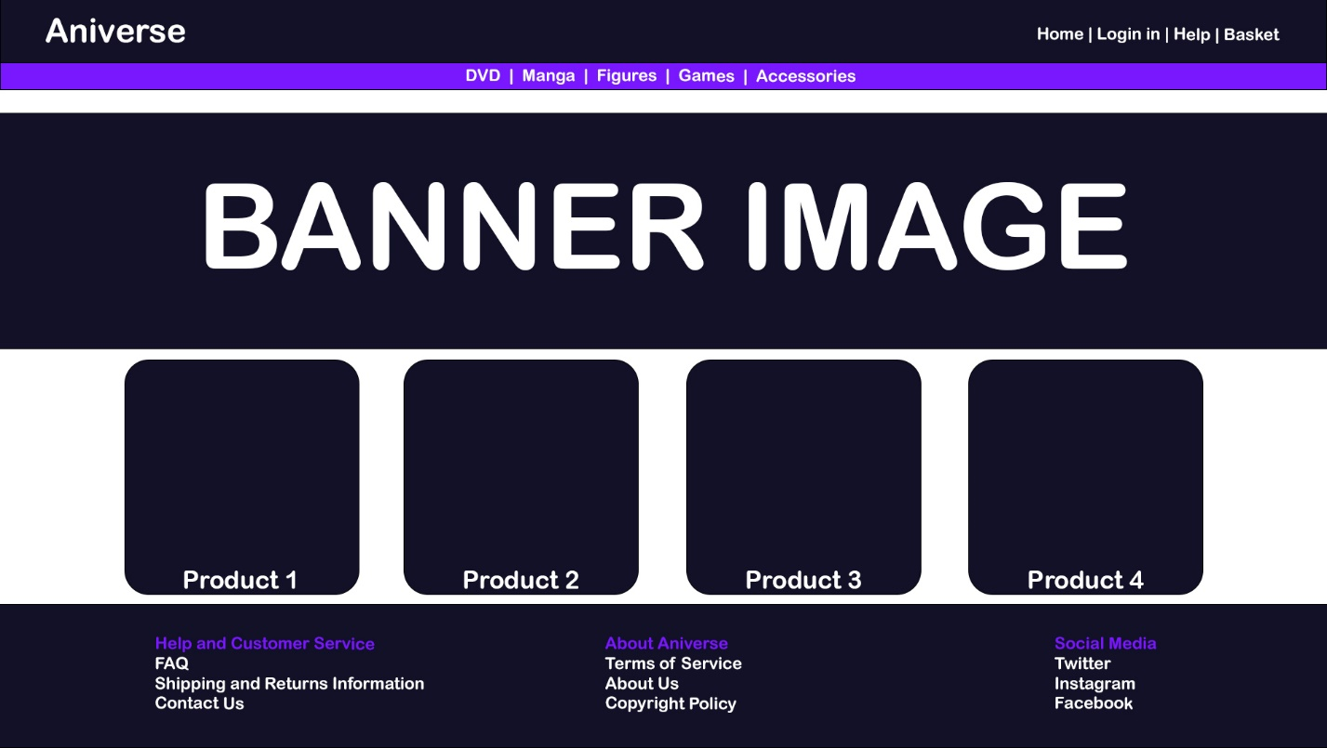

## Login Page

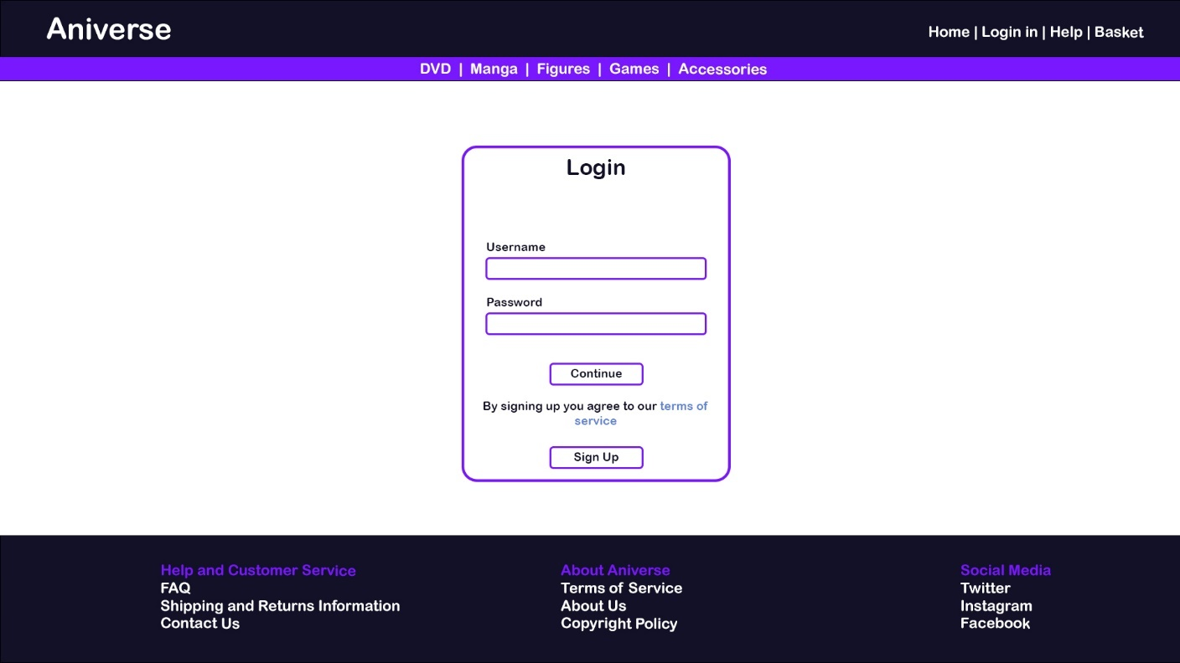

## Help

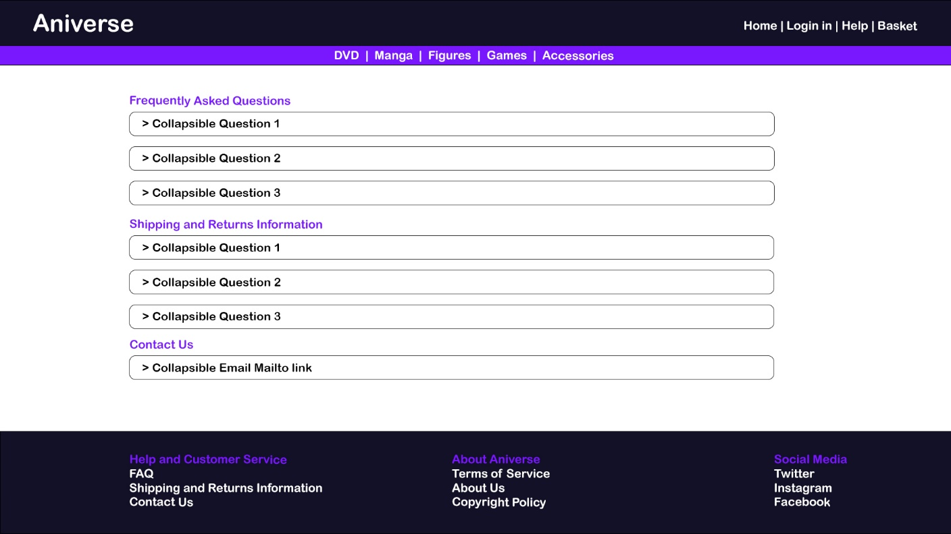

## Product Page (1 of 5)

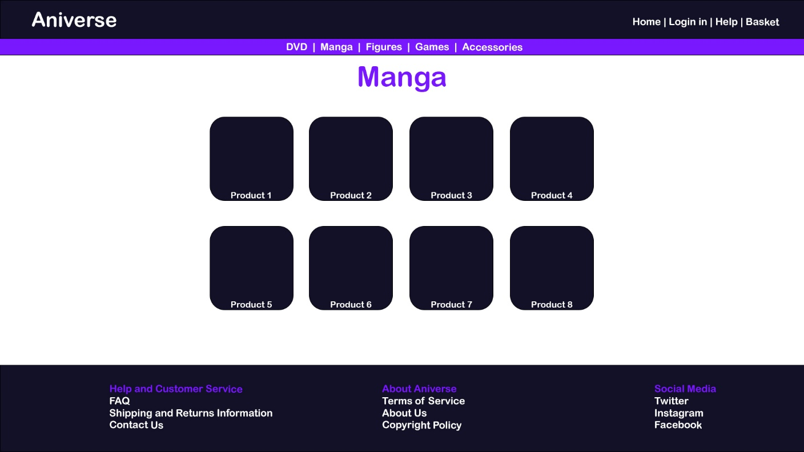

## Basket

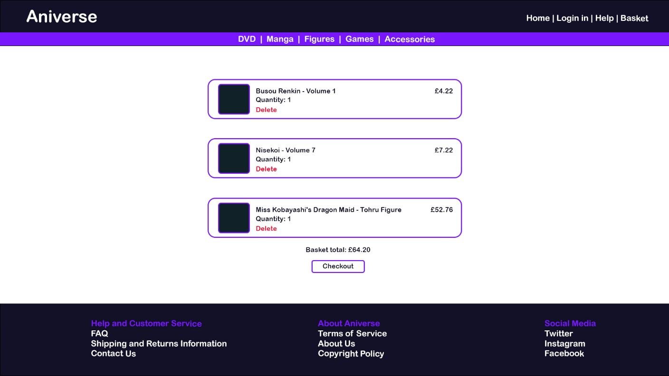

# Image References

Copyright free images were impossible to obtain with the chosen theme, hence why I have used images from websites such as DeviantArt and Crunchyroll. All the images used on the website have been referenced below.

morpheus-optoem, 2011. Gon. [image] Available at: <https://www.deviantart.com/morpheus-optoem/art/Gon-261769551> [Accessed 8 April 2022].

# Icon Reference

All the icons used for this website are available at:

<https://www.linea.is/>

Linea is distributed under CCBY license. It's free.