

CAPSTONE PROJECT REPORT
Report 1 – Project Introduction

IceBot – Design and Implementation of a Multi-Location Automated Ice Cream Vending System with Robotic Arm Integration

– Ho Chi Minh, May 2026 –
Table of Contents
I. Record of Changes 3
II. Project Introduction 4
1. Overview 4
1.1 Project Information 4
1.2 Project Team 4
2. Product Background 4
3. Existing Systems 4
3.1 System Reis & Irvy’s 4
3.2 System Robot Anno 5
4. Business Opportunity 6
5. Software Product Vision 7
6. Project Scope & Limitations 7
6.1 Major Features 7
6.2 Limitations & Exclusions 8
6.2 Limitations 8
6.2 Exclusions 9

I. Record of Changes
Date | A*  M, D | In charge | Change Description
*A - Added M - Modified D - Deleted

II. Project Introduction

1. Overview

1.1 Project Information
- Project name: IceBot – Design and Implementation of a Multi-Location Automated Ice Cream Vending System with Robotic Arm Integration
- Project code: IB
- Group name: GSU26SE28
- Software type: Web, Android App, Automatic System.

1.2 Project Team
Full Name | Role | Email | Mobile
Lam Huu Khanh Phuong | Lecturer | phuonglhk@fpt.edu.vn | 0915353001
Tran Hoang Tuan | Leader | tuanthse151518@fpt.edu.vn | 0906771080
Doan Le Thanh Trung | Member | trungdltse183054@fpt.edu.vn | 0931445712
Chu Tuan Kiet | Member | Kietctse150863@fpt.edu.vn | 0582121840
Vo Nhat Hung | Member | hungvnse173374@fpt.edu.vn | 0971357136
Tran Quang Thuan | Member | thuantqse182998@fpt.edu.vn | 0925453575

2. Product Background
The Food and Beverage industry is increasingly adopting automation and unmanned retail models to reduce labor costs, improve service consistency, and support operation in high-traffic locations. Smart vending kiosks are now common in malls, campuses, offices, hospitals, airports, tourist areas, and entertainment centers. At the same time, advances in IoT, robotics, and cloud computing make it possible to monitor machines remotely, coordinate multiple kiosks, and operate service systems with less manual supervision.
However, many existing ice cream vending systems still have limitations in automation, user experience, and centralized management. Some machines can sell products automatically, but they often provide only basic interactions and limited visibility for remote operators. When multiple machines are deployed in different locations, it becomes difficult to manage sales, inventory, machine health, maintenance schedules, and customer-facing menus consistently.
The IceBot project is created to address these issues through a multi-location robotic vending platform. The system does not focus only on one physical kiosk; it also focuses on the software platform needed to manage a network of kiosks, connect device status to the cloud, and allow different stakeholders to participate in the operation.

3. Existing Systems

3.1 System Reis & Irvy’s – Robotic Frozen Yogurt / Ice Cream Kiosk

Description:

Reis & Irvy’s is an automated robotic kiosk that serves frozen yogurt, ice cream, gelato, and sorbet. Customers can select their preferred dessert flavor and toppings through a touchscreen interface. The robot then prepares and dispenses the product automatically, usually in under 60 seconds. The system is designed for high-traffic locations such as shopping malls, airports, stadiums, universities, hospitals, and entertainment centers.

System Link:

● Official Website: https://reisandirvys.com/

System Actors:

● Customers / End Users: Individuals who interact with the kiosk, select frozen dessert flavors and toppings, make payment, and receive the finished product.

● Admin / Operators: Responsible for monitoring kiosk performance, managing sales data, restocking frozen dessert mix and toppings, checking machine status, and configuring available menu options.

● Maintenance Staff: Handle technical maintenance, cleaning, troubleshooting, mechanical inspection, and repair when the kiosk or robotic system has errors.

● Payment Service Provider: Processes digital payment transactions made through the kiosk, such as card or mobile payment.

● Ingredient Suppliers: Provide frozen yogurt, ice cream mix, gelato, sorbet, toppings, cups, and other consumable materials required for operation.

Features:

● Touchscreen ordering interface for customers.

● Automated robotic preparation and serving process.

● Supports multiple frozen dessert types such as frozen yogurt, ice cream, gelato, and sorbet.

● Allows customers to customize orders with different toppings.

● Designed for unattended or semi-unattended retail operation.

● Suitable for high-traffic commercial locations.

● Can reduce the need for on-site human staff.

Pros:

● Provides a unique and attractive customer experience because the robot prepares the dessert in front of the customer.

● Suitable for locations with high customer traffic and limited labor availability.

● Can operate with less human supervision compared to traditional ice cream stores.

● Offers menu customization through flavor and topping selection.

● Strong visual appeal, making it useful for malls, entertainment centers, and tourist locations.

Cons:

● Requires regular restocking of ingredients, toppings, cups, and cleaning materials.

● Mechanical or robotic failures can stop the entire sales process.

● Needs strict hygiene and food safety management.

● Best suited for high-traffic locations; performance may be weaker in low-traffic areas.

● Detailed technical information such as API, SDK, or system integration options is not clearly public.

3.2 System RobotAnno – 6-Axis Robot Ice Cream Machine / Kiosk

Description:

RobotAnno’s 6-Axis Robot Ice Cream Machine is an enclosed robotic ice cream kiosk that uses a six-axis robotic arm to prepare and serve ice cream automatically. Customers can place orders through a self-service interface, choose flavors or jam options, complete payment, and receive ice cream prepared by the robot. The system is designed as a smart vending solution for shopping malls, tourist areas, exhibitions, amusement parks, and other public locations.

System Link:

● Official Product Page: https://www.annorobots.com/enclosed-robot-ice-cream-machine/

System Actors:

● Customers / End Users: Individuals who place ice cream orders through the kiosk interface, choose flavors or options, complete payment, and receive the prepared ice cream.

● Admin / Operators: Responsible for managing machine settings, configuring available flavors, monitoring sales, checking machine status, and restocking ingredients.

● Maintenance Staff: Handle robot arm maintenance, machine cleaning, troubleshooting, mechanical inspection, and repair tasks when technical issues occur.

● Robot Arm System: A six-axis robotic arm that performs the physical preparation process, such as taking cups, dispensing ice cream, adding flavor or jam, and delivering the finished product.

● Payment Service Provider: Supports payment processing through available methods such as card, QR code, mobile payment, or other supported payment systems.

● Ingredient Suppliers: Provide ice cream mix, jam, flavor ingredients, cups, spoons, and other consumables needed for machine operation.

Features:

● Six-axis robotic arm for automated ice cream preparation.

● Enclosed kiosk design for safer and cleaner operation.

● Self-service ordering interface.

● Supports multiple flavors or jam options.

● Automated serving process, with short preparation time.

● Supports different payment methods depending on configuration.

● Includes automatic cleaning, preservation, and sterilization functions.

● Can operate as an unattended smart vending machine.

Pros:

● Very suitable as a reference model for a robotic ice cream kiosk because it clearly uses a robot arm.

● Fast serving process, useful for public areas with many customers.

● Enclosed design helps improve safety and hygiene.

● Automatic cleaning and preservation features reduce manual workload.

● Flexible for different commercial locations such as malls, parks, exhibitions, and tourist spots.

● Easier to analyze for system architecture because it has clear modules: ordering, payment, robot operation, ingredient storage, cleaning, and maintenance.

Cons:

● More like a hardware kiosk provider than a complete software platform, so cloud dashboard, API, and remote management details may need further verification.

● Robot arm and mechanical parts may require specialized maintenance.

● Importing or deploying in another country may require food safety certification and local technical support.

● Initial investment cost may be high compared to a normal ice cream vending machine.

● If the robot arm, refrigeration system, or payment module fails, the whole kiosk may become unusable until repaired.

4. Business Opportunity
The limitations of current ice cream vending systems create a strong opportunity to develop a next-generation robotic ice cream kiosk platform. By combining a robotic arm, IoT sensors, cloud-based management, and a user-friendly ordering interface, the system can deliver a more automated, scalable, and engaging F&B retail experience.
This project has the opportunity to solve several key problems in the current market:
● Full automation opportunity:
Using a robotic arm allows the system to automate the entire serving process, from receiving orders to preparing and delivering ice cream. This reduces the need for human staff and improves consistency in product preparation.
● Improved customer experience:
A robotic ice cream kiosk can provide a more attractive and interactive experience compared to traditional vending machines. The robot arm becomes part of the customer experience, making the buying process more entertaining and memorable.
● Centralized multi-location management:
A cloud-based dashboard can allow operators to monitor sales, machine status, inventory, errors, and maintenance needs across multiple kiosks from one platform.
● Better operational efficiency:
Real-time monitoring of ingredients, machine health, and transaction data can help operators restock more efficiently, reduce downtime, and respond quickly to technical issues.
● Scalable business model:
The system can be deployed in multiple high-traffic locations with standardized operation and remote supervision, making it suitable for franchise, chain-store, or smart retail expansion.
● Technology integration value:
The project provides a practical use case for integrating robotics, IoT, edge computing, cloud systems, and digital payment into one complete F&B automation platform.

5. Software Product Vision
The vision of this software product is to build a smart robotic ice cream kiosk management platform that connects customers, robotic kiosks, operators, and cloud services into one unified system. The platform aims to support fully automated ice cream ordering, preparation, payment, monitoring, and maintenance management.
Instead of operating each kiosk as a separate machine, the software enables centralized control and real-time supervision across multiple kiosk locations. Operators can monitor sales performance, machine status, inventory levels, payment transactions, and system errors through a cloud-based dashboard. This helps reduce manual workload, improve operational efficiency, and support scalable deployment.
The system also focuses on improving customer experience by providing a simple and interactive ordering interface. Customers can select flavors, toppings, and payment methods easily, while the robotic arm performs the serving process in a visual and engaging way. This turns the vending process into both a service and an entertainment experience.
From a technical perspective, the product follows an edge-cloud architecture. The edge system installed inside each kiosk is responsible for real-time robot control, local device coordination, and temporary offline operation. The cloud system handles centralized data management, analytics, reporting, remote monitoring, and multi-location administration.
The long-term vision is to create a reliable, scalable, and intelligent F&B automation platform that can be expanded beyond ice cream kiosks to support other robotic food vending use cases in the future.

6. Project Scope & Limitations

6.1 Major Features
FE-01: Access System
● Users can access the system through a web app, Android app, or local kiosk server.
● Ensures both online and offline functionality to prevent service interruptions.
● Allows customers, operators, and administrators to access the system based on their roles and permissions.
FE-02: Ordering System
● Cart Management:
○ View cart, add ice cream products to the cart, and modify cart contents.
○ Select ice cream flavors, toppings, cup size, and other customization options.
● Order Management:
○ Create, update, view, and cancel ice cream orders.
○ Track order status from order creation to payment confirmation, robot preparation, and product pickup.
● Payment Integration:
○ Create payments, update payment status, and view all payment information.
○ Support digital payment methods such as QR code, card payment, e-wallet, or other supported payment services.
FE-03: Monitoring
● Monitor real-time order queue, including details on orders, ice cream products, payments, and revenue.
● Monitor robot preparation progress and order completion status.
● Generate reports for business insights, such as sales performance, popular flavors, topping usage, revenue, and kiosk performance.
FE-04: Automating
● Detect machine errors automatically and initiate problem-solving processes without manual intervention.
● Monitor machine operating status in real time to ensure seamless operation.
● Automatically notify operators or maintenance staff when errors occur, such as robot arm failure, low ingredient level, refrigeration issue, payment failure, or dispenser malfunction.
● Support automated recovery workflows when possible, such as retrying robot actions, pausing orders, or switching kiosk status to unavailable.
FE-05: Machine Management
● Manage multiple robotic ice cream kiosks, including options to add, update, and remove machines from the system.
● Track the operating status of all kiosks and robot arms.
● Monitor machine health, refrigeration status, ingredient levels, cleaning status, and maintenance requirements.
● View each kiosk’s location, assigned menu, available products, and current operating mode.
FE-06: Catalog Management
● Menu Management:
○ Create, modify, and delete menus.
○ Assign menus to specific kiosks or locations.
● Product Management:
○ Create, modify, and delete ice cream products.
○ Add products to the menu and view detailed product information, including flavor, topping options, portion size, ingredient proportions, and serving instructions.
○ Manage product availability based on kiosk inventory and machine capability.
● Workflow Management:
○ Create and update workflows based on specific ice cream product requirements.
○ View all workflows and manage actions associated with workflows, such as adding or removing workflow steps.
○ Define robot preparation steps, such as taking a cup, dispensing ice cream, adding syrup or toppings, moving to pickup area, and completing the order.
FE-07: Business Management
● Organization Management:
○ Create, modify, and delete organizations.
○ Manage organization-level settings, users, roles, permissions, and business rules.
○ Create, modify, and delete store-based workflows.
● Kiosk Management:
○ Create, modify, and delete kiosks.
○ Create menus and add ice cream products based on each kiosk.
○ Create, modify, and delete devices linked to each kiosk, such as robot arm, dispenser, refrigeration unit, topping module, payment terminal, camera, and IoT sensors.
○ Manage kiosk location, operating schedule, assigned menu, and availability status.
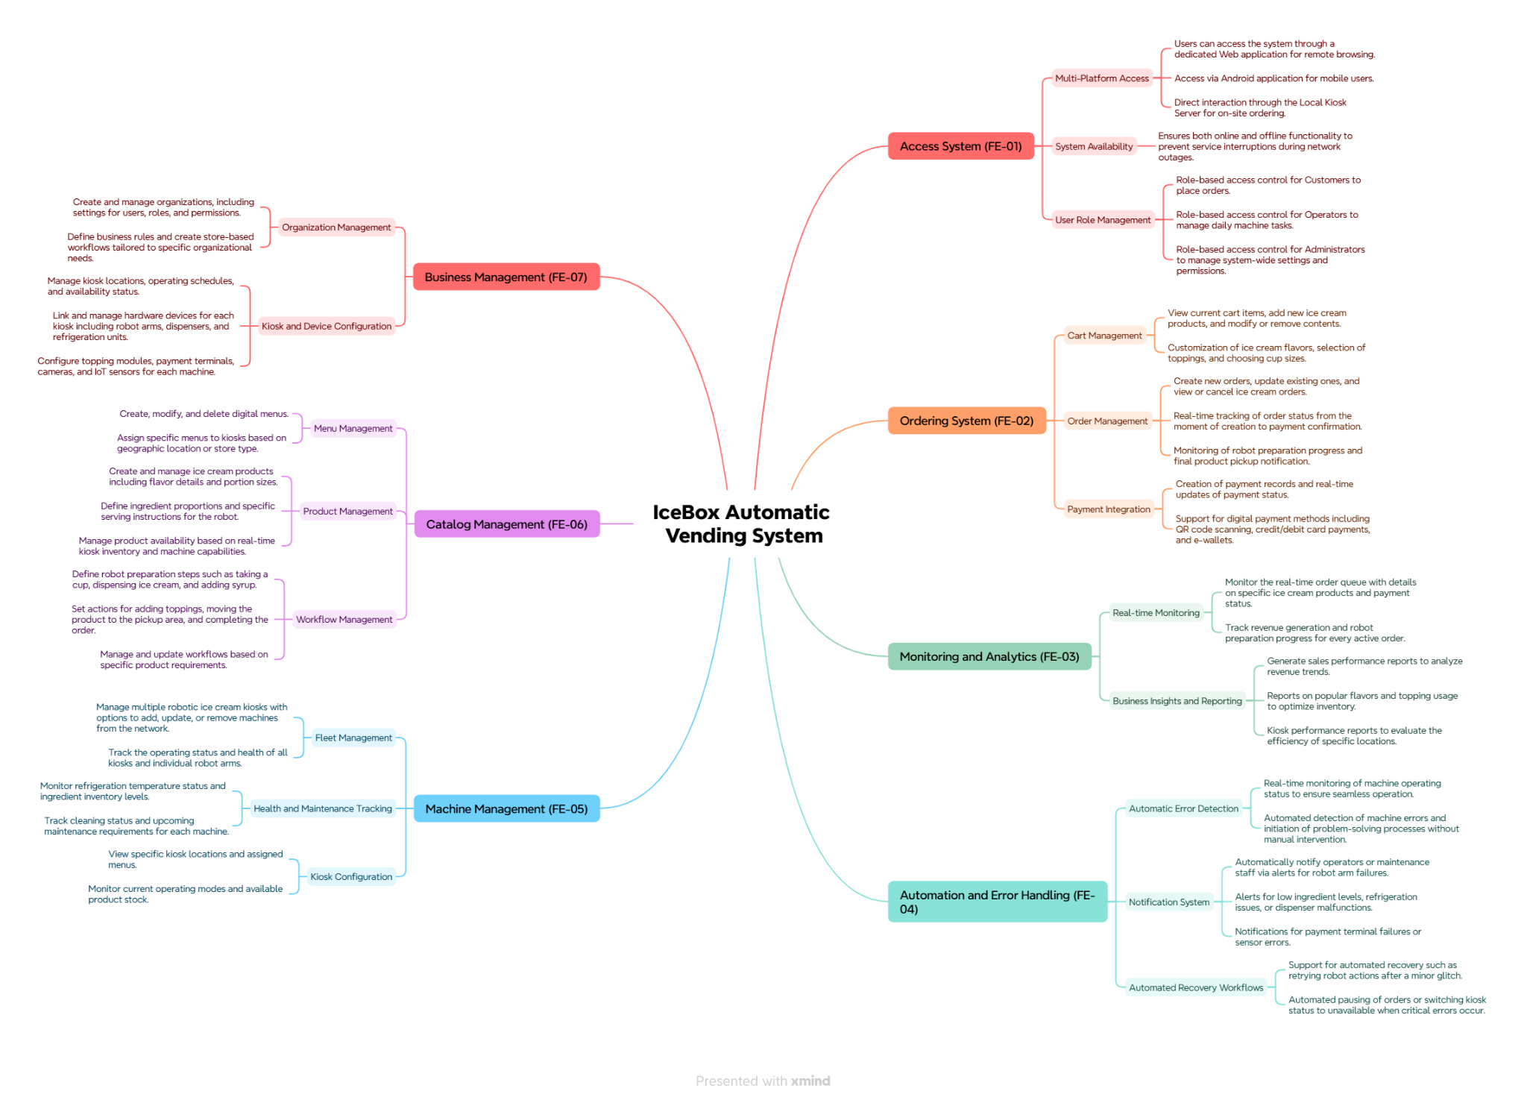

6.2 Limitations & Exclusions

6.2 Limitations
LI-1: Network and Cloud Dependency
The system relies on a stable internet connection to transmit data between devices and Azure IoT Hub. In the event of a network outage, certain functionalities such as order synchronization or cloud updates may be disrupted.
LI-2: Limited Offline Support
The system currently lacks comprehensive offline mode capabilities. Orders cannot be processed without an internet connection unless a local buffer or queue mechanism is implemented separately.
LI-3: Manual Maintenance Requirements
Certain maintenance tasks such as ingredient refilling, system cleaning, and sensor checks must be performed manually by technical staff at regular intervals.

6.2 Exclusions
EX-1: No Cash Payment Support
The system only supports online payment methods (e.g., MPOS, ATM Card). It does not accept or handle cash transactions.
EX-2: No Automated Hardware Failure Handling
Mechanical issues such as cup jams, ingredient shortages, or motor failures cannot be automatically resolved and require technician intervention.
EX-3: Not Designed for Harsh Environments
The system is not intended for outdoor use or environments with extreme temperatures, high humidity, or excessive dust.
EX-4: No AI Observation
The system does not include AI-based monitoring or intelligent observation capabilities. It cannot detect abnormal user behavior, monitor usage patterns in real time, or automatically report anomalies. All feedback and issues must be reported manually through the mobile app or on-screen interface.

