

Requirement & Design Specification
Document Case Study
TREKMATE
AI-Supported Trekking Coordination Platform For Tour Guides And Tour Operators
Subject: SWD392
Version: 1.0

– Danang, May 2026 –

Record of Changes
Version | Date | A, M, D | In charge | Change Description
V1.0 | 15/05/2026 | A | HuyTQ | Add initial version
V1.1 | 08/06/2026 | M | All | Update I.1, I.2, I.3, I.4, I.5
V1.2 | 14/06/2026 | M | All | Update II.1, II.2
*A - Added M - Modified D - Deleted

Table of Contents
Record of Changes 2
Table of Contents 3
I. Requirement Specification 9
I.1 Problem Description 9
I.2 Scope 11
I.2.1 In-Scope (System Scope) 11
I.2.2 Out-of-Scope 12
I.2.3 Assumptions 13
I.2.4. Dependencies 13
I.3 Major Features 13
I.3.1 Features for customers are as follows 13
I.3.2 Features for Staff 14
I.3.3 System Context 15
I.4 Nonfunctional Requirements 15
I.5 Functional Requirements 19
I.5.1 Use case diagrams 19
I.5.2 Use case descriptions 19
I.5.3 Activity diagrams 19
I.6 Data Requirements 19
II. Analysis models 20
II.1 Interaction diagrams 20
II.2 State diagram 20
III. Design specification 20
III.1 Integrated Communication Diagrams 20
III.2 System High-Level Design 21
III.3 Component and Package Diagram 21
III.4 Detail Design 21
III.5 Database Design 22
IV. Implementation 22
IV.1 Map architecture to the structure of the project 22
IV.2 Map Class Diagram and Interaction Diagram to Code 22
V. Applying Alternative Architecture Patterns 22
V.1 Applying the service-oriented architecture 22
V.2 Applying Service Discovery Pattern in the service-oriented architecture 23

I. Requirement Specification

I.1 Problem Description
Purpose: Build a website for TrekMate Danang, a platform that introduces, manages, and supports online booking for hiking tours in Da Nang. The website allows customers to browse hiking tours, search for suitable trips, book tours online, rent hiking equipment, make payments, and receive AI-based tour consultation. The system also supports tour guides, equipment staff, and administrators in managing tours, bookings, equipment rental, customer information, articles, and system operations.
The system requirements are described as follows:
1. TrekMate Danang provides various hiking tour categories such as beginner tours, advanced hiking tours, mountain trekking, waterfall exploration, camping tours, and group hiking tours. When the system needs to add a new tour category, the administrator is responsible for entering the tour category information into the system. The administrator can update or delete the tour category information if there are errors or changes.
2. Each tour category may contain many different hiking tours. When a new hiking tour is created, the administrator enters the tour information into the system, including tour name, location, description, difficulty level, duration, price, available schedule, required equipment, images, and tour guide information. If the tour information is incorrect or changes, the administrator can update, hide, or delete the tour information according to business rules.
3. TrekMate works with different tour guides who lead hiking tours for customers. When there is a new tour guide, the administrator enters the tour guide information into the system, including full name, phone number, email, experience, assigned tours, and working status. If the guide information is incorrect or changes, the administrator can update or deactivate the guide account. A tour guide can be assigned to many different tours.
4. Customers can visit the website to browse hiking tour information. Tours can be organized by groups such as newest tours, popular tours, promotional tours, recommended tours, and tour categories. Customers can also use the search function to find tours by name, location, difficulty level, or price range. If customers are interested in a tour, they can view detailed tour information before booking.
5. Customers can use the AI Assistant to receive tour recommendations based on their preferences, health condition, available time, budget, difficulty level, and travel purpose. The AI Assistant can also answer questions about tour details, hiking preparation, required equipment, and safety notes. The system applies Retrieval-Augmented Generation (RAG) with Google Gemini so that the AI Assistant can provide answers based on TrekMate’s real tour data instead of giving only general responses.
6. The system supports route optimization and personalized tour recommendation. Based on customer preferences, location, time, and tour difficulty, the system can suggest suitable hiking routes or schedules. The project may apply optimization algorithms such as Genetic Algorithm to support route planning and improve the quality of tour suggestions.
7. TrekMate provides hiking equipment rental services such as backpacks, trekking poles, raincoats, tents, flashlights, shoes, and first-aid kits. Equipment staff are responsible for managing equipment information, including equipment name, type, quantity, rental price, condition, and availability status. If equipment information is incorrect or changes, equipment staff can update or delete the information according to business rules.
8. When customers book a tour, they can also rent necessary equipment. The system must check equipment availability before confirming the rental request. Equipment staff can confirm equipment pickup, return, damage, loss, or rental completion. The system needs to monitor the available quantity and status of each equipment item to support rental operations.
9. Customers who want to book a tour need to log in first. Customers can log in using their account or Google OAuth. When customers log in for the first time, the system requires them to enter information such as full name, phone number, email, and address. Customers can view and update their personal information if there are any errors.
10. Customers can view the list of bookings they have made along with detailed information for each booking. For bookings that have not yet started, customers may cancel the booking according to the cancellation policy. For completed tours, customers can provide feedback, rate the tour, and book the same or similar tour again.
11. Tour guides can view detailed information about the tours assigned to them, including customer list, tour schedule, meeting location, rented equipment, and customer notes. After completing a tour, tour guides can update the tour status, report problems, and confirm whether the tour was completed successfully.
12. To promote tour information and improve customer engagement, staff can create and update news or articles about hiking experiences, new tours, travel tips, safety guidelines, equipment preparation, and Da Nang destinations. If there are errors in the content, staff can correct or delete the article. Staff can also hide outdated articles or re-display previously hidden articles.
13. To support business management, the system provides statistics and reports for administrators, such as total bookings, revenue, popular tours, customer feedback, equipment rental frequency, cancellation rate, and AI recommendation effectiveness. These reports help the administrator evaluate business performance and improve tour planning.
14. All staff must log in before performing system functions. The administrator or store owner has the highest permission and can perform staff functions when necessary. When TrekMate hires new staff, the administrator creates an account and assigns appropriate roles such as tour guide, equipment staff, or content staff. If a staff member quits or no longer works for TrekMate, the administrator can deactivate or revoke their access rights.

I.1.1 Scope

I.1.1.1 In-Scope (System Scope)
- Customer Side:
- Register and log in using a regular account or Google OAuth
- View tour lists by category (latest, popular, promotional, by category)
- Search tours by name, location, difficulty level, price range
- View tour details and book tours online
- Manage your tour shopping cart (add, edit, delete)
- Rent climbing equipment when booking tours
- Pay online via PayOS
- View tour booking history, cancellations, reviews & feedback
- Use AI Assistant to receive tour advice and get answers to your questions
- Read articles/news about climbing, preparation guides, and safety tips

- Staff & Admin:
- Manage tour catalog and information (add, edit, delete, hide/show)
- Manage tour guides (add, edit, assign tours)
- Manage rental equipment (add, edit, track status, confirm equipment receipt/return)
- Process tour bookings (confirm, assign tour guides, update status)
- Manage promotions/discounts
- Manage posts/news
- Manage user accounts & permissions
- View revenue statistics, tour booking reports, equipment performance
- Manage employee shifts
- System Features:
- AI Assistant integrated with RAG + Google Gemini based on TrekMate's real-world tour data
- Optimal itinerary suggestion system (Genetic Algorithm can be applied)
- Responsive interface supporting desktop, tablet, and mobile (320px – 1920px)
- JWT authentication & Refresh Token
- Image storage via Cloudinary

I.1.1.2 Out-of-Scope
The following items are not included in the initial release of the system:
# | Item | Reason
OS-1 | Native mobile application | Mobile access is provided through responsive web only
OS-2 | Multi-branch management | Version 1.0 supports TrekMate Da Nang as a single location only
OS-3 | Advanced analytics (revenue forecasting, customer trend analysis) | Not required in v1.0
OS-4 | Integration with third-party accounting systems | Outside current project requirements
OS-5 | Automated inventory updates via IoT devices | Inventory is updated manually through the system
OS-6 | Mobile loyalty app or membership card integration | Loyalty programs are managed internally by staff
OS-7 | Automated social media posting or email marketing | Not integrated in v1.0
OS-8 | Industry benchmarking and performance comparison tools | No built-in benchmarking in initial release

I.1.1.3 Assumptions
- All users (customers, staff, and administrators) have stable internet access when using the system
- Users possess basic digital literacy to interact with the platform (browsing tours, making bookings, processing payments, managing schedules)
- Staff and administrators follow the defined workflows for booking processing, equipment management, and shift scheduling
- All data entered into the system (tours, equipment, pricing, user information) is accurate and valid
- Google OAuth and PayOS are properly configured and remain available throughout system operation
- TrekMate's actual tour data is maintained and kept up to date within the RAG knowledge base so that the AI Assistant can provide accurate responses. It is assumed that the response time of the AI ​​Assistant and the optimization algorithm are within acceptable limits (e.g., under 10 seconds) to avoid degrading the user experience.

I.1.1.4. Dependencies
- Google OAuth: Authenticates login via Google
- PayOS/VNPay: Processes online payments
- Google Gemini API/ Groq: Provides an AI platform for tour advisory features
- Cloudinary: Stores tour images, equipment, and articles
- Mapbox: Interactive map display for tour locations, meeting points, and hiking route visualization
- SMTP Email Service: Sending OTP codes, password reset notifications, and booking confirmation emails to users
- DBMS (MySQL/PostgreSQL): Stores all system data

I.2 Major Features

I.2.1 Features for customers are as follows
F01: Viewing hiking tours:
View tour list by category, view new tours, view popular tours, view promotional tours, search tours by name/location/difficulty level, and view tour details.

F02: Tour recommendation and AI consultation:
Use AI Assistant to get tour suggestions based on customer preferences, health condition, budget, available time, difficulty level, and travel purpose. Customers can also ask questions about tour details, required equipment, preparation tips, and safety notes.

F03: Booking cart management:
Add tour to booking cart, view booking cart, edit booking cart, change number of participants, remove selected tour or rental equipment.

F04: Tour booking placement:
Select tour schedule, choose number of participants, rent hiking equipment if needed, confirm booking information, and proceed to checkout.

F05: Customer authentication:
Register/Login using a normal account or Google OAuth, manage profile, view personal information, and update profile information.

F06: My booking history:
View booking history, view booking details, cancel booking according to cancellation policy, send feedback, rate completed tours, and rebook the same or similar tour.

F07: Viewing news/articles:
View hiking news, travel guides, safety tips, equipment preparation guides, and search news/articles by title or keyword.

I.2.2 Features for Staff
F08: Tour category management:
Add, edit, delete, sort, and search tour categories such as beginner hiking, advanced hiking, camping tour, mountain trekking, waterfall exploration, and group hiking tour.

F09: Tour management:
Add, edit, delete, search, sort, hide, and display hiking tours. Manage tour information such as name, location, description, difficulty level, duration, price, images, schedule, required equipment, and assigned tour guide.

F10: Tour guide management:
Add, edit, delete/deactivate, search, and sort tour guide information. Manage guide profile, experience, contact information, assigned tours, and working status.

F11: Equipment management:
Add, edit, delete, search, and sort hiking equipment such as backpacks, trekking poles, tents, flashlights, raincoats, shoes, and first-aid kits. Manage equipment quantity, rental price, condition, and availability status.

F12: Equipment rental management:
View rental requests, confirm equipment pickup, confirm equipment return, update equipment condition, handle damaged/lost equipment, and update equipment availability.

F13: Booking processing:
View booking list, view booking details, confirm booking, assign tour guide, check rented equipment, confirm payment status, update tour status, confirm completed tour, confirm cancelled booking, and handle customer feedback.

F14: Promotion/discount management:
Create discounts, edit discounts, delete discounts, apply discounts to selected tours or equipment rental services, and manage promotional campaigns.

F15: News/article management:
View article details, add news/articles, edit articles, delete articles, disable outdated articles, and enable hidden articles.

F16: User management:
Staff login, create staff account, assign staff roles and permissions, update staff information, deactivate staff account, and revoke staff permission.

F17: Statistics and reports:
View statistics on total bookings, revenue, popular tours, cancelled bookings, customer feedback, equipment rental frequency, available equipment, damaged/lost equipment, and AI recommendation effectiveness.

I.3 System Context
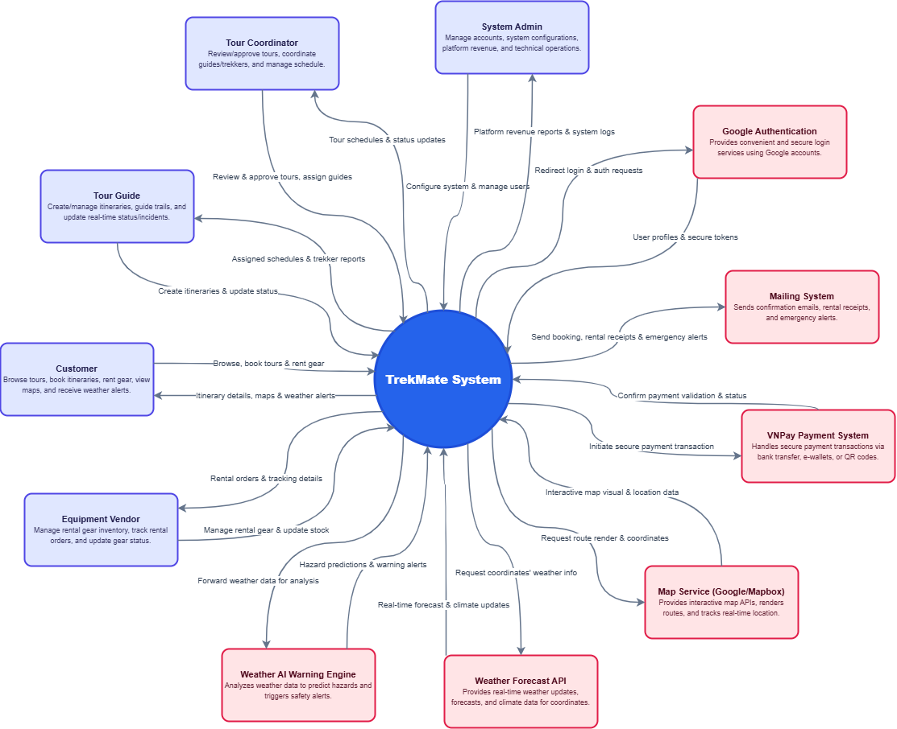
Figure I-1 System context is modeled by a class diagram
Figure 1-1 shows the system context of the TrekMate System, illustrating the interactions between the system and its various entities including external users and external systems.
External Users
- Customer: The system's primary end-user who can browse trekking tours, book itineraries, rent trekking equipment from vendors, view route maps, and receive weather alerts.
- Tour Guide: Responsible for creating and managing trekking itineraries, guiding trekkers on the trails, and updating real-time status or incidents during the trip.
- Equipment Vendor: Responsible for managing rental equipment information, tracking rental orders, and updating inventory status for trekking gear.
- Tour Coordinator: Responsible for reviewing and approving trekking tours, coordinating between tour guides and trekkers, and managing the overall schedule.
- System Admin: Manages the entire system, including user accounts, system configurations, tracking platform revenue, and ensuring smooth technical operations.
External Systems
- VNPay Payment System: Handles secure payment transactions when users book tours or rent trekking equipment via bank transfers, e-wallets, or QR codes.
- Google Authentication Service: Provides convenient and secure login services using customers' Google accounts.
- Map Service (Google Maps/Mapbox): Provides interactive map APIs to render trekking routes, track locations in real-time, and plot geographic coordinates for safety.
- Weather Forecast API: Provides real-time weather updates, forecasts, and climate data for specific trekking coordinates and regions.
- Weather AI Warning Engine: An AI-driven module that analyzes weather data to automatically predict potential environmental hazards (e.g., flash floods, heavy rain, landslides) and triggers automated safety alerts to users on the trail.
- Mailing System: Sends notification and confirmation emails to users, including booking confirmations, rental receipts, weather emergency alerts, and promotional updates.

I.4 Nonfunctional Requirements
NF-01 Maintainability:
The system should be designed to support efficient maintenance, updates, and future extension. The source code should be modular, well-organized, and clearly separated by business domains such as tour management, booking management, equipment rental, user management, payment, news management, and AI Assistant.
The system should provide clear documentation for components, modules, database design, API endpoints, and interactions between frontend, backend, database, payment service, Cloudinary storage, and AI service. This helps developers understand the system easily and modify features smoothly when business requirements change.

NF-02 Usability:
The website must provide a user-friendly interface so that customers can easily search for tours, view tour details, receive AI consultation, rent equipment, and complete tour booking.

The interface should be clear, responsive, and easy to use for both customers and staff.
- Task completion time: Customers should be able to find a suitable tour and complete booking within 5 minutes.
- Error rate: The error rate for key tasks such as searching tours, booking tours, renting equipment, and making payment should be less than 5%.
- User satisfaction: At least 85% of users should be satisfied with the website experience.
- Staff usability: Staff should be able to manage tours, bookings, equipment, and articles without needing advanced technical knowledge.

NF-03 Portability:
The website should be compatible across different browsers, devices, and operating systems.
- Browser compatibility: The system should work properly on the latest versions of Chrome, Firefox, Safari, and Edge.
- Device compatibility: The system should support desktop, tablet, and mobile screen sizes.
- Operating system compatibility: The system should work on at least Windows, macOS, Android, and iOS.
- Responsive design: The interface should support screen widths from 320px to 1920px.

NF-04 Performance:
The website should ensure fast performance, quick response time, and smooth interaction for both customers and staff.
- Page load time: Main pages such as homepage, tour list, tour detail, booking page, and login page should load in less than 4 seconds for 95% of users.
- Response time: The system should handle at least 500 users with an average response time of less than 6 seconds.
- Stress testing: The system should support at least 200 concurrent users with performance degradation of less than 20%.
- Search performance: Tour search and filtering should return results within 3 seconds under normal traffic.
- AI response time: The AI Assistant should return tour consultation responses within an acceptable time, preferably less than 10 seconds for normal questions.

NF-05 Security:
The system must protect user information, staff accounts, booking data, payment information, and system management functions.
- Authentication: Customers and staff must log in before using protected features.
- Authorization: Staff features must be restricted based on roles such as Admin, Tour Guide, Equipment Staff, and Content Staff.
- Token security: The system should use JWT and Refresh Token to manage secure authentication sessions.
- OAuth security: Google OAuth should be used securely for customer login.
- Payment security: Payment processing through PayOS must ensure that transaction information is verified before confirming a booking.
- Data protection: Sensitive user data such as phone number, email, address, and booking history must be protected from unauthorized access.

NF-06 Reliability:
The system should operate reliably and reduce the risk of booking or payment errors.
- Booking reliability: A booking should only be confirmed when customer information, tour schedule, equipment availability, and payment status are valid.
- Equipment availability: The system should prevent customers from renting unavailable equipment.
- Payment confirmation: The system should correctly update booking status after successful payment.
- Failure handling: If payment or AI service fails, the system should show clear messages and allow users to retry.

NF-07 Scalability:
The system should be designed to support future growth in users, tours, bookings, equipment, and AI-related data.
- The backend architecture should support future extension using Clean Architecture, Hexagonal Architecture, or Microservice-oriented design.
- The system should be able to add more tour types, more locations, more guides, and more equipment without major redesign.
- Redis caching can be used to reduce database load for popular tour queries.
- The AI Assistant should be extendable to support more knowledge sources and more advanced recommendation logic.

NF-08 Availability:
The system should be available for customers and staff during normal business operations.
- Customers should be able to browse tours, view articles, and make bookings at any time.
- Staff should be able to manage tours, bookings, equipment, and articles during working hours.
- The system should minimize downtime during updates and maintenance.

NF-09 Data Integrity:
The system must ensure that important data is accurate and consistent.
- Booking data, payment data, equipment rental data, and customer information must be stored correctly.
- Equipment quantity must be updated accurately after rental, return, damage, or loss.
- Tour availability and booking capacity must be consistent to avoid overbooking.
- Reports and statistics must be calculated from valid system data.

NF-10 AI Answer Quality:
The AI Assistant should provide useful, relevant, and safe tour consultation.
- AI answers should be based on TrekMate’s real tour data using RAG.
- The AI should avoid giving unsupported or misleading information.
- The AI should recommend tours based on user preferences, difficulty level, budget, time, and preparation needs.
- If the system does not have enough information, the AI should clearly state that the information is unavailable instead of guessing.

In this project, UML will be used to construct models in the requirements, analysis, and design phases of software development. These models are platform-independent and follow the PIM (Platform-Independent Model) approach. Therefore, the models focus on business logic and functional requirements of the TrekMate Danang system without being tied to a specific technology platform. In the following sections, the models for each phase, including requirements, analysis, and design, will be presented, followed by the mapping of these models to source code.

I.5 Functional Requirements

I.5.1 Use case diagrams
Based on described user requirements in Section 1.1 and detailed analysis, the system has been deployed on a web platform, consisting of two primary sites: the Customer Site and the Administration Site. Figure 1-2 presents the Overview Use Case Diagram for the Customer Site, highlighting key functionalities such as view tour list, booking tour and payment. Figures 1-3 showcase the Overview Use Case Diagram for the Administration Site, covering essential tasks like managing users, managing tours. Figures 1-4 to 1-11 show some Detailed Use Case Diagrams, which further break down the specific use cases for both the Customer Site and the Administration Site. Tables 1-1 to 1-6 show descriptions of use cases Manage Users, Manage Tours. These descriptions will be inputs to building analysis models in Section 2.

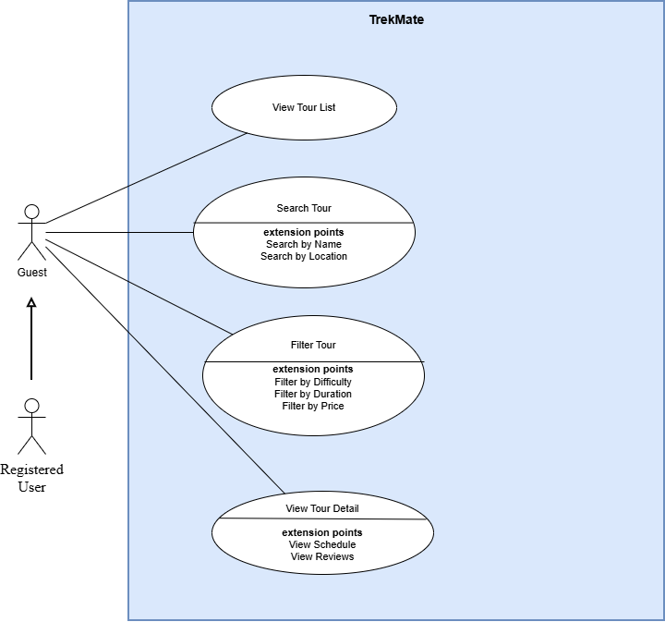
Figure I-3 Detailed Use Case Diagram for View Tour List

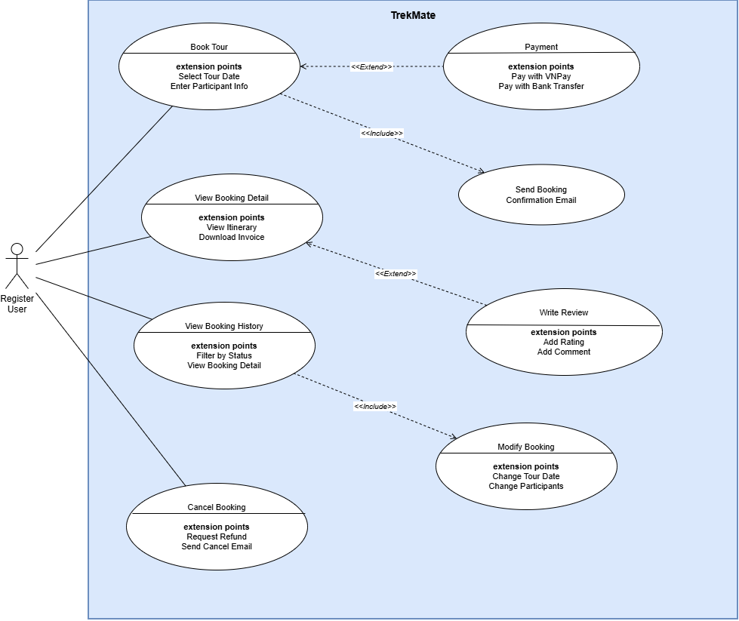
Figure I-4 Detailed Use Case Diagram for Booking Tour

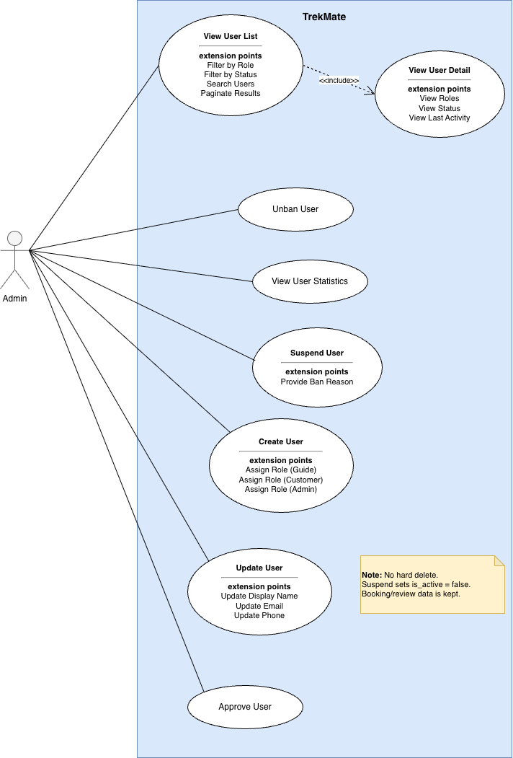
Figure I-5 Detailed Use Case Diagram for Manage Users

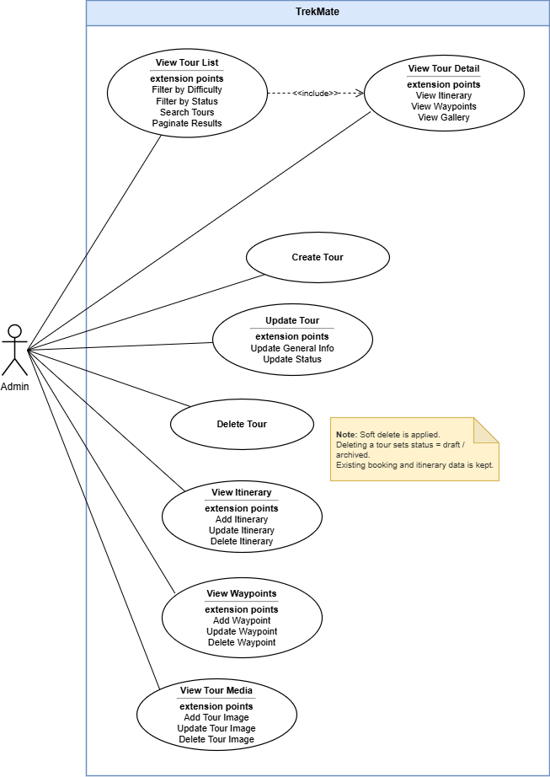
Figure I-6 Detailed Use Case Diagram for Manage Tours

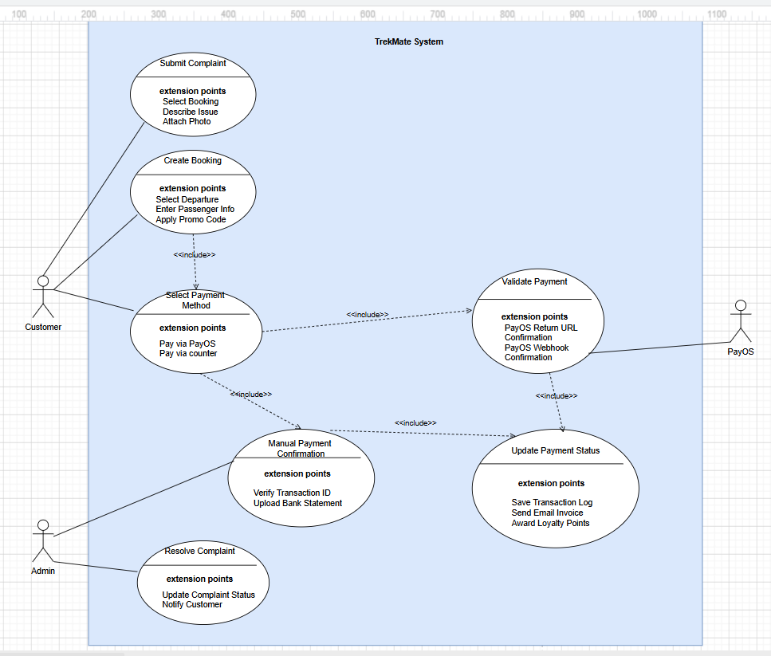
Figure I-7 Detailed Use Case Diagram for Payment

I.5.2 Use case descriptions
Tables 1-1 to 1-6 describe the use cases: View List Tour, Booking Tour, Payment, Manage Users and Manage Tours. The event flows of these use cases can be modeled using activity diagrams. For example, Figures 1-12 and 1-13 are activity diagrams modeling the event flows of the View Tour List and Booking Tour use cases.

Table I-3 Use case description for View List Tour
ID and Name: | UC-03 View List Tour
Created By: | DucTV | Date Created: | 08/06/2026
Primary Actor: | Guest  Registered User | Secondary Actors:
Description: | This use case allows any visitor (Guest) or Registered User to browse the list of available tours on the TrekMate system. Users can search, filter, and sort tours to find suitable options.
Trigger: | The user navigates to the Tour Listing page from the main menu or homepage of the TrekMate application.
Preconditions: | PRE-1. The TrekMate system is accessible and running.  PRE-2. Tour data has been loaded into the system by the operator.
Postconditions: | POST-1. The system displays a paginated list of tours matching the user's search/filter criteria.  POST-2. The user can proceed to view tour details or book a tour.
Normal Flow: | 1. The user opens the TrekMate application.  2. The system retrieves all available tours from the database.  3. The system displays the Tour List page with tour cards (name, image, price, difficulty, duration).  4. The user views the list of tours.  5. The user can perform the following actions:  - Search tour by name or location.  - Filter tours by difficulty, duration, or price range.  - Sort tours by price or rating.  - Paginate through results.  6. The system updates the displayed list according to the user's selections.
Alternative Flows: | AF-1. No tours found:  - The system displays a 'No tours available' message.  AF-2. Search returns no results:  - The system shows 'No tours match your search criteria'.  - The user can clear filters and retry.
Exceptions: | EX-1. Network/server error:  - The system displays an error message and suggests the user to reload the page.
Priority: | High
Business Rules: | BR-1. Only tours with status 'Active' are shown in the list.  BR-2. Registered Users can see additional details such as booking history and saved tours.

Table I-4 Use case description for Booking Tour
ID and Name: | UC-04 Booking Tour
Created By: | DucTV | Date Created: | 08/06/2026
Primary Actor: | Registered User | Secondary Actors:
Description: | This use case allows a Registered User to book a tour available on the TrekMate system. The user selects a tour date, enters participant information, and completes payment to confirm the booking.
Trigger: | The Registered User selects the 'Book Tour' option from the Tour Detail page.
Preconditions: | PRE-1. The Registered User is logged into the TrekMate system.  PRE-2. The selected tour has available slots for the chosen date.  PRE-3. The tour status is 'Active'.
Postconditions: | POST-1. A booking record is created and saved in the system.  POST-2. A booking confirmation email is sent to the user.  POST-3. The available slots for the selected tour date are decremented.
Normal Flow: | 1. The Registered User selects 'Book Tour' from the Tour Detail page.  2. The system checks if the user is logged in.  3. The system displays the booking form (tour date, number of participants, special notes).  4. The Registered User fills in the booking details and selects a tour date.  5. The Registered User submits 'Book Tour'.  6. The system validates the input data.  7. The system saves the new booking to the database.  8. The system displays a booking confirmation message and sends a confirmation email.
Alternative Flows: | A4.1 The Registered User selects the Close button.  - A4.1.1 closes the booking form and returns to the Tour Detail page.
Exceptions: | E1. User is not logged in:  - The system redirects the user to the Login page.  E6.1 Input data is invalid:  - The system displays an error message and prompts the user to correct the information.  E7.1 System error occurs during booking:  - The system logs the error and displays an error message.
Priority: | High
Business Rules: | BR-1. A user can only book a tour if there are available slots.  BR-2. Booking cancellation is allowed up to 48 hours before the tour start date.  BR-3. Payment must be completed within 24 hours of booking confirmation, otherwise the booking is automatically cancelled.

Table I-5 Use case description for Manage Users
ID and Name: | UC-05 Manage Users
Created By: | DuyVN | Date Created: | 08/06/2026
Primary Actor: | Admin | Secondary Actors:
Description: | This use case allows an Admin to manage user accounts on the TrekMate system via the Guide Dashboard. The Admin can view a paginated user list, see summary statistics, search and filter users by role and status, create new users, update basic profile information, approve pending accounts, and suspend or unban users. User suspension is a soft disable only; no user data is permanently deleted from the database.
Trigger: | The Admin navigates to the User Management page (/guide/users) from the Guides menu in the Guide Dashboard.
Preconditions: | PRE-1. The TrekMate backend API and PostgreSQL database are running.  PRE-2. User data exists in the system (seeded or previously created).  PRE-3. The Admin has network access to the TrekMate frontend and backend.
Postconditions: | POST-1. The system displays an up-to-date paginated list of users matching the selected filters and search criteria.  POST-2. Summary statistics (total guides, active users, pending approval) reflect the current database state.  POST-3. Any create, update, approve, suspend, or unban action is persisted in the database and reflected on the UI.  POST-4. Suspended users have is_active = false; their bookings, reviews, and related records remain intact.
Normal Flow: | 1. The Admin opens the TrekMate Guide Dashboard and selects Guides → User Management.  2. The system sends requests to GET /api/admin/users/stats and GET /api/admin/users.  3. The system displays the User Management page with:  - Three summary cards (Total guides, Active, Pending approval)  - A user table (name, email, role, status, last activity, actions)  4. The Admin views the user list.  5. The Admin may perform the following actions:  - Search users by email or display name  - Filter by role: All, Guides, Customers, Admins  - Paginate through results (10 users per page)  - Create a new user (email, phone, display name, password, role)  - Edit a user’s display name  - Approve a user with status Under Review  - Suspend an active user (optional ban reason stored in audit log)  - Unban a suspended user  6. The system updates the displayed list and statistics according to the Admin’s actions.
Alternative Flows: | AF-1. No users found:  - The system displays “No data found” in the table.  AF-2. Search returns no results:  - The system shows 'No tours match your search criteria'.  - The Admin can clear the search field or change filters and retry.  AF-3. Create user — duplicate email:  - The system returns an error (Email already exists).  - The Admin corrects the email and resubmits.  AF-4. Create user — duplicate phone:  - The system returns an error (Phone number already exists).  - The Admin corrects the phone and resubmits.  AF-5. Suspend already suspended user:  - he system returns a validation error (User is already suspended).  AF-6. Unban already active user:  - The system returns a validation error (User is already active).  AF-7. Approve user:  - The system sets is_verified = true. If the user is a Guide, profile_approved_at is set. Status changes to Active.
Exceptions: | EX-1. Network/server error:  - The system displays an error message on the page.  - The Admin is advised to check that the backend is running and reload the page.  EX-2. Database connection failure:  - The backend cannot connect to database.  - The API returns an error; the frontend shows a loading/error state.
Priority: | High
Business Rules: | BR-1. Only users with is_active = true are considered Active; is_active = false means Banned (suspended).  BR-2. Users are never hard-deleted. Suspend only sets is_active = false and optionally guides.is_available = false.  BR-3. User status is derived as follows: Banned if is_active = false; Under Review if is_verified = false or Guide profile is not approved; otherwise Active.  BR-4. Role is determined by: is_admin → Admin; existence of guides record → Guide; existence of customers record → Customer. A user may have multiple roles (e.g. Guide and Customer).  BR-5. Guide tier (Senior / Guide / Junior) is calculated from experience_years: ≥ 8 → Senior; 3–7 → Guide; < 3 → Junior.  BR-6. Ban reasons are stored in user_status_logs for audit purposes.  BR-7. List queries use server-side pagination (default 10, max 50 per page) to optimize performance.

Table I-6 Use case description for Manage Tours
ID and Name: | UC-06 Manage Tours
Created By: | HuyTQ | Date Created: | 09/06/2026
Primary Actor: | Admin | Secondary Actors:
Description: | This use case allows the Tour Manager to manage the tours in the system, including adding, editing, deleting, searching and viewing tour details.
Trigger: | The Tour Manager selects the "Manage Tours" option from the system menu.
Preconditions: | PRE-1. The Tour Manager is logged into TrekMate Admin Portal.  PRE-2. The Tour Manager is authorized to manage tours.
Postconditions: | POST-1. Tours are correctly managed, with updates reflected in the system and database.
Normal Flow: | - 1The TM selects the "Manage Tours" option from the system menu.  - The system retrieves the list of tours from the database.  - The system displays the Manage Tour interface with the list of tours.  - The TM views the list of tours.  - The TM can select actions:  - Add Tour  - Edit Tour  - Delete Tour  - Search & Filter Tours (by name, difficulty, status)  - View Tour Details
Alternative Flows:
Exceptions:
Priority: | High
Business Rules: | BR-1. The Slug for a new tour will be automatically generated from the title if left empty.  BR-2. When deleting a tour: if the tour already has active associations with departure schedules or booking orders, the system will soft-delete it by changing its status to ARCHIVED (Soft Delete).

Table I-7 Use Case Description for Select Payment Method
ID and Name: | UC-07 Select Payment Method
Created By: | HungPT | Date Created: | 09/06/2026
Primary Actor: | User | Secondary Actors: | PayOS
Description: | This use case allows a Registered User to select a payment method for a booking. The user may choose either online payment through PayOS or offline payment at the counter.
Trigger: | The User proceeds to the Payment page after creating a booking.
Preconditions: | PRE-1. The Registered User is logged in.  PRE-2. A booking record exists with status = PENDING_PAYMENT.  PRE-3. The booking has not expired.
Postconditions: | POST-1. The selected payment method is recorded.  POST-2. The user is redirected to the corresponding payment flow.
Normal Flow: | - The Registered User opens the Payment page.  - The system displays available payment methods.  - The Registered User selects one payment method.  - The system stores the selected payment method.  - The system redirects the user to the corresponding payment process.
Alternative Flows: | AF-1. User changes payment method.  - The system updates the selected method.
Exceptions: | EX-1. Booking not found.  - The system displays an error message.  EX-2. Booking has expired.  - The system informs the user and cancels the booking.
Priority: | High
Business Rules: | BR-1. Only one payment method can be selected per booking.  BR-2. Payment must be completed within 24 hours after booking creation.

Table I-8 Use Case Description for Pay via PayOS
ID and Name: | UC-08 Pay via PayOS
Created By: | HungPT | Date Created: | 09/06/2026
Primary Actor: | User | Secondary Actors: | PayOS
Description: | This use case allows a Registered User to pay for a booking using the PayOS online payment gateway.
Trigger: | The user selects "Pay via PayOS" as the payment method.
Preconditions: | PRE-1. The booking exists and is in PENDING_PAYMENT status.  PRE-2. The user selected PayOS as the payment method.  PRE-3. The PayOS service is available.
Postconditions: | POST-1. A payment record is created.  POST-2. Payment status is updated.  POST-3. A confirmation email is sent.  POST-4. Reward points are granted.
Normal Flow: | - The user selects Pay via PayOS.  - The system creates a payment record.  - The system requests a payment link from PayOS.  - PayOS returns a QR code/payment URL.  - The system displays the QR code.  - The user completes payment.  - PayOS sends a webhook notification.  - The system validates the transaction.  - The system updates the payment status to SUCCESS.  - The system sends a confirmation email.  - The system awards loyalty points.
Alternative Flows: | AF-1. User returns from PayOS before payment completion.  - Payment remains PENDING.  AF-2. User retries payment.  - The existing payment record is reused.
Exceptions: | EX-1. PayOS service unavailable.  - The system displays a payment error message.  EX-2. Payment validation failed.  - The payment status becomes FAILED..
Priority: | High
Business Rules: | BR-1. Payment amount must equal the booking amount.  BR-2. Only SUCCESS payments can confirm a booking.  BR-3. Loyalty points are awarded only once.

Table I-9 Use Case Description for Pay at Counter
ID and Name: | UC-09 Pay at Counter
Created By: | HungPT | Date Created: | 09/06/2026
Primary Actor: | User | Secondary Actors: | Admin
Description: | This use case allows a Registered User to reserve a booking and complete payment directly at the TrekMate office or tour counter.
Trigger: | The user selects "Pay at Counter" as the payment method.
Preconditions: | PRE-1. A booking exists.  PRE-2. Booking status is PENDING_PAYMENT.
Postconditions: | POST-1. A payment record is created.  POST-2. Payment status becomes PAID after Admin confirmation.  POST-3. Confirmation email is sent.
Normal Flow: | - The user selects Pay at Counter.  - The system creates a payment record.  - The system marks payment status as PENDING.  - The user visits the office and completes payment.  - The Admin verifies payment.  - The Admin confirms payment.  - The system updates payment status to SUCCESS.  - The system sends a confirmation email.  - The system awards loyalty points.
Alternative Flows: | AF-1. User cancels the booking before payment.  - Booking status becomes CANCELLED.
Exceptions: | EX-1. Admin rejects payment verification.  - Payment remains PENDING.
Priority: | Medium
Business Rules: | BR-1. Counter payment must be confirmed by Admin.  BR-2. Booking expires if payment is not completed within 24 hours.

I.5.3 Activity diagrams
Figures I-3 and I-4 are activity diagrams modeling event flows of the use case View Tour List and Booking Tour.

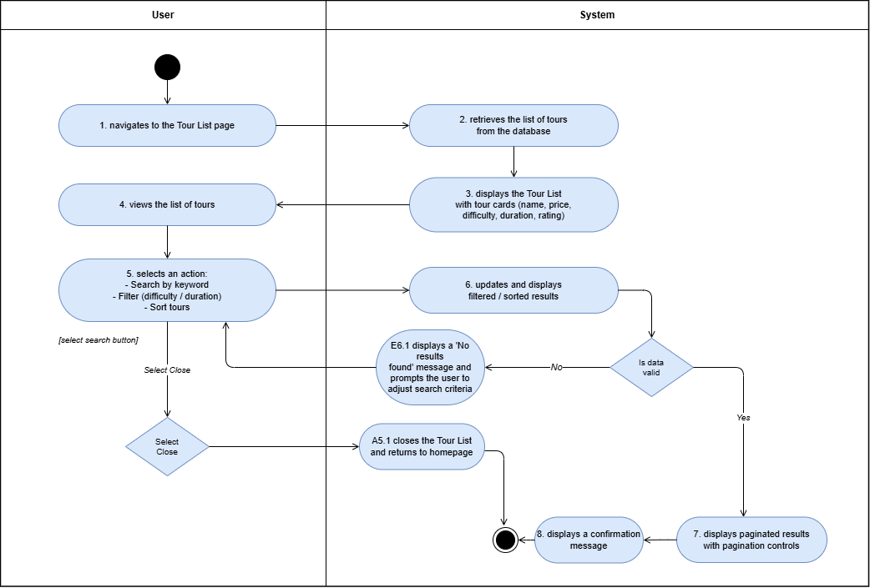
Figure I-3 Activity diagram modeling event flows of use case View Tour List

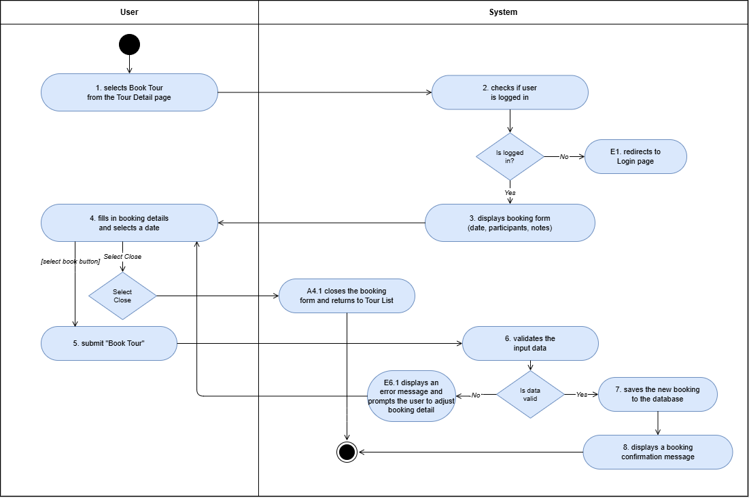
Figure I-4 Activity diagram modeling event flows of use case Booking Tour

I.6 Data Requirements
The class diagram in Figure 1.14 specifies the entity classes and the relationships between them, clearly representing the system's data requirements. Each entity class in the diagram represents a domain concept, relationships between entities are associations, aggregations, composition, or inheritances. To provide detailed information about these entity classes, they are all thoroughly described in Table 1-7, which is known as the data dictionary. This data dictionary serves as an explanatory tool, offering detailed descriptions of each class’s attributes, data types, and relationships, helping the reader better understand the data structure and system requirements.

II. Analysis models

II.1 Interaction diagrams
In this section, we will analyze objects and their interactions to realize use cases based on the MVC model's analysis pattern. Specifically, we will examine the following use cases: View Tour List, Booking Tour, User Management, User Profile. The interaction diagrams, illustrated in Figures 2-1 through 2-12 include sequence diagrams and communication diagrams that model the interactions (messages) of objects to realize these use cases.

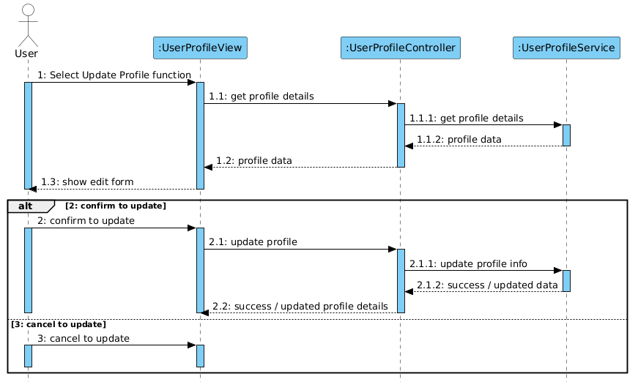
Figure II-1 Sequence Diagram for User Profile Use Case

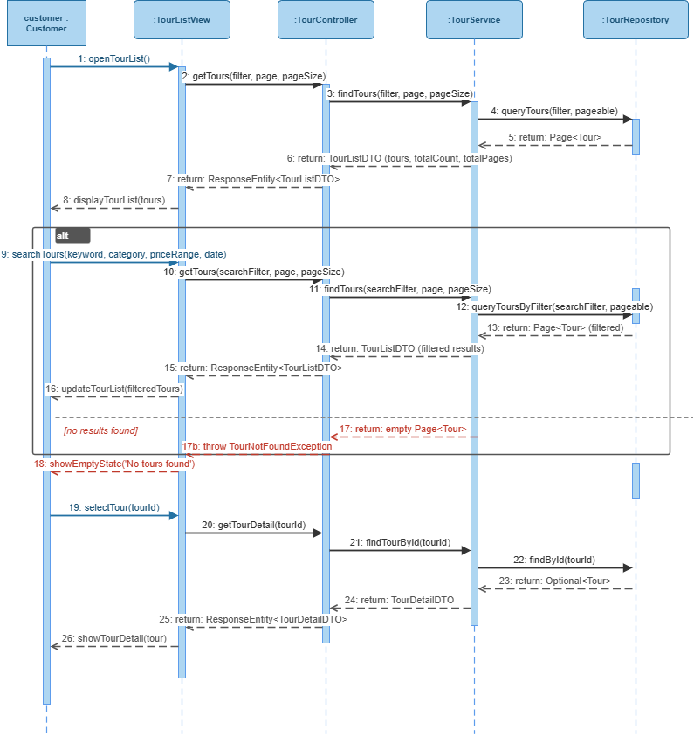
Figure II-3 Sequence Diagram for View Tour List Use Case

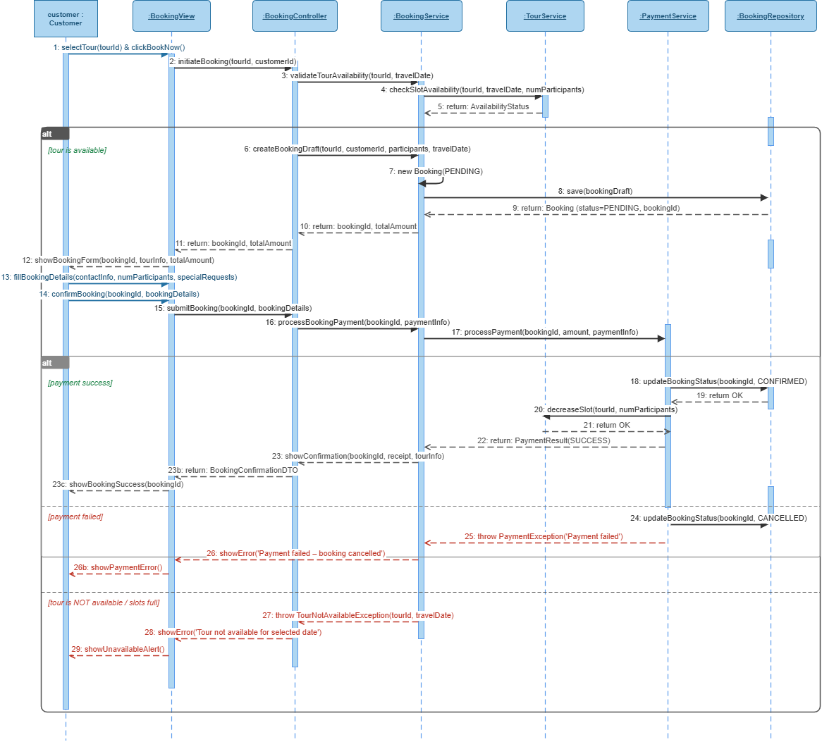Figure II-4 Sequence Diagram for Booking Tour Use Case

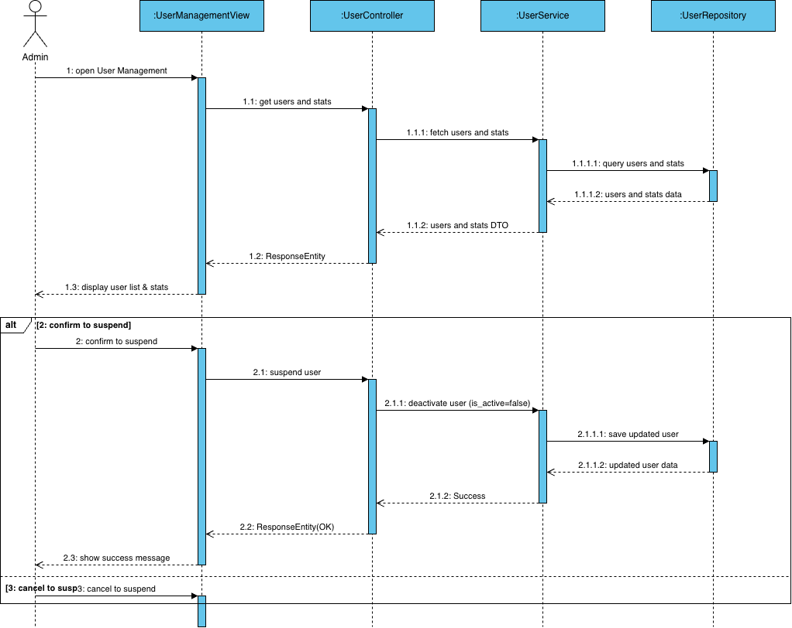
Figure II-5 Sequence Diagram for User Management Use Case

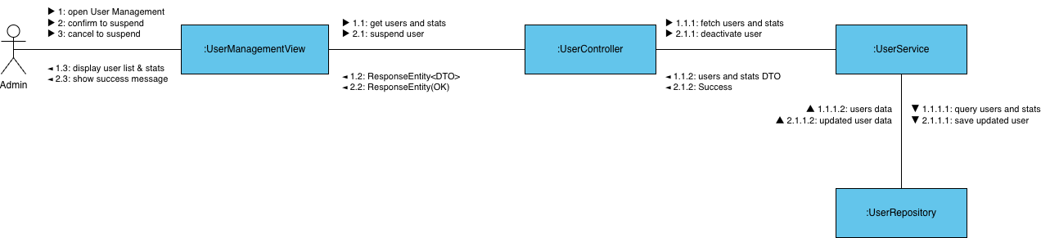
Figure II-6 Communication Diagram for User Management Use Case

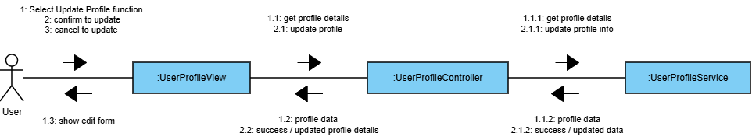
Figure II-7 Communication Diagram for User Profile Use Case

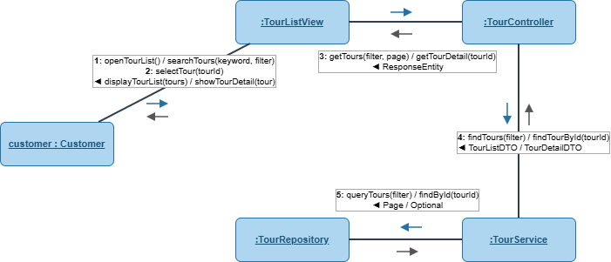
Figure II-8 Communication Diagram for View Tour List Use Case

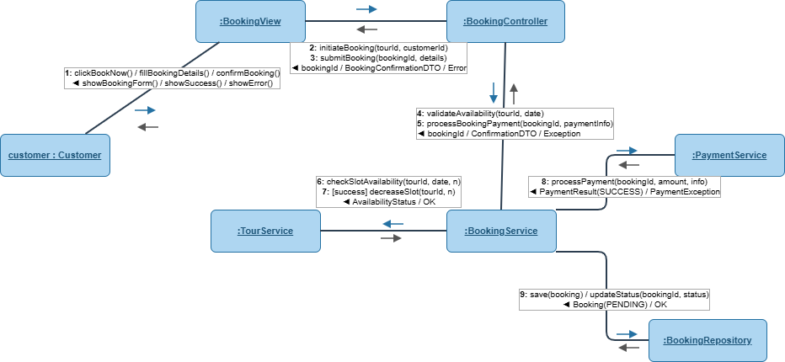
Figure II-9 Communication Diagram for Booking Tour Use Case

II.2 State diagram
In object-oriented analysis and design, a finite state machine can model the states and state transitions of a system or an object. Figure 2-13 illustrates a state diagram depicting the states and state transitions of a Booking Tour. The events Booking Tour causes state transitions to share the same names as two messages arriving at the state-dependence object in the sequence diagrams (Figures 2-5, 2-6) or the communication diagrams (Figures 2-11, 2-12).
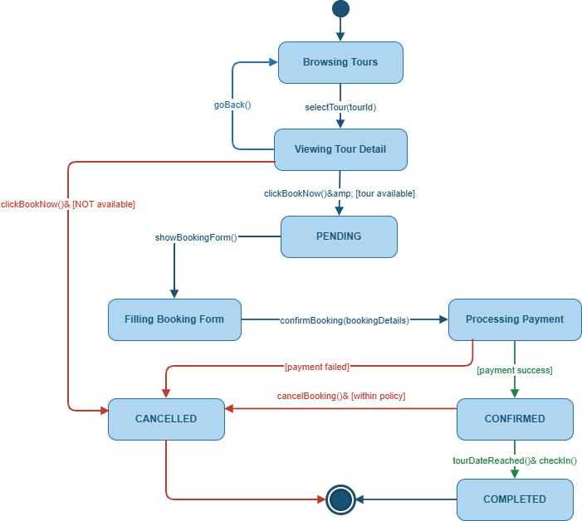
Figure II-13 State diagram model states of a Booking Tour

III. Design specification

III.1 Integrated Communication Diagrams
To transition from analysis to design and to identify the subsystems, it is necessary to synthesize an initial software design based on the analysis conducted so far. This involves integrating the use case based interaction diagrams developed as part of the dynamic model [1].
The integrated collaboration diagrams will then incorporate all interactions within the system. For large and complex systems, this integration may be performed for each subsystem individually. In this example, we will integrate the collaboration diagrams for the four use cases we have developed: Manage Products, Add Product, Edit Product, and Delete Product.
As an alternative to integrating interactive diagrams, design often involves incorporating class diagrams. This integration helps identify all the necessary classes and methods required to implement use cases. For example, Figure 3-7 shows a design-level class diagram that integrates the use cases: Manage Products, Add Product, Edit Product, and Delete Product.

III.2 System High-Level Design
The software architecture separates the overall structure of the system. The design of the software architecture can be depicted from different perspectives, referred to as different views. The static view of the software architecture is depicted on class diagrams. The dynamic view of the software architecture is depicted on communication diagrams. The deployment view of the software architecture is depicted deployment diagram. Another view of software architecture is the Component-Based view [1].
Based on the functional and non-functional requirements, the FSO system is designed using a Multiple Client/Single Service architecture. In this design, the FSO system is divided into two subsystems: one subsystem for customers and another subsystem for store staff. The software high level architecture of FSO is depicted by different views as in Figures 3-2, 3-3, and 3-4.
Note: To meet the non-functional requirements NF-02 and NF-03, we need to design the interface to ensure ease of use, enable the website to run on multiple browsers, and support Responsive capabilities. Additionally, to meet the non-functional requirements NF-01 regarding maintainability and NF-04 regarding performance, we need to design the architecture to fulfill these characteristics.

III.3 Component and Package Diagram
After designing the system into subsystems, the organization of classes within the subsystems into packages and components can also be determined. This organization is modeled in the corresponding package and component diagrams in UML. Figure 3-5 is the package diagram of the TrekMate system. This diagram shows packages and the relationships between packages. Figure 3-6 is a component diagram of the TrekMate system. This diagram shows components and the relationships between components.

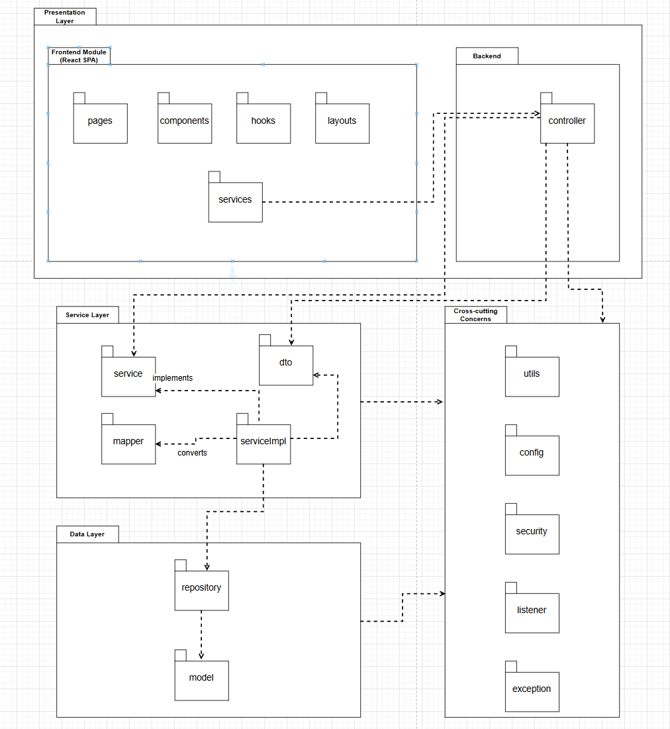

III.4 Detail Design
After high-level architectural design, the classes in the analysis model are mapped to design classes. The operations of a class can be determined from either the static model and the dynamic model. Information hiding classes are categorized by stereotype: entity classes, boundary classes, control classes, and application logic classes. In design modeling, each entity class is usually split into two separate classes. The first is a database wrapper class, which hides how data is accessed, especially when using a relational database. The second is a data abstraction class, which encapsulates the data structures [1].
Figure 3-7 shows the detailed design classes for the use cases: Manage Products, Add Product, Edit Product, and Delete Product. These classes are identified based on the architecture of the FSO system, as designed in Section 3.2. The operations of these classes are defined based on the messages in the sequence diagrams for these use cases, as shown in Figures 2-1 through 2 4.

III.5 Database Design
The data contained in the entity classes of the static model are mapped to a database (in this system, we will design a relational database). The entity class diagram of the FSO system, shown in Figure 1-4, which models the data requirements, will be mapped to a relational database design for the system.
Users(I̲d̲: uuid, Email: varchar(255), Phone: varchar(20), PasswordHash: varchar(255), IsVerified: boolean, IsActive: boolean, IsAdmin: boolean, LastLoginAt: timestamp, CreatedAt: timestamp, UpdatedAt: timestamp)
Customers(UserId: uuid, FullName: varchar(150), AvatarUrl: text, DateOfBirth: date, Gender: varchar(10), Nationality: varchar(80), HomeAddress: text, EmergencyContact: jsonb, FitnessLevel: varchar(30), MedicalNotes: text, PreferredLanguage: varchar(5), TotalToursJoined: integer, CreatedAt: timestamp, UpdatedAt: timestamp)
Guides(UserId: uuid, DisplayName: varchar(150), AvatarUrl: text, Bio: text, HomeProvince: varchar(100), ExperienceYears: smallint, Certifications: jsonb, Languages: jsonb, Specializations: jsonb, IdCardNumber: varchar(20), IdCardVerified: boolean, AvgRating: numeric(3,2), TotalReviews: integer, TotalToursLed: integer, IsAvailable: boolean, ProfileApprovedAt: timestamp, CreatedAt: timestamp, UpdatedAt: timestamp)
Tours(I̲d̲: uuid, Title: varchar(255), Slug: varchar(255), ShortDescription: varchar(500), Description: text, Difficulty: varchar(20), DurationDays: smallint, DurationNights: smallint, DistanceKm: numeric(7,2), MaxElevationM: integer, StartLocation: varchar(255), EndLocation: varchar(255), StartLat: numeric(10,7), StartLng: numeric(10,7), EndLat: numeric(10,7), EndLng: numeric(10,7), RouteGpxUrl: text, Highlights: jsonb, Includes: jsonb, Excludes: jsonb, Requirements: jsonb, Status: varchar(20), AvgRating: numeric(3,2), TotalReviews: integer, TotalDepartures: integer, TotalBookings: integer, CreatedBy: uuid, CreatedAt: timestamp, UpdatedAt: timestamp)
TourImages(I̲d̲: bigserial, TourId: uuid, ImageUrl: text, Caption: varchar(300), AltText: varchar(255), IsCover: boolean, SortOrder: smallint, UploadedBy: uuid, CreatedAt: timestamp)
TourWaypoints(I̲d̲: uuid, TourId: uuid, Name: varchar(200), Slug: varchar(200), SequenceOrder: smallint, WaypointType: varchar(30), Lat: numeric(10,7), Lng: numeric(10,7), ElevationM: integer, DayNumber: smallint, IsDayEnd: boolean, Description: text, NotesForGuide: text, HasToilet: boolean, HasShelter: boolean, HasPhoneSignal: boolean, HasFirstAid: boolean, WaterSource: varchar(20), WaterNotes: text, Accommodation: varchar(20), CampsiteCapacity: smallint, CampsiteFeeVnd: integer, ResupplyNotes: text, EmergencyPhone: varchar(20), EvacuationRouteNotes: text, NearestHospital: varchar(255), HospitalDistanceKm: numeric(6,1), HelicopterLanding: boolean, ImageUrl: text, ThumbnailUrl: text, IsActive: boolean, LastVerifiedAt: timestamp, VerifiedBy: uuid, CreatedAt: timestamp, UpdatedAt: timestamp)
TourDailyItinerary(I̲d̲: uuid, TourId: uuid, DayNumber: smallint, DayTitle: varchar(200), DayDescription: text, StartWaypointId: uuid, EndWaypointId: uuid, DistanceKm: numeric(6,2), ElevationGainM: integer, ElevationLossM: integer, WalkingHoursMin: numeric(4,1), WalkingHoursMax: numeric(4,1), DayDifficulty: varchar(20), SuggestedStartTime: time, SuggestedEndTime: time, MealsIncluded: jsonb, MealNotes: text, OvernightWaypointId: uuid, OvernightNotes: text, SafetyNotes: text, GuideNotes: text, SortOrder: smallint, CreatedAt: timestamp, UpdatedAt: timestamp)
ItineraryWaypoints(I̲d̲: bigserial, ItineraryId: uuid, WaypointId: uuid, VisitOrder: smallint, IsMandatory: boolean, VisitNotes: text, EstimatedArrival: time)
TourDepartures(I̲d̲: uuid, TourId: uuid, DepartureDate: date, ReturnDate: date, CutoffDate: date, ActualStartAt: timestamp, ActualEndAt: timestamp, PricePerPerson: numeric(12,2), MaxGroupSize: smallint, MinGroupSize: smallint, BookedSlots: smallint, AllowJoinTour: boolean, MeetingPoint: text, MeetingLat: numeric(10,7), MeetingLng: numeric(10,7), WeatherSummary: varchar(100), WeatherIcon: varchar(50), TempMinC: smallint, TempMaxC: smallint, PrecipitationMm: numeric(5,1), WindSpeedKmh: smallint, WeatherUpdatedAt: timestamp, WeatherWarning: text, ActualParticipants: smallint, IncidentLog: jsonb, RouteDeviations: jsonb, DebriefNotes: text, Notes: text, Status: varchar(20), CancelledReason: text, CreatedBy: uuid, CreatedAt: timestamp, UpdatedAt: timestamp)
DepartureGuides(D̲e̲p̲a̲r̲t̲u̲r̲e̲I̲d̲: uuid, G̲u̲i̲d̲e̲I̲d̲: uuid, Role: varchar(20), ConfirmedAt: timestamp)
DepartureWeatherDaily(I̲d̲: bigserial, DepartureId: uuid, DayNumber: smallint, ForecastDate: date, ItineraryId: uuid, LocationLabel: varchar(200), CheckpointLat: numeric(10,7), CheckpointLng: numeric(10,7), ElevationM: integer, WeatherSummary: varchar(150), WeatherIcon: varchar(50), TempMinC: smallint, TempMaxC: smallint, FeelsLikeMinC: smallint, FeelsLikeMaxC: smallint, PrecipitationMm: numeric(5,1), PrecipitationProb: smallint, WindSpeedKmh: smallint, WindDirection: varchar(10), WindGustKmh: smallint, HumidityPct: smallint, VisibilityKm: numeric(5,1), UvIndex: smallint, CloudCoverPct: smallint, WeatherWarning: text, WarningLevel: varchar(20), DataSource: varchar(50), ForecastUpdatedAt: timestamp, IsActual: boolean, CreatedAt: timestamp, UpdatedAt: timestamp)
Bookings(I̲d̲: bigserial, BookingCode: varchar(20), UserId: uuid, DepartureId: uuid, NumParticipants: smallint, ParticipantsInfo: jsonb, PriceSnapshot: numeric(12,2), SubtotalTour: numeric(12,2), SubtotalEquipment: numeric(12,2), DiscountAmount: numeric(12,2), TotalPrice: numeric(12,2), Currency: varchar(3), IsJoinTour: boolean, SpecialRequests: text, Status: varchar(20), PaidAt: timestamp, CancelledAt: timestamp, CancellationReason: text, BookedAt: timestamp, UpdatedAt: timestamp)
Payments(I̲d̲: bigserial, BookingId: bigint, Amount: numeric(12,2), Currency: varchar(3), Method: varchar(50), GatewayTxnId: varchar(255), Status: varchar(30), PaidAt: timestamp, RefundedAt: timestamp, RefundAmount: numeric(12,2), Note: text, CreatedAt: timestamp)
EquipmentCategories(I̲d̲: bigserial, Name: varchar(100), Slug: varchar(100), Icon: varchar(50), SortOrder: smallint, IsActive: boolean)
Equipment(I̲d̲: bigserial, CategoryId: bigint, Name: varchar(200), Description: text, Brand: varchar(100), Model: varchar(100), PricePerDay: numeric(10,2), DepositAmount: numeric(10,2), TotalStock: smallint, AvailableStock: smallint, Condition: varchar(20), ImageUrl: text, WeightKg: numeric(5,2), Specifications: jsonb, IsActive: boolean, CreatedAt: timestamp, UpdatedAt: timestamp)
EquipmentRentals(I̲d̲: bigserial, BookingId: bigint, EquipmentId: bigint, Quantity: smallint, RentalDays: smallint, PricePerDay: numeric(10,2), Subtotal: numeric(12,2), ReturnedAt: timestamp, ReturnCondition: varchar(20), DamageFee: numeric(10,2), Notes: text, CreatedAt: timestamp)
Reviews(I̲d̲: bigserial, UserId: uuid, BookingId: bigint, TourId: uuid, DepartureId: uuid, GuideId: uuid, OverallRating: smallint, GuideRating: smallint, DifficultyRating: smallint, SceneryRating: smallint, SafetyRating: smallint, ValueRating: smallint, EquipmentRating: smallint, Title: varchar(200), Comment: text, Photos: jsonb, IsAnonymous: boolean, IsApproved: boolean, IsFeatured: boolean, GuideReply: text, GuideRepliedAt: timestamp, HelpfulCount: integer, CreatedAt: timestamp, UpdatedAt: timestamp)
GuideRatings(I̲d̲: bigserial, GuideId: uuid, UserId: uuid, ReviewId: bigint, SkillRating: smallint, CommunicationRating: smallint, SafetyRating: smallint, LocalKnowledgeRating: smallint, PunctualityRating: smallint, Comment: text, IsApproved: boolean, CreatedAt: timestamp)
ReviewHelpful(ReviewId: bigint, UserId: uuid, CreatedAt: timestamp)
Wishlists(UserId: uuid, TourId: uuid, CreatedAt: timestamp)
Notifications(I̲d̲: bigserial, UserId: uuid, Type: varchar(60), Title: varchar(200), Body: text, Data: jsonb, IsRead: boolean, ReadAt: timestamp, CreatedAt: timestamp)

IV. Implementation

IV.1 Map architecture to the structure of the project
In the system architecture outlined in Section 3.2, the FSO (FreshFood Online) system is designed using a Multi-client/one-server model. It is divided into two subsystems: FSOAdmin and FSOCustomer, deployed in a web environment. To manage data operations effectively, these tasks are separated into a distinct component. As illustrated in Figure 3-6 (Component Diagram), the system consists of three main components: FSOAdmin (Executable - Web app), FSOCustomer (Executable - Web app), and FSOData (Library). These components are further organized into packages, as shown in Figure 3-5. Each package groups classes with similar roles and functionalities.

IV.2 Map Class Diagram and Interaction Diagram to Code
For example, two classes (ProductService, ProductController) in the detailed design classes in Figure 3-7 are mapped into code c# as follows:

V. Applying Alternative Architecture Patterns
Assuming that the functional requirements remain unchanged, the system is now being expanded to incorporate additional characteristics related to scalability and reusability. This enhancement allows the system to support the integration of new user-facing applications, including the potential development of a mobile app.

V.1 Applying the service-oriented architecture
NF-05 Reusability: The system should be built in a way that allows us to easily use the same code and features across different platforms. This means that the same functionality can be adapted for both the web and mobile apps, saving time and effort when adding new platforms or updating existing ones.
The current system architecture described in Section 3.2 does not fully meet the requirements of NF-05. To address this, the FSOData component must be restructured as a distributed component and designed using a service-oriented architecture (SOA). This adjustment will allow FSOData to function as a distributed service, thereby enhancing the system’s ability to achieve Reusability, traceability, modularity, and effective maintenance. The software architecture is redesigned as shown below.

V.2 Applying Service Discovery Pattern in the service-oriented architecture
Assuming that user requirements change and the store's scale may later expand into a chain of stores with an increasing number of users, the system will need to address an additional non functional requirement, NF-06, as follows:
NF-06: The system must be designed to accommodate an increasing number of stores and users while maintaining performance and reliability. This includes the ability to scale both horizontally and vertically. The architecture should support the addition of new stores and handle a growing volume of transactions and concurrent users without significant performance degradation. The system should implement load balancing to evenly distribute traffic and employ scalable database solutions to manage increasing amounts of data effectively.

