TRƯỜNG ĐẠI HỌC FPT

──────────────────────────────

Requirement & Design Specification

OptiCine – Cinema Operations and Resource Scheduling System

Subject: SWD392
Version: 1.0

– Da Nang , May 2026 –

Group Members
No. | Full Name | Mã sv
1 | Le Ngoc Dang
2 | Hoàng Tấn Thành
3 | Minh Tuấn | DE190100
4 | Nguyen Thai | DE190299
5 | Vinh Le

Contents
I. Requirement Specification 2
1.1 Problem Description 2
1.1.1 Purpose 2
1.1.2 Business Requirements 6
1.2 Major Features 7
1.2.1 Features for Cinema Staff 7
1.2.2 Features for Managers 9
II. Analysis Models 12
2.1 Functional Analysis 12
2.1.1 Overview 12
2.1.2 Main Actors 13
2.1.3 Business Rules 14
2.2 Use Case Analysis 15
2.2.1 Use Case Overview 15
2.2.2 Major Use Cases 15
2.3 Interaction Analysis 17
2.3.1 System Interaction Overview 17
2.3.2 Activity Diagrams 17
2.4 State Analysis 21
2.4.1 Movie State 21
2.5 Data Analysis 22
2.5.1 Core Business Entities 22
2.5.2 Data Relationships 22
2.6 Constraints and Analysis Conclusion 23

Record of Changes
Version | Date | In charge | Change Description
V1.0 | 24/05/2026 | Nguyen Thai | Added Requirement Specification – Phase 1
V1.1 | 24/05/2026 | Nguyen Thai | Add Analysis Models (theory)
A – Added M – Modified D – Deleted

I. Requirement Specification

1.1 Problem Description

1.1.1 Purpose
The purpose of OptiCine is to develop an internal cinema operation and resource scheduling management system used by cinema staff and management teams.
The system supports cinema daily operations including:
- Movie management
- Screening room management
- Showtime scheduling
- Automatic resource allocation
- Internal approval workflow
- Operational monitoring
- Business analytics
- Performance reporting
Cinema branches usually operate multiple screening rooms and multiple movie releases every day.
Operational staff are required to:
- assign movies to available rooms
- arrange screening schedules
- reserve cleaning periods
- manage maintenance
- monitor operational conflicts
- ensure business efficiency
In many small and medium cinema branches, scheduling is still managed manually using spreadsheets or traditional planning methods.
This causes several operational problems:
- A movie may be assigned to an unsuitable room.
- Two showtimes may overlap.
- Cleaning time between screenings may be insufficient.
- Prime-time slots may not be allocated properly.
- Unexpected changes may require rebuilding schedules.
- Managers may not have real-time operational visibility.
- Historical schedules are difficult to track manually.
As cinema operations expand, manual scheduling becomes difficult and error-prone.
OptiCine is developed to solve these challenges.
The system automatically evaluates:
- room availability
- room capacity
- movie popularity
- movie duration
- business hours
- preferred scheduling strategy
- cleaning buffer
- prime-time priority
The system generates optimized schedules.
Generated schedules are:
- saved as draft
- reviewed internally
- approved by supervisors
- approved by branch managers
- officially published
- stored for operational history
The system also provides:
- occupancy estimation
- room utilization statistics
- projected revenue analysis
- schedule performance reports
- operational alerts
Current project scope focuses on:
- internal cinema operation
- resource scheduling
- approval workflow
The following are not included:
- customer ticket booking
- online payment
- public cinema website
The architecture is prepared for future ticket-selling integration.
1.1.1.1 Scope
OptiCine focuses on internal cinema operation management.
Project scope includes:
• Movie Operations
- Create movie
- Update movie
- Disable movie
- Enable movie
- Upload poster
- Manage trailer link
- View movie detail
• Room Operations
- Create room
- Update room
- Disable room
- Manage maintenance
- Manage room capacity
• Showtime Operations
- Create showtime
- Edit showtime
- Cancel showtime
- View timetable
• Scheduling Engine
- Generate daily schedule
- Generate weekly schedule
- Apply scheduling strategy
- Validate conflicts
- Save draft
• Approval Workflow
- Submit draft
- Review draft
- Approve
- Reject
- Publish
• Analytics
- Monitor occupancy
- Monitor room usage
- Revenue projection
- Trend reports
• Security
- Login
- Permission control
- User role management
- Audit logs
Out of scope:
- customer ticket booking
- payment gateway
- online ticket QR
- loyalty program
- cinema public website

1.1.1.2 Existing System
Currently many cinema branches manage operations manually.
Existing tools often include:
• Spreadsheet Scheduling
Staff use spreadsheets to:
- assign rooms
- arrange showtimes
- estimate occupancy
- manage reports
Limitations:
- easy to overlap schedule
- difficult to update
- difficult to audit
- poor collaboration

• Manual Approval
Approval is handled by:
- chat groups
- email
- phone call
Limitations:
- approval delay
- missing history
- unclear responsibility

• Separate Reporting Tools
Managers use:
- Excel
- internal documents
- printed reports
Limitations:
- no real-time visibility
- duplicated work
- reporting inconsistency

• Operational Challenges
Current problems include:
- room conflict
- schedule overlap
- low visibility
- delayed approval
- difficult version tracking
- weak scalability
OptiCine is designed to replace manual workflow with centralized management.

1.1.2 Business Requirements
The cinema manages multiple movies available for screening.
Each movie contains:
- title
- description
- duration
- genre
- language
- age rating
- release date
- poster
- trailer reference
- popularity score
Cinema staff manage movie records.

The cinema operates multiple screening rooms.
Each room contains:
- room code
- seating capacity
- room type
- operational status
- maintenance schedule
Rooms may become unavailable due to:
- maintenance
- technical issue
- operational closure
System must reflect updates immediately.

Each movie may contain multiple showtimes.
Showtime includes:
- movie
- room
- date
- start time
- end time
- operational status
Business rules:
- showtimes cannot overlap
- cleaning buffer required
- inactive room cannot be scheduled

Scheduling engine evaluates:
- room availability
- capacity
- duration
- popularity
- business hour
- cleaning buffer
- scheduling strategy
System generates optimized suggestions.
Staff may:
- preview
- validate
- regenerate
- save
- submit

Approval workflow:
- Cinema Staff submit draft
- Shift Supervisor validates
- Branch Manager approves
- Official schedule published
System stores:
- approval comments
- approval history
- schedule versions

Managers can:
- monitor occupancy
- review utilization
- review projected revenue
- compare performance
- review trend reports

All users must:
- authenticate
- receive permission
- perform authorized functions only
Important actions are logged.
System guarantees transaction consistency.
System supports future ticket platform integration.

1.2 Major Features

1.2.1 Features for Cinema Staff
• F01 Movie Management
Cinema staff can:
- create movie
- edit movie
- upload poster
- upload trailer
- disable movie
- enable movie
- search by title
- filter by genre
- filter by release date
- view detail
- rank popularity
- update status

• F02 Room Management
Cinema staff can:
- create room
- update room
- disable room
- set maintenance
- reopen room
- search room
- filter room type
- update capacity
- update operational status
- view detail

• F03 Showtime Management
Cinema staff can:
- create showtime
- edit showtime
- delete showtime
- cancel showtime
- reschedule
- search room
- search movie
- search date
- filter status
- view timetable

• F04 Schedule Generation
Cinema staff can:
- generate daily schedule
- generate weekly schedule
- choose strategy
- validate schedule
- regenerate
- preview
- save draft
- compare results
- export
- submit

• F05 Approval Workflow
Cinema staff and supervisors can:
- submit draft
- approve
- reject
- add comment
- return schedule
- publish
- cancel approval
- review approval history

• F06 Schedule History
Users can:
- review history
- compare versions
- restore version
- duplicate
- archive
- search
- filter by date
- review approval records
- track changes
- audit history

1.2.2 Features for Managers
• F07 Operational Dashboard
Managers can:
- monitor schedules
- monitor rooms
- review approval queue
- detect conflict
- review occupancy
- monitor alerts
- monitor performance

• F08 Revenue and Analytics
Managers can:
- review revenue
- compare by date
- compare by room
- compare by movie
- monitor occupancy
- export reports
- track trend

• F09 User and Permission Management
Managers can:
- create account
- update account
- deactivate
- assign role
- revoke permission
- reset password
- audit activity

• F10 System Configuration
Managers can:
- define business hours
- configure prime-time
- configure cleaning buffer
- configure strategy
- configure maintenance
- configure workflow
- configure report settings

1.3 System Context
OptiCine communicates with internal users and external supporting systems.

1.3.1 External Users
• Cinema Staff
Responsible for:
- movie management
- room management
- showtime operations
- schedule generation

• Shift Supervisor
Responsible for:
- validating schedules
- checking quality
- reviewing comments
- rejecting invalid schedule

• Branch Manager
Responsible for:
- approval
- monitoring
- analytics
- permission management

• System Administrator
Responsible for:
- system configuration
- technical monitoring
- access control
- audit management

1.3.2 External Systems
• Authentication Service
Functions:
- validate login
- verify permission
- maintain session security

• Notification Service
Functions:
- send approval notification
- send alerts
- send warning

• Database Server
Stores:
- movie
- room
- showtime
- schedule
- history
- reports
- users

• Cache Service
Stores:
- temporary room availability
- scheduling state
Improves performance.

• File Storage Service
Stores:
- poster images
- exported reports
- audit files

• Future Ticketing Platform
Supports:
- receiving approved schedules
- publishing public showtime
- future integration

II. Analysis Models

2.1 Functional Analysis

2.1.1 Overview
The analysis phase of OptiCine focuses on identifying system behaviors, business interactions, operational workflows, and data processing responsibilities.
The main objective of this phase is to transform business requirements into analysis models that clearly describe:
- how internal cinema users interact with the system
- how the system processes operational data
- how scheduling decisions are generated
- how approvals and historical records are managed
The OptiCine system contains multiple business modules working together.
Major functional modules include:
- Movie Management
- Room Management
- Showtime Management
- Schedule Generation
- Approval Workflow
- Schedule History
- Operational Dashboard
- Revenue Analytics
- User Permission Management
- System Configuration
Each module supports a specific business responsibility.
- Cinema Staff mainly interact with operational modules.
- Shift Supervisors validate operational schedules.
- Branch Managers manage approvals and business monitoring.
- System Administrators manage access and technical configuration.
The analysis phase helps identify:
- major business actors
- system boundaries
- internal workflows
- relationships between modules
- business constraints
- system responsibilities
- operational rules
These results will support the design phase and later implementation.

2.1.2 Main Actors
The OptiCine system contains four major internal actors.
• Cinema Staff
Cinema Staff are responsible for day-to-day operational tasks.
Responsibilities include:
- creating movie records
- updating movie information
- managing screening rooms
- creating and editing showtimes
- generating daily schedules
- validating generated schedules
- submitting schedules for approval
- reviewing historical schedules
- updating operational status
Cinema Staff are the primary operational users.

• Shift Supervisor
Shift Supervisors validate schedules before manager approval.
Responsibilities include:
- reviewing generated schedules
- approving schedules
- rejecting schedules
- adding approval comments
- monitoring schedule conflicts
- checking operational quality
- forwarding schedules to Branch Manager
Shift Supervisors act as the first approval layer.

• Branch Manager
Branch Managers handle decision-making and business monitoring.
Responsibilities include:
- approving schedules
- rejecting schedules
- publishing approved schedules
- monitoring occupancy
- reviewing analytics
- managing user permissions
- configuring scheduling rules
- reviewing audit history
Branch Managers control official operational publishing.

• System Administrator
System Administrators maintain system infrastructure.
Responsibilities include:
- managing user access
- configuring system settings
- monitoring system logs
- managing technical notifications
- reviewing errors
- maintaining operational stability

2.1.3 Business Rules
The following business rules are applied in OptiCine.
Movie Rules
- A movie must be Active before being scheduled.
- Disabled movies cannot appear in generated schedules.
- Archived movies remain in history for reporting.
Room Rules
- A room under maintenance cannot receive showtimes.
- Disabled rooms are hidden from scheduling.
- Room capacity must be valid before scheduling.
Showtime Rules
- Two showtimes cannot overlap inside the same room.
- A cleaning buffer must exist between screenings.
- Every showtime must contain:
  - movie
  - room
  - date
  - start time
  - end time
  - status
Schedule Rules
- A draft schedule must be approved before publishing.
- Rejected schedules cannot become official.
- Every modification must be logged.
- Schedule history cannot be permanently deleted.
Permission Rules
- Only authorized users may configure system settings.
- Only Branch Managers may publish schedules.
- All users must log in before access.
System Rules
- Transaction consistency must be maintained.
- Failed schedule generation must rollback.
- Configuration changes must be tracked.

2.2 Use Case Analysis

2.2.1 Use Case Overview
The OptiCine system contains multiple use cases grouped by functional modules.
Main groups include:
- Movie Management
- Room Management
- Showtime Management
- Schedule Generation
- Approval Workflow
- Schedule History
- Operational Dashboard
- Revenue Analytics
- Permission Management
- Configuration Management
Relationships between actors and use cases will be modeled later.
[Placeholder – Figure II-1: Overview Use Case Diagram]

2.2.2 Major Use Cases
• UC-01 Manage Movies
Primary Actor: Cinema Staff
Description:
Allows cinema staff to manage movie information.
Functions include:
- Add movie
- Edit movie
- Disable movie
- Enable movie
- Search movie
- Filter movie
- View detail
- Update popularity score
Preconditions:
- Staff logged in
- Permission granted
Postconditions:
- Movie information updated
- Status reflected in system

• UC-02 Manage Rooms
Primary Actor: Cinema Staff
Functions include:
- Create room
- Edit room
- Disable room
- Mark maintenance
- Reopen room
- Update capacity
- Search room
- View room detail

• UC-03 Manage Showtimes
Primary Actor: Cinema Staff
Functions include:
- Create
- Edit
- Delete
- Cancel
- Reschedule
- Search
- View timetable

• UC-04 Generate Schedule
Primary Actor: Cinema Staff
Functions include:
- Daily scheduling
- Weekly scheduling
- Strategy selection
- Validation
- Regeneration
- Preview
- Save draft
- Export
- Submit approval

• UC-05 Approval Workflow
Primary Actors:
- Shift Supervisor
- Branch Manager
Functions include:
- Approve
- Reject
- Add comment
- Return schedule
- Publish schedule
- Review approval history

• UC-06 View Dashboard
Primary Actor: Branch Manager
Functions include:
- Monitor schedules
- Review occupancy
- Detect conflicts
- Review alerts
- Monitor room utilization

• UC-07 Manage Users
Primary Actor:
- Branch Manager
- System Administrator
Functions include:
- Create account
- Deactivate
- Assign role
- Reset password
- Review login history

2.3 Interaction Analysis

2.3.1 System Interaction Overview
The OptiCine system processes multiple interactions.
Examples include:
- Cinema Staff → Movie Module
- Cinema Staff → Room Module
- Cinema Staff → Showtime Module
- Cinema Staff → Schedule Engine
- Schedule Engine → Database
- Schedule Engine → Cache
- Staff → Approval Service
- Supervisor → Approval Service
- Manager → Dashboard
- Manager → Analytics
- Administrator → Configuration Module
Detailed diagrams will be added later.
[Placeholder – Figure II-2: Sequence Diagram – Generate Schedule]
[Placeholder – Figure II-3: Sequence Diagram – Approval Workflow]
[Placeholder – Figure II-4: Communication Diagram]

2.3.2 Activity Diagrams
This section illustrates the dynamic behavior of the OptiCine system by modeling the flow of control from activity to activity. The focus is on the core scheduling algorithms that drive the system's automated capabilities.
1. Auto-scheduling Flow This flow describes how the algorithm gathers input data (movies, screening rooms, business rules), executes the scheduling engine (CSA/PSO), and outputs a draft schedule.
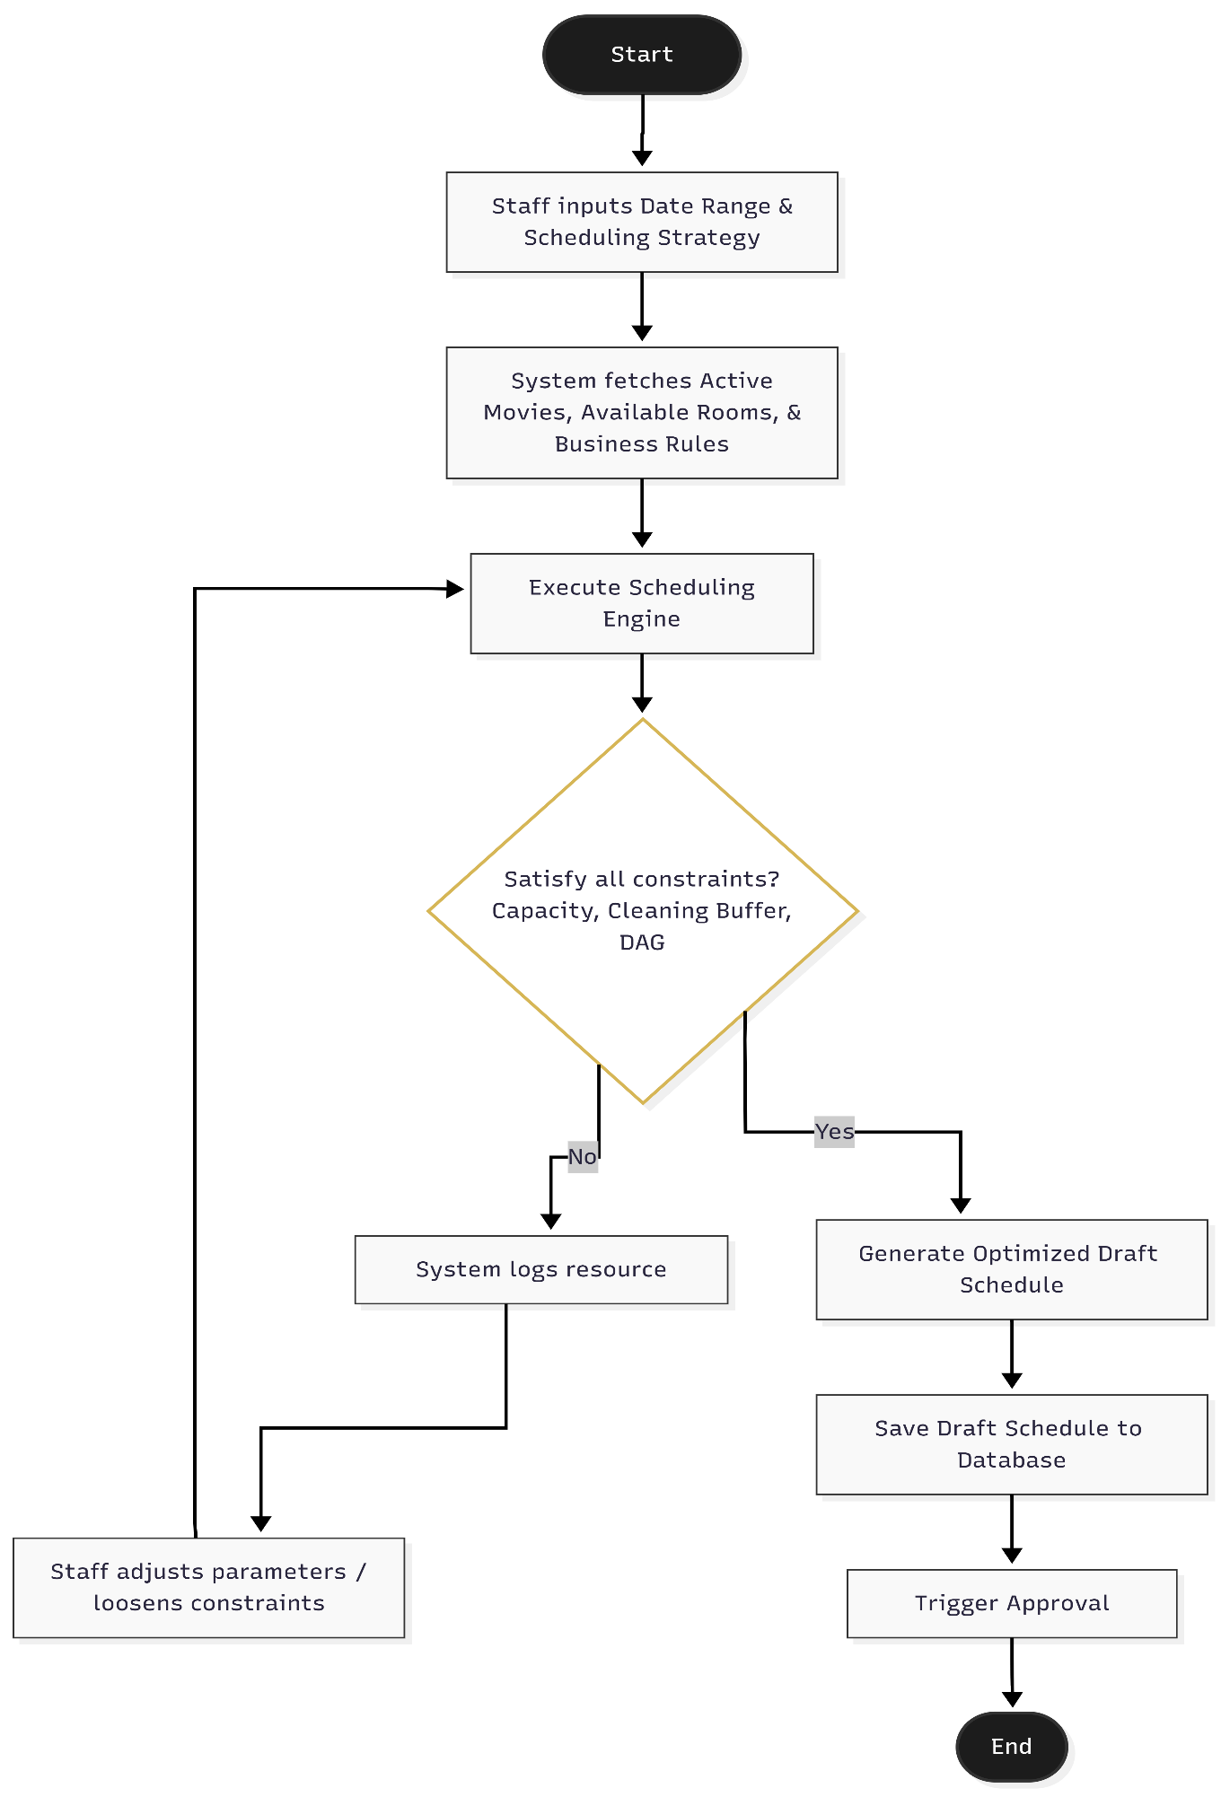
Figure II-5: Activity Diagram for Auto-scheduling Flow
Flow Description:
- Cinema staff inputs the desired date range and selects the scheduling strategy.
- The system fetches all active movies, available rooms, and operational constraints (business hours, capacity, etc.).
- The core Scheduling Engine executes the CSA/PSO metaheuristic algorithm.
- The system evaluates all constraints (e.g., room capacity, cleaning buffer, DAG workflow).
- If conflicts arise, the system logs them for staff to adjust parameters. If all constraints are satisfied, an optimized draft schedule is generated.
- The draft is saved to the database, and the approval workflow is triggered.
2. Rescheduling / Inverse Scheduling Flow This flow illustrates the scenario where a screening room breaks down unexpectedly. The system applies the Inverse Scheduling algorithm to relocate only the affected showtimes instead of rebuilding the entire schedule from scratch.
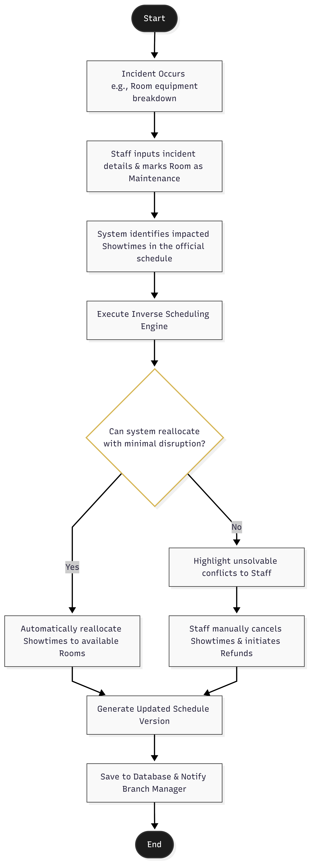
Figure II-6: Activity Diagram for Rescheduling / Inverse Scheduling Flow
Flow Description:
- An incident occurs (e.g., equipment breakdown in a specific room).
- Cinema staff inputs the incident details and marks the room status as "Maintenance".
- The system identifies all impacted showtimes in the currently published schedule.
- The Inverse Scheduling Engine is executed to find alternative slots for the affected showtimes.
- If the system can reallocate the showtimes with minimal disruption, it automatically updates the schedule.
- If the conflict is unsolvable (e.g., no available rooms), the system alerts the staff to manually cancel the showtimes and initiate customer refunds.
- The final updated schedule version is saved, and a notification is sent to the Branch Manager.

2.4 State Analysis

2.4.1 Movie State
Movie lifecycle:
- Created
- Active
- Disabled
- Archived
Transitions:
- Created → Active
- Active → Disabled
- Disabled → Active
- Active → Archived

2.4.2 Room State
Room lifecycle:
- Available
- Busy
- Maintenance
- Disabled
Transitions:
- Available → Busy
- Busy → Available
- Available → Maintenance
- Maintenance → Available
- Disabled → Available

2.4.3 Schedule State
Schedule lifecycle:
- Draft
- Submitted
- Supervisor Approved
- Manager Approved
- Published
- Rejected
- Archived
Transitions:
- Draft → Submitted
- Submitted → Supervisor Approved
- Supervisor Approved → Manager Approved
- Manager Approved → Published
- Rejected → Draft
- Published → Archived

2.5 Data Analysis

2.5.1 Core Business Entities
Main entities include:
- Movie
- Room
- Showtime
- Schedule
- ScheduleVersion
- ApprovalRequest
- ApprovalComment
- User
- Role
- Permission
- Report
- SystemConfiguration
- AuditLog
- Notification
These entities represent business data.
Detailed diagrams will be added later.
[Placeholder – Figure II-5: Entity Relationship Diagram]

2.5.2 Data Relationships
Main relationships:
- One movie may contain multiple showtimes.
- One room may contain multiple showtimes.
- One schedule contains multiple rooms.
- One schedule stores approval history.
- One manager may approve multiple schedules.
- One user may contain multiple permissions.
- Configuration rules affect scheduling.
- Reports are generated from schedules.
- Audit logs belong to user actions.
A user may contain multiple permissions.
A configuration may affect many schedules.
A report is generated from multiple schedules.
An audit log belongs to a system action.

2.6 Constraints and Analysis Conclusion
The analysis confirms important technical constraints.
Scheduling depends on:
- room availability
- movie duration
- cleaning buffer
- business hours
- strategy rules
- approval workflow
Operational reliability requires:
- transaction rollback
- audit logging
- permission validation
- version history
- performance optimization
These constraints directly influence the design phase.
The next phase will define:
- High-level architecture
- Package structure
- Design classes
- Database design
- Component diagram
- Detailed technical specification

