FPT UNIVERSITY
REQUIREMENT & DESIGN SPECIFICATION
OptiCine - Cinema Operations and Resource Scheduling System
Subject: SWD392
Version: 1.2
Document type: Research-oriented system structure and design specification

Da Nang, July 2026

Group Members
No. | Full Name | Student ID
1 | Le Ngoc Dang | DE180613
2 | Hoang Tan Thanh | DE180672
3 | Minh Tuan | DE190100
4 | Nguyen Thai | DE190299
5 | Vinh Le | DE190369

Record of Changes
Version | Date | A/M/D | In Charge | Change Description
V1.0 | 24/05/2026 | A | Nguyen Thai | Initial requirement specification.
V1.1 | 09/06/2026 | M | Project Team | Added analysis models, ERD, use cases and non-functional requirements.
V1.2 | 13/07/2026 | M | Project Team | Completed and normalized the research-oriented requirement, analysis and design specification; corrected scope, actors, states, data model and diagram placeholders.
A - Added; M - Modified; D - Deleted.

Table of Contents
I. Requirement Specification | 4
I.1 Problem Description | 4
I.2 Stakeholders and Roles | 5
I.3 Business Requirements and Rules | 5
I.4 Major Features | 5
I.5 System Context | 6
I.6 Non-functional Requirements | 6
I.7 Functional Requirements | 8
I.7.1 Use Case Overview | 8
I.7.2 Use Case Catalogue | 9
I.7.3 Core Use Case Descriptions | 9
I.8 Data Requirements | 14
I.8.1 Conceptual Data Model | 14
I.8.2 Data Dictionary | 15
II. Analysis Models | 23
II.1 Interaction Diagrams | 23
II.2 Activity Diagrams | 26
II.3 State Analysis | 32
II.4 Data Analysis | 37
II.5 Scheduling Constraint Model | 37
II.6 Requirements Traceability Matrix | 38
III. Design Specification | 40
III.1 Design Principles | 40
III.2 Integrated Communication Diagram | 40
III.3 System High-Level Design | 41
III.4 Component Design | 43
III.5 Package Design | 44
III.6 Detailed Design Patterns | 45
III.7 Database Design | 47
III.8 Security and Access Design | 49
III.9 Reliability, Versioning and Audit Design | 49
III.10 Research Basis and Future Scope | 49
IV. Conclusion | 51
Appendix A. Glossary | 52
Appendix B. Diagram Replacement Guide | 52
Appendix C. Research References | 53
Appendix D. Redraw and Standardize OptiCine Sequence Diagrams | 53

List of Abbreviations
Abbreviation | Meaning
CSP | Constraint Satisfaction Problem
ERD | Entity-Relationship Diagram
NFR | Non-functional Requirement
RBAC | Role-Based Access Control
RDS | Requirement & Design Specification
UML | Unified Modeling Language
UI | User Interface

I. Requirement Specification

I.1 Problem Description

I.1.1 Purpose
OptiCine is a proposed internal cinema operations and resource scheduling system for cinema staff and management teams. The document focuses on the structure, requirements, analysis and design of the system; it does not claim that the described components or algorithms have been implemented in software.
Many small and medium cinema branches still coordinate screening schedules through spreadsheets, email and chat groups. This manual approach increases the risk of overlapping showtimes, unsuitable room allocation, insufficient cleaning buffers, delayed approvals and limited operational visibility.
OptiCine addresses these problems through a centralized schedule model, explicit business rules, configurable scheduling strategies, multi-level approval, schedule versioning, operational monitoring and projected performance analysis.

I.1.2 Scope
In Scope:
- Internal movie, room, maintenance and showtime management.
- Automatic generation of daily or weekly screening schedule proposals.
- Constraint validation for room availability, overlap, cleaning buffer and business hours.
- Two-level approval workflow and official schedule publication.
- Schedule history, version comparison, audit logging, dashboard and projected analytics.
- Role-based access control and system configuration.
Out of Scope:
- Customer ticket booking, seat selection and public cinema website functions.
- Online payment, payment gateways, ticket QR codes and loyalty programmes.
- Direct refund processing or customer order management.
- Real-time ticket inventory management. A future external ticketing platform may only receive published schedule data.

I.1.3 Objectives
Reduce schedule conflicts and manual coordination errors.
Create a consistent method for assigning movies to rooms and time slots.
Support different scheduling objectives without changing the overall system structure.
Provide controlled review, approval, publication and revision of schedules.
Preserve traceability through versions, comments, notifications and audit records.
Provide management views of room utilization, projected occupancy and projected revenue.

I.1.4 Assumptions and Dependencies
- The proposed deployment manages one cinema branch. Multi-branch coordination is a future extension.
- Movie popularity, room capacity, business hours, cleaning buffers and time-slot weights are available as scheduling inputs.
- Projected revenue is an estimate derived from configured assumptions; actual ticket sales remain outside OptiCine.
- External authentication, notification, file storage and future ticketing interfaces are replaceable supporting services.

I.2 Stakeholders and Roles
Stakeholder | Responsibilities
Cinema Staff | Maintains movie, room, maintenance and showtime data; generates schedules; reviews drafts; submits schedules; handles operational incidents.
Shift Supervisor | Reviews submitted schedules for conflicts and operational quality; adds comments; approves, returns or rejects at level 1.
Branch Manager | Reviews business suitability and projections; approves, returns or rejects at level 2; publishes official schedules; reviews dashboards and reports.
System Administrator | Manages accounts, roles, permissions, system configuration, technical monitoring and audit access.

I.3 Business Requirements and Rules
ID | Business Requirement / Rule
BR-01 | The system shall maintain movie records with duration, classification, popularity and operational status.
BR-02 | The system shall maintain screening rooms, capacity, room type, operational status and maintenance periods.
BR-03 | Two showtimes assigned to the same room shall not overlap.
BR-04 | A configurable cleaning buffer shall be preserved after each showtime before the next room use.
BR-05 | A showtime shall not be scheduled while its room is under maintenance or disabled.
BR-06 | A showtime shall remain within configured business hours, and its end time shall include the movie duration.
BR-07 | Schedule generation shall support selectable strategies such as revenue-oriented, diversity-oriented and stability-oriented scheduling.
BR-08 | A schedule shall follow the hierarchy Draft -> Submitted -> Supervisor Approved -> Manager Approved -> Published.
BR-09 | Only a manager-approved schedule version may be published as the official schedule.
BR-10 | Any material schedule revision shall create a new version and preserve prior versions.
BR-11 | Important actions shall be authorized by role and recorded in the audit log.
BR-12 | Integration with a future ticketing platform shall be limited to published schedule data and schedule-change notifications.

I.4 Major Features
ID | Feature | Description
F01 | Movie Management | Create, update, activate, disable, archive, search and filter movie records.
F02 | Room and Maintenance Management | Maintain room data and planned or emergency maintenance periods.
F03 | Showtime Management | Create, edit, cancel, move and search showtimes while validating room constraints.
F04 | Schedule Generation | Generate daily or weekly schedule proposals using selected strategies and configurable rules.
F05 | Approval Workflow | Submit, review, comment, approve, return, reject and publish schedule versions.
F06 | Schedule History | Compare versions, review changes, duplicate, archive and restore eligible drafts.
F07 | Operational Dashboard | Monitor official schedules, room status, approval queues, conflicts and operational alerts.
F08 | Projected Analytics | Review projected occupancy, room utilization, schedule utility and projected revenue.
F09 | User and Permission Management | Maintain accounts, roles and permissions according to RBAC.
F10 | System Configuration | Maintain business hours, buffers, time-slot weights, strategies, workflow and report settings.

I.5 System Context
The system context separates internal stakeholders from supporting systems. Database, cache and runtime nodes are treated as deployment infrastructure and are therefore described later in the deployment design rather than as business actors.
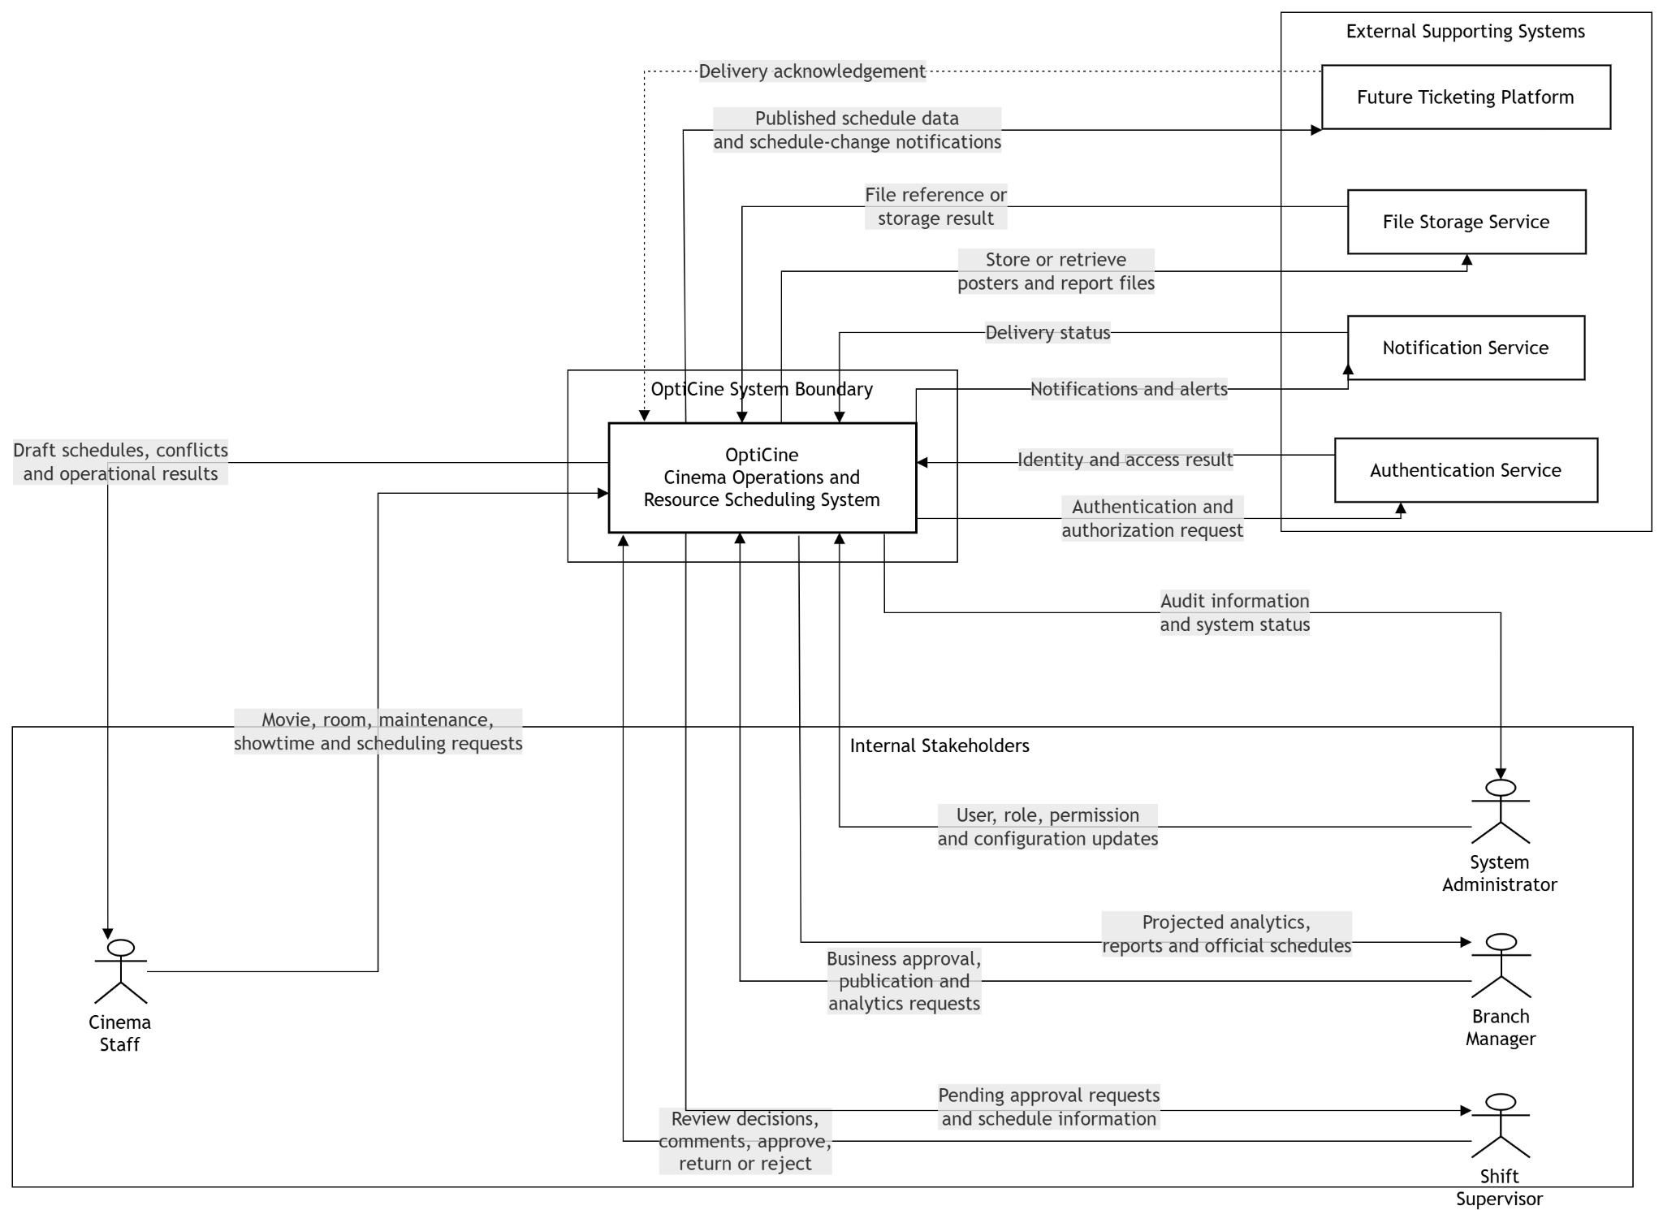
Figure I-1: System Context Diagram

I.6 Non-functional Requirements
ID | Quality | Requirement | Target / Design Criterion
NF-01 | Maintainability | The architecture shall separate presentation, application coordination, domain rules, scheduling strategies and data access. | Trace each core use case to a component and data entity; a strategy or approval level can be added without redesigning unrelated modules.
NF-02 | Usability | Staff shall be able to configure and request schedule generation without specialist technical knowledge. | The date range, movie/room selection and strategy configuration should be completable within three minutes; errors shall identify the violated rule and affected resource.
NF-03 | Performance | The design shall support computationally intensive schedule generation while maintaining responsive operational views. | Research target: produce or report failure for a seven-day, ten-room, twenty-movie dataset within 30 seconds; calendar view target under one second for hundreds of showtime blocks.
NF-04 | Security | The system shall protect internal operational data and enforce role-based access. | Use time-limited authentication, adaptive one-way password hashing, encrypted network communication, access checks and rate control for expensive operations.
NF-05 | Reliability and Data Integrity | Schedule versions, approvals and publication shall remain consistent when an operation fails. | Changes to an approval or published schedule shall be atomic at the conceptual transaction boundary; rejected or failed operations shall not leave partial schedule data.
NF-06 | Extensibility | The system shall support future scheduling strategies and external schedule consumers. | Scheduling strategies and external adapters shall be replaceable behind stable interfaces; ticketing integration remains one-way and outside the operational core.
The numeric values above are proposed design and research targets, not measured implementation results.

I.7 Functional Requirements

I.7.1 Use Case Overview
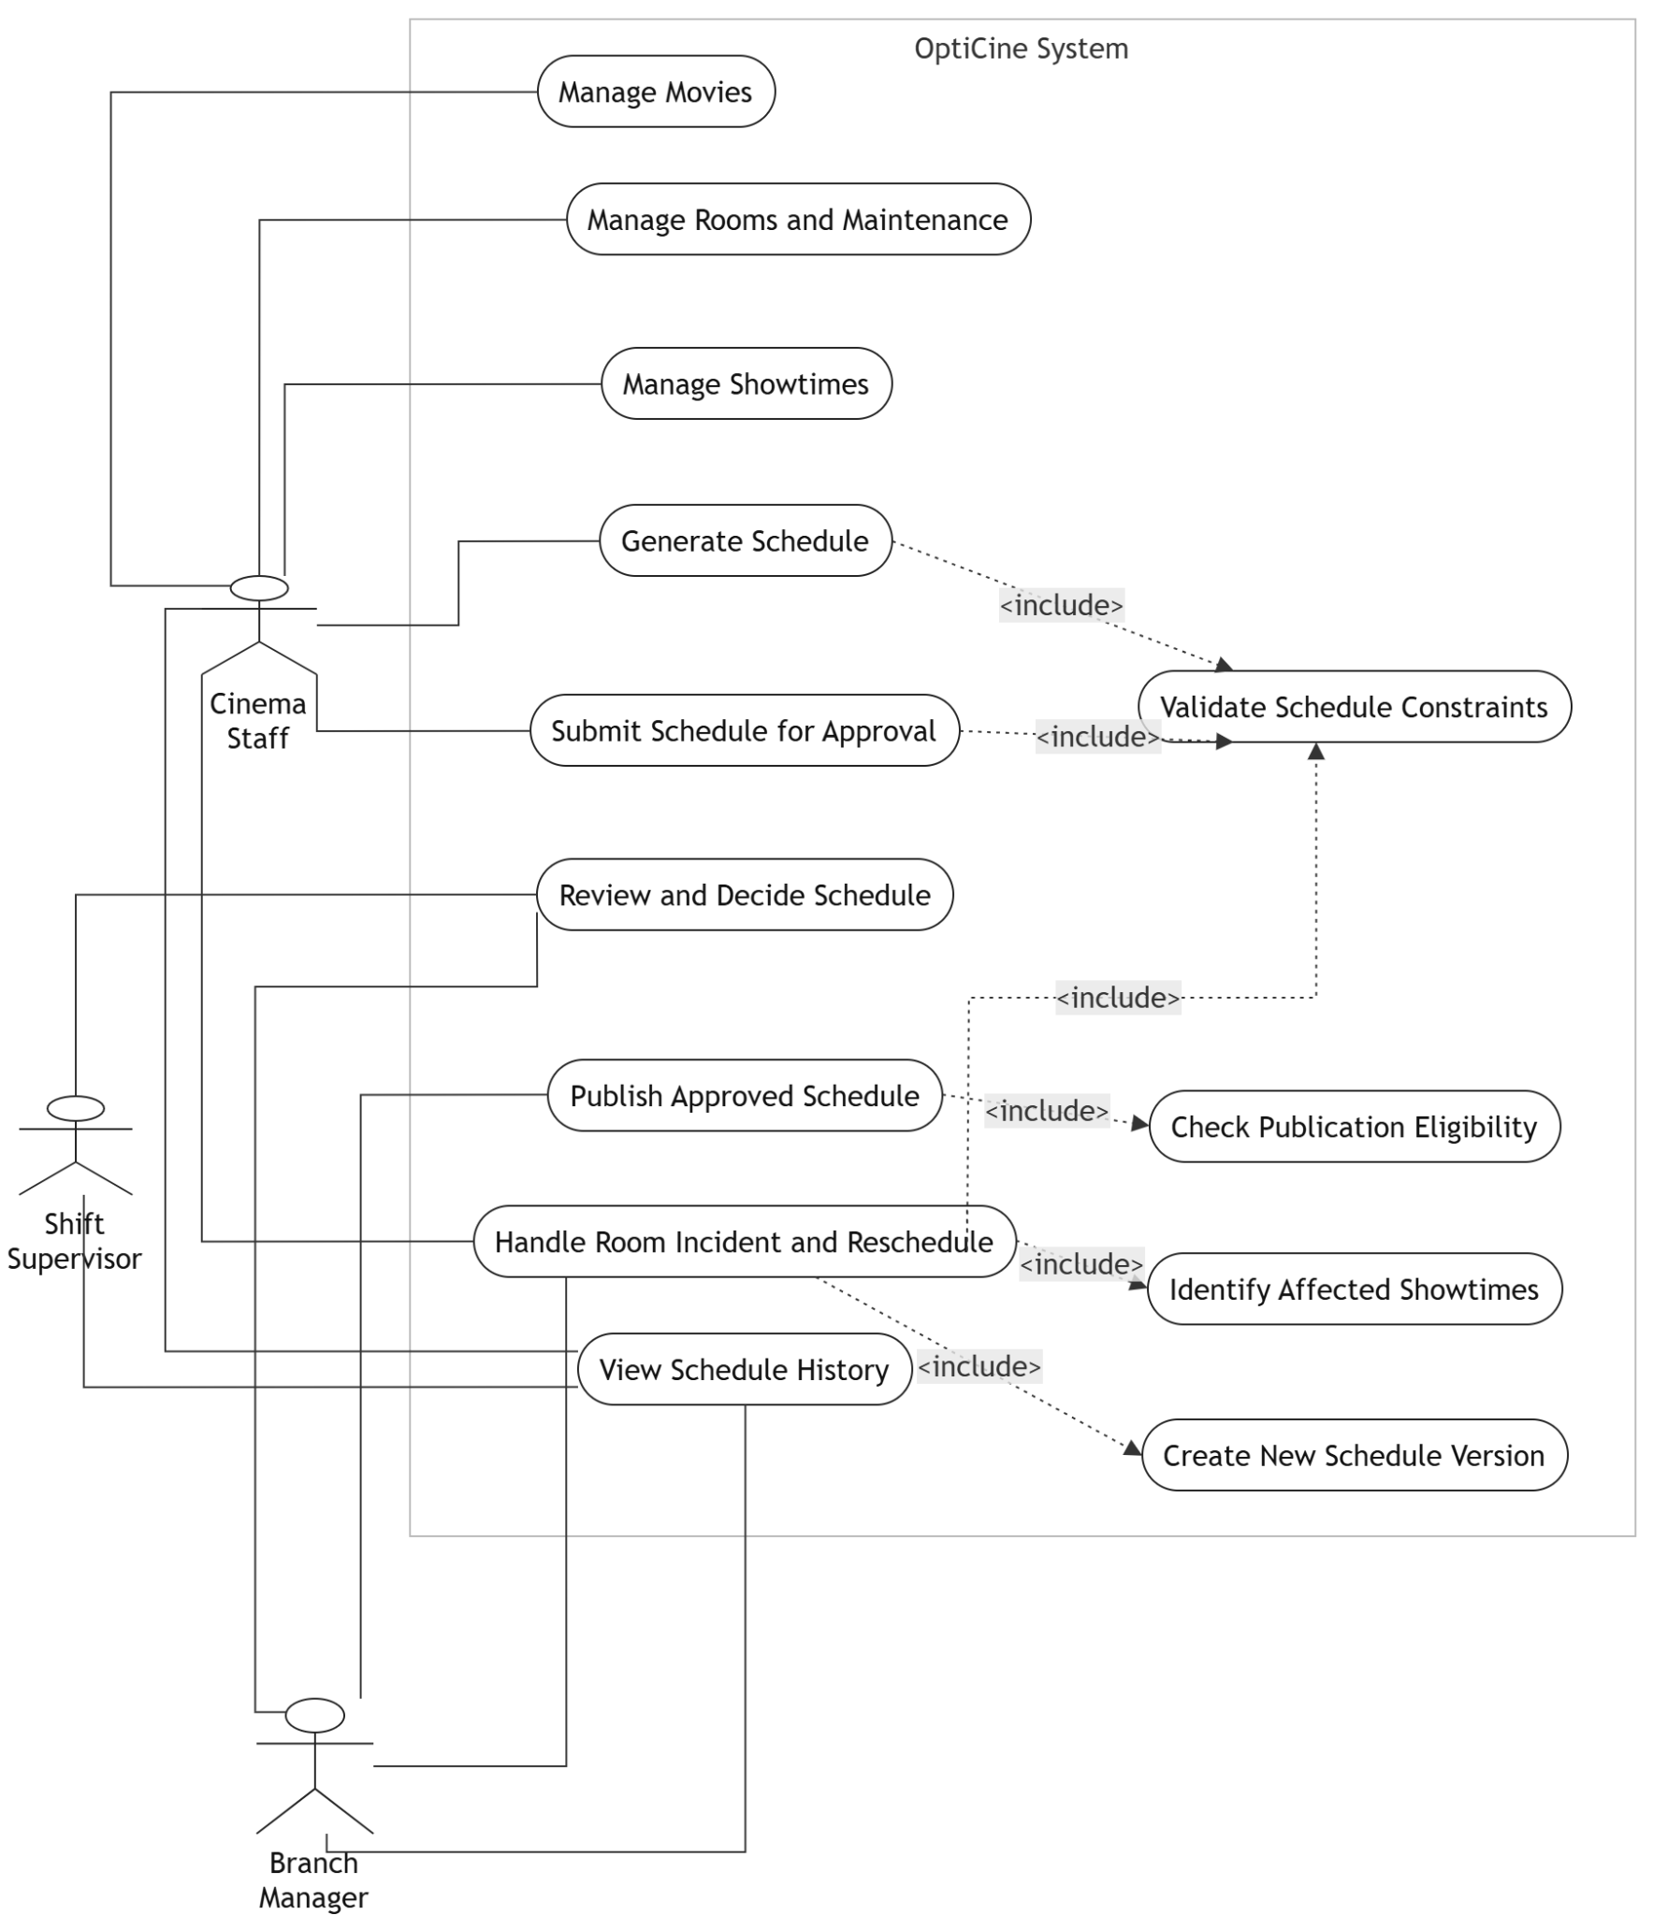

Figure I-2: Operations and Scheduling Use Case Diagram
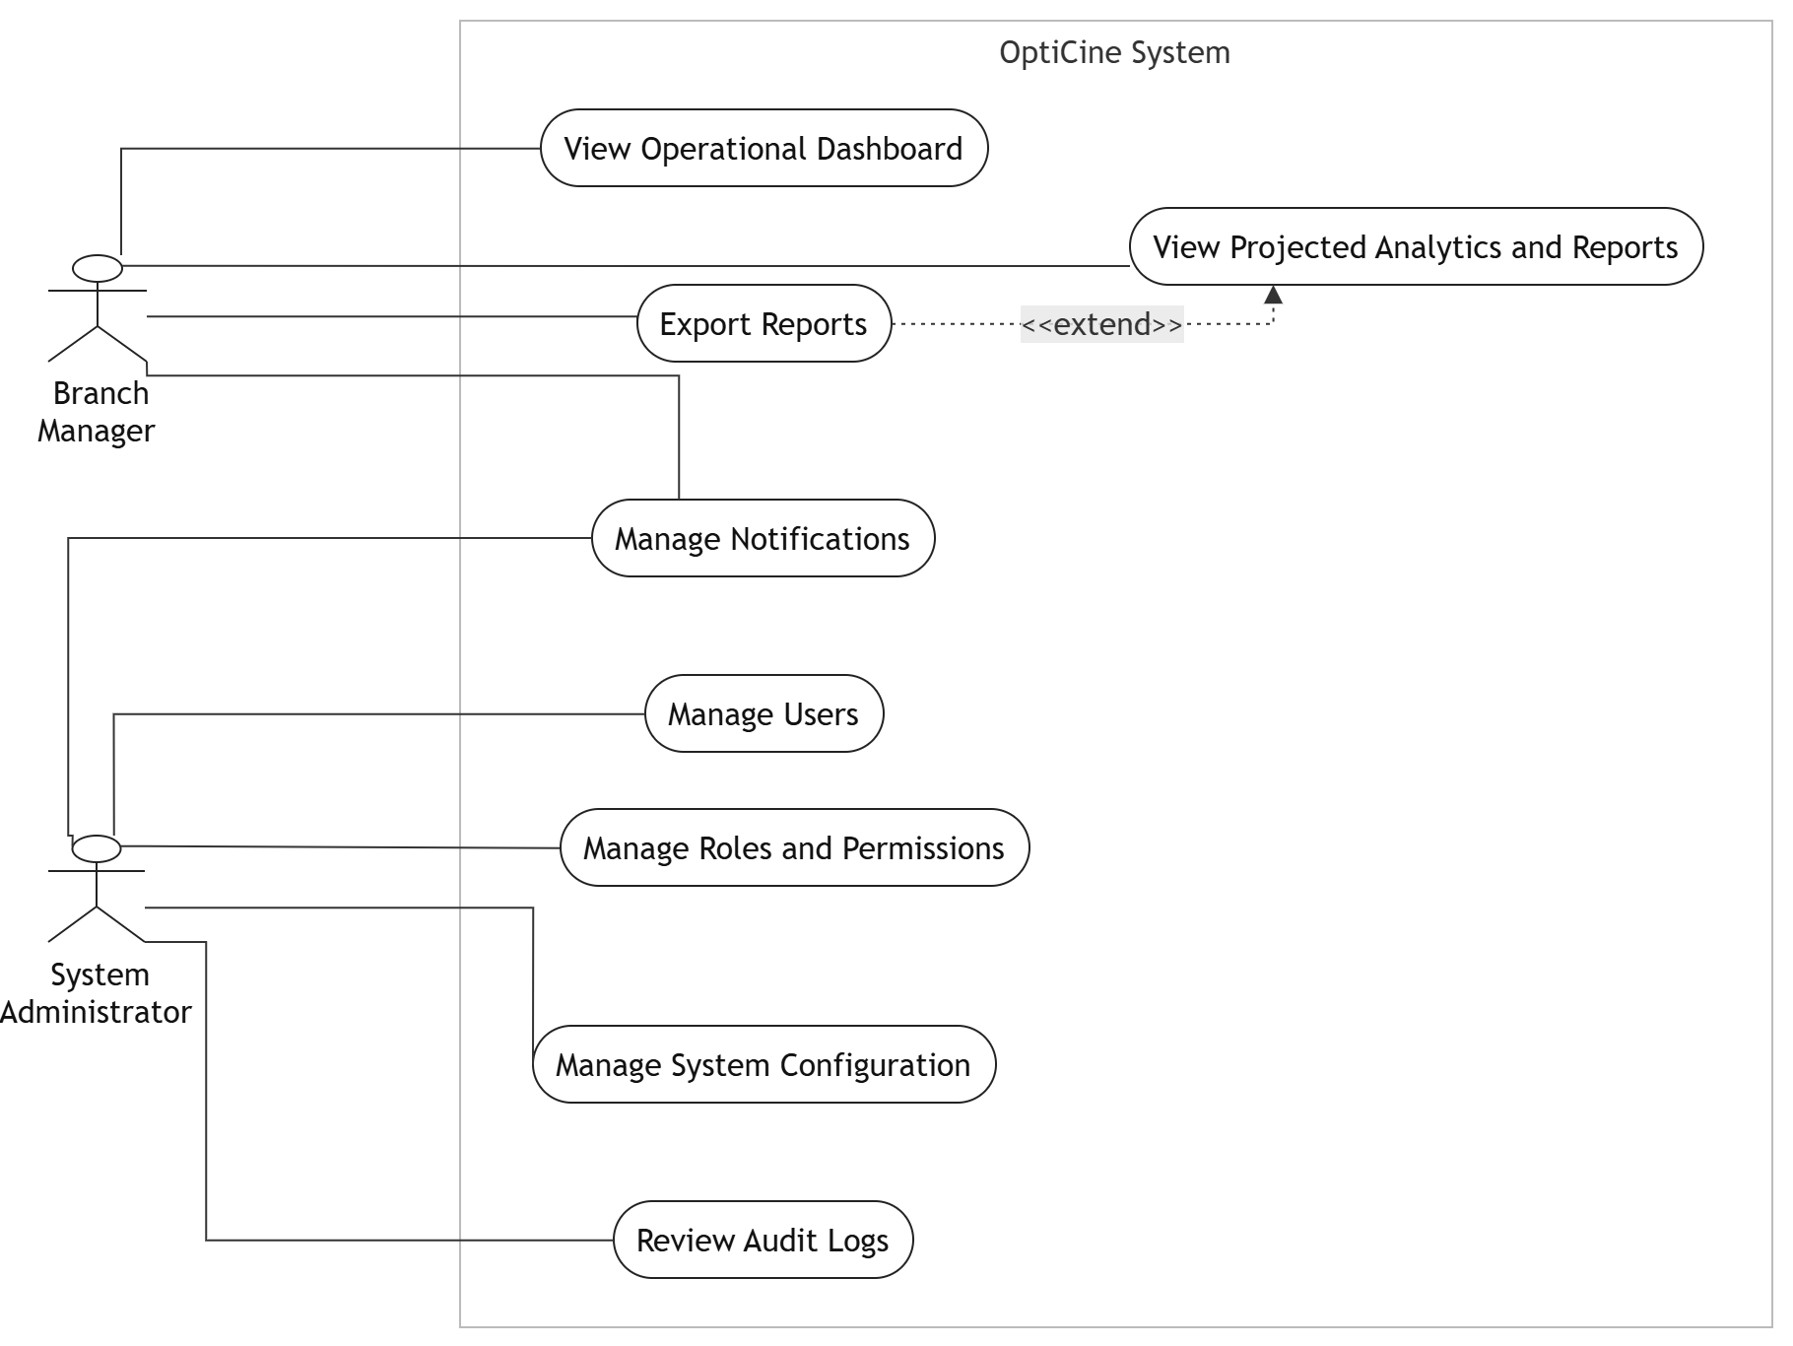
Figure I-3: Management and Administration Use Case Diagram

I.7.2 Use Case Catalogue
ID | Use Case | Primary Actor | Feature
UC-01 | Manage Movies | Cinema Staff | F01
UC-02 | Manage Rooms and Maintenance | Cinema Staff | F02
UC-03 | Manage Showtimes | Cinema Staff | F03
UC-04 | Generate Schedule | Cinema Staff | F04
UC-05 | Submit Schedule for Approval | Cinema Staff | F05
UC-06 | Review and Approve Schedule | Shift Supervisor / Branch Manager | F05
UC-07 | Publish Approved Schedule | Branch Manager | F05
UC-08 | Handle Room Incident and Reschedule | Cinema Staff / Branch Manager | F02, F03, F04
UC-09 | View Dashboard and Reports | Branch Manager | F07, F08
UC-10 | Manage Users and Configuration | System Administrator | F09, F10

I.7.3 Core Use Case Descriptions

UC-01 Manage Movies
ID and Name | UC-01 Manage Movies
Primary Actor | Cinema Staff
Supporting Actors / Systems | File Storage Service
Goal | Maintain accurate movie information used by showtime planning and schedule generation.
Trigger | Cinema Staff selects Movie Management.
Preconditions | PRE-1. The actor is authenticated and authorized.  PRE-2. Referenced files satisfy the configured format and size rules.
Postconditions | POST-1. Movie data and status are updated.  POST-2. The action is recorded in the audit log.
Main Flow | 1. The system displays the movie list and filters.  2. The actor selects create, update, activate, disable or archive.  3. The system validates required fields and duration.  4. The system stores the accepted change.  5. The system refreshes the list and confirms the result.
Alternative / Exception Flows | A3.1 Invalid data: show field-specific errors and keep the form.  A4.1 Movie is referenced by future showtimes: prevent archive or request that affected showtimes be resolved first.
Business Rules / Priority | BR-01, BR-11. Priority: High.

UC-02 Manage Rooms and Maintenance
ID and Name | UC-02 Manage Rooms and Maintenance
Primary Actor | Cinema Staff
Supporting Actors / Systems | Notification Service
Goal | Maintain room capacity, type, operational status and unavailable periods.
Trigger | Cinema Staff opens Room Management or records a maintenance event.
Preconditions | PRE-1. The actor is authorized.  PRE-2. The room exists for update or maintenance actions.
Postconditions | POST-1. Room or maintenance data are stored.  POST-2. Affected schedule items are flagged for review when required.
Main Flow | 1. The system displays rooms and current availability.  2. The actor selects a room or creates a new room.  3. The actor enters room details or a maintenance interval.  4. The system validates time range and room status.  5. The system stores the change and identifies affected showtimes.  6. The system displays impact information and sends relevant alerts.
Alternative / Exception Flows | A4.1 Maintenance interval is invalid: reject the input.  A5.1 Published showtimes are affected: start UC-08.
Business Rules / Priority | BR-02, BR-05, BR-11. Priority: High.

UC-03 Manage Showtimes
ID and Name | UC-03 Manage Showtimes
Primary Actor | Cinema Staff
Supporting Actors / Systems | None
Goal | Create or adjust showtimes without violating room and timing constraints.
Trigger | Cinema Staff selects Showtime Management or an affected showtime.
Preconditions | PRE-1. The selected movie and room are active.  PRE-2. The actor is authorized to edit the current schedule state.
Postconditions | POST-1. A valid showtime is created or changed.  POST-2. Conflicting changes are not stored.
Main Flow | 1. The actor selects movie, room, date and start time.  2. The system calculates the end time from movie duration.  3. The system loads maintenance and existing room use.  4. The system checks business hours, overlap and cleaning buffer.  5. The system stores the showtime in the current draft version.  6. The system displays the updated timeline.
Alternative / Exception Flows | A4.1 Conflict detected: show the conflicting showtime and violated rule.  A4.2 Room unavailable: suggest available rooms or time slots.
Business Rules / Priority | BR-03, BR-04, BR-05, BR-06. Priority: High.

UC-04 Generate Schedule
ID and Name | UC-04 Generate Schedule
Primary Actor | Cinema Staff
Supporting Actors / Systems | Scheduling Component, Availability Cache
Goal | Produce one or more valid schedule candidates for a selected period and strategy.
Trigger | Cinema Staff selects Generate Schedule.
Preconditions | PRE-1. Active movies, rooms and configuration data exist.  PRE-2. Date range and strategy are selected.  PRE-3. The actor is authorized.
Postconditions | POST-1. A draft schedule version and its showtimes are created, or a failure report is returned.  POST-2. Existing official schedules remain unchanged.
Main Flow | 1. The actor enters the date range, allowed movies/rooms and strategy.  2. The system validates configuration inputs.  3. The system loads active resources, maintenance periods and rules.  4. The scheduling strategy generates candidate assignments.  5. The system validates all hard constraints.  6. The system calculates utility and projected metrics.  7. The system saves the selected candidate as a draft schedule version.  8. The system displays the timeline, metrics and conflicts.
Alternative / Exception Flows | A2.1 Invalid configuration: show the invalid field and stop.  A5.1 No feasible schedule: return a constraint report and allow parameter adjustment.  A7.1 The actor regenerates: preserve or discard the current draft according to the selected option.
Business Rules / Priority | BR-03 through BR-07, BR-10. Priority: Critical.

UC-05 Submit Schedule for Approval
ID and Name | UC-05 Submit Schedule for Approval
Primary Actor | Cinema Staff
Supporting Actors / Systems | Notification Service
Goal | Lock a selected draft version for review and create the first approval request.
Trigger | Cinema Staff selects Submit on a valid draft schedule version.
Preconditions | PRE-1. The schedule version is DRAFT.  PRE-2. No unresolved hard constraint remains.  PRE-3. The actor created or is authorized to submit the version.
Postconditions | POST-1. The schedule status becomes SUBMITTED.  POST-2. A pending Shift Supervisor approval request is created.  POST-3. The assigned reviewer is notified.
Main Flow | 1. The system performs a final constraint check.  2. The actor confirms submission and may add a note.  3. The system creates an approval request at the Shift Supervisor step.  4. The system updates the schedule version status.  5. The system records history and sends notification.
Alternative / Exception Flows | A1.1 Constraint found: submission is denied and the conflict is displayed.  A3.1 No reviewer is assigned: keep the draft and notify the administrator.
Business Rules / Priority | BR-08, BR-10, BR-11. Priority: High.

UC-06 Review and Approve Schedule
ID and Name | UC-06 Review and Approve Schedule
Primary Actor | Shift Supervisor / Branch Manager
Supporting Actors / Systems | Notification Service
Goal | Validate operational quality and business suitability through two approval levels.
Trigger | An assigned reviewer opens a pending approval request.
Preconditions | PRE-1. The reviewer is authorized for the current approval step.  PRE-2. The schedule version is in the expected state.
Postconditions | POST-1. The version advances, returns to DRAFT, or becomes REJECTED.  POST-2. The decision and comment are stored.  POST-3. The next responsible actor is notified.
Main Flow | 1. The reviewer opens the schedule version and conflict summary.  2. The reviewer examines timeline, room utilization and projected metrics.  3. The reviewer adds a comment.  4. The reviewer selects Approve.  5. For level 1, the status becomes SUPERVISOR_APPROVED and a manager request is created.  6. For level 2, the status becomes MANAGER_APPROVED and the version becomes eligible for publication.
Alternative / Exception Flows | A4.1 Return: status returns to DRAFT and the creator is notified to revise.  A4.2 Reject: status becomes REJECTED and the rejection reason is mandatory.  E2.1 Version changed after request creation: invalidate the stale request and require resubmission.
Business Rules / Priority | BR-08, BR-09, BR-11. Priority: Critical.

UC-07 Publish Approved Schedule
ID and Name | UC-07 Publish Approved Schedule
Primary Actor | Branch Manager
Supporting Actors / Systems | Notification Service, Future Ticketing Platform
Goal | Make a manager-approved version the official schedule for its period.
Trigger | Branch Manager selects Publish on a MANAGER_APPROVED version.
Preconditions | PRE-1. The version is MANAGER_APPROVED.  PRE-2. No newer approved version already covers the same period.  PRE-3. The actor is authorized to publish.
Postconditions | POST-1. The schedule version and its showtimes become PUBLISHED.  POST-2. A previous official version for the period is archived when applicable.  POST-3. Internal users and the future ticketing adapter receive the publication event.
Main Flow | 1. The system revalidates publication eligibility.  2. The manager confirms publication.  3. The system marks the version and showtimes as PUBLISHED.  4. The system archives the replaced official version when applicable.  5. The system records the action and sends notifications.  6. The system sends published schedule data to the future ticketing adapter.
Alternative / Exception Flows | A1.1 Eligibility fails: deny publication and show the reason.  E6.1 External adapter unavailable: keep the internal publication, record pending delivery and retry without changing ticket data directly.
Business Rules / Priority | BR-09, BR-10, BR-11, BR-12. Priority: Critical.

UC-08 Handle Room Incident and Reschedule
ID and Name | UC-08 Handle Room Incident and Reschedule
Primary Actor | Cinema Staff
Supporting Actors / Systems | Branch Manager, Notification Service, Future Ticketing Platform
Goal | Revise only the affected part of a published schedule while minimizing disruption.
Trigger | A room is marked unavailable during a published schedule period.
Preconditions | PRE-1. A published schedule contains showtimes in the affected room.  PRE-2. The maintenance interval is known.  PRE-3. The actor is authorized to record the incident.
Postconditions | POST-1. A revised schedule version is created and approved, or unresolved showtimes are presented for a manager decision.  POST-2. The original published version remains in history.  POST-3. Schedule-change notifications are issued.
Main Flow | 1. The actor records the incident and unavailable period.  2. The system identifies impacted showtimes.  3. The system creates a new version from the official schedule.  4. The stability-oriented strategy searches alternative rooms and times.  5. The system validates the revised assignments.  6. The actor reviews the proposed changes.  7. The revised version follows an expedited approval and publication flow.  8. The system notifies internal users and sends schedule changes to the future ticketing adapter.
Alternative / Exception Flows | A4.1 No feasible reassignment: mark unresolved showtimes and present cancellation or manual adjustment options.  A6.1 Staff rejects proposal: adjust constraints and regenerate.  E8.1 External adapter unavailable: queue the change notification; OptiCine does not process refunds or ticket orders.
Business Rules / Priority | BR-03 through BR-06, BR-10, BR-12. Priority: Critical.

I.8 Data Requirements

I.8.1 Conceptual Data Model
The conceptual model separates a logical schedule period from its versions. Showtimes belong to a schedule version so that a revision can be compared with earlier versions without overwriting history. Approval requests and comments also reference the reviewed version.
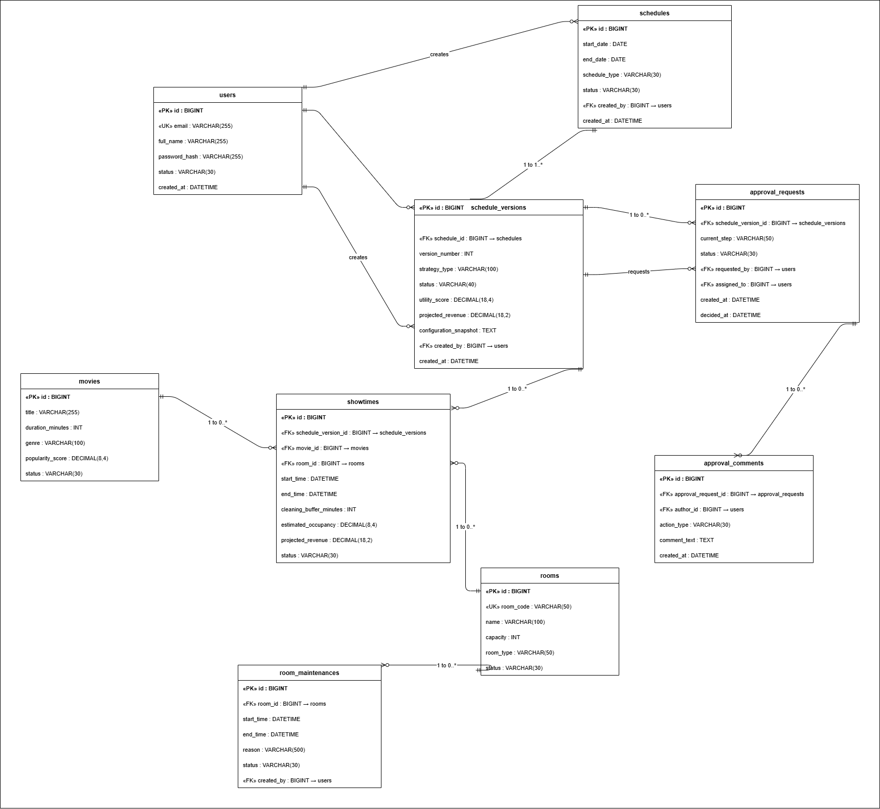
Figure I-4: Core Domain Entity-Relationship Diagram

I.8.2 Data Dictionary

1. Identity and Access

users
Stores identity and account status for internal system users.

Marker | Attribute | Type | Constraints | Description | Cardinality / Relationship
PK | id | BIGINT | PK, mandatory | Unique user identifier. | 1 user → 0..* schedules, 0..* schedule_versions, 0..* approval_requests
UK | email | VARCHAR(255) | mandatory, unique | Login and notification address. | —
 | full_name | VARCHAR(255) | mandatory | User display name. | —
 | password_hash | VARCHAR(255) | mandatory | Adaptive one-way password hash. | —
 | status | VARCHAR(30) | mandatory | ACTIVE, INACTIVE or LOCKED. | —
 | created_at | DATETIME | mandatory | Creation timestamp. | —
 | updated_at | DATETIME | optional | Last update timestamp. | —

roles
Defines named responsibilities used by role-based access control.
Marker | Attribute | Type | Constraints | Description | Cardinality / Relationship
PK | id | BIGINT | PK, mandatory | Role identifier. | 1 role → 0..* user_roles, 0..* role_permissions
UK | name | VARCHAR(100) | mandatory, unique | CINEMA_STAFF, SHIFT_SUPERVISOR, BRANCH_MANAGER or SYSTEM_ADMINISTRATOR. | —
 | description | VARCHAR(500) | optional | Role purpose and scope. | —

permissions
Defines atomic system actions that may be granted to roles.
Marker | Attribute | Type | Constraints | Description | Cardinality / Relationship
PK | id | BIGINT | PK, mandatory | Permission identifier. | 1 permission → 0..* role_permissions
UK | code | VARCHAR(150) | mandatory, unique | Stable permission code. | —
 | description | VARCHAR(500) | optional | Human-readable meaning. | —

user_roles
Associates users with one or more roles. Composite PK.
Marker | Attribute | Type | Constraints | Description | Cardinality / Relationship
PK,FK | user_id | BIGINT | PK, FK → users.id | Assigned user. | N users ↔ M roles (junction)
PK,FK | role_id | BIGINT | PK, FK → roles.id | Assigned role. | —

role_permissions
Associates roles with granted permissions. Composite PK.
Marker | Attribute | Type | Constraints | Description | Cardinality / Relationship
PK,FK | role_id | BIGINT | PK, FK → roles.id | Role receiving the permission. | N roles ↔ M permissions (junction)
PK,FK | permission_id | BIGINT | PK, FK → permissions.id | Granted permission. | —

2. Resource Catalogue

movies
Stores movie data used by showtime planning and schedule generation.
Marker | Attribute | Type | Constraints | Description | Cardinality / Relationship
PK | id | BIGINT | PK, mandatory | Movie identifier. | 1 movie → 0..* showtimes
 | title | VARCHAR(255) | mandatory | Display title. | —
 | description | TEXT | optional | Synopsis. | —
 | duration_minutes | INT | mandatory, > 0 | Running time used to calculate showtime end. | —
 | genre | VARCHAR(100) | optional | Movie genre. | —
 | language | VARCHAR(100) | optional | Language or subtitle information. | —
 | age_rating | VARCHAR(50) | optional | Audience classification. | —
 | release_date | DATE | optional | Release date. | —
 | poster_url | VARCHAR(500) | optional | Poster storage reference. | —
 | trailer_url | VARCHAR(500) | optional | Trailer reference. | —
 | popularity_score | DECIMAL(8,4) | mandatory | Normalized scheduling input. | —
 | status | VARCHAR(30) | mandatory | CREATED, ACTIVE, DISABLED or ARCHIVED. | —

rooms
Stores stable physical attributes and operational status of screening rooms.
Marker | Attribute | Type | Constraints | Description | Cardinality / Relationship
PK | id | BIGINT | PK, mandatory | Room identifier. | 1 room → 0..* showtimes, 0..* room_maintenances
UK | room_code | VARCHAR(50) | mandatory, unique | Branch room code. | —
 | name | VARCHAR(100) | mandatory | Room name. | —
 | capacity | INT | mandatory, > 0 | Seat capacity. | —
 | room_type | VARCHAR(50) | mandatory | STANDARD, VIP, IMAX or configured type. | —
 | status | VARCHAR(30) | mandatory | ACTIVE, MAINTENANCE or DISABLED.  ⚠ BUSY is derived — not stored. | —
* BUSY is a DERIVED state computed from scheduled showtimes for a requested interval. It is NOT stored as a persistent room status value.

room_maintenances
Represents planned or emergency room unavailability intervals.
Marker | Attribute | Type | Constraints | Description | Cardinality / Relationship
PK | id | BIGINT | PK, mandatory | Maintenance identifier. | 1 room_maintenance → 1 room
FK | room_id | BIGINT | FK → rooms.id, mandatory | Affected room. | Many maintenances → 1 room
 | start_time | DATETIME | mandatory | Unavailable interval start. | —
 | end_time | DATETIME | mandatory, > start_time | Unavailable interval end. | —
 | reason | VARCHAR(500) | mandatory | Maintenance or incident reason. | —
 | status | VARCHAR(30) | mandatory | PLANNED, ACTIVE, COMPLETED or CANCELLED. | —
FK | created_by | BIGINT | FK → users.id | Actor who recorded the interval. | Many maintenances → 1 user

time_slots
Defines named time ranges and scheduling weights.
Marker | Attribute | Type | Constraints | Description | Cardinality / Relationship
PK | id | BIGINT | PK, mandatory | Time-slot identifier. | 1 time_slot → 0..* showtimes
 | name | VARCHAR(100) | mandatory | Human-readable slot name. | —
 | start_time | TIME | mandatory | Daily start time. | —
 | end_time | TIME | mandatory | Daily end time. | —
 | weight | DECIMAL(8,4) | mandatory | Relative utility weight. | —
 | slot_type | VARCHAR(30) | mandatory | NORMAL or PRIME_TIME. | —

system_configurations
Stores configurable scheduling and workflow rules.
Marker | Attribute | Type | Constraints | Description | Cardinality / Relationship
PK | id | BIGINT | PK, mandatory | Configuration identifier. | —
UK | config_key | VARCHAR(150) | mandatory, unique | Stable configuration key. | —
 | config_value | TEXT | mandatory | Serialized configuration value. | —
 | value_type | VARCHAR(30) | mandatory | STRING, NUMBER, BOOLEAN, TIME or JSON. | —
 | effective_from | DATETIME | mandatory | Effective timestamp. | —
 | status | VARCHAR(30) | mandatory | ACTIVE or INACTIVE. | —

3. Schedule Core

schedules
Represents a logical daily or weekly planning period. A schedule owns one or more immutable ScheduleVersion records.
Marker | Attribute | Type | Constraints | Description | Cardinality / Relationship
PK | id | BIGINT | PK, mandatory | Schedule identifier. | 1 schedule → 1..* schedule_versions
 | start_date | DATE | mandatory | Planning period start. | —
 | end_date | DATE | mandatory, >= start | Planning period end. | —
 | schedule_type | VARCHAR(30) | mandatory | DAILY or WEEKLY. | —
 | status | VARCHAR(30) | mandatory | Overall lifecycle status of the current official version. | —
FK | created_by | BIGINT | FK → users.id | Original creator. | Many schedules → 1 user
 | created_at | DATETIME | mandatory | Creation timestamp. | —

schedule_versions
Stores immutable versioned plans for a logical schedule. Showtimes and ApprovalRequests belong to a ScheduleVersion, not directly to a Schedule.
Marker | Attribute | Type | Constraints | Description | Cardinality / Relationship
PK | id | BIGINT | PK, mandatory | Version identifier. | 1 schedule_version → 0..* showtimes, 0..* approval_requests
FK | schedule_id | BIGINT | FK → schedules.id, mandatory | Logical schedule. | Many versions → 1 schedule
 | version_number | INT | mandatory, unique per schedule | Monotonic version number. UNIQUE(schedule_id, version_number). | —
 | strategy_type | VARCHAR(100) | mandatory | Selected scheduling strategy. | —
 | status | VARCHAR(40) | mandatory | DRAFT, SUBMITTED, SUPERVISOR_APPROVED, MANAGER_APPROVED, PUBLISHED, REJECTED or ARCHIVED. | —
 | utility_score | DECIMAL(18,4) | optional | Calculated schedule utility score. | —
 | projected_revenue | DECIMAL(18,2) | optional | Projected value, not actual ticket revenue. | —
 | configuration_snapshot | TEXT | mandatory | Rules and weights used to generate the version. | —
FK | created_by | BIGINT | FK → users.id | Creator of this version. | Many versions → 1 user
 | created_at | DATETIME | mandatory | Version creation timestamp. | —

showtimes
Stores movie-room-time assignments within a schedule version. A showtime belongs to schedule_versions (via schedule_version_id), NOT directly to schedules.
Marker | Attribute | Type | Constraints | Description | Cardinality / Relationship
PK | id | BIGINT | PK, mandatory | Showtime identifier. | 1 showtime → 1 schedule_version, 1 movie, 1 room
FK | schedule_version_id | BIGINT | FK → schedule_versions.id, mandatory | Owning version. ⚠ NOT schedule_id. | Many showtimes → 1 schedule_version
FK | movie_id | BIGINT | FK → movies.id, mandatory | Scheduled movie. | Many showtimes → 1 movie
FK | room_id | BIGINT | FK → rooms.id, mandatory | Assigned room. | Many showtimes → 1 room
FK | time_slot_id | BIGINT | FK → time_slots.id, optional | Named slot classification. | Many showtimes → 0..1 time_slot
 | start_time | DATETIME | mandatory | Start timestamp. | —
 | end_time | DATETIME | mandatory, > start_time | End timestamp. | —
 | cleaning_buffer_minutes | INT | mandatory, >= 0 | Buffer after the showtime. | —
 | estimated_occupancy | DECIMAL(8,4) | optional | Projected occupancy ratio. | —
 | projected_revenue | DECIMAL(18,2) | optional | Projected value for analysis. | —
 | status | VARCHAR(30) | mandatory | DRAFT, APPROVED, PUBLISHED, CANCELLED or COMPLETED. | —

4. Approval and Notifications

approval_requests
Stores each approval stage for one schedule version. References schedule_version_id, NOT schedule_id.
Marker | Attribute | Type | Constraints | Description | Cardinality / Relationship
PK | id | BIGINT | PK, mandatory | Approval request identifier. | 1 approval_request → 0..* approval_comments
FK | schedule_version_id | BIGINT | FK → schedule_versions.id, mandatory | Reviewed version. ⚠ NOT schedule_id. | Many requests → 1 schedule_version
 | current_step | VARCHAR(50) | mandatory | SHIFT_SUPERVISOR or BRANCH_MANAGER. | —
 | status | VARCHAR(30) | mandatory | PENDING, APPROVED, RETURNED, REJECTED or CANCELLED. | —
FK | requested_by | BIGINT | FK → users.id, mandatory | Requesting actor. | Many requests → 1 user
FK | assigned_to | BIGINT | FK → users.id, mandatory | Assigned reviewer. | Many requests → 1 user
 | created_at | DATETIME | mandatory | Request timestamp. | —
 | decided_at | DATETIME | optional | Decision timestamp. | —

approval_comments
Stores review comments and decisions for an approval request.
Marker | Attribute | Type | Constraints | Description | Cardinality / Relationship
PK | id | BIGINT | PK, mandatory | Comment identifier. | 1 comment → 1 approval_request
FK | approval_request_id | BIGINT | FK → approval_requests.id, mandatory | Related request. | Many comments → 1 approval_request
FK | author_id | BIGINT | FK → users.id, mandatory | Comment author. | Many comments → 1 user
 | action_type | VARCHAR(30) | mandatory | COMMENT, APPROVE, RETURN or REJECT. | —
 | comment_text | TEXT | mandatory for RETURN/REJECT | Review explanation. | —
 | created_at | DATETIME | mandatory | Creation timestamp. | —

notifications
Stores internal alerts and delivery state.
Marker | Attribute | Type | Constraints | Description | Cardinality / Relationship
PK | id | BIGINT | PK, mandatory | Notification identifier. | —
FK | recipient_id | BIGINT | FK → users.id, mandatory | Recipient. | Many notifications → 1 user
FK | schedule_version_id | BIGINT | FK → schedule_versions.id, optional | Related version. | Many notifications → 0..1 schedule_version
 | type | VARCHAR(50) | mandatory | SUBMISSION, DECISION, PUBLICATION, INCIDENT or SYSTEM_ALERT. | —
 | message | TEXT | mandatory | Notification content. | —
 | status | VARCHAR(30) | mandatory | PENDING, SENT, READ or FAILED. | —
 | created_at | DATETIME | mandatory | Creation timestamp. | —
 | read_at | DATETIME | optional | Read timestamp. | —

5. Operations and Audit

reports
Stores generated operational and projected analytics reports.
Marker | Attribute | Type | Constraints | Description | Cardinality / Relationship
PK | id | BIGINT | PK, mandatory | Report identifier. | —
FK | schedule_id | BIGINT | FK → schedules.id, optional | Related schedule. | Many reports → 0..1 schedule
 | report_type | VARCHAR(50) | mandatory | UTILIZATION, OCCUPANCY, PROJECTED_REVENUE or AUDIT. | —
 | period_start | DATE | mandatory | Report period start. | —
 | period_end | DATE | mandatory | Report period end. | —
 | file_url | VARCHAR(500) | optional | Exported file reference. | —
FK | generated_by | BIGINT | FK → users.id | Requesting actor. | Many reports → 1 user
 | generated_at | DATETIME | mandatory | Generation timestamp. | —

audit_logs
Records security-relevant and business-critical actions. Append-only; no UPDATE or DELETE.
Marker | Attribute | Type | Constraints | Description | Cardinality / Relationship
PK | id | BIGINT | PK, mandatory | Audit identifier. | —
FK | user_id | BIGINT | FK → users.id, optional | Actor; null for system actions. | Many logs → 0..1 user
 | action | VARCHAR(150) | mandatory | Action code. | —
 | entity_name | VARCHAR(100) | mandatory | Affected entity type. | —
 | entity_id | BIGINT | optional | Affected entity identifier. | —
 | old_value | TEXT | optional | Previous state snapshot. | —
 | new_value | TEXT | optional | New state snapshot. | —
 | ip_address | VARCHAR(100) | optional | Origin address. | —
 | created_at | DATETIME | mandatory | Action timestamp. | —

II. Analysis Models

II.1 Interaction Diagrams
The interaction diagrams model the ordered messages among actors, boundary objects, coordination objects, services and persistent data. Existing diagrams that are structurally usable are retained, enlarged and given consistent captions.

II.1.1 Sequence Diagram - Generate Schedule
The sequence shows the request path from Cinema Staff through the schedule interface, controller, service and scheduling engine, followed by either a saved draft or a conflict response.
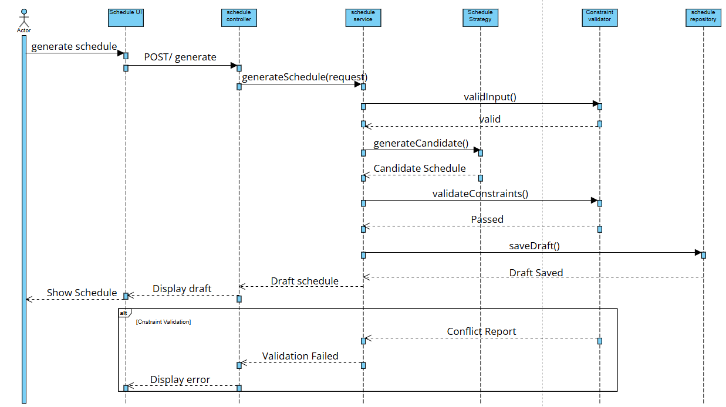

Figure II-1: Sequence Diagram - Generate Schedule

II.1.2 Sequence Diagram - Shift Supervisor Approval
The sequence shows review, approval, rejection and return alternatives at the Shift Supervisor level.
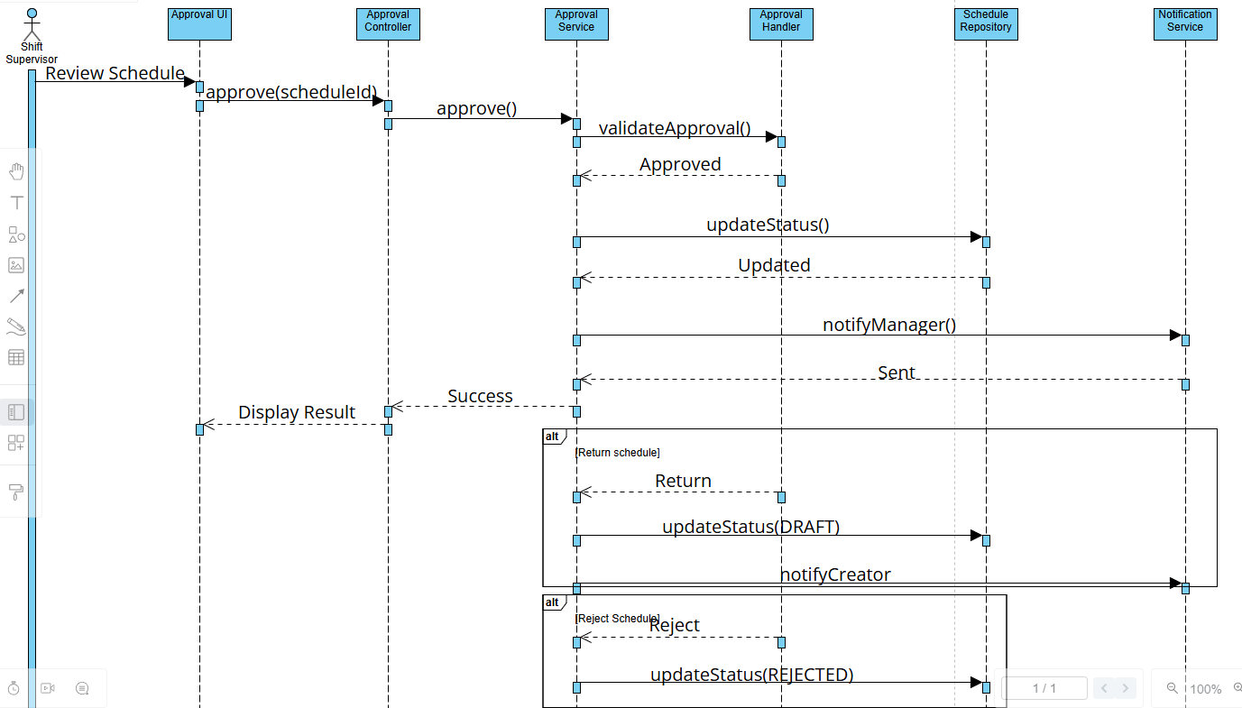

Figure II-2: Sequence Diagram - Shift Supervisor Approval

II.1.3 Sequence Diagram - Publish Schedule
The sequence shows the Branch Manager publishing only an approved schedule and notifying supporting services.
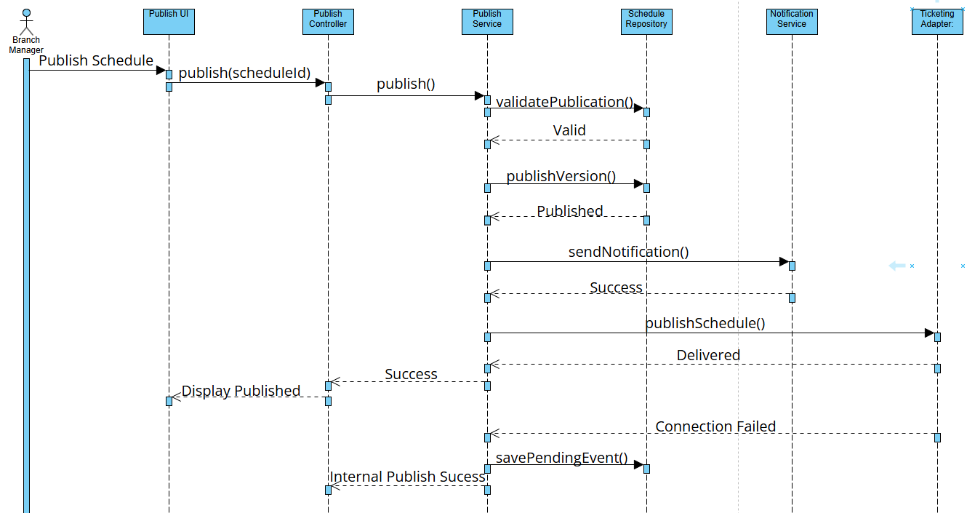

Figure II-3: Sequence Diagram - Publish Schedule

II.1.4 Sequence Diagram - View Dashboard Analytics
The sequence shows the dashboard requesting projected revenue, occupancy and schedule metrics.
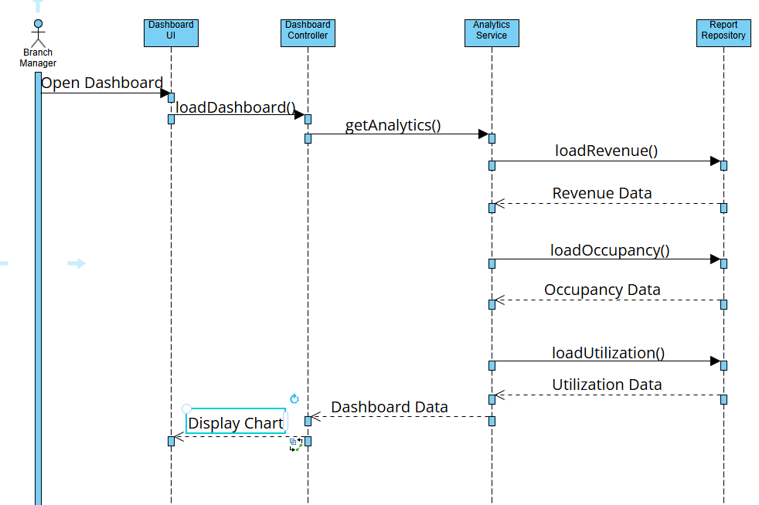

Figure II-4: Sequence Diagram - View Dashboard Analytics

II.1.5 Sequence Diagram - Manage Movies
The sequence shows the main create, update and disable alternatives for movie data.
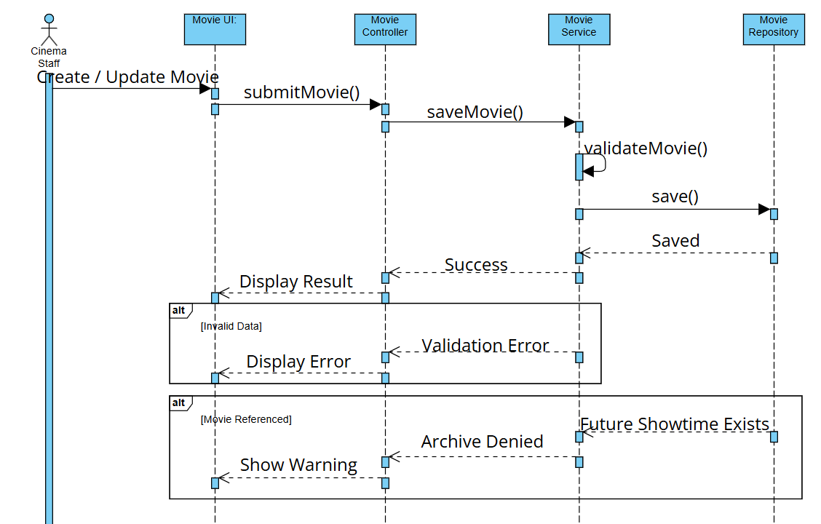

Figure II-5: Sequence Diagram - Manage Movies

II.2 Activity Diagrams
Activity diagrams describe end-to-end control flow. The retained diagrams are kept where their scope and terminology match the revised requirements. The disruption flow is replaced because the original diagram included direct refund processing, which is outside OptiCine.

II.2.1 Auto-scheduling Flow
This high-level flow describes input collection, candidate generation, constraint validation, draft creation and approval initiation. CSA/PSO labels in the retained source are interpreted as candidate research strategies, not an implementation claim.
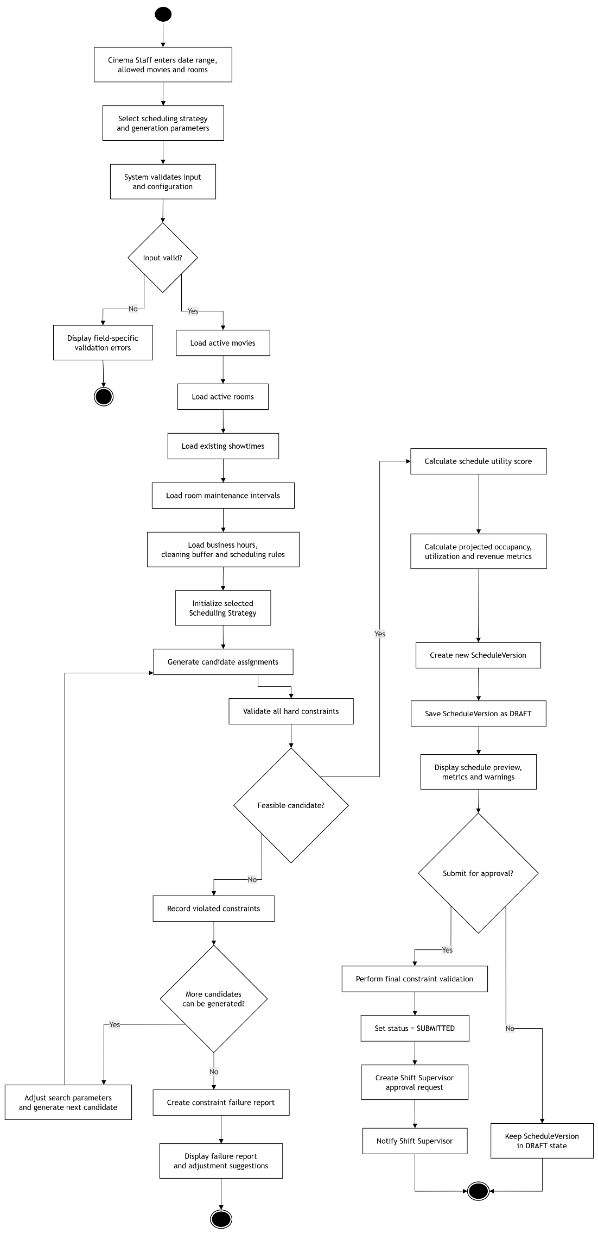
Figure II-6: Activity Diagram - Auto-scheduling Flow

II.2.2 Disruption and Rescheduling Flow
The revised flow creates a new schedule version, minimizes changes and notifies the future ticketing adapter. OptiCine records schedule cancellation decisions but does not process customer refunds.
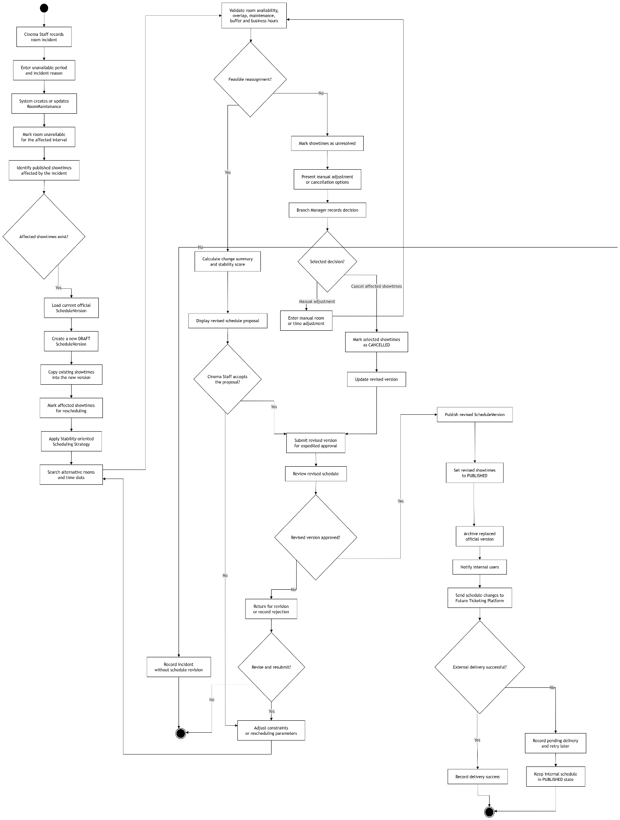
Figure II 1: Activity Diagram - Disruption and Rescheduling Flow

II.2.3 Detailed Generate Schedule Flow
The detailed flow expands validation, repeated assignment, conflict handling, scoring, draft creation and optional submission.
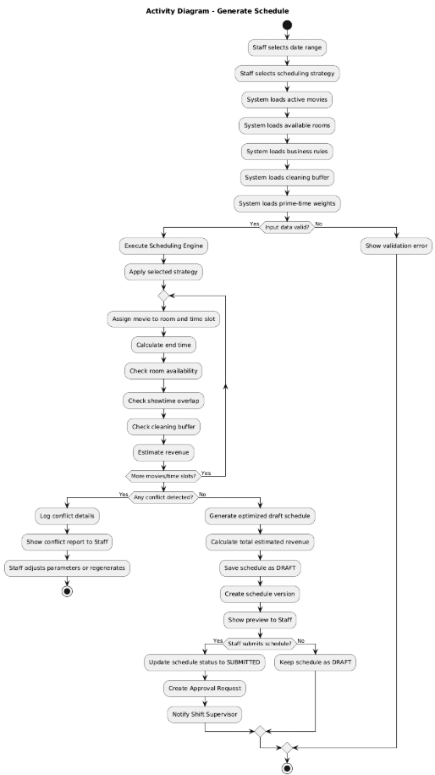
Figure II-8: Activity Diagram - Detailed Generate Schedule Flow

II.2.4 Approval Workflow
The workflow separates Shift Supervisor review from Branch Manager approval and publication. Return and rejection are distinct decisions: return creates a revision path; rejection closes the reviewed version unless a new draft version is created.
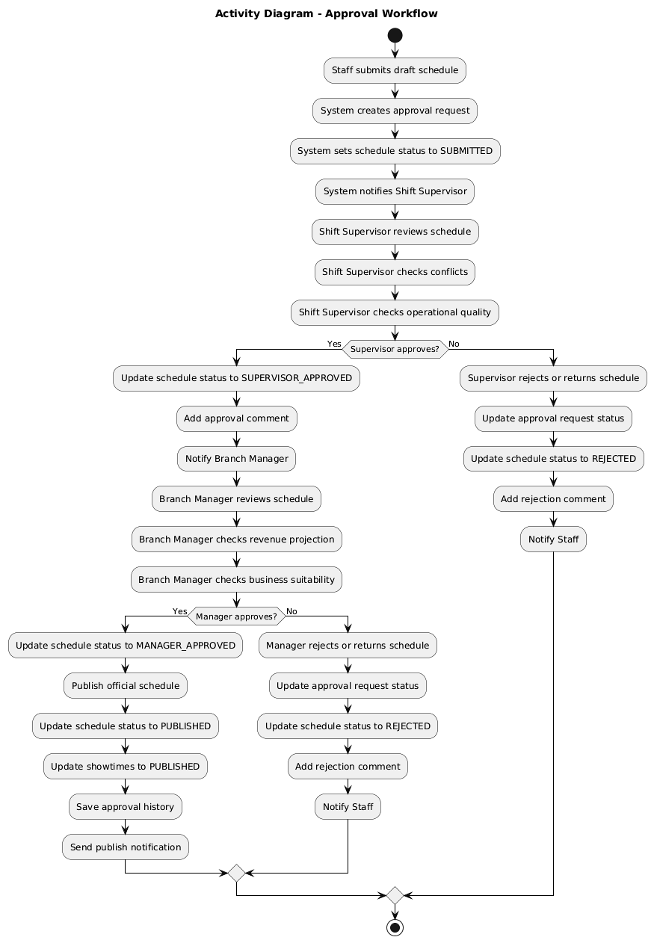
Figure II-9: Activity Diagram - Approval Workflow

II.3 State Analysis

II.3.1 Movie State
Movie state determines whether a movie may be selected by schedule generation. Archived records remain available for history but are excluded from new schedules.
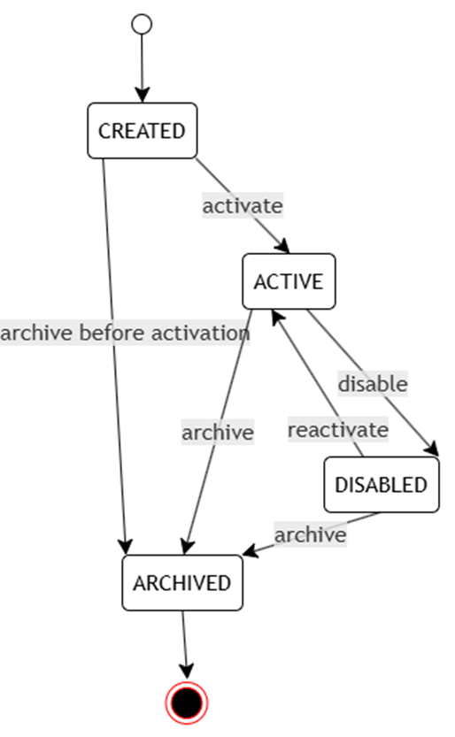
Figure II-10: State Diagram - Movie

II.3.2 Room State
Room status represents persistent operational availability. BUSY is not stored as a room lifecycle state; it is derived from scheduled showtimes for a requested interval.
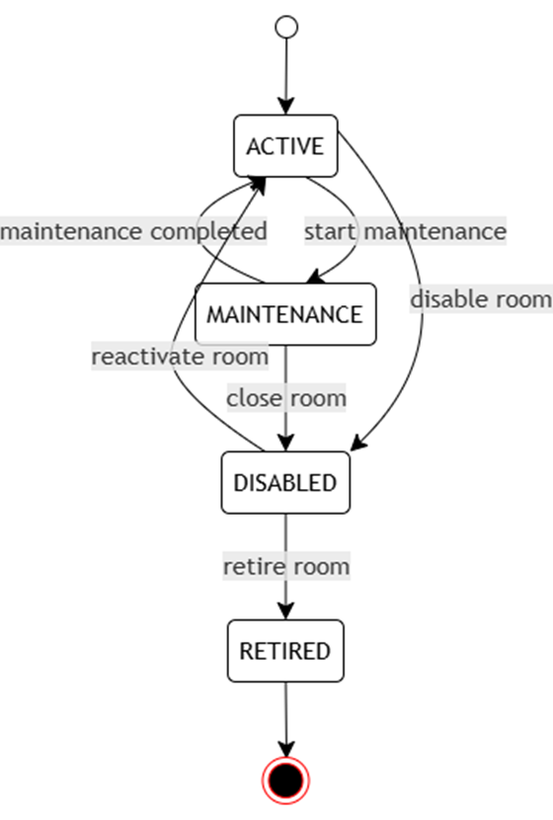
Figure II-11: State Diagram - Room

II.3.3 ScheduleVersion State
The schedule state machine is corrected to distinguish return from rejection and to permit revision through a new draft version.
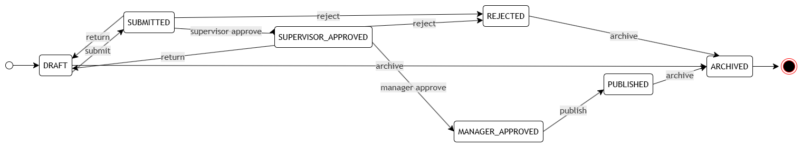
Figure II-12: State Diagram - ScheduleVersion

II.3.4 Showtime State
A showtime follows the parent version from draft through approval and publication. A published showtime may be cancelled by a room incident; completed showtimes are retained for reporting and history.
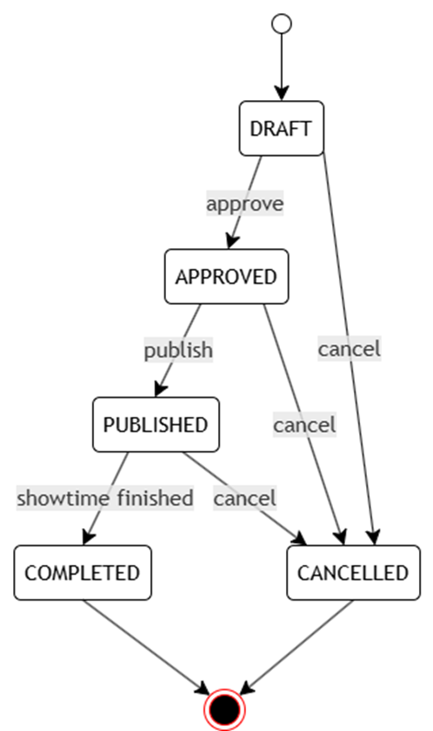
Figure II-13: State Diagram - Showtime
From | To | Condition
DRAFT | APPROVED | Parent schedule version becomes MANAGER_APPROVED.
APPROVED | PUBLISHED | Parent schedule version is published.
DRAFT / APPROVED | CANCELLED | The version is rejected or the showtime is removed before publication.
PUBLISHED | CANCELLED | An approved operational incident requires cancellation.
PUBLISHED | COMPLETED | The showtime end time passes and operational completion is confirmed.

II.4 Data Analysis

II.4.1 Core Business Entities
The central aggregate is a Schedule with one or more immutable ScheduleVersion records. Each ScheduleVersion contains showtimes and may be reviewed through approval requests. Movie and Room are reusable resources, while RoomMaintenance and SystemConfiguration constrain feasible assignments.

II.4.2 Corrected Relationships
Relationship | Meaning
Movie - Showtime | One movie may appear in many showtimes; each showtime references one movie.
Room - Showtime | One room hosts many showtimes over time; each showtime references one room.
Schedule - ScheduleVersion | One schedule has many ordered versions; each version belongs to one logical schedule period.
ScheduleVersion - Showtime | One version contains many showtimes; showtimes are not shared between versions.
Room - RoomMaintenance | One room has zero or many unavailable intervals.
ScheduleVersion - ApprovalRequest | A version may have approval requests for each workflow stage.
ApprovalRequest - ApprovalComment | A request may contain comments and decision records.
User - Role - Permission | Users receive roles through user_roles; roles receive permissions through role_permissions.
Schedule - Report | Reports may summarize one logical schedule or a selected period.
User - AuditLog | A user may perform many audited actions; system actions may have no user.

II.5 Scheduling Constraint Model

II.5.1 Inputs and Decision Variables
Let M be the set of active movies, R the set of active rooms, D the set of dates in the planning period and T the set of candidate start times. The binary decision variable x(m,r,d,t) equals 1 when movie m is assigned to room r on date d at start time t, and 0 otherwise.
Input Group | Examples
Movie data | Duration, popularity score, active period, genre, age rating and optional minimum/maximum show count.
Room data | Capacity, room type, operational status and maintenance intervals.
Time data | Business hours, candidate start times, prime-time ranges and time-slot weights.
Policy data | Cleaning buffer, scheduling strategy, diversity rules and approval workflow.
Historical / projected data | Estimated occupancy and configured average ticket value for projected analysis only.

II.5.2 Hard Constraints
ID | Constraint
HC-01 | A room may host at most one showtime at any instant.
HC-02 | The next use of a room must start after the previous end time plus cleaning buffer.
HC-03 | The room must be ACTIVE and outside all maintenance intervals.
HC-04 | The movie must be ACTIVE for the scheduled date.
HC-05 | The showtime start and end must fall within configured business hours.
HC-06 | End time equals start time plus movie duration; buffer is evaluated separately.
HC-07 | Room type compatibility and any configured movie restrictions must be satisfied.
HC-08 | A submitted or approved version is read-only; changes create a new draft version.

II.5.3 Soft Constraints and Objectives
ID | Preference
SC-01 | Place high-popularity movies in larger rooms when feasible.
SC-02 | Place high-popularity movies in high-weight time slots when feasible.
SC-03 | Maintain movie diversity across time periods and rooms.
SC-04 | Reduce avoidable idle gaps between room uses.
SC-05 | For rescheduling, minimize moved or cancelled showtimes and preserve the published plan.
A simple schedule utility score may be defined as:
Utility = Σ(popularity × room capacity × time-slot weight) - λ₁(idle-gap penalty) - λ₂(change penalty)
This expression is a utility score, not actual revenue. Projected revenue may be estimated separately as projected occupancy × room capacity × configured average ticket value. Actual sales remain outside the system scope.

II.5.4 Candidate Scheduling Strategies
Strategy | Design Intent
Constraint-first baseline | Creates feasible assignments using deterministic ordering; provides a benchmark for more advanced strategies.
Revenue-oriented strategy | Prioritizes utility from popularity, capacity and time-slot weight.
Diversity-oriented strategy | Balances movie exposure across rooms and time ranges.
Stability-oriented strategy | Used during disruption to minimize changes to an existing published version.
Metaheuristic research option | CSA, GA-PSO or another search method may be evaluated as a candidate strategy; the RDS does not claim implementation.

II.6 Requirements Traceability Matrix
Business Rule | Feature | Use Case | Primary Data | Analysis / Design Evidence
BR-01 | F01 | UC-01 | movies | II-5
BR-02, BR-05 | F02 | UC-02, UC-08 | rooms, room_maintenances | II-6 / Mermaid rescheduling
BR-03, BR-04, BR-06 | F03, F04 | UC-03, UC-04 | showtimes, time_slots | II-1, II-7
BR-07 | F04 | UC-04 | schedule_versions, system_configurations | II-1, III.6
BR-08, BR-09 | F05 | UC-05, UC-06, UC-07 | approval_requests, approval_comments | II-2, II-8
BR-10 | F06 | UC-04, UC-08 | schedules, schedule_versions | II.3, III.9
BR-11 | F09 | UC-01 through UC-10 | roles, permissions, audit_logs | III.8
BR-12 | F05 | UC-07, UC-08 | notifications | III-3 deployment

III. Design Specification
This section describes a proposed system structure. Component, class and package names are design abstractions and do not assert the existence of source code.

III.1 Design Principles
Principle | Application to OptiCine
Separation of concerns | Presentation, application coordination, domain rules, scheduling and infrastructure are separated.
Explicit domain model | Schedule, ScheduleVersion, Showtime, ApprovalRequest and RoomMaintenance have distinct responsibilities.
Strategy independence | Scheduling objectives are selected through a stable strategy abstraction.
Controlled state transitions | Approval and publication operations validate the current version state.
Version-first change management | Material changes create new schedule versions instead of overwriting history.
External integration isolation | Notification, storage and future ticketing systems are accessed through adapters.
Traceability | Use cases, components, data entities and state transitions use consistent terminology.

III.2 Integrated Communication Diagram
The integrated communication diagram combines schedule generation, review, approval and publication into a single lifecycle view. The existing diagram is retained because its actors and major message paths remain consistent with the revised scope.
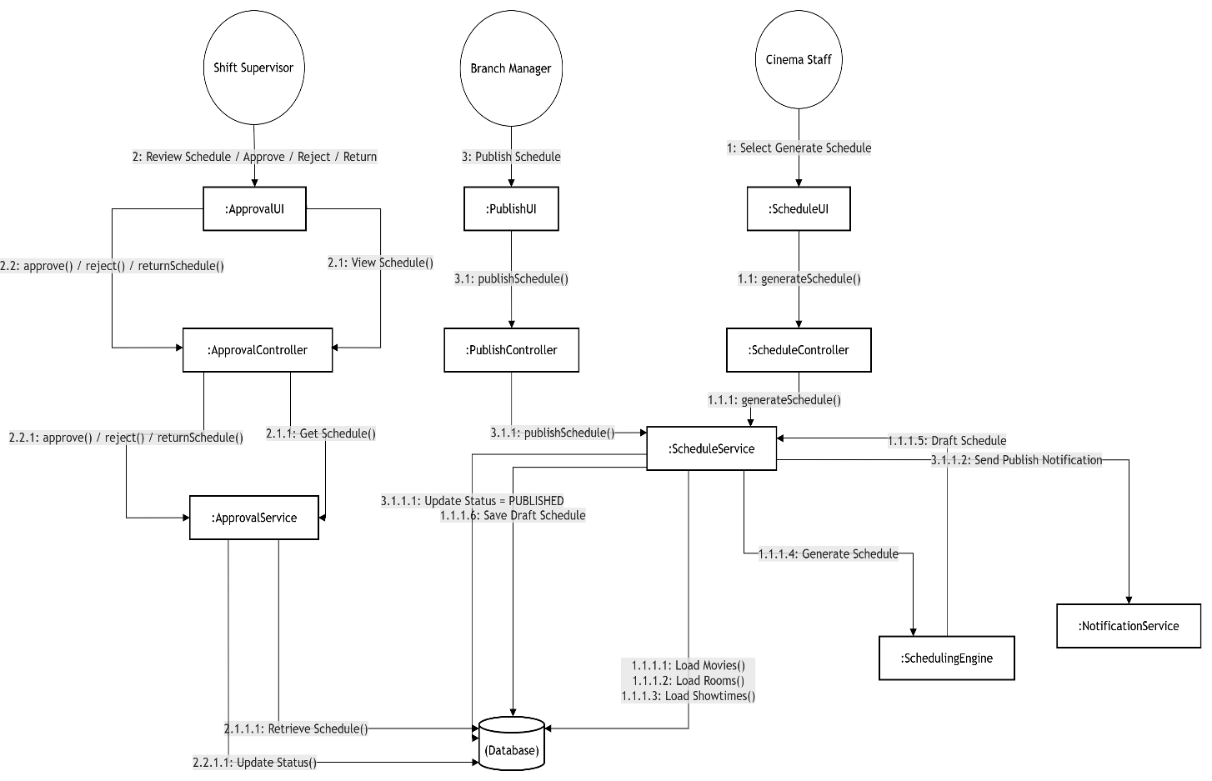
Figure III-1: Integrated Communication Diagram

III.3 System High-Level Design

III.3.1 Logical Architecture
OptiCine uses a layered modular architecture. The presentation layer receives user interactions; application services coordinate use cases; the domain layer contains scheduling, approval and versioning rules; infrastructure adapters provide persistence, cache, notification, file storage and future schedule publication interfaces.
The retained architecture class diagram illustrates boundary, control, service and entity responsibilities. Any class labels that imply a framework should be interpreted as conceptual responsibilities rather than required implementation technology.
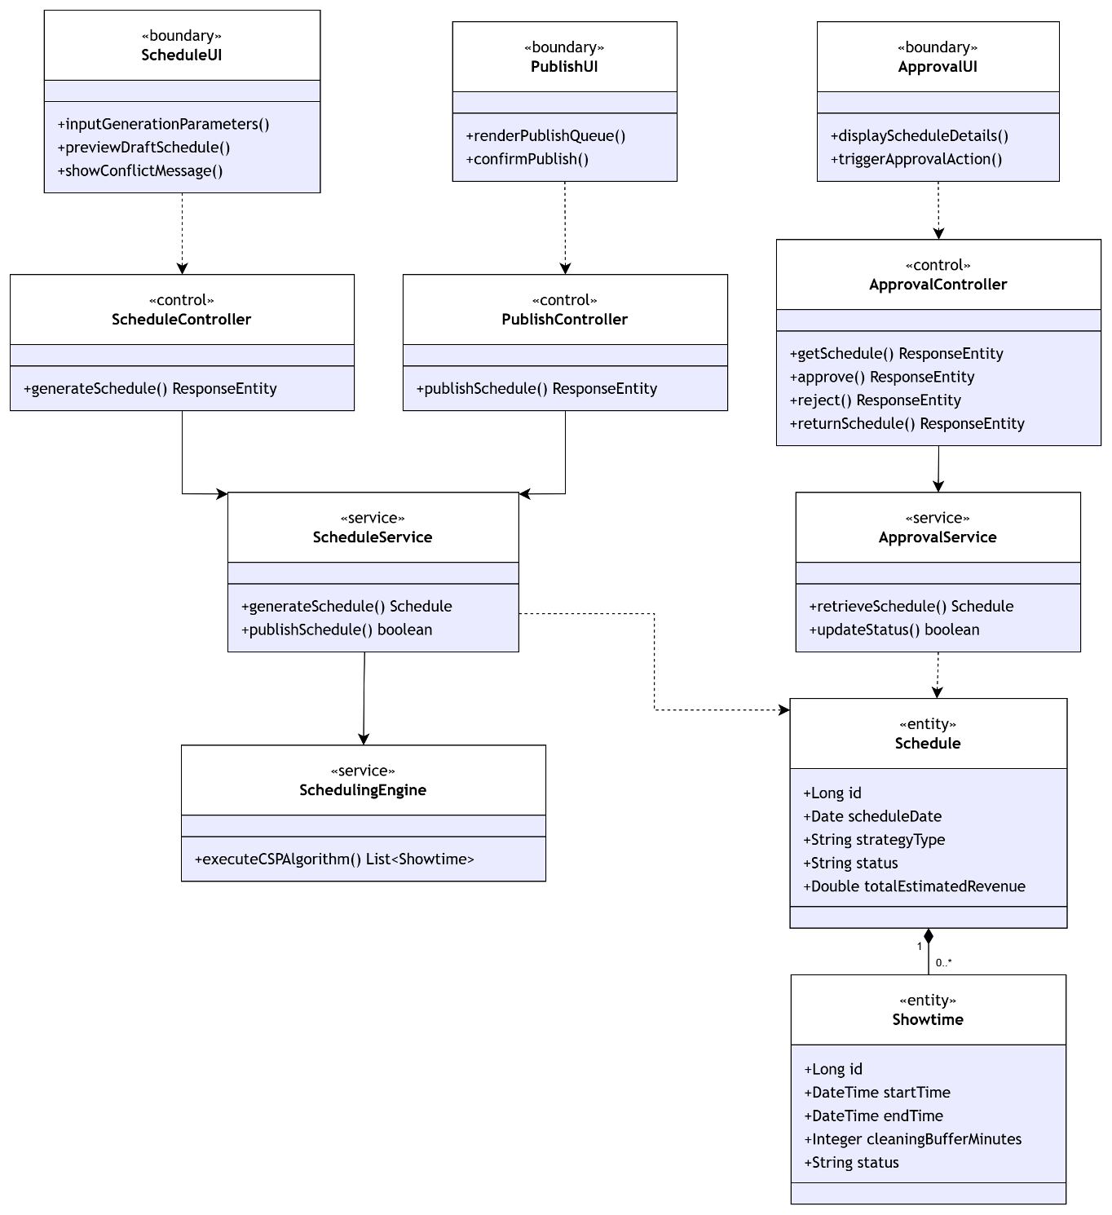
Figure III-2: Architecture Class Diagram

III.3.2 Deployment View
The deployment view proposes a client interface, an application runtime, a scheduling execution environment, a database, an availability cache, file storage and external services. MySQL and Redis labels are technology options from the original design, not mandatory requirements of the platform-independent model.
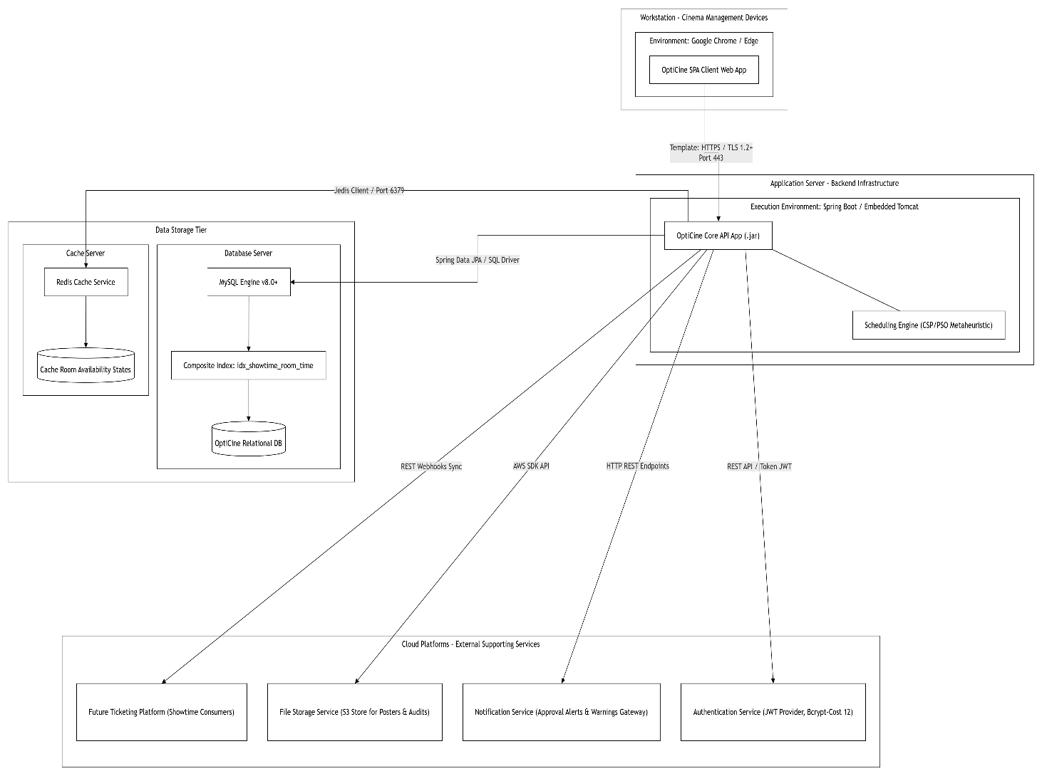
Figure III-3: Deployment Diagram

III.4 Component Design
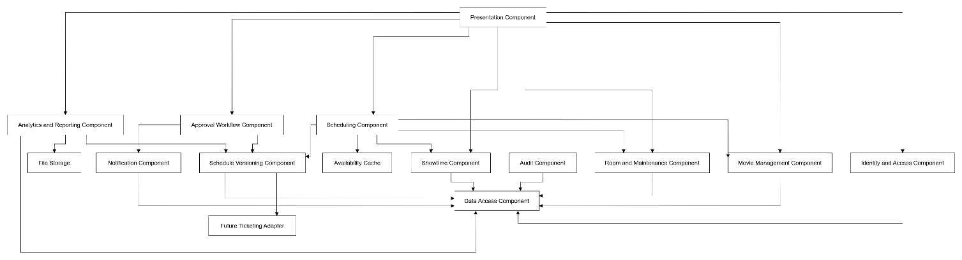
Figure III-4: Component Diagram

III.5 Package Design
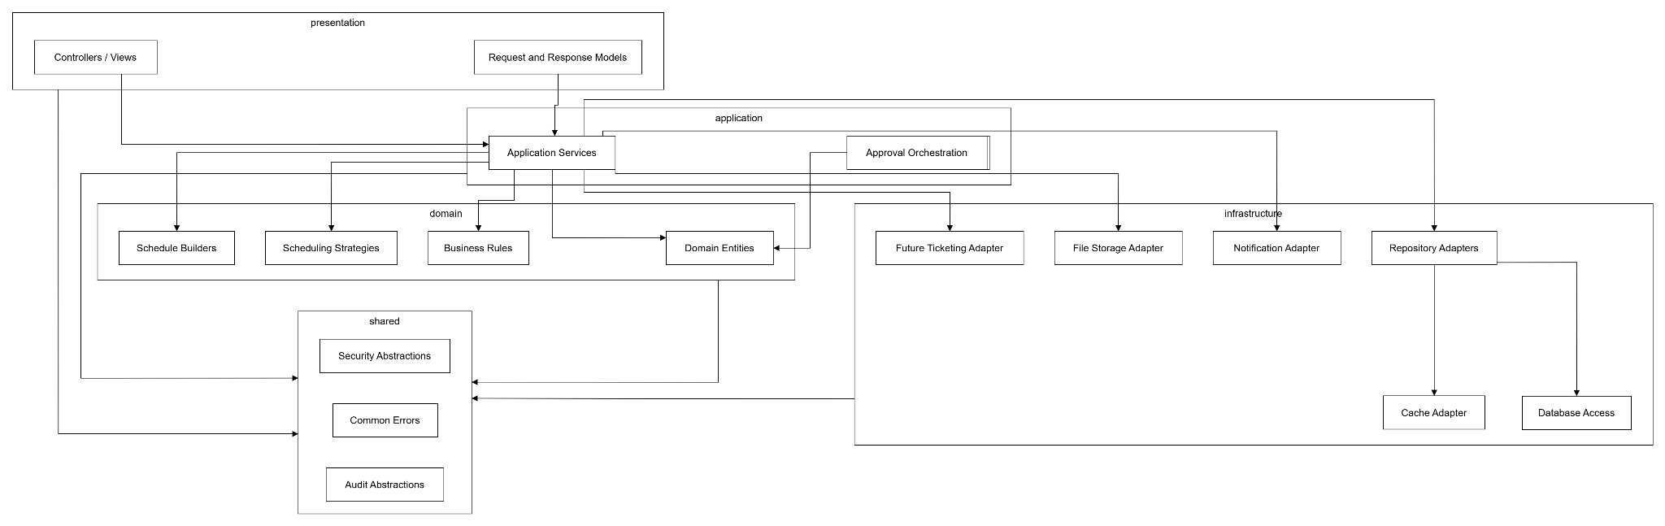 Figure III-5: Package Diagram

III.6 Detailed Design Patterns

III.6.1 Strategy Pattern - Schedule Generation
The Strategy pattern isolates scheduling objectives. SchedulingContext receives a generation request and delegates candidate creation and evaluation to the selected SchedulingStrategy. The same input and output contracts permit comparison among strategies.
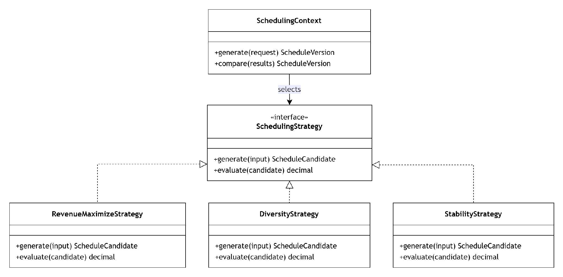
Figure III-6: Strategy Pattern Class Diagram

III.6.2 Chain of Responsibility - Approval Workflow
The approval chain allows a schedule version to pass through Shift Supervisor and Branch Manager handlers while keeping each level responsible for its own validation and decision. The workflow state remains the source of truth; the chain does not bypass authorization.
Figure III-7: Chain of Responsibility Pattern Class Diagram
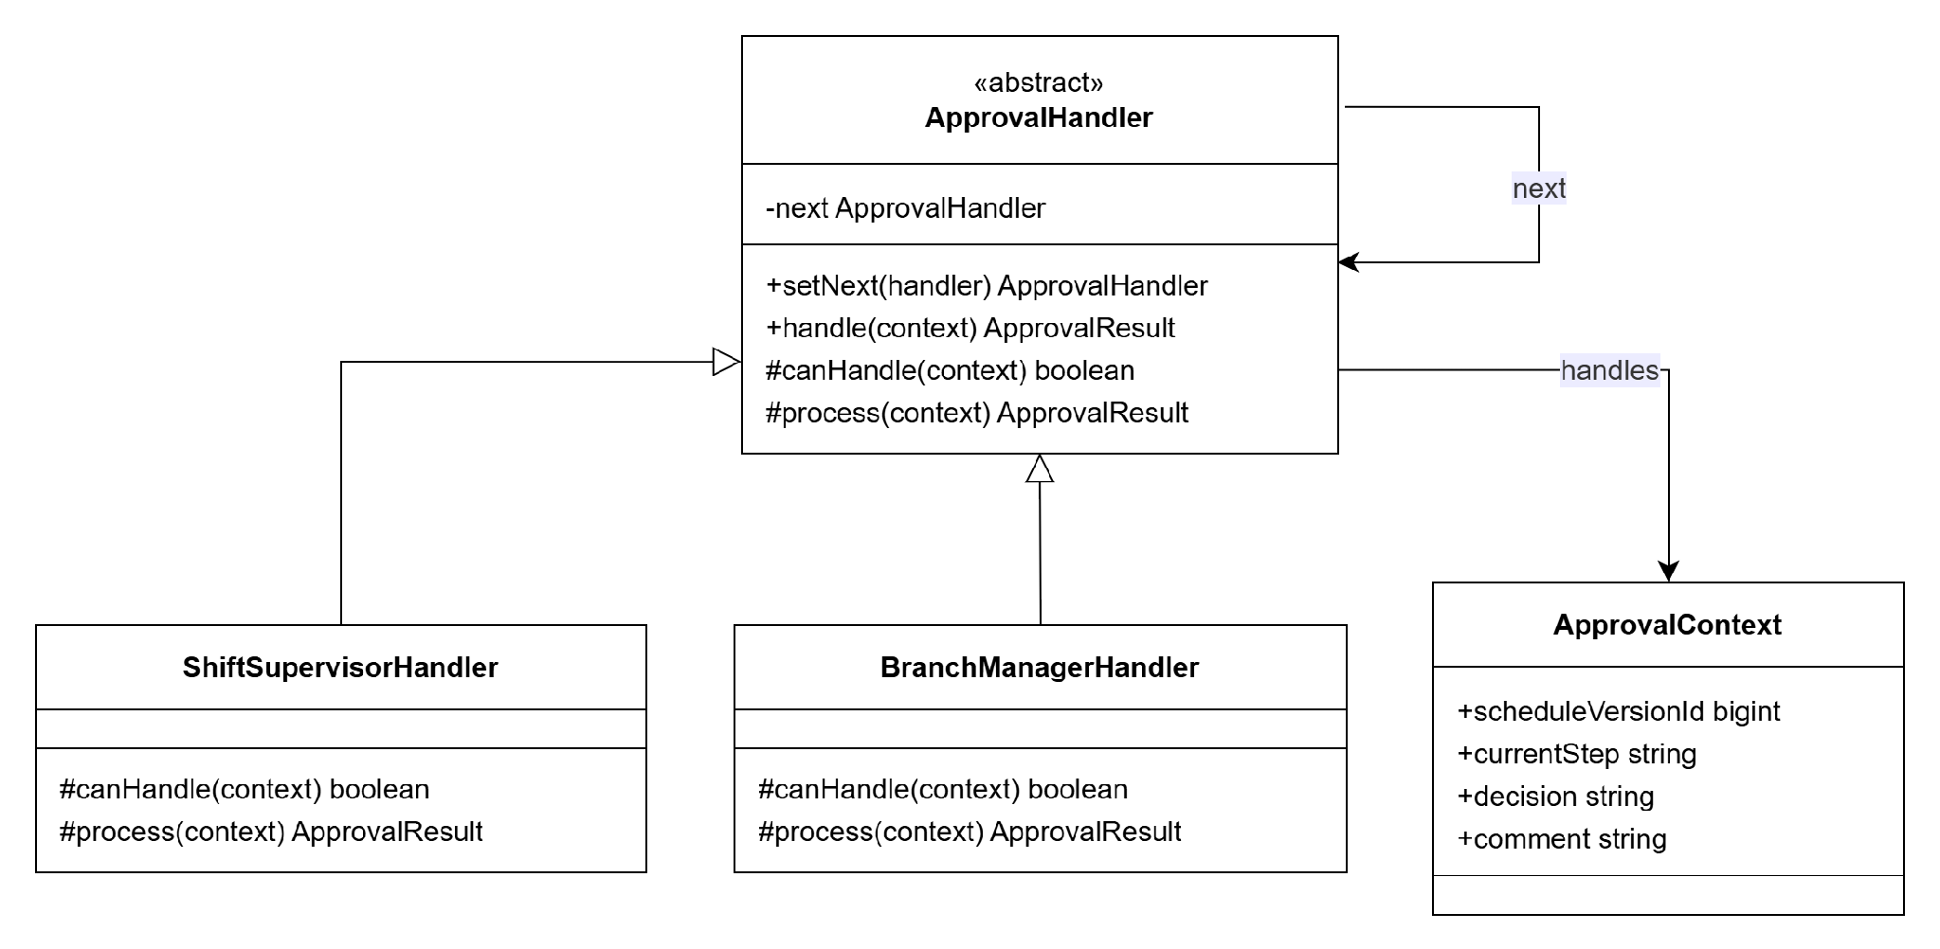

III.6.3 Builder Pattern - Schedule Version Construction
The Builder pattern separates gradual construction of a complex ScheduleVersion from the coordination of generation. It is especially useful when a version contains many showtimes and calculated metrics.
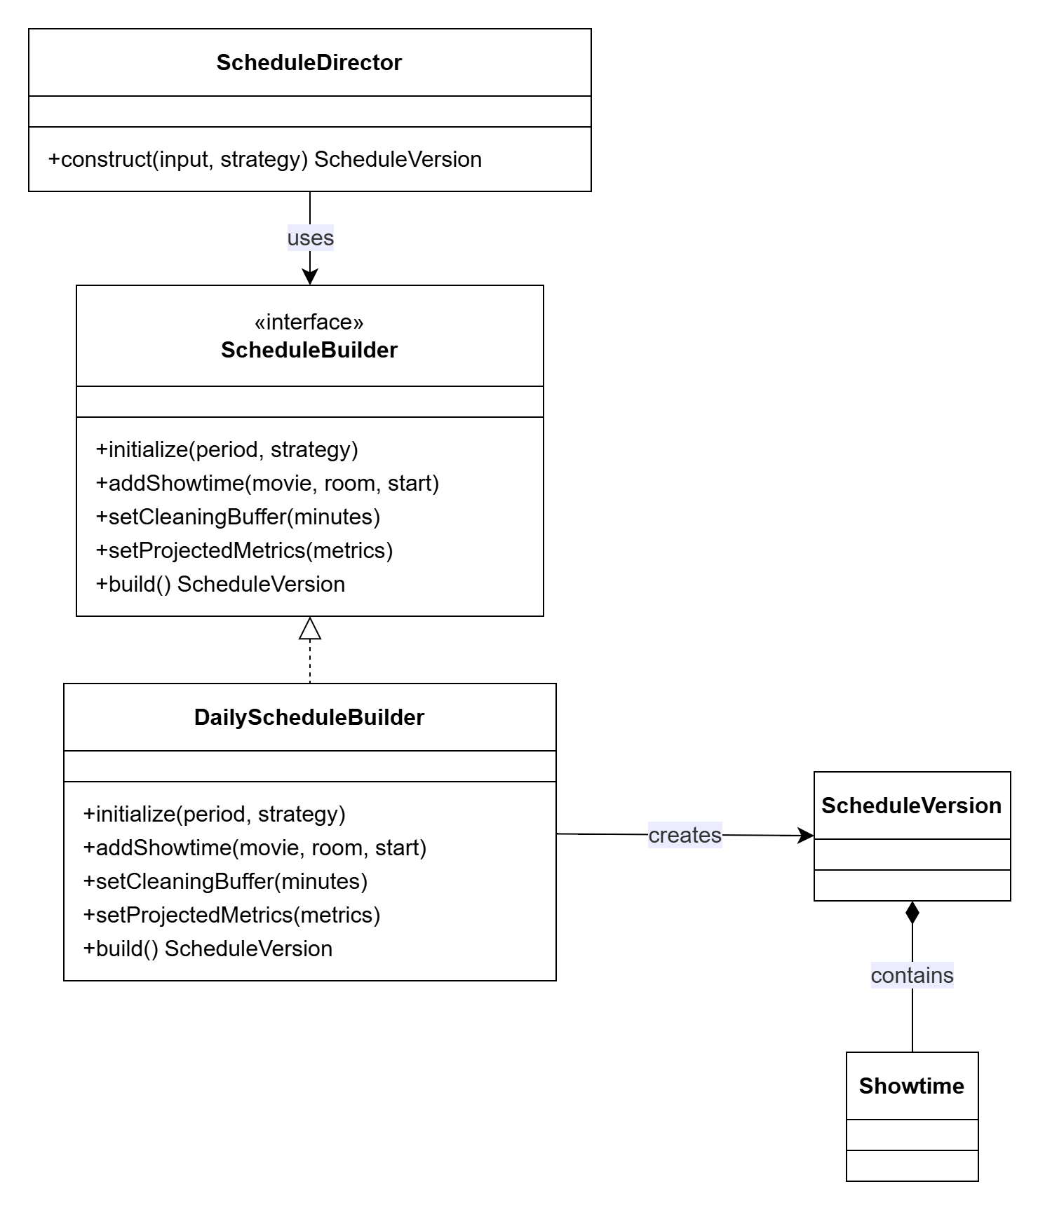
Figure III-8: Builder Pattern Class Diagram

III.7 Database Design

III.7.1 Relational Mapping Summary
Area | Relations | Key Integrity Rules
Identity and access | users, roles, permissions, user_roles, role_permissions | Unique email; unique role name; unique permission code; composite PK in junction tables.
Resource catalogue | movies, rooms, room_maintenances, time_slots | Unique room_code; maintenance end > start; BUSY not stored as room status.
Schedule core | schedules, schedule_versions, showtimes | UNIQUE(schedule_id, version_number); showtimes.schedule_version_id → schedule_versions.id; start < end.
Approval | approval_requests, approval_comments | approval_requests.schedule_version_id → schedule_versions.id; one pending request per version/step; mandatory reason for return/reject.
Operations | notifications, reports, system_configurations, audit_logs | Unique config_key; audit records append-only; notification delivery tracked.

III.7.2 Unique Constraints
Table | Constraint | Column(s)
users | UNIQUE | email
roles | UNIQUE | name
permissions | UNIQUE | code
rooms | UNIQUE | room_code
system_configurations | UNIQUE | config_key
schedule_versions | UNIQUE composite | (schedule_id, version_number)
approval_requests | UNIQUE composite | (schedule_version_id, current_step) — one active request per step

III.7.3 Versioning Rules
1. A Schedule identifies the planning period; ScheduleVersion stores each concrete plan.
2. Version numbers increase within one schedule and are never reused.
3. Submitted, approved, published and archived versions are not edited in place.
4. A return or operational incident creates or reopens a draft version while preserving the reviewed version.
5. Showtimes are copied into a new version before rescheduling so change comparison remains possible.

III.7.4 Proposed Indexes
Index Name | Table | Columns | Purpose
idx_showtimes_room_time | showtimes | (room_id, start_time, end_time) | Room conflict detection
idx_showtimes_sv | showtimes | (schedule_version_id) | Showtime lookup by version
idx_approval_requests_sv | approval_requests | (schedule_version_id, status) | Approval lookup by version
idx_schedule_versions_sch | schedule_versions | (schedule_id, status) | Version lookup by schedule
idx_notifications_recipient | notifications | (recipient_id, status) | Notification delivery queries
idx_room_maintenances_room | room_maintenances | (room_id, start_time, end_time) | Maintenance overlap check
idx_audit_logs_entity | audit_logs | (entity_name, entity_id) | Audit trail lookup

III.7.5 Referential Integrity and Audit Preservation
• All FK references use RESTRICT on DELETE to prevent orphaned records.
• audit_logs.user_id uses SET NULL on DELETE (system actions may have no actor).
• Audit log records are append-only. No UPDATE or DELETE is permitted on audit_logs.
• Archived schedule versions and their showtimes are retained indefinitely for history and comparison.
• A publication operation updates the schedule version status and all its showtime statuses as one atomic conceptual transaction.
• Notification and ticketing delivery failures are recorded without altering the internal schedule state.

APPENDIX-Full-Logical-ERD
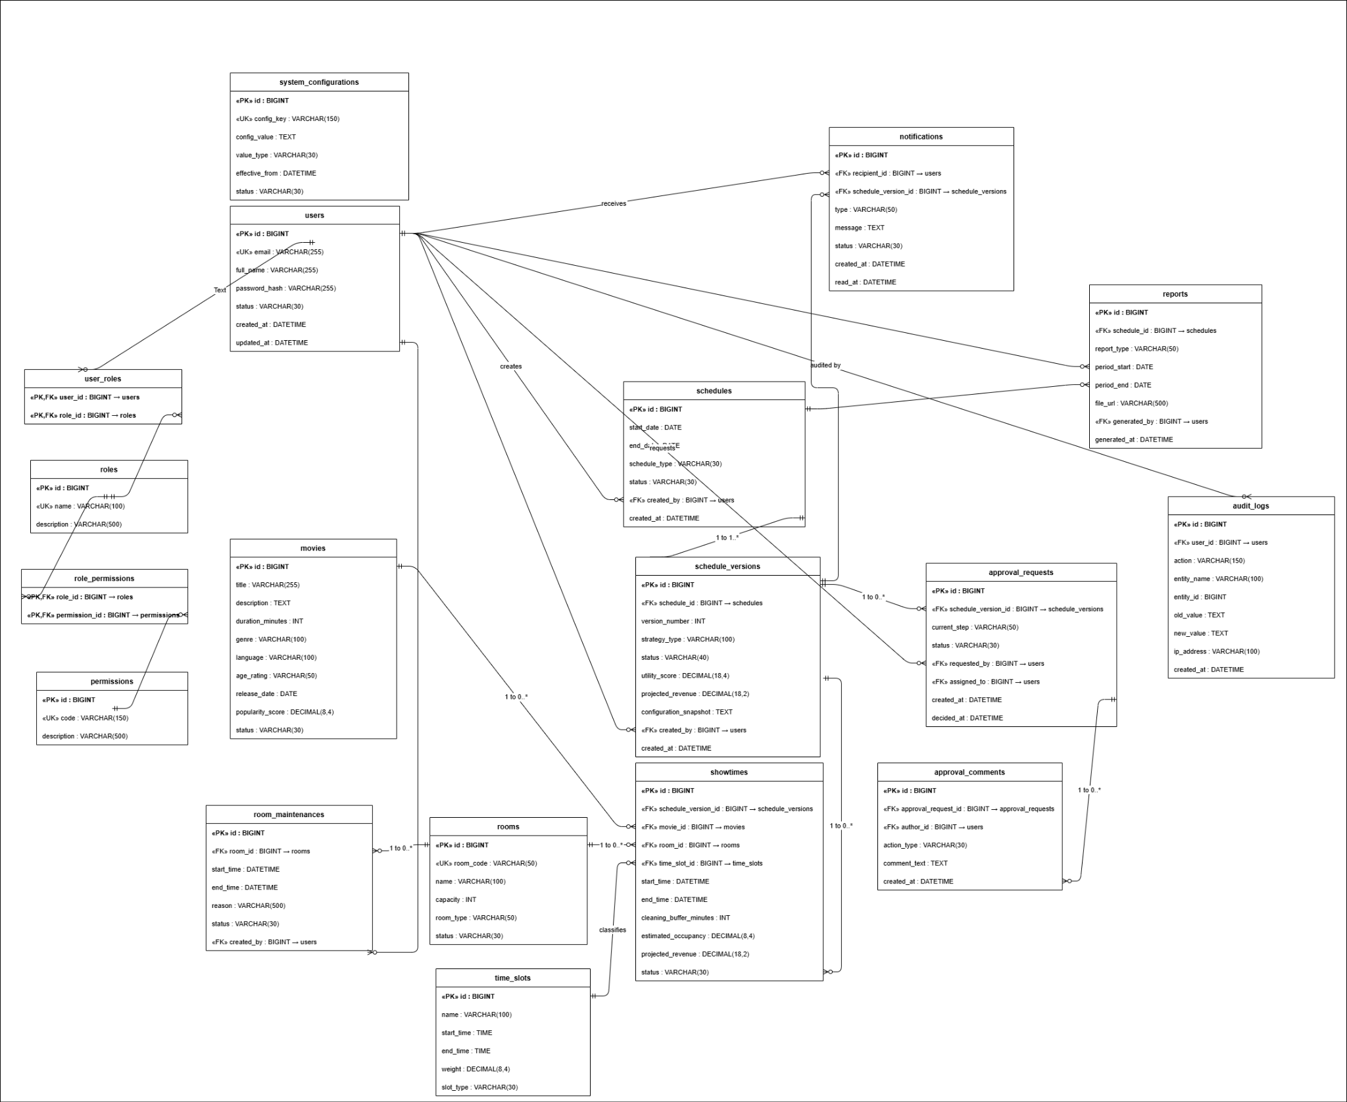
Figure III-9: Full Logical Entity-Relationship Diagram

III.8 Security and Access Design
Capability | Cinema Staff | Shift Supervisor | Branch Manager | System Administrator
Manage movies, rooms and showtimes | Allowed | View | View | Administrative override only
Generate and submit schedule | Allowed | View | View | Configure only
Level-1 review decision | No | Allowed | View | No
Level-2 review and publication | No | No | Allowed | No
View projected analytics | Limited | Operational view | Allowed | Technical view
Manage accounts, roles and permissions | No | No | Limited branch request | Allowed
Manage system configuration | No | No | Business settings | Allowed
Review audit logs | Own actions | Relevant workflow | Branch scope | Allowed
- Authorization is evaluated for every protected action, not only when a screen is displayed.
- Approval decisions require the role associated with the current workflow step.
- Sensitive configuration and projected analytics are limited to authorized roles.
- Authentication events, decisions, publication and configuration changes are auditable.

III.9 Reliability, Versioning and Audit Design
Concern | Design Response
Atomic schedule update | A version, its showtimes and workflow status change together or remain unchanged.
Idempotent publication event | Repeated delivery to an external adapter does not create a second internal publication.
Stale review protection | An approval request identifies an exact schedule version and cannot approve a newer version.
Failure isolation | Notification or future ticketing delivery failure is recorded without corrupting the internal schedule state.
Audit immutability | Audit records are append-only and preserve actor, action, target and timestamp.
Recovery through versions | A prior version remains available for comparison and controlled restoration into a new draft.

III.10 Research Basis and Future Scope
The research set supplied with the project covers metaheuristic optimization, real-time scheduling benchmarks, DAG-constrained workloads, hybrid GA-PSO search and inverse scheduling. For OptiCine, these works are used as conceptual sources for candidate strategies and evaluation criteria rather than proof that a particular algorithm has already been implemented.

III.10.1 Directly Relevant Research Directions
- Constraint and metaheuristic search for producing feasible schedules under many interacting rules.
- Benchmarking scheduling approaches by feasibility rate, computation time, utility score and stability.
- Multi-objective optimization for balancing projected utility, diversity and room idle time.
- Inverse or stability-oriented scheduling for revising only the showtimes affected by a disruption.

III.10.2 Future Scope
- Multi-branch coordination and centralized policy management.
- A verified external ticketing integration that receives published schedule changes.
- Use of actual historical sales as input to occupancy prediction while keeping ticket processing outside OptiCine.
- Crowd-density or lobby-operation analytics as a separate future module, not part of the current scheduling core.
- Formal benchmark comparison among deterministic, metaheuristic and hybrid strategies.

IV. Conclusion
The completed OptiCine RDS defines a coherent research-oriented structure for internal cinema schedule management. The revised document fixes the scope around internal operations, standardizes the four actor roles, separates logical schedules from immutable versions, aligns approval and state transitions, and distinguishes projected metrics from actual ticket revenue.
The Requirement Specification defines the problem, scope, rules, features, use cases and data requirements. The Analysis Models describe interactions, activities, states, relationships and scheduling constraints. The Design Specification proposes a layered modular architecture, components, packages, design patterns, database rules, access controls and reliability mechanisms. Implementation evidence is intentionally outside the scope of this document.

Appendix A. Glossary
Term | Definition
Approval Request | A workflow record assigning an exact schedule version to a reviewer at one approval level.
Cleaning Buffer | Minimum interval reserved after a showtime before the room can be used again.
Future Ticketing Platform | An external out-of-scope system that may receive published schedule data and change notifications.
Projected Revenue | An analytical estimate based on configured assumptions; it is not actual sales revenue.
Room Availability | A derived property for a time interval based on room status, maintenance and existing showtimes.
Schedule | A logical daily or weekly planning period.
Schedule Strategy | A replaceable rule set that produces and evaluates schedule candidates.
Schedule Utility Score | A configurable objective value combining popularity, capacity, time-slot weight and penalties.
Schedule Version | An immutable concrete set of showtimes for a logical schedule.
Showtime | A movie-room-time assignment within one schedule version.
Stability-oriented Rescheduling | Revision that minimizes changes to an already published schedule.

Appendix B. Diagram Replacement Guide
The Mermaid blocks in this document are drafting sources and placeholders. Replace each block with a PNG or SVG exported from Visual Paradigm or draw.io after the team reviews the model.
Item | Required Standard
Connector style | Use orthogonal or elbow connectors. Disable curved connectors and unnecessary line jumps.
Direction | Prefer left-to-right for context/use-case/component diagrams and top-to-bottom for activities/states.
Colour | Use white or very light blue fill, black/dark-gray text and one restrained accent colour. No gradients or shadows.
Font | Use Arial, Calibri or Times New Roman consistently at 10-11 pt.
Arrows | Use UML-correct arrowheads. Check every dependency, realization, generalization and state transition.
Spacing | Align objects to a grid, maintain equal gaps and avoid crossing lines where possible.
System boundary | Use one clearly labelled boundary. External actors and systems remain outside it.
ERD | Display PK/FK, cardinality and relationship labels. Do not add database-tool screenshots or toolbars.
Export | Export at high resolution with a white background. Crop unused margins before insertion.
Caption | Use the same figure title as the placeholder heading and update figure numbering after replacement.

Appendix B.1 Diagram Replacement Checklist
Diagram | Current Form | Action
System Context Diagram | Mermaid placeholder | Redraw
Operational and Scheduling Use Case Diagram | Mermaid placeholder | Redraw in UML use-case notation
Management and Administration Use Case Diagram | Mermaid placeholder | Redraw in UML use-case notation
Entity-Relationship Diagram | Mermaid placeholder | Redraw and verify PK/FK/cardinality
Sequence Diagrams | Existing images retained | Review labels and keep
Auto-scheduling Activity Diagram | Existing image retained | Keep; treat CSA/PSO as candidate research strategies
Disruption and Rescheduling Activity Diagram | Mermaid placeholder | Redraw; no refund-processing step
Generate Schedule / Approval Activities | Existing images retained | Review labels and keep
Movie, Room and Schedule State Diagrams | Mermaid placeholders | Redraw
Showtime State Diagram | Existing image retained | Review labels and keep
Integrated Communication Diagram | Existing image retained | Keep
Architecture Class / Deployment Diagrams | Existing images retained | Keep as proposed design
Component, Package and Pattern Class Diagrams | Mermaid placeholders | Redraw

Appendix C. Research References
The following papers were supplied with the project research package. Bibliographic details should be verified against the final PDF metadata before formal submission.
[1] Selvaraj, G. et al. (2024). Optimal power scheduling in real-time distribution systems using crow search algorithm for enhanced microgrid performance. Scientific Reports.
[2] Liu, F. et al. (2025). Scalable hybrid framework for real-time and non-real-time task scheduling in fog computing using federated reinforcement learning and PSO-GA. Scientific Reports.
[3] Naeem, A. B. et al. (2025). Intelligent job scheduling and real-time resource optimization for the edge-cloud continuum. Scientific Reports.
[4] Xiang, X., Lin, W., and Li, D. (2025). A hybrid MARL clustering framework for real-time open-pit mine truck scheduling. Scientific Reports.
[5] Du, N. et al. (2025). Scheduling DAG-structured workloads based on whale optimization algorithm. The Journal of Supercomputing.
[6] Stadtler, J., Stahmann, P., and Janiesch, C. (2026). A benchmark for selecting real-time scheduling approaches for fleets of automated guided vehicles in intralogistics. Business & Information Systems Engineering.
[7] Qi, D. et al. (2024). Real-time scheduling of power-grid digital-twin tasks in cloud via deep reinforcement learning. Journal of Cloud Computing.
[8] Zhao et al. (2026). Hybrid model combining Genetic Algorithm and Particle Swarm Optimization for multi-objective scheduling optimization in power systems. Discover Computing.
[9] Xing, B. et al. (2025). Real-time detection algorithm of port ships based on improved YOLOv11. International Journal of Computational Intelligence Systems.
[10] Li, T. et al. (2025). Inverse scheduling method for aircraft flat-tail assembly production based on improved genetic algorithm. Scientific Reports.

Appendix D. Redraw and Standardize OptiCine Sequence Diagrams

