TRƯỜNG ĐẠI HỌC FPT

──────────────────────────────

Requirement & Design Specification

OptiCine – Cinema Operations and Resource Scheduling System

Subject: SWD392
Version: 1.0

– Da Nang , May 2026 –

Group Members
No. | Full Name | Mã sv
1 | Le Ngoc Dang
2 | Hoàng Tấn Thành
3 | Minh Tuấn | DE190100
4 | Nguyen Thai | DE190299
5 | Vinh Le | DE190369

Table of Contents
I. Requirement Specification 1
I.1 Problem Description 2
I.2 Business Requirements 2
I.3 Major Features 3
I.4 System Context 3
I.5. Nonfunctional Requirements (NFRs) 5
I.6. ERD 8
I.6.1 Sơ đồ ERD 8
I.7. Usecase diagram 8
I.8. Data Dictionary 11
II. Analysis Models 15
II.1 Interaction diagrams 15
II. 2 Activity Diagrams 19
II.2.1 Generate Schedule 23
II.2.2 Approval workflow 25
II.2.3 State Analysis 26
Movie State 26
II.2.4 Room State 26
II.2.5 Schedule State 26
II.2.6. Showtime State 28
II.3. Data Analysis 29
Core Business Entities 29
Data Relationships 30
Constraints and Analysis Conclusion 30

Record of Changes
Version | Date | In charge | Change Description
V1.0 | 24/05/2026 | Nguyen Thai | Added Requirement Specification – Phase 1
V1.1 | 24/05/2026 | Nguyen Thai | Add Analysis Models (theory)
V1.1 | 02/06/2026 | Quang Vinh | Add Erd, Jpa document
V1.1 | 02/06/2026 | Nguyen Thai | Add usecase diagram,
V1.1 | 9/6/2026 | Nguyen Thai | Add Nonfuntion_requirements
A – Added M – Modified D – Deleted

I. Requirement Specification

I.1 Problem Description

I.1.1 Purpose
OptiCine is an internal cinema operation and resource scheduling management system designed for cinema staff and management teams.

Currently, many small and medium cinema branches manage scheduling manually using spreadsheets, emails, and chat groups. This manual approach leads to significant operational challenges, including overlapping showtimes, unsuitable room assignments, insufficient cleaning buffers, delayed approvals, and a lack of real-time visibility for managers.

OptiCine solves these challenges by replacing manual workflows with a centralized, automated system. It automatically evaluates variables (room availability, capacity, movie popularity, duration, business hours, and cleaning buffers) to generate optimized screening schedules. The system also features a structured internal approval workflow, operational monitoring, and business analytics.

(Note: The architecture is prepared for future ticket-selling integration, though customer-facing features are currently excluded).

I.1.2 Scope Outline
- In Scope: Internal cinema operations, automated resource scheduling, approval workflows, business analytics, performance reporting, and role-based security.
- Out of Scope: Customer ticket booking, online payments/payment gateways, public cinema websites, online ticket QR codes, and loyalty programs.

I.2 Business Requirements
To operate efficiently, the system must handle the following core business entities and rules:

- Movie Records: Managed by staff, containing details such as title, description, duration, genre, language, age rating, release date, poster, trailer reference, and popularity score.
- Screening Rooms: Must track room code, seating capacity, room type, operational status, and maintenance schedules. Rooms can be unavailable due to maintenance, technical issues, or closure. Updates must reflect immediately.
- Showtimes: Includes the movie, room, date, start/end time, and status. Strict Business Rules: Showtimes cannot overlap, mandatory cleaning buffers must be enforced, and inactive rooms cannot be scheduled.
- Scheduling Engine: Generates optimized suggestions based on room availability, capacity, duration, popularity, business hours, cleaning buffers, and scheduling strategies.
- Approval Workflow: Ensures quality control via a strict hierarchy: Staff submits draft -> Shift Supervisor validates -> Branch Manager approves -> Official schedule published. The system tracks all versions, history, and comments.
- Analytics & Security: Managers must be able to monitor occupancy, utilization, and projected revenue. All users must authenticate and operate strictly within their assigned role permissions. Important actions must be logged for transaction consistency.

I.3 Major Features

I.3.1 Features for Cinema Staff
- F01 Movie Management: Create, edit, enable/disable movies. Upload posters and trailers. Search by title, filter by genre/release date, rank popularity, and update status.
- F02 Room Management: Create, update, enable/disable rooms. Manage maintenance schedules, update capacity/operational status, and search/filter by room type.
- F03 Showtime Management: Create, edit, delete, cancel, or reschedule showtimes. Search by room, movie, or date. Filter by status and view timetables.
- F04 Schedule Generation: Automatically generate daily/weekly schedules based on chosen strategies. Validate conflicts, preview, regenerate, compare results, save drafts, export, and submit.
- F05 Approval Workflow: Submit schedule drafts, add comments, approve, reject, return schedules, publish, cancel approvals, and review approval history.
- F06 Schedule History: Review history, compare versions, restore previous versions, duplicate, archive, search/filter by date, track changes, and audit logs.

I.3.2 Features for Managers
- F07 Operational Dashboard: Monitor real-time schedules, rooms, and approval queues. Detect conflicts, review occupancy, and monitor operational alerts and performance.
- F08 Revenue and Analytics: Review projected revenue, compare data by date/room/movie, monitor occupancy trends, and export reports.
- F09 User and Permission Management: Create, update, and deactivate accounts. Assign roles, revoke permissions, reset passwords, and audit user activity.
- F10 System Configuration: Define business hours, configure prime-time slots, set cleaning buffers, define scheduling strategies, and configure workflows and report settings.

I.4 System Context
OptiCine communicates with internal users and external supporting systems.

I.4.1 External Users
• Cinema Staff
Responsible for:
- movie management
- room management
- showtime operations
- schedule generation

• Shift Supervisor
Responsible for:
- validating schedules
- checking quality
- reviewing comments
- rejecting invalid schedule

• Branch Manager
Responsible for:
- approval
- monitoring
- analytics
- permission management

• System Administrator
Responsible for:
- system configuration
- technical monitoring
- access control
- audit management

1.4.2 External Systems
• Authentication Service
Functions:
- validate login
- verify permission
- maintain session security

• Notification Service
Functions:
- send approval notification
- send alerts
- send warning

• Database Server
Stores:
- movie
- room
- showtime
- schedule
- history
- reports
- users

• Cache Service
Stores:
- temporary room availability
- scheduling state
Improves performance.

• File Storage Service
Stores:
- poster images
- exported reports
- audit files

• Future Ticketing Platform
Supports:
- receiving approved schedules
- publishing public showtime
- future integration

I.5. Nonfunctional Requirements (NFRs)
Field | Value
ID | NF-01
Name | Maintainability
Description | The OptiCine system must have a highly modular architecture, clearly separating Core CRUD (Movie, Room management) from the Scheduling Engine. This allows for easy updates to the algorithm logic or adding new approval levels without affecting the whole system.
Measurement / Metrics
- Design Patterns
- Traceability | Ensure logic traceability from API to Database.
- Documentation | 100% of REST APIs related to Schedule/Approval must be documented using Swagger/OpenAPI. CSP algorithm code must have detailed JavaDocs.

Field | Value
ID | NF-02
Name | Usability
Description | The cinema management Dashboard and Timeline View (Calendar) must be intuitive, helping Cinema Staff and Shift Supervisors easily detect showtime conflicts and perform actions quickly without deep technical knowledge.
Measurement / Metrics
- Task Completion Time | The parameter configuration process (selecting date, room, movie, strategy) and triggering "Generate Schedule" must be completed in < 3 minutes.
- Error Rate | The rate of users setting invalid configurations (e.g., wrong Prime-time weight, violating the 15-minute cleaning buffer) must be < 5% using frontend validation.
- Error Messages | The system must not throw generic 500 errors. It must return clear, actionable error messages (e.g., "Room A1 is under maintenance from 12:00 to 15:00, cannot schedule").
- Load Time | The Calendar View containing hundreds of showtime blocks must render in < 1 second.

Field | Value
ID | NF-03
Name | Performance
Description | The system must efficiently handle heavy computational loads when running the CSP Engine (generating hundreds of showtimes for multiple rooms over 7 days), while ensuring APIs respond quickly.
Measurement / Metrics
- API Response Time | Standard CRUD APIs (Get movie/room lists) must respond in < 200ms.
- CSP Algorithm Timeout | The auto-scheduling algorithm must find a solution (or report no solution) within < 30 seconds for a 7-day schedule, 10 rooms, and 20 movies.
- Database Optimization | Conflict-checking queries must be extremely fast. A Composite Index idx_showtime_room_time (room_id, start_time, end_time) must be created in MySQL to ensure the logic newStart < existingEnd AND newEnd > existingStart executes in under 10ms.

Field | Value
ID | NF-04
Name | Security
Description | Internal cinema data (revenue calculation formulas, Popularity Score, role structures) are highly secure assets. The system must enforce strict access control and prevent spamming.
Measurement / Metrics
- Authentication | Use JWT Tokens with a strict expiration time of 30 minutes.
- Password Security | Passwords stored in the DB must be hashed using the Bcrypt algorithm with a cost >= 12.
- Authorization | Strict Role-Based Access Control (RBAC). Ensure Staff cannot call approval APIs (Level 1/2) and Supervisors cannot view the Manager's Revenue Reports.
- Encryption | 100% of network communication must use HTTPS (TLS 1.2+).
- Rate Limiting | Enable API rate limiting (e.g., max 5 requests/minute/IP for the /generate-schedule endpoint) to prevent spam that could crash the CSP Engine.

I.6. ERD

I.6.1 Sơ đồ ERD
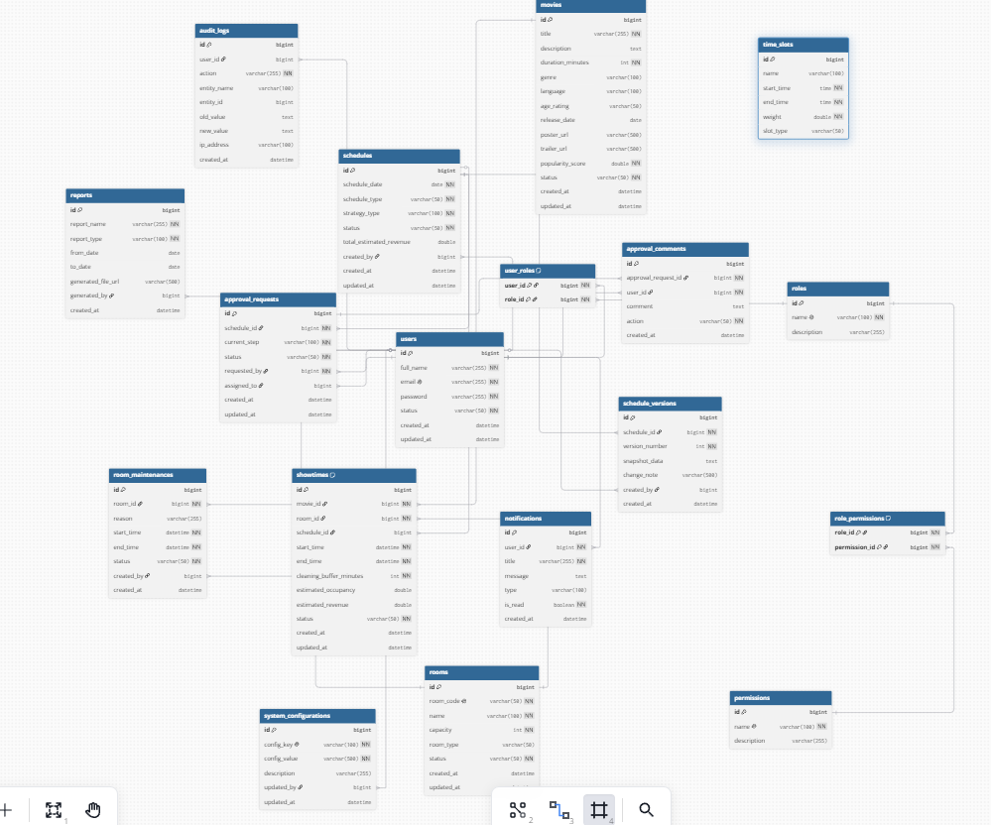

I.7. Usecase diagram
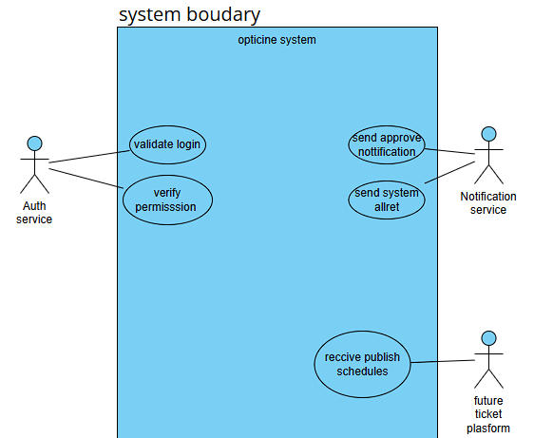
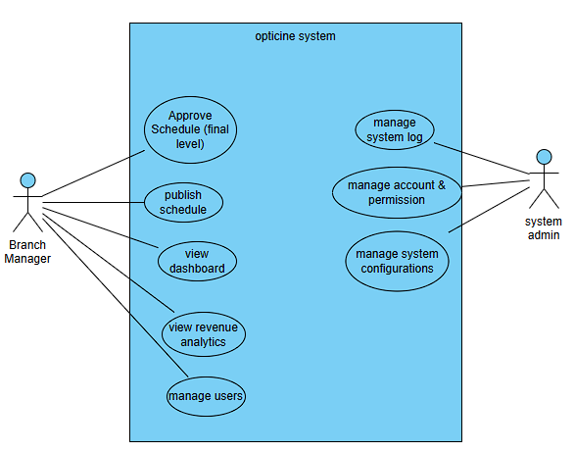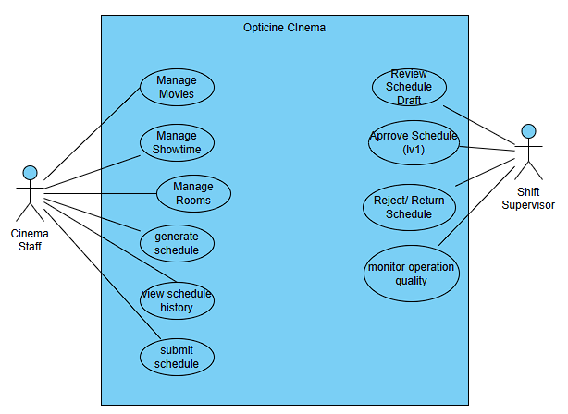

I.8. Data Dictionary
users
Attribute | Description
id (bigint) | Primary key, Auto-increment, Mandatory (NOT NULL)
full_name (varchar 255) | User's full name. Mandatory (NOT NULL)
email (varchar 255) | Login email. Mandatory (NOT NULL), Unique (UNIQUE)
password (varchar 255) | Hashed password (Bcrypt). Mandatory (NOT NULL)
status (varchar 50) | Account status (ACTIVE / INACTIVE). Mandatory (NOT NULL)
created_at (datetime) | Account creation time. Optional
updated_at (datetime) | Last update time. Optional
Manages account information for users logging into the cinema system.

movies
Attribute | Description
id (bigint) | Primary key, Auto-increment, Mandatory (NOT NULL)
title (varchar 255) | Display movie title. Mandatory (NOT NULL)
description (text) | Movie synopsis. Optional
duration_minutes (int) | Movie duration in minutes. Mandatory (NOT NULL)
genre (varchar 100) | Movie genre. Optional
language (varchar 100) | Language/Subtitle. Optional
age_rating (varchar 50) | Age restriction (e.g., PG, PG-13, R). Optional
release_date (date) | Release date. Optional
poster_url (varchar 500) | Poster image file link. Optional
trailer_url (varchar 500) | Trailer video link. Optional
popularity_score (double) | Popularity index (P) used for the formula Z = P * C * W. Mandatory (NOT NULL)
status (varchar 50) | Status (CREATED, ACTIVE, DISABLED, ARCHIVED). Mandatory (NOT NULL)
created_at (datetime) | Record creation time. Optional
updated_at (datetime) | Last update time. Optional
Stores movie information, used as input for the scheduling algorithm.

rooms
Attribute | Description
id (bigint) | Primary key, Auto-increment, Mandatory (NOT NULL)
room_code (varchar 50) | Room code (e.g., R-A1). Mandatory (NOT NULL), Unique (UNIQUE)
name (varchar 100) | Room name. Mandatory (NOT NULL)
capacity (int) | Seating capacity (C), used in formula Z. Mandatory (NOT NULL)
room_type (varchar 50) | Room type (STANDARD, VIP, IMAX). Optional
status (varchar 50) | Status (AVAILABLE, BUSY, MAINTENANCE, DISABLED). Mandatory (NOT NULL)
created_at (datetime) | Record creation time. Optional
updated_at (datetime) | Last update time. Optional
Manages physical screening rooms in the cinema.

showtimes
Attribute | Description
id (bigint) | Primary key, Auto-increment, Mandatory (NOT NULL)
movie_id (bigint) | Foreign key -> movies.id. Mandatory (NOT NULL)
room_id (bigint) | Foreign key -> rooms.id. Mandatory (NOT NULL)
schedule_id (bigint) | Foreign key -> schedules.id. Optional (NULL if showtime is manually added outside a schedule)
start_time (datetime) | Start time. Mandatory (NOT NULL)
end_time (datetime) | End time. Mandatory (NOT NULL)
cleaning_buffer_minutes (int) | Cleaning time in minutes. Mandatory (NOT NULL)
estimated_occupancy (double) | Estimated occupancy rate. Optional
estimated_revenue (double) | Estimated revenue for the showtime. Optional
status (varchar 50) | Status (DRAFT, APPROVED, PUBLISHED, CANCELLED). Mandatory (NOT NULL)
created_at (datetime) | Record creation time. Optional
updated_at (datetime) | Last update time. Optional
The core entity storing screening sessions (intersection of Movie, Room, and Time).

schedules
Attribute | Description
id (bigint) | Primary key, Auto-increment, Mandatory (NOT NULL)
schedule_date (date) | Applied schedule date. Mandatory (NOT NULL)
schedule_type (varchar 50) | Schedule type (DAILY, WEEKLY). Mandatory (NOT NULL)
strategy_type (varchar 100) | Algorithm strategy (REVENUE_MAXIMIZE, DIVERSITY). Mandatory (NOT NULL)
status (varchar 50) | Status (DRAFT, SUBMITTED, SUPERVISOR_APPROVED...). Mandatory (NOT NULL)
total_estimated_revenue (double) | Total estimated revenue. Optional
created_by (bigint) | Foreign key -> users.id (Staff who created it). Optional
created_at (datetime) | Time the algorithm was executed. Optional
updated_at (datetime) | Last update time. Optional
Represents an overall schedule version (Daily/Weekly).

approval_requests
Attribute | Description
id (bigint) | Primary key, Auto-increment, Mandatory (NOT NULL)
schedule_id (bigint) | Foreign key -> schedules.id. Mandatory (NOT NULL)
current_step (varchar 100) | Approval level (SHIFT_SUPERVISOR, BRANCH_MANAGER). Mandatory (NOT NULL)
status (varchar 50) | Status (PENDING, APPROVED, REJECTED, RETURNED, CANCELLED). Mandatory (NOT NULL)
requested_by (bigint) | Foreign key -> users.id (Requester). Mandatory (NOT NULL)
assigned_to (bigint) | Foreign key -> users.id (Approver). Optional
created_at (datetime) | Request time. Optional
updated_at (datetime) | Last update time. Optional
Stores the multi-level approval workflow requests.

time_slots
Attribute | Description
id (bigint) | Primary key, Auto-increment, Mandatory (NOT NULL)
name (varchar 100) | Time slot name (e.g., Weekend Evening). Optional
start_time (time) | Start time. Mandatory (NOT NULL)
end_time (time) | End time. Mandatory (NOT NULL)
weight (double) | Time weight (W) in formula Z. Mandatory (NOT NULL)
slot_type (varchar 50) | Slot type (NORMAL, PRIME_TIME). Optional
Configures timeframes and weights (prime-time) for the cinema.

audit_logs
Attribute | Description
id (bigint) | Primary key, Auto-increment, Mandatory (NOT NULL)
user_id (bigint) | Foreign key -> users.id. Optional (NULL if system action)
action (varchar 255) | Action name (e.g., APPROVE_SCHEDULE). Mandatory (NOT NULL)
entity_name (varchar 100) | Affected table name (e.g., schedules). Optional
entity_id (bigint) | Specific record ID. Optional
old_value (text) | Value before update (JSON format). Optional
new_value (text) | Value after update (JSON format). Optional
ip_address (varchar 100) | User's IP address. Optional
created_at (datetime) | Log creation time. Optional
Stores tracking logs for important actions.

II. Analysis Models

II.1 Interaction diagrams
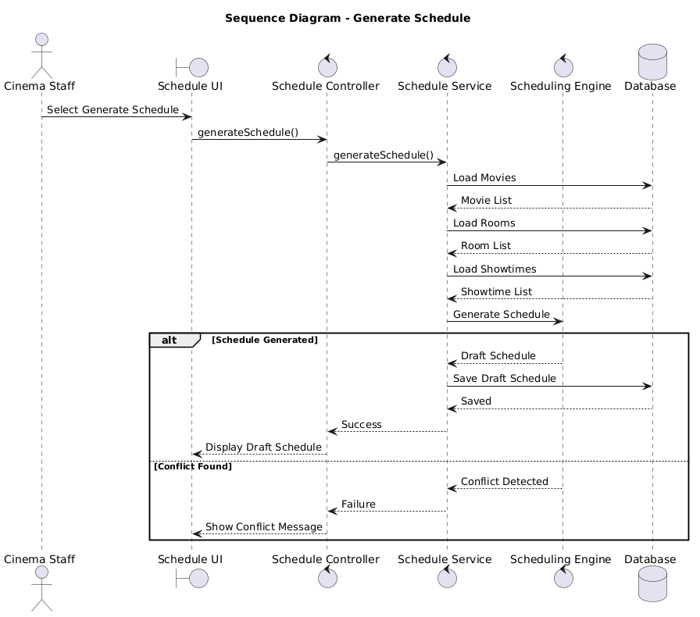

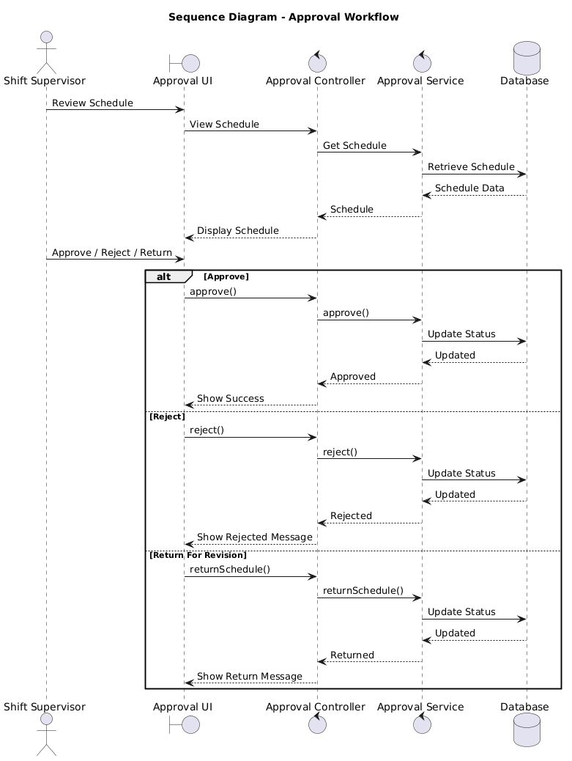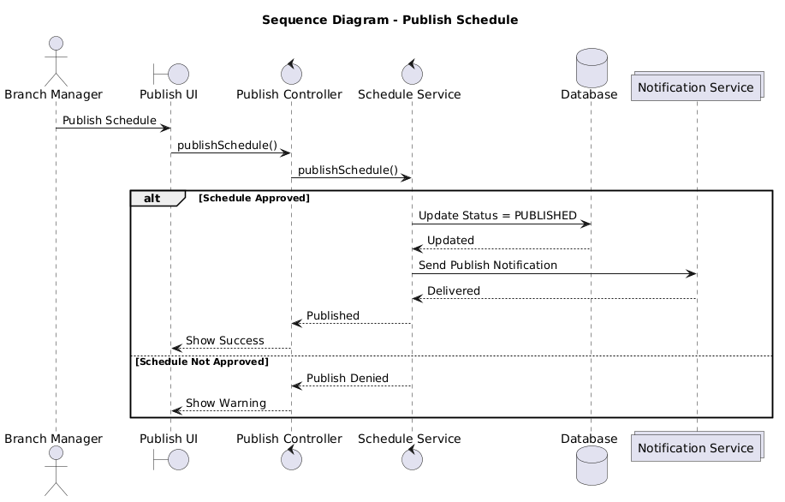

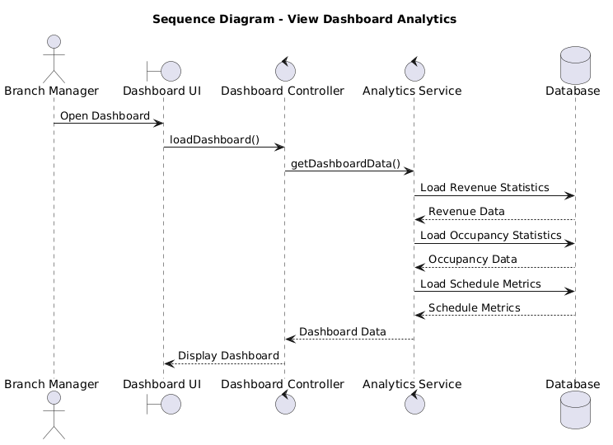

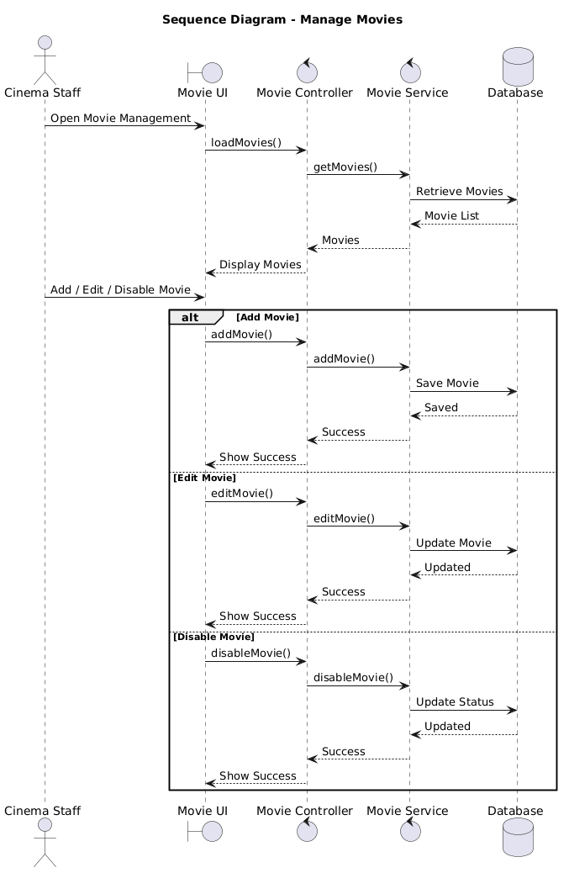

II. 2 Activity Diagrams
This section illustrates the dynamic behavior of the OptiCine system by modeling the flow of control from activity to activity. The focus is on the core scheduling algorithms that drive the system's automated capabilities.
1. Auto-scheduling Flow This flow describes how the algorithm gathers input data (movies, screening rooms, business rules), executes the scheduling engine (CSA/PSO), and outputs a draft schedule.
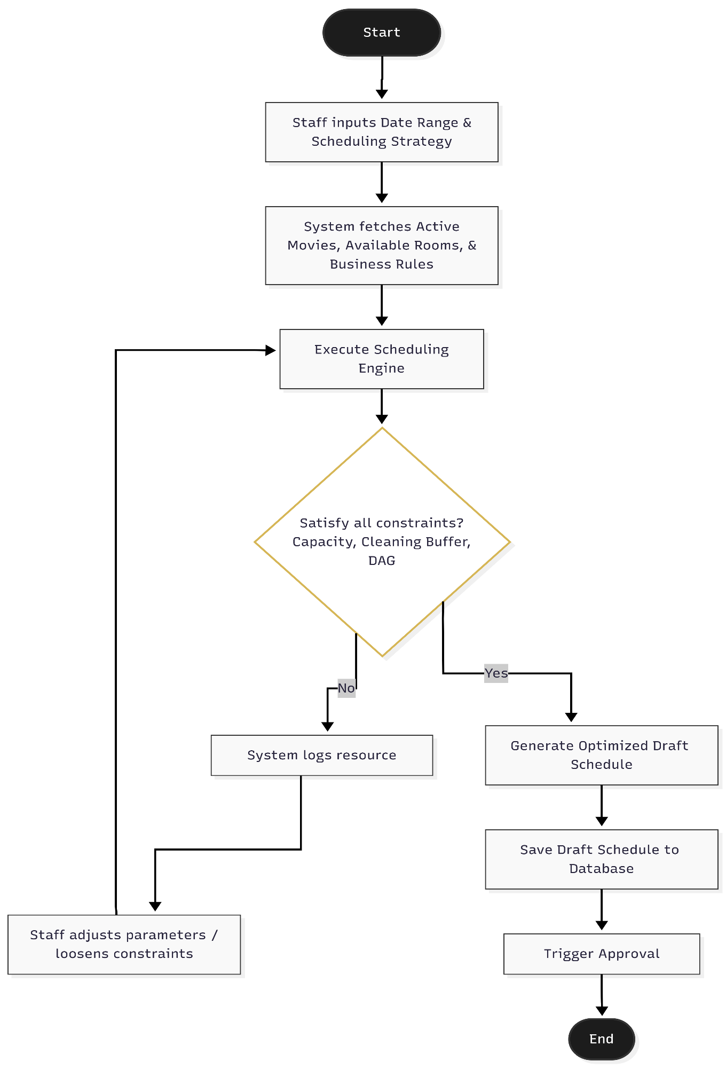
Figure II-5: Activity Diagram for Auto-scheduling Flow

Flow Description:
- Cinema staff inputs the desired date range and selects the scheduling strategy.
- The system fetches all active movies, available rooms, and operational constraints (business hours, capacity, etc.).
- The core Scheduling Engine executes the CSA/PSO metaheuristic algorithm.
- The system evaluates all constraints (e.g., room capacity, cleaning buffer, DAG workflow).
- If conflicts arise, the system logs them for staff to adjust parameters. If all constraints are satisfied, an optimized draft schedule is generated.
- The draft is saved to the database, and the approval workflow is triggered.
2. Rescheduling / Inverse Scheduling Flow This flow illustrates the scenario where a screening room breaks down unexpectedly. The system applies the Inverse Scheduling algorithm to relocate only the affected showtimes instead of rebuilding the entire schedule from scratch.
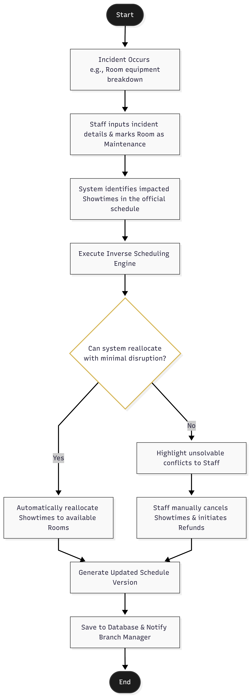
Figure II-6: Activity Diagram for Rescheduling / Inverse Scheduling Flow
Flow Description:
- An incident occurs (e.g., equipment breakdown in a specific room).
- Cinema staff inputs the incident details and marks the room status as "Maintenance".
- The system identifies all impacted showtimes in the currently published schedule.
- The Inverse Scheduling Engine is executed to find alternative slots for the affected showtimes.
- If the system can reallocate the showtimes with minimal disruption, it automatically updates the schedule.
- If the conflict is unsolvable (e.g., no available rooms), the system alerts the staff to manually cancel the showtimes and initiate customer refunds.
- The final updated schedule version is saved, and a notification is sent to the Branch Manager.

II.2.1 Generate Schedule
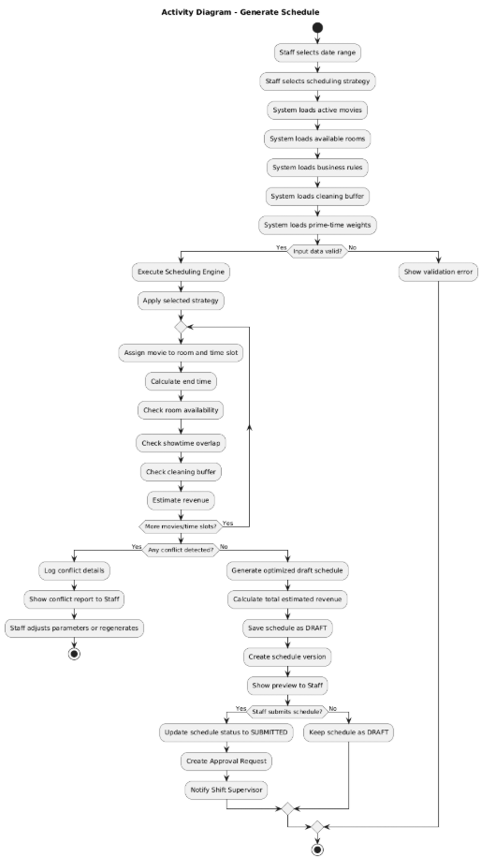

II.2.2 Approval workflow
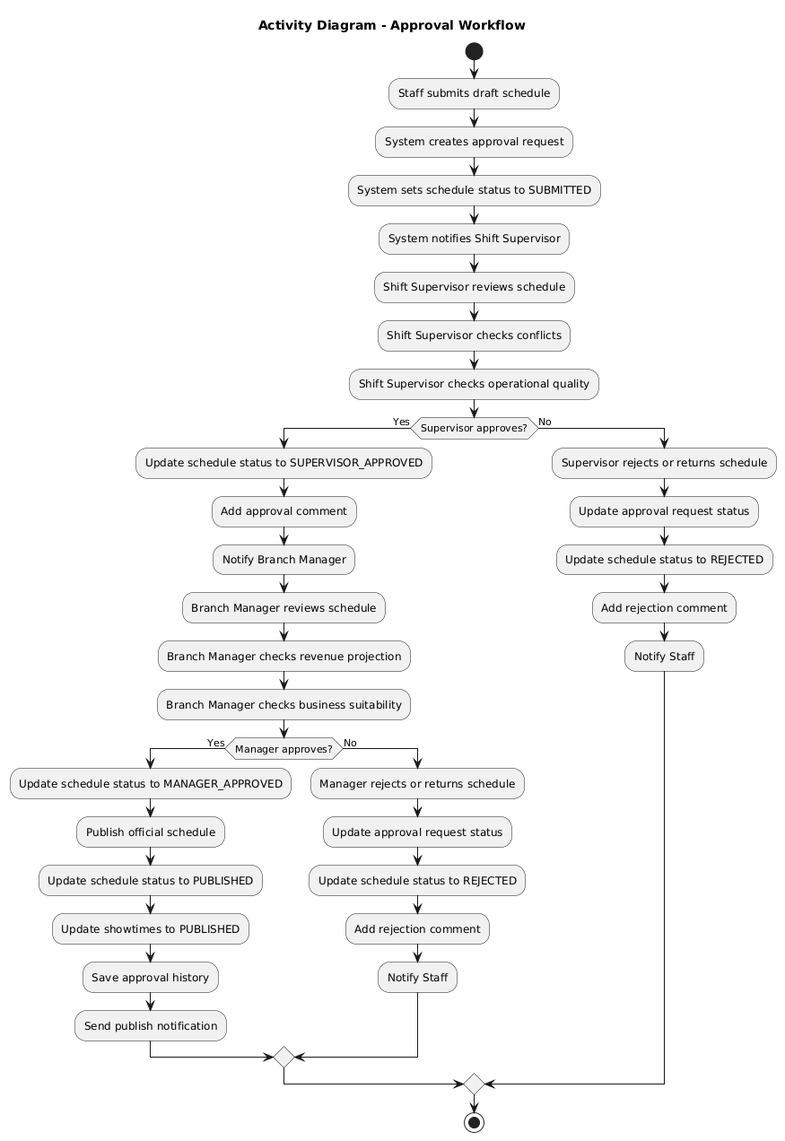

II.2.3 State Analysis

Movie State
Movie lifecycle:
- Created
- Active
- Disabled
- Archived
Transitions:
- Created → Active
- Active → Disabled
- Disabled → Active
- Active → Archived

II.2.4 Room State
Room lifecycle:
- Available
- Busy
- Maintenance
- Disabled
Transitions:
- Available → Busy
- Busy → Available
- Available → Maintenance
- Maintenance → Available
- Disabled → Available

II.2.5 Schedule State

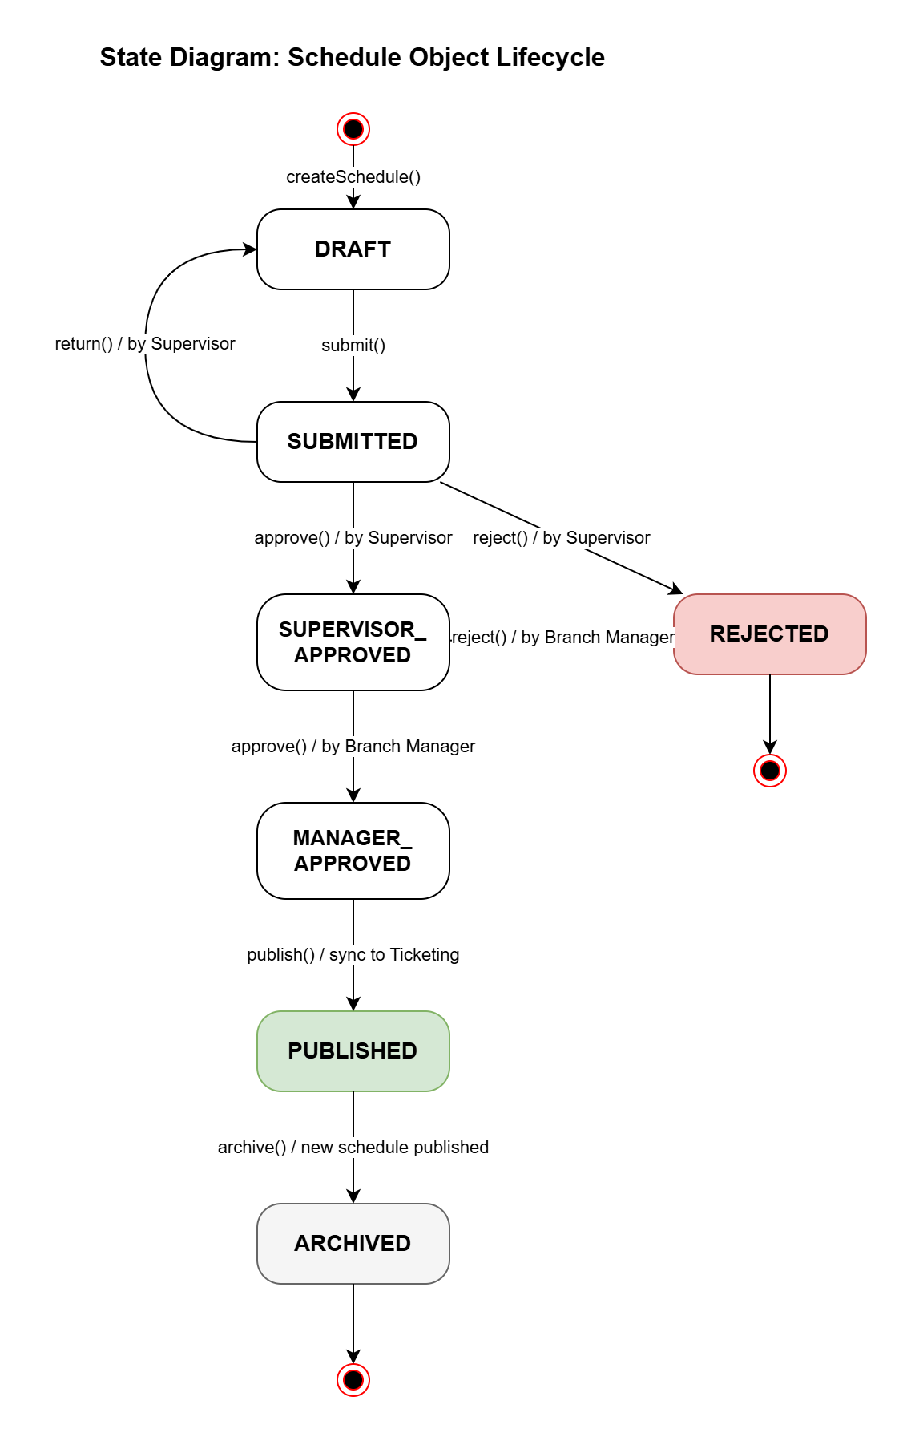
Figure II-2: State Diagram of Schedule

Schedule lifecycle:
- Draft
- Submitted
- Supervisor Approved
- Manager Approved
- Published
- Rejected
- Archived
Transitions:
- Draft → Submitted
- Submitted → Supervisor Approved
- Supervisor Approved → Manager Approved
- Manager Approved → Published
- Rejected → Draft
- Published → Archived

II.2.6. Showtime State

Showtime lifecycle:
- Draft, Approved, Published, Cancelled

Transitions:
- Draft → Approved (when parent Schedule reaches MANAGER_APPROVED)
- Approved → Published (when Schedule is published)
- Draft/Approved → Cancelled (when Schedule is rejected)
- Published → Cancelled (e.g., room emergency maintenance — AF-21.1)
- Published → end (when Schedule is archived)
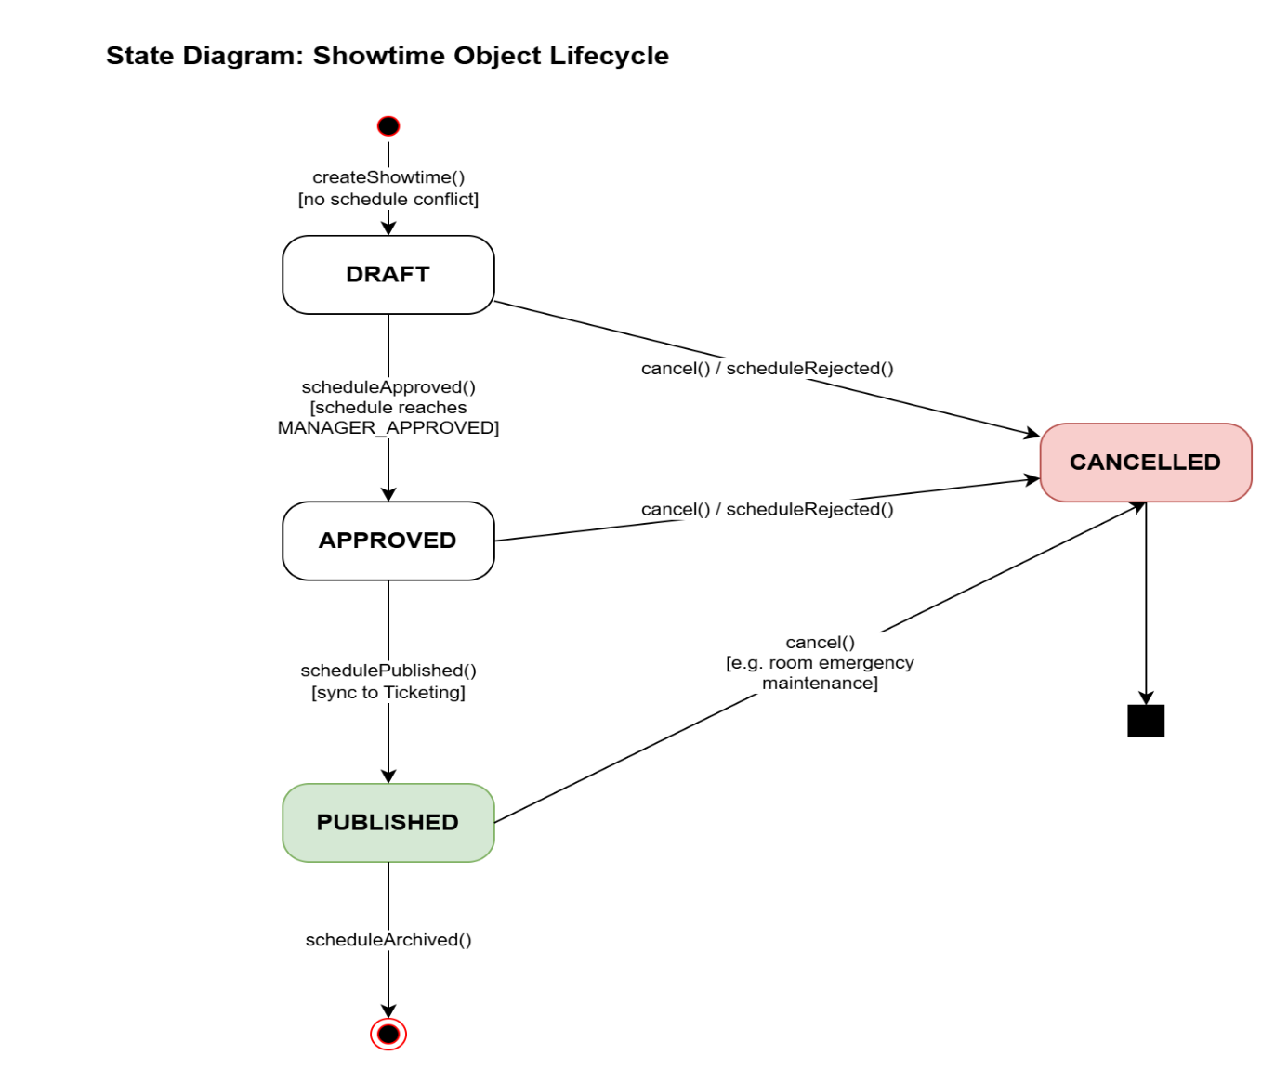
Figure II-3: State Diagram of Showtime Object

II.3. Data Analysis

Core Business Entities
Main entities include:
- Movie
- Room
- Showtime
- Schedule
- ScheduleVersion
- ApprovalRequest
- ApprovalComment
- User
- Role
- Permission
- Report
- SystemConfiguration
- AuditLog
- Notification
These entities represent business data.
Detailed diagrams will be added later.
[Placeholder – Figure II-5: Entity Relationship Diagram]

Data Relationships
Main relationships:
- One movie may contain multiple showtimes.
- One room may contain multiple showtimes.
- One schedule contains multiple rooms.
- One schedule stores approval history.
- One manager may approve multiple schedules.
- One user may contain multiple permissions.
- Configuration rules affect scheduling.
- Reports are generated from schedules.
- Audit logs belong to user actions.
A user may contain multiple permissions.
A configuration may affect many schedules.
A report is generated from multiple schedules.
An audit log belongs to a system action.

Constraints and Analysis Conclusion
The analysis confirms important technical constraints.
Scheduling depends on:
- room availability
- movie duration
- cleaning buffer
- business hours
- strategy rules
- approval workflow
Operational reliability requires:
- transaction rollback
- audit logging
- permission validation
- version history
- performance optimization
These constraints directly influence the design phase.
The next phase will define:
- High-level architecture
- Package structure
- Design classes
- Database design
- Component diagram
- Detailed technical specification

