

Requirement & Design Specification
Real-time Online Auction System (ROAS)
Subject: SWD392 Version: 1.0

– Da Nang, May 2026 –
Record of Changes

Version | Date | A* M, D | In charge | Change Description
V1.0 | 22/5 | A | Hung | Add and format RDS
v1.1 | 27/5 | A | Doan | Add use case diagram
v1.2 | 01/6 | A | Hoang | Add use case diagam
v1.3 | 07/06 | A | Quan | Add class diagram
v1.4 | 17/06 | A | Tai | Add actiivity diagram
V1.5 | 22/06 | M | Doan | Modify use case
*A - Added M - Modified D - Deleted

Contents
I. Requirement Specification 4
I.1 Problem description 4
I.2 Major Features 5
I.2.1 Features for customers are as follows 5
I.2.2 Features for staff are as follows 5
I.3 System context 6
I.4 Nonfunction Requirements 8
I.5 Functional requirements 9
I.5.1 Class diagram 9
I.5.2 Use case diagrams 12
I.5.2 Use case descriptions 28
I.5.3 Activity diagrams 46
I.6 Data Requirements 56
II. Analysis models 61
II.1 Sequence diagrams 61
II.2 State machine diagram 79
III. Design specification 83
III.1 Integrated Communication Diagrams 83
III.1.1. Subsystem 1: Auction Item & Session Management 86
Component Mapping Table 86
III.2 System High-Level Design 93
III.2.1 Component Architecture Descriptions 94
1. Deployment View (Figure III-3) 94
2. Architecture Class View (Figure III-4) 94
III.3 Component and Package Diagram 96
III.3.1 Package Diagram Structure (Figure III-5) 96
III.3.2 Component Diagram Allocation (Figure III-6) 98
III.4 Detail Design 100
III.4.1 Key Architecture Mappings & Patterns 102
III.5 Database Design 103
Core Structural Transformations from the Base Template: 103
IV. Implementation 105
IV.1 Map architecture to the structure of the project 105
IV.1.1 Component Module Manifests 105
IV.2 Map Class Diagram and Interaction Diagram to Code 106
IAuctionSessionService Interface 106
V. Applying Alternative Architecture Patterns 110
V.1 Service-Oriented Architecture (SOA) 110
New Architecture Configurations (Figures III-3, V-1, V-2): 110
V.2 Applying Service Discovery Pattern in the service-oriented architecture 113

Requirement Specification

Problem description
Purpose: Build a real-time online auction platform for high-value assets such as collectibles, rare cards, antiques, and electronics. The system allows users to participate in live auctions, place bids instantly, receive real-time notifications, and manage their auction activities online. Administrators can manage auction rooms, items, users, and monitor auction operations.
- The platform organizes multiple auction categories. Administrators are responsible for creating, updating, or deleting auction category information.
- Each auction category can contain multiple auction items. Auction managers handle item information including descriptions, starting price, reserve price, images, and auction duration.
- Sellers can submit auction items to the platform. Administrators review and approve submitted items before they are published into auction rooms.
- The system manages auction sessions and bidding history. Auction managers can create, update, postpone, or cancel auction sessions according to business rules.
- The platform supports real-time bidding with high concurrency handling. The system must process thousands of simultaneous bids without race conditions or inconsistent bid values.
- Users can browse auction rooms by category, trending auctions, ending soon auctions, or newly listed items. Users can search auction items by name and view detailed information before joining auctions.
- Users must log in to participate in auctions. Authentication can be performed using Google or Facebook accounts. New users provide Full Name, Email, Phone Number, and Address information.
- Users can view bidding history, joined auctions, won auctions, and payment history. They can also configure Auto-Bid Agents by setting maximum bid amounts.
- The system provides instant notifications using WebSocket/Push Notification when users are outbid, when auctions are about to end, or when they win an auction.
- Administrators can publish, update, disable, or re-enable news articles and announcements related to auction events and featured items.
- The system supports Anti-Snipe Protection, automatically extending the auction time if new bids are placed during the last few seconds of an auction session.
- All administrators and staff members must log in before accessing management functions. System administrators manage staff accounts, permissions, auction monitoring, and platform statistics.

Major Features

Features for customers are as follows
      - F01: Viewing Auction Items – View auction items by category, trending auctions, ending soon auctions, newly listed auctions; Search Auction Items by Name; View Auction Item Details.
      - F02: Real-time Bidding – Join live auction rooms, place bids in real time, receive instant bid updates without reloading the page.
      - F03: Auto-Bid Agent – Configure automatic bidding with maximum bid limits; system automatically places bids on behalf of users.
      - F04: Customer Authentication – Register/Login using Google/Facebook; manage profile information.
      - F05: Auction History – View joined auctions, bidding history, won auctions and payment history.
      - F06: Notification System – Receive instant notifications for outbid events, auction results, auction reminders, and payment confirmation.
      - F07: Viewing News – View auction news, announcements, and featured auction events.-

Features for staff are as follows
      - F08: Auction Category Management – Add, Edit, Delete, Sort, Search Auction Categories.+
      - F09: Auction Item Management – Add, Edit, Delete Auction Items; Approve seller submissions; Search and Sort Auction Items.
      - F10: Auction Session Management – Create, Edit, Cancel, Extend Auction Sessions; Configure auction duration and reserve price.
      - F11: Bid Monitoring – View bid logs, monitor live auction activities, detect suspicious bidding behavior, and handle auction disputes.
      - F12: Auto-Bid Management – Configure and monitor Auto-Bid rules and bidding limits.
      - F13: News Management – Add, Edit, Delete, Disable, and Enable News Articles.
      - F14: User Management – Manage user accounts, assign permissions, suspend or reactivate accounts,export.
      - F15: Auction Statistics – Revenue reports, successful auction statistics, concurrent bidding statistics, and auction performance analytics,export.

System context
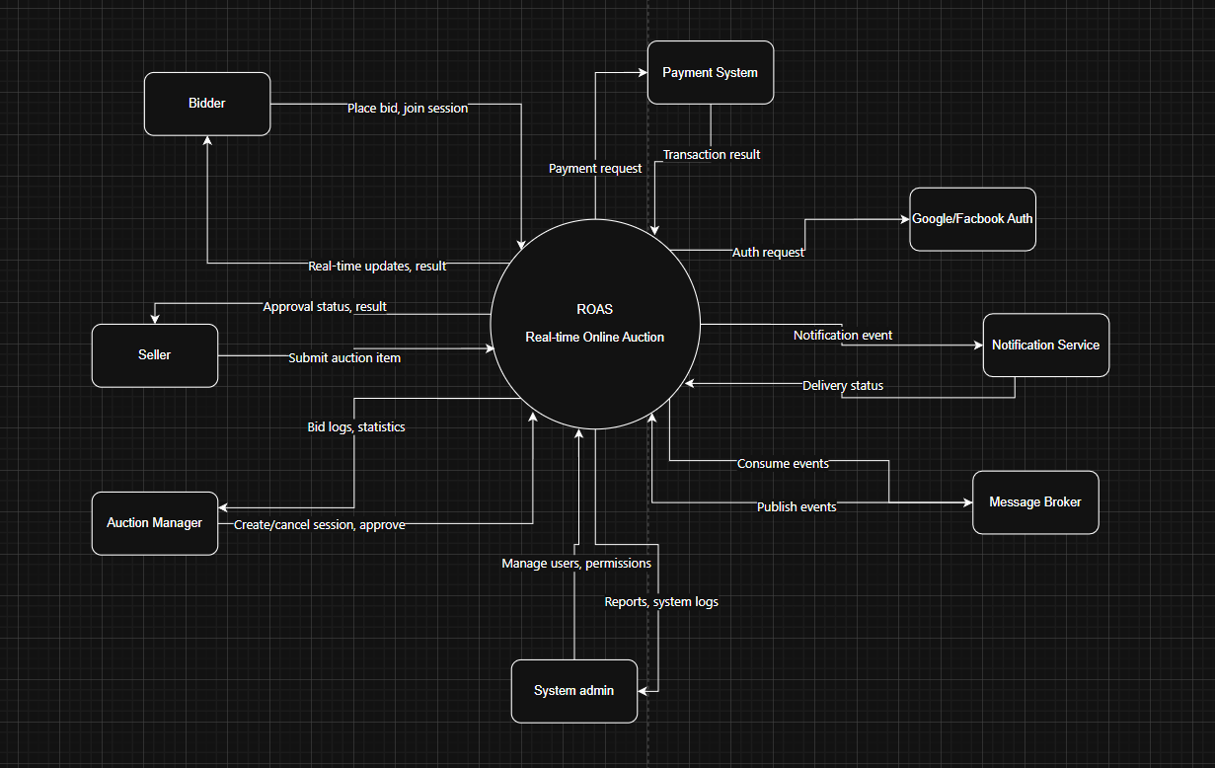
Figure I-1 System context is modeled by a class diagram
Figure 1-1 shows the system context of the Real-time Online Auction System, illustrating the
interactions between the system and its various entities including external users and external
systems.
Internal Users
- Bidder (User) : Participates in auctions, places bids, configures Auto-Bid Agents, and receives real-time notifications.
- Seller (User): Submits auction items and monitors auction performance.
- Auction Manager (Staff): Manages auction sessions, approves auction items, and monitors bidding activities.
- System Administrator (Admin): Manages the entire platform including users, permissions, auction operations, and system monitoring.
External Systems
- Payment System: Handles online payment transactions for winning bids and auction fees.
- Google Authentication Service: Provides login functionality using Google accounts.
- Facebook Authentication Service: Provides login functionality using Facebook accounts.
- Notification Service: Sends real-time notifications through WebSocket and Push Notification services.
- Message Broker Service: Handles asynchronous event processing using Kafka or RabbitMQ for real-time bidding and event-driven communication.

Nonfunction Requirements
NF-01 Maintainability: The system should be designed to support efficient maintenance and future updates. The architecture should be modular and well-organized, with clear documentation for auction modules, bidding services, notification systems, and external integrations. This ensures that system changes and feature enhancements can be implemented smoothly while maintaining scalability and stability.
NF-02 Usability: The website must provide a user-friendly interface for real-time auction participation and auction management.
- Task completion time (find auction item and place a bid within 5 minutes).
- Error rate (less than 5% for key auction activities).
- User satisfaction (at least 85% score).
NF-03 Portability: The website should be compatible across different browsers and devices.
- Browser compatibility (latest versions of Chrome, Firefox, Safari, Edge).
- Device compatibility (desktop, tablet, and mobile devices).
- Responsive design (screen widths from 320px to 1920px).
NF-04 Performance: The website should provide fast response times and stable real-time bidding performance under high concurrency conditions.
- Page load time should remain below 4 seconds for 95% of users.
- Average response time should remain below 6 seconds while handling at least 500 active users.
- The system should support stress testing with at least 200 concurrent bidders while maintaining performance degradation below 20%.
- Real-time bid updates should be delivered with minimal latency to ensure fairness during auction sessions.

In this project, UML models will be used in the requirements, analysis, and design phases of the Real-time Online Auction System (ROAS). These models follow the Platform-Independent Model (PIM) approach, focusing on business logic and functional requirements without depending on a specific technology platform. In the following sections, the requirement, analysis, and design models will be presented together with the mapping of these models to the system implementation and source code.

Functional requirements

Class diagram
The Class Diagram architecture is strictly structured around clean architecture and Spring Boot MVC patterns, maintaining a unified and consistent domain model across all core functional modules:
- Auction Session & Bidding Core (Đoàn, Tài, Hoàng): Models the lifecycle of auction events (AuctionSession), live bidding activity (Bid, AutoBidConfig), real-time monitoring, and historical analytics (AuctionHistory). It dynamically manages room statuses using background scheduling and automated timing rules.
- Item Lifecycle & Approvals (Hưng, Tài): Manages the end-to-end seller workflow from initial media/item submission (Customer Upload Item) to administrative review, verification, and categorization (Staff Approve Item, Category Management).
- Transaction & Settlement (Đoàn): Handles post-auction operations through Invoice creation and secure third-party gateway payment processing (Customer Payment via VNPay), updating inventory states upon successful settlement.
- Security & System Services (Quân): Enforces platform-wide authentication (Double Token with OTP Verification) and delivers real-time notifications (NotificationService) across all user interactions.

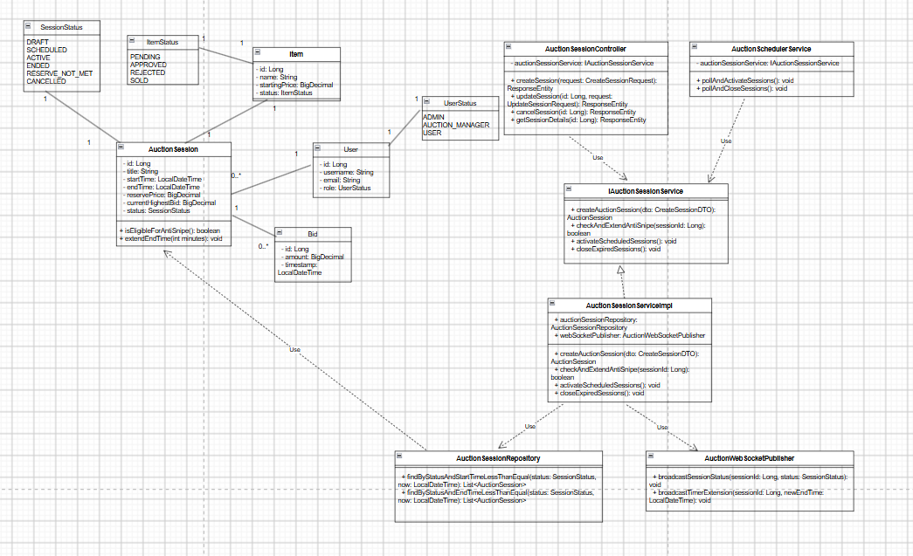
Figure I-2 Class Diagram for Auction Session
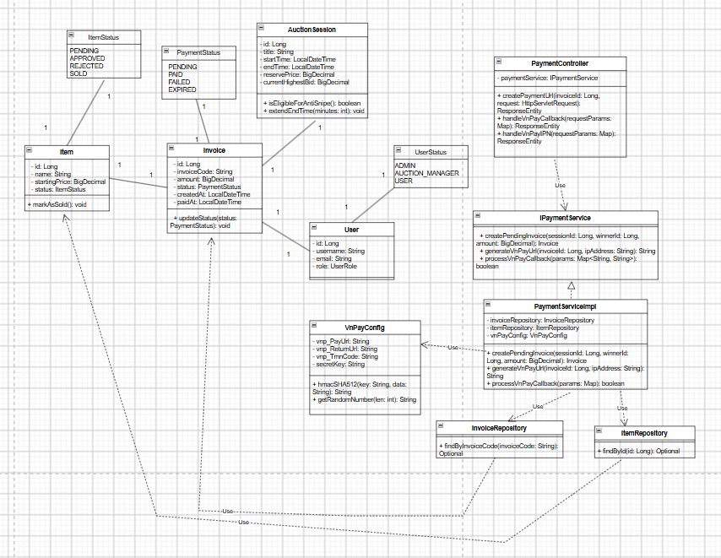
Figure I-3 Class Diagram for Customer Payment
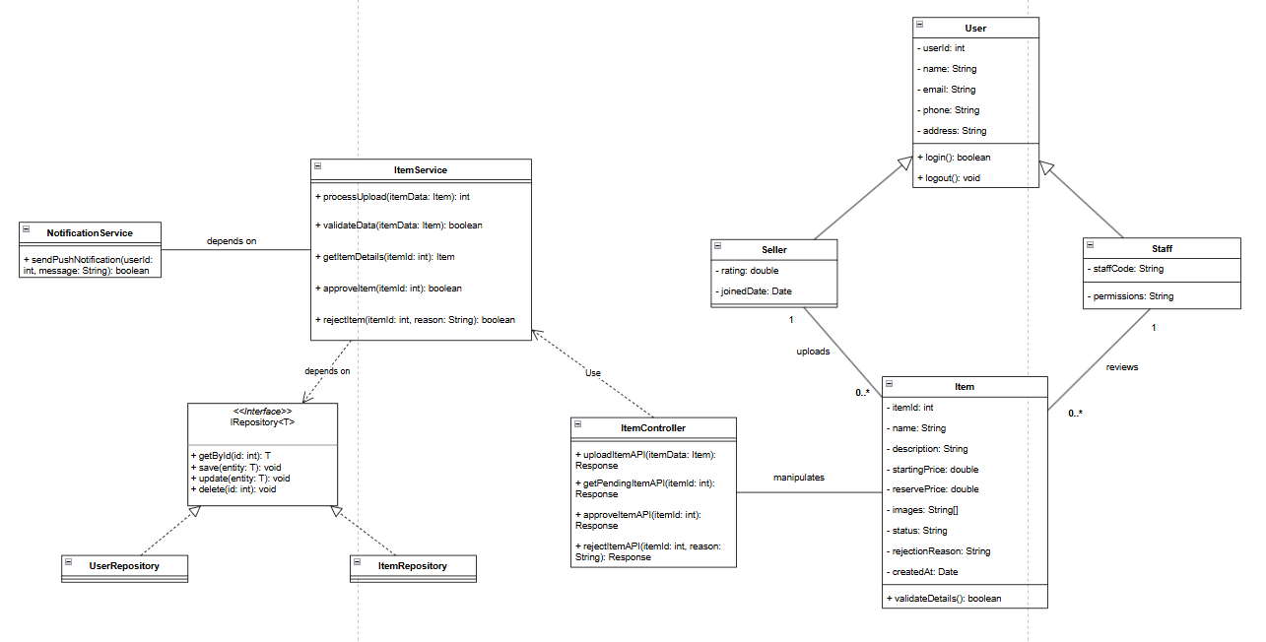
Figure I-4 Class Diagram for Customer Upload Item- Staff Approve Item
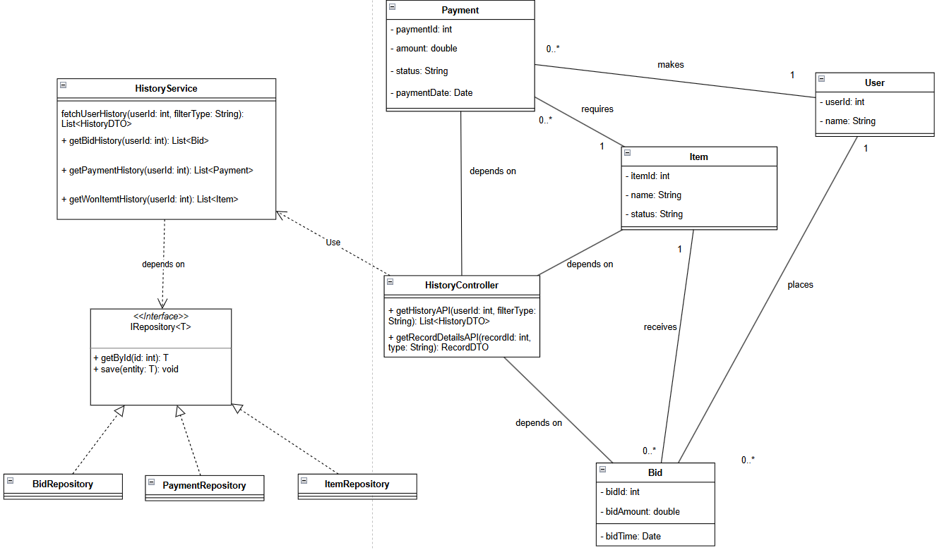
Figure I-5 Class Diagram for Auction History

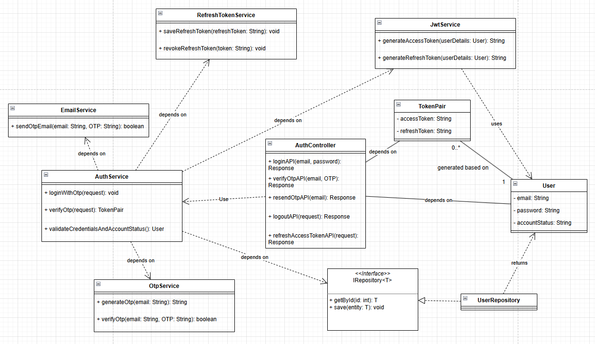
Figure I-6 Class Diagram for Authentication
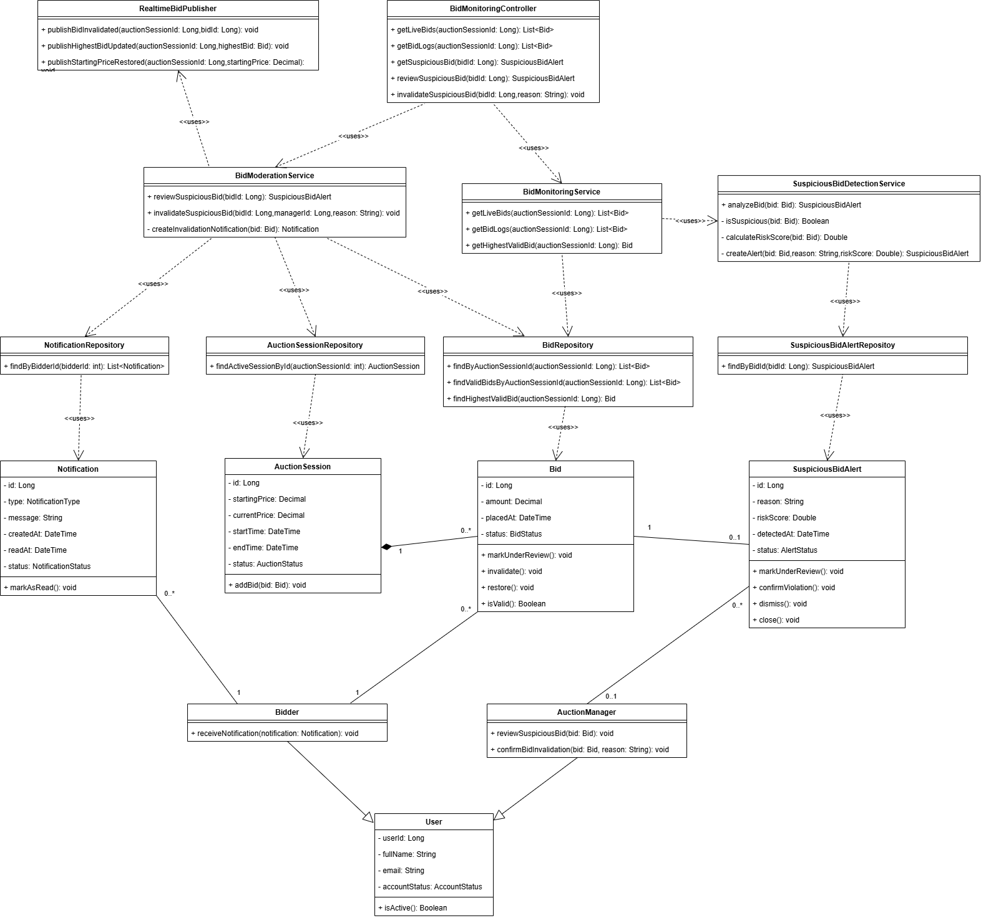
Figure I-7 Class Diagram for Monitor and Moderate Bidding Activity
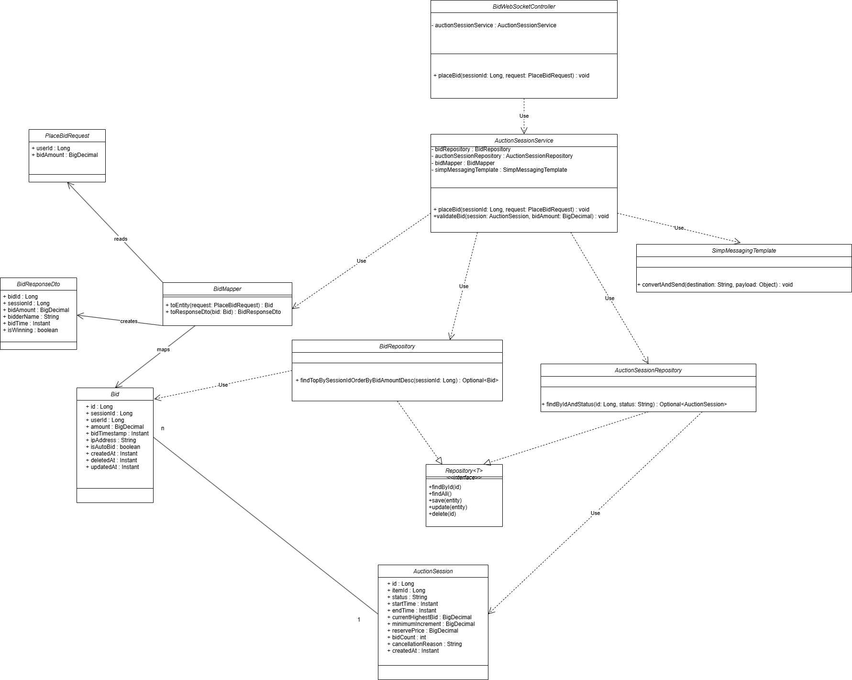
Figure I-8 Class Diagram for place bid
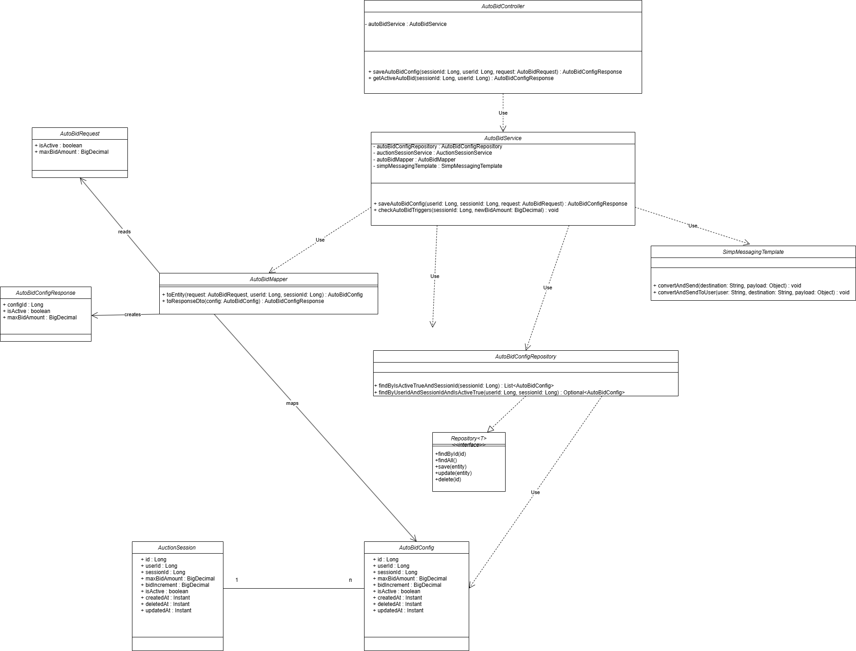
Figure I-9 Class Diagram for Autobid

Use case diagrams
Based on described user requirements in Section 1.1 and detailed analysis, the system has been deployed on a web platform, consisting of two primary sites: the Customer Site and the Administration Site. Figures I-8 through I-21 present the Detailed Use Case Diagrams, which illustrate the specific use cases for both the Customer Site and the Administration Site, including functionalities such as viewing auction items, real-time bidding, configuring auto-bid agents, customer authentication, auction history, notifications, and administrative tasks like managing categories, items, sessions, bids, and statistics.
Tables I-1 through I-17 provide comprehensive descriptions for all defined use cases, covering the complete functional requirements for both the Customer Site and the Administration Site. These include critical operations such as user authentication, auction item and session management, real-time bidding, payment processing, notification systems, and administrative analytics. These detailed descriptions serve as the essential input for developing the analysis models presented in Section 2.

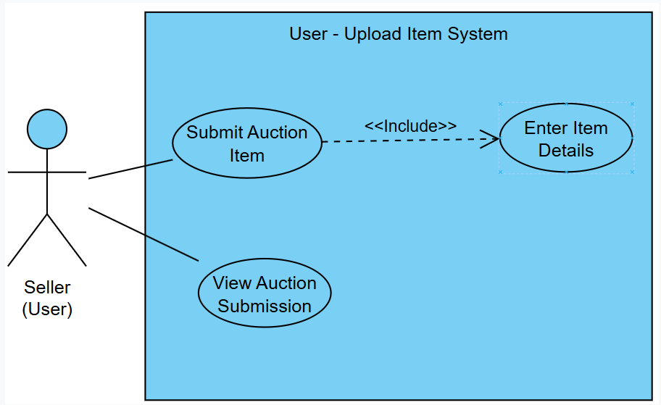
Figure I-8 Detailed Use Case Diagram for Upload Item System

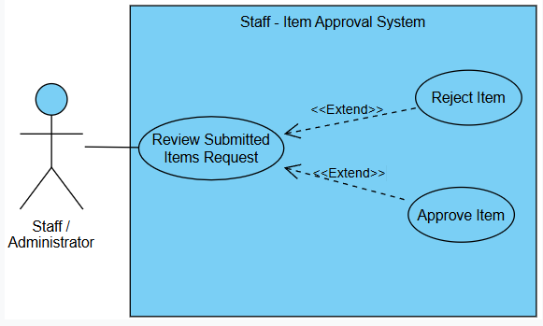

Figure I-9 Detailed Use Case Diagram for Item Approval System

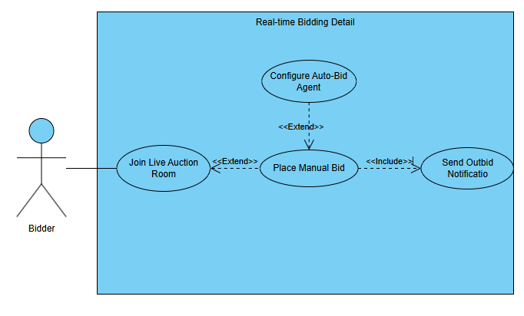
Figure I-10 Detailed Use Case Diagram for Real-time Bidding & Auto-Bid
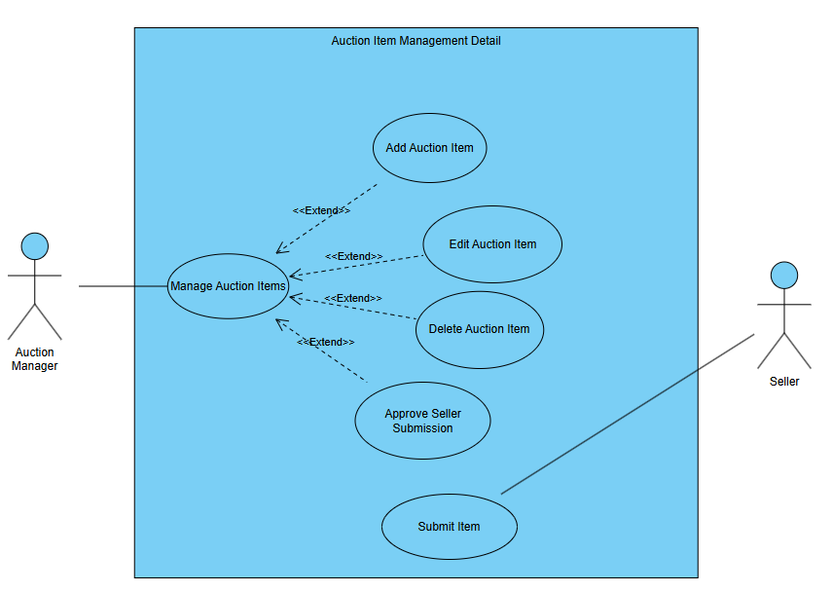
Figure I-11 Detailed Use Case Diagram for Managing Auction Items

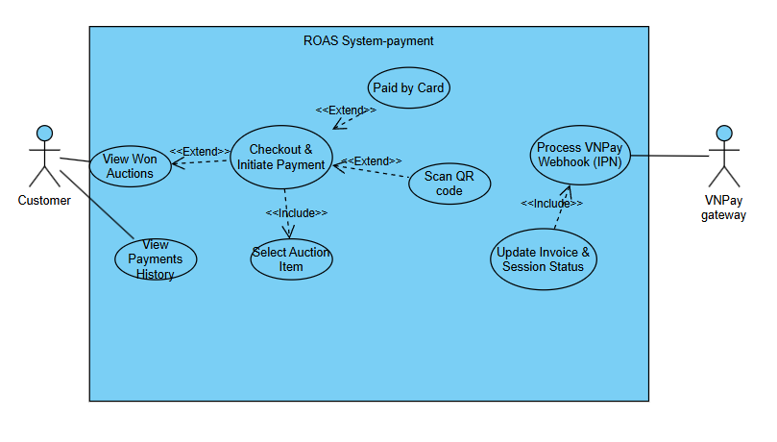
Figure I-12 Detailed Use Case Diagram for Payment

\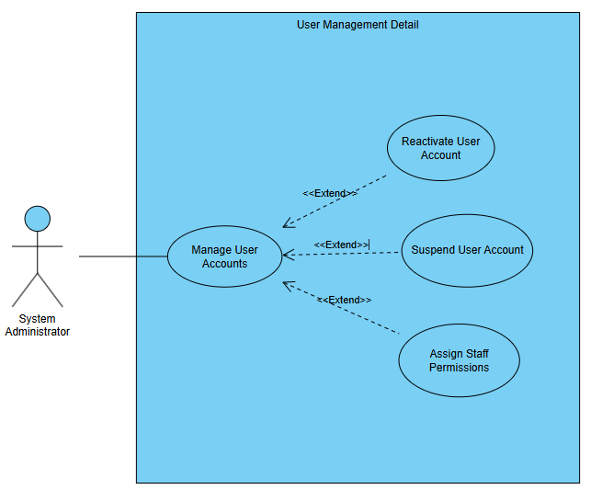

Figure I-13 Detailed Use Case Diagram for ManagingUsers

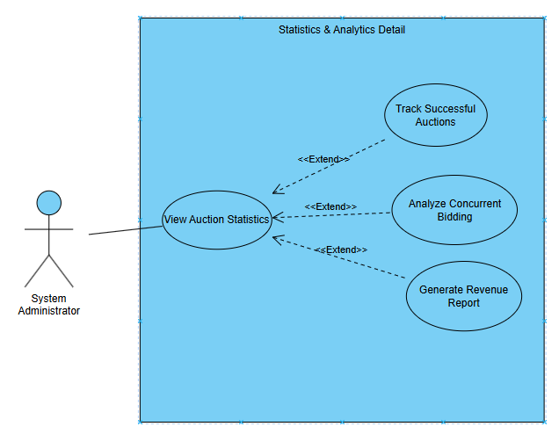

Figure I-14 Detailed Use Case Diagram for Statistics & Analytics
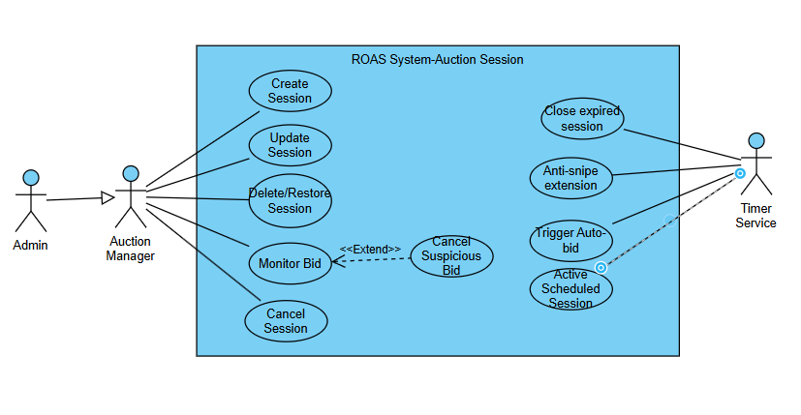
Figure I-15 Detailed Use Case Diagram for Auction Session

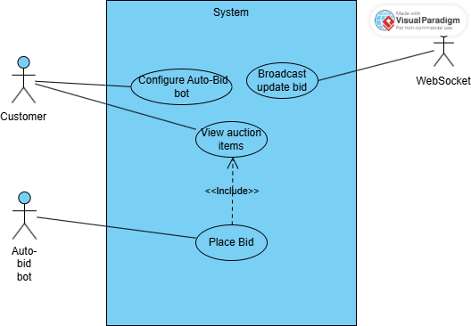
Figure I-16 Detailed Use Case Diagram for Place Bid

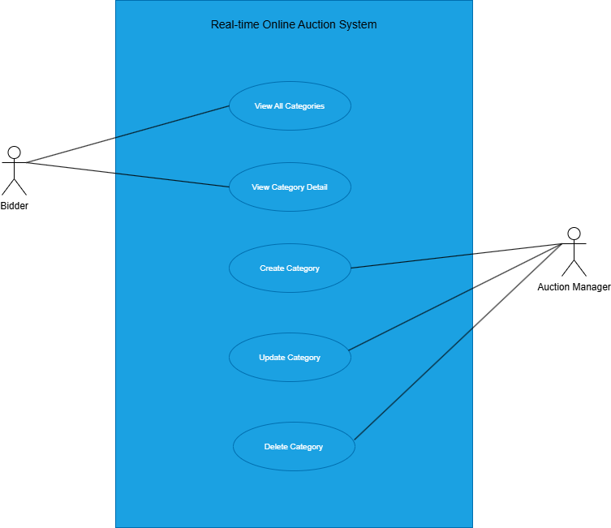
Figure I-17 Detailed Use Case Diagram for category management
\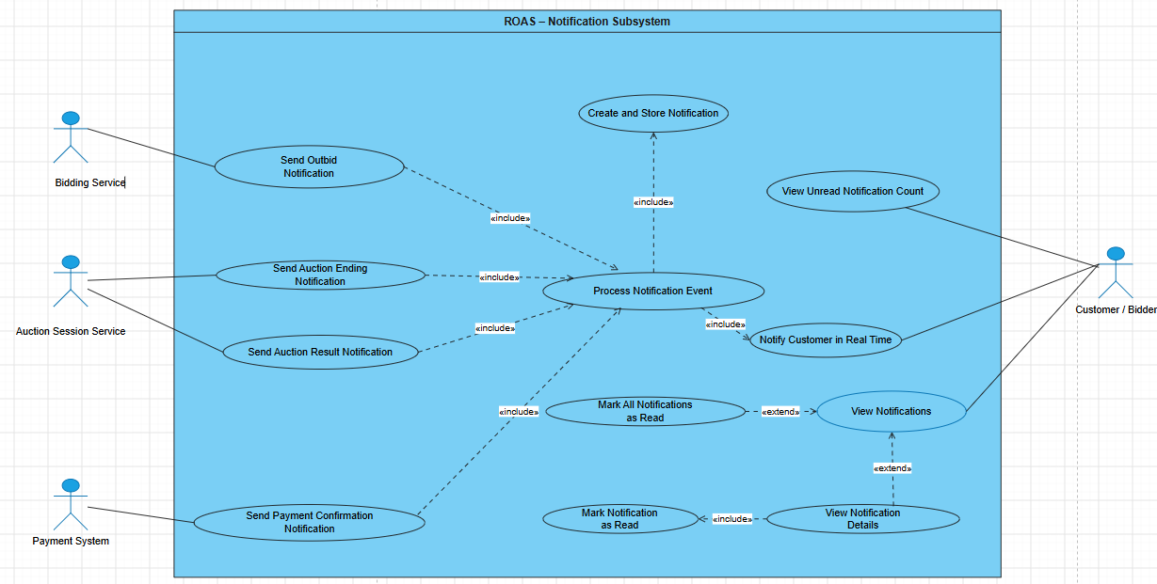

Figure I-18 Detailed Use Case Diagram for Notification System

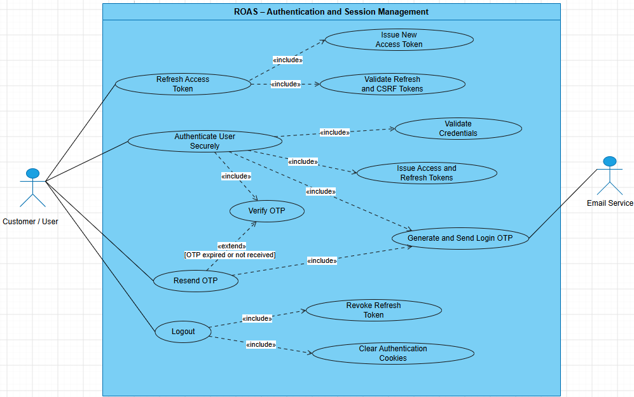

Figure I-19 Detailed Use Case Diagram for Secure Authentication and Session Management
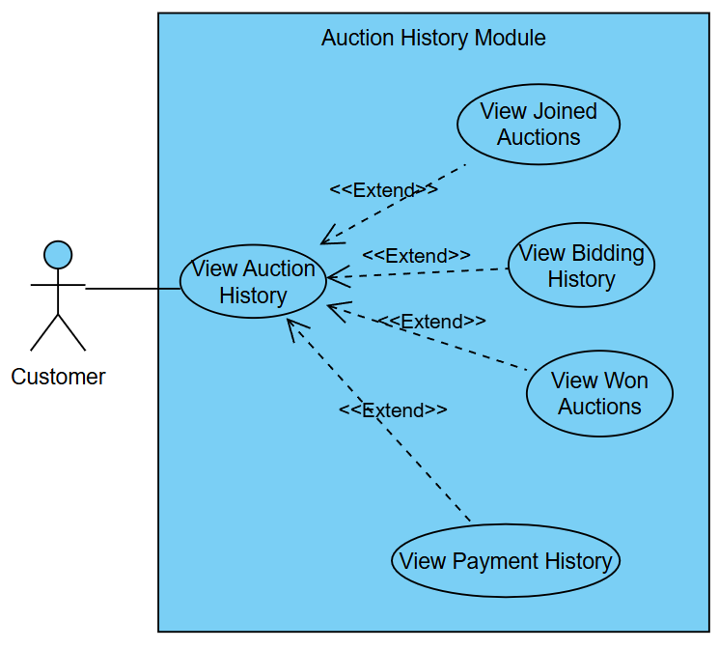
Figure I-20 Detailed Use Case Diagram for Auction History

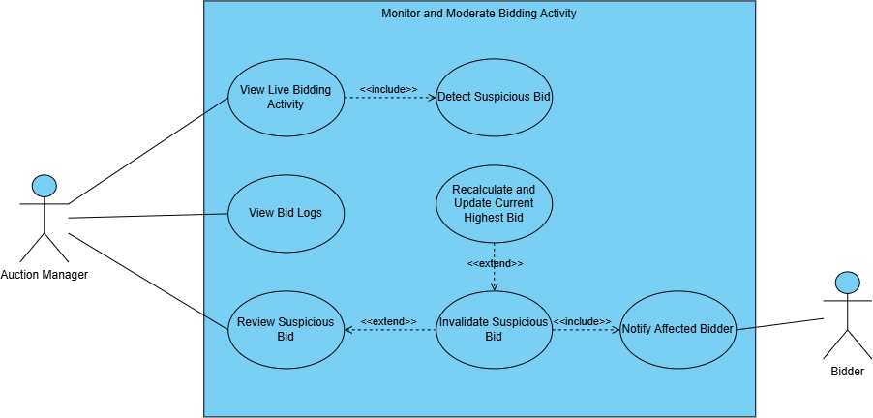
Figure I-21 Use Case Diagram for Monitor and Moderate Bidding Activity

Use case descriptions
Tables I-1 through I-17 provide comprehensive descriptions for all 17 defined use cases, covering the complete functional requirements for both the Customer Site and the Administration Site. These include critical operations such as user authentication, auction item and session management, real-time bidding, payment processing, notification systems, and administrative analytics. These detailed descriptions serve as the essential input for developing the analysis models.

Table I-1 Use case description for upload Item

ID and Name: | UC-01 Submit Auction Item
Created By: | Hung | Date Created: | 24/05/2024
Primary Actor: | Seller (User) | Secondary  Actors:
Description: | This use case allows a Seller to submit a new item for auction by entering detailed information about the item.
Trigger: | The Seller clicks on the "Submit Item" button on the user portal.
Preconditions: | PRE-1: The Seller must be logged into their account.  PRE-2: The Seller's account must be active and verified.
Postconditions: | POST-1: The item is saved in the system with a "Pending Approval" status.
Normal Flow: | - The Seller selects "Submit Item".  - The system presents a form to enter item details.  - The Seller inputs item details (name, description, starting price, images). (<> Enter Item Details)  - The Seller submits the form.  - The system validates the input and saves the item.
Alternative  Flows: | A1.1 User Cancels: The seller decides to cancel the submission process before clicking submit.
Exceptions: | E1.1 Incomplete Fields: System prompts user to fill in all mandatory item attributes.  E5.1 Database Error: System displays "Failed to submit item. Please try again."
Priority: | High
Business Rules: | Submitted items cannot be auctioned immediately; they must await staff approval.

Table I-2 Use case description for Add Auction Item

ID and Name: | UC-02 Approve Item
Created By: | Hung | Date Created: | 24/05/2024
Primary Actor: | Auction Manager / Staff | Secondary  Actors:
Description: | Allows staff members to review items submitted by sellers and either approve or reject them.
Trigger: | Staff navigates to the "Pending Items" dashboard.
Preconditions: | PRE-1: Staff is logged in with appropriate approval permissions.
Postconditions: | POST-1: The item's status is updated to "Approved" or "Rejected".
Normal Flow: | - Staff selects a pending item from the list.  - The system displays the item details.  - Staff reviews the details.  - Staff selects "Approve" (<> Approve Item) or "Reject" (<> Reject Item).  - System updates the status and notifies the seller.
Alternative  Flows: | A2.1 Request Modification: Staff rejects with a note for the seller to update the item description.
Exceptions: | E4.1 Status Conflict: If another staff already reviewed it, system shows "Item already processed."  E4.2 Data Error: Item information is corrupted; staff cannot save the approval status.
Priority: | High
Business Rules: | Items can only be approved if the reserve price is within a valid range.

Table I-3 Use case description for Placing Manual Bid
ID and Name: | UC-03 Real-time Bidding & Auto-Bid
Created By: | Hung | Date Created: | 24/05/2024
Primary Actor: | Bidder (User) | Secondary  Actors:
Description: | Allows a bidder to place a manual bid on an active live auction.
Trigger: | Bidder enters an amount and clicks "Place Bid" inside the Live Auction Room.
Preconditions: | PRE-1: Bidder has joined the Live Auction Room.  PRE-2: The auction session is currently active.
Postconditions: | POST-1: The bid is recorded, and the current highest price is updated.
Normal Flow: | - Bidder joins Live Auction Room (<> Place Manual Bid).  - Bidder enters a bid amount.  - System validates if the bid is higher than the current highest bid + minimum step.  - System accepts the bid and updates the room in real-time.  - System notifies the previous highest bidder (<> Send Outbid Notification).
Alternative  Flows: | A1.1 Auto-Bid: User configures an auto-bid agent.  A1.2 Outbid Warning: User receives notification to increase bid.
Exceptions: | E3.1 Invalid Bid: System rejects the bid if it's lower than the required threshold.  E3.2 Connection Loss: WebSocket disconnects, preventing real-time bid updates.
Priority: | High
Business Rules: | Bids must be at least one increment higher than the current price.

Table I-4 Use case description for Delete product

ID and Name: | UC-04 Manage Auction Items
Created By: | Hung | Date Created: | 24/05/2024
Primary Actor: | Auction Manager | Secondary  Actors:
Description: | This use case allows the Auction Manager to remove an item from the active system.
Trigger: | The Auction Manager selects the Delete option next to an entry in the Manage Auction Items section.
Preconditions: | PRE-1. Auction Manager is logged into ROAS.  PRE-2. Auction Manager is authorized to delete items.  PRE-3. The auction item exists and must not be linked to any historical or ongoing transactions.
Postconditions: | POST-1. Successful Delete: The auction item is removed or disabled in the system.  POST-2. Unsuccessful Delete: The system provides feedback, and the item remains unchanged.
Normal Flow: | - The AM selects Delete next to the selected item from the Manage Auction Items section.  - The system verifies if the item is locked by active bids or reference constraints (See E2.1).  - The system displays a confirmation pop-up window: "Are you sure you want to delete this item?".  - The AM clicks the Confirm Delete button (See A4.1).  - The system deletes/soft-deletes the item record from the database.  - The system displays a confirmation message that the item was successfully deleted.  - The system updates and reloads the Manage Auction Items screen.
Alternative  Flows: | A4.1 Select Cancel (Step 4)  - The AM selects the Cancel button on the confirmation pop-up window.  - The system closes the pop-up window and makes no data changes.
Exceptions: | E2.1 Relational Integrity Conflict (Step 2)  - The system detects the item has active bids or historical invoices, blocks the deletion, and displays an error message.  E5.1 System Error (Step 5)  - The system logs the error and displays an error message to the AM.  E4.1 Constraint Violation: Item is currently part of an active session, deletion blocked.
Priority: | High
Business Rules: | Items cannot be deleted if they have ever been part of a completed auction session (for audit reasons).

Table I-5 Use case description for Payment

ID and Name: | UC-05-Checkout & Initiate Payment
Created By: | Hung | Date Created: | 24/05/2024
Primary Actor: | User | Secondary  Actors: | VNPay Gateway
Description: | Allows a customer who won an auction to checkout and pay via VNPay.
Trigger: | Customer selects "Pay Now" for a won auction item.
Preconditions: | PRE-1: Customer has won at least one auction. PRE-2: Unpaid invoice exists.
Postconditions: | POST-1: Payment session is initiated with the third-party gateway.
Normal Flow: | - Normal Flow:  - Customer accesses "View Won Auctions".  - Customer selects an item to pay (<> Select Auction Item).  - Customer initiates checkout.  - Customer chooses payment method (Card or QR Code) (<> Paid by Card / Scan QR code).  - System redirects to VNPay Gateway.  - VNPay processes and sends Webhook back to system (Process VNPay Webhook (IPN)) to update status (<> Update Invoice & Session Status).
Alternative  Flows: | A5.1 Payment Failed: Redirect back to payment selection page.
Exceptions: | E5.1 Gateway Timeout: VNPay service unreachable.
Priority: | Critical
Business Rules: | Payment must be completed within 48 hours of winning the auction.

Table I-6 Use case description for Managing Users

ID and Name: | UC-06 Manage User Accounts
Created By: | Hung | Date Created: | 24/05/2024
Primary Actor: | Admin | Secondary  Actors:
Description: | Allows the admin to oversee user accounts, suspend, reactivate, or assign staff roles.
Trigger: | Admin navigates to User Management menu.
Preconditions: | PRE-1: Logged in as System Administrator.
Postconditions: | POST-1: User account status or permissions are successfully updated in the database.
Normal Flow: | - Admin opens the User Accounts list.  - Admin selects a specific user.  - Admin chooses an action: Suspend (<>), Reactivate (<>), or Assign Permissions (<>).  - System prompts for confirmation.  - Admin confirms.  - System updates user profile.
Alternative  Flows: | A6.1 Filter Users: Admin filters by role (Customer, Staff).
Exceptions: | E6.1 Self-Lock: Admin cannot suspend their own account.
Priority: | Medium
Business Rules: | Only "System Admin" role can modify "Staff" or "Admin" accounts.

Table I-7 Use case description for Statistics & Analytics

ID and Name: | UC-07 View Auction Statistics
Created By: | Hung | Date Created: | 24/05/2024
Primary Actor: | Admin | Secondary  Actors:
Description: | Allows the admin to view dashboards containing statistics, revenue reports, and concurrent bidding analysis.
Trigger: | Admin clicks on "Statistics & Analytics".
Preconditions: | PRE-1: Admin has analytics viewing permissions.
Postconditions: | POST-1: Charts and data tables are rendered correctly.
Normal Flow: | - Admin requests the statistics dashboard.  - System aggregates data from the database.  - System displays overall metrics.  - Admin can choose to view specific reports: Revenue Report, Concurrent Bidding, or Successful Auctions (<>).
Alternative  Flows: | A7.1 Export Data: Admin downloads the report as a CSV/Excel file.
Exceptions: | E7.1 Data Aggregation Timeout: Too much data; report generation fails.
Priority: | Low/Medium
Business Rules: | Reports must aggregate data from completed sessions only.

Table I-8 Use case description for Auction Session

ID and Name: | UC-08 Configure Auction Session
Created By: | Hung | Date Created: | 24/05/2024
Primary Actor: | Auction Manager | Secondary  Actors: | Message Broker (MB)
Description: | This use case allows the Auction Manager to schedule live auction rooms, map approved items, and configure duration parameters and Anti-Snipe safeguards.
Trigger: | The Auction Manager selects the Create New Session option from the Auction Session Management section.
Preconditions: | PRE-1. Auction Manager is logged into ROAS.  PRE-2. Auction Manager is authorized to manage auction sessions.  PRE-3. The target auction item holds an 'Approved' status profile.
Postconditions: | POST-1. Successful Configuration: The auction session record is created, and event listeners are initialized.  POST-2. Unsuccessful Configuration: The system returns feedback, and no schedule profiles are created.
Normal Flow: | - The AM selects Create New Session from the Auction Session Management section.  - The system displays a blank session configuration form interface.  - The system retrieves a list of available 'Approved' items from the database and populates the picker field list.  - The AM configures parameters (Session Name, Approved Item selection, Start Time, End Time, and Anti-Snipe configurations) (See A4.1).  - The AM submits the form.  - The system validates the input scheduling values and constraints (See E6.1).  - The system registers the schedule row in the database and synchronizes timers with the Message Broker service.  - The system displays a session setup success message.  - The system closes the workspace and returns to the Auction Session Management dashboard screen.
Alternative  Flows: | A8.1 Postpone Session: Manager updates the StartTime.  - The AM unchecks the "Enable Anti-Snipe Protection" checkbox parameter.  - The system hides the time-extension window text field inputs.  - The system returns to Step 4 of the Normal Flow.  A4.2 Select Close (Step 4)  - The AM selects the Close button.  - The system closes the form and returns to the main dashboard.
Exceptions: | E8.1 Conflict: Another session is already using the same item at the same time.  - The system detects the chosen date/time conflicts with another session running on the same item, alerts the AM, and highlights the field.  E6.2. Past Datetime Constraint (Step 6)  - The system detects the Start Time is set in the past, displays an error message, and prompts for a valid future timestamp.  E7.1 System Error (Step 7)  - The system logs the error and displays an error message to the AM.
Priority: | High
Business Rules: | Auction duration cannot exceed 30 days.

Table I-9 Use case description for Login

ID and Name: | UC-09 Login
Created By: | Hung | Date Created: | 24/05/2024
Primary Actor: | User/ Auction Manager/ Admin | Secondary  Actors: | Google Authentication Service
Description: | Allows a customer to access their account via standard login or Google OAuth
Trigger: | Customer clicks "Login".
Preconditions: | PRE-1: Customer is not currently authenticated.
Postconditions: | POST-1: Customer is logged in and a session is created.
Normal Flow: | - Customer enters credentials or selects Google Login.  - System authenticates credentials or communicates with Google (<> Authenticate with OAuth Provider).  - System checks if the account is active/banned (<> Check Account Status).  - System creates a secure session (<> Create Login Session).  - Customer is redirected to the homepage.
Alternative  Flows: | A9.1 Forgot Password: User initiates password recovery.
Exceptions: | E9.1 Account Locked: Account is suspended due to multiple failed login attempts.
Priority: | High
Business Rules: | Successful login requires MFA or OTP if the user has enabled security settings.

Table I-10 Use case description for Signup

ID and Name: | UC-10 Signup
Created By: | Hung | Date Created: | 24/05/2024
Primary Actor: | User | Secondary  Actors: | Google Authentication Service
Description: | Allows a new user to create an account either manually or via Google.
Trigger: | User clicks "Sign Up".
Preconditions: | PRE-1: The email is not already registered in the system.
Postconditions: | POST-1: A new customer profile is created in the database.
Normal Flow: | - User provides registration details or clicks Google Signup.  - System authenticates/retrieves data via Google (<> Authenticate with Google).  - System validates the provided profile information (<> Validate Profile Information).  - System creates the account (<> Create Customer Account).
Alternative  Flows: | A10.1 Email Exists: System suggests login instead.
Exceptions: | E10.1 Validation Error: Invalid email format or password complexity not met.
Priority: | High
Business Rules: | User must be 18+ years old to register.

Table I-11 Use case description for Handle Auction Dispute

ID and Name: | UC-11 Handle Auction Dispute
Created By: | Hung | Date Created: | 24/05/2024
Primary Actor: | Auction Manager | Secondary  Actors: | Bidder / Seller (User)
Description: | Allows the manager to process disputes raised by users regarding an auction's outcome.
Trigger: | Manager opens a pending dispute ticket.
Preconditions: | PRE-1: A dispute has been submitted by a Bidder or Seller.
Postconditions: | POST-1: The dispute is resolved (refunded, canceled, or rejected).
Normal Flow: | - Manager selects "Handle Auction Dispute".  - Manager reviews the bid logs (Review Bid History).  - If necessary, Manager contacts the users for proof (Request Additional Evidence).  - Manager makes a final decision and closes the ticket (Resolve Dispute).
Alternative  Flows: | A11.1 Escalation: Dispute is escalated to System Admin.
Exceptions: | E11.1 Missing Evidence: Cannot resolve without proof; request more info from user.
Priority: | Medium
Business Rules: | Disputes must be filed within 7 days of the auction close.

Table I-12 Use case description for Monitor Bidding Activity

ID and Name: | UC-12 Monitor Bidding Activity
Created By: | Hung | Date Created: | 24/05/2024
Primary Actor: | Auction Manager | Secondary  Actors: | Real-Time Bidding Engine
Description: | Allows the manager to oversee live bids to detect fraud or system issues.
Trigger: | Manager accesses the Live Monitoring dashboard.
Preconditions: | PRE-1: An auction session is actively running.
Postconditions: | POST-1: Bidding anomalies are identified and flagged.
Normal Flow: | - Manager opens the monitoring tool.  - System streams live data from the Real-Time Bidding Engine (Monitor Live Auction Activity).  - System automatically flags abnormal patterns (Detect Suspicious Bidding).  - Manager views detailed transaction logs to investigate (View Bid Logs).
Alternative  Flows: | A12.1 Manual Override: Manager suspends a specific user.
Exceptions: | E12.1 Log Missing: System fails to record a bid event.
Priority: | Medium
Business Rules: | Abnormal bidding patterns (e.g., rapid micro-bidding) trigger an automatic investigation flag.

Table I-13 Use case description for Place Bid

ID and Name: | UC-13 Place Bid
Created By: | Hung | Date Created: | 24/05/2024
Primary Actor: | User / Auto-bid bot | Secondary  Actors: | WebSocket
Description: | Represents the technical interaction of placing a bid where WebSockets broadcast the update to all clients.
Trigger: | User or bot submits a bid.
Preconditions: | PRE-1: User is viewing auction items.
Postconditions: | POST-1: All connected clients see the updated bid price immediately.
Normal Flow: | - Customer views items (View auction items).  - Customer (or Bot) submits a bid (Place Bid, which is <> by View auction items).  - System records the bid.  - System triggers the WebSocket to broadcast the new highest bid (Broadcast update bid).
Alternative  Flows: | A13.1 Bid Rejected: Bid is too low.
Exceptions: | E13.1 Server Error: Bid not processed due to server lag.
Priority: | Critical
Business Rules: | The system closes the bid window exactly at the end time unless Anti-Snipe extends it.

Table I-14 Use case description for Category Management

ID and Name: | UC-14 Manage Category
Created By: | Hung | Date Created: | 24/05/2024
Primary Actor: | Auction Manager | Secondary  Actors: | User (View only)
Description: | Allows the Manager to Create, Update, or Delete item categories, while Bidders can view them.
Trigger: | Manager accesses the Category Management page.
Preconditions: | PRE-1: Manager holds administrative rights.
Postconditions: | POST-1: Category hierarchy is updated.
Normal Flow: | - Manager selects the category menu.  - Manager clicks Create, Update, or Delete.  - System applies changes to the database.  - (Bidder flow): Bidder accesses the homepage and views all categories or category details.
Alternative  Flows: | A14.1 Sort Category: Manager changes the display order.
Exceptions: | E14.1 Dependency: Cannot delete a category that still contains active items.
Priority: | Medium
Business Rules: | Category names must be unique.

Table I-15 Use case description for Notification System

ID and Name: | UC-15 Process Notification Event
Created By: | Hung | Date Created: | 24/05/2024
Primary Actor: | System Services (Bidding, Auction, Payment) | Secondary  Actors: | User
Description: | Core system process that handles various incoming triggers (outbid, ending, payment) and distributes notifications to users.
Trigger: | An event occurs (e.g., Auction ends, user is outbid).
Preconditions: | PRE-1: The recipient user must exist in the system.
Postconditions: | POST-1: Notification is stored and sent to the user in real-time.
Normal Flow: | - A service sends an event to the Notification Subsystem.  - System processes the event (Process Notification Event).  - System creates a database record (<> Create and Store Notification).  - System pushes a real-time alert via socket/email (<> Notify Customer in Real Time).  - Customer views the notification (View Notifications / View Notification Details), which triggers <> Mark as Read.  - The system closes the workspace and returns to the Auction Session Management dashboard screen.
Alternative  Flows: | A15.1 Resend Notification: User clicks 'Retry' on a failed push notification.
Exceptions: | E15.1 Push Service Down: Notification failed to deliver via WebSocket/Email.
Priority: | High
Business Rules: | High priority notifications (Winning, Outbid) are delivered instantly; informational notifications can be batched.

Table I-16 Use case description for Secure Authentication and Session Management

ID and Name: | UC-16 Secure Authentication and Session Management
Created By: | Hung | Date Created: | 24/05/2024
Primary Actor: | User | Secondary  Actors: | Email Service
Description: | Handles the secure, multi-step authentication process, including token management and OTP generation.
Trigger: | User attempts to log in securely.
Preconditions: | PRE-1: User must have a registered account.
Postconditions: | POST-1: Valid Access and Refresh tokens are issued.
Normal Flow: | - User provides credentials.  - System validates credentials (<> Validate Credentials).  - System generates and sends an OTP via Email Service (<> Generate and Send Login OTP).  - User enters OTP (Verify OTP).  - System verifies OTP (if failed/expired, user can <> Resend OTP).  - System issues tokens (<> Issue Access and Refresh Tokens).  - (Logout flow): User clicks logout -> Revoke token, clear cookies.
Alternative  Flows: | A16.1 OTP Resend: User requests a new OTP.
Exceptions: | E16.1 Token Expired: Access token is invalid; user must log in again.
Priority: | High
Business Rules: | Tokens expire after 60 minutes of inactivity.

Table I-17 Use case description for Auction History

ID and Name: | UC-17 View Auction History
Created By: | Hung | Date Created: | 24/05/2024
Primary Actor: | User | Secondary  Actors:
Description: | Allows the customer to review their past activities including joined auctions, bids, wins, and payments.
Trigger: | Customer accesses their "My Profile" or "History" tab.
Preconditions: | PRE-1: Customer is authenticated.
Postconditions: | POST-1: Historical data is retrieved and displayed without modifying any system state.
Normal Flow: | - Customer clicks on "Auction History".  - System fetches historical data.  - Customer can filter or navigate to specific sections via extensions:  - View Joined Auctions (<>)  - View Bidding History (<>)  - View Won Auctions (<>)  - View Payment History (<>)  - System displays the detailed list for the chosen section.
Alternative  Flows: | A17.1 View Details: User drills down into a specific auction item.
Exceptions: | E17.1 History Unavailable: Historical data service temporarily down.
Priority: | High
Business Rules: | Users can only view their own history; Admins can view any user's history for dispute resolution.

Table I-18 Use case description for Monitor and Moderate Bidding Activity

ID and Name: | UC-18 Monitor and Moderate Bidding Activity
Created By: | Hoang | Date Created: | 24/05/2024
Primary Actor: | Auction Manager | Secondary  Actors: | Bidder
Description: | Allows the Auction Manager to monitor live bidding activity and bid logs, review bids automatically flagged as suspicious, and invalidate a bid when a violation is confirmed. After invalidation, the system determines the current highest valid bid, updates connected clients in real time, and notifies the affected bidder.
Trigger: | The Auction Manager opens the monitoring dashboard for an active auction session.
Preconditions: | PRE-1: The Auction Manager is authenticated.  PRE-2: The Auction Manager has permission to monitor and moderate auctions.  PRE-3: The selected auction session exists.  PRE-4: The real-time bidding service is available.
Postconditions: | POST-1: Live bidding activity and bid logs are displayed to the Auction Manager.  POST-2: If no bid is invalidated, all bid records remain unchanged.  POST-3: If a violation is confirmed, the selected bid is soft-deleted by changing its status to INVALIDATED.  POST-4: The invalidation reason and invalidation time are recorded.  POST-5: The bid record remains available for bid logs and audit purposes.  POST-6: The current highest valid bid is determined after invalidation.  POST-7: If no valid bid remains, the auction starting price is displayed.  POST-8: Updated auction information is broadcast to connected clients in real time.  POST-9: The affected bidder receives an invalidation notification.
Normal Flow: | - Auction Manager opens the monitoring dashboard for an auction session.  - System retrieves and displays the existing bid data and bid logs.  - System establishes a real-time connection for new bid updates.  - Bidder places a bid through the bidding module.  - System validates and saves the new bid.  - System displays the new bid on the monitoring dashboard in real time.  - System automatically analyzes the new bid for suspicious activity.  - System identifies the bid as suspicious.  - System creates and stores a suspicious bid alert.  - System displays the suspicious bid alert to the Auction Manager.  - Auction Manager selects the suspicious bid.  - System retrieves and displays the bid details and related suspicious alert information.  - Auction Manager manually reviews the displayed information.  - Auction Manager determines that the bid violates auction rules.  - Auction Manager enters an invalidation reason and confirms the invalidation.  - System changes the bid status to INVALIDATED.  - System records the invalidation reason and invalidation time.  - System preserves the bid record for logs and audit purposes.  - System finds the highest remaining valid bid.  - System broadcasts the invalidated bid and updated auction state to connected clients.  - System creates and saves a notification for the affected bidder.  - Bidder receives the bid invalidation notification.  - System confirms that the invalidation was completed successfully.
Alternative  Flows: | A18.1 Bid Is Not Suspicious:  At Step 8, if the bid is not suspicious:  - System treats the bid as a normal valid bid.  - No suspicious bid alert is created.  - Live monitoring continues.  A18.2 Auction Manager Keeps the Bid:  At Step 14, if the Auction Manager determines that the bid does not violate auction rules:  - Auction Manager closes the suspicious bid details.  - The bid remains VALID.  - No invalidation information is recorded.  - Live monitoring continues.  A18.3 No Valid Bid Remains:  At Step 19, if no valid bid remains after invalidation:  - System retrieves the auction starting price.  - System displays the starting price as the current auction price.  - System broadcasts the starting price to connected clients.  A18.4 View Bid Logs:  At any time while monitoring the auction:  - Auction Manager selects the bid log view.  - System retrieves the complete bid history for the auction session.  - System displays valid and invalidated bids without removing historical records.
Exceptions: | E18.1 Monitoring Data Unavailable:  If the system cannot retrieve existing bid data or bid logs:  - System displays an error message.  - No bid data is modified.  - Auction Manager may retry loading the monitoring dashboard.  E18.2 Real-Time Connection Failure:  If the real-time connection is interrupted:  - System informs the Auction Manager that live updates are temporarily unavailable.  - Existing displayed data remains available.  - System attempts to restore the real-time connection.  E18.3 Bid Invalidation Failure:  If the system cannot save the invalidated bid:  - The bid remains in its previous status.  - No auction-state update is broadcast.  - No bidder notification is sent.  - System displays an invalidation failure message to the Auction Manager.  E18.4 Bid Already Invalidated:  If the selected bid has already been invalidated by another moderation operation:  - System does not invalidate the bid again.  - System refreshes the displayed bid information.  - System informs the Auction Manager that the bid has already been processed.
Priority: | High
Business Rules: | Only an authorized Auction Manager may monitor bid logs and invalidate suspicious bids.

Activity diagrams
Figures I-22 to I-33 present the activity diagrams for the Real-time Online Auction System (ROAS). These diagrams illustrate the complex event flows and operational workflows for critical functional requirements, including auction item lifecycle management, real-time bidding operations, automated agent logic, payment processing, user authentication, and administrative monitoring and moderation tasks.
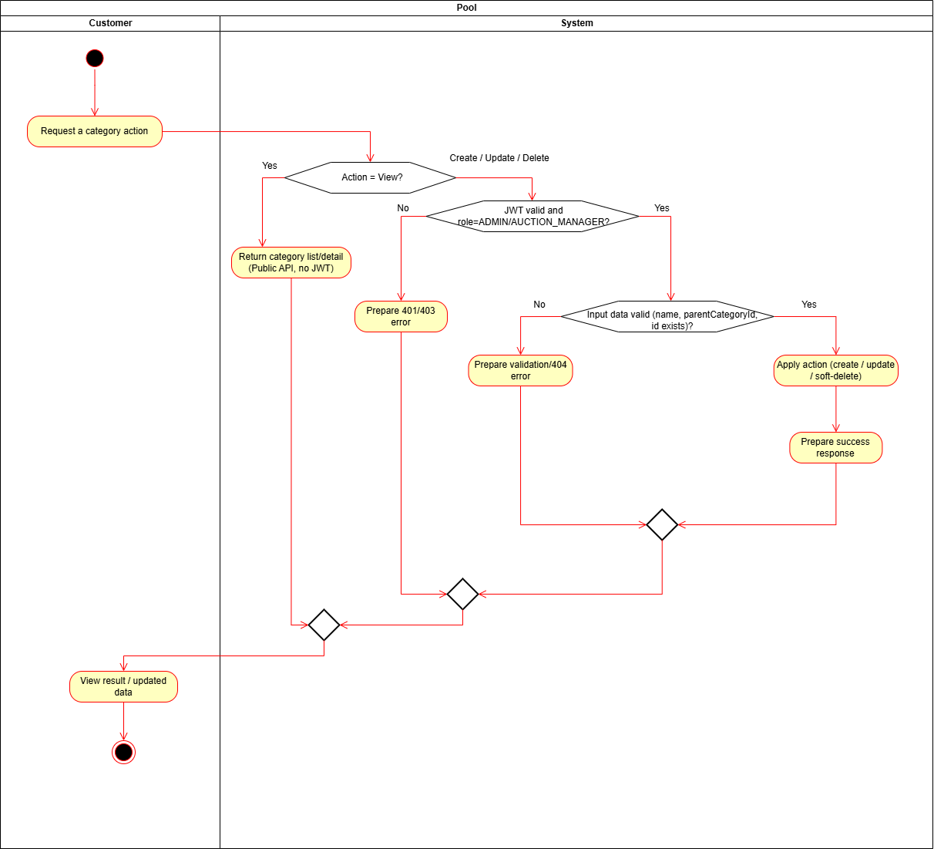
Figure I-22 Activity diagram modeling event flows of use case category management
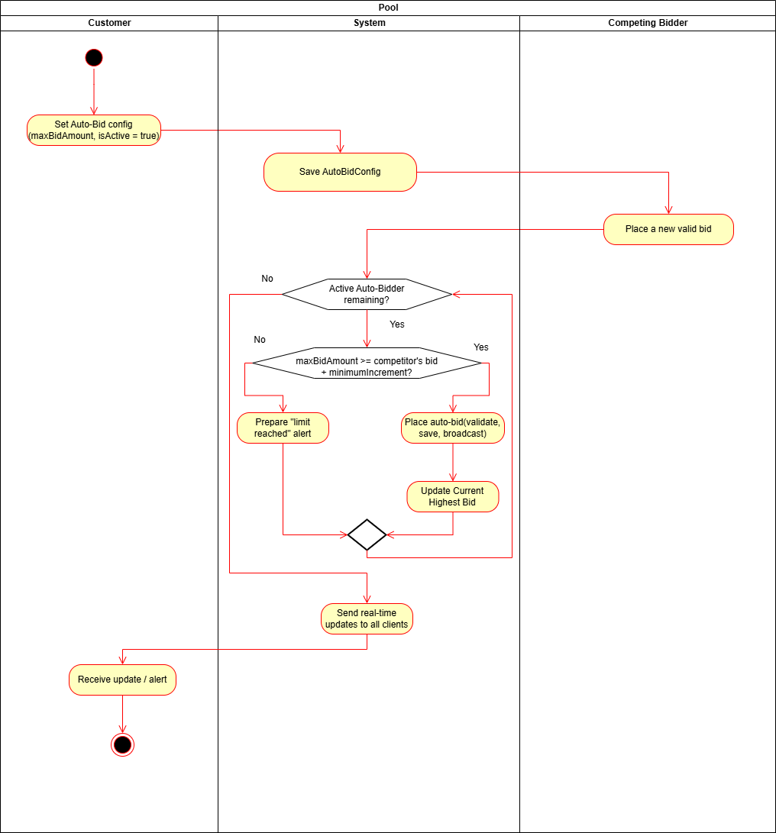
Figure I-23 Activity diagram modeling event flows of use case auto-Bid
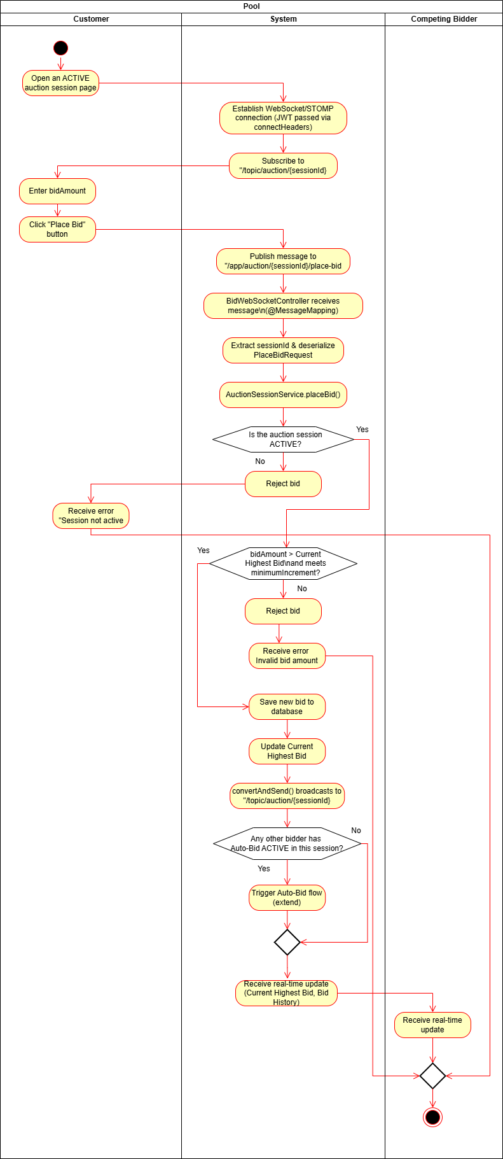
Figure I-24 Activity diagram modeling event flows of use case place Bid

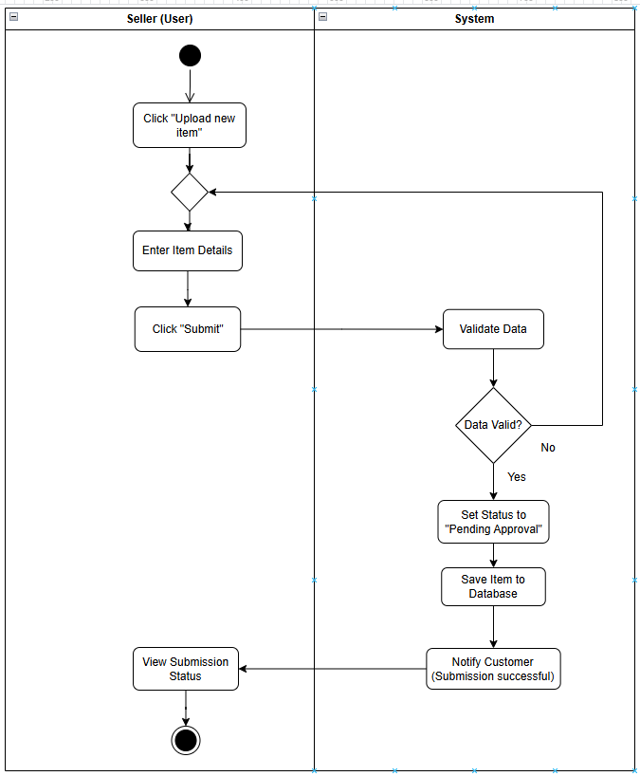
Figure I-25 Activity diagram modeling event flows of use case Upload Item

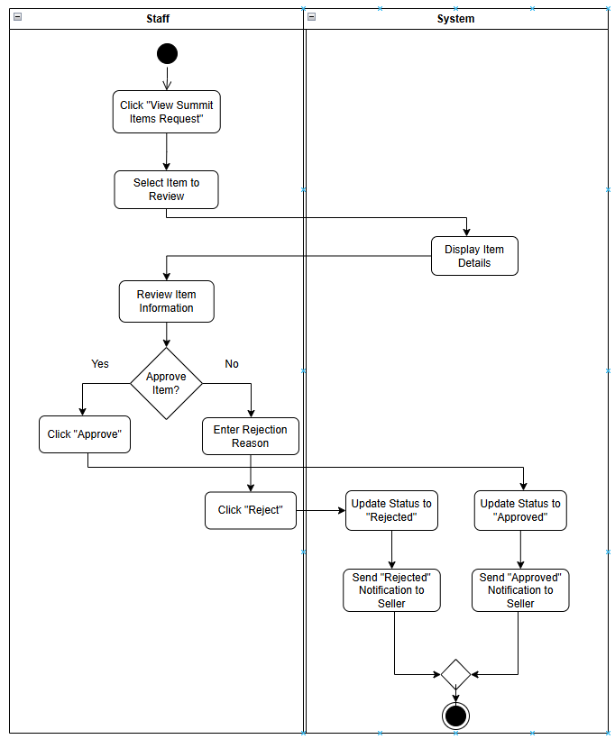

Figure I-26 Activity diagram modeling event flows of use case Approve Item
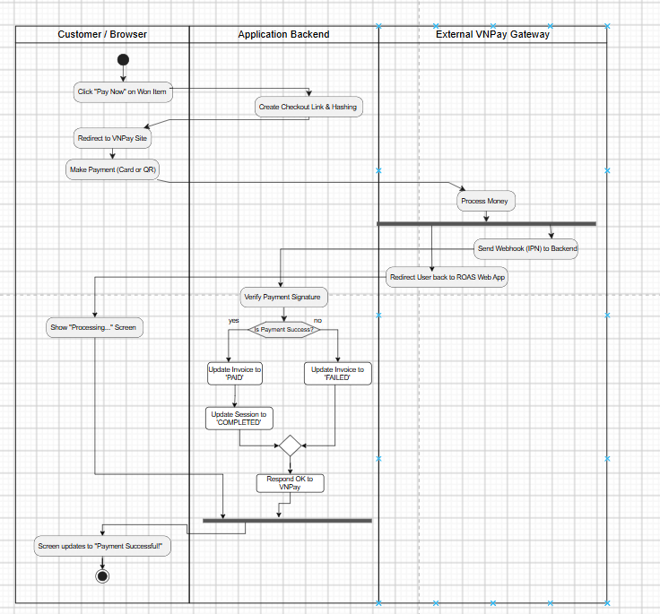

Figure I-27 Activity diagram modeling event flows of use case Customer Payment Processing
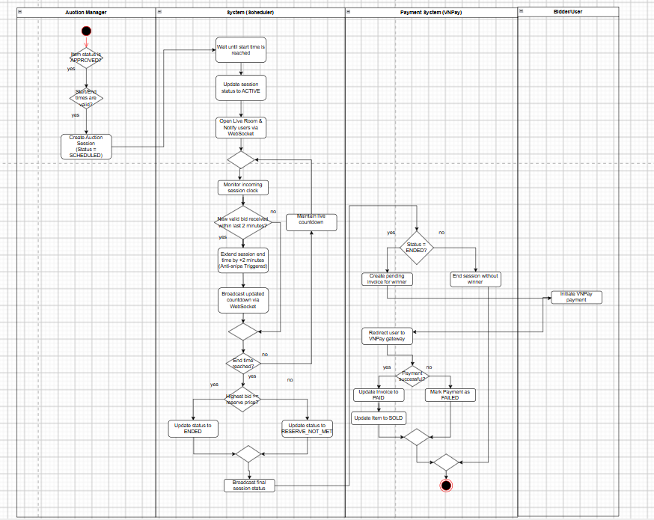
Figure I-28 Activity diagram modeling event flows of use case Auction Session
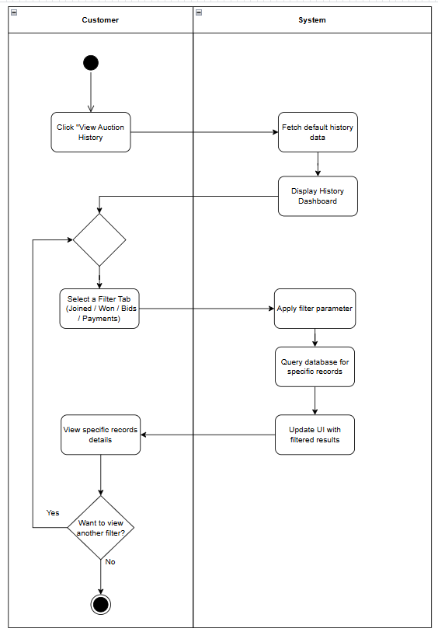
Figure I-29 Activity diagram modeling event flows of Auction History

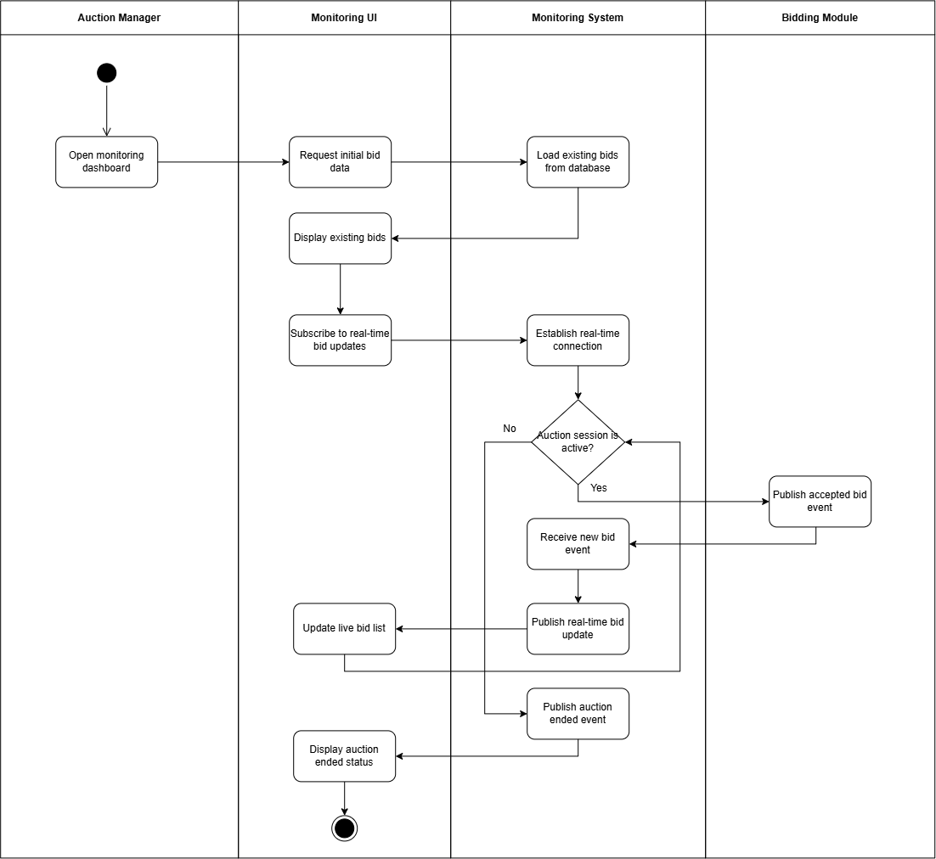
Figure I-30 Activity diagram for Monitor Live Bidding Activity

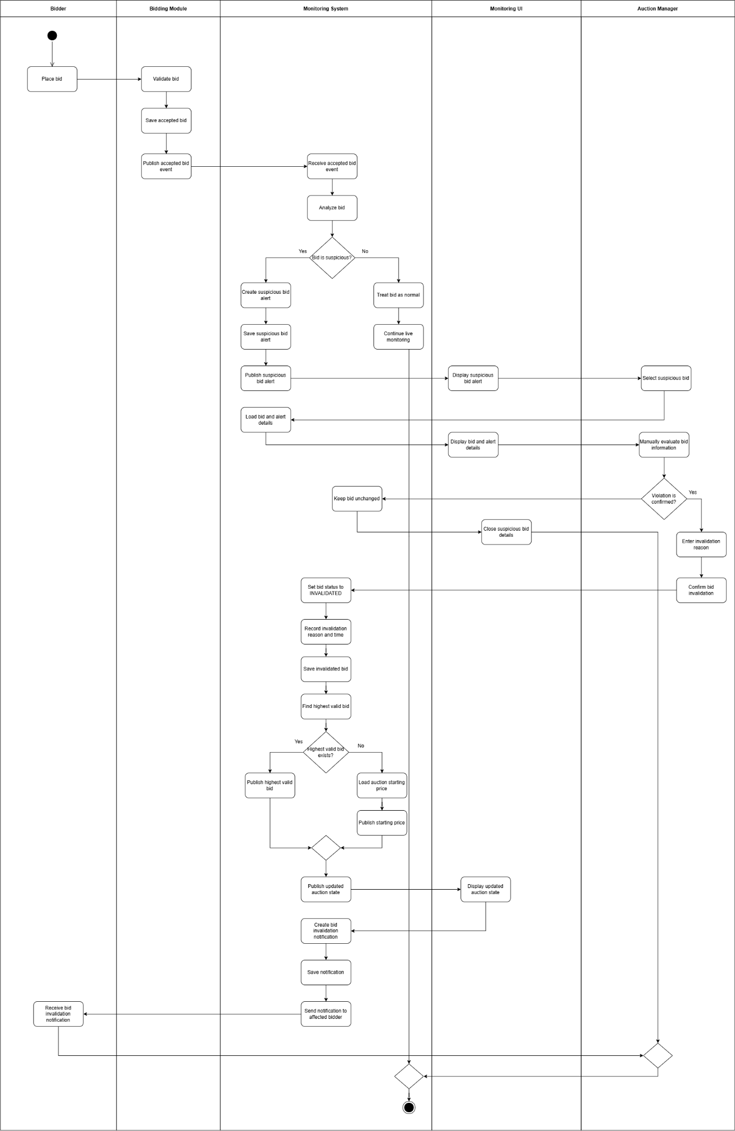
Figure I-31 Activity diagram for Detect and Moderate Suspicious Bid

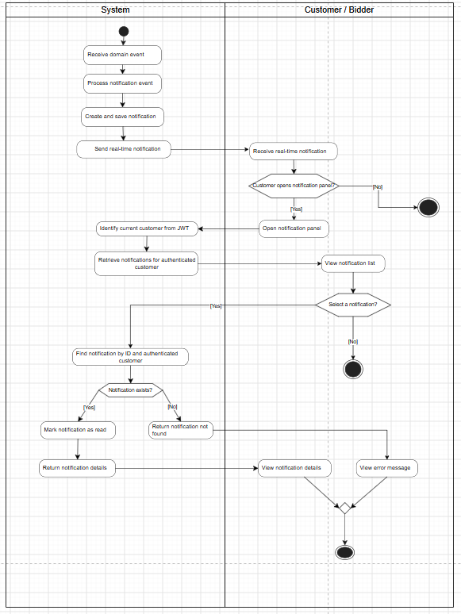
Figure I-32 – Activity Diagram: Notification System
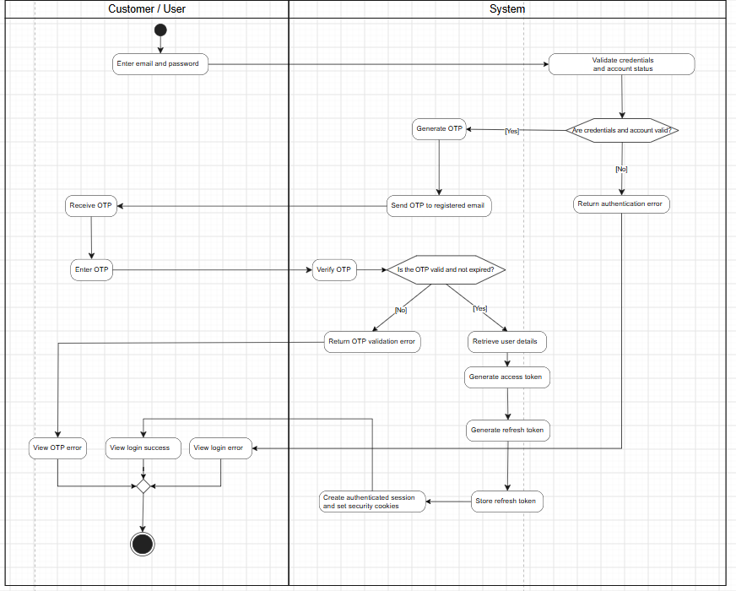
  - Figure I-33 – Activity Diagram: Secure Authentication with OTP and Token Generation

Data Requirements
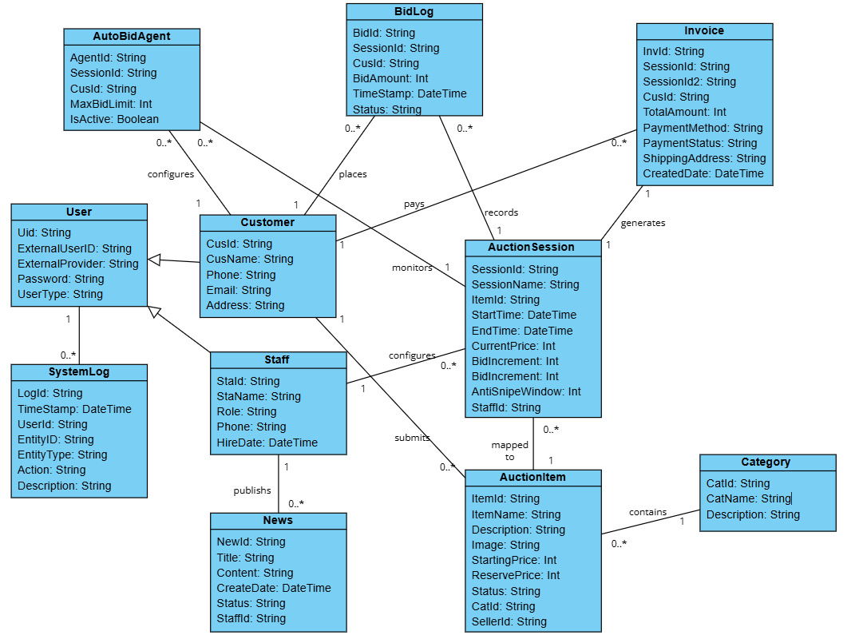
Figure I-34 Entity class diagram modeling data requirements

The class diagram in Figure 1.14 specifies the entity classes and the relationships between them, clearly representing the system's data requirements. Each entity class in the diagram represents a domain concept, relationships between entities are associations, aggregations, composition, or inheritances. To provide detailed information about these entity classes, they are all thoroughly described in Table 1-7, which is known as the data dictionary. This data dictionary serves as an explanatory tool, offering detailed descriptions of each class’s attributes, data types, and relationships, helping the reader better understand the data structure and system requirements.

Table I-7 Data Description (Data dictionary)

Name | Data Type | Length | Description
Category |  |  | Product category
CatId | String | 20 | Auction Category Identifier
CatName | String | 50 | Auction Category Name
Description | String | 500 | Description of auction category
AuctionItem |  |  | Auction Item details
ItemId | String | 20 | Auction Item Identifier
ItemName | String | 50 | Auction Item Name
Status | String | 20 | Lifecycle state of item (Pending, Approved, Rejected, Auctioned)
Description | String | Max | Detailed technical/historical description of the item
Image | String | 50 | The visual representation of the product. It stores information about an image file that shows what the product looks like.
StartingPrice | Int |  | The opening price required to start bidding for this item
ReservePrice | Int |  | The minimum hidden price the seller is willing to accept
CatId | String | 20 | Associated Category Identifier (Foreign Key)
SellerId | String | 20 | Associated Customer Identifier who owns the asset (Foreign Key)
User |  |  | Users of the system
Uid | String | 20 | User identifier
ExternalUserID | String | 50 | Unique identifier for users from third-party social log-ins (Google, Facebook)
ExternalProvider | String | 500 | The name of the authentication provider (e.g., "Google", "Facebook")
Password | String | 50 | Hashed password of the user for native authentication
UserType | String | 50 | Categorizes users based on core access levels (Customer, Staff, Admin)
Customer |  |  | Bidders and Sellers
CusId | String | 20 | Customer Identifier (Inherited from Uid)
CusName | String | 50 | Full Name of the customer
Phone | String | 15 | The contact telephone number for the customer
Email | String | 50 | The unique email address of the customer
Address | String | 500 | The baseline registration physical address of the customer
Staff |  |  | Employees & Managers
StaId | String | 20 | The name or description of a discount applied to orders or products.
StaName | String | 50 | The monetary value or percentage of the discount applied to an order or product
Role | String | 20 | It indicates whether the discount amount is represented as a percentage or a fixed monetary value
Phone | String | 15 | The date and time when a particular record or action becomes effective
EndDate | DateTime |  | The date and time when a particular record or action expires or is no longer effective
AuctionSession |  |  | Live bidding rooms
SessionId | String | 20 | Unique Auction Session Identifier
SessionName | String | 100 | Display title of the live auction event room
ItemId | String | 20 | Associated Approved Item Identifier (Foreign Key)
StartTime | DateTime |  | Scheduled timestamp to open the room for active bids
EndTime | DateTime |  | Scheduled timestamp to officially close the bidding room
CurrentPrice | Int |  | The highest active bid value recorded in real time
BidIncrement | Int |  | The mandatory minimum price step increase for successive bids
Status | String | 20 | Current room state (Scheduled, Active, Postponed, Cancelled, Closed)
AntiSnipeWindow | Int |  | Duration in seconds to automatically extend session if a late bid occurs
StaffId | String | 20 | Identifier of the Auction Manager who set up the session
BidLog |  |  | Bidding transactions
BidId | String | 20 | Unique Bidding transaction Identifier
SessionId | String | 20 | Target Auction Session Identifier (Foreign Key)
CusId | String | 20 | Identifier of the Bidder who placed the bid (Foreign Key)
BidAmount | Int | StaffId | The exact monetary value offered by the bidder
TimeStamp | DateTime | StaffId | Precise system log timestamp when the bid transaction hit the server
Status | String | 20 | Bid evaluation status (Valid, Outbid, Winning, Rejected)
AutoBidAgent |  |  | Robotic bidding agents
AgentId | String | 20 | Unique Automated Bid Agent Identifier
SessionId | String | 20 | Associated Active Auction Session Identifier (Foreign Key)
CusId | String | 20 | Identifier of the Bidder owner who set up the bot (Foreign Key)
MaxBidLimit | Int |  | Maximum financial ceiling allowed for the bot to automatically bid
IsActive | Boolean |  | Flag determining whether the proxy bidding engine is active
Invoice |  |  | Winning settlement bills
InvId | String | 20 | Unique Invoice / Settlement Identifier
SessionId | String | 20 | Associated Closed Auction Session Identifier (Foreign Key)
CusId | String | 20 | Identifier of the winning Customer (Foreign Key)
TotalAmount | Int |  | Final hammer price plus any applicable platform/shipping fees
PaymentMethod | String | 30 | Gateway utilized by customer (Credit Card, Banking Link, E-Wallet)
PaymentStatus | String | 20 | Transaction status (Pending, Completed, Refunded, Cancelled)
ShippingAddress | String | 255 | Delivery address specified by the winner for asset physical transit
CreatedDate | DateTime |  | Timestamp indicating when the settlement ledger was initialized
News |  |  | Articles & Announcements
NewId | String | 20 | News/Announcement identifier
Title | String | 255 | Title header of the published marketing or system article
Content | String | Max | Core body text/HTML media elements of the news entry
CreateDate | DateTime |  | Dynamic creation date of the post
Status | String | 20 | Visibility status (Enabled, Disabled, Draft)
StaffId | String | 20 | Staff identifier of the author who created the news entry
SystemLog |  |  | Audit trails
LogId | String | 20 | Unique system security log Identifier
TimeStamp | DateTime |  | Precise execution timestamp when the system log entry was captured
UserId | String | 20 | The identifier of the User (Staff/Customer) who executed the action
EntityID | String | 20 | Affected target profile instance ID (e.g., SessionId, ItemId)
EntityType | String | 50 | Type categorization of data affected (e.g., "Session", "Item", "User")
Action | String | 20 | Type categorization of data affected (e.g., "Session", "Item", "User")
Description | String | 225 | Detailed audit text tracing parameters or reasons behind the transaction

Analysis models

Sequence diagrams

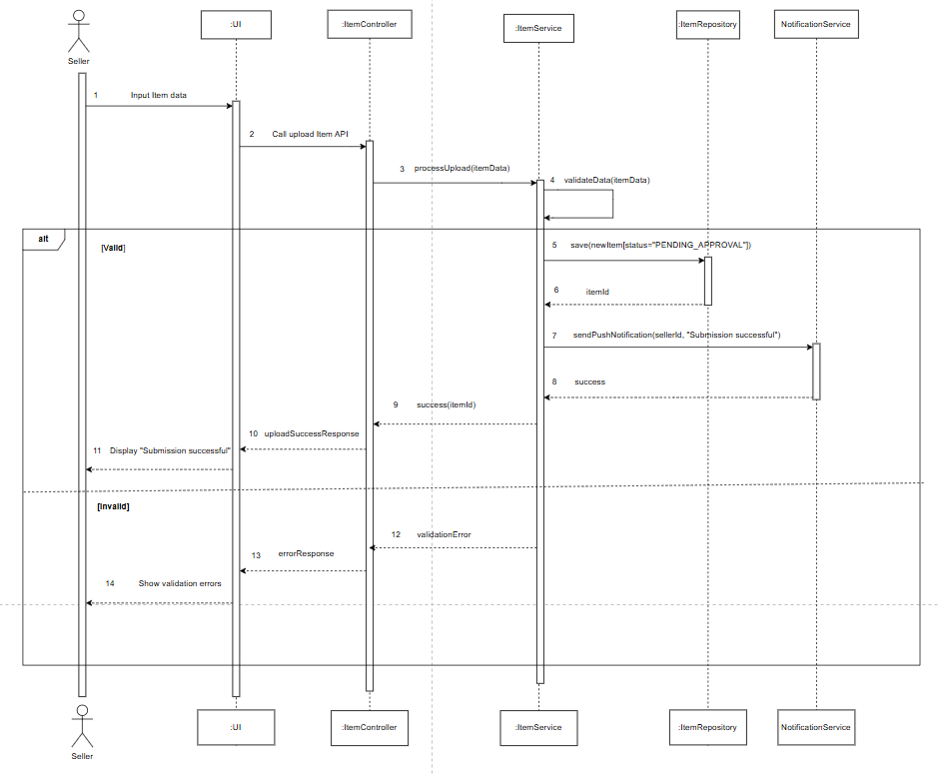
Figure II-1 – Sequence Diagram: Submit Auction Item (UC-03)
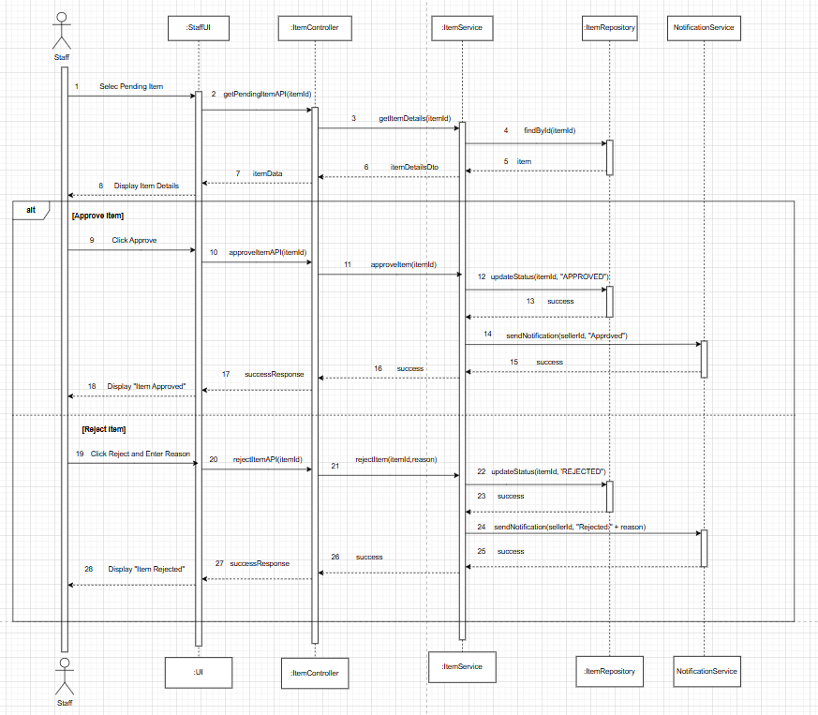
Figure II-2 – Sequence Diagram: Approve Auction Item (UC-04)

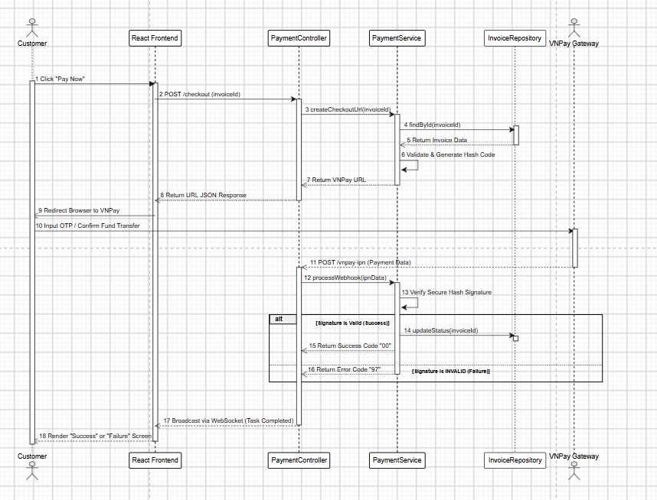
Figure II-3 – Sequence Diagram: Customer Payment

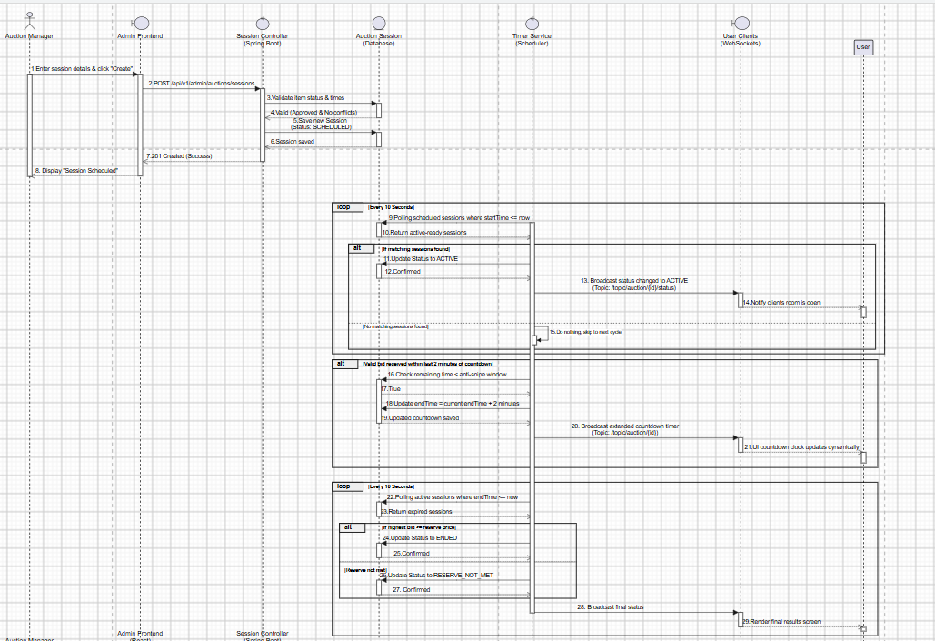
Figure II-4 – Sequence Diagram: Auction Session
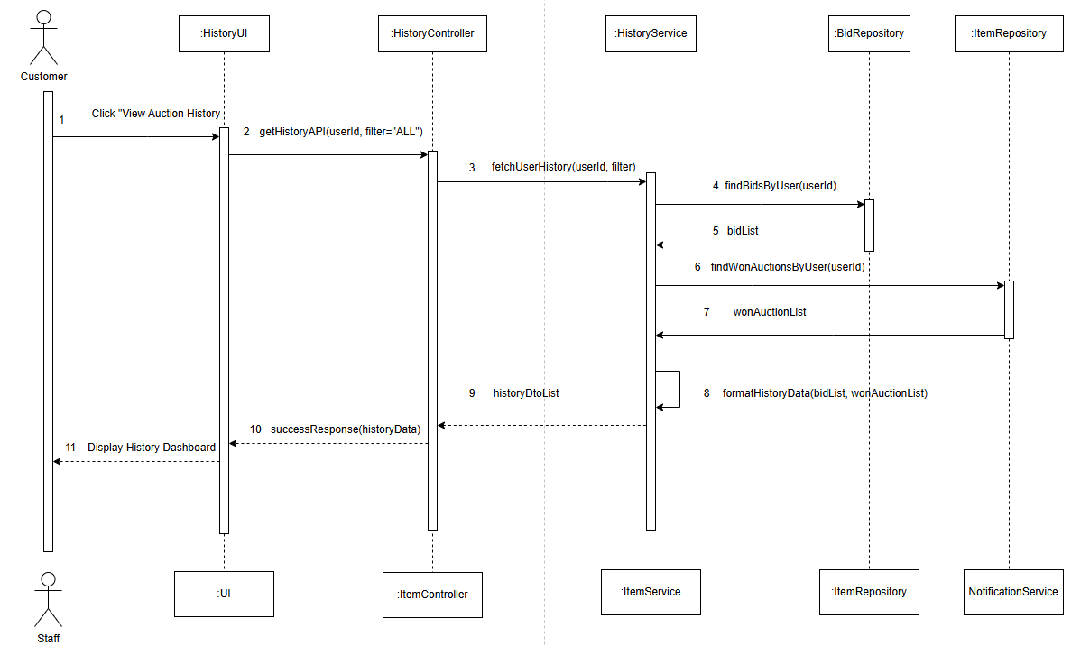
Figure II-5 – Sequence Diagram: View Auction History
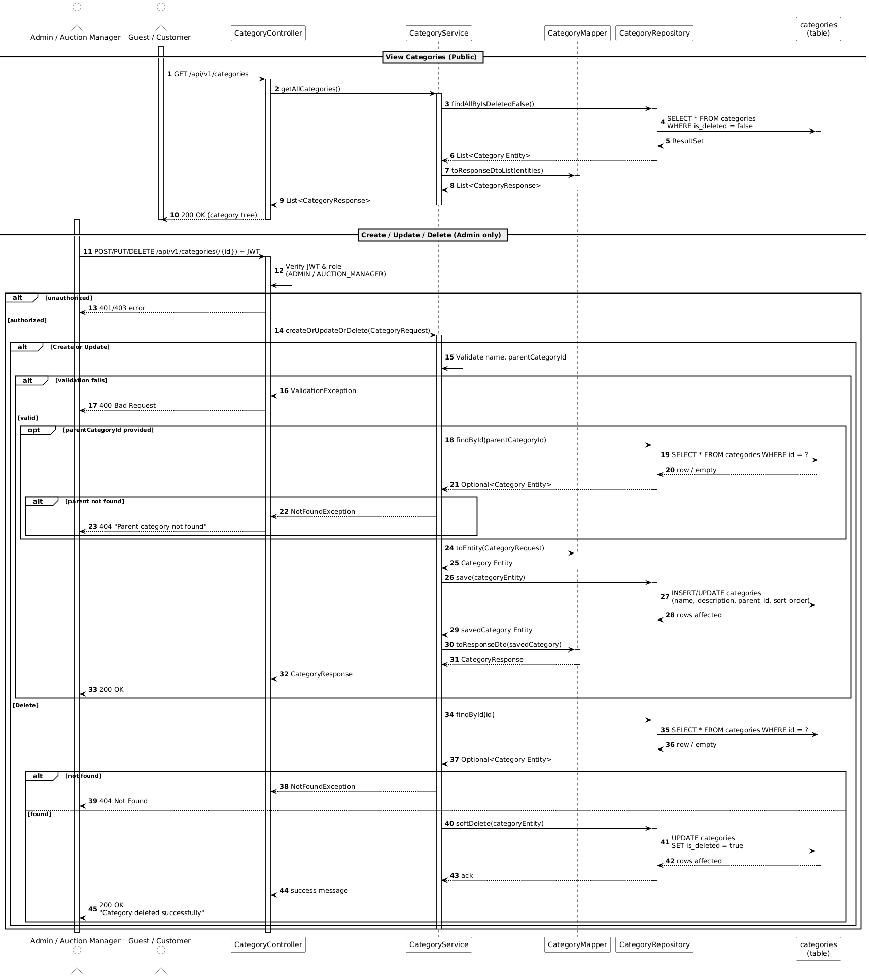
Figure II-6 – Sequence Diagram: Category Management

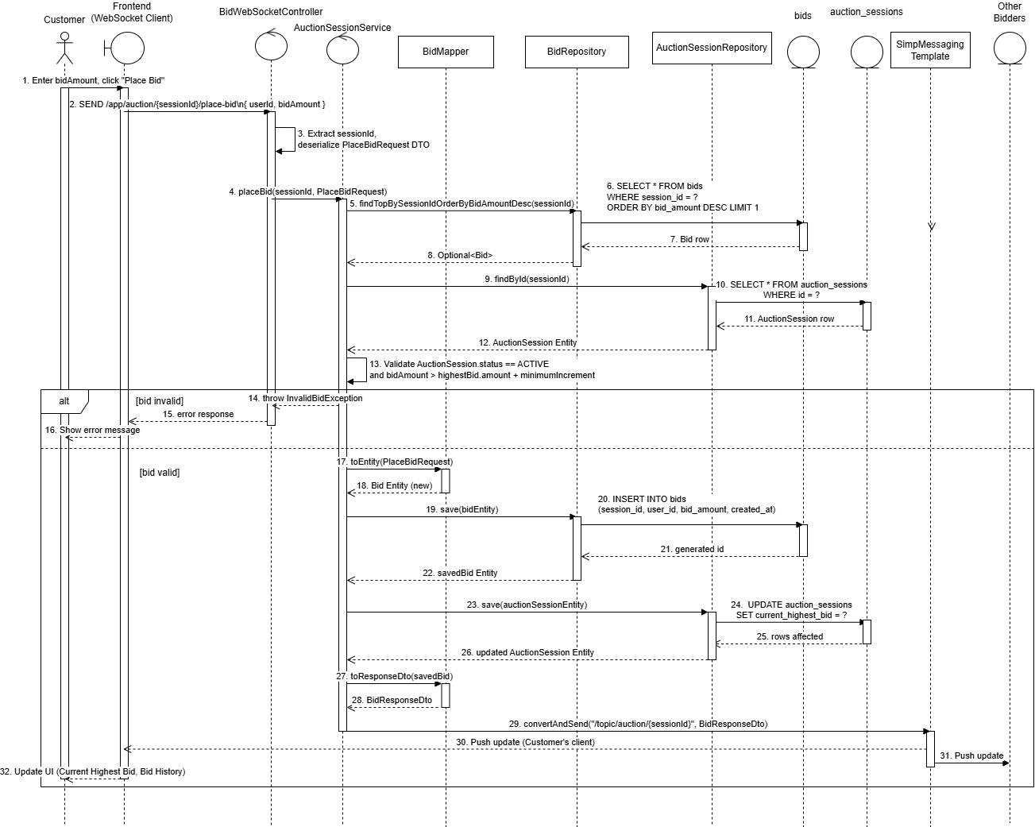
Figure II-7 – Sequence Diagram:Place Bid
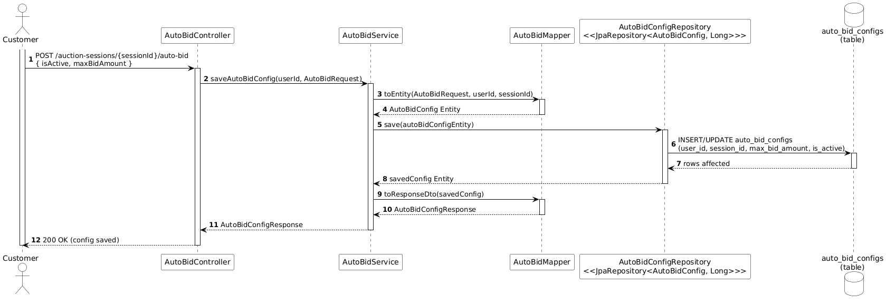
Figure II-8 – Sequence Diagram: AutoBid Configuration
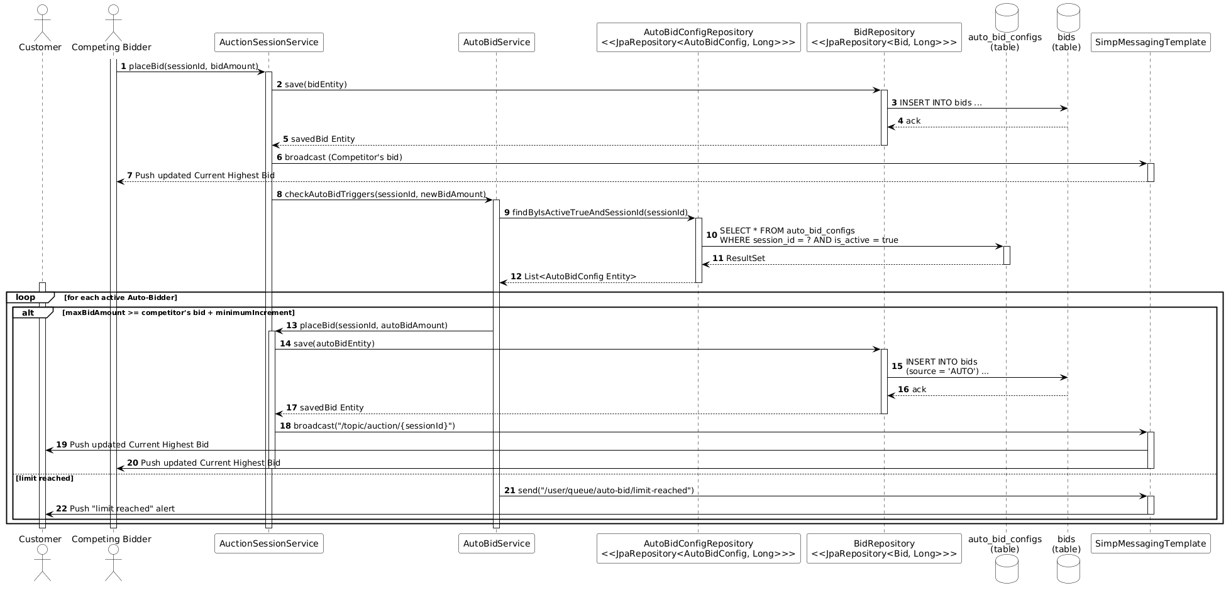
Figure II-9 – Sequence Diagram: AutoBid Execution

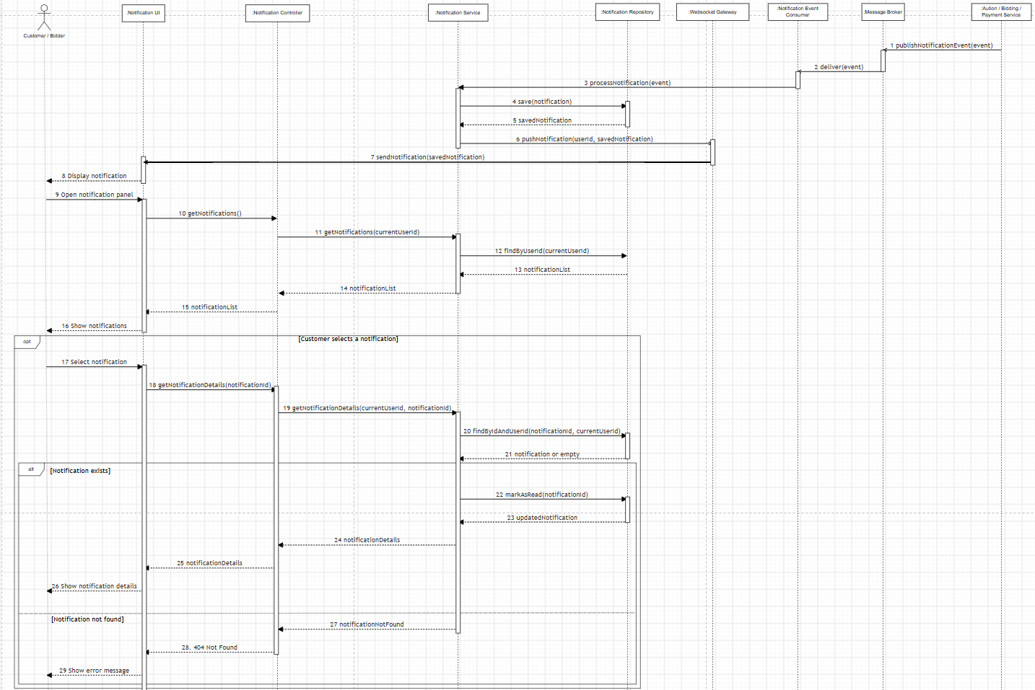
Figure II-10 – Sequence Diagram: Notification System
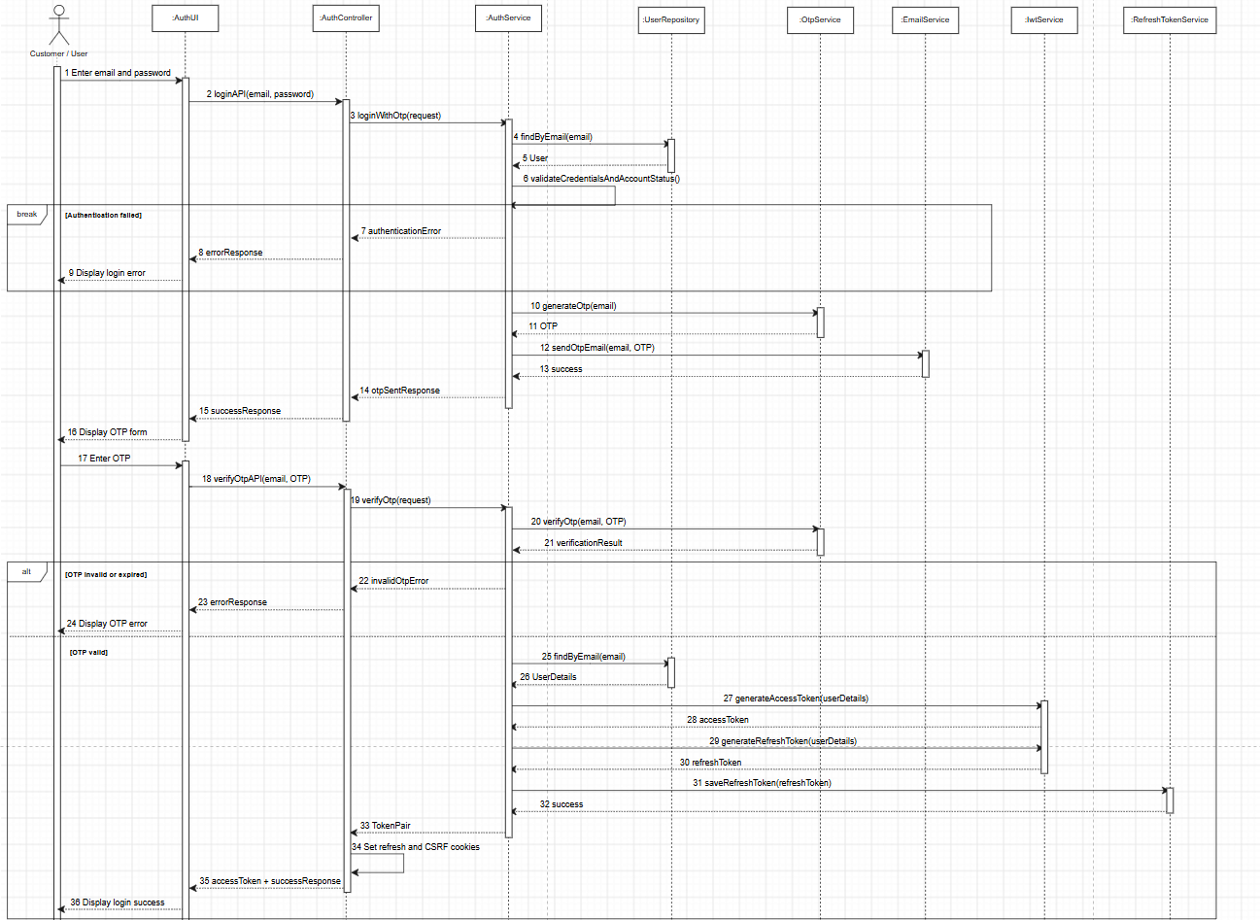
Figure II-11 – Sequence Diagram: Secure Authentication with OTP and Token Generation
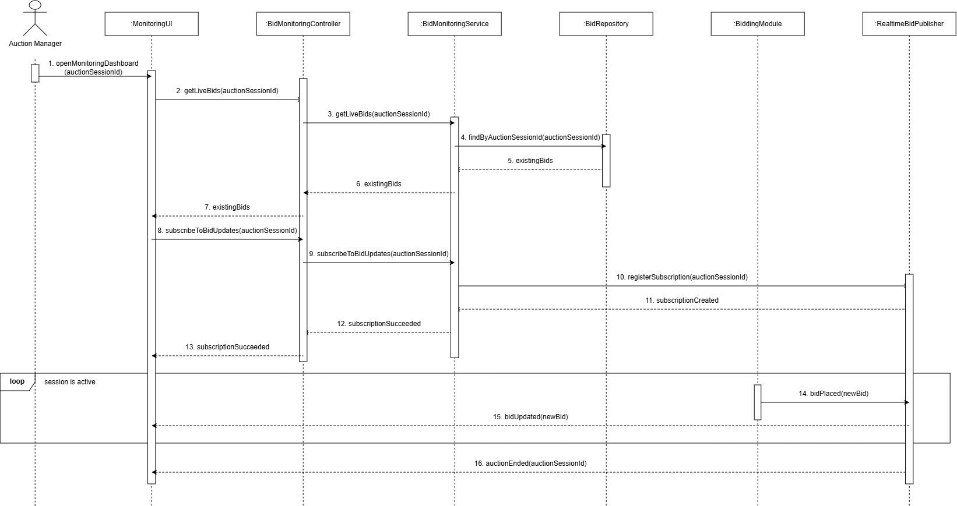
Figure II-12 – Sequence Diagram: Monitor Live Bidding Activity
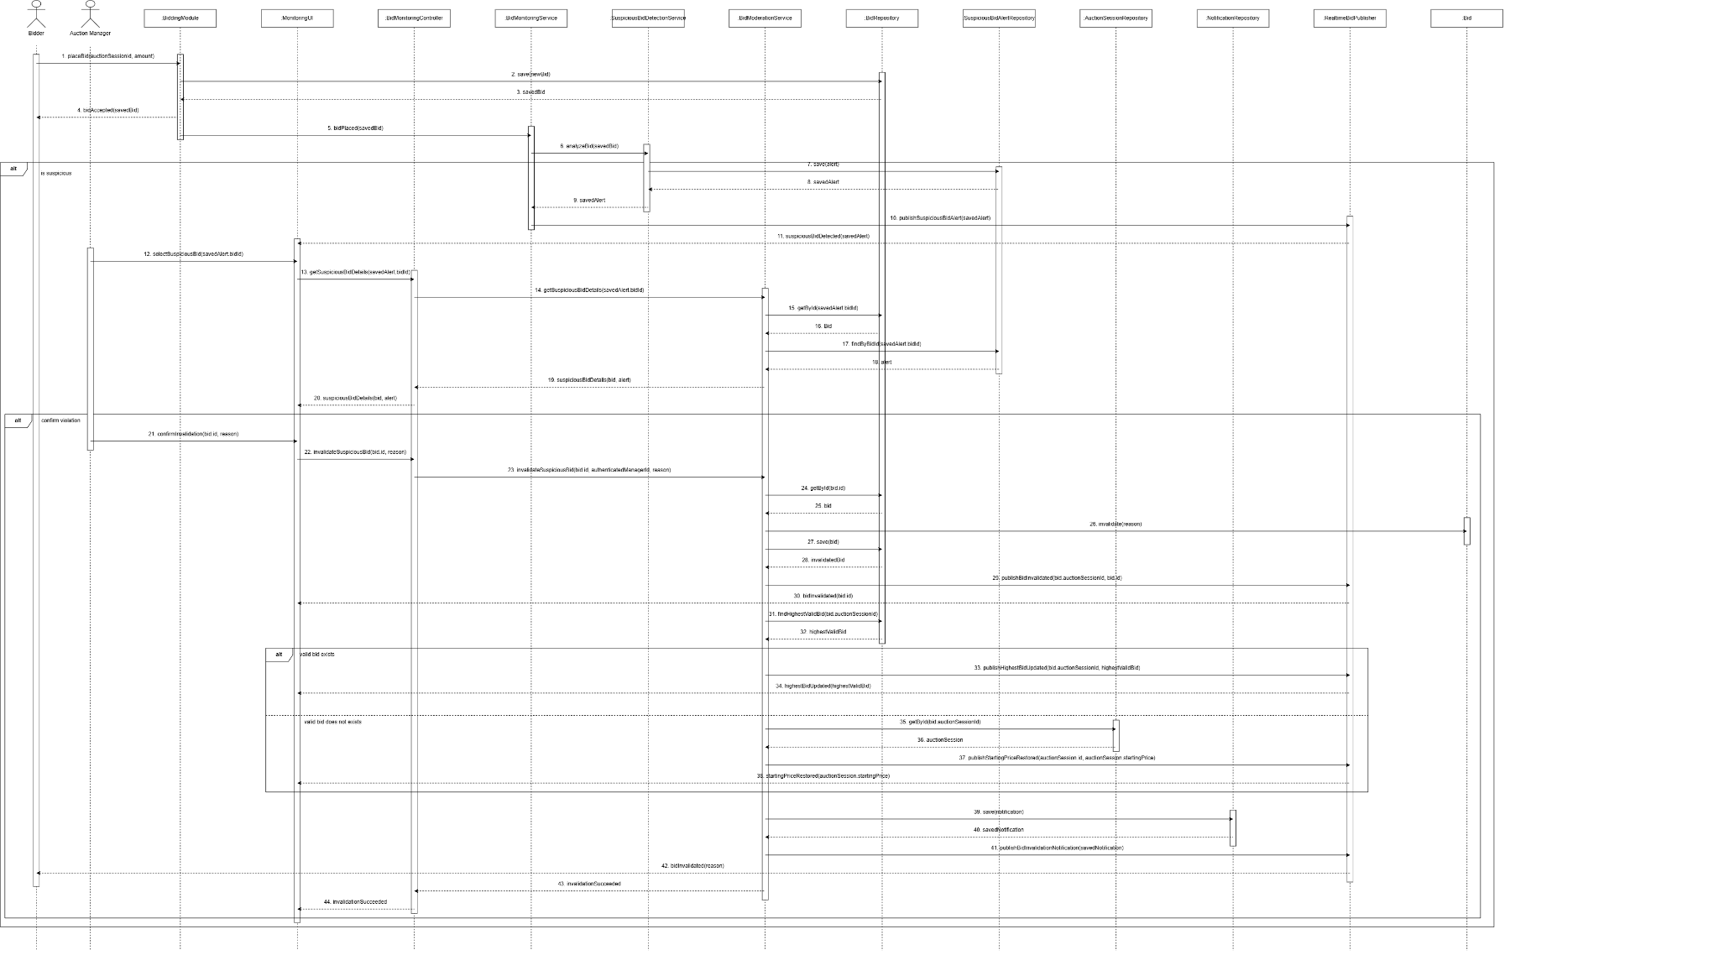
Figure II-13 – Sequence Diagram: Detect and Moderate Suspicious Bid

State machine diagram
In object-oriented analysis and design, a finite state machine models the dynamic lifecycle of critical system entities. It illustrates the states an object can exist in and the specific events that trigger transitions between these states. For the Real-time Online Auction System (ROAS), state machine diagrams are utilized to define the complex lifecycles of key business entities such as AuctionSession, AuctionItem, and PaymentTransaction. These diagrams demonstrate how objects react to system events (e.g., an auction starting, a bid being placed, or a payment being verified) and ensure that business rules are enforced during state changes. The transitions depicted here are synchronized with the business logic workflows defined in the corresponding sequence diagrams.
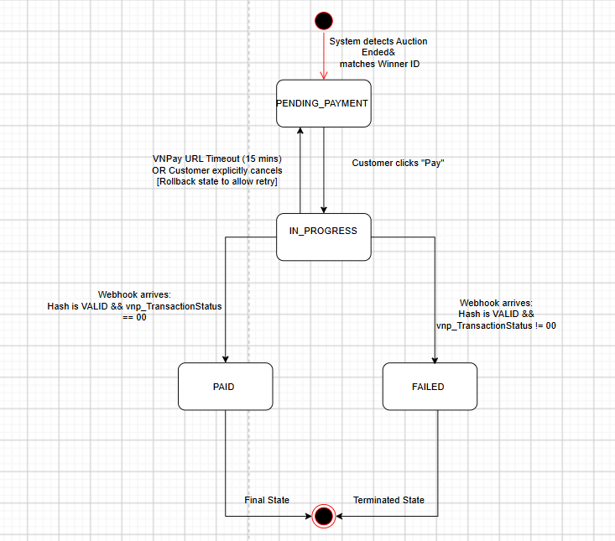

Figure II-14 Lifecycle States of Customer Payment Transaction
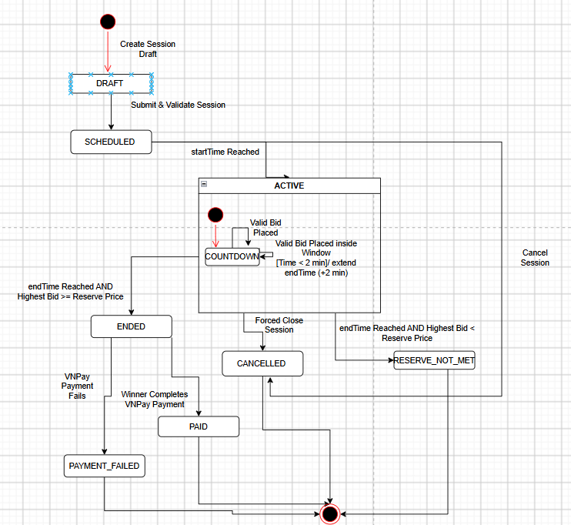
Figure II-15: State Machine Diagram for Auction Session Entity

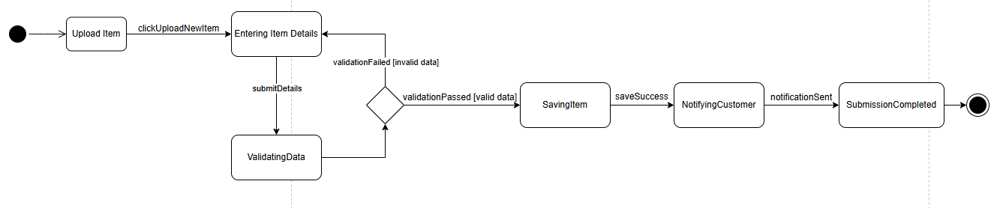
Figure II-16: State Machine Diagram for Upload Auction Item
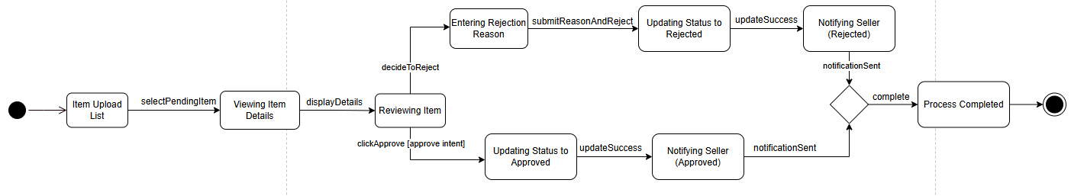
Figure II-17: State Machine Diagram for Approve Auction Item

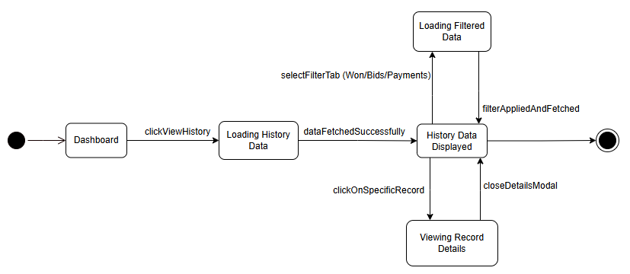
Figure II-18: State Machine Diagram for View Auction History

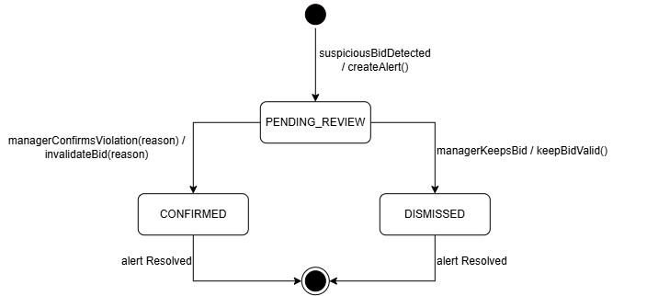
Figure II-19: State Machine Diagram for Suspicious Bid Alert

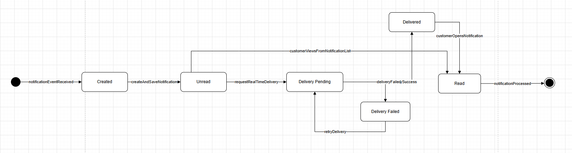
Figure II-20: State Machine Diagram for Notification

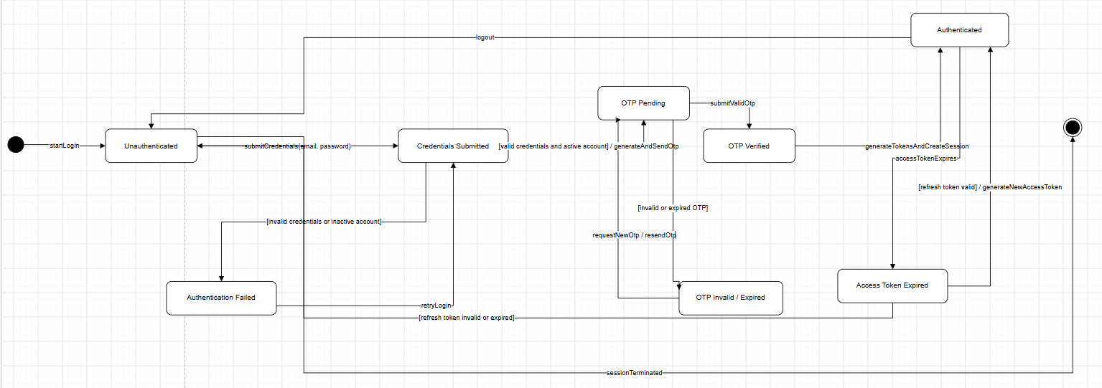
Figure II-21: State Machine Diagram for Authentication

Design specification

Integrated Communication Diagrams
To transition from requirement analysis to system architecture, the platform's core use case interactions are synthesized into Integrated Communication Diagrams.
Because an online auction platform handles both standard transactional administrative workflows and asynchronous, high-concurrency real-time operations, the system is clean-cut and decomposed into two primary operational subsystems:
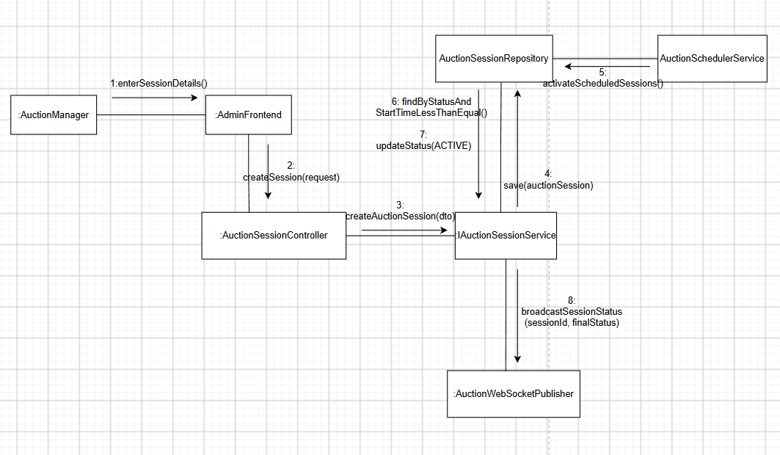Figure III-1. Auction Session Integrated Communication Diagram
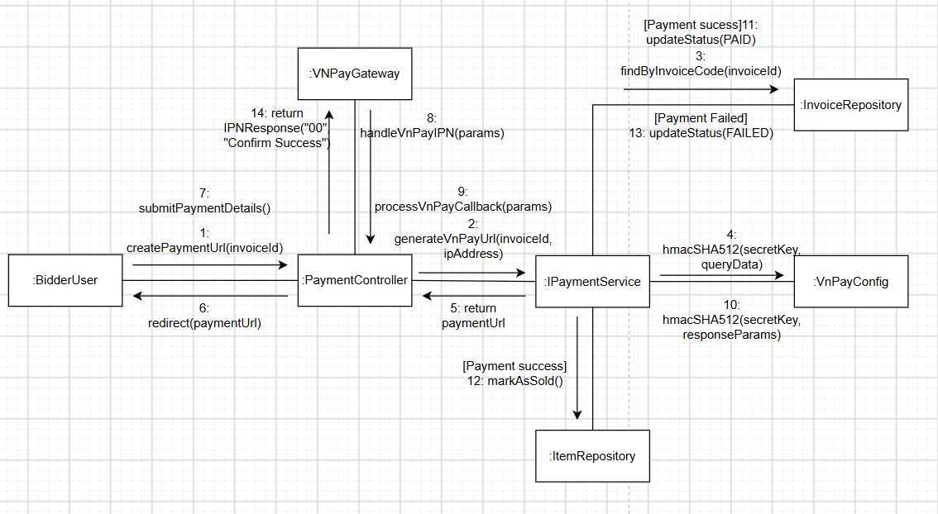
Figure III-2. Customer Payment Integrated Communication Diagram
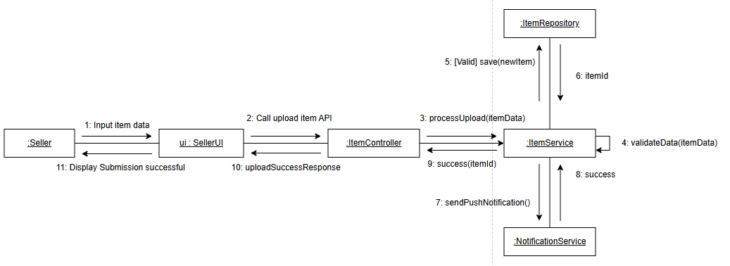
Figure III-3. Customer Upload Auction Item Communication Diagram
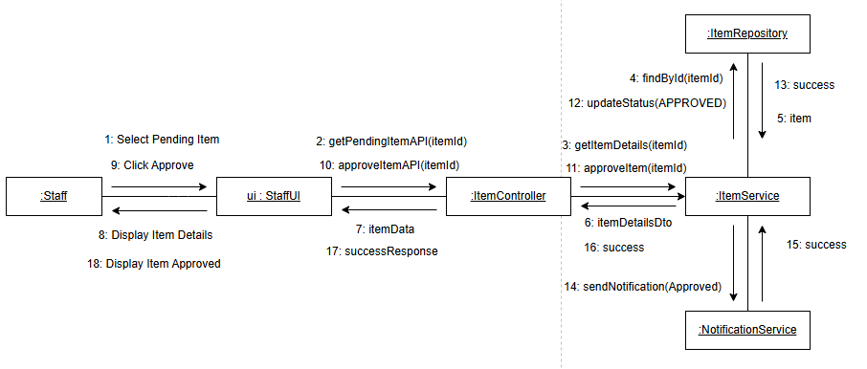
Figure III-4. Staff Approve Auction Item Communication Diagram
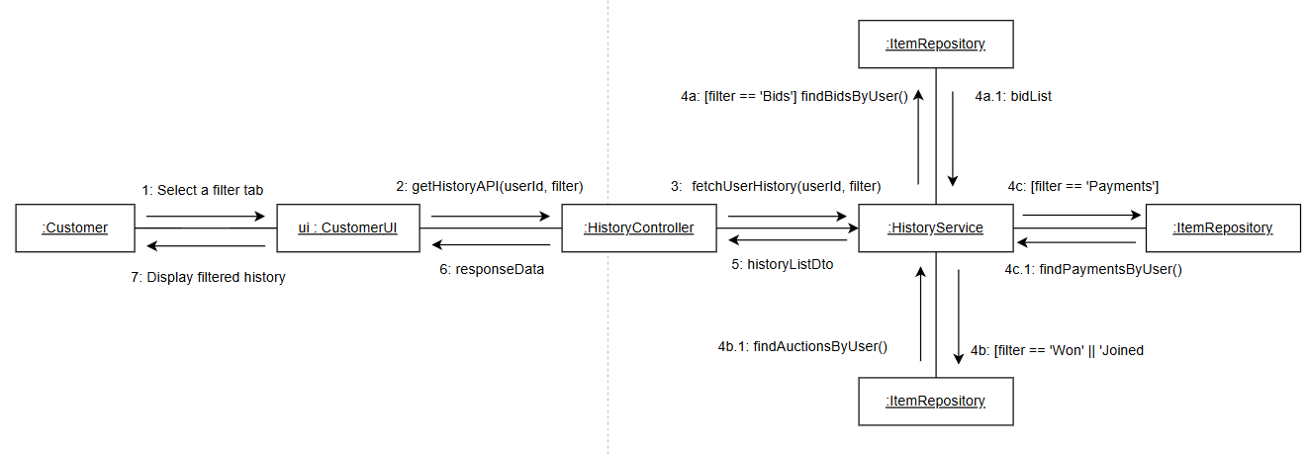
Figure III-5. Auction History Communication Diagram
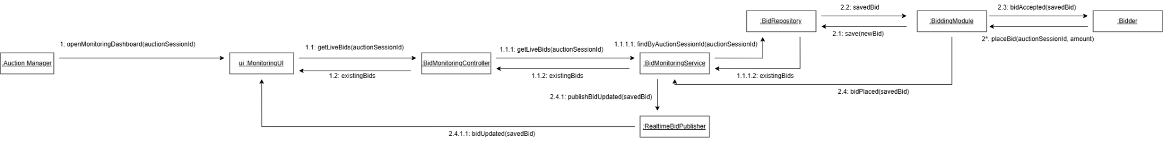
Figure III-6. Monitor Live Bidding Activity Communication Diagram
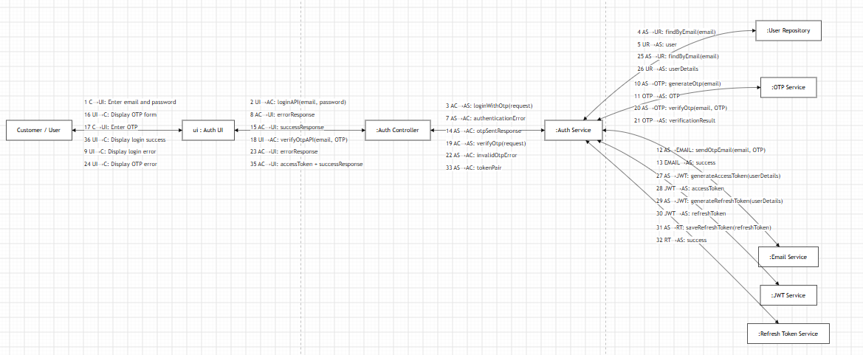
Figure III-7. Authentication Communication Diagram 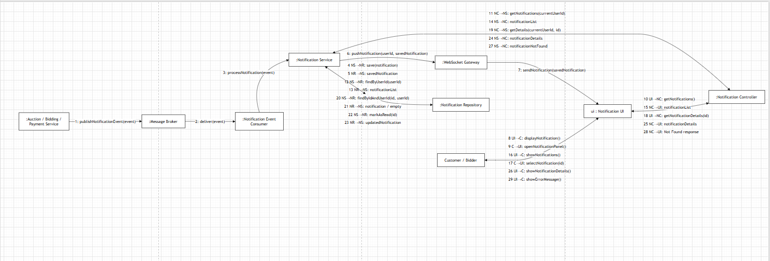
Figure III-8. Notification Communication Diagram

III.1.1. Subsystem 1: Auction Item & Session Management

This section covers features F08, F09, F10, and F14 (Staff and Admin workflows).

Component Mapping Table

Component Name | Type | Description
Staff / Manager | Actor | The user triggering the management actions.
:ManagerDashboardView | Boundary | The main staff control panel UI.
:ItemApprovalView | Boundary | Interface for inspecting and approving seller submissions.
:SessionManagementView | Boundary | Interface to schedule, extend, or cancel live sessions.
:AuctionController | Control | Routes administrative traffic and executes validation logic.
:ItemService | Entity/Service | Manages the state and persistence of auction items.
:AuctionSessionService | Entity/Service | Manages scheduling, durations, and room states.

Message Sequence Flow
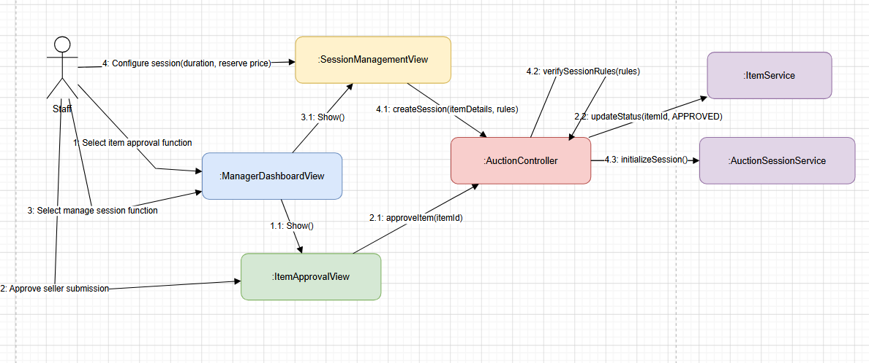

Figure III-1. Auction Administration Integrated Communication Diagram

Seller Item Submission Approval Loop

1: Select item approval function → Passed from Auction Manager to :ManagerDashboardView.

1.1: Show() → Invoked to render and display the :ItemApprovalView interface.

2: Review and Approve submission → Administrative action executed by the staff member on :ItemApprovalView.

2.1: approveItem(itemId) → The routing action is dispatched to the central :AuctionController.

2.2: updateStatus(itemId, APPROVED) → Forwarded to :ItemService to permanently modify the asset state in the database.

Auction Session Scheduling & Management Loop

3: Select manage session function → Passed from Auction Manager to :ManagerDashboardView.

3.1: Show() → Invoked to render and display the :SessionManagementView interface.

4: Configure session properties (duration, reserve price) → Configuration properties submitted via :SessionManagementView.

4.1: createSession(itemDetails, rules) → Dispatched as a session initialization request to :AuctionController.

4.2: verifySessionRules(rules) → A self-invocation validation loop on the controller to guarantee data integrity against business policies.

4.3: initializeSession() → Handed off to :AuctionSessionService to schedule the live public-facing room.

III. 2.2. Subsystem 2: Real-Time Bidding & Auto-Bid Engine
This subsystem integrates ultra-high concurrency use cases that demand instantaneous operations: joining live auction rooms, placing manual bids (F02), and executing automated proxy-bidding agents (F03).
Component Mapping Table

Component Name | Component Type | System Responsibility Description
Bidder | Actor | The end-user placing manual monetary bids inside live rooms.
:LiveAuctionRoomView | Boundary (UI) | The client-side live interface rendering dynamic timers and ongoing price updates.
:WebSocketGateway | Boundary (Network) | Persistent duplex connection pipeline streaming event frames down to clients.
:BiddingEngineController | Control | Low-latency memory controller evaluating incoming fast bid packets.
:RedisCacheService | Entity / Cache | In-memory atomic data structure managing thread locks to avert race conditions.
:MessageBrokerService | Infrastructure | Asynchronous message network (Kafka/RabbitMQ) ingesting valid transaction events.
:AutoBidAgentEngine | System Actor | The internal rule-based background processing agent placing automated proxy bids.
:AuctionSessionService | Entity / Service | Persistent disk layer syncing event logs to the primary database asynchronously.

Message Flow Sequence
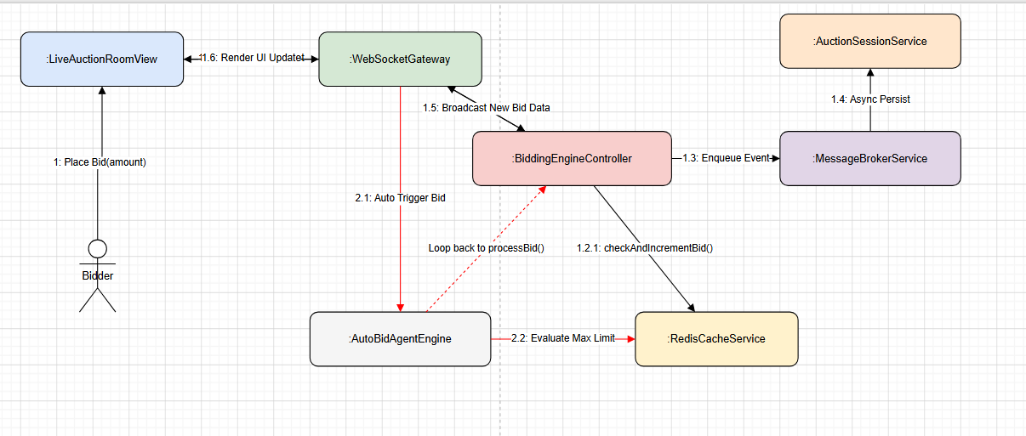

Figure III-2.Real-Time Auction Bid Processing Communication Diagram
Manual Bidding Loop

1: Place Bid (amount) → Action fired from Bidder to :LiveAuctionRoomView.

1.1: Forward Bid Packet → Streamed instantly through the open bidirectional pipe to :WebSocketGateway.

1.2: processBid(bidderId, sessionId, amount) → Directed straight into the memory-bound :BiddingEngineController.

1.2.1: checkAndIncrementBid() → Evaluated atomically within :RedisCacheService to verify that the incoming bid outperforms the concurrent highest price, resolving race conditions instantly without hitting disk limits.

1.3: Enqueue Event → The validated winning transaction event is pushed into the :MessageBrokerService queue partitions.

1.4: Async Persist → A worker consumer reads from the queue asynchronously and commits records via :AuctionSessionService to disk.

1.5: Broadcast New Bid Data → Concurrently, :BiddingEngineController pushes the state changes back out through the :WebSocketGateway.

1.6: Render UI Update → Client views update the price and user profiles instantly without performing a hard page reload (F02).

Auto-Bid Agent Execution Trigger

The moment step 1.5 broadcasts a higher current price, it awakens the proxy bidding thread.

2.1: Auto-Trigger Next Incremental Bid → Fired by :AutoBidAgentEngine for any outbid users configured inside that specific pool.

2.2: Evaluate Max Limit → Queries active values from :RedisCacheService / :AuctionSessionService to verify that the next calculated auto-increment does not break the user's preconfigured maximum ceiling budget limit (F03).

If validated, the workflow loops back into step 1.2 for atomic execution.

III.1.3. Architectural Design Justifications
Unlike a basic retail e-commerce system that relies on a synchronous, sequential request-response pipeline, sequential request-response pipeline (View -> Controller ->Service ->DB), this live auction communication architecture introduces these specialized patterns:
- Persistent Duplex Boundary Interfaces (:WebSocketGateway): Utilizing simple HTTP polling to get continuous price state would saturate server networks and create visual lag. WebSockets ensure notifications are pushed instantly down a single open socket connection.
- Decoupled Caching and Messaging Middleware: Interfacing high-volume operations (such as the intense traffic seen during last-second anti-snipe triggers) straight to a relational database creates thread blocks and memory exhaustion. Processing inputs atomically inside Redis and buffering operations through a message queue protects the database while providing a highly responsive experience.

System High-Level Design
Based on functional and non-functional requirements, the Online Auction Platform is designed using a Multi-Client / Distributed Service architecture, divided into three core subsystems to ensure scalability, fault isolation, and low latency:
- AuctionCustomer Subsystem: Subsystem for public consumers and bidders (Web/Mobile application servers handling authentication, browsing, history tracking, and payment flows).
- AuctionAdmin Subsystem: Subsystem for internal store staff and platform administrators (Web application servers dedicated to content management, catalogs, item approvals, and platform auditing statistics).
- AuctionRealTime Engine Subsystem: High-speed real-time ingestion layer (Stateful WebSocket gateways, in-memory caches, and message brokers processing high-frequency live bids and automated bot activities without blocking the core web servers).
All three subsystems connect to a centralized, highly available persistent Database Server layer and share transactional data over secured connection pools. The overall structural topology is illustrated through the following architectural views:
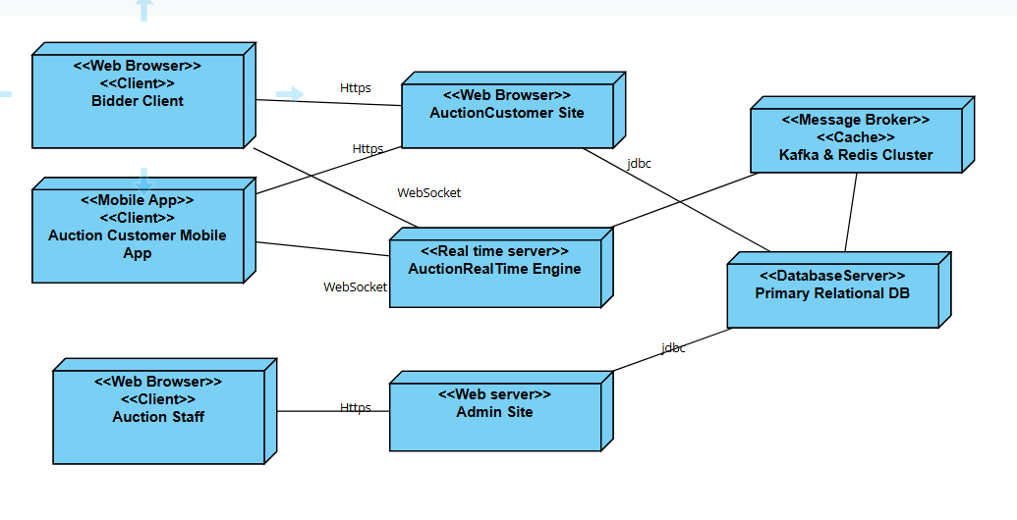
Figure III-3: Deployment Diagram for the Auction System Architecture

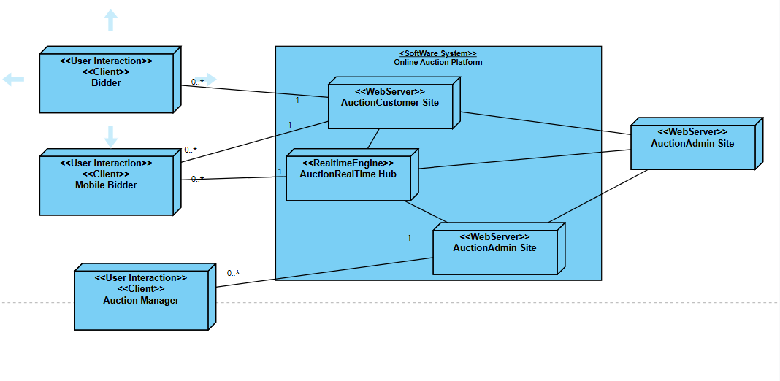
Figure III-4: Architecture Class Diagram for the Auction System Architecture

III.2.1 Component Architecture Descriptions
To provide clear visibility into the physical topology and software boundaries of the platform, the high-level design is mapped across three standard Unified Modeling Language (UML) structural viewpoints:

1. Deployment View (Figure III-3)
This diagram maps out the physical execution environments and hardware nodes hosting the platform:
- Client Nodes: Consumer Web/Mobile web apps interacting via standard Web HTTPS protocols and stateful WebSocket TCP layers.
- Web Server App Nodes (AuctionCustomer & AuctionAdmin): Statelessly scaled instances handling standard business logic computations, routing REST APIs via secure HTTPS connections.
- Real-time Engine Clusters: Dedicated Node.js/Go instances managing open TCP socket pools, directly decoupled from the main web application threads.
- Middleware Infrastructure Layer: Split cluster nodes running memory caches (Redis instance clusters) and reliable distributed stream logs (Kafka/RabbitMQ cluster partitions).
- Data Server Tier: Resilient primary relational database nodes handling ACID transactional compliance.

2. Architecture Class View (Figure III-4)
This diagram visually maps out the client-to-server object model networks and interfaces:
- Exposes how boundary objects (views and web hooks) communicate through logical routing controllers.
- Illustrates the strict structural separation between synchronous transactional classes and asynchronous event-driven subscriber classes (Event Consumers).
- Highlights how decoupled services share common data access layers (DAL) to prevent duplicate structural abstractions.

Component and Package Diagram

To manage system complexity and maintain loose coupling, the classes within the platform's subsystems are organized into logical packages and distinct deployable components. This structure isolates user interface boundaries, orchestration control layers, in-memory caches, and persistent business domain models.
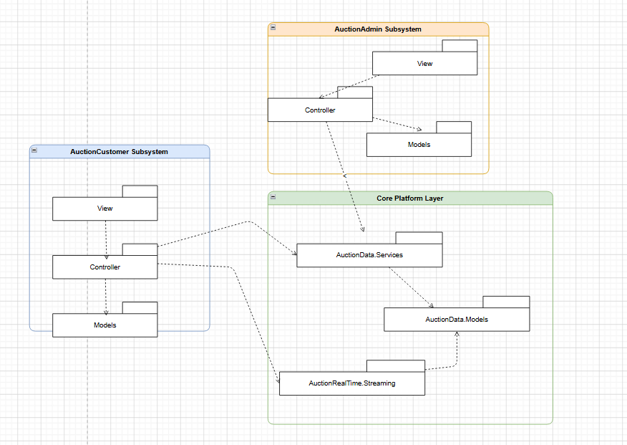
Figure III-5: Package Diagram

III.3.1 Package Diagram Structure (Figure III-5)
The platform's logical classes are grouped into the following packages to enforce structural separation of concerns:
- AuctionCustomer Subsystem Packages:
  - AuctionCustomer.View: Contains client-side user interfaces, real-time dashboards, and single-page application (SPA) views utilized by bidders and sellers ($F01, F02, F04$).
  - AuctionCustomer.Controller: Coordinates API routing, processes standard client requests, and establishes initial WebSocket connections.
  - AuctionCustomer.Models: Houses data transfer objects (DTOs), request payload validation logic, and view models tailored for client application delivery.
- AuctionAdmin Subsystem Packages:
  - AuctionAdmin.View: Contains back-office dashboard components, administrative charts, data grids, and configuration panels used by internal staff ($F08, F09, F10$).
  - AuctionAdmin.Controller: Handles secure administrative endpoints, role-based access control (RBAC) validations, and reporting configurations.
  - AuctionAdmin.Models: Manages complex data aggregation structures, dashboard analytics payloads, and staff audit structures.
- AuctionData & RealTime Core Packages:
  - AuctionData.Models: The core system domain entities (e.g., User, AuctionItem, AuctionSession, BidLog) shared across the entire enterprise database layer to ensure strict transactional consistency.
  - AuctionData.Services: Contains concrete business engines, automated bidding algorithms (AutoBidAgentEngine), database access repository patterns, and notification event dispatch layers.
  - AuctionRealTime.Streaming: Houses the active memory state objects, Redis transaction managers, and message broker publishers/consumers that drive live bid ingestion ($F02, F03$).
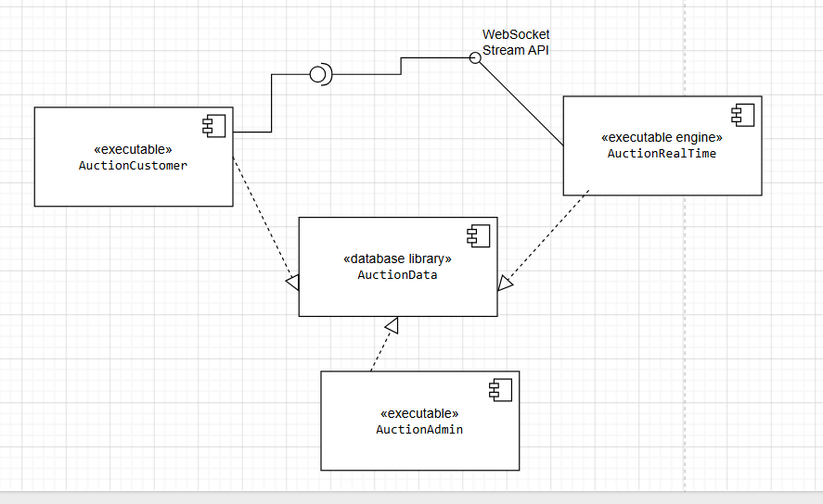
Figure III-6: Component Diagram

III.3.2 Component Diagram Allocation (Figure III-6)
At a physical deployment and build level, these logical packages are compiled into independent, reusable, and deployable components:
- AuctionCustomer (Executable Component): A lightweight, stateless executable application server instance. It serves the customer portal and scales horizontally behind a load balancer to handle fluctuating user traffic.
- AuctionAdmin (Executable Component): A highly secure executable application server instance isolated inside a private corporate subnet, dedicated entirely to staff operations, catalog management, and reporting services.
- AuctionRealTime (Executable Engine Component): A stateful, highly optimized networking engine component built exclusively for holding open WebSocket connections, parsing incoming stream frames, and communicating with message queue partitions.
- AuctionData (Library / Shared Module Component): A centralized, reusable data-access assembly compiled as a standalone library (.dll or .jar). It is embedded inside the executable components to supply standard database connection pools, ORM configurations, and unified domain model abstractions.

Detail Design
Analysis classes are mapped to design classes categorized by stereotype: entity, boundary, control, and application logic classes. Each entity class is split into a database wrapper class (handling direct database orchestration and persistence operations) and a data abstraction class (representing pure system data states).
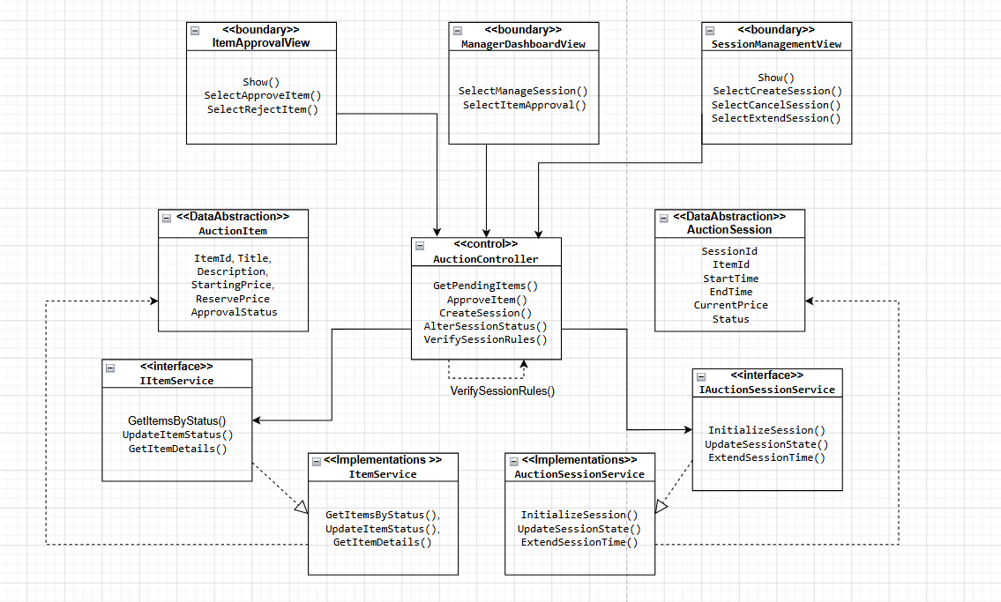
Figure III-7 Detailed design classes
Figure III-7 shows the detailed design classes for managing auction elements, approving seller submissions, and creating live rooms. Key design classes include:

Class | Stereotype | Key Methods
ManagerDashboardView | <<boundary>> | SelectManageSession(), SelectItemApproval()
ItemApprovalView | <<boundary>> | Show(), SelectApproveItem(), SelectRejectItem()
SessionManagementView | <<boundary>> | Show(), SelectCreateSession(), SelectCancelSession(), SelectExtendSession()
AuctionController | <<control>> | GetPendingItems(), ApproveItem(), CreateSession(), AlterSessionStatus(), VerifySessionRules()
IItemService | <<interface>> | GetItemsByStatus(), UpdateItemStatus(), GetItemDetails()
ItemService | <<DataWrapper>> | Implements IItemService; accesses data persistence layer for submitted assets
IAuctionSessionService | <<interface>> | InitializeSession(), UpdateSessionState(), ExtendSessionTime()
AuctionSessionService | <<DataWrapper>> | Implements IAuctionSessionService; manages scheduling clocks and live transaction records
AuctionItem | <<DataAbstraction>> | ItemId, Title, Description, StartingPrice, ReservePrice, ApprovalStatus
AuctionSession | <<DataAbstraction>> | SessionId, ItemId, StartTime, EndTime, CurrentPrice, Status

III.4.1 Key Architecture Mappings & Patterns
- Boundary Layer Evolution: The system boundaries (*View) pass client requests directly into unified REST/WebSocket controllers. For real-time updates, separate boundary components map connection sockets cleanly onto the underlying controls.
- Separation of Contract from Implementation: By implementing the IItemService and IAuctionSessionService interfaces, business logic components are completely decoupled from concrete database technology changes.
- Data Wrappers vs. Abstractions: Classes categorized as <<DataAbstraction>> act as lightweight Data Transfer Objects (DTOs) completely stripped of internal logic, allowing them to pass over networks seamlessly. The <<DataWrapper>> components explicitly house the system data infrastructure configurations and active database

Database Design
Entity classes from the static model are mapped to a relational database. The structural relational schema for the platform is designed as follows, enforcing strict foreign key constraints and optimization attributes for high-concurrency environments:
- User(UserId: nvarchar(50), FullName: nvarchar(100), Email: nvarchar(150), PhoneNumber: nvarchar(15), Address: nvarchar(500), Role: nvarchar(20), AuthProvider: nvarchar(20), Status: nvarchar(20), CreatedAt: DateTime)
- Category(CatId: nvarchar(20), CatName: nvarchar(100), Description: nvarchar(500), DisplayOrder: int)
- AuctionItem(ItemId: nvarchar(50), SellerId: nvarchar(50), CatId: nvarchar(20), Title: nvarchar(255), Description: LongText, StartingPrice: numeric(12,2), ReservePrice: numeric(12,2), ImageUrls: LongText, ApprovalStatus: nvarchar(20), CreatedAt: DateTime)
- AuctionSession(SessionId: nvarchar(50), ItemId: nvarchar(50), CurrentWinnerId: nvarchar(50), StartTime: DateTime, EndTime: DateTime, CurrentPrice: numeric(12,2), Status: nvarchar(20), AntiSnipeSeconds: int)
- BidLog(BidId: bigint, SessionId: nvarchar(50), BidderId: nvarchar(50), BidAmount: numeric(12,2), BidType: nvarchar(15), CreatedAt: DateTime)
- AutoBidAgent(AgentId: nvarchar(50), SessionId: nvarchar(50), UserId: nvarchar(50), MaxBidLimit: numeric(12,2), IsActive: bit)
- News(NewId: nvarchar(20), StaffId: nvarchar(50), Title: nvarchar(255), Content: LongText, IsActive: bit, CreateDate: DateTime)
- PaymentTransaction(TransactionId: nvarchar(50), SessionId: nvarchar(50), WinnerId: nvarchar(50), Amount: numeric(12,2), PaymentMethod: nvarchar(50), PaymentStatus: nvarchar(20), TransactionDate: DateTime)
- AuditLog(LogId: nvarchar(50), StaffId: nvarchar(50), Action: nvarchar(50), EntityType: nvarchar(50), EntityID: nvarchar(50), Description: nvarchar(255), TimeStamp: DateTime)

Core Structural Transformations from the Base Template:
Unified Identity Architecture: The decoupled Supplier, Customer, Staff, and User tables from the old retail store template are collapsed into a singular, highly efficient User table structured with an explicitly assigned Role descriptor ('BIDDER', 'SELLER', 'STAFF', 'ADMIN') to easily handle third-party federated social logins ($F04$).
Bidding Stream Optimization: Cart, CartItem, and OrderProduct are replaced with a fast BidLog schema. The primary identifier for this table uses a high-capacity bigint data type rather than a standard alphanumeric string, accommodating the massive data volume generated by thousands of concurrent live bids ($F02$).
Real-Time State Tracking: The Order entity is converted into a PaymentTransaction record mapped on a strict $1:1$ matching configuration with an asset's completed AuctionSession to lock final sale prices and capture dynamic anti-snipe updates.

Implementation

Map architecture to the structure of the project

The online auction system is implemented using a Multi-Client / Distributed Service model with four main architectural components and physical project modules:
AuctionCustomer (Executable – Web/Mobile App): The user-facing application workspace serving public interfaces, live bidding rooms, and user authentication loops.
AuctionAdmin (Executable – Web App): The administrative dashboard portal restricted to store staff and platform administrators for catalog curation and operational auditing.
AuctionRealTime (Executable – Stateful Streaming Engine): A dedicated, lightweight networking module responsible for managing active WebSocket connection pools and processing fast bid payloads.
AuctionData (Library): The centralized, shared data access and core business logic layer embedded across all executable assemblies to guarantee single-source-of-truth data mutations.

IV.1.1 Component Module Manifests
The AuctionData core library encapsulates all enterprise domain model data definitions, repository infrastructure patterns, and interface contracts shared throughout the platform ecosystem:
- Model Classes (AuctionData.Models): User, Category, AuctionItem, AuctionSession, BidLog, AutoBidAgent, News, PaymentTransaction, AuditLog.
- Service Interfaces & Data Contexts (AuctionData.Services): * DataContext (Manages primary ORM relational connection strings and pooling parameters).
  - RedisCacheContext (Manages transient in-memory key-value connections for atomic counter lock processing).
  - IItemService, ItemService (Executes catalog drafting, media parsing, and staff-side approvals).
  - IAuctionSessionService, AuctionSessionService (Orchestrates live clocks, anti-snipe updates, and final price closures).
  - IBiddingService, BiddingEngine (Interfaces directly with the message broker pipelines to queue manual and automated proxy bids).

Map Class Diagram and Interaction Diagram to Code
Design classes are mapped to structured, clean, and asynchronous C# code. Below are the core implementations of the IAuctionSessionService interface, the concrete AuctionSessionService data wrapper, and the administrative AuctionController handling session creation and dynamic state mutation rules.

IAuctionSessionService Interface
package com.auction.data.services;

import com.auction.data.models.AuctionSession;
import java.util.List;
import java.util.Optional;
import java.util.concurrent.CompletableFuture;

public interface IAuctionSessionService {
CompletableFuture<List<AuctionSession>> getActiveSessions();
CompletableFuture<Optional<AuctionSession>> getSessionById(String sessionId);
CompletableFuture<Void> initializeSession(AuctionSession session);
CompletableFuture<Void> alterSessionStatus(String sessionId, String action);
CompletableFuture<Boolean> extendSessionTime(String sessionId, int extraSeconds);
}
AuctionSessionService Implementation
package com.auction.data.services;

import com.auction.data.models.AuctionSession;
import com.auction.data.repositories.AuctionSessionRepository;
import com.auction.data.repositories.BidLogRepository;
import org.springframework.beans.factory.annotation.Autowired;
import org.springframework.scheduling.annotation.Async;
import org.springframework.stereotype.Service;
import org.springframework.transaction.annotation.Transactional;

import java.time.LocalDateTime;
import java.util.List;
import java.util.Optional;
import java.util.concurrent.CompletableFuture;

@Service
public class AuctionSessionService implements IAuctionSessionService {

private final AuctionSessionRepository sessionRepository;
private final BidLogRepository bidLogRepository;

@Autowired
public AuctionSessionService(AuctionSessionRepository sessionRepository, BidLogRepository bidLogRepository) {
this.sessionRepository = sessionRepository;
this.bidLogRepository = bidLogRepository;
}

@Override
@Async
@Transactional(readOnly = true)
public CompletableFuture<List<AuctionSession>> getActiveSessions() {
return CompletableFuture.completedFuture(sessionRepository.findByStatus("ACTIVE"));
}

@Override
@Async
@Transactional(readOnly = true)
public CompletableFuture<Optional<AuctionSession>> getSessionById(String sessionId) {
return CompletableFuture.completedFuture(sessionRepository.findById(sessionId));
}

@Override
@Async
@Transactional
public CompletableFuture<Void> initializeSession(AuctionSession session) {
sessionRepository.save(session);
return CompletableFuture.completedFuture(null);
}

@Override
@Async
@Transactional
public CompletableFuture<Void> alterSessionStatus(String sessionId, String action) {
sessionRepository.findById(sessionId).ifPresent(session -> {
session.setStatus(action.toUpperCase()); // SCHEDULED, COMPLETED, CANCELLED
sessionRepository.save(session);
});
return CompletableFuture.completedFuture(null);
}

@Override
@Async
@Transactional
public CompletableFuture<Boolean> extendSessionTime(String sessionId, int extraSeconds) {
// Checks if session has related bid events before altering the timeline
boolean hasBids = bidLogRepository.existsBySessionId(sessionId);

Optional<AuctionSession> sessionOpt = sessionRepository.findById(sessionId);
if (sessionOpt.isPresent()) {
AuctionSession session = sessionOpt.get();
if ("ACTIVE".equals(session.getStatus())) {
LocalDateTime updatedEndTime = session.getEndTime().plusSeconds(extraSeconds);
session.setEndTime(updatedEndTime);
sessionRepository.save(session);
return CompletableFuture.completedFuture(true);
}
}
return CompletableFuture.completedFuture(false);
}
}
AuctionController (Key Management Actions)
package com.auction.admin.controllers;

import com.auction.data.models.AuctionItem;
import com.auction.data.models.AuctionSession;
import com.auction.data.services.IAuctionSessionService;
import com.auction.data.services.IItemService;
import org.springframework.beans.factory.annotation.Autowired;
import org.springframework.http.ResponseEntity;
import org.springframework.web.bind.annotation.*;

import java.util.HashMap;
import java.util.List;
import java.util.Map;
import java.util.Optional;
import java.util.concurrent.CompletableFuture;

@RestController
@RequestMapping("/api/admin/auction")
public class AuctionController {

private final IAuctionSessionService sessionService;
private final IItemService itemService;

@Autowired
public AuctionController(IAuctionSessionService sessionService, IItemService itemService) {
this.sessionService = sessionService;
this.itemService = itemService;
}

// GET: /api/admin/auction/manage
@GetMapping("/manage")
public CompletableFuture<ResponseEntity<List<AuctionSession>>> manage() {
return sessionService.getActiveSessions()
.thenApply(ResponseEntity::ok);
}

// POST: /api/admin/auction/create-session
@PostMapping("/create-session")
public CompletableFuture<ResponseEntity<Object>> createSession(@RequestBody AuctionSession session) {
return itemService.getItemById(session.getItemId())
.thenCompose(itemOpt -> {
Map<String, String> errorResponse = new HashMap<>();

if (itemOpt.isEmpty()) {
errorResponse.put("error", "Item profile not found.");
return CompletableFuture.completedFuture(ResponseEntity.badRequest().body(errorResponse));
}

AuctionItem item = itemOpt.get();
// Verify the item is approved by staff before initializing a live room
if (!"APPROVED".equalsIgnoreCase(item.getApprovalStatus())) {
errorResponse.put("error", "Cannot create a session for an unapproved item.");
return CompletableFuture.completedFuture(ResponseEntity.badRequest().body(errorResponse));
}

return sessionService.initializeSession(session)
.thenApply(v -> ResponseEntity.ok().body((Object) session));
});
}

// POST: /api/admin/auction/alter-status
@PostMapping("/alter-status")
public CompletableFuture<ResponseEntity<Map<String, Object>>> alterStatus(
@RequestParam String id,
@RequestParam String action) {

return sessionService.alterSessionStatus(id, action)
.thenApply(v -> {
Map<String, Object> response = new HashMap<>();
response.put("success", true);
response.put("message", "Session state updated to " + action + " successfully.");
return ResponseEntity.ok(response);
})
.exceptionally(ex -> {
Map<String, Object> errorResponse = new HashMap<>();
errorResponse.put("success", false);
errorResponse.put("message", "Failed to update session state.");
return ResponseEntity.internalServerError().body(errorResponse);
});
}
}

Applying Alternative Architecture Patterns
Assuming functional requirements remain unchanged but the system must expand to support ultra-low latency operations, high concurrency handling, and structural reusability (including a potential mobile app), two additional non-functional requirements are introduced.

Service-Oriented Architecture (SOA)
NF-05 Reusability:
The system should allow the same real-time core engines, verification rules, and data layers to be reused across different client platforms (web and mobile apps), reducing development overhead when adding new channels or updating existing features.
The shared AuctionData library is restructured as a distributed tier using Service-Oriented Architecture (SOA). This allows the monolithic library to function as a distributed Auction Core Service, enhancing platform reusability, modularity, and cross-platform message streaming.

New Architecture Configurations (Figures III-3, V-1, V-2):
- AuctionCustomer Web Site and AuctionAdmin Site connect to the Auction Core Service via HTTPS and stateful WebSockets.
- Auction Core Service manages connections to the Database Server and high-speed Redis clusters via dedicated connection pools.
- AuctionCustomerApp (Mobile) connects natively to the exact same Auction Core Service endpoints via HTTPS/WebSockets, instantly inheriting all active bidding engine logic and authorization configurations.

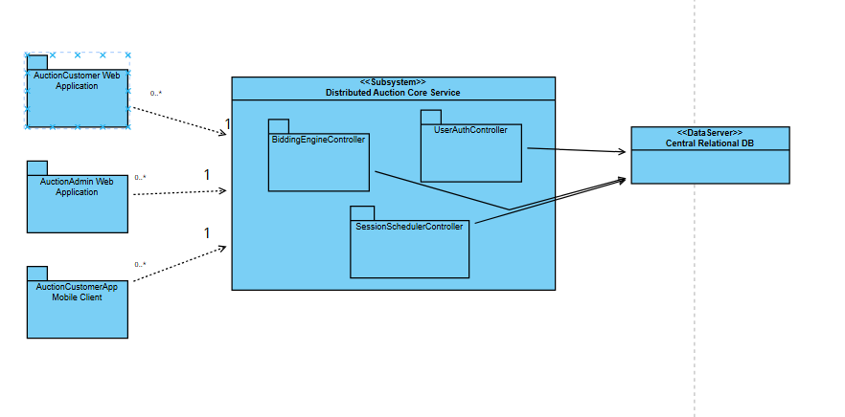
Figure V-1 SOA Architecture Class Diagram

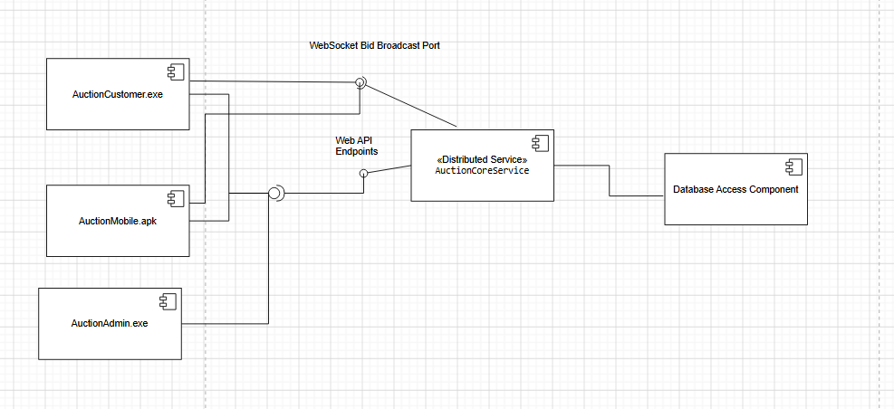

Figure V-2 SOA Component View

Applying Service Discovery Pattern in the service-oriented architecture
Assuming that user requirements change and the store's scale may later expand into a chain of stores with an increasing number of users, the system will need to address an additional non-functional requirement, NF-06, as follows:
NF-06:
The system must handle high-concurrency spikes effortlessly—specifically thousands of simultaneous bids during the final seconds of an auction session—while maintaining reliable uptime. This requires horizontal service scaling, traffic load balancing, and a completely decoupled event ingestion pipeline.
To isolate fault domains and ensure data consistency under heavy load, the unified Auction Service is decomposed into targeted microservices (Figures V-4, V-5, V-6):

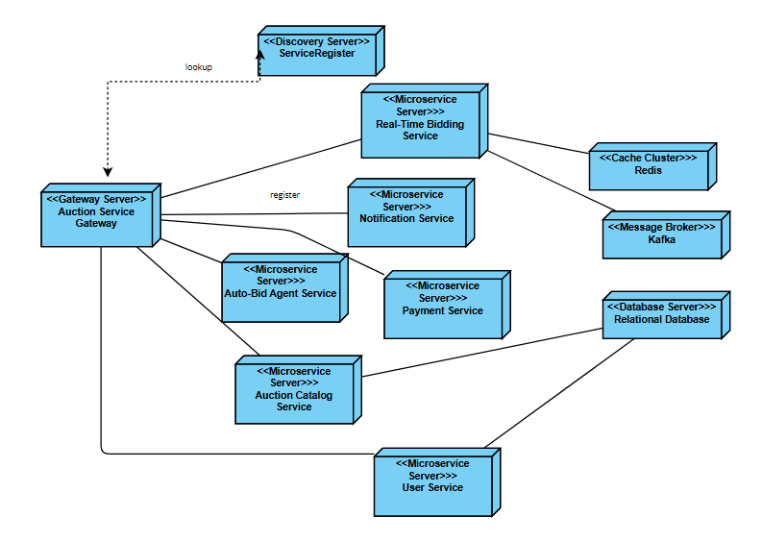

Figure V-3: Microservices Deployment Diagram
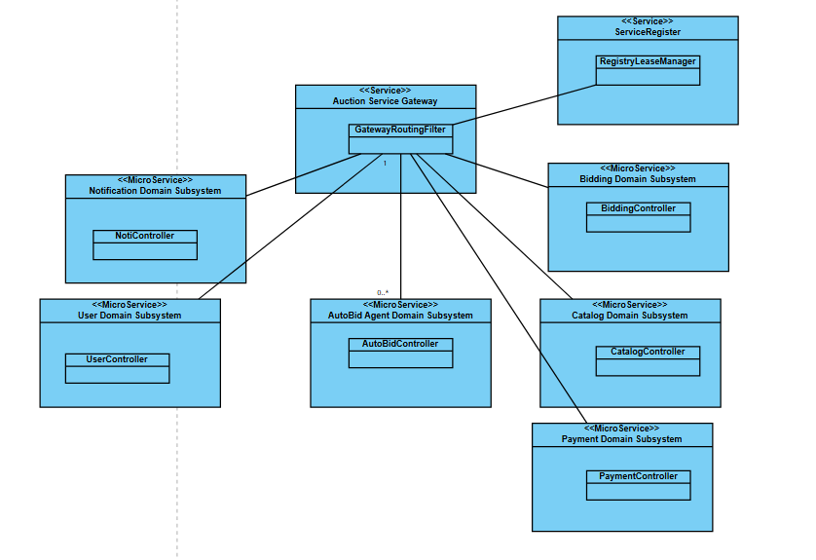

Figure V-4 Microservices Class Diagram
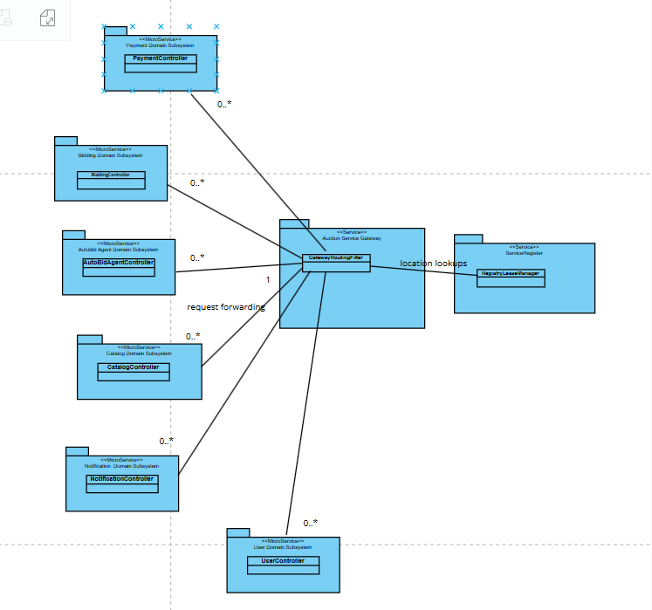
Figure V-5 Microservices Class Diagram (Logical Subsystems)

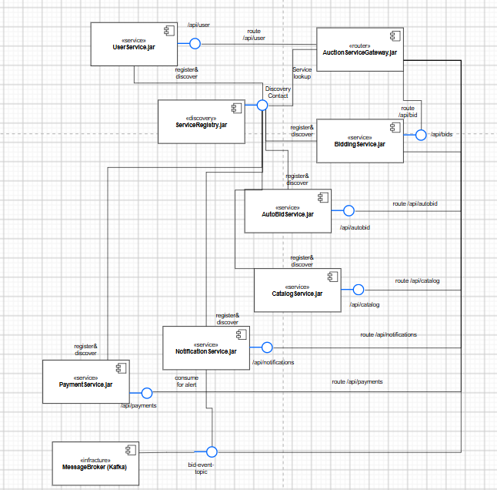
Figure V-6: Microservices Component View (API Routing & Messaging)

