Capstone Project
Automated Cloud Deployment Pipeline
Containerised web application deployed to AWS with Terraform, GitHub Actions CI/CD and CloudWatch monitoring
Student name | Jeu Bulantulu
Student number | [ your student number ]
Course / Module | [ course name and code ]
Lecturer / Assessor | [ name ]
Submission date | [ date ]
GitHub repository | https://github.com/SUB-Bzero/cloud-deploy-pipeline

Project Overview
This project builds, ships and operates a small containerised web application on Amazon Web Services without any manual console work. A git push to the main branch triggers a GitHub Actions pipeline that tests the code, builds a Docker image, pushes it to Amazon ECR, provisions or updates the cloud infrastructure with Terraform, and finally deploys the new container to an EC2 host. The application is health-checked continuously, CloudWatch alarms send an e-mail when CPU or HTTP 5xx errors exceed their limits, and a failed deployment is rolled back automatically.
Area | Choice | Why
Application | Python 3.12, Flask, gunicorn, psycopg 3 | Small, fast to test; exposes /health and a notes REST API backed by PostgreSQL
Containers | Docker multi-stage build, Docker Compose | Small non-root runtime image; one command local Web + DB stack
IaC | Terraform 1.9, modules: vpc, database, compute, monitoring | Repeatable, reviewable infrastructure; remote state in S3 with DynamoDB locking
Compute | EC2 (Amazon Linux 2023) running Docker, behind an Application Load Balancer | Simple host for the container; ALB provides health checks and the 5xx metrics
Database | Amazon RDS PostgreSQL 16 in private subnets | Managed, encrypted database that is unreachable from the internet
CI/CD | GitHub Actions, Amazon ECR, AWS Systems Manager (SSM) | Native to the repo; no SSH keys or open port 22 needed to deploy
Monitoring | CloudWatch Alarms, SNS e-mail | CPU > 80 %, 5xx error-rate and unhealthy-host alarms notify the administrator

1. Architecture Diagram
Figure 1 shows how a user request travels through the system and how the delivery pipeline and monitoring services are connected. Arrows show the direction of communication.
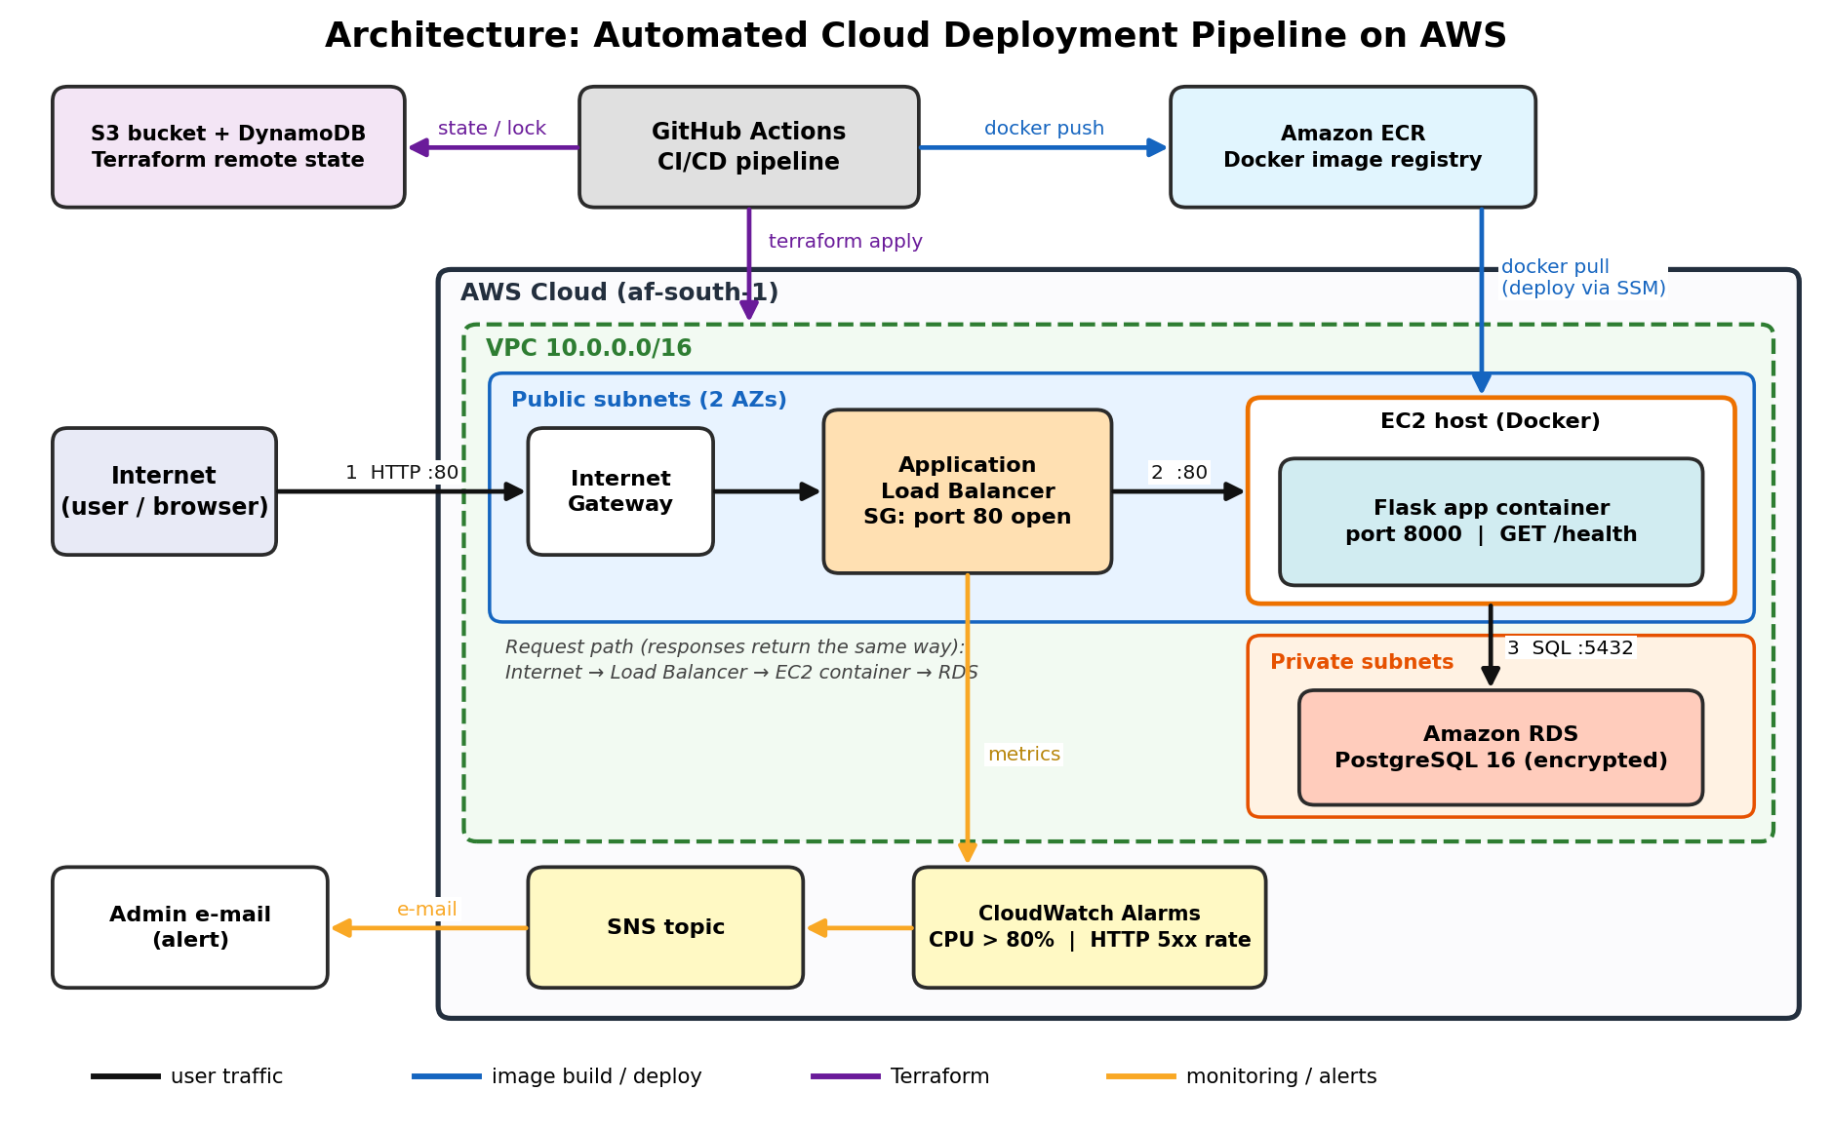
Figure 1: Architecture and traffic flow: Internet → Application Load Balancer → EC2 host (Docker container) → RDS PostgreSQL, with the CI/CD, Terraform state and monitoring paths.

1.1 Traffic flow (Internet → Cloud Host → Database)
- Step 1 - Internet → Load Balancer. The user's browser sends HTTP on port 80. It enters the VPC through the Internet Gateway and reaches the Application Load Balancer in the public subnets.
- Step 2 - Load Balancer → Cloud Host. The ALB forwards the request on port 80 to the EC2 host (target group). Only the ALB's security group may reach the host, and the ALB only forwards while /health returns HTTP 200.
- Step 3 - Cloud Host → Database. The Flask container (port 8000, mapped to host port 80) opens an SSL connection to RDS PostgreSQL on port 5432. The database sits in private subnets with no internet route, and only the host's security group is allowed in.
- Response. The answer returns along the same path in the opposite direction.

1.2 Components
Component | Role | Key security setting
VPC 10.0.0.0/16 | Isolated network with 2 public + 2 private subnets in 2 Availability Zones | Private subnets have no route to the Internet Gateway
Application Load Balancer | Public entry point, /health checks, 5xx metrics | SG: port 80 from 0.0.0.0/0 only
EC2 t3.micro (Docker) | Runs the Flask container | SG: port 80 from the ALB SG only; no SSH (SSM Session Manager); IMDSv2 required; encrypted disk
RDS PostgreSQL 16 | Managed database | Private, encrypted, SG: port 5432 from the host SG only, SSL enforced
ECR | Stores the Docker images | Scan-on-push, lifecycle policy keeps last 15 images
S3 + DynamoDB | Terraform remote state and locking | Versioned, encrypted, public access blocked
CloudWatch + SNS | Alarms and e-mail alerts | Alarm and OK notifications to the admin e-mail
SSM Parameter Store | Holds the database connection string | SecureString; the host role can read only that parameter

2. Implementation Steps
Each task below states what was done, the main steps, the tools used and the purpose of the important settings. Evidence is referenced by figure number in Section 3. All source files are in the GitHub repository (Section 4).

Task 1 - Application containerisation
What was done. A small Flask web application with a PostgreSQL back end was written, unit-tested, packaged into a lightweight multi-stage Docker image and run together with a PostgreSQL container using Docker Compose.
Tools: Python 3.12, Flask, gunicorn, psycopg 3, pytest, flake8, Docker, Docker Compose.
Main steps
- Created app/app.py with routes / (landing page), /health, GET/POST /api/notes, and a /boom endpoint that returns HTTP 500 and is only enabled when ENABLE_FAULT_ENDPOINT=true (used later to trigger the 5xx alarm safely).
- Created app/db.py (PostgreSQL access layer) which creates the notes table on first use.
- Wrote 7 unit tests in app/tests/test_app.py (health up/down, create/list notes, validation, fault endpoint on/off). The database layer is replaced by a fake, so the tests run anywhere without a database (Figure 2).
- Wrote the multi-stage `app/Dockerfile` (see Appendix A): stage 1 (builder) creates a virtual environment and installs dependencies; stage 2 (runtime) starts from a clean python:3.12-slim, copies only the virtual environment and the two source files, and runs as a non-root user.
- Wrote docker-compose.yml with a db service (postgres:16-alpine, health check pg_isready) and a web service that waits until the database is healthy (depends_on: condition: service_healthy). Run with docker compose up --build and test with curl localhost:8000/health (Figures 3-5).
Purpose of important settings
Setting | Purpose
Multi-stage build | Build tools and pip caches stay in the discarded builder stage, so the final image is small and has a smaller attack surface.
USER appuser (UID 10001) | The container never runs as root.
HEALTHCHECK in the Dockerfile | Docker marks the container unhealthy if /health stops answering 200.
.dockerignore | Keeps tests, caches and dev files out of the image.
DATABASE_URL environment variable | Connection details are injected at run time (Compose locally, SSM Parameter Store on AWS); nothing is hard-coded in the image.
/health returns 503 when the DB is down | Load balancer and deploy script can tell a broken instance from a healthy one (Figure 3).

Task 2 - Infrastructure as Code with Terraform
What was done. All AWS resources are defined as modular Terraform code. A one-time *bootstrap* configuration creates the remote-state bucket and the ECR repository; the main configuration then builds the network, database, compute and monitoring through four reusable modules.
Tools: Terraform 1.9 (AWS provider 5.x, random provider), AWS CLI, S3, DynamoDB.
terraform/
├── bootstrap/ # run once: S3 state bucket + DynamoDB lock table + ECR repository
├── backend.tf # S3 remote backend (bucket injected at init time)
├── main.tf # wires the modules together
├── variables.tf outputs.tf versions.tf
└── modules/
├── vpc/ # VPC, 2 public + 2 private subnets, IGW, route tables, 3 security groups
├── database/ # RDS PostgreSQL, subnet group, random password, SSM SecureString URL
├── compute/ # EC2 + IAM role/profile, Application Load Balancer, target group, listener
└── monitoring/ # SNS topic + e-mail subscription, CloudWatch alarms

Main steps
- Remote state (requirement: S3 bucket). terraform/bootstrap creates the S3 bucket capstone-app-tfstate-<account-id> with versioning, AES-256 encryption and all public access blocked, plus a DynamoDB table for state locking. It is applied once with terraform init && terraform apply (Figure 7). The main configuration then uses backend "s3"; the pipeline passes the bucket, region and lock table with -backend-config flags.
- VPC module. Creates the VPC, two public subnets (ALB and EC2) and two private subnets (RDS) across two Availability Zones, an Internet Gateway and route tables. Only the public route table has a 0.0.0.0/0 route. Three chained security groups are created: Internet → ALB-SG (80) → App-SG (80) → DB-SG (5432) (Figure 8).
- Database module. Creates an encrypted, non-public RDS PostgreSQL 16 instance in the private subnets. The master password is generated by Terraform (random_password) and the full connection string is stored as an SSM SecureString, so no secret is committed to Git or printed in workflow logs (Figure 10).
- Compute module. Creates the EC2 instance (Amazon Linux 2023, IMDSv2 only, encrypted root disk) with an IAM role that allows SSM, pulling from ECR and reading only the database-URL parameter. user_data installs Docker once; image updates are deployed by the pipeline so they never replace the instance. It also creates the Application Load Balancer, target group (health check GET /health expecting 200) and HTTP listener (Figure 9).
- Monitoring module. Creates the SNS topic, e-mail subscription and CloudWatch alarms (Task 4).
- Ran terraform fmt -check, terraform init -backend=false and terraform validate on both configurations; both report *Success! The configuration is valid* (Figure 6).
Purpose of important settings
Setting | Purpose
S3 versioning + DynamoDB lock | Every state revision is recoverable (rollback of infrastructure) and two applies can never run at once.
Private subnets without internet route | The database cannot be reached from the internet even if a security group were misconfigured.
Security group referencing (security_groups = [...]) | Least privilege: each tier only accepts traffic from the tier directly in front of it.
No SSH key, no port 22 | Administration and deployment go through SSM Session Manager/Run Command; nothing to brute-force.
lifecycle { ignore_changes = [ami, user_data] } | Avoids replacing the running host when a newer AMI is published.
sslmode=require in the connection string | RDS PostgreSQL 15+ enforces encrypted connections.
default_tags | Every resource is tagged Project / Environment / ManagedBy for cost tracking.

Task 3 - Continuous Integration & Deployment (GitHub Actions)
What was done. .github/workflows/deploy.yml defines a four-stage pipeline that runs on every push to main (pull requests run only the test stage). The full file is in Appendix C.
Tools: GitHub Actions, aws-actions/configure-aws-credentials, amazon-ecr-login, Docker Buildx, HashiCorp setup-terraform, AWS SSM Run Command.
Job | What it does | Fails the pipeline when
1. test | Installs dependencies, runs flake8 (lint) and pytest (unit tests) | Lint error or failing test
2. build-and-push | Builds the multi-stage image, tags it with the short commit SHA and latest, pushes to Amazon ECR (Figure 13) | Build or push error
3. terraform | init with the S3 backend, fmt -check, validate, plan, then apply of the saved plan (Figure 12) | Invalid or failing infrastructure change
4. deploy | Waits for the host to register with SSM, sends scripts/deploy.sh via SSM Run Command, waits for the result, then smoke-tests /health through the load balancer (Figure 14) | Health check fails (after automatic rollback) or smoke test fails

Configuration. Repository secrets: AWS_ACCESS_KEY_ID, AWS_SECRET_ACCESS_KEY, TF_STATE_BUCKET, TF_LOCK_TABLE, ALERT_EMAIL. Repository variables: AWS_REGION, ECR_REPOSITORY, ENABLE_FAULT_ENDPOINT. The jobs are chained with needs: so a failing test stops everything; concurrency prevents two applies from overlapping; and the deployed image is identified by the commit SHA so every release is traceable (Figures 11-13).

Task 4 - Monitoring and rollback
What was done. The application exposes /health, the load balancer and the deploy script use it, CloudWatch alarms watch CPU and 5xx errors and notify the administrator by e-mail through SNS, and a failed release is reverted automatically.
Tools: Flask /health endpoint, ALB target-group health check, Amazon CloudWatch Alarms, Amazon SNS, scripts/deploy.sh.
Alarm | Metric and condition | Action
…-ec2-cpu-high | EC2 CPUUtilization average > 80 % for 2 consecutive 5-minute periods | SNS → e-mail
…-http-5xx-rate | ALB HTTPCode_Target_5XX_Count ÷ RequestCount × 100 > 5 % in 1 minute (evaluated only when ≥ 10 requests, to avoid false alarms on tiny traffic), via CloudWatch metric math | SNS → e-mail
…-unhealthy-hosts | ALB UnHealthyHostCount > 0 for 2 minutes (the /health check is failing) | SNS → e-mail
…-rds-cpu-high | RDS CPUUtilization > 80 % | SNS → e-mail

Main steps
- Implemented GET /health: returns 200 {"status":"ok","database":"up"} when PostgreSQL answers, otherwise 503. Figure 3 shows the 503 when the database is unreachable; Figure 14 shows the 200 on AWS.
- Configured the ALB target group to call /health every 15 s; two successes mark the host healthy, three failures unhealthy.
- Created the SNS topic and e-mail subscription with Terraform (alert_email variable). The recipient must click *Confirm subscription* once in the e-mail AWS sends (Figure 16).
- Created the alarms above (Figure 15). To test the 5xx alarm the pipeline variable ENABLE_FAULT_ENDPOINT=true enables /boom; about 40 requests to /boom push the error rate above 5 % and the alarm e-mail arrives (Figure 16). The CPU alarm can be tested by running a CPU load through SSM Session Manager.
- Rollback. scripts/deploy.sh remembers the last healthy image. It starts the new container, polls /health for up to 60 s and, if the new version never becomes healthy, it restarts the previous image, prints the container logs and exits non-zero so the pipeline is marked failed while users keep getting the old, working version. The logic was verified with a simulated good release followed by a broken release (Figure 17). Infrastructure changes can be reverted by restoring the previous version of the state object in the versioned S3 bucket and re-running the pipeline with the previous commit.

3. Screenshots as Evidence
Figure 1 is the architecture diagram. Figures 2, 3, 6 and 17 are real command output captured while developing and validating the project (unit tests, running application, Terraform validation and the rollback test of the deploy script). The remaining figures are screenshots of the AWS console, Docker and GitHub taken after the pipeline has run in the student's own AWS account.

3.1 Application containerisation
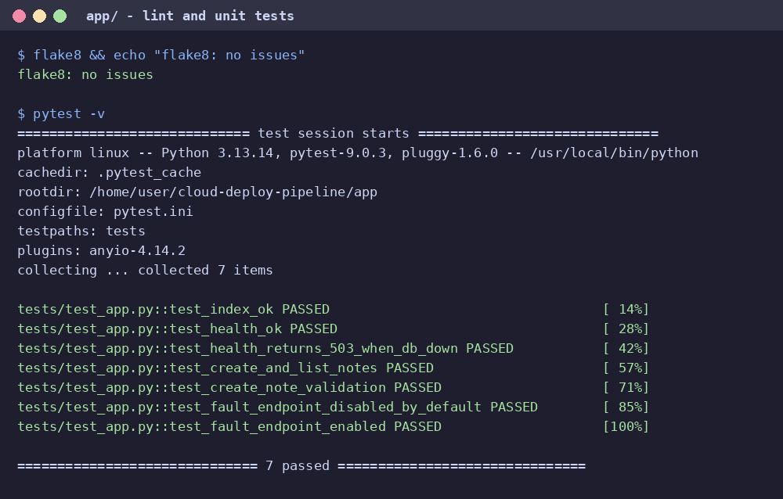
Figure 2: Linting (flake8) and all 7 unit tests passing - the first stage of the pipeline.
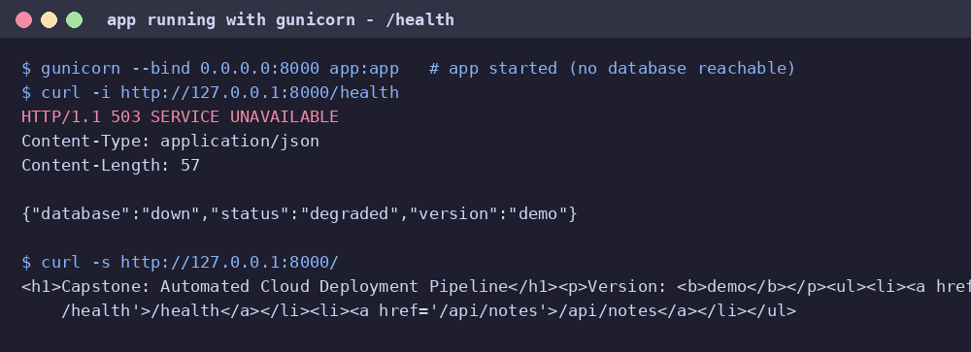
Figure 3: Application served by gunicorn: `/` responds and `/health` correctly reports HTTP 503 / database "down" when no database is reachable.
[ INSERT SCREENSHOT - Figure 4 ]
Capture: terminal showing `docker compose up -d`, `docker compose ps` (both containers Up/healthy) and `curl -i http://localhost:8000/health`.
(delete this box and paste the screenshot; keep the caption below)

Figure 4: `docker compose up --build` running the web and PostgreSQL containers locally; `curl localhost:8000/health` returns HTTP 200 with database "up".
[ INSERT SCREENSHOT - Figure 5 ]
Capture: terminal output of `docker images capstone-app` (or `docker compose images`) showing the size in MB.
(delete this box and paste the screenshot; keep the caption below)

Figure 5: Multi-stage image is lightweight: `docker images` shows the final runtime image size.

3.2 Infrastructure as Code
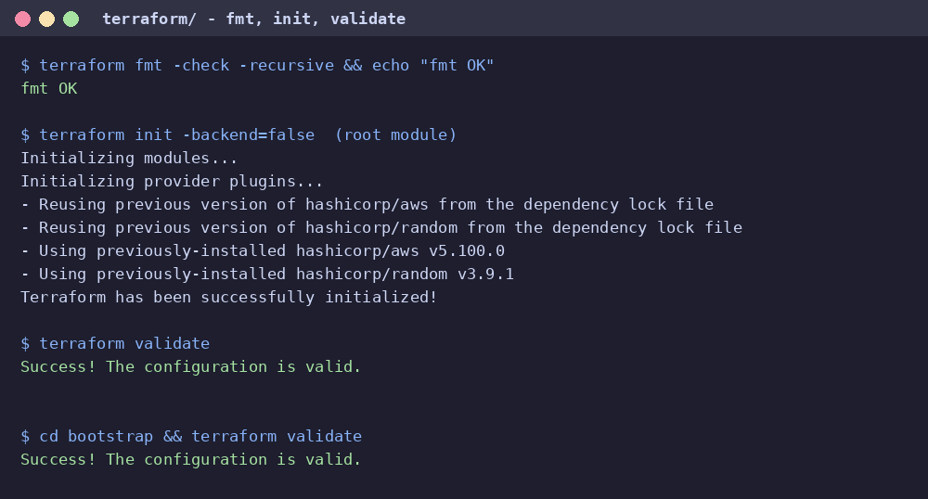
Figure 6: `terraform fmt -check` and `terraform validate` succeed for the main configuration and the bootstrap configuration.
[ INSERT SCREENSHOT - Figure 7 ]
Capture: AWS Console → S3 → `capstone-app-tfstate-…` → Objects tab and Properties tab (Bucket Versioning: Enabled).
(delete this box and paste the screenshot; keep the caption below)

Figure 7: S3 bucket holding the remote Terraform state (versioning enabled) and the `capstone/terraform.tfstate` object.
[ INSERT SCREENSHOT - Figure 8 ]
Capture: AWS Console → VPC → Your VPCs / Subnets (4 subnets) and EC2 → Security Groups (alb, app, db).
(delete this box and paste the screenshot; keep the caption below)

Figure 8: VPC with public and private subnets and the three security groups created by Terraform.
[ INSERT SCREENSHOT - Figure 9 ]
Capture: AWS Console → EC2 → Instances showing `capstone-app-prod-app`.
(delete this box and paste the screenshot; keep the caption below)

Figure 9: EC2 instance hosting the container in the `running` state with 2/2 status checks passed.
[ INSERT SCREENSHOT - Figure 10 ]
Capture: AWS Console → RDS → Databases → `capstone-app-prod-pg` (Connectivity & security tab: Publicly accessible = No).
(delete this box and paste the screenshot; keep the caption below)

Figure 10: RDS PostgreSQL database in the `Available` state, not publicly accessible, in the private subnets.

3.3 CI/CD pipeline
[ INSERT SCREENSHOT - Figure 11 ]
Capture: GitHub → Actions → the latest run of "CI/CD - Test, Build, Provision, Deploy" showing 4 green jobs.
(delete this box and paste the screenshot; keep the caption below)

Figure 11: GitHub Actions run triggered by `git push`: all four jobs (test, build-and-push, terraform, deploy) completed successfully.
[ INSERT SCREENSHOT - Figure 12 ]
Capture: GitHub → Actions → job `Terraform apply` → step "Terraform apply" log (scroll to the Apply complete line and outputs).
(delete this box and paste the screenshot; keep the caption below)

Figure 12: `terraform apply` step of the pipeline showing resources created and `Apply complete!`.
[ INSERT SCREENSHOT - Figure 13 ]
Capture: AWS Console → ECR → repository `capstone-app` → Images.
(delete this box and paste the screenshot; keep the caption below)

Figure 13: Docker image built by the pipeline is stored in Amazon ECR, tagged with the commit SHA and `latest`.
[ INSERT SCREENSHOT - Figure 14 ]
Capture: browser (or `curl -i`) on `http://<alb-dns-name>/health`, plus the deploy job log showing "SUCCESS … is healthy".
(delete this box and paste the screenshot; keep the caption below)

Figure 14: Successful deployment of the application on the cloud host: `/health` answers HTTP 200 through the load balancer URL.

3.4 Monitoring and rollback
[ INSERT SCREENSHOT - Figure 15 ]
Capture: AWS Console → CloudWatch → Alarms → All alarms (state OK; click the 5xx alarm and show its threshold).
(delete this box and paste the screenshot; keep the caption below)

Figure 15: CloudWatch alarms created by Terraform (CPU > 80 %, HTTP 5xx rate, unhealthy hosts, RDS CPU).
[ INSERT SCREENSHOT - Figure 16 ]
Capture: your mailbox showing "ALARM: capstone-app-prod-http-5xx-rate …"; blur personal details if needed.
(delete this box and paste the screenshot; keep the caption below)

Figure 16: E-mail alert received from Amazon SNS when an alarm fired (and/or the confirmed SNS subscription).
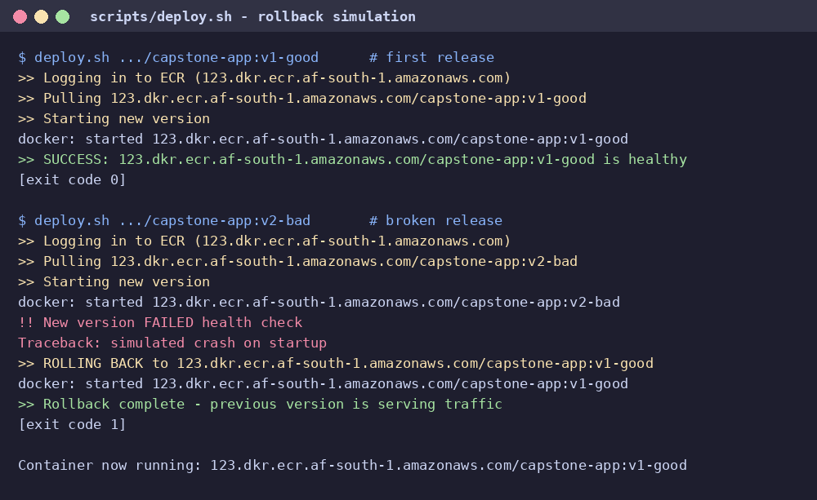
Figure 17: Rollback test of `scripts/deploy.sh`: a healthy release is kept; a broken release fails the health check and the previous version is restored automatically.
[ INSERT SCREENSHOT - Figure 18 ]
Capture: GitHub Actions → failed deploy job log after pushing a deliberately broken commit; then revert the commit.
(delete this box and paste the screenshot; keep the caption below)

Figure 18: (Optional) The same rollback in the real pipeline: deploy job log showing "FAILED health check → ROLLING BACK" while the site stays online.

4. GitHub Repository
Item | Value
Repository link | https://github.com/SUB-Bzero/cloud-deploy-pipeline
Visibility | Public (or private with the assessor invited as a collaborator)
Branch | main (latest version of the project)

Repository contents:
cloud-deploy-pipeline/
├── app/ Flask app, unit tests, multi-stage Dockerfile
├── docker-compose.yml local Web + PostgreSQL stack
├── terraform/ main configuration + modules (vpc, database, compute, monitoring)
│ └── bootstrap/ S3 state bucket, DynamoDB lock table, ECR repository
├── .github/workflows/deploy.yml CI/CD pipeline
├── scripts/deploy.sh on-host deploy with health check and automatic rollback
├── docs/ architecture diagram, evidence and report generator
└── README.md run / deploy / tear-down instructions

5. Final Submission Checklist
Check | Status
Architecture diagram is included (Figure 1) | Done
All implementation steps are documented (Tasks 1-4) | Done
Relevant screenshots are included, numbered and captioned (Section 3) | Replace every yellow placeholder with your screenshot
GitHub repository link is provided and accessible to the assessor | Link added; open it in a private window to check it is public
Word document converted to PDF | File → Save As → PDF (after the two items above)
PDF uploaded to the LMS portal | Upload the PDF

Appendix A - Multi-stage Dockerfile (app/Dockerfile)
# syntax=docker/dockerfile:1
# ---------- Stage 1: builder (has pip + wheels, discarded afterwards) ----------
FROM python:3.12-slim AS builder
ENV PIP_NO_CACHE_DIR=1 PIP_DISABLE_PIP_VERSION_CHECK=1
WORKDIR /build
RUN python -m venv /opt/venv
ENV PATH="/opt/venv/bin:$PATH"
COPY requirements.txt .
RUN pip install -r requirements.txt
# ---------- Stage 2: runtime (only venv + source, runs as non-root) ----------
FROM python:3.12-slim AS runtime
ARG APP_VERSION=dev
ENV PATH="/opt/venv/bin:$PATH" \
PYTHONUNBUFFERED=1 \
PYTHONDONTWRITEBYTECODE=1 \
APP_VERSION=${APP_VERSION} \
PORT=8000
RUN useradd --system --create-home --uid 10001 appuser
WORKDIR /app
COPY --from=builder /opt/venv /opt/venv
COPY app.py db.py ./
USER appuser
EXPOSE 8000
HEALTHCHECK --interval=30s --timeout=3s --start-period=10s --retries=3 \
CMD python -c "import urllib.request,sys; sys.exit(0 if urllib.request.urlopen('http://127.0.0.1:8000/health', timeout=2).status==200 else 1)"
CMD ["gunicorn", "--bind", "0.0.0.0:8000", "--workers", "2", "--access-logfile", "-", "app:app"]

Appendix B - docker-compose.yml
# Local test stack: Web app + PostgreSQL. Run: docker compose up --build
services:
db:
image: postgres:16-alpine
container_name: capstone-db
environment:
POSTGRES_DB: appdb
POSTGRES_USER: appuser
POSTGRES_PASSWORD: localpassword
volumes:
- pgdata:/var/lib/postgresql/data
healthcheck:
test: ["CMD-SHELL", "pg_isready -U appuser -d appdb"]
interval: 5s
timeout: 3s
retries: 10
web:
build:
context: ./app
args:
APP_VERSION: local
container_name: capstone-web
environment:
DATABASE_URL: postgresql://appuser:localpassword@db:5432/appdb
ENABLE_FAULT_ENDPOINT: "true"
ports:
- "8000:8000"
depends_on:
db:
condition: service_healthy
volumes:
pgdata:

Appendix C - CI/CD workflow (.github/workflows/deploy.yml)
name: CI/CD - Test, Build, Provision, Deploy
on:
push:
branches: [main]
pull_request:
branches: [main] # PRs only run the test job
workflow_dispatch:
env:
AWS_REGION: ${{ vars.AWS_REGION || 'af-south-1' }}
ECR_REPOSITORY: ${{ vars.ECR_REPOSITORY || 'capstone-app' }}
concurrency:
group: deploy-${{ github.ref }}
cancel-in-progress: false # never kill a running terraform apply
permissions:
contents: read
jobs:
# ------------------------------------------------------------------ 1
test:
name: Lint & unit tests
runs-on: ubuntu-latest
defaults:
run:
working-directory: app
steps:
- uses: actions/checkout@v4
- uses: actions/setup-python@v5
with:
python-version: "3.12"
cache: pip
cache-dependency-path: app/requirements-dev.txt
- run: pip install -r requirements-dev.txt
- name: Lint (flake8)
run: flake8
- name: Unit tests (pytest)
run: pytest -v
# ------------------------------------------------------------------ 2
build-and-push:
name: Build & push image to ECR
needs: test
if: github.event_name != 'pull_request'
runs-on: ubuntu-latest
outputs:
image: ${{ steps.meta.outputs.image }}
steps:
- uses: actions/checkout@v4
- uses: aws-actions/configure-aws-credentials@v4
with:
aws-access-key-id: ${{ secrets.AWS_ACCESS_KEY_ID }}
aws-secret-access-key: ${{ secrets.AWS_SECRET_ACCESS_KEY }}
aws-region: ${{ env.AWS_REGION }}
- id: login
uses: aws-actions/amazon-ecr-login@v2
- uses: docker/setup-buildx-action@v3
- id: meta
run: echo "image=${{ steps.login.outputs.registry }}/${{ env.ECR_REPOSITORY }}:${GITHUB_SHA::7}" >> "$GITHUB_OUTPUT"
- name: Build and push (multi-stage Dockerfile)
uses: docker/build-push-action@v6
with:
context: app
push: true
build-args: APP_VERSION=${{ github.sha }}
tags: |
${{ steps.meta.outputs.image }}
${{ steps.login.outputs.registry }}/${{ env.ECR_REPOSITORY }}:latest
cache-from: type=gha
cache-to: type=gha,mode=max
# ------------------------------------------------------------------ 3
terraform:
name: Terraform apply (infrastructure)
needs: build-and-push
runs-on: ubuntu-latest
outputs:
instance_id: ${{ steps.out.outputs.instance_id }}
app_url: ${{ steps.out.outputs.app_url }}
defaults:
run:
working-directory: terraform
env:
TF_VAR_alert_email: ${{ secrets.ALERT_EMAIL }}
TF_VAR_aws_region: ${{ vars.AWS_REGION || 'af-south-1' }}
steps:
- uses: actions/checkout@v4
- uses: aws-actions/configure-aws-credentials@v4
with:
aws-access-key-id: ${{ secrets.AWS_ACCESS_KEY_ID }}
aws-secret-access-key: ${{ secrets.AWS_SECRET_ACCESS_KEY }}
aws-region: ${{ env.AWS_REGION }}
- uses: hashicorp/setup-terraform@v3
with:
terraform_version: 1.9.8
terraform_wrapper: false
- name: Terraform init (S3 remote backend)
run: |
terraform init -input=false \
-backend-config="bucket=${{ secrets.TF_STATE_BUCKET }}" \
-backend-config="region=${{ env.AWS_REGION }}" \
-backend-config="dynamodb_table=${{ secrets.TF_LOCK_TABLE }}"
- run: terraform fmt -check -recursive
- run: terraform validate
- run: terraform plan -input=false -out=tfplan
- name: Terraform apply
run: terraform apply -input=false -auto-approve tfplan
- id: out
run: |
echo "instance_id=$(terraform output -raw instance_id)" >> "$GITHUB_OUTPUT"
echo "app_url=$(terraform output -raw app_url)" >> "$GITHUB_OUTPUT"
# ------------------------------------------------------------------ 4
deploy:
name: Deploy container to EC2 (with auto-rollback)
needs: [build-and-push, terraform]
runs-on: ubuntu-latest
steps:
- uses: actions/checkout@v4
- uses: aws-actions/configure-aws-credentials@v4
with:
aws-access-key-id: ${{ secrets.AWS_ACCESS_KEY_ID }}
aws-secret-access-key: ${{ secrets.AWS_SECRET_ACCESS_KEY }}
aws-region: ${{ env.AWS_REGION }}
- name: Wait for the instance to register with SSM
run: |
for i in $(seq 1 30); do
n=$(aws ssm describe-instance-information \
--filters "Key=InstanceIds,Values=${{ needs.terraform.outputs.instance_id }}" \
--query 'length(InstanceInformationList)' --output text)
[ "$n" = "1" ] && exit 0
echo "waiting for SSM agent ($i/30)"; sleep 10
done
echo "Instance never registered with SSM"; exit 1
- name: Send deploy script via SSM Run Command
id: send
run: |
SCRIPT=$(base64 -w0 scripts/deploy.sh)
CMD_ID=$(aws ssm send-command \
--instance-ids "${{ needs.terraform.outputs.instance_id }}" \
--document-name AWS-RunShellScript \
--comment "deploy ${GITHUB_SHA::7}" \
--parameters "commands=[\"until [ -f /opt/app/host.env ] && systemctl is-active docker; do sleep 5; done\",\"echo $SCRIPT | base64 -d > /opt/app/deploy.sh\",\"chmod +x /opt/app/deploy.sh\",\"/opt/app/deploy.sh ${{ needs.build-and-push.outputs.image }} ${{ vars.ENABLE_FAULT_ENDPOINT || 'false' }}\"]" \
--query Command.CommandId --output text)
echo "command_id=$CMD_ID" >> "$GITHUB_OUTPUT"
- name: Wait for deploy result
run: |
for i in $(seq 1 60); do
STATUS=$(aws ssm get-command-invocation \
--command-id "${{ steps.send.outputs.command_id }}" \
--instance-id "${{ needs.terraform.outputs.instance_id }}" \
--query Status --output text 2>/dev/null || echo Pending)
case "$STATUS" in Pending|InProgress|Delayed) sleep 10 ;; *) break ;; esac
done
aws ssm get-command-invocation \
--command-id "${{ steps.send.outputs.command_id }}" \
--instance-id "${{ needs.terraform.outputs.instance_id }}" \
--query '{Status:Status,Output:StandardOutputContent,Errors:StandardErrorContent}' \
--output json | tee result.json
[ "$(jq -r .Status result.json)" = "Success" ] || { echo "::error::Deploy failed (auto-rollback was attempted)"; exit 1; }
- name: Smoke test through the load balancer
run: |
URL="${{ needs.terraform.outputs.app_url }}/health"
for i in $(seq 1 20); do
if curl -fsS -m 5 "$URL"; then echo; echo "Smoke test passed"; exit 0; fi
echo "retry $i/20"; sleep 10
done
echo "::error::Smoke test failed"; exit 1

Appendix D - CloudWatch alarms (terraform/modules/monitoring/main.tf, excerpt)
# 1) EC2 CPU > 80% for 2 consecutive 5-minute periods
resource "aws_cloudwatch_metric_alarm" "cpu_high" {
alarm_name = "${var.name}-ec2-cpu-high"
alarm_description = "EC2 CPU utilization above ${var.cpu_threshold}%"
namespace = "AWS/EC2"
metric_name = "CPUUtilization"
dimensions = { InstanceId = var.instance_id }
statistic = "Average"
period = 300
evaluation_periods = 2
threshold = var.cpu_threshold
comparison_operator = "GreaterThanThreshold"
treat_missing_data = "notBreaching"
alarm_actions = [aws_sns_topic.alerts.arn]
ok_actions = [aws_sns_topic.alerts.arn]
}
# 2) HTTP 5xx error RATE (%) served by the app > threshold
# rate = 100 * 5xx / total requests (only evaluated when enough traffic)
resource "aws_cloudwatch_metric_alarm" "http_5xx_rate" {
alarm_name = "${var.name}-http-5xx-rate"
alarm_description = "More than ${var.http_5xx_rate_threshold}% of requests return HTTP 5xx"
comparison_operator = "GreaterThanThreshold"
threshold = var.http_5xx_rate_threshold
evaluation_periods = 1
datapoints_to_alarm = 1
treat_missing_data = "notBreaching"
alarm_actions = [aws_sns_topic.alerts.arn]
ok_actions = [aws_sns_topic.alerts.arn]
metric_query {
id = "rate"
expression = "IF(requests >= ${var.min_requests_for_5xx_alarm}, 100 * FILL(errors, 0) / requests, 0)"
label = "5xx error rate (%)"
return_data = true
}
metric_query {
id = "errors"
metric {
namespace = "AWS/ApplicationELB"
metric_name = "HTTPCode_Target_5XX_Count"
dimensions = {
LoadBalancer = var.alb_arn_suffix
TargetGroup = var.target_group_arn_suffix
}
period = 60
stat = "Sum"
}
}
metric_query {
id = "requests"
metric {
namespace = "AWS/ApplicationELB"
metric_name = "RequestCount"
dimensions = {
LoadBalancer = var.alb_arn_suffix
TargetGroup = var.target_group_arn_suffix
}
period = 60
stat = "Sum"
}
}
}

