ES204L Ecology, Environment and Sustainability
Team number:13
Air Quality Monitoring System


Abstract:
Air pollution has become a major environmental and health concern due to rapid urbanization, industrial activities, and vehicular emissions. Continuous monitoring of air quality is essential to assess pollution levels and ensure public safety. This project presents the design and implementation of an IoT-based Air Quality Monitoring System using an ESP32 DevKit V1 integrated with multiple high-precision sensors. The system measures critical air quality parameters including particulate matter (PM1.0, PM2.5, PM10), carbon monoxide (CO), carbon dioxide (CO₂), and volatile organic compounds (VOC) using sensors such as Winsen ZH03B, Winsen ZE07-CO, Sensirion SCD40, and ScioSense ENS160. The collected data is processed by the ESP32 and transmitted in real time to a cloud-based database using Wi-Fi. The system enables continuous monitoring and analysis of environmental conditions through remote access. Experimental results demonstrate the system’s ability to detect variations in air quality and identify polluted environments effectively. The proposed solution is cost-effective, scalable, and suitable for both indoor and outdoor air quality monitoring applications, contributing to environmental awareness and smart city development.

Introduction:
Air pollution is one of the most pressing environmental challenges faced globally, affecting human health, ecosystems, and climate. Rapid industrial growth, urbanization, and increased vehicular emissions have significantly contributed to the deterioration of air quality. Pollutants such as carbon monoxide (CO), carbon dioxide (CO₂), volatile organic compounds (VOCs), and particulate matter (PM1.0, PM2.5, and PM10) pose serious risks, leading to respiratory diseases, cardiovascular problems, and other health issues. Monitoring and controlling air pollution has therefore become essential for sustainable development and public safety.
Traditional air quality monitoring systems are often expensive, bulky, and limited to specific locations, making it difficult to obtain real-time and widespread data. These systems typically rely on manual data collection and laboratory analysis, which may not provide timely information to address rapidly changing environmental conditions. As a result, there is a growing need for cost-effective, portable, and real-time monitoring solutions that can provide continuous updates on air quality.
Advancements in Internet of Things (IoT) technology have opened new possibilities for environmental monitoring. IoT-based systems enable the integration of sensors, microcontrollers, and communication modules to collect and transmit data over the internet. This allows users to monitor environmental parameters remotely and in real time. In air quality monitoring applications, multiple gas and particulate sensors can be interfaced with microcontrollers to detect and analyze various pollutants.
The Air Quality Monitoring System developed in this project is based on IoT principles and utilizes the ESP32 DevKit V1 as the central controller. It integrates multiple sensors, including the Winsen ZH03B for measuring particulate matter (PM1.0, PM2.5, PM10), the Winsen ZE07-CO sensor for carbon monoxide detection, the Sensirion SCD40 for carbon dioxide (CO₂) measurement, and the ScioSense ENS160 sensor for volatile organic compounds (VOCs) and air quality index estimation. These sensors are connected using UART and I2C communication protocols, enabling efficient and simultaneous acquisition of multiple air quality parameters. The collected data is processed by the ESP32 and transmitted via Wi-Fi to cloud platforms such as Firebase for real-time visualization and monitoring.
Several studies have explored IoT-based air quality monitoring systems using similar architectures. Many implementations use low-cost microcontroller platforms such as Arduino and ESP8266/ESP32 combined with gas and particulate sensors to measure environmental parameters. Cloud integration enables real-time data visualization and remote access. Some systems also incorporate alert mechanisms that notify users when pollution levels exceed safe thresholds.
Recent advancements focus on improving accuracy, reliability, and scalability of such systems. Sensor calibration, multi-sensor fusion, and data filtering techniques are commonly used to enhance measurement precision. In more advanced implementations, machine learning techniques are employed to analyze pollution trends and predict air quality changes, enabling early warning systems for hazardous conditions.
Despite these developments, challenges such as sensor drift, calibration errors, network reliability, and power consumption remain important considerations for large-scale deployment. However, continuous improvements in IoT hardware and cloud computing platforms are making these systems increasingly practical and efficient.
In summary, IoT-based air quality monitoring systems provide a cost-effective, real-time, and scalable solution for environmental monitoring. By integrating multiple sensors such as ZH03B, ZE07-CO, SCD40, and ENS160 with ESP32 and cloud platforms, the present project aims to deliver an efficient system for accurate air quality assessment and improved public awareness.
Methodology:

The proposed Air Quality Monitoring System is designed using an Internet of Things (IoT) architecture to enable real-time monitoring and analysis of air pollution parameters. The system integrates multiple environmental sensors with an ESP32 microcontroller, which processes the data and transmits it to a cloud platform for visualization and storage.

3.1 System Architecture
The system consists of three main layers:
- Sensing Layer
- Processing Layer
- Cloud & Visualization Layer
The sensing layer collects environmental data using multiple gas and particulate sensors. The processing layer (ESP32) handles sensor data acquisition and communication. The cloud layer stores and visualizes real-time data for user access.
Dashboard
Firebase
WiFi
ESP32Qs
Sensors

Figure 3.1: Block Diagram of IoT-based Air Quality Monitoring System

3.2 Hardware Components
The system uses the following sensors:
- Winsen ZH03B – Measures particulate matter (PM1.0, PM2.5, PM10)
- Winsen ZE07-CO – Detects carbon monoxide (CO) concentration
- Sensirion SCD40 – Measures carbon dioxide (CO₂), temperature, and humidity
- ScioSense ENS160 – Measures volatile organic compounds (VOC) and air quality index (AQI)
All sensors are connected to the ESP32 DevKit V1, which acts as the central controller of the system.

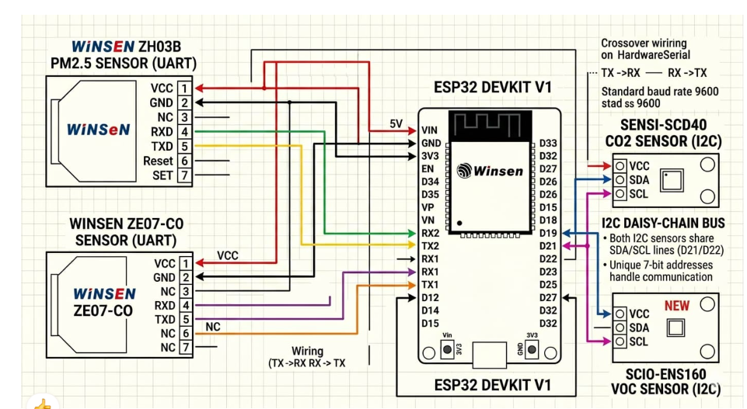
Figure 3.2: Circuit Diagram of the IoT-based Air Quality Monitoring System
The wiring diagram illustrates the connections between the ESP32 and various air quality sensors. UART is used for ZH03B and ZE07-CO sensors, while I2C is used for SCD40 and ENS160. The ESP32 processes the sensor data and sends it to the cloud via Wi-Fi for real-time monitoring.

3.3 Communication Protocols
The system uses two main communication protocols:
- UART Communication
  - Used for ZH03B (PM sensor)
  - Used for ZE07-CO (CO sensor)
- I2C Communication
  - Shared bus for SCD40 (CO₂ sensor)
  - ENS160 (VOC sensor)
This multi-protocol design allows simultaneous data acquisition from all sensors. This enables efficient parallel data acquisition from multiple sensors without communication conflict.

3.4 Data Acquisition and Processing
The ESP32 continuously reads data from all connected sensors at fixed time intervals. The raw sensor outputs are processed to obtain meaningful air quality parameters such as:
- Particulate matter concentration (PM1.0, PM2.5, PM10)
- Carbon monoxide (CO) levels
- Carbon dioxide (CO₂) concentration
- VOC index and air quality score
The microcontroller performs basic filtering and formatting before transmitting the data. Data is sampled at regular intervals to ensure continuous monitoring of environmental conditions.

3.5 IoT Data Transmission
The ESP32, which is Wi-Fi enabled, transmits the processed data to a cloud platform (Firebase / web dashboard as per implementation in GitHub project). This allows:
- Real-time monitoring of air quality parameters
- Remote access through web interface
- Continuous data logging for analysis

3.6 Data Visualization
The collected data is displayed in graphical format on a web dashboard. Users can monitor:
- Live pollutant levels
- Historical trends
- Sensor-wise breakdown of air quality parameters
This helps in understanding pollution variations over time. Firebase enables real-time synchronization between the hardware system and the web dashboard.

3.7 System Workflow
- Sensors continuously measure air quality parameters
- ESP32 collects data using UART and I2C communication
- Data is processed and formatted inside ESP32
- ESP32 transmits data via Wi-Fi
- Cloud platform stores data and enables real-time visualization
- User accesses real-time air quality information through dashboard

3.8 Summary
The system provides a low-cost, scalable, and real-time air quality monitoring solution using IoT technology. By integrating multiple advanced sensors with ESP32 and cloud connectivity, the system ensures accurate monitoring of environmental conditions and improves accessibility of pollution data for users.
Results and discussion:

4.1 Introduction to Results
The Air Quality Monitoring System was successfully implemented using ESP32 and multiple environmental sensors to measure key air pollutants in real time. The system was tested under different environmental conditions such as indoor environments, roadside locations, and moderately polluted areas to evaluate its performance. The results obtained from the sensors were transmitted to a cloud platform and visualized through a web dashboard, enabling continuous monitoring of air quality parameters.

4.2 Sensor Output Observations
The system provides real-time measurements of multiple air quality parameters:

Particulate Matter (PM1.0, PM2.5, PM10) – ZH03B Sensor
The ZH03B sensor successfully detected variations in dust and particulate matter levels. Higher readings were observed in dusty and outdoor environments, while lower values were recorded in indoor controlled conditions. This demonstrates the sensor’s ability to effectively monitor airborne particulate pollution.

Carbon Monoxide (CO) – ZE07-CO Sensor
The ZE07-CO sensor measured CO concentration levels in the environment. Elevated CO levels were observed near vehicle-heavy areas, indicating pollution from combustion sources. In indoor environments, CO levels remained relatively low and stable.

Carbon Dioxide (CO₂) – SCD40 Sensor
The SCD40 sensor provided accurate CO₂ readings along with temperature and humidity data. CO₂ levels increased in closed indoor spaces due to limited ventilation, while outdoor readings remained comparatively lower.

VOC and Air Quality Index – ENS160 Sensor
The ENS160 sensor measured volatile organic compounds and provided an overall air quality index. The AQI values varied depending on surrounding pollution sources such as smoke, chemicals, and indoor air freshness.

4.3 Real-Time Data Transmission Performance
The ESP32 successfully transmitted sensor data to the Firebase cloud platform using Wi-Fi connectivity. The data update rate was consistent, and minimal delay was observed during transmission. The system ensured real-time synchronization between hardware and the web dashboard, allowing users to monitor live air quality conditions remotely.

4.4 Data Visualization Analysis
The cloud dashboard displayed sensor data in graphical format, enabling better interpretation of air quality trends. The visualization included:
- Line graphs for PM, CO, CO₂, and VOC levels
- Real-time numerical display of sensor values
- Historical trend tracking over time
This helped in identifying pollution spikes and comparing environmental conditions across different time periods.

4.5 System Performance Discussion
The system demonstrated reliable performance in continuous monitoring of air quality parameters. The integration of multiple sensors allowed comprehensive environmental analysis. The use of both UART and I2C communication protocols ensured smooth data acquisition without conflicts. The ESP32 efficiently handled data processing and transmission, proving suitable for IoT-based environmental monitoring applications. The system also showed stable Wi-Fi connectivity and consistent cloud updates.

4.6 Advantages of the Proposed System
- Low-cost implementation using ESP32
- Real-time monitoring of multiple pollutants
- Multi-sensor integration for improved accuracy
- Remote access via cloud platform
- Scalable for smart city applications

4.7 Limitations
Despite good performance, the system has certain limitations:
- Sensor calibration may be required for higher accuracy
- Slight delays may occur in unstable network conditions
- Environmental factors may affect sensor readings
- Limited range of low-cost gas sensors compared to industrial systems

4.8 Discussion
The results indicate that the proposed IoT-based system is effective for real-time air quality monitoring. The combination of particulate, gas, and VOC sensors provides a comprehensive view of environmental conditions. Compared to traditional monitoring systems, this approach is more cost-effective and scalable. The system successfully demonstrates how IoT technology can be used to bridge the gap between environmental data collection and real-time public accessibility. The integration with Firebase enables remote monitoring, making it suitable for urban and industrial applications.
Conclusion:
The IoT-based Air Quality Monitoring System developed in this project successfully achieves the objective of providing real-time, low-cost, and multi-parameter environmental monitoring. The system integrates multiple sensors, including the Winsen ZH03B for particulate matter (PM1.0, PM2.5, PM10), ZE07-CO for carbon monoxide (CO), Sensirion SCD40 for carbon dioxide (CO₂), and ScioSense ENS160 for volatile organic compounds (VOCs) and air quality index estimation. These sensors collectively enable comprehensive monitoring of both particulate and gaseous pollutants present in the environment.
The ESP32 microcontroller acts as the central processing unit of the system and efficiently manages data acquisition from all sensors using UART and I2C communication protocols. The collected sensor data is processed and transmitted via Wi-Fi to a cloud platform (Firebase), enabling real-time storage, remote access, and visualization. This IoT-based architecture ensures continuous monitoring and easy accessibility of air quality information through a web dashboard.
The results obtained from the system demonstrate its effectiveness in detecting variations in air pollution levels across different environments. Higher particulate matter and gas concentrations were observed in polluted and high-traffic areas, while relatively stable readings were recorded in indoor or controlled environments. The visualization of real-time data helps in understanding pollution trends and supports better environmental awareness.
Compared to traditional air quality monitoring systems, this proposed solution is more cost-effective, compact, and scalable. It eliminates the need for expensive infrastructure while still delivering reliable and continuous monitoring. The integration of cloud technology further enhances usability by allowing remote monitoring from any location.
However, the system has certain limitations such as sensor calibration requirements, sensitivity to environmental conditions, and dependency on stable internet connectivity. These limitations can be improved in future work by incorporating advanced calibration techniques, data filtering algorithms, and predictive analytics using machine learning.
In conclusion, the developed system effectively demonstrates the practical application of IoT in environmental monitoring and has strong potential for deployment in smart cities, industrial zones, and residential areas.
Reference:
[1] Sung, Y., Lee, S., Kim, Y., & Park, H. (2019). Development of a smart air quality monitoring system and its operation. Asian Journal of Atmospheric Environment, 13(1), 30-38.
[2] Oyo-Ita, E. U., Ekah, U. J., Ana, P., & Ewona, I. O. (2023). Development of a smart air quality monitoring system using wireless sensors. Advances in Research, 24(6), 50-59.
[3] Hassan, A. K., Saraya, M. S., Ali-Eldin, A. M. T., & Abdelsalam, M. M. (2024). Low-Cost IoT Air Quality Monitoring Station Using Cloud Platform and Blockchain Technology. Applied Sciences, 14(13), 5774.
[4] Desavale, R., Rakibe, O., Deshmukh, S. K., & Palkar, P. (2025). IoT Based Air Quality Monitoring System. International Journal for Research in Applied Science & Engineering Technology (IJRASET).
[5] IJSRST (2021). IoT Based Air Pollution Monitoring and Data Analytics Using Machine Learning Approach. International Journal of Scientific Research in Science and Technology.
[6] Gudlavalleru et al. (2025). IoT-Based Air Quality Monitoring and Prediction System. International Journal for Multidisciplinary Research (IJFMR).
[7] IOT Based Air Pollution Monitoring System (Anjali et al., 2025). IJRASET.

