**1.DATA PREPROCESSING**

**MISSING VALUES:**

**FIXING DATATYPES:**

**HANDLING DUPLICATES:**

**NORMALIZATION:**

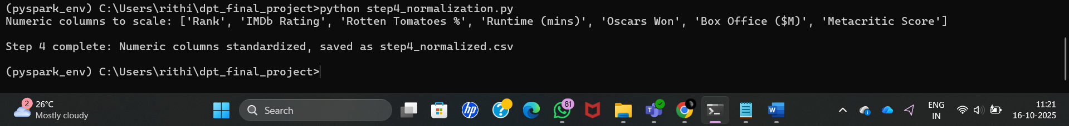

**FEATURE GENERALIZATION:**

2. **Real-Time Data Streaming**

3. **Incremental Data Processing**

4. **In-Memory Data Processing**

