SUBJECT NAME : DIGITAL SYSTEM DESIGN
UNIT NAME : LOGIC GATES AND MINIMIZATION TECHNIQUES
SESSION 2 - Boolean Postulates, Laws, and Minimization of Boolean Expressions

CLIP 1 SCRIPT - BOOLEAN LOGIC: THE SECRET LANGUAGE BEHIND COMPUTERS
SEGMENT 1 - WHAT THIS VIDEO WILL COVER [0:00 – 0:45]

BOARD Title: LEARNING OBJECTIVE
BOARD displays (one by one):
- What Boolean Algebra is
- Boolean variables and operations
- Boolean Postulates
- Fundamental Boolean Laws
- How Boolean expressions are simplified
- Why minimization is important
- Real-world applications of Boolean simplification

Aadhi speaks:
In this video, we will learn:
What Boolean Algebra is
Boolean variables and operations
Boolean Postulates
Fundamental Boolean Laws
How Boolean expressions are simplified
Why minimization is important
Real-world applications of Boolean simplification
By the end of this lesson, you will understand how engineers reduce complex logic circuits into simpler, faster, and more efficient designs.

ANIMATION: Bullets appear one by one. Final line "simpler, faster, and more efficient designs" expands and glows gold.
DETAILED ANIMATION / VISUAL:
Reveal each learning point in narration order with a short upward fade, keeping previous points visible but slightly dimmed. After the final point appears, draw a thin line beneath the list and bring the phrase “simpler, faster, and more efficient designs” forward with a controlled scale-up and gold glow. Hold the complete list briefly so students can read it before moving on.

SCENE 1 - TITLE CARD [0:45 – 1:00]
ON SCREEN - full screen, no board, no Aadhi:
BOOLEAN POSTULATES, LAWS, AND MINIMIZATION OF BOOLEAN EXPRESSIONS
ANIMATION: Title text appears with a golden glow over a dark digital circuit background. Binary 0s and 1s flow softly in the background.
DETAILED ANIMATION / VISUAL:
Begin on a dark navy digital grid with faint binary digits moving at different depths. Thin golden circuit paths draw inward from the frame edges and meet behind the title while the camera makes a slow forward push. Keep the title fully readable, allow one restrained golden pulse, and dissolve smoothly into the board view without showing Aadhi during the title card.
SEGMENT 2 - HOOK: THE SECRET LANGUAGE BEHIND COMPUTERS [0:10 - 1:15]
BOARD Title: THE SECRET LANGUAGE BEHIND COMPUTERS
Aadhi speaks:
Every second, your smartphone performs millions of calculations.
Your laptop processes information, plays videos, and runs applications.
Robots make decisions in factories.
Automated vehicles react to their surroundings.
But have you ever wondered how these systems make logical decisions?
The answer lies in Boolean Logic.
Boolean Logic is the mathematical foundation of digital electronics and computer systems.
Every digital circuit, processor, memory unit, and automation system relies on Boolean algebra to process information efficiently.
BOARD displays (one by one):
- Smartphone calculations
- Laptop processing
- Robotic decisions
- Automated vehicle reactions
- Boolean Logic = mathematical foundation of digital systems
ANIMATION: Show smartphone, laptop, robot arm, and automated vehicle icons. Each icon sends a stream of 0s and 1s into a glowing center label: BOOLEAN LOGIC.
DETAILED ANIMATION / VISUAL:
Arrange the smartphone, laptop, robot arm, and automated vehicle as four clean visual tiles around the frame. Activate them one at a time with a brief gold outline, then send narrow streams of 0s and 1s from each tile toward the central BOOLEAN LOGIC label. When all streams connect, pulse the centre label once and gently move the camera toward it before returning to the board.
SEGMENT 3 - WHAT IS BOOLEAN ALGEBRA? [1:55 - 3:10]
BOARD Title: WHAT IS BOOLEAN ALGEBRA?
Aadhi speaks:
Boolean Algebra was developed by the English mathematician George Boole.
Unlike ordinary algebra, Boolean Algebra deals with only two values:
0 and 1
Where:
0 means FALSE
1 means TRUE
In ordinary mathematics:
2 + 3 = 5
But in Boolean Algebra, operations are based on logic rather than numerical quantities.
Boolean Algebra is used to describe and analyze digital circuits.
Every logical decision made by a computer can be represented using Boolean expressions.
SOURCE IMAGE - preserved from uploaded Word document: George Boole: Founder of Digital Logic
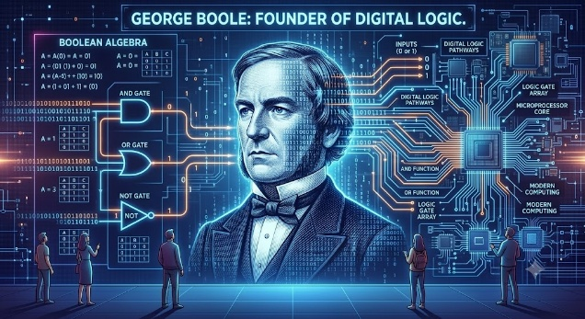
BOARD displays - formula / expression block:
0 means FALSE
1 means TRUE
2 + 3 = 5
ANIMATION: Split screen: left side shows ordinary arithmetic 2 + 3 = 5. Right side shows Boolean values 0 and 1 switching between FALSE and TRUE. Then both merge into a digital circuit diagram.
DETAILED ANIMATION / VISUAL:
Use the preserved George Boole image without cropping or redrawing it, placing it clearly beside the explanation. Open a split screen: ordinary arithmetic remains stable on the left, while 0 and 1 toggle between FALSE and TRUE on the right. Guide both panels inward along thin circuit traces, then settle on a simple digital-circuit background while the original image remains intact and readable.
SEGMENT 4 - BRIDGE TO NEXT PART [3:10 - 3:20]
BOARD Title: COMING UP NEXT
BOARD displays: BOOLEAN VARIABLES AND LOGICAL OPERATIONS
Aadhi speaks:
Now that Boolean Algebra is clear, we will see how Boolean variables are written and how AND, OR, and NOT operations form the base of every Boolean expression.
DETAILED ANIMATION / VISUAL:
Hold the COMING UP NEXT board for two seconds with the next-part title fully readable. Add a soft gold sweep across the title, then fade the board elements to black in layers, leaving a one-second full-black hold before the next title card. Do not show Aadhi during the transition.
NOTE: No farewell. No goodbye wave. Clean fade to black. The next part starts from its own title card.

CLIP 2 SCRIPT - BOOLEAN VARIABLES AND LOGICAL OPERATIONS
Estimated duration: 3 minutes
SCENE 1 - TITLE CARD [0:00 - 0:10]
ON SCREEN - full screen, no board, no Aadhi:
BOOLEAN VARIABLES AND LOGICAL OPERATIONS
ANIMATION: Title appears with three gate symbols: AND, OR, and NOT. Each symbol pulses once in gold.
DETAILED ANIMATION / VISUAL:
Place the AND, OR, and NOT symbols in a balanced horizontal row beneath the title. Draw each symbol from its input side to its output side using a thin gold trace, then pulse them once from left to right. Keep the camera centred and transition into the board by enlarging the three symbols slightly before fading them into the lesson layout.
SEGMENT 1 - BOOLEAN VARIABLES [0:10 - 0:55]
BOARD Title: BOOLEAN VARIABLES
Aadhi speaks:
In Boolean Algebra, variables can take only two values:
A = 0 or 1
B = 0 or 1
Three basic logical operations are used.
BOARD displays - formula / expression block:
A = 0 or 1
B = 0 or 1
ANIMATION: Show A and B as two switches. Each switch toggles between 0 and 1. Label the switch states as FALSE and TRUE.
DETAILED ANIMATION / VISUAL:
Display A and B as two separate switch modules with clear 0/FALSE and 1/TRUE labels. Toggle A first, then B, and finally show both changing independently so students can see that each Boolean variable has only two possible states. Use gentle indicator lights and keep all state labels visible throughout the sequence.
SEGMENT 2 - THREE BASIC LOGICAL OPERATIONS [0:55 - 1:50]
BOARD Title: THREE BASIC LOGICAL OPERATIONS
Aadhi speaks:
AND Operation
Represented by a dot.
A · B
OR Operation
Represented by a plus sign.
A + B
NOT Operation
Represented by a bar over the variable.
A̅
These operations form the foundation of all Boolean expressions.
BOARD displays (one by one):
- AND Operation - represented by a dot: A · B
- OR Operation - represented by a plus sign: A + B
- NOT Operation - represented by a bar over the variable: A̅
ANIMATION: Three cards appear: AND, OR, NOT. Under each card, show the corresponding notation. Highlight dot, plus sign, and bar separately.
DETAILED ANIMATION / VISUAL:
Reveal three technical cards in sequence: AND, OR, and NOT. Under each heading, write its notation and briefly highlight only the defining symbol—the dot, plus sign, or complement bar—while the other cards remain visible. Finish by aligning the three cards evenly and drawing a subtle connection line to show that they form the basic Boolean operations.
SEGMENT 3 - BOOLEAN OPERATIONS COMPARED WITH ARITHMETIC [1:50 - 2:15]
BOARD Title: BOOLEAN ALGEBRA VS ORDINARY ARITHMETIC
Aadhi speaks:
Just as arithmetic uses addition, subtraction, multiplication, and division, Boolean Algebra uses AND, OR, and NOT.
BOARD displays (one by one):
- Arithmetic: addition, subtraction, multiplication, division
- Boolean Algebra: AND, OR, NOT
ANIMATION: Show two columns. Arithmetic symbols appear on the left. Boolean symbols appear on the right. The Boolean column glows to indicate digital circuit relevance.
DETAILED ANIMATION / VISUAL:
Build two clean columns from top to bottom. Introduce the ordinary arithmetic operations on the left and the Boolean operations on the right, matching their reveal to the narration. After both columns are complete, dim the arithmetic side slightly and add a restrained gold circuit glow behind the Boolean column without changing any displayed text.
SEGMENT 4 - REAL-WORLD UNDERSTANDING OF BOOLEAN LOGIC [2:15 - 3:20]
BOARD Title: REAL-WORLD BOOLEAN LOGIC
Aadhi speaks:
Let's understand Boolean logic through a simple example.
A student can enter an examination hall only if:
ID Card is available
AND
Hall Ticket is available.
Let:
A = ID Card
B = Hall Ticket
The condition becomes:
A · B
Both conditions must be true.
Now consider another situation.
You can enter a building using:
Fingerprint
OR
Access Card
The condition becomes:
A + B
Either one is sufficient.
Boolean Algebra allows us to mathematically represent such logical decisions.
BOARD displays - formula / expression block:
A = ID Card
B = Hall Ticket
Condition: A · B
A = Fingerprint
B = Access Card
Condition: A + B
ANIMATION: First, show an exam hall entrance. ID Card and Hall Ticket both turn green before entry opens. Then show a building access system where either fingerprint or access card turns green and opens the door.
DETAILED ANIMATION / VISUAL:
Present the examination-hall example first. Move the ID card and hall ticket into separate verification positions; keep the gate closed until both indicators are green, then open it. Transition to the building-access example, activate fingerprint and access-card options separately, and show that either one sends an approval pulse to open the door. Keep the AND and OR conditions visually distinct and easy to compare.
SEGMENT 5 - BRIDGE TO NEXT PART [3:20 - 3:30]
BOARD Title: COMING UP NEXT
BOARD displays: BOOLEAN POSTULATES
Aadhi speaks:
Now that the basic operations are clear, we will study the fundamental rules on which Boolean Algebra is built.
DETAILED ANIMATION / VISUAL:
Keep the COMING UP NEXT title centred and readable for two seconds. Use a restrained topic-related icon or formula trace as a brief preview, then fade the complete board to black over one second. Do not include any farewell gesture, and begin the following part from a clean black frame.
NOTE: No farewell. No goodbye wave. Clean fade to black.

CLIP 3 SCRIPT - BOOLEAN POSTULATES
Estimated duration: 3.5-4 minutes
SCENE 1 - TITLE CARD [0:00 - 0:10]
ON SCREEN - full screen, no board, no Aadhi:
BOOLEAN POSTULATES
ANIMATION: Title appears over a foundation block graphic. The word POSTULATES sits as the base layer under BOOLEAN ALGEBRA.
DETAILED ANIMATION / VISUAL:
Start with a clean foundation block rising from the lower edge of the screen. Place POSTULATES firmly on the base, then build the BOOLEAN ALGEBRA title above it using stacked glowing lines. Use a slow upward camera reveal, hold the completed foundation visual, and crossfade into the board while preserving the sense that postulates support the entire topic.
SEGMENT 1 - BOOLEAN POSTULATES INTRODUCTION [0:10 - 0:55]
BOARD Title: BOOLEAN POSTULATES - INTRODUCTION
Aadhi speaks:
Boolean Algebra is built upon a set of fundamental rules called postulates.
A postulate is a statement accepted as true without proof.
These postulates serve as the foundation for deriving all Boolean laws and theorems.
Understanding these postulates helps us simplify logic circuits effectively.
BOARD displays (one by one):
- Postulate = accepted as true without proof
- Foundation for Boolean laws and theorems
- Useful for simplifying logic circuits
ANIMATION: Show a pyramid. Base layer: POSTULATES. Middle layer: LAWS. Top layer: SIMPLIFIED LOGIC CIRCUITS.
DETAILED ANIMATION / VISUAL:
Construct the pyramid one layer at a time from the bottom upward. The POSTULATES layer appears first and remains solid, followed by LAWS, then SIMPLIFIED LOGIC CIRCUITS at the top. Add a short upward flow of light through the layers to show progression, then freeze the full pyramid beside the board explanation.
SEGMENT 2 - POSTULATE 1: CLOSURE PROPERTY [0:55 - 1:50]
BOARD Title: POSTULATE 1 - CLOSURE PROPERTY
Aadhi speaks:
The Closure Property states that performing Boolean operations on Boolean variables always produces another Boolean value.
For example:
0 + 1 = 1
1 · 1 = 1
1 · 0 = 0
The result is always either 0 or 1.
This ensures that digital circuits remain within the binary system.
BOARD displays - formula / expression block:
0 + 1 = 1
1 · 1 = 1
1 · 0 = 0
Result is always 0 or 1
ANIMATION: Show two input values entering a logic operation box. The output always becomes either 0 or 1. Never show any output outside binary.
DETAILED ANIMATION / VISUAL:
Send several pairs of binary input chips into a central logic-operation box, one pair at a time. For every pass, show the output indicator resolving clearly to either 0 or 1, with no intermediate or non-binary value appearing. Keep a small binary boundary frame around the operation box to reinforce closure within the Boolean set.
SEGMENT 3 - POSTULATE 2: IDENTITY ELEMENTS [1:50 - 2:45]
BOARD Title: POSTULATE 2 - IDENTITY ELEMENTS
Aadhi speaks:
Identity elements leave variables unchanged.
For OR operation:
A + 0 = A
For AND operation:
A · 1 = A
Example:
If a machine is enabled by a signal A,
adding a constant zero using OR does not change its behavior.
Similarly, multiplying by one using AND does not affect the result.
BOARD displays - formula / expression block:
A + 0 = A
A · 1 = A
ANIMATION: Show signal A passing through two paths. Path 1: A OR 0 gives A. Path 2: A AND 1 gives A. Output remains unchanged in both paths.
DETAILED ANIMATION / VISUAL:
Split signal A into two parallel routes. On the upper route, combine A with 0 through an OR block; on the lower route, combine A with 1 through an AND block. Animate both outputs returning to the same A signal, then align them side by side and add a brief unchanged-output highlight.
SEGMENT 4 - POSTULATE 3: COMPLEMENTS [2:45 - 3:50]
BOARD Title: POSTULATE 3 - COMPLEMENTS
Aadhi speaks:
Every Boolean variable has a complement.
If:
A = 1
then
A̅ = 0
If:
A = 0
then
A̅ = 1
Important results:
A + A̅ = 1
A · A̅ = 0
A variable and its complement can never be true simultaneously.
BOARD displays - formula / expression block:
If A = 1, then A̅ = 0
If A = 0, then A̅ = 1
A + A̅ = 1
A · A̅ = 0
ANIMATION: Show A and A̅ as opposite switches. When A is ON, A̅ is OFF. When A is OFF, A̅ is ON. Then show the two complement results as gold formula cards.
DETAILED ANIMATION / VISUAL:
Place A and its complement as linked opposite-state switches. Toggle A ON and simultaneously turn the complement OFF, then reverse the states in one smooth motion. After both cases are shown, bring the two complement identities forward as separate gold-bordered formula cards and hold them together for comparison.
SEGMENT 5 - BRIDGE TO NEXT PART [3:50 - 4:00]
BOARD Title: COMING UP NEXT
BOARD displays: FUNDAMENTAL BOOLEAN LAWS
Aadhi speaks:
Using these postulates, we will now study the important Boolean laws used frequently in logic simplification.
DETAILED ANIMATION / VISUAL:
Keep the COMING UP NEXT title centred and readable for two seconds. Use a restrained topic-related icon or formula trace as a brief preview, then fade the complete board to black over one second. Do not include any farewell gesture, and begin the following part from a clean black frame.
NOTE: No farewell. No goodbye wave. Clean fade to black.

CLIP 4 SCRIPT - FUNDAMENTAL BOOLEAN LAWS
Estimated duration: 3.5-4 minutes
SCENE 1 - TITLE CARD [0:00 - 0:10]
ON SCREEN - full screen, no board, no Aadhi:
FUNDAMENTAL BOOLEAN LAWS
ANIMATION: Title appears on a digital chalkboard. Five law cards slide in: Commutative, Associative, Distributive, Idempotent, Null.
DETAILED ANIMATION / VISUAL:
Reveal the title on a dark digital chalkboard, then slide in the five law cards one at a time in a neat row-and-column arrangement. Give each card a brief gold edge glow as it arrives, but keep the movement restrained so every name remains readable. End by dimming the cards slightly and opening space for the first law.
SEGMENT 1 - INTRODUCTION TO BOOLEAN LAWS [0:10 - 0:30]
BOARD Title: MOST IMPORTANT BOOLEAN LAWS
Aadhi speaks:
Now let us study the most important Boolean laws.
ANIMATION: Board clears and prepares space for each law formula. Use a gold highlight whenever a law name appears.
DETAILED ANIMATION / VISUAL:
Wipe the board clean from left to right while retaining a small navigation strip containing the five law names. As each law is introduced, brighten only its name in gold and open a dedicated formula area beside it. Use consistent timing and positioning for every law so the sequence feels like one continuous lesson.
SEGMENT 2 - COMMUTATIVE LAW [0:30 - 1:05]
BOARD Title: COMMUTATIVE LAW
Aadhi speaks:
Commutative Law
A + B = B + A
A · B = B · A
Order does not matter.
SOURCE IMAGE - preserved from uploaded Word document: The Commutative Law: Digital Logic & Arithmetic
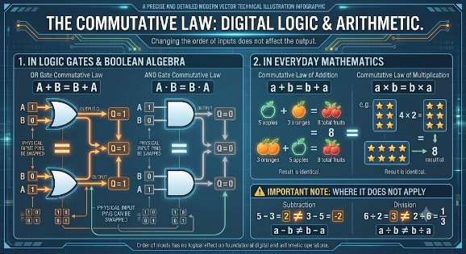
BOARD displays - formula / expression block:
A + B = B + A
A · B = B · A
Order does not matter
ANIMATION: Swap A and B visually. Output stays the same. Add a check mark after both OR and AND forms.
DETAILED ANIMATION / VISUAL:
Use the preserved Commutative Law image exactly as provided. Animate overlay labels A and B exchanging positions across a curved path, first for OR and then for AND, while the output indicator remains unchanged. Add a small check mark only after each equality is visually confirmed, leaving the original image and formulas untouched.
SEGMENT 3 - ASSOCIATIVE LAW [1:05 - 1:40]
BOARD Title: ASSOCIATIVE LAW
Aadhi speaks:
Associative Law
(A + B) + C = A + (B + C)
(A · B) · C = A · (B · C)
Grouping does not matter.
SOURCE IMAGE - preserved from uploaded Word document: Understanding the Associative Property (Addition)
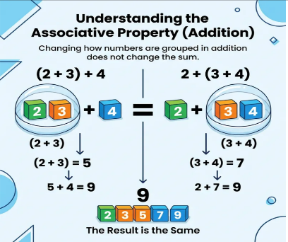
BOARD displays - formula / expression block:
(A + B) + C = A + (B + C)
(A · B) · C = A · (B · C)
Grouping does not matter
ANIMATION: Show brackets moving from left grouping to right grouping. The final output remains unchanged.
DETAILED ANIMATION / VISUAL:
Use the preserved Associative Property image without alteration. Highlight the left grouping first, then slide only the bracket overlays to form the right grouping while keeping A, B, and C fixed. Show the output line remaining identical and finish with both equivalent groupings visible side by side.
SEGMENT 4 - DISTRIBUTIVE LAW [1:40 - 2:25]
BOARD Title: DISTRIBUTIVE LAW
Aadhi speaks:
Distributive Law
A(B + C) = AB + AC
A + BC = (A + B)(A + C)
This law helps simplify complex expressions.
SOURCE IMAGE - preserved from uploaded Word document: The Distributive Law: A Simplified Overview
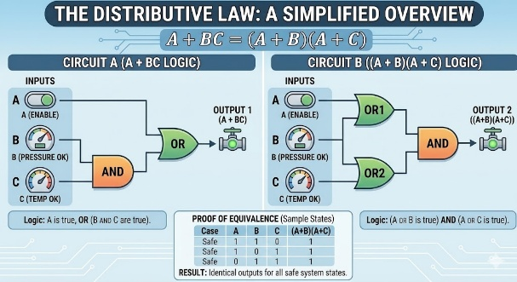
BOARD displays - formula / expression block:
A(B + C) = AB + AC
A + BC = (A + B)(A + C)
ANIMATION: Show A distributing into B + C. Then transform the longer expression into a simplified equivalent circuit view.
DETAILED ANIMATION / VISUAL:
Keep the preserved Distributive Law visual intact. Send two thin arrows from A toward B and C to demonstrate distribution, then reveal the expanded terms in sequence. Use a clean match transition to the equivalent circuit arrangement, keeping both forms on screen long enough for students to compare them.
SEGMENT 5 - IDEMPOTENT LAW [2:25 - 3:00]
BOARD Title: IDEMPOTENT LAW
Aadhi speaks:
Idempotent Law
A + A = A
A · A = A
Repeating a variable does not change its value.
SOURCE IMAGE - preserved from uploaded Word document: The Idempotent Law: A Simplified Overview
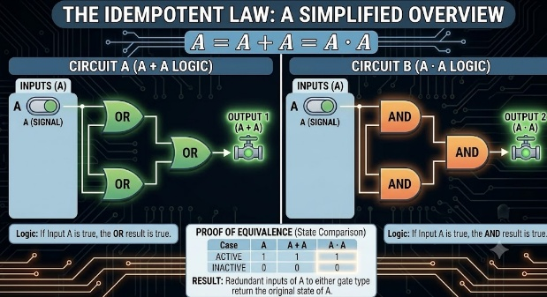
BOARD displays - formula / expression block:
A + A = A
A · A = A
ANIMATION: Duplicate A signals combine. Output still shows only A. Fade repeated inputs to show redundancy removed.
DETAILED ANIMATION / VISUAL:
Use the preserved Idempotent Law image as the base frame. Introduce duplicate A signals on two input paths, combine them through the displayed operation, and keep the output as a single A. Gradually reduce the opacity of the repeated input overlay to show that duplication adds no new result, without changing the original formula or image.
SEGMENT 6 - NULL LAW [3:00 - 3:40]
BOARD Title: NULL LAW
Aadhi speaks:
Null Law
A + 1 = 1
A · 0 = 0
These laws are frequently used in logic simplification.
SOURCE IMAGE - preserved from uploaded Word document: The Null Law: Simplified Logic Circuit Demonstration
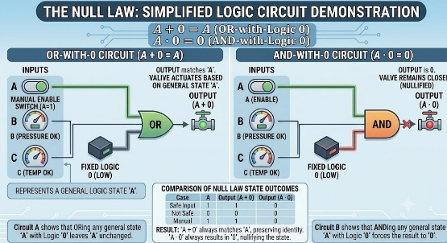
BOARD displays - formula / expression block:
A + 1 = 1
A · 0 = 0
ANIMATION: For OR with 1, output locks to 1. For AND with 0, output locks to 0. Show both as fixed-output cases.
DETAILED ANIMATION / VISUAL:
Display the preserved Null Law visual unchanged and divide attention between its two cases. In the OR-with-1 case, activate a fixed HIGH output regardless of A; in the AND-with-0 case, activate a fixed LOW output regardless of A. Run one short A toggle in each case to demonstrate that the output remains locked.
SEGMENT 7 - BRIDGE TO NEXT PART [3:40 - 3:50]
BOARD Title: COMING UP NEXT
BOARD displays: DE MORGAN'S THEOREMS
Aadhi speaks:
Next, we will study DeMorgan's Theorems, which are among the most powerful tools for transforming Boolean expressions.
DETAILED ANIMATION / VISUAL:
Keep the COMING UP NEXT title centred and readable for two seconds. Use a restrained topic-related icon or formula trace as a brief preview, then fade the complete board to black over one second. Do not include any farewell gesture, and begin the following part from a clean black frame.
NOTE: No farewell. No goodbye wave. Clean fade to black.

CLIP 5 SCRIPT - DE MORGAN'S THEOREMS AND BOOLEAN MINIMIZATION
Estimated duration: 3-3.5 minutes
SCENE 1 - TITLE CARD [0:00 - 0:10]
ON SCREEN - full screen, no board, no Aadhi:
DE MORGAN'S THEOREMS
ANIMATION: Title appears with an AND gate converting into an OR gate, and an OR gate converting into an AND gate.
DETAILED ANIMATION / VISUAL:
Place an AND gate and an OR gate on opposite sides of the title. Trace an inversion bubble and complement marks across the first gate as it visually changes into the other form, then repeat in the reverse direction. Keep the transformation schematic and slow, ending with both converted forms aligned beneath the title.
SEGMENT 1 - DE MORGAN'S THEOREMS [0:10 - 1:35]
BOARD Title: DE MORGAN'S THEOREMS
Aadhi speaks:
DeMorgan's Theorems are among the most powerful tools in Boolean Algebra.
First Theorem:
(A · B)̅ = A̅ + B̅
Second Theorem:
(A + B)̅ = A̅ · B̅
These theorems help convert AND operations into OR operations and vice versa.
They are extensively used in digital circuit design and gate conversion.
SOURCE IMAGE - preserved from uploaded Word document: De Morgan's Theorem: A Simplified Overview
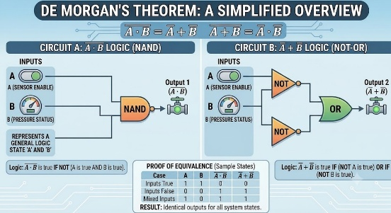
BOARD displays - formula / expression block:
(A · B)̅ = A̅ + B̅
(A + B)̅ = A̅ · B̅
ANIMATION: Show the first theorem as an AND block with an inverter becoming two inverted inputs feeding an OR block. Then show the second theorem as an OR block with an inverter becoming two inverted inputs feeding an AND block.
DETAILED ANIMATION / VISUAL:
Use the preserved De Morgan’s Theorem image exactly as supplied. For the first theorem, animate the output inversion moving backward to the inputs while the central gate changes from AND to OR; repeat with OR changing to AND for the second theorem. Highlight complement marks and gate changes in sequence, then hold both equivalent forms together.
SEGMENT 2 - REAL-WORLD ANALOGY [1:35 - 2:20]
BOARD Title: REAL-WORLD ANALOGY
Aadhi speaks:
Real-World Analogy
Consider a classroom.
"The class is NOT open."
This means either:
Teacher is absent
OR
Students are absent
The logical interpretation follows DeMorgan's theorem.
BOARD displays (one by one):
- The class is NOT open
- Teacher is absent
- OR
- Students are absent
ANIMATION: Show classroom door labeled OPEN. When the NOT condition appears, either the teacher icon disappears or the student group disappears. The door stays closed.
DETAILED ANIMATION / VISUAL:
Begin with a classroom door and both teacher and student icons present. Apply the NOT condition as a clear overlay, then demonstrate the two alternatives separately: remove the teacher icon in the first case and the student group in the second. In both cases, keep the door closed and highlight the OR relationship between the two absence conditions.
SEGMENT 3 - WHY SIMPLIFY BOOLEAN EXPRESSIONS? [2:20 - 3:20]
BOARD Title: WHY SIMPLIFY BOOLEAN EXPRESSIONS?
Aadhi speaks:
Why do engineers simplify Boolean expressions?
Because simpler circuits require:
Fewer logic gates
Less power consumption
Lower cost
Higher speed
Improved reliability
Imagine reducing a circuit from ten gates to four gates.
The system becomes faster, cheaper, and easier to manufacture.
This process is called Boolean Minimization.
SOURCE IMAGE - preserved from uploaded Word document: Visualizing Logic Circuit Simplification: The Distributive Law
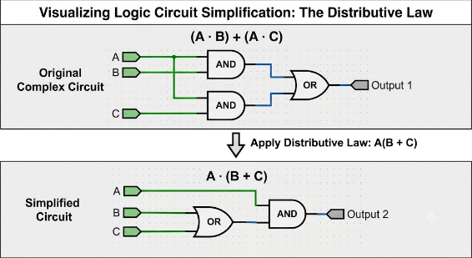
BOARD displays (one by one):
- Fewer logic gates
- Less power consumption
- Lower cost
- Higher speed
- Improved reliability
- Boolean Minimization = reducing complex logic into simpler logic
ANIMATION: Show a circuit with ten gates shrinking into a cleaner circuit with four gates. Add icons for power saving, speed, cost, and reliability.
DETAILED ANIMATION / VISUAL:
Use the preserved circuit-simplification image without cropping or redesigning it. Highlight the larger circuit first, then trace equivalent signal paths while redundant gate overlays fade away until the smaller circuit remains. Introduce the power, speed, cost, and reliability icons one by one around the simplified circuit, keeping the original comparison visible.
SEGMENT 4 - BRIDGE TO NEXT PART [3:20 - 3:30]
BOARD Title: COMING UP NEXT
BOARD displays: BOOLEAN MINIMIZATION EXAMPLES
Aadhi speaks:
Now we will apply these laws directly to simplify Boolean expressions step by step.
DETAILED ANIMATION / VISUAL:
Keep the COMING UP NEXT title centred and readable for two seconds. Use a restrained topic-related icon or formula trace as a brief preview, then fade the complete board to black over one second. Do not include any farewell gesture, and begin the following part from a clean black frame.
NOTE: No farewell. No goodbye wave. Clean fade to black.

CLIP 6 SCRIPT - BOOLEAN MINIMIZATION EXAMPLES, APPLICATIONS, QUIZ, AND SUMMARY
Estimated duration: 3.5-4 minutes
SCENE 1 - TITLE CARD [0:00 - 0:10]
ON SCREEN - full screen, no board, no Aadhi:
BOOLEAN MINIMIZATION AND APPLICATIONS
ANIMATION: Title appears over a complex circuit transforming into a simpler circuit. The simpler circuit glows gold.
DETAILED ANIMATION / VISUAL:
Open on a dense but readable circuit silhouette behind the title. Trace the active path through it, fade redundant branches, and transition to a compact circuit with fewer visible elements. Apply a restrained gold glow to the simplified result, hold the title clearly, and dissolve into the first worked example.
SEGMENT 1 - EXAMPLE 1: BOOLEAN MINIMIZATION [0:10 - 1:05]
BOARD Title: EXAMPLE OF BOOLEAN MINIMIZATION
Aadhi speaks:
Consider the expression:
Y = A + AB
Using the Absorption Law:
A + AB = A
Therefore:
Y = A
A two-term expression is reduced to a single variable.
BOARD displays - formula :
Y = A + AB
Using Absorption Law:
A + AB = A
Therefore:
Y = A
ANIMATION: Write Y = A + AB. Highlight A as the absorbed term. Fade AB and leave Y = A in large gold text.
DETAILED ANIMATION / VISUAL:
Write the expression line by line as if on the board. Highlight the leading A and draw a short absorption bracket over AB, then reduce the opacity of AB while preserving the original step on screen. Bring the final Y = A result forward in gold and keep the derivation visible beneath it for continuity.
SEGMENT 2 - EXAMPLE 2: BOOLEAN MINIMIZATION [1:05 - 2:00]
BOARD Title: EXAMPLE OF BOOLEAN MINIMIZATION
Aadhi speaks:
Let's take another example.
Y = AB + AB̅
Factor A:
Y = A(B + B̅)
Since:
B + B̅ = 1
Y = A × 1
Y = A
The circuit becomes much simpler.
BOARD displays - formula / expression block:
Y = AB + AB̅
Factor A:
Y = A(B + B̅)
Since B + B̅ = 1
Y = A × 1
Y = A
ANIMATION: Show AB and AB̅ terms. Pull A outside as a common factor. Then B + B̅ turns into 1, and the final output becomes A.
DETAILED ANIMATION / VISUAL:
Reveal AB and AB̅ as two separate terms, highlight the common A in both, and animate the two A symbols joining outside a bracket. Next, transform only the bracketed B + B̅ overlay into 1, then show A × 1 resolving to A. Keep each preceding line visible so the full simplification path can be followed.
SEGMENT 3 - REAL-WORLD ENGINEERING APPLICATIONS [2:00 - 2:55]
BOARD Title: REAL-WORLD ENGINEERING APPLICATIONS
Aadhi speaks:
Boolean minimization is used everywhere.
Computer processors use simplified logic to increase speed.
PLCs use Boolean expressions to control industrial machines.
Robots use logical decisions for navigation and sensing.
Traffic signal controllers use Boolean logic to manage intersections efficiently.
Without simplification, modern digital systems would be slower, larger, and more expensive.
BOARD displays (one by one):
- Computer processors - increase speed
- PLCs - control industrial machines
- Robots - navigation and sensing
- Traffic signal systems - manage intersections efficiently
ANIMATION: Show processor, PLC, robot controller, and traffic signal system icons. Each icon receives a simplified Boolean expression and glows gold.
DETAILED ANIMATION / VISUAL:
Arrange the processor, PLC, robot controller, and traffic-signal system as four application panels. Send the same simplified-expression card toward each panel in narration order; when it arrives, activate a brief gold pulse within that application. Finish with all four panels connected to the central Boolean-minimization label.
SEGMENT 4 - QUICK QUIZ [2:55 - 3:40]
BOARD Title: QUICK QUIZ
Aadhi speaks:
Question 1:
What values can a Boolean variable take?
Answer:
0 and 1.
Question 2:
Who developed Boolean Algebra?
Answer:
George Boole.
Question 3:
What is A + 0 equal to?
Answer:
A.
Question 4:
What is A · A̅ equal to?
Answer:
0.
Question 5:
Why is Boolean minimization important?
Answer:
To reduce hardware complexity and improve efficiency.
BOARD displays (one by one):
- Q1: What values can a Boolean variable take? Answer: 0 and 1.
- Q2: Who developed Boolean Algebra? Answer: George Boole.
- Q3: What is A + 0 equal to? Answer: A.
- Q4: What is A · A̅ equal to? Answer: 0.
- Q5: Why is Boolean minimization important? Answer: To reduce hardware complexity and improve efficiency.
ANIMATION: Show animated quiz cards. Each question appears first, then the answer flips in with a check mark.
DETAILED ANIMATION / VISUAL:
Present one quiz card at a time in the centre of the board. Show the question face first, pause briefly, then flip or slide the card to reveal the answer and a small check mark. Move each completed card into a tidy side stack before introducing the next, and end with all five answered cards visible together.
SEGMENT 5 - SUMMARY [3:40 - 4:20]
BOARD Title: SUMMARY
Aadhi speaks:
Let's summarize.
Boolean Algebra is the language of digital systems.
Boolean variables use only two values: 0 and 1.
Boolean postulates form the foundation of logical operations.
Boolean laws help simplify expressions.
DeMorgan's theorems provide powerful transformation techniques.
Boolean minimization reduces circuit complexity, cost, and power consumption.
These concepts form the backbone of digital electronics, computer engineering, embedded systems, robotics, and industrial automation.
Thank you for watching.
BOARD displays (one by one):
- Boolean Algebra = language of digital systems
- Boolean variables use 0 and 1
- Postulates form the foundation
- Boolean laws simplify expressions
- DeMorgan's theorems transform expressions
- Minimization reduces complexity, cost, and power consumption
ANIMATION: Summary bullets appear one by one. Final line glows: DIGITAL ELECTRONICS - COMPUTER ENGINEERING - ROBOTICS - INDUSTRIAL AUTOMATION. Smooth fade out.
DETAILED ANIMATION / VISUAL:
Reveal the summary points one at a time with a consistent short fade and retain them on screen as the list builds. After the final point, connect the concepts with thin circuit lines leading to the four application fields named in the closing line. Give that line one controlled gold glow, reduce all motion gradually, and finish with a smooth fade to black.
NOTE: Final part may end with Aadhi closing naturally. Smooth fade to black after the thank-you line.

