**CHAPTER 1**

# INTRODUCTION

Intelligent Transportation Systems (ITS) is the use of Information Technology (IT), sensors and communications technologies for surface transport applications-though road transport applications vastly predominate. Road and other infrastructure building is expensive and environmentally unfriendly; we can make better use of the civil infrastructure by using a broad range of electronic technologies, making transportation systems safe, e client, reliable and environmentally friendly, without implementing new physical infrastructure. ITS cuts across disciplines such as transportation, engineering, telecommunications, computer science, finance, electronic commerce and automotive manufacturing. Use of wireless/radio mobile communications and satellite positioning systems are particularly important.

# 1.1 OBJECTIVE

The main aim is to monitor the goods loading in commercial goods vehicle. Things to checks are Goods loading, goods height and persons in goods garage area in vehicle.

**CHAPTER 2**

## LITERATURE SURVEY

Load management is a process that monitors the load and performs some controlling actions to reduce the electricity consumption and maximum demand. Among all the methods above load shifting is one of the common and better method for the load management in most of the industries because load shifting method is to shift the load from peak period to non-peak period to modify the load profile without affecting the total actual consumption. Power utilities world over are faced with the problem of satisfying electric power demands. Meeting consumer demand for electric power is one of the major glitches faced by Power utilities. Due to prohibitive costs in the addition of new generation capacity, Power utilities have designed programs and techniques in order to balance demand and supply within their generating capacity hence load management has come in as an important approach in providing electric power proportional in times of peak demands.

The goods monitoring system provides a proper notification system about the good level (load capacity, load height and persons in load place) in the vehicle and also buzzer is used to alert. The driver can make a false statement about the goods level to the owner and can gain extra money. This scenario can be changed by the notification system. The system helps the owner to have the knowledge of goods level in vehicle and the person of the vehicle load area at regular interval of time. It helps to know the honesty of the driver to the owner and also can save the money. This project goods monitoring system in vehicle represents the notification to the mobile numbers. The proposed goods monitoring system can track the load level in the vehicle and also the alert the information of the vehicle and sends the notification to the owner. This made the project more user-friendly and reliable. The proposed method can be highly beneficial for the automotive industry.

# CHAPTER 3

## EXISTING METHOD

These state electricity boards and utilities suffers huge losses due to the reason that the transformers are damaged on account of overloading of distribution system, non-augmentation of transformers, poor maintenance and negligence on the part of maintenance staff of the board. According to the above discussion, we need a distribution transformer real-time monitoring system to detect all operating parameters operation, and send to the monitoring canter in time. Transformers are a crucial part of the transmission and distribution system. The state electricity boards and utilities incur huge money to procure distribution transformers every year. These state electricity boards and utilities suffers huge losses due to the reason that the transformers are damaged on account of overloading of distribution system, non-augmentation of transformers, poor maintenance and negligence on the part of maintenance staff of the board. Apart from this, there are several other drawbacks in the present system that are discussed below.

* For proper maintenance of transformers, boards require huge man power to check each and every transformer spread over vast and remote areas where the transformers have been installed in villages, cluster of houses, in agricultural fields etc. which is not feasible for the technical line staff.
* It involves financial cost to be incurred on travelling on vehicles to various sites where the transformers are installed.
* The scheduled maintenance of transformers is not possible as the technical line staff is already overburdened with multiple types of duties assigned to them.
* The critical weather conditions in various states of India make interruption for the technical staff in performing their duties. Several research works have been done in this field to develop a solution for health monitoring of transformers to prevent premature failure of distribution transformers and improving reliability of services to the customers. We also initiated our work in the same field and completed the same with better and advantageous results.

# CHAPTER 4

## PROPOSED METHOD

In this project we are going monitoring the goods using sensors and wireless network. Here we are going monitoring goods loading and height management and person monitor in goods area using sensors node. In this Arduino nano controller is used to control all the sensors. Here load cell used to monitor good load. If the load exit limited means it will alert through buzzer. IR sensor is used to measure the goods height and ultrasonic sensor is used check person movement in goods garage area. And also, it will not to start the engine. It will permit once it will reach permitted level for all conditions.

## 4.1 BLOCK DIAGRAM

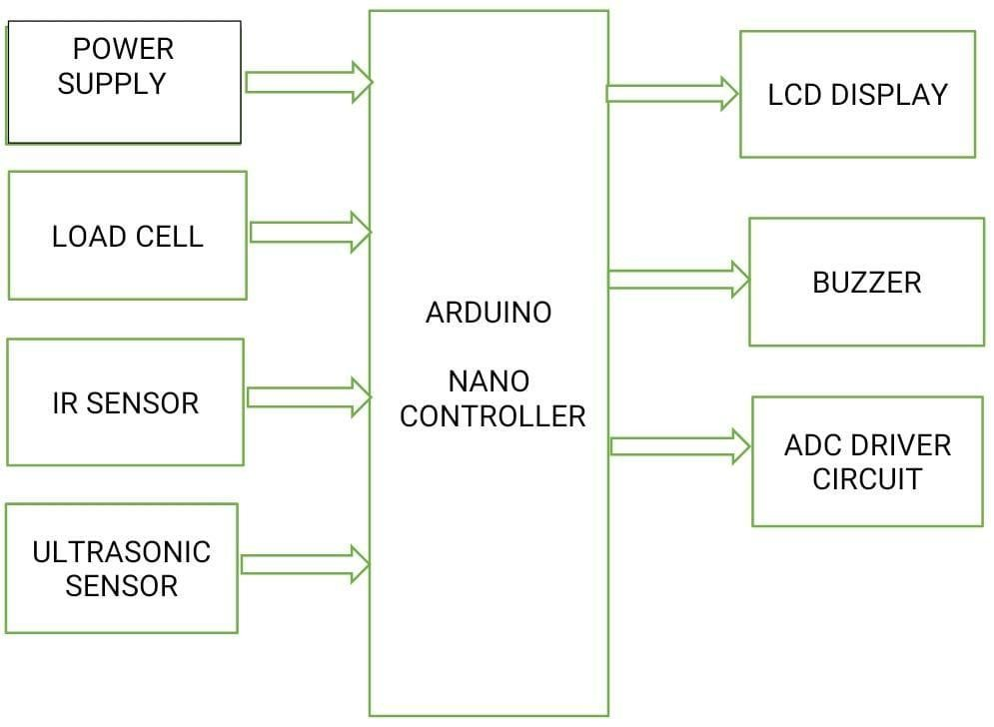

**Fig 4.1 Block Diagram**

## 4.2 HARDWARE REQUIRED

* Power Supply
* Load Cell Sensor
* IR Sensor
* PIR Sensor
* LCD Display

### 4.2.1 POWER SUPPLY

The ac voltage, typically 220V rms, is connected to a transformer, which steps that ac voltage down to the level of the desired dc output. A diode rectifier then provides a full-wave rectified voltage that is initially filtered by a simple capacitor filter to produce a dc voltage. This resulting dc voltage usually has some ripple or ac voltage variation.

A regulator circuit removes the ripples and also remains the same dc value even if the input dc voltage varies, or the load connected to the output dc voltage changes. This voltage regulation is usually obtained using one of the popular voltage regulator IC units.

**Fig**

**4**

**.2**

**Power Supply**



TRANSFORM

ER



RECTIFIE

R



FILTE

R



IC

REGULATO



LOAD

#### 4.2.1.1 TRANSFORMER

The potential transformer will step down the power supply voltage (0230V) to (0-6V) level. Then the secondary of the potential transformer will be connected to the precision rectifier, which is constructed with the help of op–amp. The advantages of using precision rectifier are it will give peak voltage output as DC, rest of the circuits will give only RMS output.

**4.2.1.2 BRIDGE RECTIFIER**

When four diodes are connected as shown in figure, the circuit is called as bridge rectifier. The input to the circuit is applied to the diagonally opposite corners of the network, and the output is taken from the remaining two corners.

Let us assume that the transformer is working properly and there is a positive potential, at point A and a negative potential at point B. the positive potential at point A will forward bias D3 and reverse bias D4. The negative potential at point B will forward bias D1 and reverse D2. At this time D3 and D1 are forward biased and will allow current flow to pass through them; D4 and D2 are reverse biased and will block current flow.

The path for current flow is from point B through D1, up through RL, through D3, through the secondary of the transformer back to point B. this path is indicated by the solid arrows. Waveforms and can be observed across D1 and D3.

One-half cycle later the polarity across the secondary of the transformer reverse, forward biasing D2 and D4 and reverse biasing D1 and D3. Current flow will now be from point A through D4, up through RL, through D2, through the secondary of T1, and back to point A.

This path is indicated by the broken arrows. Waveforms and can be observed across D2 and D4. The current flow through RL is always in the same direction. In flowing through RL this current develops a voltage corresponding to that shown waveform. Since current flows through the load (RL) during both half cycles of the applied voltage, this bridge rectifier is a full-wave rectifier.

One advantage of a bridge rectifier over a conventional full-wave rectifier is that with a given transformer the bridge rectifier produces a voltage output that is nearly twice that of the conventional full-wave circuit.

This may be shown by assigning values to some of the components shown in views A and B. assume that the same transformer is used in both circuits. The peak voltage developed between points X and y is 1000 volts in both circuits. In the conventional full-wave circuit shown in view A, the peak voltage from the center tap to either X or Y is 500 volts. Since only one diode can conduct at any instant, the maximum voltage that can be rectified at any instant is 500 volts.

The maximum voltage that appears across the load resistor is nearly-but never exceeds-500 v0lts, as result of the small voltage drop across the diode. In the bridge rectifier shown in view B, the maximum voltage that can be rectified is the full secondary voltage, which is 1000 volts. Therefore, the peak output voltage across the load resistor is nearly 1000 volts. With both circuits using the same transformer, the bridge rectifier circuit produces a higher output voltage than the conventional full-wave rectifier circuit.

#### 4.2.1.3 IC VOLTAGEREGULATORS

Voltage regulators comprise a class of widely used ICs. Regulator IC units contain the circuitry for reference source, comparator amplifier, control device, and overload protection all in a single IC. IC units provide regulation of either a fixed positive voltage, a fixed negative voltage, or an adjustably set voltage. The regulators can be selected for operation with load currents from hundreds of milli amperes to tens of amperes, corresponding to power ratings from milli watts to tens of watts.

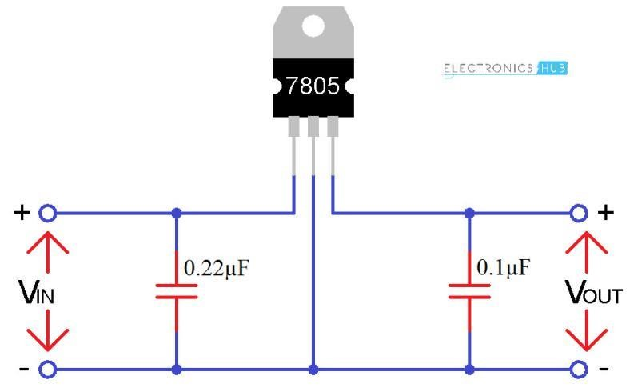

**Fig 4.3 Voltage Regulators**

A fixed three-terminal voltage regulator has an unregulated dc input voltage, Vi, applied to one input terminal, a regulated dc output voltage, Vo, from a second terminal, with the third terminal connected to ground. The series 78 regulators provide fixed positive regulated voltages from 5 to 24 volts. Similarly, the series 79 regulators provide fixed negative regulated voltages from 5 to 24 volts.

### 4.2.2 LOAD CELL SENSOR

A load cell is a type of transducer, specifically a force transducer. It converts a force such as tension, compression, pressure, or torque into an electrical signal that can be measured and standardized. As the force applied to the load cell increases, the electrical signal changes proportionally. The most common types of load cell used are hydraulic, pneumatic, and strain gauge.

Strain Gauge Load Cell:

Strain gauge load cells are the kind most often found in industrial settings. This kind of load cell is ideal as it is highly accurate, versatile, and cost-effective. Structurally, a load cell has a metal body to which strain gauges have been secured. The body is usually made of aluminium, alloy steel, or stainless steel which makes it very sturdy but also minimally elastic.

This elasticity gives rise to the term "spring element", referring to the body of the load cell. When force is exerted on the load cell, the spring element is slightly deformed, and unless overloaded, always returns to its original shape. As the spring element deforms, the strain gauges also change shape. The resulting alteration to the resistance in the strain gauges can be measured as voltage. The change in voltage is proportional to the amount of force applied to the cell, thus the amount of force can be calculated from the load cell's output.

A strain gauge is constructed of very fine wire, or foil, set up in a grid pattern and attached to a flexible backing. When the shape of the strain gauge is altered, a change in its electrical resistance occurs. The wire or foil in the strain gauge is arranged in a way that, when force is applied in one direction, a linear change in resistance results. Tension force stretches a strain gauge, causing it to get thinner and longer, resulting in an increase in resistance. Compression force does the opposite. The strain gauge compresses, becomes thicker and shorter, and resistance decreases.

The strain gauge is attached to a flexible backing enabling it to be easily applied to a load cell, mirroring the minute changes to be measured. Since the change in resistance measured by a single strain gauge is extremely small, it is difficult to accurately measure changes. Increasing the number of strain gauges applied collectively magnifies these small changes into something more measurable. A set of 4 strain gauges set in a specific circuit is called Wheatstone bridge.

The Load cell is designed to automatically regulate the balancing pressure. Air pressure is applied to one end of the diaphragm and it escapes through the nozzle placed at the bottom of the load cell. A pressure gauge is attached with the load cell to measure the pressure inside the cell. The deflection of the diaphragm affects the airflow through the nozzle as well as the pressure inside the chamber.

The hydraulic load cell uses a conventional piston and cylinder arrangement with the piston placed in a thin elastic diaphragm. The piston doesn't actually come in contact with the load cell. Mechanical stops are placed to prevent over strain of the diaphragm when the loads exceed certain limit. The load cell is completely filled with oil. When the load is applied on the piston, the movement of the piston and the diaphragm results in an increase of oil pressure. This pressure is then transmitted to a hydraulic pressure gauge via a high pressure hose.

The gauge's Bourdon tube senses the pressure and registers it on the dial. Because this sensor has no electrical components, it is ideal for use in hazardous areas. Typical hydraulic load cell applications include tank, bin, and hopper weighing. By example, a hydraulic load cell is immune to transient voltages (lightning) so these type of load cells might be a more effective device in outdoor environments.

This technology is more expensive than other types of load cells. It is a more costly technology and thus cannot effectively compete on a cost of purchase basis. Piezoelectric load cells work on the same principle of deformation as the strain gauge load cells, but a voltage output is generated by the basic piezoelectric material proportional to the deformation of load cell. Useful for dynamic/frequent measurements of force.

Most applications for piezo-based load cells are in the dynamic loading conditions, where strain gauge load cells can fail with high dynamic loading cycles. The piezoelectric effect is dynamic, that is, the electrical output of a gauge is an impulse function and is not static.

The voltage output is only useful when the strain is changing and does not measure static values. However, depending on conditioning system used, "quasi static" operation can be done. Using a so-called "Charge amplifier " with "Long" time constant allow accurate measurement lasting many hours for large loads to many minutes for small loads.

Another advantage of Piezoelectric load cell, conditioned with a Charge amplifier, is the wide measuring range that can be achieved. Users can choose a load cell with a range of hundred of and use it for measuring few N of forces with the same Signal/Noise ratio, again this is possible only with the use of a Charge amplifier conditioning.

The full-bridge cells come typically in four-wire configuration. The wires to the top and bottom end of the bridge are the excitation (often labelled E+ and E−, or Ex+ and Ex−), the wires to its sides are the signal (labelled S+ and S−). Ideally, the voltage difference between S+ and S− is zero under zero load, and grows proportionally to the load cell's mechanical load. Sometimes a six-wire configuration is used.

The two additional wires are "sense" (Sen+ and Sen−), and are connected to the bridge with the Ex+ and Ex- wires, in a fashion similar to four-terminal sensing. With these additional signals, the controller can compensate for the change in wire resistance due to e.g., temperature fluctuations. The individual resistors on the bridge usually have resistance of 350 Ω. Sometimes other values (typically 120 Ω, 1,000 Ω) can be encountered.

The bridge is typically electrically insulated from the substrate. The sensing elements are in close proximity and in good mutual thermal contact, to avoid differential signals caused by temperature differences. ➢ Full Scale Output (FSO): Electronic output expressed in mv/V. Measured at full scale.

* Combined Error: % of the full scale output that represents the maximum deviation from the straight line drawn between no load and load at rated capacity. Often measured during decreasing and increasing loads.
* Non-Linearity: The maximum deviation of the calibration curve from a straight line drawn between the rated capacity and zero load. Measured on increasing load and expressed as % of full scale output.
* Hysteresis: Maximum difference between load cell output signals for the same applied load. The first measurement can be obtained by decreasing the load from rated output and the second by increasing the load from zero.
* Repeatability: Maximum difference between output measurements for repeated loads under identical conditions. Measured in % of rated output.
* Zero Balance (Offset): Output reading of the load cell with rated excitation under no load. The deviation in output between a true zero measurement and a real load cell under zero load expressed as a percentage of full scale output.
* Compensated Temperate Range: The temperature range over which a load cell is compensated so that it can ensure zero balance & rated output within specified limits. Expressed as °F or °C.
* Operating Temperature Range: Temperature range extremes in which a load cell can operate without permanent, adverse effects on any of its performance characteristics. Expressed as °F or °C.
* Temperature Effect on Output: Modification of output readings caused by load cell temperature. Expressed as % of full scale output per degree of °F or °C.
* Temperature Effect on Zero: Change in zero balance caused by ambient temperature changes. Expressed as % of full scale output per degree of °F or °C.
* Input Resistance: Input resistance of the load cell's bridge circuit. Measured at the positive & negative excitation leads with no load applied. Measured in Ohms.
* Output Resistance: Output resistance of the load cell's bridge circuit. Measured at the positive & negative excitation leads with no load applied. Measured in Ohms.
* Insulation Resistance: The resistance measured along pathways between the: bridge circuit and transducer element, bridge circuit and the cable shield, and the transducer element and the cable shield. Typically measured at fifty volts under standard test conditions.
* Recommended Excitation: Maximum recommended excitation voltage of the transducer for it to operate within its specifications. Expressed in VDC.
* Cable Length: Length of the standard cable for which the load cell is calibrated. Cable length affects how the load cell is calibrated.
* Safe Overload: The maximum load that can be applied to a load cell without causing permanent effects to its performance specifications. Measured as a % of full scale output.
* Ultimate Overload: Maximum load that can be withstood without causing structural failure.
* Material: Substance that comprises the spring element of the load cell.

### 4.2.3 IR SENSOR

An [infrared sensor](https://www.elprocus.com/ir-remote-control-basics-operation-application/) is an electronic device that emits in order to sense some aspects of the surroundings. An IR sensor can measure the heat of an object as well as detects the motion. These types of sensors measures only infrared radiation, rather than emitting it that is called as a [passive IR sensor.](https://www.elprocus.com/passive-infrared-pir-sensor-with-applications/) Usually in the infrared spectrum, all the objects radiate some form of thermal radiations. These types of radiations are invisible to our eyes that can be detected by an infrared sensor. The emitter is simply an IR LED ([Light Emitting Diode)](http://www.elprocus.com/explain-different-types-leds-working-applications-engineering-students/) and the detector is simply an IR photo diode which is sensitive to IR light of the same wavelength as that emitted by the IR LED. When IR light falls on the photo diode, the resistances and these output voltages, change in proportion to the magnitude of the IR light received.

#### 4.2.3.1 IR SENSOR WORKING

An infrared sensor circuit is one of the basic and popular sensor module in an [electronic device.](http://www.elprocus.com/basic-components-used-electronics-electrical/) This sensor is analogous to human’s visionary senses, which can be used to detect obstacles and it is one of the common applications in real time. This circuit comprises of the following component

* [LM358 IC](http://www.elprocus.com/op-amp-ics-pin-configuration-features-working/) 2 IR transmitter and receiver pair Resisters of the range of kilo ohms Variable resistors.
* LED (Light Emitting Diode).

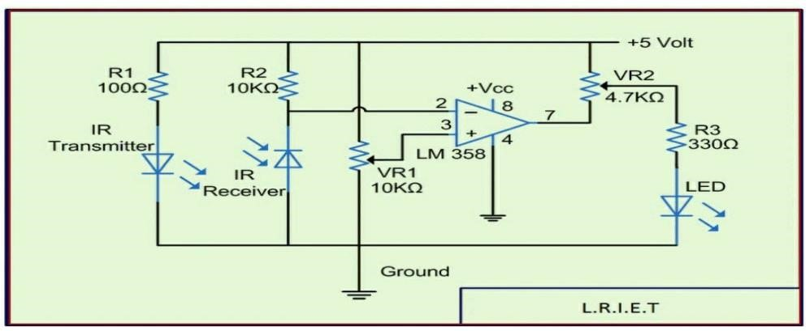

**Fig 4.4 IR Sensor Circuit**

In this project, the transmitter section includes an IR sensor, which transmits continuous IR rays to be received by an IR receiver module. An IR output terminal of the receiver varies depending upon its receiving of IR rays.

Since this variation cannot be analyzed as such, therefore this output can be fed to a comparator circuit. Here an [operational amplifier](https://www.elprocus.com/op-amp-ics-pin-configuration-features-working/) (op-amp) of LM 339 is used as comparator circuit. When the IR receiver does not receive a signal, the potential at the inverting input goes higher than that non-inverting input of the comparator (LM339). Thus the output of the comparator goes low, but the LED does not glow. When the IR receiver module receives signal to the potential at the inverting input goes low.

Thus the output of the comparator (LM 339) goes high and the LED starts glowing. Resistor R1 (100 ), R2 (10k ) and R3(330) are used to ensure that minimum 10 mA current passes through the IR LED Devices like Photodiode and normal LEDs respectively. Resistor VR2 (pre-set=5k ) is used to adjust the output terminals. Resistor VR1 (pre-set=10k) is used to set the sensitivity of the circuit Diagram.

### 4.2.4 ULTRASONIC SENSOR

Product features: Ultrasonic ranging module HC - SR04 provides 2cm - 400cm non-contact measurement function, the ranging accuracy can reach to 3mm. The modules includes ultrasonic transmitters, receiver and control circuit.

The basic principle of work: Using IO trigger for at least 10us high level signal,The Module automatically sends eight 40 kHz and detect whether there is a pulse signal back.If the signal back, through high level , time of high output IO duration is the time from sending ultrasonic to returning.

* Test distance = (high level time× velocity of sound (340M/S) / 2, Wire connecting direct as following:
* 5V Supply
* Trigger Pulse Input
* Echo Pulse Output
* 0V Ground

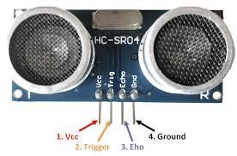

**Fig 4.5 Ultrasonic Sensor**

### 4.2.5 LIQUID CRYSTAL DISPLAY

LCD is used to display the results of the system operation such as sensed values, motor status etc.. A liquid-crystal display (LCD) is a flat panel display, electronic visual display, or video display that uses the light modulating properties of liquid crystals. Liquid crystals do not emit light directly. The LCD standard requires 3 control lines and 8 I/O lines for the data bus. The most commonly used Character based LCDs are based on Hitachi's HD44780 controller or other which are compatible with HD44580. In this tutorial, we will discuss about character based LCDs, their interfacing with various microcontrollers, various interfaces (8-bit/4-bit).

**4.3 SOFTWARE REQUIRED:**

* Arduino IDE
* Embedded C

### 4.3.1 ARDUINO

This article gives detailed information about an Arduino Nano board, and it is one kind of microcontroller board which is designed by the Arduino team. This microcontroller is based on Atmega168 or Atmega328p. It is fairly similar to Arduino Uno board but when it comes to pin-configuration and features, this nano board has replaced Arduino Uno due to small in size. As we know that while designing an embedded system small size components are preferred. Arduino boards are mainly used to build electronic projects. Embedded systems, robotics, etc. But the nano boards are mainly introduced for the beginners who are not from the technical background.

## 4.4 BUZZER

A buzzer or beeper is a signalling device, usually electronic, typically used in automobiles, household appliances such as a microwave oven, or game shows. It most commonly consists of a number of switches or sensors connected to a control unit that determines if and which button was pushed or a preset time has lapsed, and usually illuminates a light on the appropriate button or control panel, and sounds a warning in the form of a continuous or intermittent buzzing or beeping sound. Initially this device was based on an electromechanical system which was identical to an electric bell without the metal gong (which makes the ringing noise). Often these units were anchored to a wall or ceiling and used the ceiling or wall as a sounding board. Another implementation with some AC-connected devices was to implement a circuit to make the AC current into a noise loud enough to drive a loudspeaker and hook this circuit up to a cheap 8-ohm speaker. Nowadays, it is more popular to use a ceramic-based piezoelectric sounder like a Son alert which makes a high-pitched tone. Usually these were hooked up to "driver" circuits which varied the pitch of the sound or pulsed the sound on and off.

**4.4.1 SPECIFICATIONS:**

1. On-board passive buzzer
2. On-board 8550 triode drive
3. Can control with single-chip microcontroller IO directly
4. Working voltage: 5V
5. Board size: 22 (mm) x12 (mm)

### 4.4.2 SCHEMATIC DIAGRAM

### 

**Fig 4.6 Schematic Diagram**

**HOW TO TEST?**

1. Connect your Arduino microcontroller to the computer.
2. Connect the VCC pin of your module to the to the 5V pin of your Arduino.
3. Connect the GND pin of your module to the GND pin of your Arduino.
4. Connect the Input pin of your module to the pin 13 of your Arduino.
5. Enter this program to your Arduino Integrated Development Environment (IDE).

int buzzer = 13; void setup ()

{

Pin Mode (buzzer, OUTPUT);

}

void loop ()

{

digital Write (buzzer, HIGH); delay (1000); digital Write (buzzer, LOW); delay (1000);

}

6. Lastly, click the Upload Button.

**CHAPTER 5**

**RESULT AND DISCUSSION**

## The sample sketch above is a blink which is constructed with the help of opamp. The advantages of using precision rectifier are it will give peak voltage output as DC, rest of the circuits will give only RMS output also applicable for LEDs. The output is the turning on and off of the buzzer every other second. The picture below shows the setup of your module and Arduino.

## The proposed goods monitoring system can track the load level in the vehicle and also the alert the information of the vehicle and sends the notification to the owner. This made the project more user-friendly and reliable. The proposed method can be highly beneficial for the automotive industry.

## 

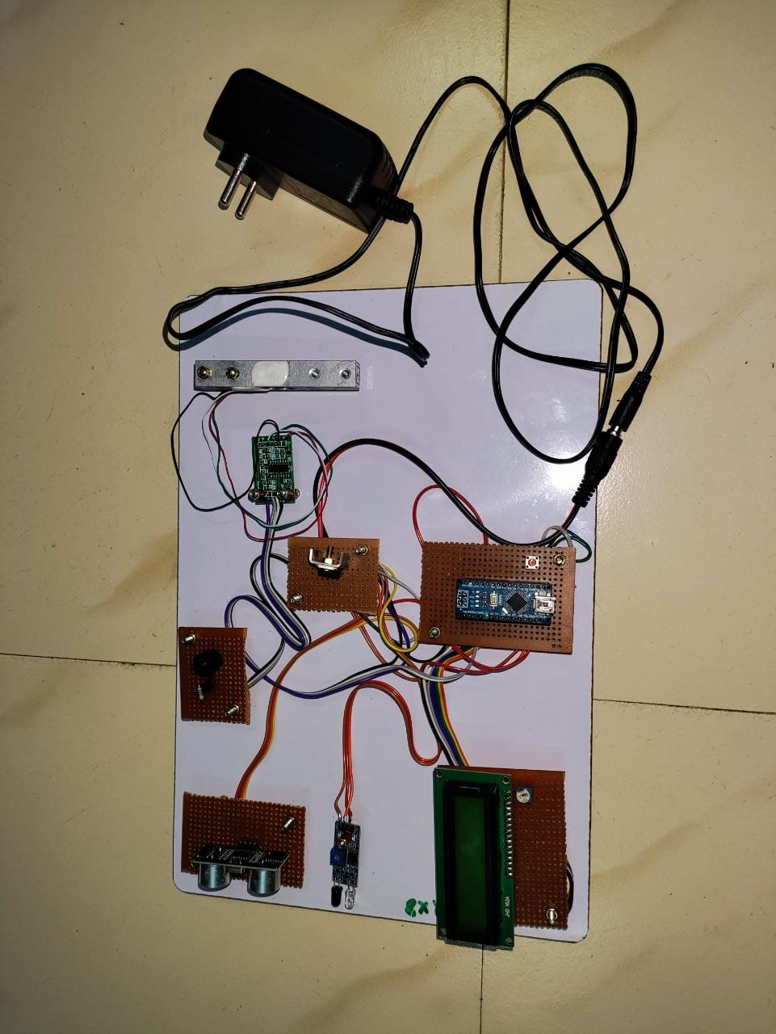

**CHAPTER 6**

**CONCLUSION**

The goods monitoring system provides a proper notification system about the good level (load capacity, load height and persons in load place) in the vehicle and also buzzer is used to alert. The driver can make a false statement about the goods level to the owner and can gain extra money. This scenario can be changed by the notification system. The system helps the owner to have the knowledge of goods level in vehicle and the person of the vehicle load area at regular interval of time. It helps to know the honesty of the driver to the owner and also can save the money. This project goods monitoring system in vehicle represents the notification to the mobile numbers. The proposed goods monitoring system can track the load level in the vehicle and also the alert the information of the vehicle and sends the notification to the owner. This made the project more user-friendly and reliable. The proposed method can be highly beneficial for the automotive industry.

#### 

**REFERENCES**

1. Albert Alexe, R.Ezhilarasie, “Cloud Computing Based Vehicle Tracking Information Systems”, ISSN : 2229-4333 (Print) ISSN: 0976-8491 (Online) IJCST Vol. 2, Issue 1, March 2011.
2. Anand. T. M, Banupriya. K, M. Deepika, and A. Ansuya, Intelligent Transportation Systems using IoT Service for Vehicular Data Cloud, International Journal for Innovative Research in Science & Technology, Vol.2, No. 02, pp. 80-86, 2015.
3. Hoang Dat Pham; Drieberg, M.; Chi Cuong Nguyen, "Development of vehicle tracking system using GPS and GSM modem," Open Systems (ICOS), 2013 IEEE Conference on, vol., no., pp.89,94, 2-4 Dec. 2013.
4. JaunZambada, Ricardo Quintero, Ramon Isijara, Ricardo Galeana, Luis Santillan, “An IoT based scholar bus monitoring system”, IEEE 2015.
5. Jyothi kiran. M, Ravi teja. S. Vehicle Health Monitoring Systems.. International Journal of Engineering Research and Applications Vol. 2, Issue 5, September-October 2012, pp.1162-1167.
6. Lee. S, G. Tewelde and J. Kwon, "Design and implementation of vehicle tracking system using GPS/GSM/GPRS technology and smartphone application,"2014 IEEE World Forum on Internet of Things (WF-IoT), Seoul, 2014.
7. Ceraolo, M. “New Dynamical Models of Lead–Acid Batteries” IEEE Transactions on Power Systems, Vol. 15, issue: 4, 2000, pp. 1184-1190.
8. Barsali, Stefano; Ceraolo, M. “Dynamical Models of Lead–Acid Batteries: implementation issues” IEEE Transactions on Energy Conversion, Vol. 17, issue: 1, 2002, pp. 16-23.
9. Lijun Gao; Liu, Shengyi ; Dougal, R.A. “Dynamic Lithium-Ion Battery Model for System Simulation” IEEE Transactions on Components and Packaging Technologies, Vol 25, issue: 3, 2002, pp. 495-505.
10. University of California at Irvine, Machine Learning Repository, http://alturl.com/5z7au 0 5 10 15 20 250510152025Time [Hour]Power [KW]Centre-Tap Transformer.